FIFTEENTH SUNDAY AFTER PENTECOST
SEPTEMBER 6TH, 2015 9:00 a.m.
WORSHIP SERVICE
In the Name of Jesus!
Our Mission Statement:
Anchored in Christ, each person a missionary.

PRELUDE

ANNOUNCEMENTS:
God is with us all during the week, wherever we are and in whatever we are doing. This week, let’s enjoy His presence.

OPENING HYMN:

Pastor: In the Name of the Father and of the Son and of the Holy Spirit.
Congregation: Amen

PREPARATION

(Please Remain Standing Or You May Kneel…)
CONFESSION OF SIN:
All: God, I admit I have broken all of your commandments; I am not holy or sinless even though I often pretend a righteousness I do not have. I offer excuses. I have broken relationships by what I have said, or done. I have not loved either You or my neighbor as I ought. (time for personal confession____)

YOU ARE FORGIVEN:
Pastor: God is merciful and gracious; He has given His Son, Jesus Christ to die and rise again for us, the sinful ones that we might be forgiven and enjoy His Peace. This is also a reminder of God’s gifts and blessing that have become ours in Holy Baptism.
Congregation: thank you God for Your blessing!
Pastor: Yes, the Grace of our Lord Jesus Christ, and the Love of God, and the fellowship of His Holy Spirit is with you all.
Congregation: And also with you.
Pastor: In peace and as His forgiven people, we can pray to the Lord:
Congregation: He is gracious to us and hears our prayers.
Pastor: For the peace of the whole world and our involvement in Christ’s Mission in the world, we pray:
Congregation: Keep us mindful of our purpose as Christians and our ability to share your blessings of peace and forgiveness with others.
Pastor: We are the children of the Risen Christ. His victory is Our Victory!

THE PRAYERS OF THE CHURCH:
All: O Lord, let Your merciful ears be open to the prayers of Your humble servants and grant that what they ask may be in accord with Your gracious will; through Jesus Christ, our Son, our Lord, who lives and reigns with You and the Holy Spirit, one God, now and forever. Amen

SERVICE OF THE WORD

God speaks to us through his word, the Bible:

(You may be seated…)
THE OLD TESTAMENT LESSON: Isaiah 35:4-7a
Lector: This is the Word of the Lord.
People: Thanks be to God.

THE EPISTLE LESSON: James 2:1-10, 14-18
Lector: This is the Word of the Lord.
People: Thanks be to God.

(Please stand…)
THE HOLY GOSPEL: Mark 7:31-37
Pastor: The Holy Gospel according to St. Mark Chapter 7.
People: Glory to You, O Lord.
Pastor: This is the Gospel of the Lord.
People: Praise to You, O Christ!

(Please be seated…)
NOISE OFFERING

THE SERMON HYMN:

THE SERMON: “Touched with Grace” Isaiah 35:4-7a

OFFERING
SERVICE OF THE SACRAMENT

(Please stand…)
PREPARE FOR THE LORD’S SUPPER:
Pastor: We begin with the reminder: “The Lord is with you.”
Congregation: We are mindful and thankful for His presence.
Pastor: Let your life reflect the joy of your salvation.
Congregation: We do give Him thanks and praise. We will share His blessing with others.
Pastor: It is proper that we should at all times and in all places…(prayer)… we praise your name and join others in singing:
All: (sing) “Holy, holy, holy Lord God of pow’r and might:
Heaven and earth are full of your glory.
Hosanna, Hosanna, Hosanna in the highest.
Blessed is he who comes in the name of the Lord.
Hosanna in the highest.”

(Please be seated…)
THE CONSECRATION AND DISTRIBUTION:

Hymns:
“O Son of God, in Galilee” LSB 841
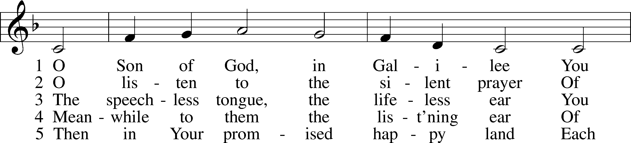
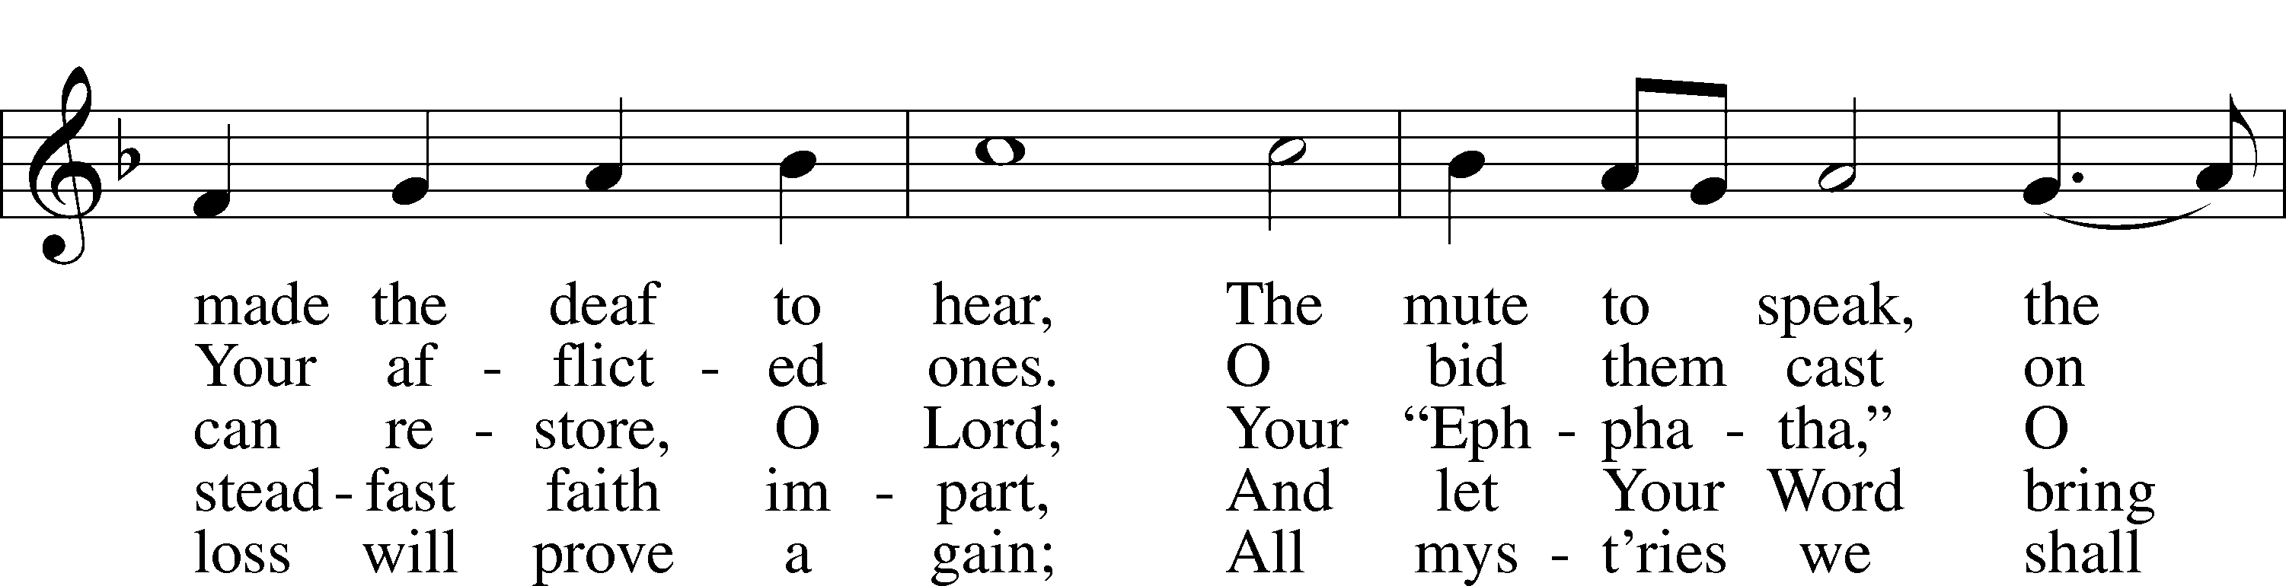
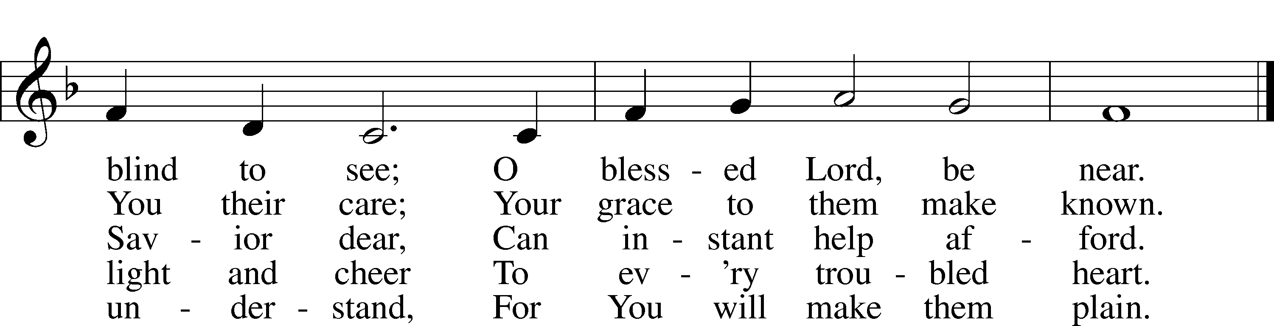
© 1978 Lutheran Book of Worship. Used by permission: LSB Hymn License .NET, no. 100011641.
Public domain

“O Christ, Who Called the Twelve” LSB 856
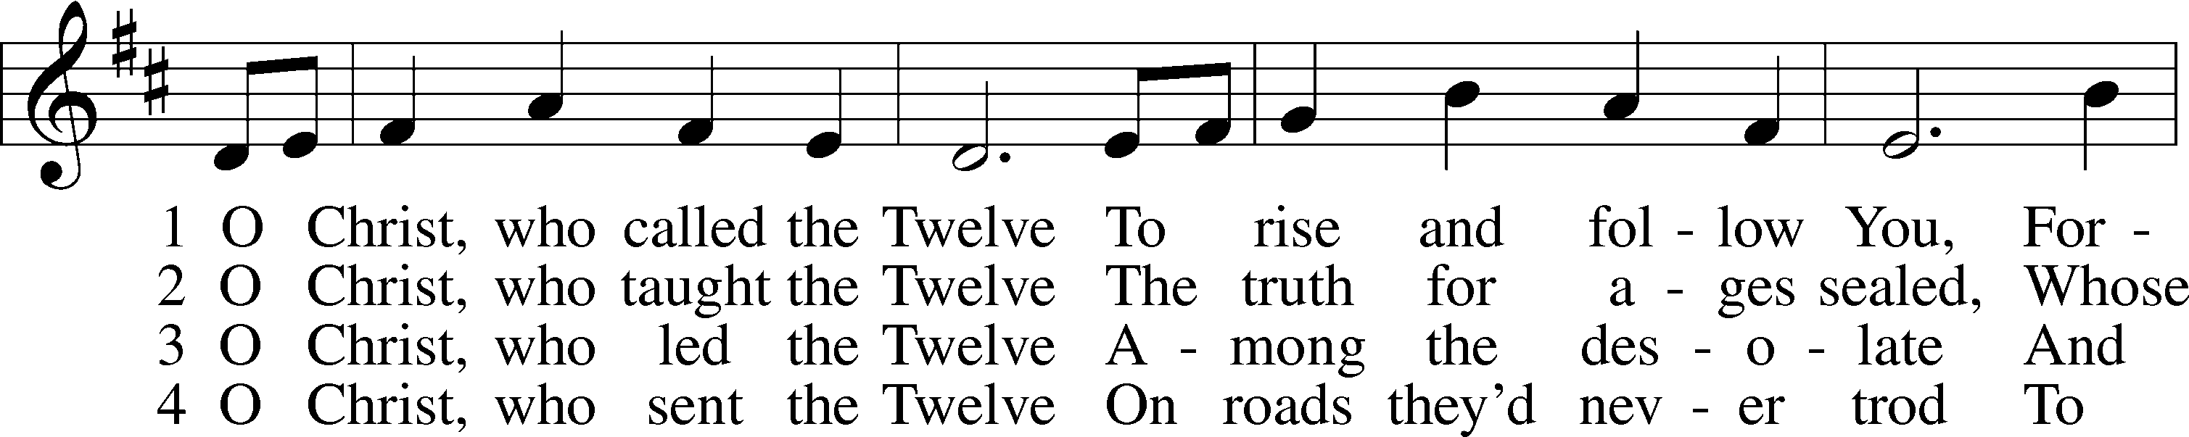
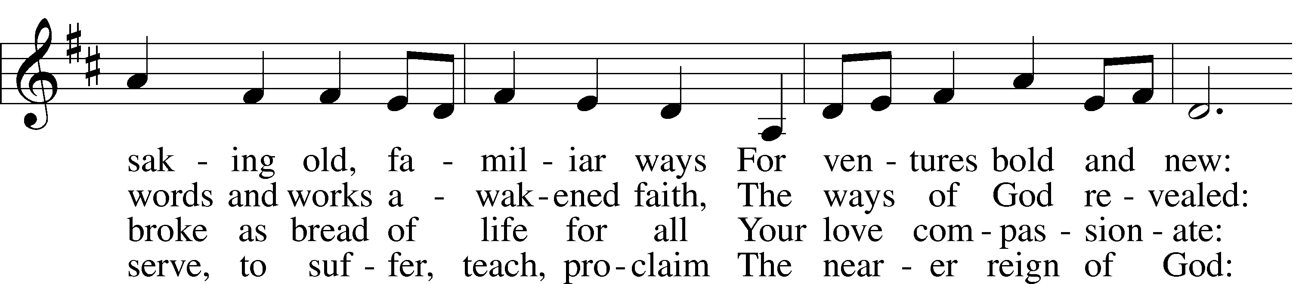
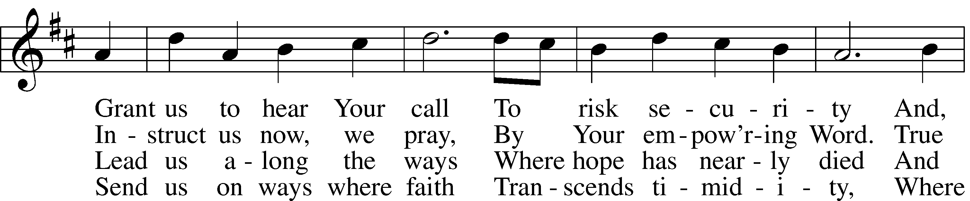
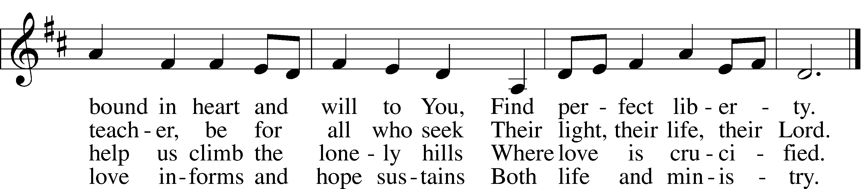

5 O Christ, the_apostles’ Lord,
The martyrs’ strength and song,
The crucified and risen King
To whom the saints belong:
Though generations pass,
Our tribute still we bring,
Our hymns a sacrifice of praise,
Our lives an offering.
© 1993 GIA Publications, Inc. Used by permission: LSB Hymn License .NET, no. 100011641.
Public domain

“Jesus Shall Reign” LSB 832
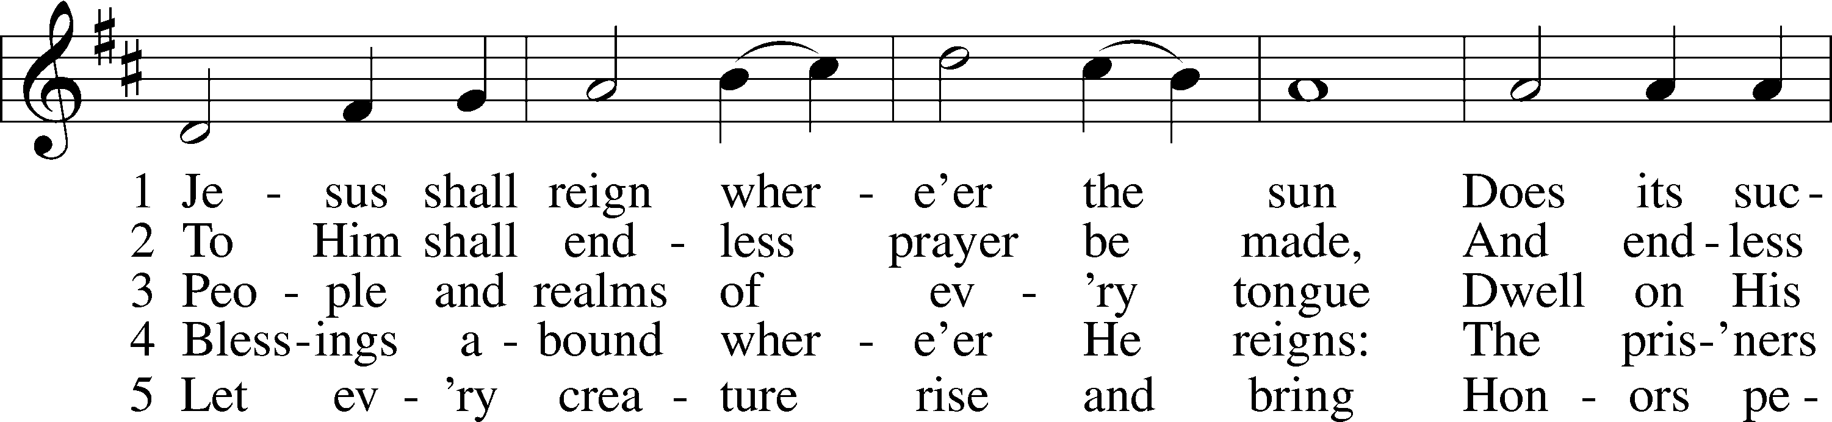
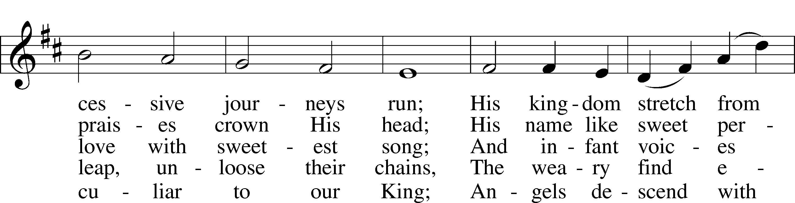
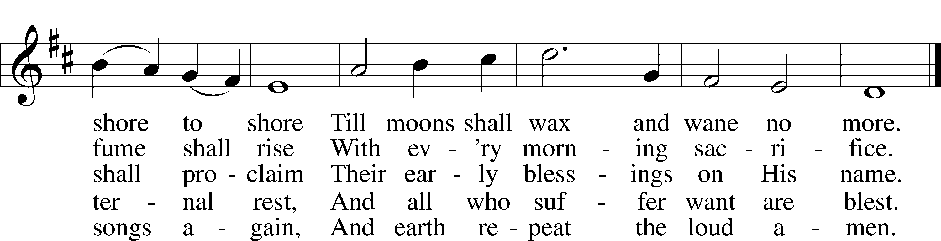
Public domain
(Please stand…)
THE LORD’S PRAYER:
All: Our Father, who art in heaven, Hallowed be thy name, thy kingdom come, thy will be done, on earth as it is in heaven. Give us this day our daily bread; and forgive us our trespasses, as we forgive those who trespass against us; and lead us not into temptation, but deliver us from evil. For thine is the kingdom, and the power, and the glory, forever and ever. Amen.

THE BLESSING AND BENEDICTION:
Pastor: The Lord Blesses you and keeps you, the Lord makes His face to shine upon you and He is Gracious to you. The Lord looks upon you with His favor and gives you His peace.
Congregation: God blesses us so that we can be a blessing to others.
Pastor: Go in His peace and serve the Lord by serving others.
Congregation: Amen

THE CLOSING HYMN: “Joyful, Joyful We Adore Thee” LSB 803
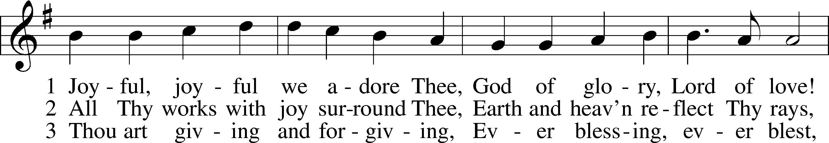
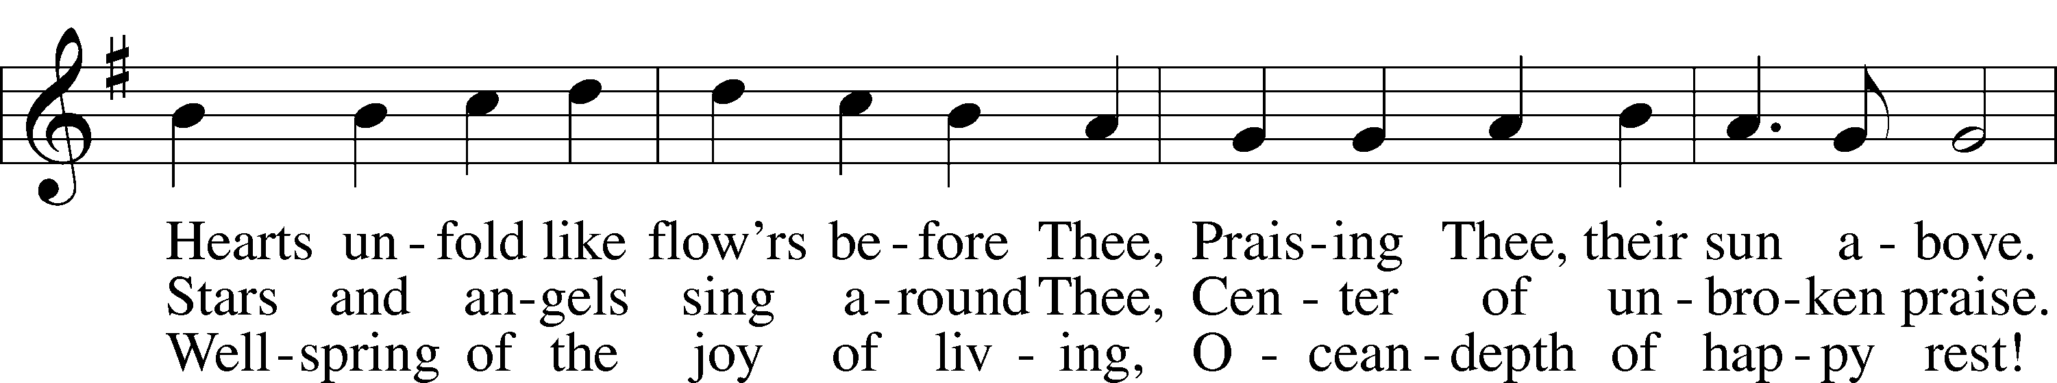
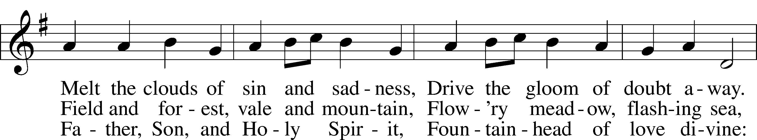
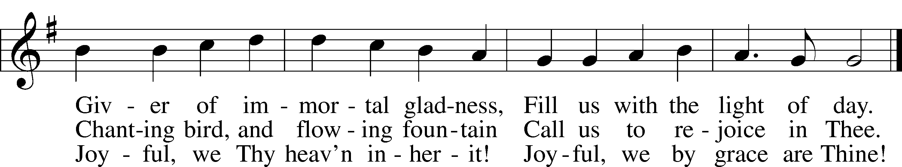
Public domain

ANNOUNCEMENTS

WELCOME TO GRACE LUTHERAN CHURCH: We are glad that you are here to worship God with us today! We pray that you will enjoy the wonderful fellowship as friends in Christ as God gathers us around His means of grace, the Word and Sacraments, to bless us with His treasured gifts of forgiveness, faith, abundant life and eternal salvation. If you are a guest, please also sign our Guest Book. Please talk to Pastor if you would like to learn more about becoming a member of Grace. Also, please join us for refreshments and fellowship after the Service. We invite you to come and worship with us often as God gathers us in His Grace.

WELCOME TO THE LORD”S TABLE: We invite and encourage all present who are baptized and faithful Christians, and who confess the Father, Son, and Holy Spirit to be the only true God and who believe that Jesus Christ died for the sins of the World and is our only hope and salvation…to join us in receiving the very and true body and blood of Christ in this Sacrament. The clear liquid cups in the center of the tray are non-alcoholic wine.

Children not yet confirmed in the faith are always welcome to join their parents at the Lord’s Table, but should keep their hands folded in front of them. The Pastor will give them a blessing.

SERVING TODAY: Acolyte: Elizabeth Reynolds; Lector: David Rose, Communion Assistants: Don Bly and Vince Winters; Usher: Terry Richardson; Altar Care: Ed and Nancy Swift;
Refreshments: Ed and Nancy Swift.
SERVING NEXT SUNDAY: Acolyte: James Reynolds; Lector: David Rose; Communion Assistants: Don Bly and Vince Winters; Usher: Terry Richardson; Altar Care: __________; Refreshments: _________________.

FLOWERS: were placed on the altar today to the glory of God and by the Howard family to celebrate Bo’s birthday.

THIS WEEK AT A GLANCE:

Today: This Sunday
9:00 am Worship Service with Communion
10:15 am Fellowship
10:30 am Adult Bible Class/Children’s Sunday School

Monday: September 7th
Pastor’s Day Off
5:00 pm Zumba

Tuesday: September 8th
12:00 pm Hot Tin Roof
3:00 pm Jan’s Mobile Gym (Parish Hall)
6:00 pm Weight Watcher’s (Parish Hall)

Wednesday: September 9th
8:30 am Chapel
10:00 am Water Aerobics (Community Pool)

Thursday: September 10th
5:00 pm Zumba
6:30 pm Missional Community (Pastor’s Home)

Next Sunday: September 13th
9:00 am Worship Service with Communion
10:10 am Children’s Chime and Vocal Choir Rehearsal
10:15 am Fellowship
10:30 am Adult Bible Class/Children’s Sunday School

IN YOUR PRAYERS THIS WEEK: Friends and family of Gerald Sattelmeier, Carol Sebree, Holly Purdy, friends and family of Wendy Asplundh, Floss Flenard, Katie Higgs Wyrwicki, Peggy Mira, Micheal son of Will and Noelle Plagens, Walter Lepperd, Mary Hoffman, Robert Hoffmann, Will Plagens, Peter Pike, Frank, Harry, Mary McNeal, Donald Rollman, Jonathan Satel, Mable Paul, VanderKooi family, Bobby Bringle, Meggan Meggs, Cheryl Kucera, Tim Rodriguez, Elsie Hamilton, Mary Bacle, Michael Gillis, Joe Lamberson, Vernon Julson, Dennis Julson, Mary Ellen Jessel, and those you are praying for at home. If anyone has a special prayer request please submit it in writing in the collection plate; or you may call Pastor Gary Faith at (504-858-8872), or Kris Howard at (305-296-5161).

GIFTS, TITHES, & ATTENDANCE LAST SUNDAY were $2717.00, the building fund received $100.00, and the noise offering was $44.99. The attendance for last Sunday was 65.

TO HELP US GROW… The Bible readings for next Sunday’s service readings are Isaiah 50:4-10, James 3:1-12, and Mark 9:14-29.

THE GRACIOUS LADIES OF GRACE: had a 5 star lunch at Square Grouper with Shrimp Salad Sliders being the favorite and Fried Conch coming in second. We had a group of 12 and as usual a good time was had by all. The next gourmet delight will be on September 8th at 12:00 pm at the Hot Tin Roof which offers a local discount. Please join us ladies.

NEW TOWN ARTS AND CRAFT FAIR: There will be a meeting in room 3 on Thursday September 10th at 12:30pm to discuss this event. We will be discussing whether or not to continue it. If it is decided to continue having the Fair than we will also be discussing how we can make it better.l

WE HAVE SCHEDULED AN ADULT INFORMATION CLASS for the Sundays of September 13th and September 20th. Classes will being at noon and end by 2. This is for those who would like to become a member of Grace and/or learn more about what we teach and believe. It is also a good review for members. If interested please let Pastor or Kris know. Thanks.

PICTORIAL DIRECTORY: We are in the process of putting together an electronic pictorial directory. Henry Hamilton will be taking pictures before and after worship. Smile pretty. If you prefer send Kris Howard a favorite pic of you electronically. We hope to have the directory available on our website soon. We are only putting the names by the pictures, addresses and phone numbers will not be available online. If anyone prefers to not have their picture online please let Kris know.

MARK YOUR CALEDARS for the following Octoberfest at the parsonage on Saturday October 10th from noon until 3pm and share Halloween with the community in the school parking lot on Saturday October 31st.

WATER AEROBICS: Christine Gorham is now teaching a low impact water aerobics class for women and men at the Martin Luther King community pool on Wednesdays from 10:00am – 10:45 am. There is a low cost of $5.00 per class. Please come and join in the fun.

IF YOU ARE NOT currently in our Missional Community and would like to be please let Pastor or Pattie know. Questions give Pastor a call 504-858-8872.

IF YOU ARE INTERESTED IN STARTING a 2nd Missional Community in your home (neighborhood) lets chat. 504-858-8872

NOISE OFFERING: We are now having a noise offering every Sunday. The children will serve as ushers collecting pocket change. The offerings will go to “School of Promise.” Hope International Schools is actively working to break the cycle of poverty and oppression in Thailand through the development of the School of Promise, an excellent school rooted in the Gospel of Jesus Christ.

The School of Promise is located in Hang Dong, Thailand, where we seek to be God's tools for meeting spiritual and temporal needs within the community.

Operating within the Thai education system, the school is bilingual, with classes taught in English and Thai. The proficiency that students gain in both languages will give them unique advantages in future life. Students at the School of Promise also enjoy the benefits of small class sizes and student centered teaching methods. They learn from Christian teachers who truly love them and who share God's love with them inside and outside of the classroom. Visit the School of Promise at www.theschoolofpromise.org.

THE GRACE LUTHERAN CHURCH WEB PAGE AND FACE BOOK PAGE now contains a vocal recording of last week’s sermon. So if you are not able to attend church on Sunday please go to our website where you will find a copy of the bulletin and a recording of Pastor Faith’s sermon. The new webpage address is gracelutherankw.360unite.

A NUMBER OF CAPITAL IMPROVEMENTS are needed to keep our facilities in good health for the future. The narthex has been rebuilt. Roof repairs are needed on school buildings.
If you can help it would be much appreciated! A big thanks to all who have contributed to these repairs.

MUSIC MINISTRY:
Children's Chime/Vocal Choir (Kindergarten - 4th grade) - Our first rehearsal will be Sunday, September 13 from 10:10 - 10:25 am. We will meet at the chime table at the back of the church. If you have any questions, you can email Beverly Walker at beverlywalker@gmail.com.

Bell Choir (5th grade - Adult) - Our first rehearsal will be Thursday, September 24 from 5:45 - 6:25 pm. New ringers are always welcome. If you have any questions, you can email Beverly Walker at beverlywalker@gmail.com.

WOMEN’S BIBLE STUDY: We are called to be daughters and wives, sisters, and friends, mothers and grandmas. We are called to be volunteers, employees, citizens, and leaders. And as we fill these various roles, we are to be intuitive, creative, persistent, supportive, and productive.

This nine-session Bible study titled Golden Fruit by Julie Hale Maschhoff helps the Christian woman put all of these roles, characteristics, and emotions into perspective. Each session focuses on one fruit of the spirit and considers how the lives and stories of nine biblical women convey that characteristic. Like these women you'll see how God is at work in your life too.

Won't you please join our group for one hour on Wednesday's at 4:30 in room 3 and grow in your faith and in unity and fellowship with your sisters at Grace

The MEN’S BIBLE FELLOWSHIP will be working on their study “The Journey from Unbelief to Faith”, Wednesday September 16th. They meet the first and third Wednesday’s of each month at 12:30 at Chico’s Restaurant. All guys are welcome.

This is a preliminary sketch of one of 7 windows that are planned to replace the existing ones. They include the 3 windows looking to the left of the center window of Christ and the 4 to the right. They will represent the life of Christ starting with Creation, Christmas, Crucifixion, Easter, Ascension,
Heaven, and ending with the Trinity.
Paul Pickel at Pickel Studios and his artist Apryl Moyer are designing the windows and are responsible for the new windows already installed. These windows have all been funded by special contributions from members of Grace.
The Board of Directors is asking for donors who would be interested at an estimated cost of $15,000.00 per new window.
This is a work in progress and not all details have been worked out but changes will be minor.
Contact Jim Reynolds 305 394-5987 with questions or to donate a window.

