FOURTEENTH SUNDAY AFTER PENTECOST
AUGUST 30TH, 2015 9:00 a.m.
WORSHIP SERVICE
In the Name of Jesus!
Our Mission Statement:
Anchored in Christ, each person a missionary.

ORGAN PRELUDE: (A time for Meditation and Preparation)

WELCOME

ANNOUNCEMENTS
PREPARATION
(Please stand…)
OPENING HYMN: “A Mighty Fortress Is Our God” LSB 657
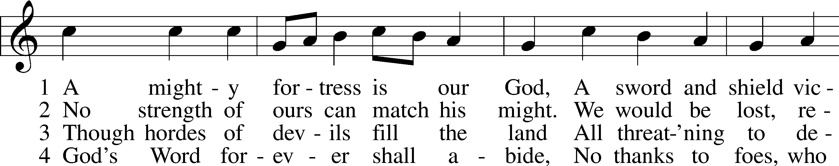
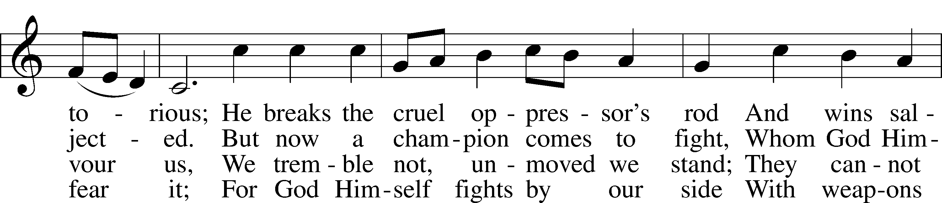
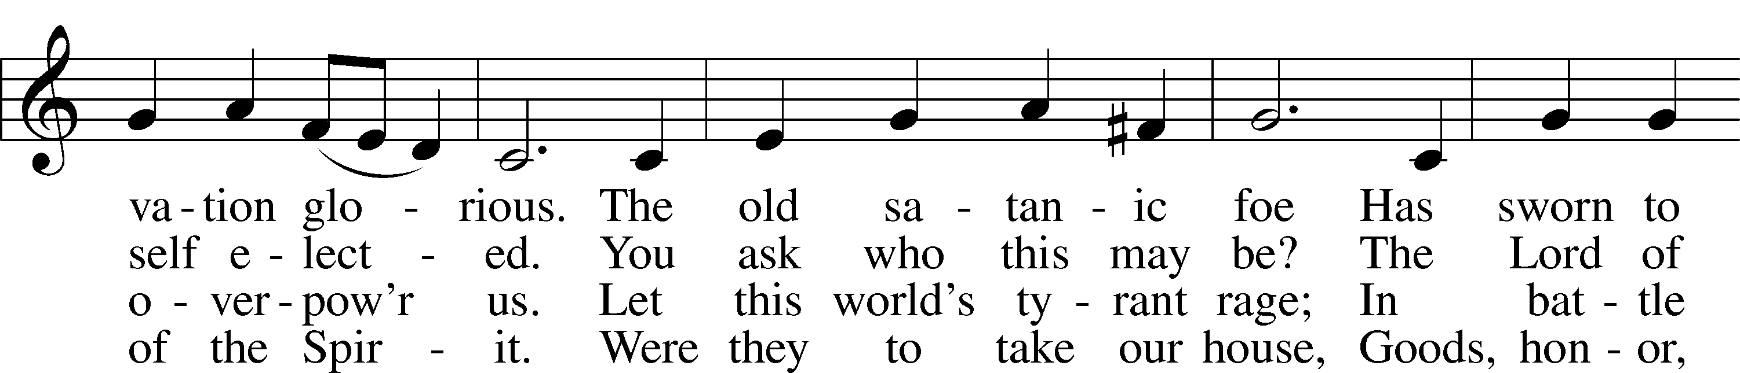
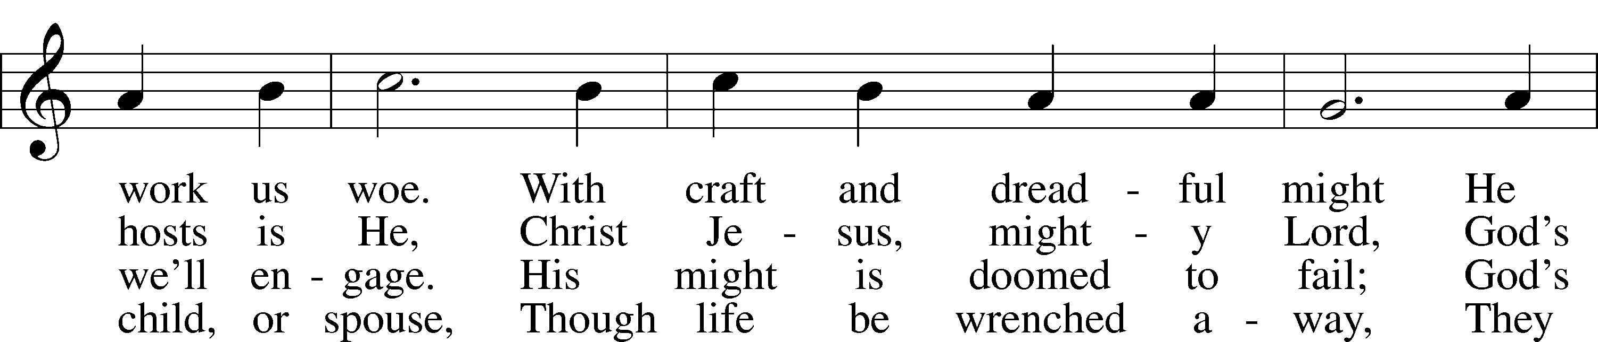
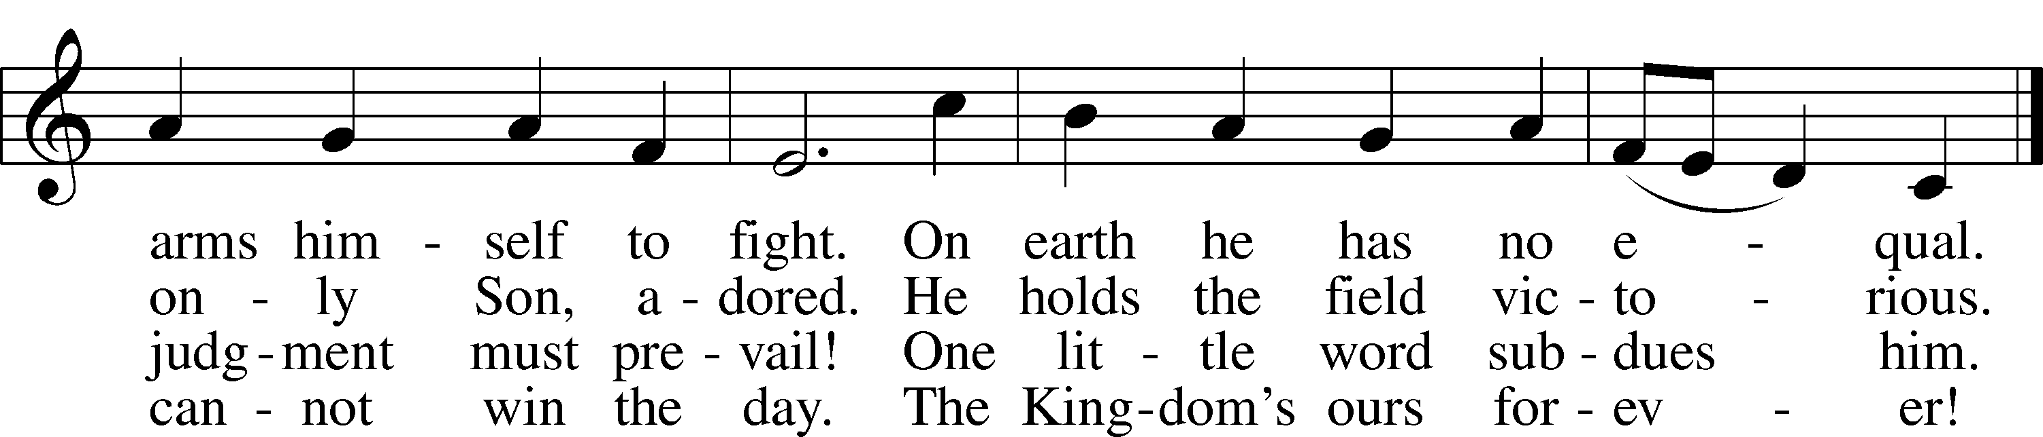
© 1978 Lutheran Book of Worship. Used by permission: LSB Hymn License .NET, no. 100011641.
Public domain

(Please Remain Standing or You May Kneel)
CONFESSION AND ABSOLUTION:
Pastor: Holy God, in your mercy you look with grace and favor upon us, Your people. Hear now, our solemn confession, and as Your Spirit moves us to true repentance, remind us again that You have forgiven us for the sake of Jesus Christ.
Congregation: Father, how often my sinful nature controls my life! I am easily tempted and fall into sin; I am blind to Your will; I am self-serving, self-seeking, self-righteous and deluded; I am dead in sin. The works of my flesh are demonstrated in my actions and thoughts and words. I have not acted as your baptized child. My heart breaks in my shame and guilt. Gratefully I remember Your blood shed for me to wash me clean. I am forgiven. Holy Spirit, control my life.
Pastor: God has heard our cry. He is faithful even when we are not. As your called servant of His Word, I announce that we have what we seek; the entire forgiveness of all our sins, as God’s free gift. New life, new sights and a new heart are ours. Live in the freedom of the Spirit.
Congregation: Amen!

THE PRAYERS OF THE DAY:
All: O God, the source of all that is just and good, nourish in us every virtue and bring to completions every good intent that we may grow in grace and bring forth the fruit of good works; through Jesus Christ, Our Son, our Lord, who lives and reigns with You and the Holy Spirit, one God now and forever. Amen

SERVICE OF THE WORD

(You may be seated…)
THE FIRST READING: Deuteronomy 4:1-2, 6-9
Lector: This is the Word of the Lord.
People: Thanks be to God.

THE SECOND READING: Ephesians 6:10-20
Lector: This is the Word of the Lord.
People: Thanks be to God.

(Please stand…)
THE HOLY GOSPEL: Mark 7:14-23
Pastor: The Holy Gospel according to St. Mark the 7th chapter.
People: Glory to You, O Lord.
Pastor: This is the Gospel of the Lord.
People: Praise to You, O Christ!

(You may be seated…)
CHILDREN’S MESSAGE

NOISE OFFERING

THE SERMON HYMN: “Onward, Christian Soldiers” LSB 662
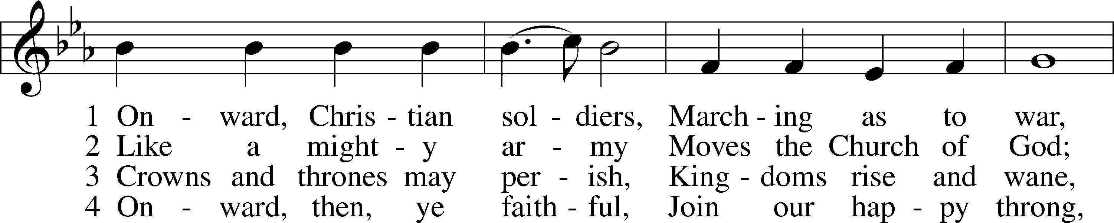
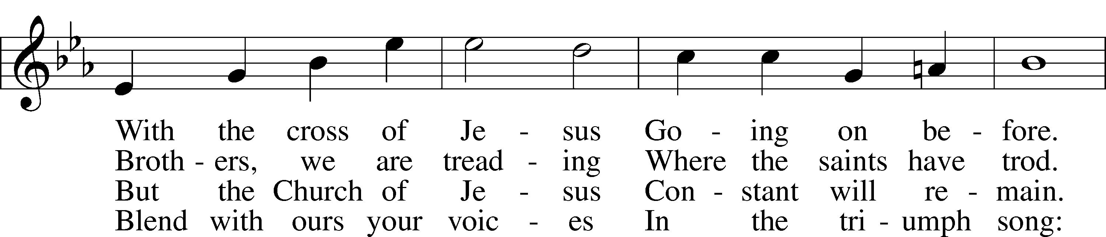
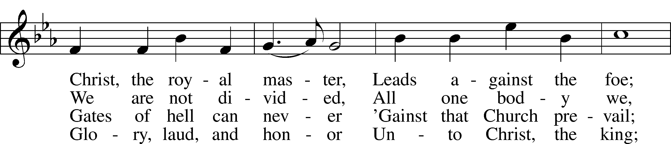
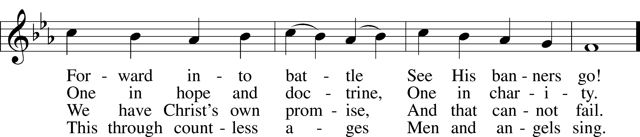
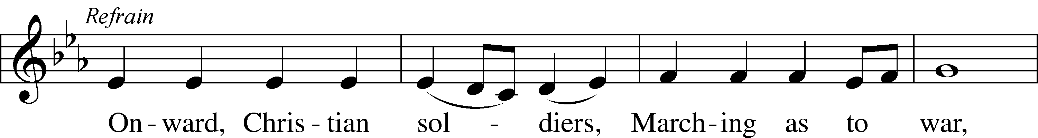
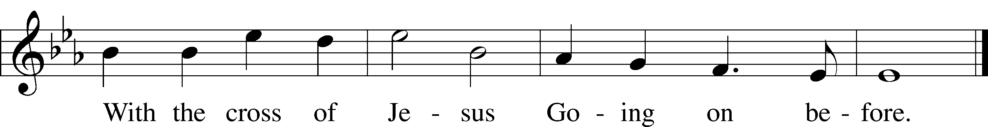
Public domain

THE SERMON: “Does God Play Fair?” Ephesians 6:10-20

(Please stand…)
THE PROFESSION OF FAITH:
Pastor: God has given us a great message to take to His world. Let us remind ourselves and one another of what that message is:
Pastor: I believe in God the Father, Almighty
Congregation: Maker of heaven and earth
Pastor: And in His Son, Jesus Christ our Lord,
Congregation: Who was conceived by the Holy Spirit
Pastor: Born of the Virgin Mary
Congregation: Suffered under Pontius Pilate
Pastor: Was crucified, died and was buried
Congregation: He descended into hell.
Pastor: On the third day He rose again from the dead,
Congregation: And ascended into heaven
Pastor: And sits on the right hand of God, the Father almighty
Congregation: From there He will come to judge the living and the dead
Pastor: I believe in the Holy Spirit,
Congregation: The Holy Christian Church as
All: the communion of saints; the forgiveness of sins, the resurrection of the body, and the life everlasting. Amen.

THE OFFERING

(Please stand…)
THE PRAYER:
Pastor: Lord God, Heavenly Father, You are the Light of our life and the Hope of our salvation.
Response: With you we have nothing to fear.
Pastor: You protect us, and are the source of all our joy and happiness.
Response: Accept our grateful songs of praise.
Pastor: We pray for those whom we now name silently in our hearts or out
loud…According to Your will, heal the sick, strengthen the faith of all who doubt and lift up the depressed. Into Your hand we commend all for whom we pray, trusting in Your mercy, through Your Son, Jesus Christ our Lord.
All: Amen!

SERVICE OF THE SACRAMENT

(You may be seated…)
THE WORDS OF INSTITUTION

DISTRIBUTION HYMNS:
“Drawn to the Cross, Which Thou Hast Blessed” LSB 560
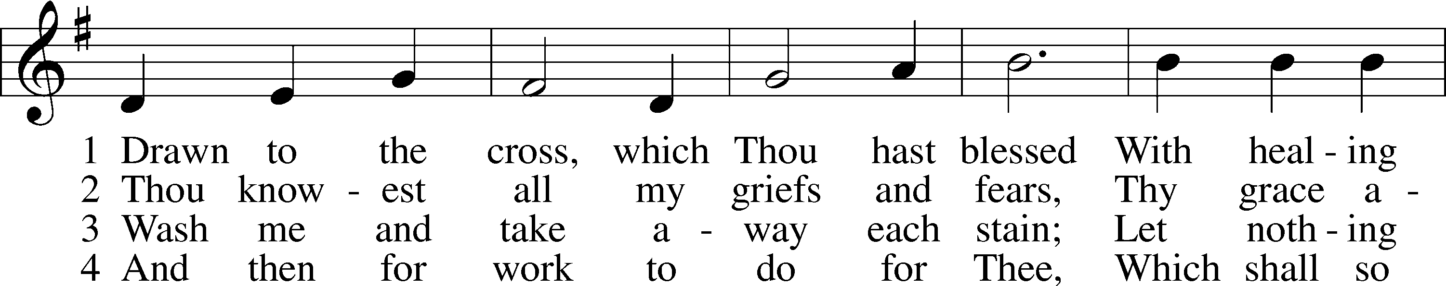
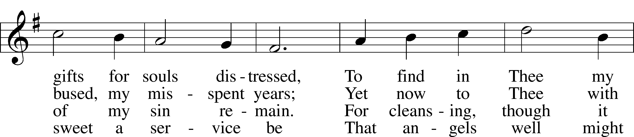
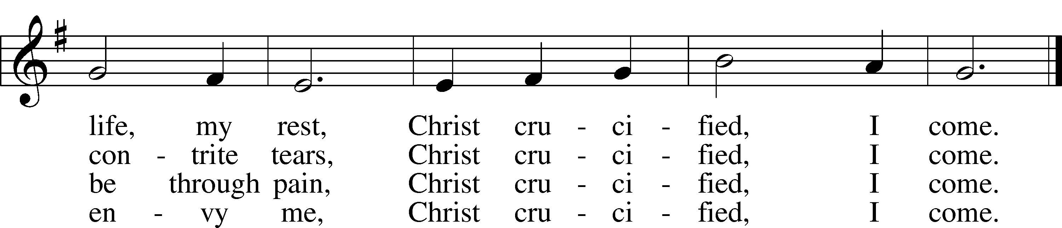
Public domain

“What Wondrous Love Is This” LSB 543
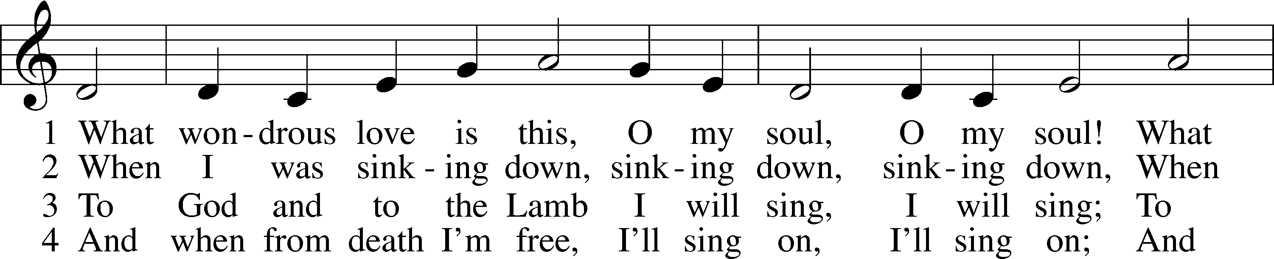
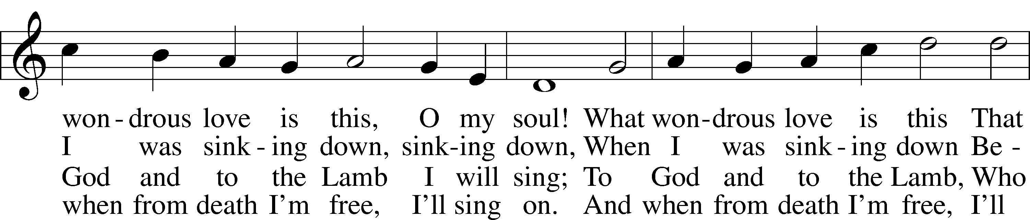
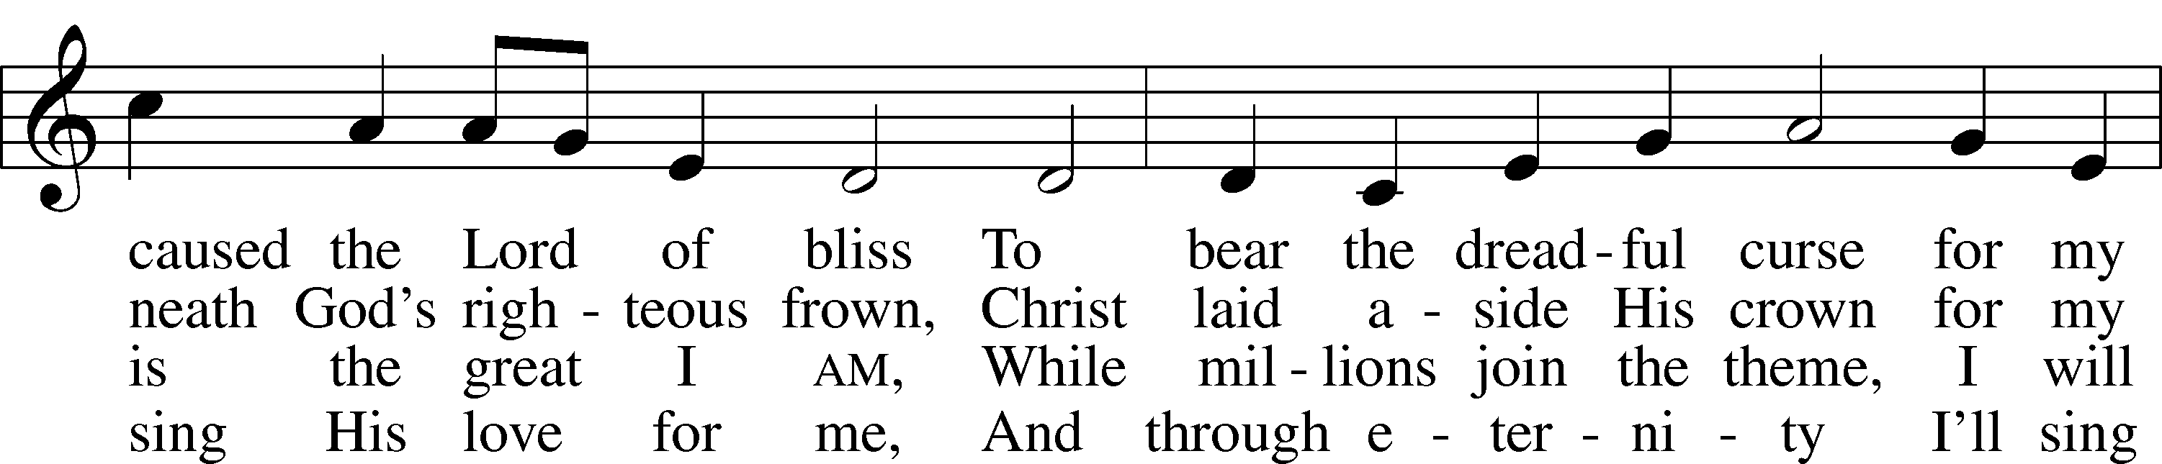
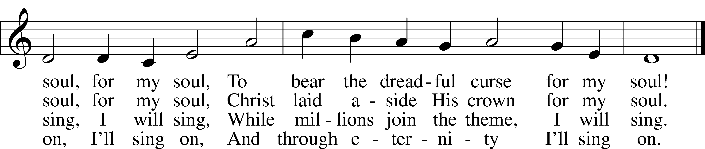
Public domain

“Oh, That the Lord Would Guide My Ways” LSB 707
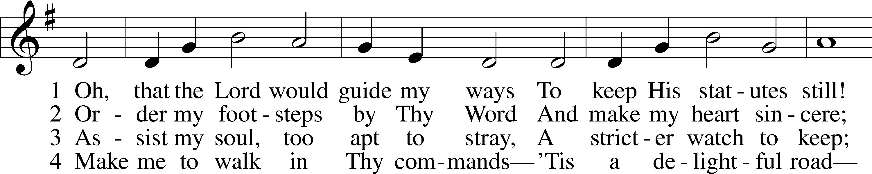
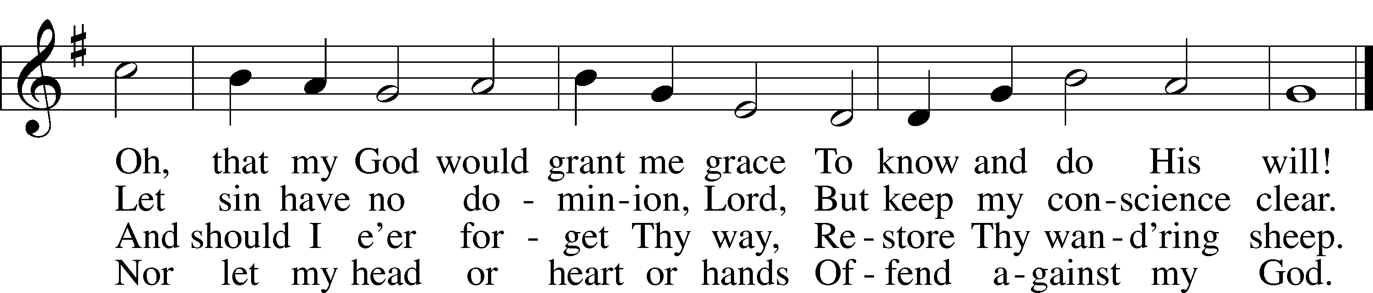
Public domain
(Please stand…)
THE LORD’S PRAYER:
All: Our Father, who art in heaven, Hallowed be thy name, thy kingdom come, thy will be done, on earth as it is in heaven. Give us this day our daily bread; and forgive us our trespasses, as we forgive those who trespass against us; and lead us not into temptation, but deliver us from evil. For thine is the kingdom, and the power, and the glory, forever and ever. Amen.

BENEDICTION

THE CLOSING HYMN: “Stand Up, Stand Up for Jesus” LSB 660
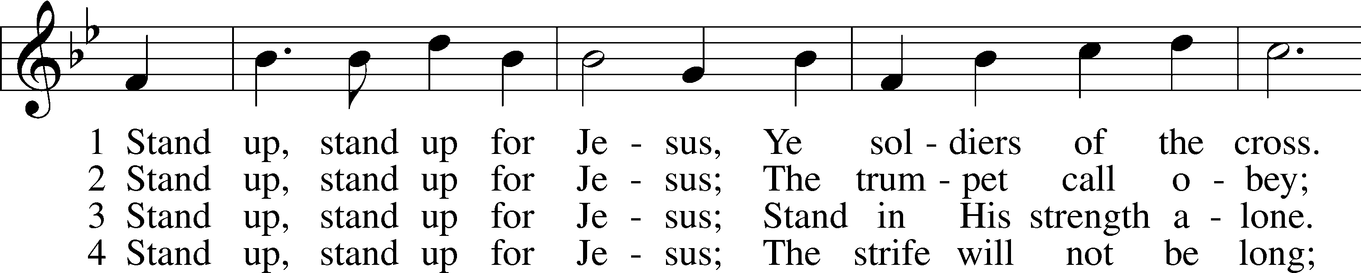
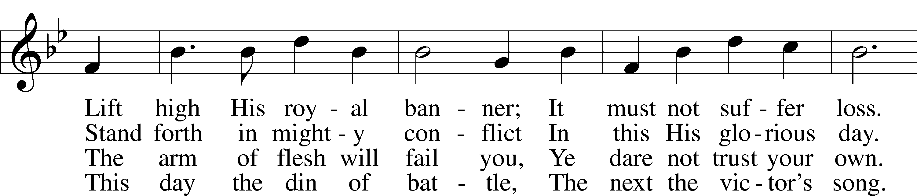
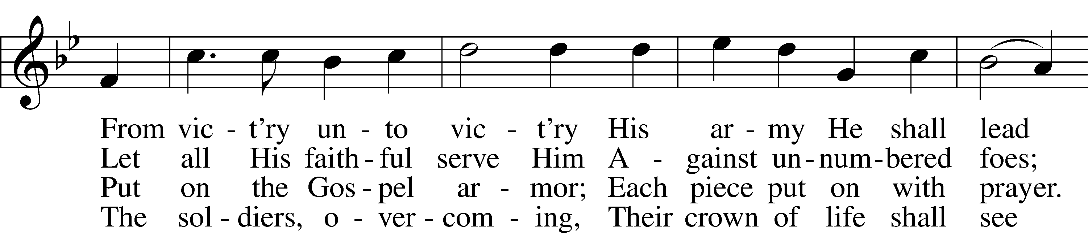
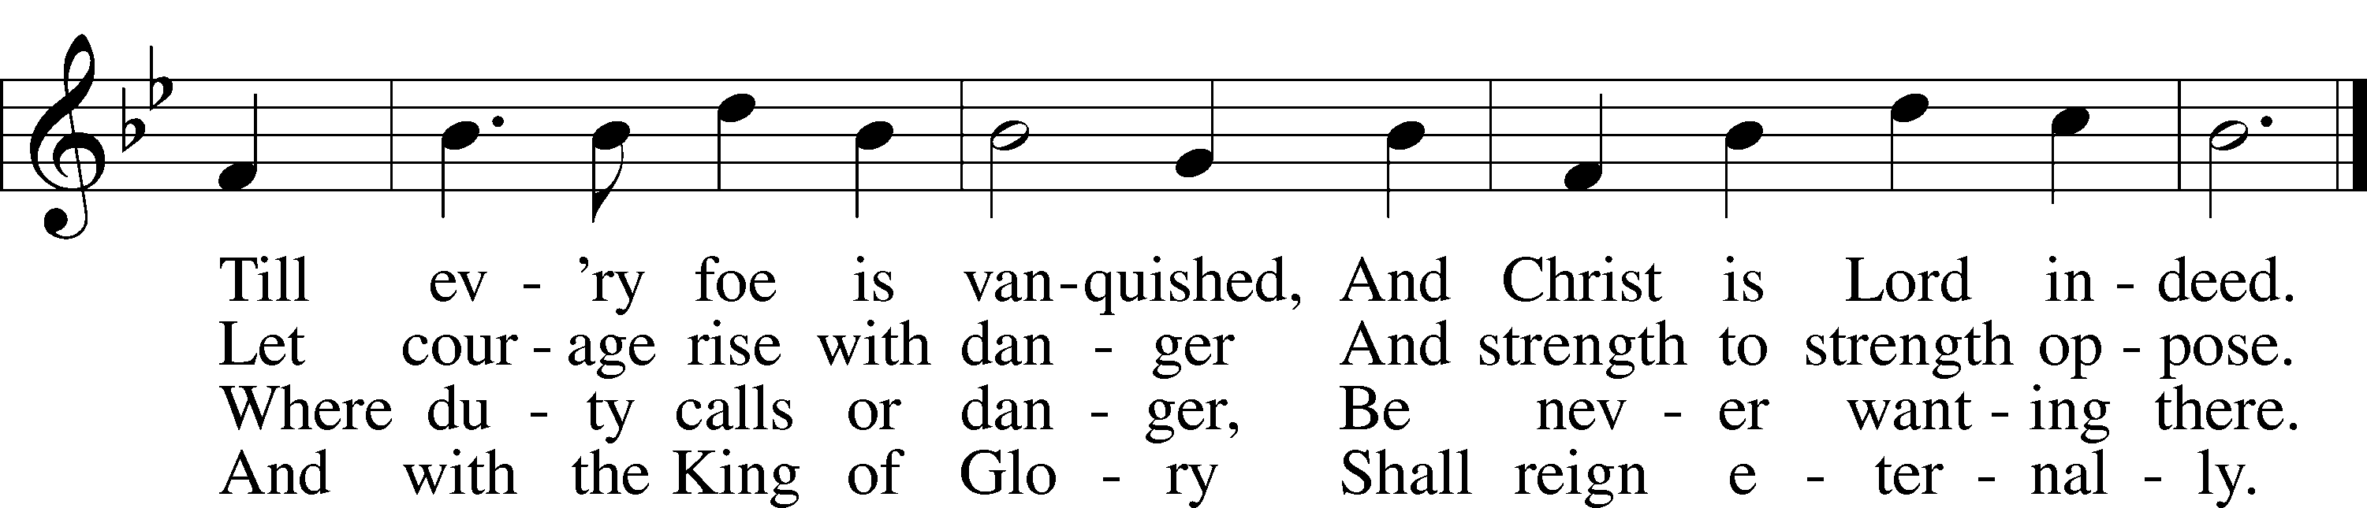
Public domain

ANNOUNCEMENTS

WELCOME TO GRACE LUTHERAN CHURCH: We are glad that you are here to worship God with us today! We pray that you will enjoy the wonderful fellowship as friends in Christ as God gathers us around His means of grace, the Word and Sacraments, to bless us with His treasured gifts of forgiveness, faith, abundant life and eternal salvation. If you are a guest, please also sign our Guest Book. Please talk to Pastor if you would like to learn more about becoming a member of Grace. Also, please join us for refreshments and fellowship after the Service. We invite you to come and worship with us often as God gathers us in His Grace.

WELCOME TO THE LORD”S TABLE: We invite and encourage all present who are baptized and faithful Christians, and who confess the Father, Son, and Holy Spirit to be the only true God and who believe that Jesus Christ died for the sins of the World and is our only hope and salvation…to join us in receiving the very and true body and blood of Christ in this Sacrament. The clear liquid cups in the center of the tray are non-alcoholic wine.

Children not yet confirmed in the faith are always welcome to join their parents at the Lord’s Table, but should keep their hands folded in front of them. The Pastor will give them a blessing.

SERVING TODAY: Acolyte: Jack Cook; Lector: Beverly Walker, Communion Assistants: Peter Bacle and Dean Thompson; Usher: David Rose; Altar Care: _________; Refreshments: ____________.

SERVING NEXT SUNDAY: Acolyte: Elizabeth Reynolds; Lector: David Rose; Communion Assistants: Don Bly and Vince Winters; Usher: Terry Richardson; Altar Care: Ed and Nancy Swift; Refreshments: Ed and Nancy Swift.
FLOWERS: were placed on the altar today to the glory of God.

THIS WEEK AT A GLANCE:

Today: This Sunday
9:00 am Worship Service with Communion
10:15 am Adult/Children’s Bible Class

Monday: August 31st
Pastor’s Day Off
5:00 pm Zumba

Tuesday: September 1st
3:00 pm Jan’s Mobile Gym (Parish Hall)
6:00 pm Weight Watcher’s (Parish Hall)

Wednesday: September 2nd
10:00 am Water Aerobics (Community Pool)
12:30 pm Men’s Bible Fellowship (Chico’s Restaurant)

Thursday: September 3rd
5:00 pm Zumba
6:30 pm Missional Community (Pastor’s Home)

Next Sunday: September 6th
9:00 am Worship Service with Communion
10:15 am Fellowship
10:30 am Adult Bible Class/Children’s Sunday School

IN YOUR PRAYERS THIS WEEK: Friends and family of Gerald Sattelmeier, Carol Sebree, Holly Purdy, Wendy Asplundh, Floss Flenard, Katie Higgs Wyrwicki, Peggy Mira, Friends and family of Andy Hetu, Micheal son of Will and Noelle Plagens, Walter Lepperd, Mary Hoffman, Robert Hoffmann, Will Plagens, Peter Pike, Frank, Harry, Mary McNeal, Donald Rollman, Jonathan Satel, Mable Paul, VanderKooi family, Bobby Bringle, Meggan Meggs, Cheryl Kucera, Tim Rodriguez, Elsie Hamilton, Mary Bacle, Michael Gillis, Joe Lamberson, Vernon Julson, Dennis Julson, Mary Ellen Jessel, and those you are praying for at home. If anyone has a special prayer request please submit it in writing in the collection plate; or you may call Pastor Gary Faith at (504-858-8872), or Kris Howard at (305-296-5161).

GIFTS, TITHES, & ATTENDANCE LAST SUNDAY were $4526.52, the building fund received $400.00, the window fund received $15000.00, the Halloween Fest Fund received $500.00, and the noise offering was $48.56. The attendance for last Sunday was 104.

TO HELP US GROW… The Bible readings for next Sunday’s service readings are Isaiah 35:4-7a, James 2:1-10, 14-18, and Mark 7:31-37.

THE GRACIOUS LADIES OF GRACE: had a 5 star lunch at Square Grouper with Shrimp Salad Sliders being the favorite and Fried Conch coming in second. We had a group of 12 and as usual a good time was had by all. The next gourmet delight will be on September 8th at 12:00 pm at the Hot Tin Roof which offers a local discount. Please join us ladies.

WE HAVE SCHEDULED AN ADULT INFORMATION CLASS for the Sundays of September 13th and September 20th. Classes will being at noon and end by 2. This is for those who would like to become a member of Grace and/or learn more about what we teach and believe. It is also a good review for members. If interested please let Pastor or Kris know. Thanks.

THANKS TO ALL who helped with last Sundays Installation and Brunch. Y’all did a great job. We are blessed with many gifted cooks. To God be glory!

WATER AEROBICS: Christine Gorham is now teaching a low impact water aerobics class for women and men at the Martin Luther King community pool on Wednesdays from 10:00am – 10:45 am. There is a low cost of $5.00 per class. Please come and join in the fun.

IF YOU ARE NOT currently in our Missional Community and would like to be please let Pastor or Pattie know. Questions give Pastor a call 504-858-8872.

IF YOU ARE INTERESTED IN STARTING a 2nd Missional Community in your home (neighborhood) lets chat. 504-858-8872

NOISE OFFERING: We are now having a noise offering every Sunday. The children will serve as ushers collecting pocket change. The offerings will go to “School of Promise.” Hope International Schools is actively working to break the cycle of poverty and oppression in Thailand through the development of the School of Promise, an excellent school rooted in the Gospel of Jesus Christ.

The School of Promise is located in Hang Dong, Thailand, where we seek to be God's tools for meeting spiritual and temporal needs within the community.

Operating within the Thai education system, the school is bilingual, with classes taught in English and Thai. The proficiency that students gain in both languages will give them unique advantages in future life. Students at the School of Promise also enjoy the benefits of small class sizes and student centered teaching methods. They learn from Christian teachers who truly love them and who share God's love with them inside and outside of the classroom. Visit the School of Promise at www.theschoolofpromise.org.

THE GRACE LUTHERAN CHURCH WEB PAGE AND FACE BOOK PAGE now contains a vocal recording of last week’s sermon. So if you are not able to attend church on Sunday please go to our website where you will find a copy of the bulletin and a recording of Pastor Faith’s sermon. The new webpage address is gracelutherankw.360unite.

A NUMBER OF CAPITAL IMPROVEMENTS are needed to keep our facilities in good health for the future. The narthex has been rebuilt. Roof repairs are needed on school buildings.
If you can help it would be much appreciated! A big thanks to all who have contributed to these repairs.

MUSIC MINISTRY:
Children's Chime/Vocal Choir (Kindergarten - 4th grade) - Our first rehearsal will be Sunday, September 13 from 10:10 - 10:25 am. We will meet at the chime table at the back of the church. If you have any questions, you can email Beverly Walker at beverlywalker@gmail.com.

Bell Choir (5th grade - Adult) - Our first rehearsal will be Thursday, September 24 from 5:45 - 6:25 pm. New ringers are always welcome. If you have any questions, you can email Beverly Walker at beverlywalker@gmail.com.

WOMEN’S BIBLE STUDY: We have just finished our study on “Discerning the Voice of God” by Priscilla Shirer. It was a great study on hearing and obeying God's voice. It was so insightful I thought I might share some of the high points with everyone. Priscilla shares: Listen for His voice. God has an appointed time for everything, we must wait on His timing. God speaks through His Holy Spirt and His Word. God's responsibility to reveal His will to me. God has a plan for us. God's voice is loving and encouraging, Devil’s voice brings condemnation. If we feel rushed to make a decision and not at peace, it's probably not God's voice. The Church is one of the ways God speaks to us. To see God at work in our lives, we must adopt His plan and surrender in obedience. The Enemy's voice will focus on the past and the future while the voice of God will focus on today. He is the God of right now.
If you weren't able to join us for this study, we encourage you to come to the next one titled "Golden Fruit" by Julie Hale Maschhoff. Each session focuses on one fruit of the Spirit and considers how the lives and stories of nine biblical women convey that characteristic. You'll see how God is at work in your life too and how His promise of salvation and peace through Jesus are fully yours all the time. Please come and reap the blessings studying God's Word will bring you. "The fruit of the Spirit is love, joy, peace, patience, kindness, goodness, faithfulness, gentleness, self-control: against such things there is no law." Galatians 5:22-23 ESV God Bless, Monica

The MEN’S BIBLE FELLOWSHIP will be working on their study “The Journey from Unbelief to Faith”, Wednesday September 2nd. They meet the first and third Wednesday’s of each month at 12:30 at Chico’s Restaurant. All guys are welcome.

This is a preliminary sketch of one of 7 windows that are planned to replace the existing ones. They include the 3 windows looking to the left of the center window of Christ and the 4 to the right. They will represent the life of Christ starting with Creation, Christmas, Crucifixion, Easter, Ascension,
Heaven, and ending with the Trinity.
Paul Pickel at Pickel Studios and his artist Apryl Moyer are designing the windows and are responsible for the new windows already installed. These windows have all been funded by special contributions from members of Grace.
The Board of Directors is asking for donors who would be interested at an estimated cost of $15,000.00 per new window.
This is a work in progress and not all details have been worked out but changes will be minor.
Contact Jim Reynolds 305 394-5987 with questions or to donate a window.

