SEVENTH SUNDAY AFTER PENTECOST
JULY 12, 2015 9:00 a.m.
WORSHIP SERVICE
In the Name of Jesus!
Our Mission Statement:
Anchored in Christ, each person a missionary.

PRELUDE

ANNOUNCEMENTS:
We welcome you. We are glad you are here to share with us the joy and peace we have in Jesus Christ. It doesn’t matter whether this is your first time in this church or if you are a lifelong member, you are welcome. We come together today in order to celebrate the gift God has given us-His own Son, Jesus, Our Savior.

PREPARATION

(Please Stand…)
HYMN: ”Come, Thou Fount of Every Blessing” LSB 686
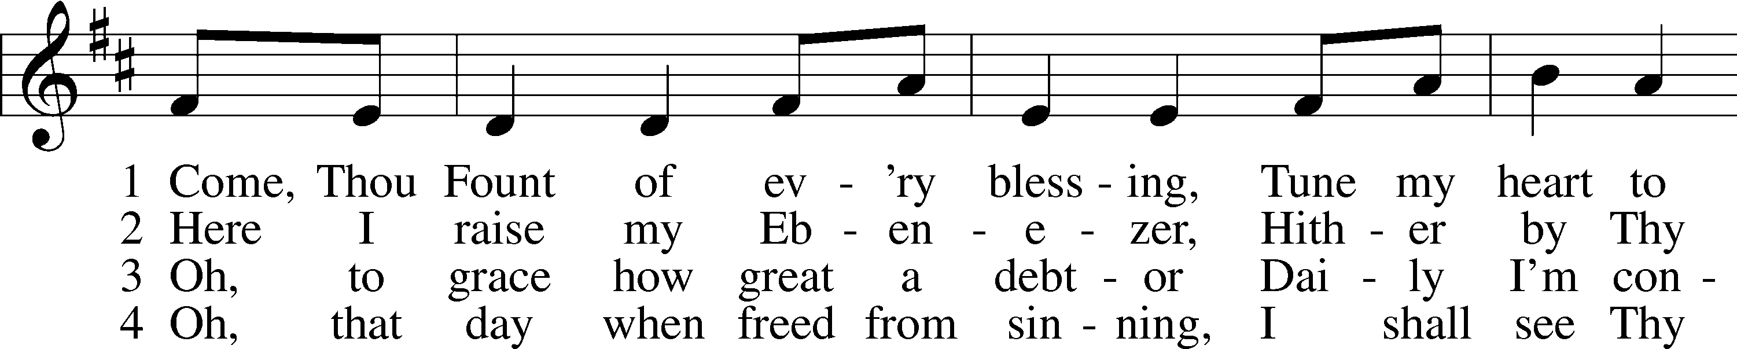
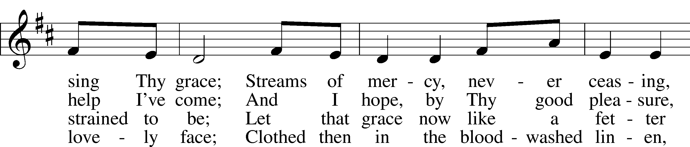
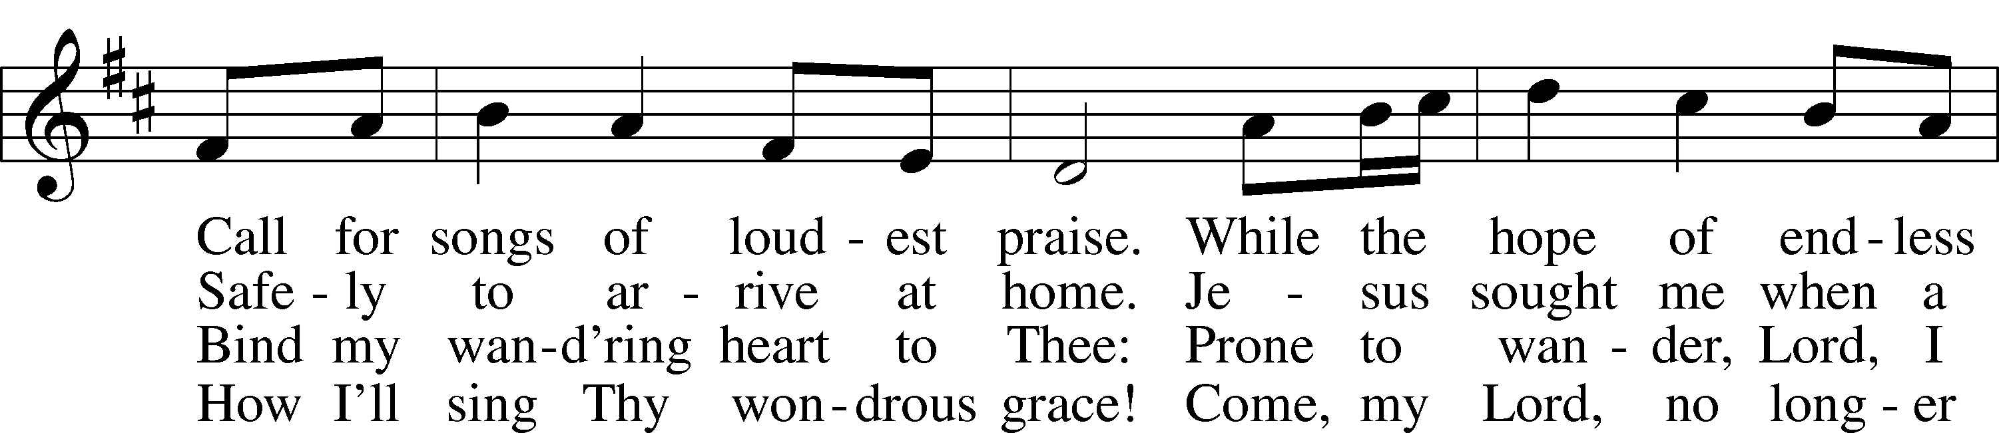
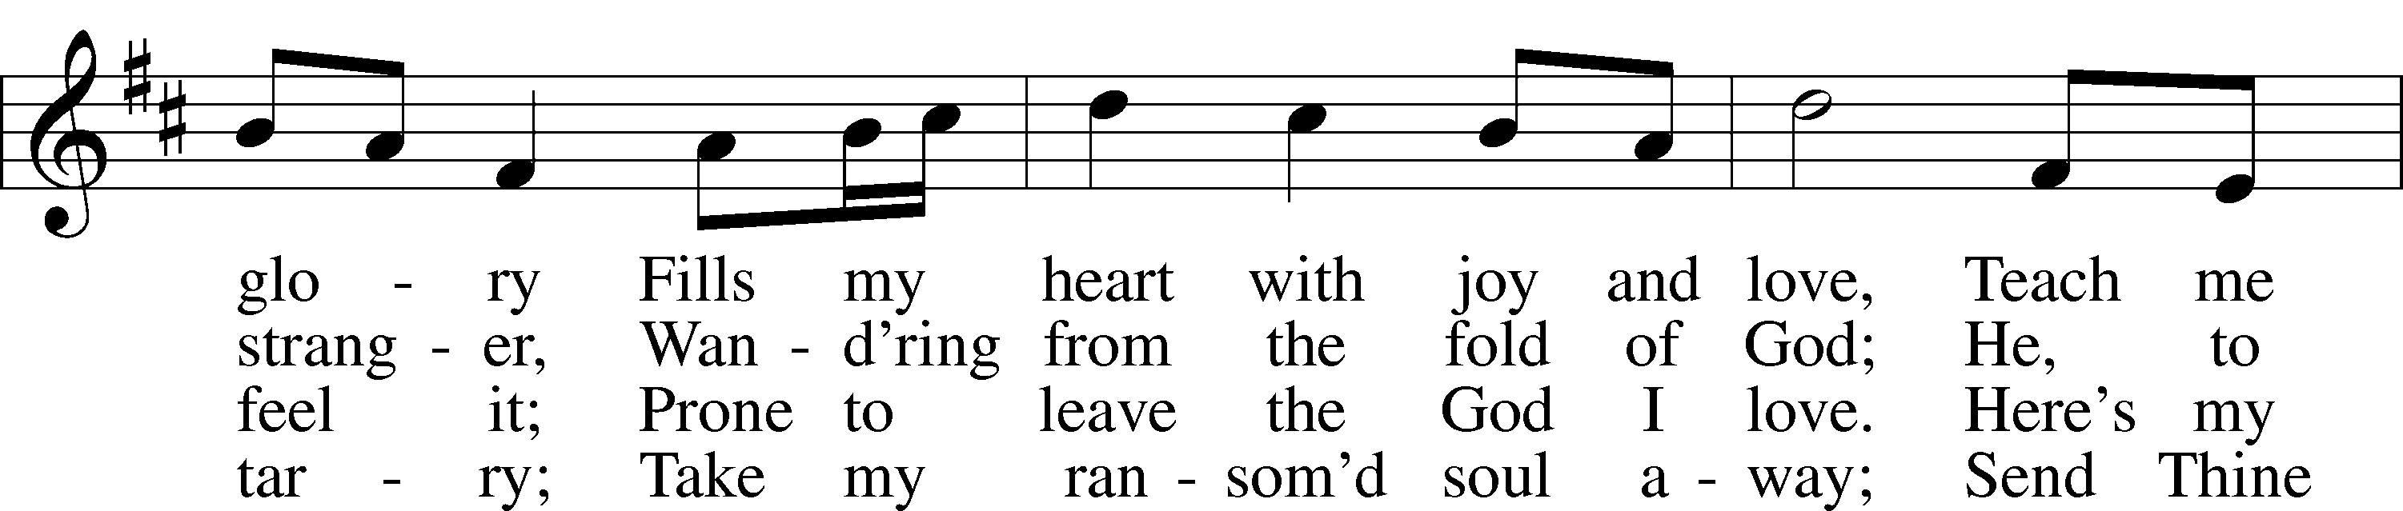
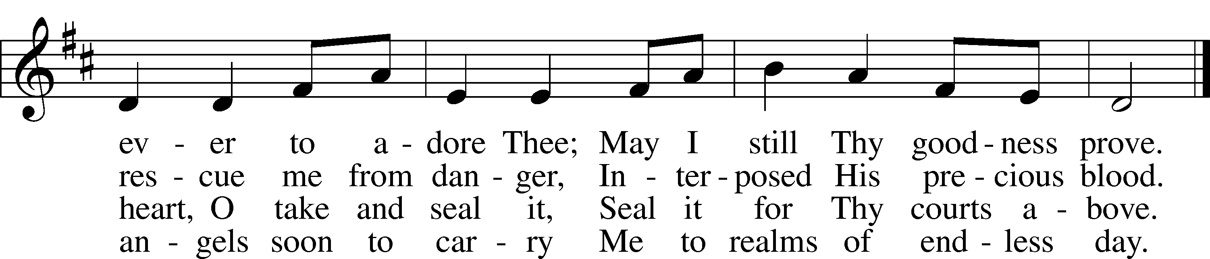
Public domain

Pastor: In the Name of the Father and of the Son and Holy Spirit.
Congregation: Amen.

(Please Remain Standing Or You May Kneel…)
GOD’S PEOPLE CONFESS THEIR SINS:
Pastor: By grace you have been saved, through faith-and this is not from yourselves, it is the gift of God-not of works, so that no man can boast, for we are God’s workmanship, created in Christ Jesus.
Congregation: I know that nothing good lives in me, that is, in my sinful nature, for I have the desire to do what is good, but I cannot carry it out.
Pastor: What I do is not the good I want to do; no, the evil I do not want to do-this I keep doing.
Congregation: In my heart I delight in God’s law, the law that points out what a wretched person I am! Who will rescue me from this body of death?
Pastor: Thanks be to God through Jesus Christ our Lord! Only He can achieve the perfection we fail to achieve. By the forgiveness He purchased on the cross, our forgiveness is complete!

SERVICE OF THE WORD

You may be seated…
THE FIRST READING: Amos 7:7-15
Lector: This is the Word of the Lord.
People: Thanks be to God.

THE EPISTLE LESSON: Ephesians 1:3-14
Lector: This is the Word of the Lord.
People: Thanks be to God.

Please stand…
THE HOLY GOSPEL: Mark 6:14-29
Pastor: The Holy Gospel according to St. Mark the 6th Chapter
People: Glory to You, O Lord.
Pastor: This is the Gospel of the Lord.
People: Praise to You, O Christ!

Please be seated…
CHILDREN’S MESSAGE

NOISE OFFERING

THE SERMON HYMN: “Amazing Grace” LSB 744
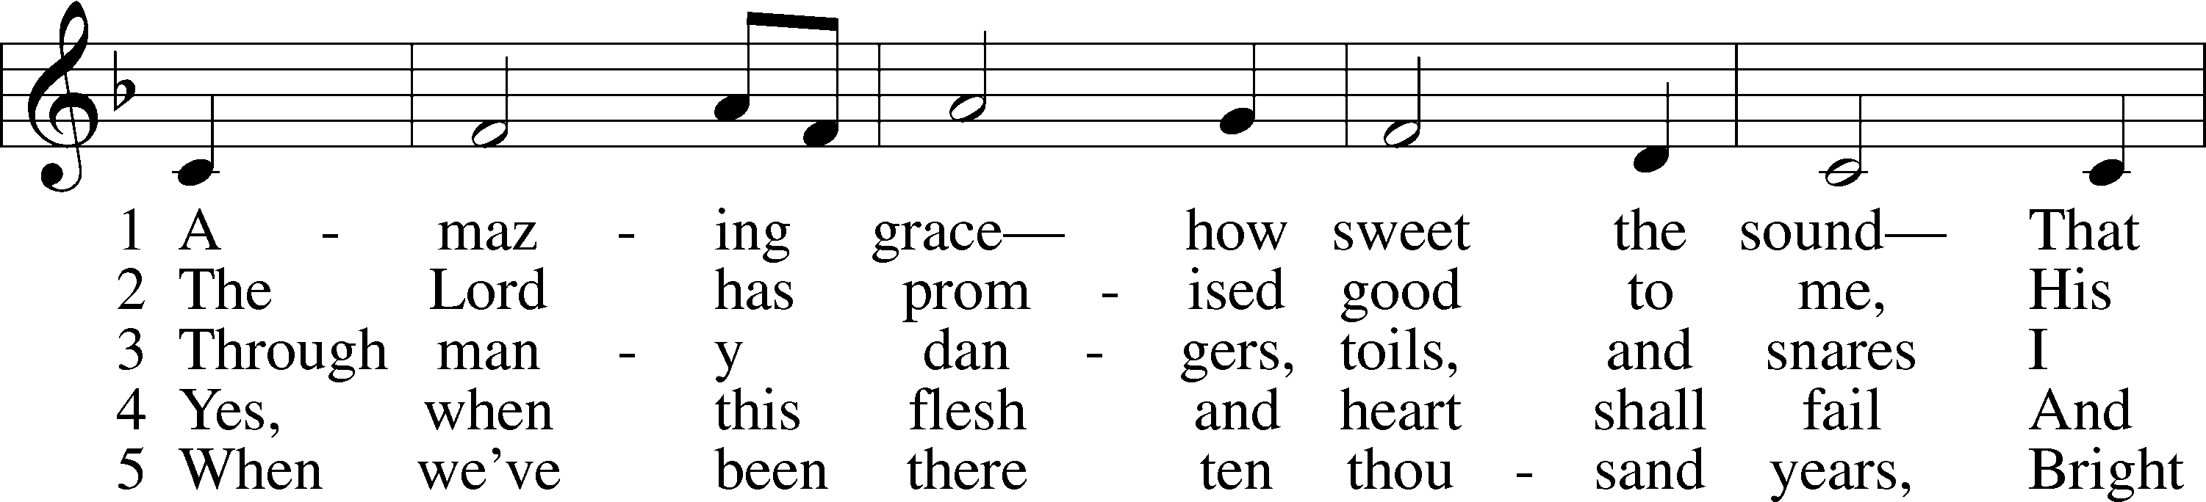
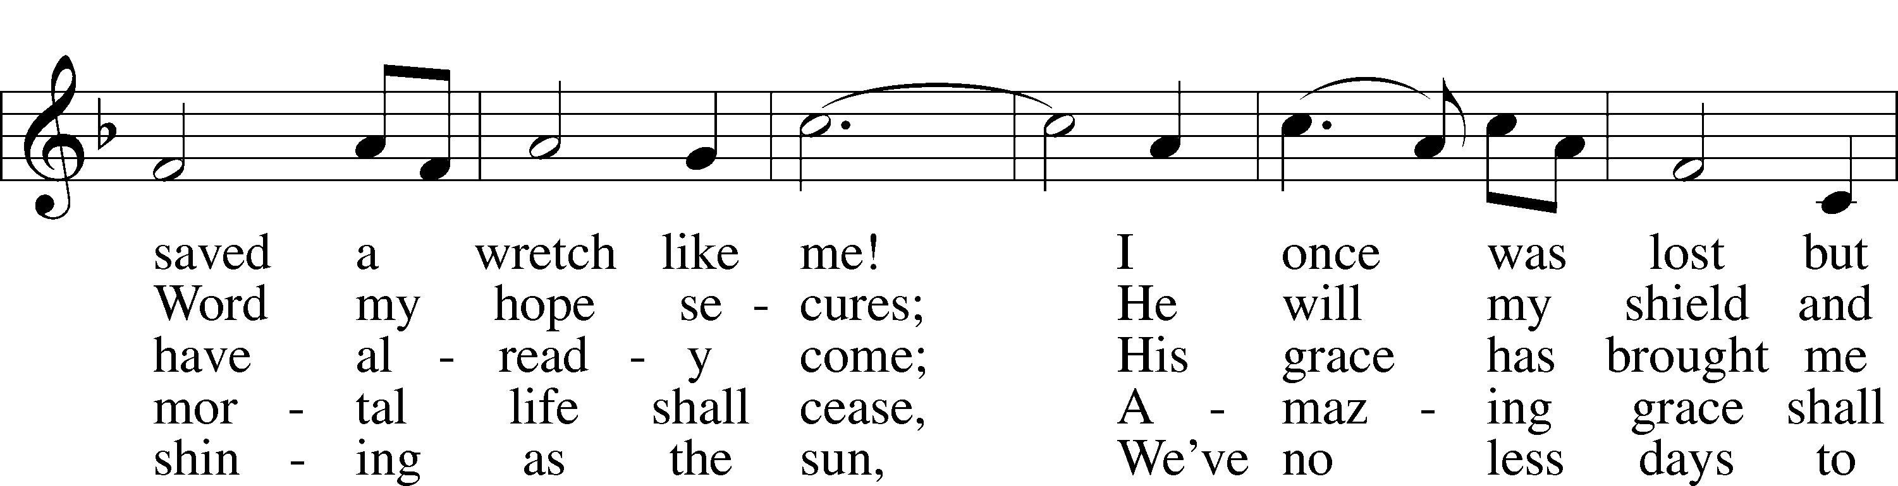
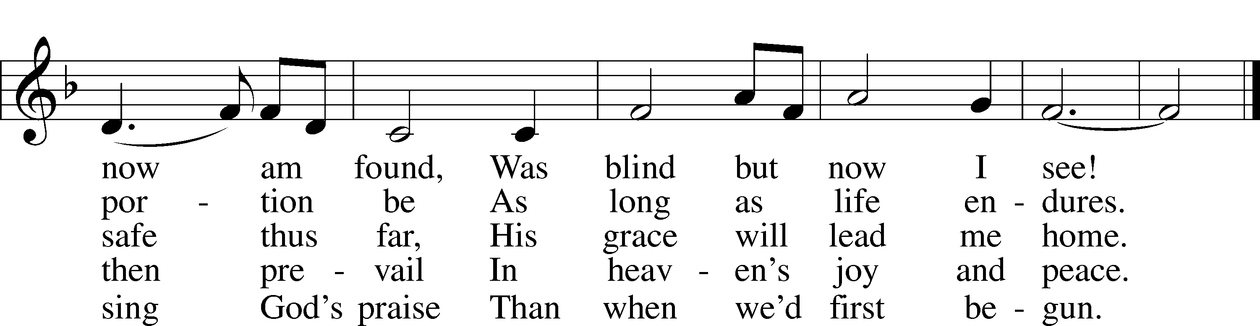
© 1991 Editorial Concordia. Used by permission: LSB Hymn License .NET, no. 100011641.
Public domain

THE SERMON: “Lavished with Grace” Ephesians 1:3-14

(Please stand…)
THE PROFESSION OF FAITH:
Pastor: God has given us a great message to take to His world. Let us remind ourselves and one another of what that message is:
Pastor: I believe in God the Father, Almighty
Congregation: Maker of heaven and earth
Pastor: And in His Son, Jesus Christ our Lord,
Congregation: Who was conceived by the Holy Spirit
Pastor: Born of the Virgin Mary
Congregation: Suffered under Pontius Pilate
Pastor: Was crucified, died and was buried
Congregation: He descended into hell.
Pastor: On the third day He rose again from the dead,
Congregation: And ascended into heaven
Pastor: And sits on the right hand of God, the Father almighty
Congregation: From there He will come to judge the living and the dead
Pastor: I believe in the Holy Spirit,
Congregation: The Holy Christian Church as
All: the communion of saints; the forgiveness of sins, the resurrection of the body, and the life everlasting. Amen.

(You may be seated…)
OFFERING RECEIVED

(Please stand…)
THE PRAYERS OF THE CHURCH: based on Psalm 98
Pastor: Dear Lord, we thank You for everything You’ve done for us, and most of all for Your own Son, Jesus, our Savior. We will never stop praising You for this wonderful gift.
Congregation: Sing to the Lord a new song, for He has done marvelous things; His right hand and His holy arm have worked salvation for Him.
Pastor: We thank You for those missionaries long ago who brought the Good News to our people. When we were in darkness, You sent men and women to bring us the light. Thank you, Lord.
Congregation: The Lord has made His salvation known and revealed His Righteousness to the nation.
Pastor: O Lord, You are our Savior, we trust in You for all our needs, give healing to the sick, courage to those who are afraid, and peace to those we name in our hearts now. (a moment of silence) We praise You, gracious Lord, for all Your benefits to us. You give us home, friends and family, food, shelter, rest and everything we need. You give us sight and hearing and touch and taste and provide for all of our needs.
Congregation: Shout for joy to the Lord, praise His Name Amen.

SERVICE OF THE SACRAMENT

(Please be seated…)
THE WORDS OF INSTITUTION

DISTRIBUTION HYMNS:
“The Lamb” LSB 547
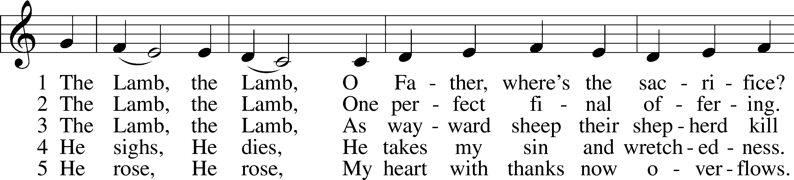
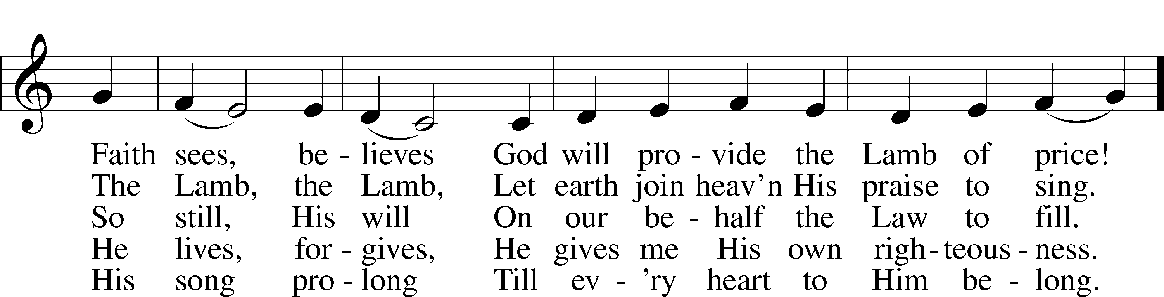
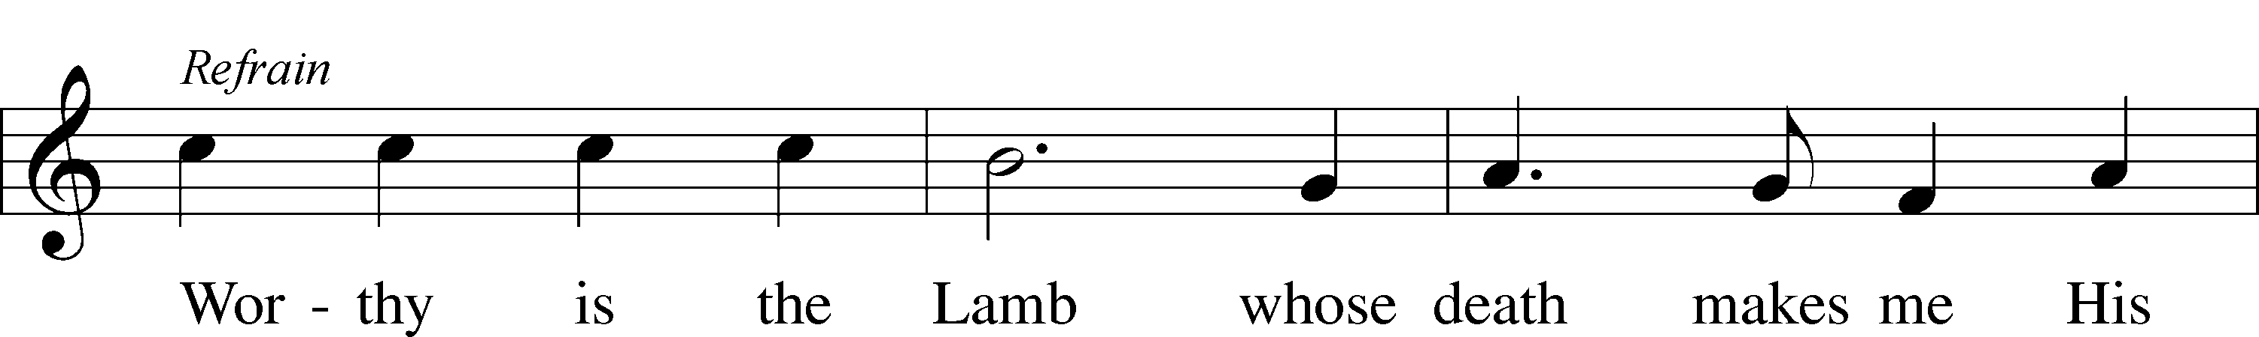

© 1987 and 1997 MorningStar Music Publishers. Used by permission: LSB Hymn License .NET, no. 100011641.

“God Loves Me Dearly” LSB 392
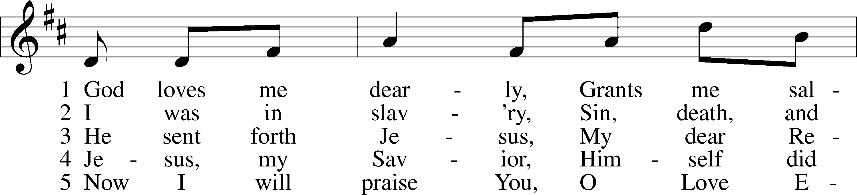
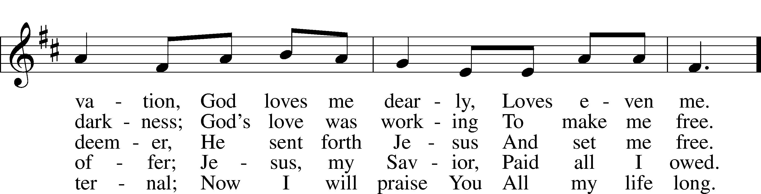
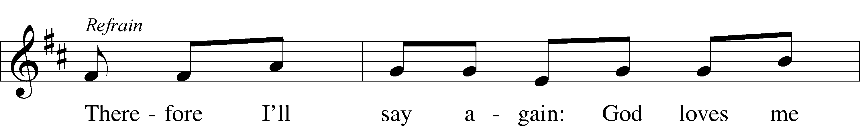
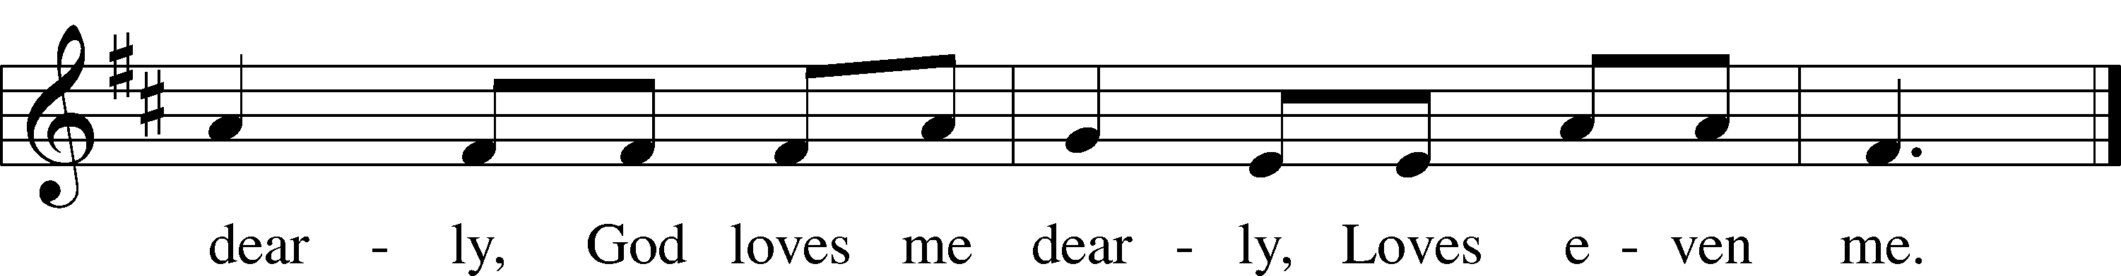
Public domain

“Lord, Keep Us Steadfast in Your Word” LSB 655
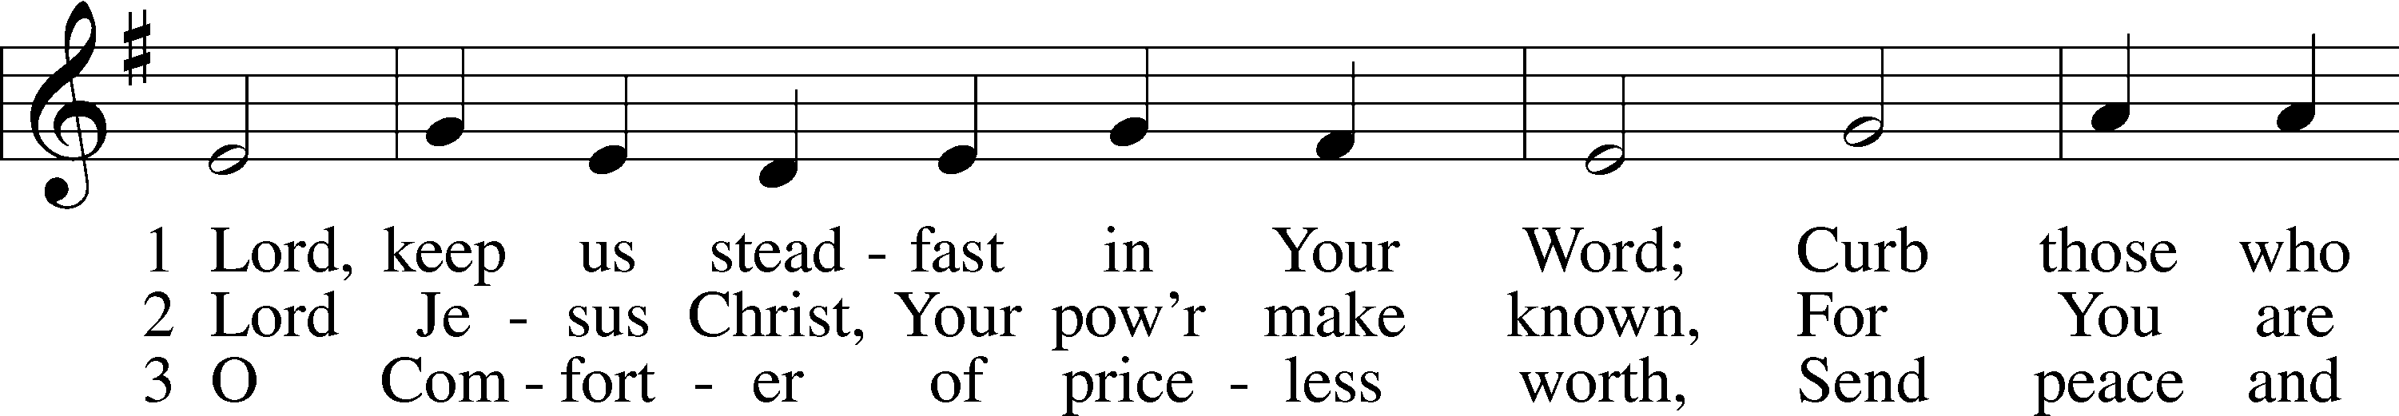
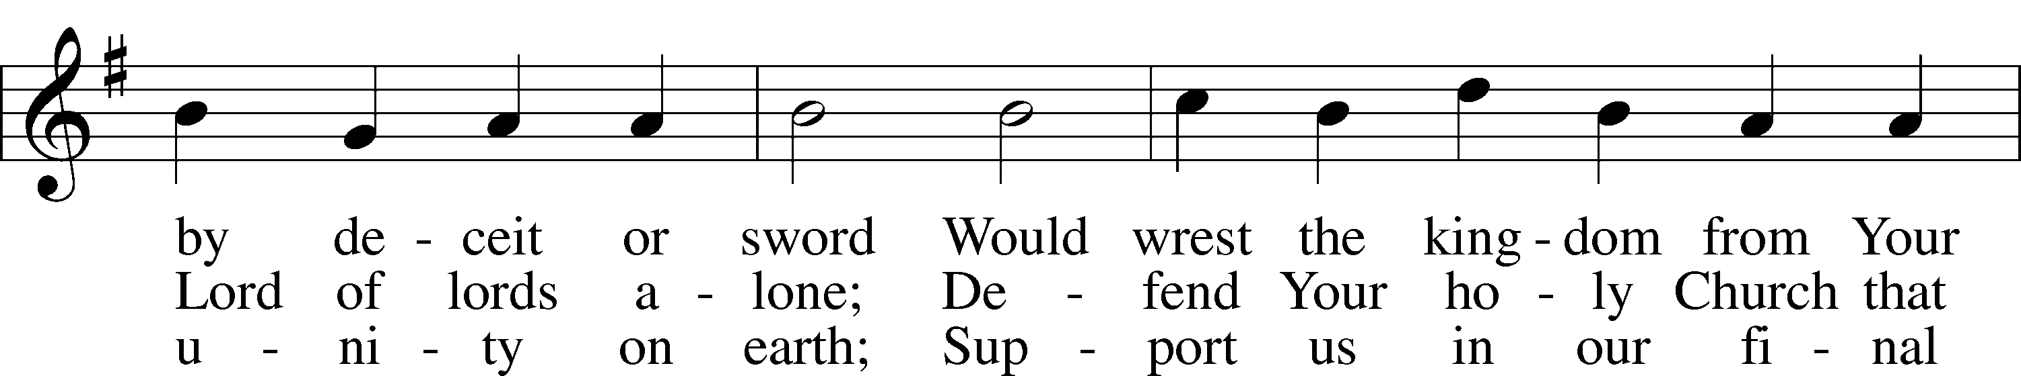
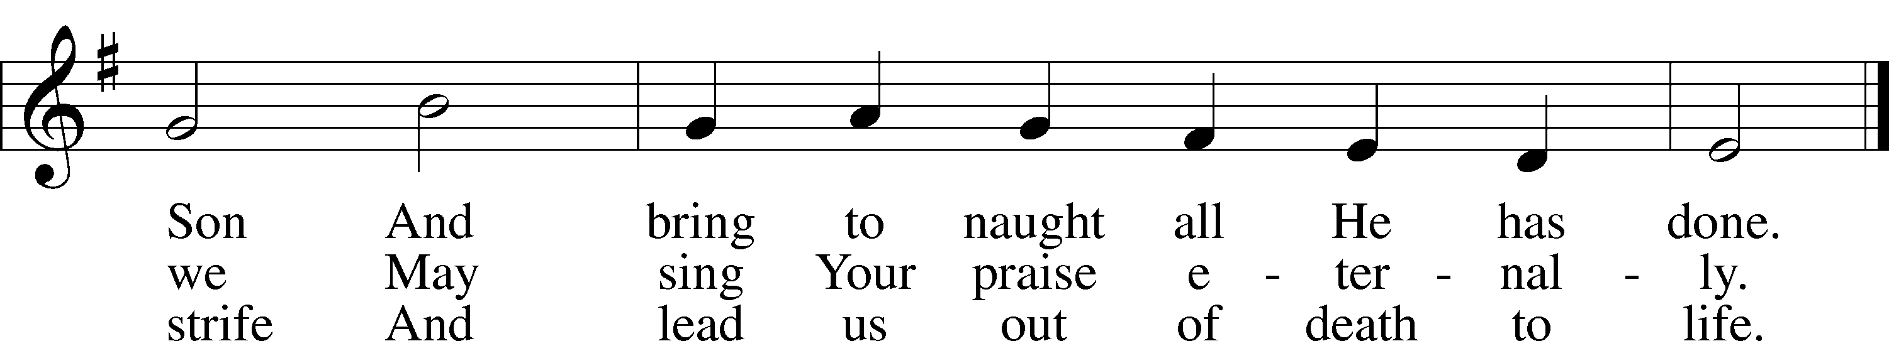
Public domain
(Please stand…)
THE LORD’S PRAYER:
All: Our Father, who art in heaven, hallowed be thy name, thy kingdom come, thy will be done, on earth as it is in heaven. Give us this day our daily bread; and forgive us our trespasses as we forgive those who trespass against us; and lead us not into temptation, but deliver us from evil. For thine is the kingdom, and the power, and the glory, forever and ever. Amen
THE BENEDICTION

CLOSING HYMN:

ANNOUNCEMENTS

WELCOME TO GRACE LUTHERAN CHURCH: We are glad that you are here to worship God with us today! We pray that you will enjoy the wonderful fellowship as friends in Christ as God gathers us around His means of grace, the Word and Sacraments, to bless us with His treasured gifts of forgiveness, faith, abundant life and eternal salvation. If you are a guest, please also sign our Guest Book. Please talk to Pastor if you would like to learn more about becoming a member of Grace. Also, please join us for refreshments and fellowship after the Service. We invite you to come and worship with us often as God gathers us in His Grace.

WELCOME TO THE LORD”S TABLE: We invite and encourage all present who are baptized and faithful Christians, and who confess the Father, Son, and Holy Spirit to be the only true God and who believe that Jesus Christ died for the sins of the World and is our only hope and salvation…to join us in receiving the very and true body and blood of Christ in this Sacrament. The clear liquid cups in the center of the tray are non-alcoholic wine.

Children not yet confirmed in the faith are always welcome to join their parents at the Lord’s Table, but should keep their hands folded in front of them. The Pastor will give them a blessing.

SERVING TODAY: Acolyte: Jack Cook; Lector: Monica Bacle; Communion Assistants: David Walker and Mike Sattelmeier; Usher: Matt Meritt; Altar Care: Kim Harrison; Refreshments: ____________.

SERVING NEXT SUNDAY: Acolyte: Amelia Bly; Lector: Peter Bacle; Communion Assistants: David Walker and Mike Sattelmeier; Usher: Matt Meritt; Altar Care: ___________; Refreshments: ____________.

FLOWERS: were placed on the altar today to the glory of God and by Norma Bringle.

THIS WEEK AT A GLANCE:

Today: This Sunday
9:00 am Worship Service with Communion
10:15 am Fellowship
10:30 am Adult Bible Class/Children’s Sunday School

Monday: July 13th
Pastor’s Vacation
5:00 pm Zumba

Tuesday: July 14th
Pastor’s Vacation
3:00 pm Jan’s Mobile Gym (Parish Hall)
6:00 pm Weight Watcher’s (Parish Hall)

Wednesday: July 15th
Pastor’s Vacation
12:30 pm Men’s Bible Fellowship
10:00 am Water Aerobics (Community Pool)
3:00 pm Jan’s Mobile Gym (Parish Hall)
4:30 pm Women’s Bible Study

Thursday: July 16th
Pastor’s Vacation
5:00 pm Zumba

Next Sunday: July 19th
9:00 am Worship Service with Communion
10:15 am Fellowship

IN YOUR PRAYERS THIS WEEK: Friends and Family of Mo Mosher, Walter Lepperd, Mary Hoffman, the Ferrer family, family of Layfield Long, Robert Hoffmann, Pastor Jan Cucera and family, Gerald Sattelmeier, Mo Mosher, family of Jonathan Wells, Will Plagens, Peter Pike, Frank, Harry, Mary McNeal, Donald Rollman, Jonathan Satel, Mable Paul, VanderKooi family, Bobby Bringle, Meggan Meggs, Cheryl Kucera, Tim Rodriguez, Elsie Hamilton, Mary Bacle, Michael Gillis, Joe Lamberson, Vernon Julson, Dennis Julson, Mary Ellen Jessel, and those you are praying for at home. If anyone has a special prayer request please submit it in writing in the collection plate; or you may call Pastor Gary Faith at (504-858-8872), or Kris Howard at (305-296-5161).

GIFTS, TITHES, & ATTENDANCE LAST SUNDAY will be mentioned in Sunday the 19th’s bulletin.

TO HELP US GROW… The Bible readings for next Sunday’s service readings are Jeremiah 23:1-6, Ephesians 2:11-22, and Mark 6:30-44.

THE GRACIOUS LADIES OF GRACE ate at the Green Pineapple. The next lunch will be Tuesday July 21st at 11:30, at location to be announced. All ladies are welcome.

WATER AEROBICS: Christine Gorham is now teaching a low impact water aerobics class for women and men at the Martin Luther King community pool on Wednesdays from 10:00am – 10:45 am. There is a low cost of $5.00 per class. Please come and join in the fun.

IT HAS BEEN SUGGESTED that we consider giving the next few months of noise offering to another nonprofit. If you have suggestions please share them with the Worship Committee (Beverly Walker, Don Bly, Auwina Weed, and Kris Howard).

IF YOU ARE NOT currently in our Missional Community and would like to be please let Pastor or Pattie know. Questions give Pastor a call 504-858-8872.

IF YOU ARE INTERESTED IN STARTING a 2nd Missional Community in your home (neighborhood) lets chat. 504-858-8872

NOISE OFFERING: We are now having a noise offering every Sunday. The children will serve as ushers collecting pocket change. The offerings will go to a nonprofit outside of the Grace community.

THE GRACE LUTHERAN CHURCH WEB PAGE AND FACE BOOK PAGE now contains a vocal recording of last week’s sermon. So if you are not able to attend church on Sunday please go to our website where you will find a copy of the bulletin and a recording of Pastor Faith’s sermon. The new webpage address is gracelutherankw.360unite.

A NUMBER OF CAPITAL IMPROVEMENTS are needed to keep our facilities in good health for the future. The narthex has been rebuilt. Roof repairs are needed on school buildings.

If you can help it would be much appreciated! A big thanks to all who have contributed to these repairs.

Women’s Bible Study: Our next meeting will be Wednesday July 16th at 4:30 in room 3. We will be working on a 6 week study on Discerning the Voice of God by Priscilla Shirer. When was the last time you heard the voice of God? Come discover how God speaks to us and become more familiar with the Holy Spirit, God's character, language and tone of voice.

The Men’s Bible Fellowship will be working on their study on Noah, Wednesday July 15th. They meet the first and third Wednesday’s of each month at 12:30 at Chico’s Restaurant. All guys are welcome.


This is a preliminary sketch of one of 7 windows that are planned to replace the existing ones. They include the 3 windows looking to the left of the center window of Christ and the 4 to the right. They will represent the life of Christ starting with Creation, Christmas, Crucifixion, Easter, Ascension,
Heaven, and ending with the Trinity.
Paul Pickel at Pickel Studios and his artist Apryl Moyer are designing the windows and are responsible for the new windows already installed. These windows have all been funded by special contributions from members of Grace.
The Board of Directors is asking for donors who would be interested at an estimated cost of $15,000.00 per new window.
This is a work in progress and not all details have been worked out but changes will be minor.
Contact Jim Reynolds 305 394-5987 with questions or to donate a window.

