FIFTH SUNDAY AFTER PENTECOST
JUNE 28, 2015 9:00 a.m.
WORSHIP SERVICE
In the Name of Jesus!
Our Mission Statement:
Anchored in Christ, each person a missionary.

PRELUDE

ANNOUNCEMENTS:
God is with us all during the week, wherever we are and in whatever we are doing. This week, let’s enjoy His presence.

OPENING HYMN: “Great Is Thy Faithfulness” LSB 809
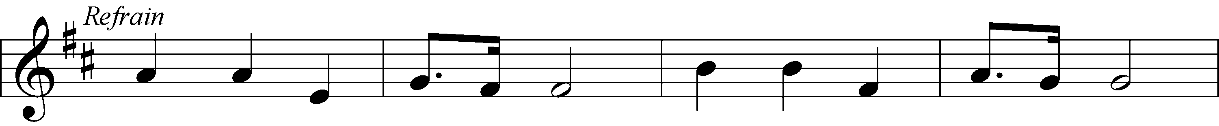
Text and Music: © 1923, renewed 1951 Hope Publishing Co. Used by permission: LSB Hymn License .NET, number 100011641.

Pastor: In the Name of the Father and of the Son and of the Holy Spirit.
Congregation: Amen

PREPARATION

(Please Remain Standing Or You May Kneel…)
CONFESSION OF SIN:
All: God, I admit I have broken all of your commandments; I am not holy or sinless even though I often pretend a righteousness I do not have. I offer excuses. I have broken relationships by what I have said, or done. I have not loved either You or my neighbor as I ought. (time for personal confession____)

YOU ARE FORGIVEN:
Pastor: God is merciful and gracious; He has given His Son, Jesus Christ to die and rise again for us, the sinful ones that we might be forgiven and enjoy His Peace. This is also a reminder of God’s gifts and blessing that have become ours in Holy Baptism.
Congregation: thank you God for Your blessing!
Pastor: Yes, the Grace of our Lord Jesus Christ, and the Love of God, and the fellowship of His Holy Spirit is with you all.
Congregation: And also with you.
Pastor: In peace and as His forgiven people, we can pray to the Lord:
Congregation: He is gracious to us and hears our prayers.
Pastor: For the peace of the whole world and our involvement in Christ’s Mission in the world, we pray:
Congregation: Keep us mindful of our purpose as Christians and our ability to share your blessings of peace and forgiveness with others.
Pastor: We are the children of the Risen Christ. His victory is Our Victory!

THE PRAYERS OF THE CHURCH:
All: Heavenly Father, during His earthly ministry Your Son Jesus healed the sick and raised the dead. By the healing medicine of the Word and Sacraments pour into our hearts such love toward You that we may live eternally; through the same Jesus Christ, our Lord, who lives and reigns with You and the Holy Spirit, one God, now and forever. Amen

SERVICE OF THE WORD

God speaks to us through his word, the Bible:

(You may be seated…)
THE OLD TESTAMENT LESSON: Lamentations 3:22-33
Lector: This is the Word of the Lord.
People: Thanks be to God.

THE EPISTLE LESSON: 2 Corinthians 8:1-9, 13-15
Lector: This is the Word of the Lord.
People: Thanks be to God.

(Please stand…)
THE HOLY GOSPEL: Mark 5:21-43
Pastor: The Holy Gospel according to St. Mark Chapter 5.
People: Glory to You, O Lord.
Pastor: This is the Gospel of the Lord.
People: Praise to You, O Christ!

(Please be seated…)
NOISE OFFERING

THE SERMON HYMN:

THE SERMON: “Interrupted by Grace” Mark 5:21-43

OFFERING
SERVICE OF THE SACRAMENT

(Please stand…)
PREPARE FOR THE LORD’S SUPPER:
Pastor: We begin with the reminder: “The Lord is with you.”
Congregation: We are mindful and thankful for His presence.
Pastor: Let your life reflect the joy of your salvation.
Congregation: We do give Him thanks and praise. We will share His blessing with others.
Pastor: It is proper that we should at all times and in all places…(prayer)… we praise your name and join others in singing:
All: (sing) “Holy, holy, holy Lord God of pow’r and might:
Heaven and earth are full of your glory.
Hosanna, Hosanna, Hosanna in the highest.
Blessed is he who comes in the name of the Lord.
Hosanna in the highest.”

(Please be seated…)
THE CONSECRATION AND DISTRIBUTION:
Hymns:
“When Peace, like a River” LSB 763
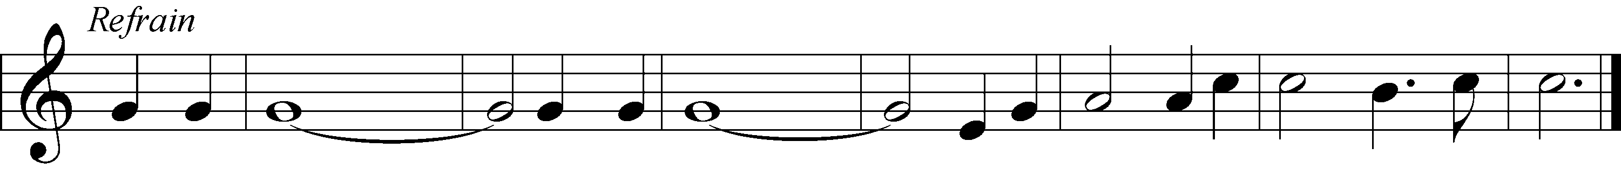
Text and Music: Public domain

“Jesus Comes Today with Healing” LSB 620 v.1-4
Text: © David W. Rogner Used by permission: LSB Hymn License .NET, number 100011641.
Music: Public domain

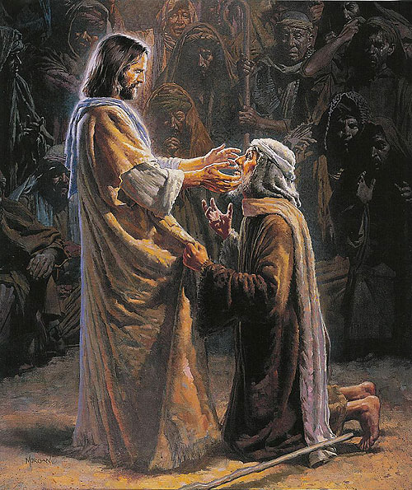
“I Know That My Redeemer Lives” LSB 461
5 | He lives to silence all my fears;  He lives to wipe away my tears;  He lives to calm my troubled heart;  He lives all blessings to impart.

6 | He lives, my kind, wise, heav’nly friend;  He lives and loves me to the end;  He lives, and while He lives, I’ll sing;  He lives, my Prophet, Priest, and King.

7 | He lives and grants me daily breath;  He lives, and I shall conquer death;  He lives my mansion to prepare;  He lives to bring me safely there.

8 | He lives, all glory to His name!  He lives, my Jesus, still the same;  Oh, the sweet joy this sentence gives:  I know that my Redeemer lives!
Text and Music: Public domain

(Please stand…)
THE LORD’S PRAYER:
All: Our Father, who art in heaven, Hallowed be thy name, thy kingdom come, thy will be done, on earth as it is in heaven. Give us this day our daily bread; and forgive us our trespasses, as we forgive those who trespass against us; and lead us not into temptation, but deliver us from evil. For thine is the kingdom, and the power, and the glory, forever and ever. Amen.

THE BLESSING AND BENEDICTION:
Pastor: The Lord Blesses you and keeps you, the Lord makes His face to shine upon you and He is Gracious to you. The Lord looks upon you with His favor and gives you His peace.
Congregation: God blesses us so that we can be a blessing to others.
Pastor: Go in His peace and serve the Lord by serving others.
Congregation: Amen

THE CLOSING HYMN: “Joyful, Joyful We Adore Thee” LSB 803
Text and Music: Public domain
ANNOUNCEMENTS

WELCOME TO GRACE LUTHERAN CHURCH: We are glad that you are here to worship God with us today! We pray that you will enjoy the wonderful fellowship as friends in Christ as God gathers us around His means of grace, the Word and Sacraments, to bless us with His treasured gifts of forgiveness, faith, abundant life and eternal salvation. If you are a guest, please also sign our Guest Book. Please talk to Pastor if you would like to learn more about becoming a member of Grace. Also, please join us for refreshments and fellowship after the Service. We invite you to come and worship with us often as God gathers us in His Grace.

WELCOME TO THE LORD”S TABLE: We invite and encourage all present who are baptized and faithful Christians, and who confess the Father, Son, and Holy Spirit to be the only true God and who believe that Jesus Christ died for the sins of the World and is our only hope and salvation…to join us in receiving the very and true body and blood of Christ in this Sacrament. The clear liquid cups in the center of the tray are non-alcoholic wine.

Children not yet confirmed in the faith are always welcome to join their parents at the Lord’s Table, but should keep their hands folded in front of them. The Pastor will give them a blessing.

SERVING TODAY: Acolyte: James Reynolds; Lector: David Walker; Communion Assistants: Matt Meritt and Mitch Cook; Usher: Terry Richardson; Altar Care: Kris Howard; Refreshments: The Howard Family.

SERVING NEXT SUNDAY: Acolyte: Jacob Baugh; Lector: David Walker; Communion Assistants: Matt Meritt and Mitch Cook; Usher: Terry Richardson; Altar Care: Kris Howard; Refreshments:.

FLOWERS: were placed on the altar today to the glory of God and by the Bacle family for thanksgivings for the new grandchild and to celebrate their anniversary.

THIS WEEK AT A GLANCE:

Today: This Sunday
9:00 am Worship Service with Communion
10:15 am Fellowship
10:30 am Adult Bible Class/Children’s Sunday School
12:00 pm New Member Class

Monday: June 29th
Pastor’s Day Off
5:00 pm Zumba

Tuesday: June 30th
3:00 pm Jan’s Mobile Gym (Parish Hall)
6:00 pm Weight Watcher’s (Parish Hall)

Wednesday: July 1st
10:00 am Water Aerobics (Community Pool)
12:30 pm Men’s Bible Fellowship
3:00 pm Jan’s Mobile Gym (Parish Hall)

Thursday: July 2nd
6:30 pm Missional Community Meeting (Parsonage)

Next Sunday: July 5th
9:00 am Worship Service with Communion
10:15 am Fellowship
10:30 am Adult Bible Class/Children’s Sunday School

IN YOUR PRAYERS THIS WEEK: Walter Lepperd, Mary Hoffman, the Ferrer family, family of Layfield Long, Robert Hoffmann, Pastor Jan Cucera and family, Gerald Sattelmeier, Mo Mosher, family of Jonathan Wells, Will Plagens, Peter Pike, Frank, Harry, Mary McNeal, Donald Rollman, Jonathan Satel, Mable Paul, VanderKooi family, Bobby Bringle, Meggan Meggs, Cheryl Kucera, Tim Rodriguez, Elsie Hamilton, Mary Bacle, Michael Gillis, Joe Lamberson, Vernon Julson, Dennis Julson, Mary Ellen Jessel, and those you are praying for at home. If anyone has a special prayer request please submit it in writing in the collection plate; or you may call Pastor Gary Faith at (504-858-8872), or Kris Howard at (305-296-5161).

GIFTS, TITHES, & ATTENDANCE LAST SUNDAY were $4203.00. The total attendance was 79.

TO HELP US GROW… The Bible readings for next Sunday’s service readings are Ezekiel 2:1-5, 2 Corinthians 12:1-10, and Mark 6:1-13.

THE GRACIOUS LADIES OF GRACE ate at Azur. The next lunch will be Tuesday July 7th at 11:30, location to be announced. All ladies are welcome.

WATER AEROBICS: Christine Gorham is now teaching a low impact water aerobics class for women and men at the Martin Luther King community pool on Wednesdays from 10:00am – 10:45 am. There is a low cost of $5.00 per class. Please come and join in the fun.

IT HAS BEEN SUGGESTED that we consider giving the next few months of noise offering to another nonprofit. If you have suggestions please share them with the Worship Committee (Beverly Walker, Don Bly, Auwina Weed, and Kris Howard).

IF YOU ARE NOT currently in our Missional Community and would like to be please let Pastor or Pattie know. Questions give Pastor a call 504-858-8872.

IF YOU ARE INTERESTED IN STARTING a 2nd Missional Community in your home (neighborhood) lets chat. 504-858-8872

NOISE OFFERING: We are now having a noise offering every Sunday. The children will serve as ushers collecting pocket change. The offerings will go to a nonprofit outside of the Grace community.

THE GRACE LUTHERAN CHURCH WEB PAGE AND FACE BOOK PAGE now contains a vocal recording of last week’s sermon. So if you are not able to attend church on Sunday please go to our website where you will find a copy of the bulletin and a recording of Pastor Faith’s sermon. The new webpage address is gracelutherankw.360unite.

A NUMBER OF CAPITAL IMPROVEMENTS are needed to keep our facilities in good health for the future. The narthex has been rebuilt. Roof repairs are needed on school buildings.
If you can help it would be much appreciated! A big thanks to all who have contributed to these repairs.

Women’s Bible Study: Our next meeting will be announced at a later date. Monica is away enjoying her new grandbaby, mother and baby are doing well. When she returns we will be working on a 6 week study on Discerning the Voice of God by Priscilla Shirer. When was the last time you heard the voice of God? Come discover how God speaks to us and become more familiar with the Holy Spirit, God's character, language and tone of voice.

The Men’s Bible Fellowship will be working on their study on Noah, Wednesday July 1st. They meet the first and third Wednesday’s of each month at 12:30 with the next session set for Wednesday June 17th at Chico’s Restaurant. All guys are welcome.

This is a preliminary sketch of one of 7 windows that are planned to replace the existing ones. They include the 3 windows looking to the left of the center window of Christ and the 4 to the right. They will represent the life of Christ starting with Creation, Christmas, Crucifixion, Easter, Ascension,
Heaven, and ending with the Trinity.
Paul Pickel at Pickel Studios and his artist Apryl Moyer are designing the windows and are responsible for the new windows already installed. These windows have all been funded by special contributions from members of Grace.
The Board of Directors is asking for donors who would be interested at an estimated cost of $15,000.00 per new window.
This is a work in progress and not all details have been worked out but changes will be minor.
Contact Jim Reynolds 305 394-5987 with questions or to donate a window.

