FOURTH SUNDAY AFTER PENTECOST
JUNE 21, 2015 9:00 a.m.
WORSHIP SERVICE
In the Name of Jesus!
Our Mission Statement:
Anchored in Christ, each person a missionary.

ORGAN PRELUDE: (A time for Meditation and Preparation)

WELCOME

ANNOUNCEMENTS
PREPARATION
(Please stand…)
OPENING HYMN: “For the Beauty of the Earth” See Insert

(Please Remain Standing or You May Kneel)
CONFESSION AND ABSOLUTION:
Pastor: Holy God, in your mercy you look with grace and favor upon us, Your people. Hear now, our solemn confession, and as Your Spirit moves us to true repentance, remind us again that You have forgiven us for the sake of Jesus Christ.
Congregation: Father, how often my sinful nature controls my life! I am easily tempted and fall into sin; I am blind to Your will; I am self-serving, self-seeking, self-righteous and deluded; I am dead in sin. The works of my flesh are demonstrated in my actions and thoughts and words. I have not acted as your baptized child. My heart breaks in my shame and guilt. Gratefully I remember Your blood shed for me to wash me clean. I am forgiven. Holy Spirit, control my life.
Pastor: God has heard our cry. He is faithful even when we are not. As your called servant of His Word, I announce that we have what we seek; the entire forgiveness of all our sins, as God’s free gift. New life, new sights and a new heart are ours. Live in the freedom of the Spirit.
Congregation: Amen!

THE PRAYERS OF THE DAY:
All: Almighty God, in Your mercy guide the course of this world so that Your Church may joyfully serve You in godly peace and quietness; through Jesus Christ, Your Son, our Lord, who lives and reigns with Your and the Holy Spirit, one God now and forever. Amen

SERVICE OF THE WORD

(You may be seated…)
THE FIRST READING: Job 38:1-11
Lector: This is the Word of the Lord.
People: Thanks be to God.

THE SECOND READING: 2 Corinthians 6:1-13
Lector: This is the Word of the Lord.
People: Thanks be to God.

(Please stand…)
THE HOLY GOSPEL: Mark 4:35-41
Pastor: The Holy Gospel according to St. Mark the 4th chapter.
People: Glory to You, O Lord.
Pastor: This is the Gospel of the Lord.
People: Praise to You, O Christ!

(You may be seated…)
CHILDREN’S MESSAGE

NOISE OFFERING

THE SERMON HYMN: “Oh, Blest the House” LSB 862
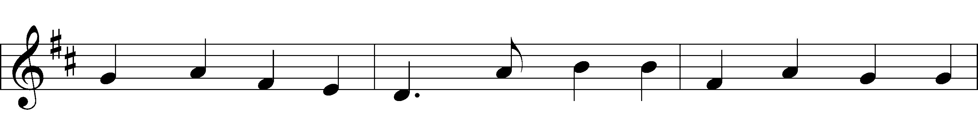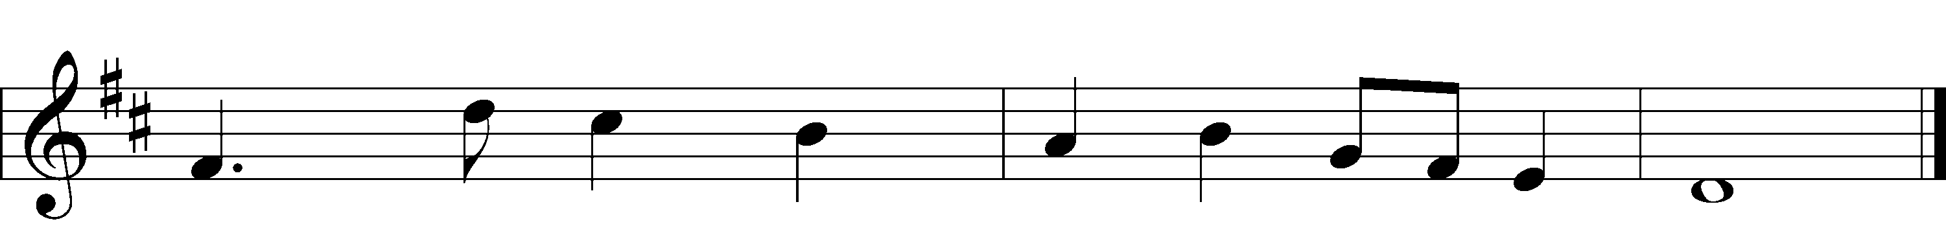
Text and Music: Public domain
Unknown: Public domain

THE SERMON: “Who Cares?” Mark 4:35-41
(Please stand…)
THE PROFESSION OF FAITH:
Pastor: God has given us a great message to take to His world. Let us remind ourselves and one another of what that message is:
Pastor: I believe in God the Father, Almighty
Congregation: Maker of heaven and earth
Pastor: And in His Son, Jesus Christ our Lord,
Congregation: Who was conceived by the Holy Spirit
Pastor: Born of the Virgin Mary
Congregation: Suffered under Pontius Pilate
Pastor: Was crucified, died and was buried
Congregation: He descended into hell.
Pastor: On the third day He rose again from the dead,
Congregation: And ascended into heaven
Pastor: And sits on the right hand of God, the Father almighty
Congregation: From there He will come to judge the living and the dead
Pastor: I believe in the Holy Spirit,
Congregation: The Holy Christian Church as
All: the communion of saints; the forgiveness of sins, the resurrection of the body, and the life everlasting. Amen.

THE OFFERING

(Please stand…)
THE PRAYER:
Pastor: Lord God, Heavenly Father, You are the Light of our life and the Hope of our salvation.
Response: With you we have nothing to fear.
Pastor: You protect us, and are the source of all our joy and happiness.
Response: Accept our grateful songs of praise.
Pastor: We pray for those whom we now name silently in our hearts or out
loud…According to Your will, heal the sick, strengthen the faith of all who doubt and lift up the depressed. Into Your hand we commend all for whom we pray, trusting in Your mercy, through Your Son, Jesus Christ our Lord.
All: Amen!

SERVICE OF THE SACRAMENT

(You may be seated…)
THE WORDS OF INSTITUTION

DISTRIBUTION HYMNS:
“Precious Lord, Take My Hand” LSB 739
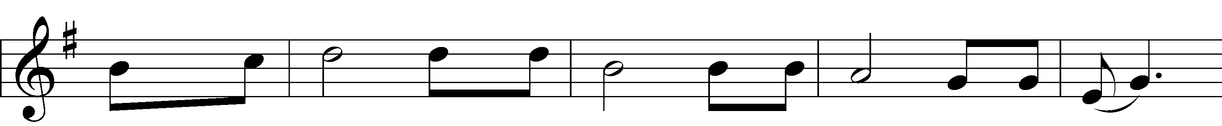
Text and Music: © 1938 Unichappell Music Used by permission: LSB Hymn License .NET, number 100011641.; admin. Alfred Publishing Co., Inc. Used by permission: LSB Hymn License .NET, number 100011641.

“Give Thanks with a Grateful Heart” LSB 806
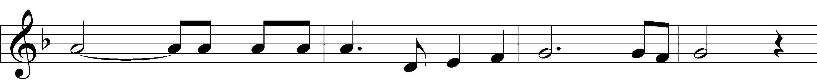
Text and Music: © 1978 Integrity’s Hosanna! Music Used by permission: LSB Hymn License .NET, number 100011641.

“Be Still, My Soul” LSB 752
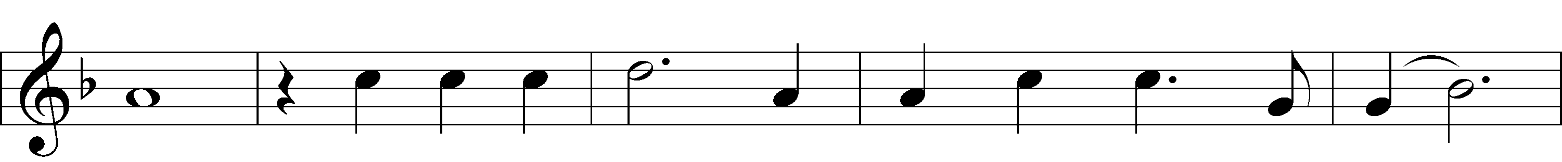
Text and Tune: Public domain

(Please stand…)
THE LORD’S PRAYER:
All: Our Father, who art in heaven, Hallowed be thy name, thy kingdom come, thy will be done, on earth as it is in heaven. Give us this day our daily bread; and forgive us our trespasses, as we forgive those who trespass against us; and lead us not into temptation, but deliver us from evil. For thine is the kingdom, and the power, and the glory, forever and ever. Amen.

BENEDICTION

THE CLOSING HYMN: “Eternal Father, Strong to Save” LSB 717
Text (sts. 1, 4, 2*, 3*) and Music: Public domain
Text (sts. 2–3, 2*, 3*): © The Church Pension Fund Used by permission: LSB Hymn License .NET, number 100011641.
Music: Public domain
ANNOUNCEMENTS

WELCOME TO GRACE LUTHERAN CHURCH: We are glad that you are here to worship God with us today! We pray that you will enjoy the wonderful fellowship as friends in Christ as God gathers us around His means of grace, the Word and Sacraments, to bless us with His treasured gifts of forgiveness, faith, abundant life and eternal salvation. If you are a guest, please also sign our Guest Book. Please talk to Pastor if you would like to learn more about becoming a member of Grace. Also, please join us for refreshments and fellowship after the Service. We invite you to come and worship with us often as God gathers us in His Grace.

WELCOME TO THE LORD”S TABLE: We invite and encourage all present who are baptized and faithful Christians, and who confess the Father, Son, and Holy Spirit to be the only true God and who believe that Jesus Christ died for the sins of the World and is our only hope and salvation…to join us in receiving the very and true body and blood of Christ in this Sacrament. The clear liquid cups in the center of the tray are non-alcoholic wine.

Children not yet confirmed in the faith are always welcome to join their parents at the Lord’s Table, but should keep their hands folded in front of them. The Pastor will give them a blessing.

SERVING TODAY: Acolyte: Jack Cook; Lector: Beverly Walker; Communion Assistants: Matt Meritt and Mitch Cook; Usher: Terry Richardson; Altar Care: Kris Howard; Refreshments: The Reynolds Family.

SERVING NEXT SUNDAY: Acolyte: Elizabeth Reynolds; Lector: David Walker; Communion Assistants: Matt Meritt and Mitch Cook; Usher: Terry Richardson; Altar Care: Kris Howard; Refreshments: The Bly Family.

FLOWERS: were placed on the altar today to the glory of God and by the Bacle family to celebrate Emmie’s Birthday.

THIS WEEK AT A GLANCE:

Today: This Sunday
9:00 am Worship Service with Communion
10:15 am Fellowship
10:30 am Adult Bible Class/Children’s Sunday School
12:00 pm New Member Class

Monday: June 22nd
Pastor’s Day Off
5:00 pm Zumba

Tuesday: June 23rd
11:30 am Gracious Ladies of Grace Luncheon (Azur)
3:00 pm Jan’s Mobile Gym (Parish Hall)
6:00 pm Weight Watcher’s (Parish Hall)

Wednesday: June 24th
10:00 am Water Aerobics (Community Pool)
3:00 pm Jan’s Mobile Gym (Parish Hall)

Thursday: June 25th
6:30 pm Missional Community Meeting (Parsonage)

Next Sunday: June 28th
9:00 am Worship Service with Communion
10:15 am Fellowship
10:30 am Adult Bible Class/Children’s Sunday School
12:00 pm New Member Class

IN YOUR PRAYERS THIS WEEK: Family of Layfield Long, Robert Hoffmann, Pastor Jan Cucera and family, Kay Sattelmeier, Gerald Sattelmeier, Mo Mosher, the family of Pastor Dick Knapp, family of Jonathan Wells, Will Plagens, Peter Pike, Frank, Harry, Mary McNeal, Donald Rollman, Jonathan Satel, Mable Paul, VanderKooi family, Bobby Bringle, Meggan Meggs, Cheryl Kucera, Tim Rodriguez, Elsie Hamilton, Mary Bacle, Michael Gillis, Joe Lamberson, Vernon Julson, Dennis Julson, Mary Ellen Jessel, and those you are praying for at home. If anyone has a special prayer request please submit it in writing in the collection plate; or you may call Pastor Gary Faith at (504-858-8872), or Kris Howard at (305-296-5161).

GIFTS, TITHES, & ATTENDANCE LAST SUNDAY were $2058.53 and the noise offering for this last week was $65.51. The total attendance was 62.

TO HELP US GROW… The Bible readings for next Sunday’s service readings are Lamentations 3:22-33, 2 Corinthians 8:1-9, 13-15, and Mark 5:21-43.

A BIG THANK YOU to all who helped with Vacation Bible School. Jesus did some very cool things through all of you. “Jesus works through you and me!”

THE GRACIOUS LADIES OF GRACE ate at Rustica. The next lunch will be Tuesday June 23rd at 11:30 at Azur. All ladies are welcome.

WATER AEROBICS: Christine Gorham is now teaching a low impact water aerobics class for women and men at the Martin Luther King community pool on Wednesdays from 10:00am – 10:45 am. There is a low cost of $5.00 per class. Please come and join in the fun.

IT HAS BEEN SUGGESTED that we consider giving the next few months of noise offering to another nonprofit. If you have suggestions please share them with the Worship Committee (Beverly Walker, Don Bly, Auwina Weed, and Kris Howard).

OUR NEXT ADULT INFORMATION CLASS is scheduled for Sunday June 21st and June 28th. We will meet from noon – 2. This class is designed for those who are interested in learning more about what we teach and believe. It is also a good review for members.

IF YOU ARE NOT currently in our Missional Community and would like to be please let Pastor or Pattie know. Questions give Pastor a call 504-858-8872.

IF YOU ARE INTERESTED IN STARTING a 2nd Missional Community in your home (neighborhood) lets chat. 504-858-8872

NOISE OFFERING: We are now having a noise offering every Sunday. The children will serve as ushers collecting pocket change. The offerings will go to a nonprofit outside of the Grace community.

THE GRACE LUTHERAN CHURCH WEB PAGE AND FACE BOOK PAGE now contains a vocal recording of last week’s sermon. So if you are not able to attend church on Sunday please go to our website where you will find a copy of the bulletin and a recording of Pastor Faith’s sermon. The new webpage address is gracelutherankw.360unite.

A NUMBER OF CAPITAL IMPROVEMENTS are needed to keep our facilities in good health for the future. The narthex has been rebuilt. Roof repairs are needed on school buildings.
If you can help it would be much appreciated! A big thanks to all who have contributed to these repairs.

MUSIC MINISTRY: Thank you to all of you who have participated in our music ministry this past year. We thank God for the gift of music and for the time and talents of our singers, ringers and instrumentalists. We will occasionally sing or ring over the summer so watch the bulletin for special rehearsals. Weekly rehearsals will resume in the fall.

Women’s Bible Study: Our next meeting will be announced at a later date. Monica is away enjoying her new grandbaby, mother and baby are doing well. When she returns we will be working on a 6 week study on Discerning the Voice of God by Priscilla Shirer. When was the last time you heard the voice of God? Come discover how God speaks to us and become more familiar with the Holy Spirit, God's character, language and tone of voice.

The Men’s Bible Fellowship will be working on their study on Noah Wednesday July 1st. They meet the first and third Wednesday’s of each month at 12:30 with the next session set for Wednesday June 17th at Chico’s Restaurant. All guys are welcome.

This is a preliminary sketch of one of 7 windows that are planned to replace the existing ones. They include the 3 windows looking to the left of the center window of Christ and the 4 to the right. They will represent the life of Christ starting with Creation, Christmas, Crucifixion, Easter, Ascension,
Heaven, and ending with the Trinity.
Paul Pickel at Pickel Studios and his artist Apryl Moyer are designing the windows and are responsible for the new windows already installed. These windows have all been funded by special contributions from members of Grace.
The Board of Directors is asking for donors who would be interested at an estimated cost of $15,000.00 per new window.
This is a work in progress and not all details have been worked out but changes will be minor.
Contact Jim Reynolds 305 394-5987 with questions or to donate a window.

