**March 4th, 2018**

**9:00 am**

**THIRD SUNDAY**

**IN**

**LENT**



**Grace Lutheran Church**

**2713 Flagler Ave.**

**Key West, FL 33040**

**305-296-5161**

**GraceLutheranKW@att.net**

**Pastor Faith**

**(504) 858-8872**

**garyfaith@aol.com**

**THIRD SUNDAY IN LENT**

**MARCH 4TH, 2018 9 a.m.**

**WORSHIP SERVICE**

***In the Name of Jesus!***

**Our Mission Statement: Anchored in Christ, each person a missionary.**

**ORGAN PRELUDE: *“How Firm A Foundation”*  -Janet Linker**

**WELCOME**

**ANNOUNCEMENTS**

**PREPARATION**

*(Please Stand…)*

**HYMN:  *“How Firm a Foundation”* LSB 728**

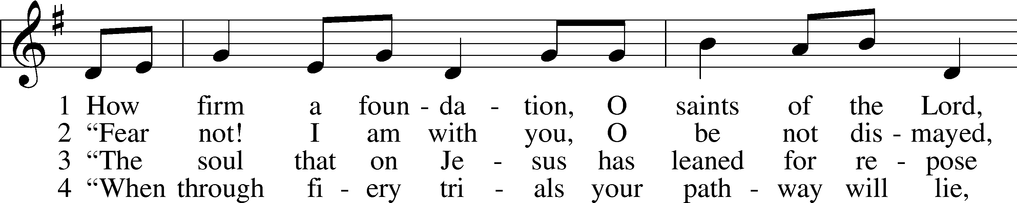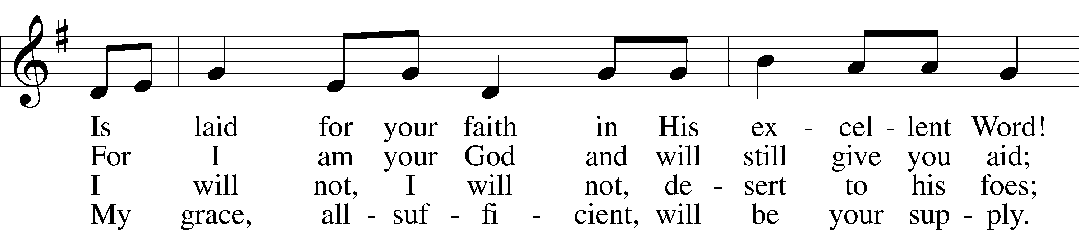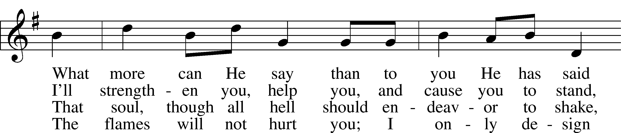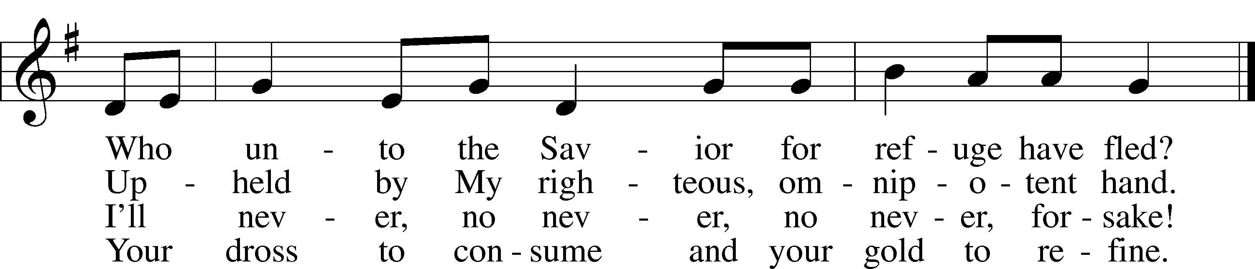

5 “Throughout all their lifetime My people will prove  
My sov’reign, eternal, unchangeable love;  
And then, when gray hairs will their temples adorn,  
Like lambs they will still in My bosom be borne.”

Public domain

Pastor: In the Name of the Father and of the Son and Holy Spirit.

**Congregation: Amen.**

*(Please Remain Standing or You May Kneel)*

**CONFESSION AND ABSOLUTION:**

Pastor: Holy God, in your mercy you look with grace and favor upon us, Your people. Hear now, our solemn confession, and as Your Spirit moves us to true repentance, remind us again that You have forgiven us for the sake of Jesus Christ.

**Congregation: Father, how often my sinful nature controls my life! I am easily tempted and fall into sin; I am blind to Your will; I am self-serving, self-seeking, self-righteous and deluded; I am dead in sin. The works of my flesh are demonstrated in my actions and thoughts and words. I have not acted as your baptized child. My heart breaks in my shame and guilt. Gratefully I remember Your blood shed for me to wash me clean. I am forgiven. Holy Spirit, control my life.**

Pastor: God has heard our cry. He is faithful even when we are not. As your called servant of His Word, I announce that we have what we seek; the entire forgiveness of all our sins, as God’s free gift. New life, new sights and a new heart are ours. Live in the freedom of the Spirit.

**Congregation: Amen!**

**THE PRAYERS OF THE DAY:**

**All: O Lord, whose glory it is always to have mercy, be gracious to all who have gone astray from Your ways and bring them again with penitent hearts and steadfast faith to embrace and hold fast the unchangeable truth of Your Word; through Jesus Christ, Your Son, our Lord, who lives and reigns with You and the Holy Spirit, one God, now and forever. Amen.**

**SERVICE OF THE WORD**

*You may be seated…*

**THE OLD TESTAMENT READING: Exodus 20:1-17**

Lector: This is the Word of the Lord.

**People: Thanks be to God.**

**THE EPISTLE LESSON: 1 Corinthians 1:18-31**

Lector: This is the Word of the Lord.

**People: Thanks be to God.**

*Please stand…*

**THE HOLY GOSPEL: John 2:13-22**

Pastor: The Holy Gospel according to St. John the 2nd Chapter

**People: Glory to You, O Lord.**



Pastor: This is the Gospel of the Lord.

**People: Praise to You, O Christ!**

*Please be seated…*

**CHILDREN’S MESSAGE**

**NOISE OFERING**

**THE SERMON HYMN: *“Come, Thou Fount of Every Blessing”* LSB 686**

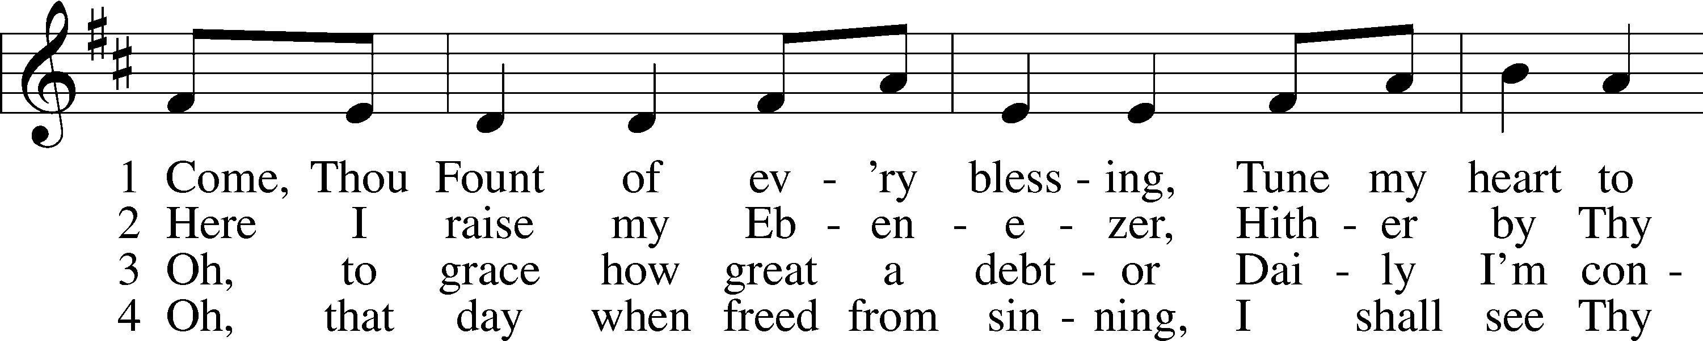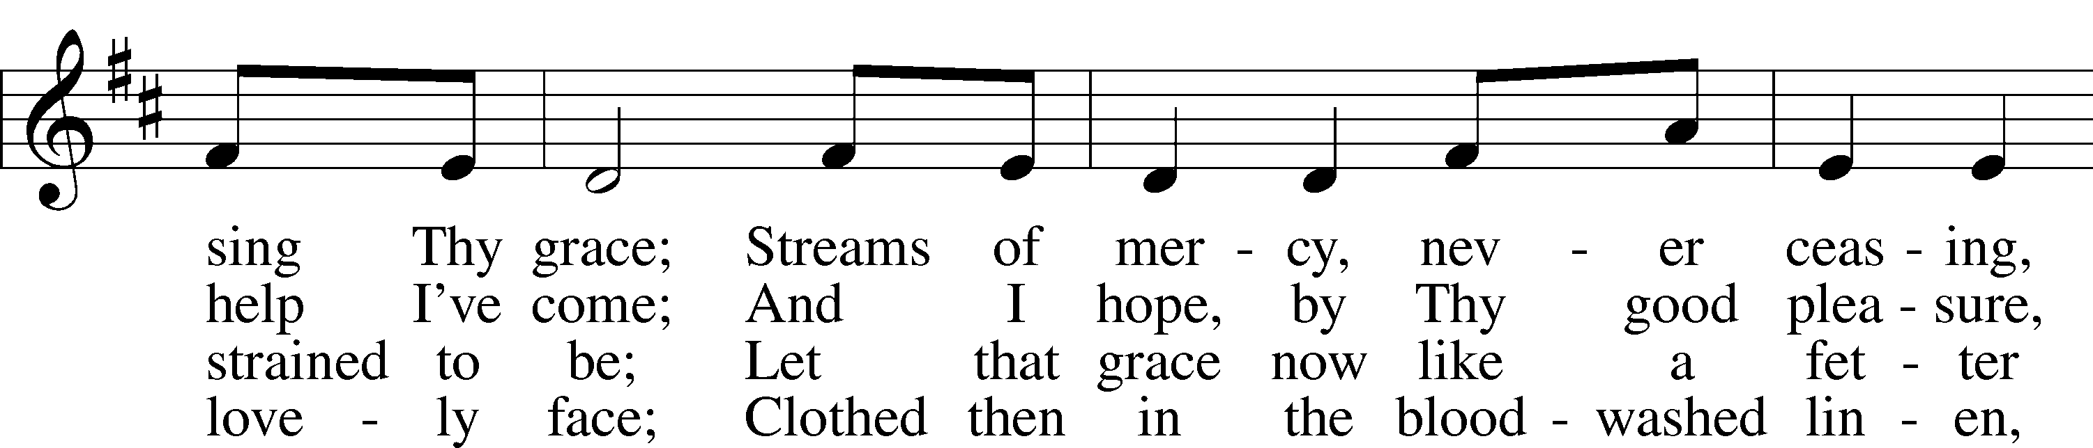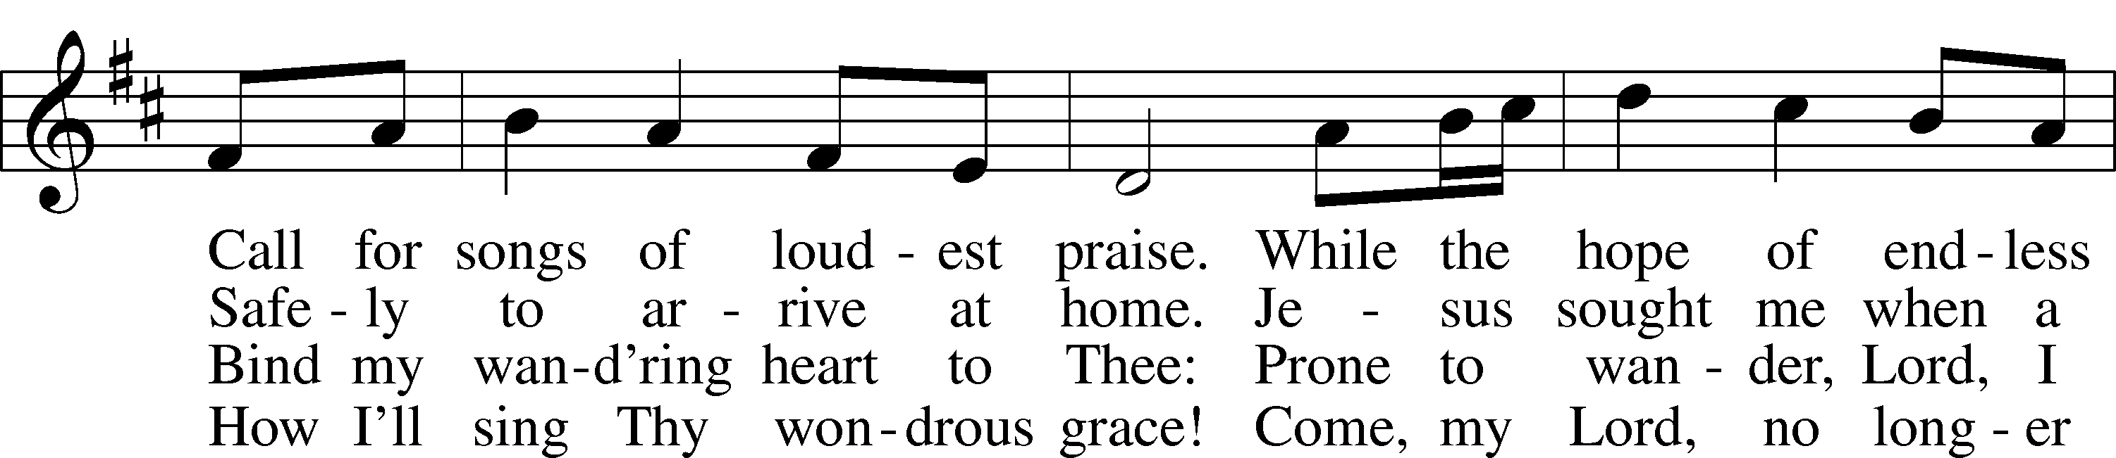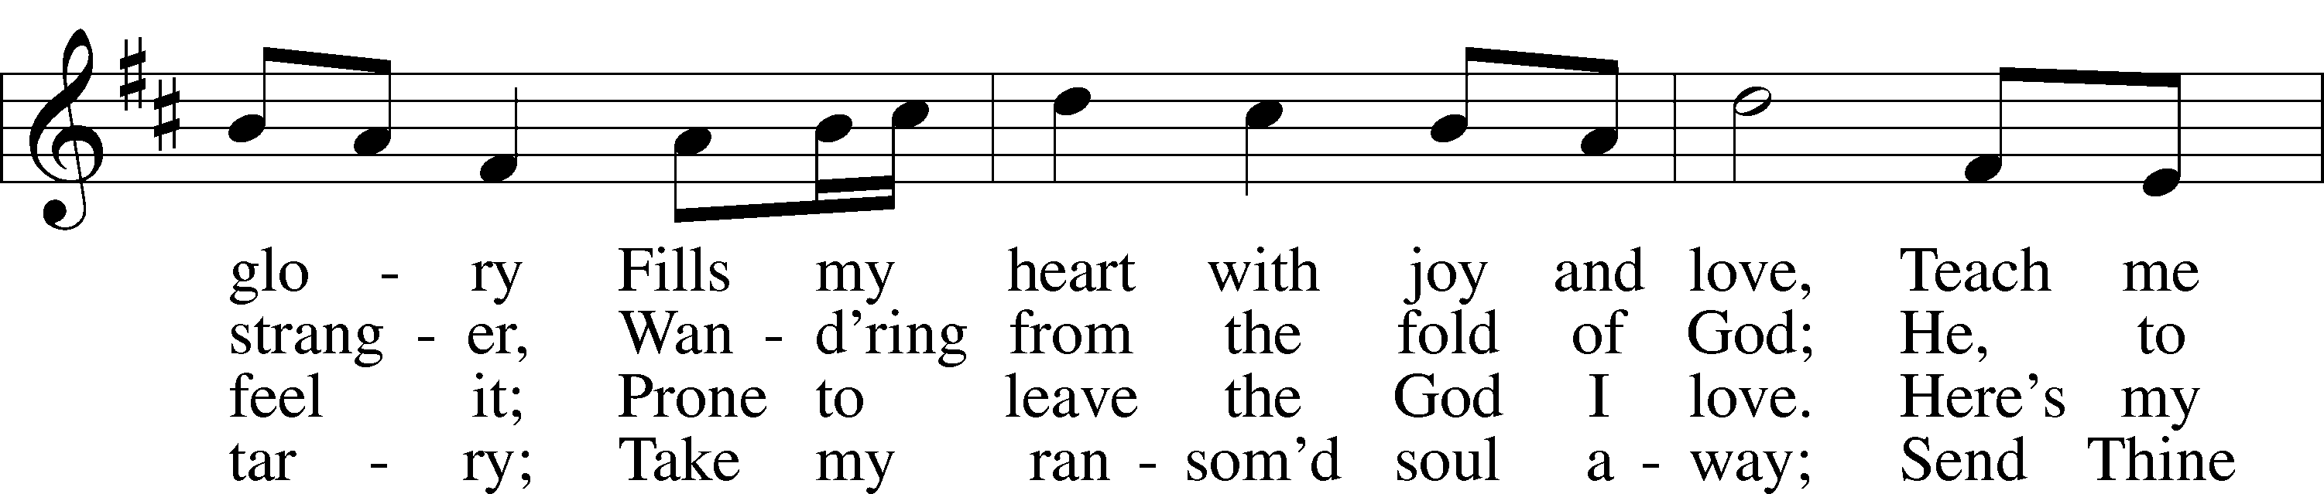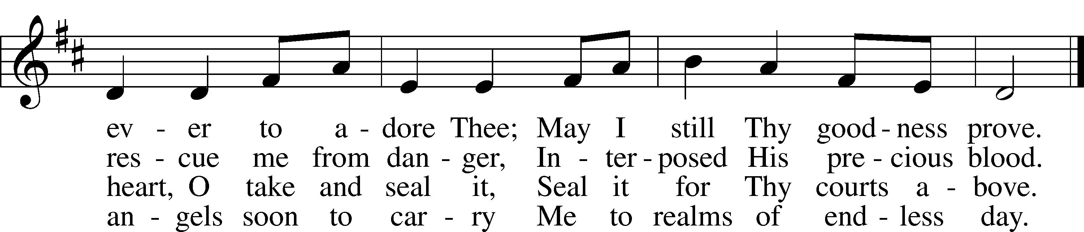

Public domain

**THE SERMON: *“Because He Loves Us”* Exodus 20:1-17**

As a result of what I have heard from God’s word today, what is one thing I think He is giving me to believe or do in the coming week especially for the good of other?

**MISSION MOMENT**



*(Please stand…)*

**THE PROFESSION OF FAITH:**

Pastor: God has given us a great message to take to His world. Let us remind ourselves and one another of what that message is:

**Congregation:** **I believe in God the Father, Almighty**

Pastor: Maker of heaven and earth

**Congregation:** **And in His Son, Jesus Christ our Lord,**

**Pastor:** Who was conceived by the Holy Spirit

**Congregation:** **Born of the Virgin Mary**

**Pastor:** Suffered under Pontius Pilate

**Congregation:** **Was crucified, died and was buried**

**Pastor:** He descended into hell.

**Congregation:** **On the third day He rose again from the dead,**

**Pastor:** And ascended into heaven

**Congregation:** **And sits on the right hand of God, the Father almighty**

**Pastor:** From there He will come to judge the living and the dead

**Congregation:** **I believe in the Holy Spirit,**

**Pastor:** The Holy Christian Church as

**All: the communion of saints; the forgiveness of sins, the resurrection of the body, and the life everlasting. Amen.**

*(You may be seated…)*

**OFFERING RECEIVED: “*In All Our Grief”* Vocal Choir**

**(***Please stand…)*  ***“Praise God, from Whom All Blessings Flow”* LSB 805**

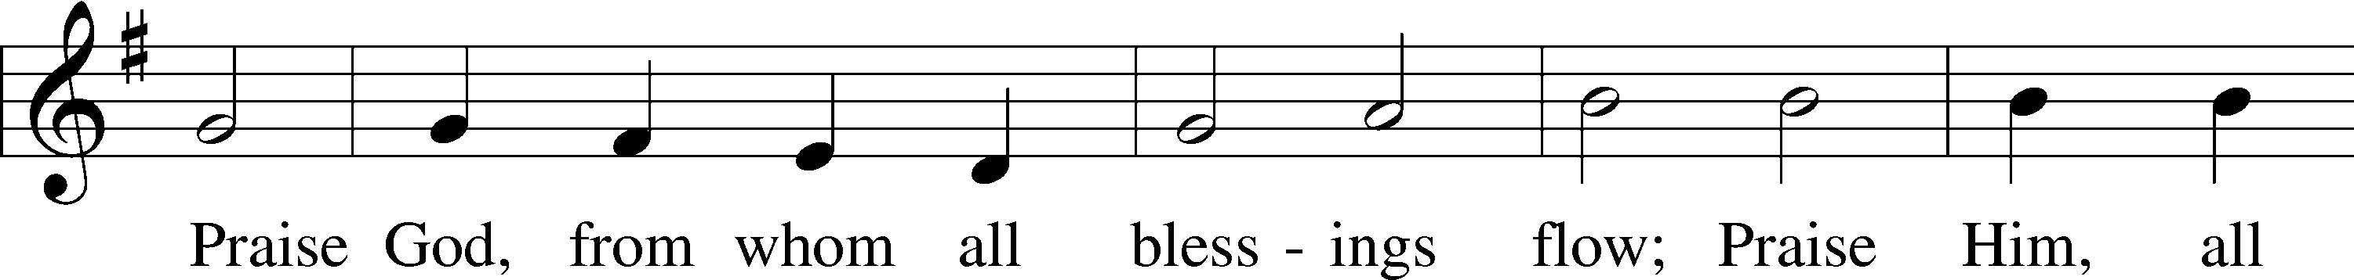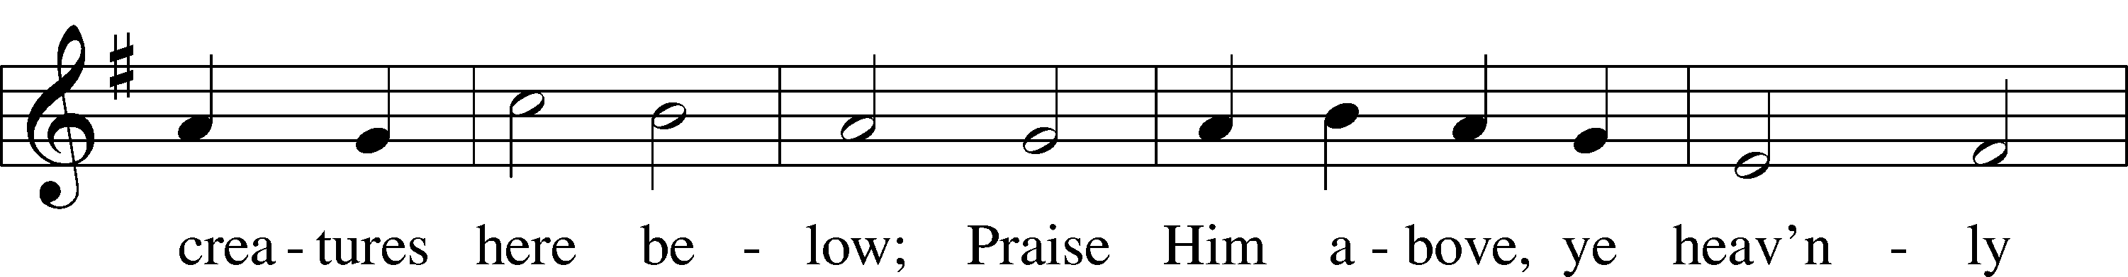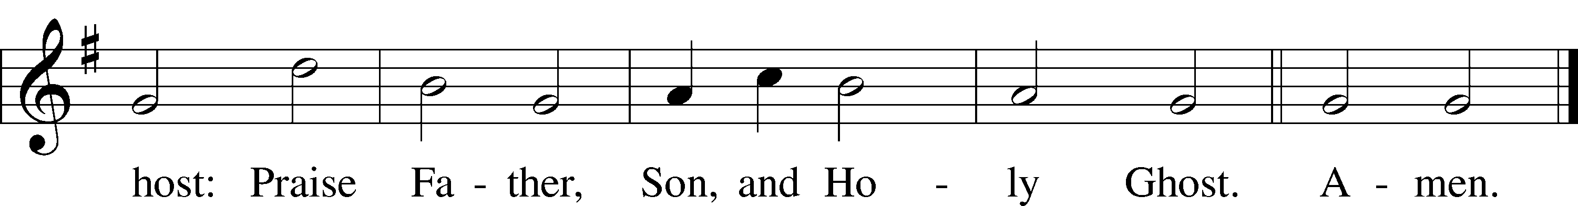

Public domain

*(Please stand…)*

**THE PRAYER:**

Pastor: Lord God, Heavenly Father, You are the Light of our life and the Hope of

our salvation.

**Response: With you we have nothing to fear.**

Pastor: You protect us, and are the source of all our joy and happiness.

**Response: Accept our grateful songs of praise.**

Pastor: We pray for those whom we now name silently in our hearts or out loud… According to Your will, heal the sick, strengthen the faith of all who doubt and lift up the depressed. Into Your hands we commend all for whom we pray, trusting in Your mercy, through Your Son, Jesus Christ our Lord.

**All: Amen!**

**SERVICE OF THE SACRAMENT**

*(Please be seated…)*

**THE WORDS OF INSTITUTION**

**DISTRIBUTION HYMNS: *“Cross of Jesus, Cross of Sorrow”* LSB 428**

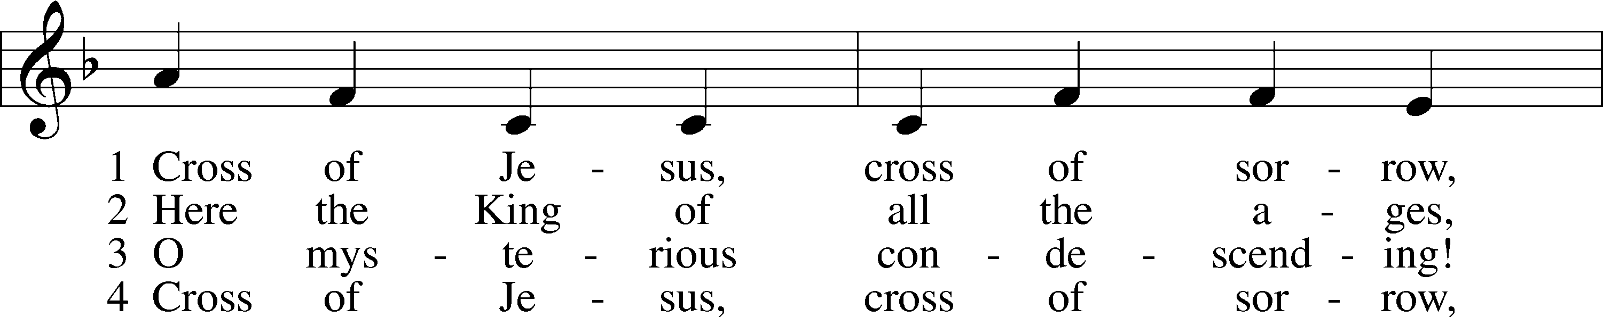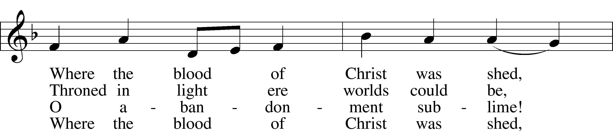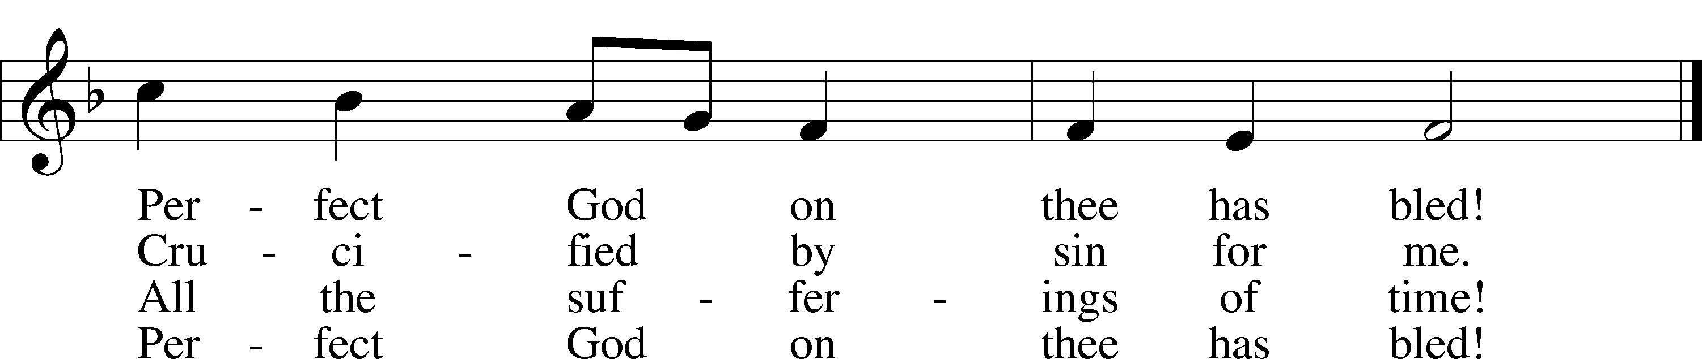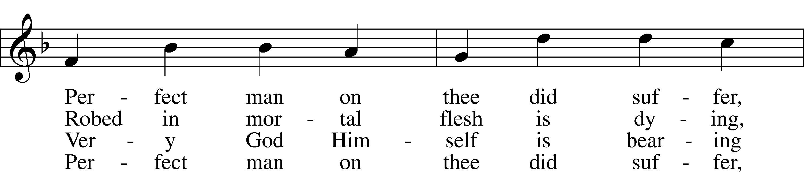

Public domain

Public Domain

***“Precious Lord, Take My Hand”* LSB 739**

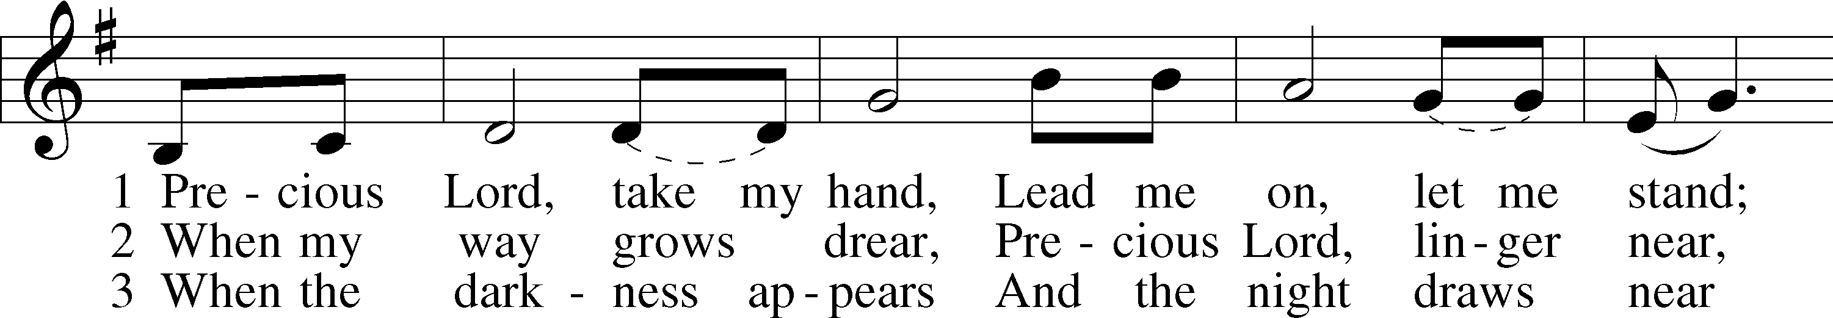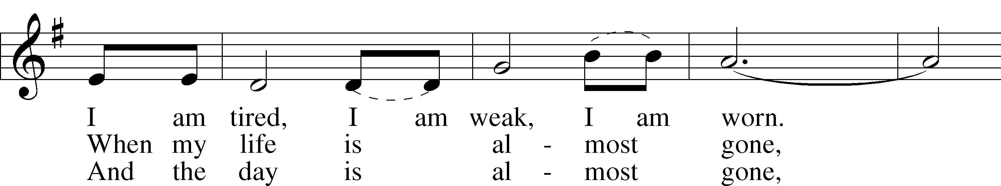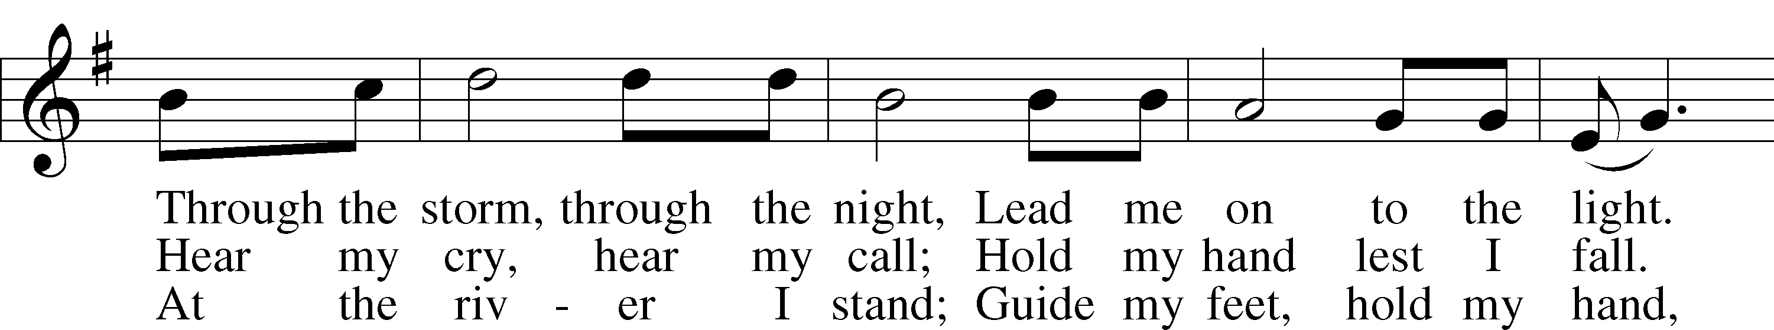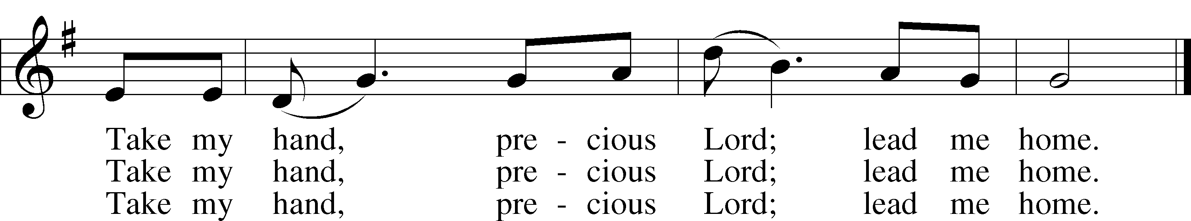

© 1938 Warner-Tamerlane Publishing Corp.; admin. Alfred Music. Used by permission: LSB Hymn License .NET, no. 100011641.

***“The Church's One Foundation”* LSB 644**

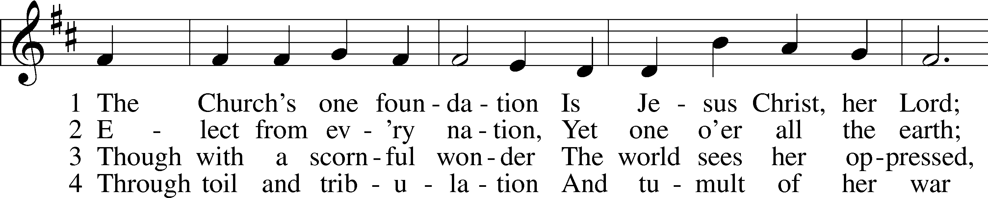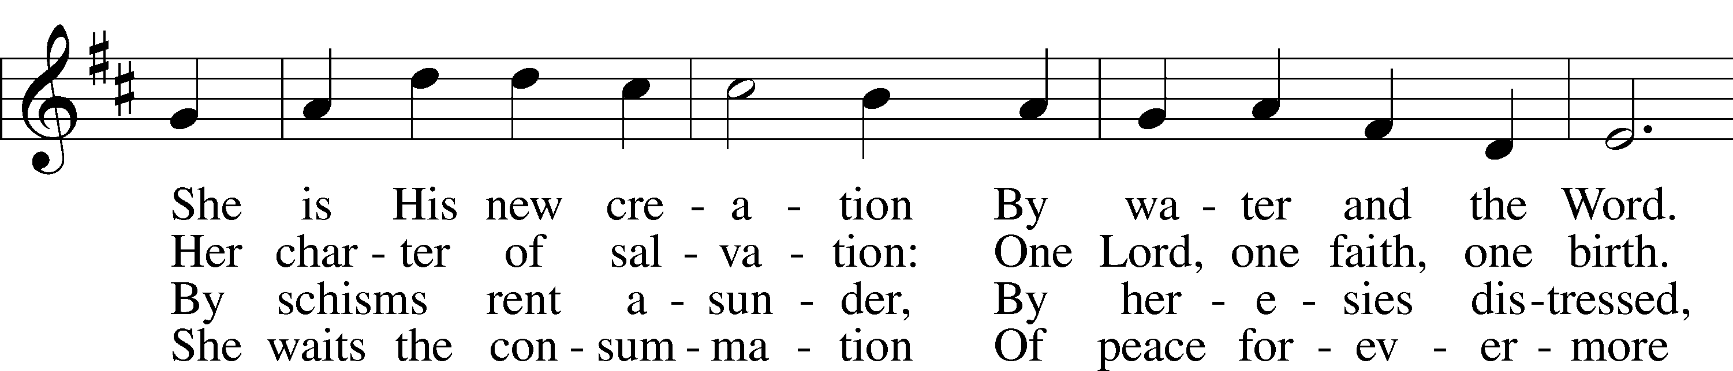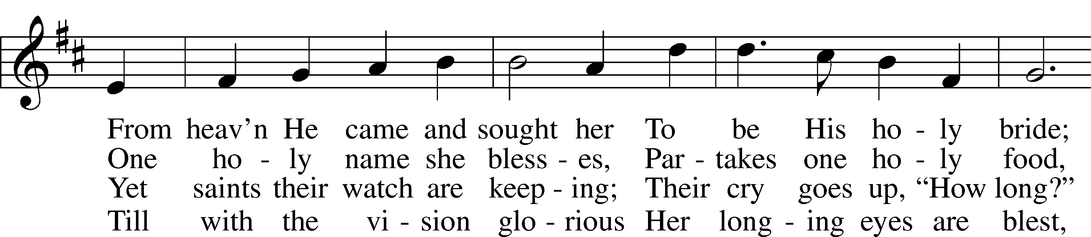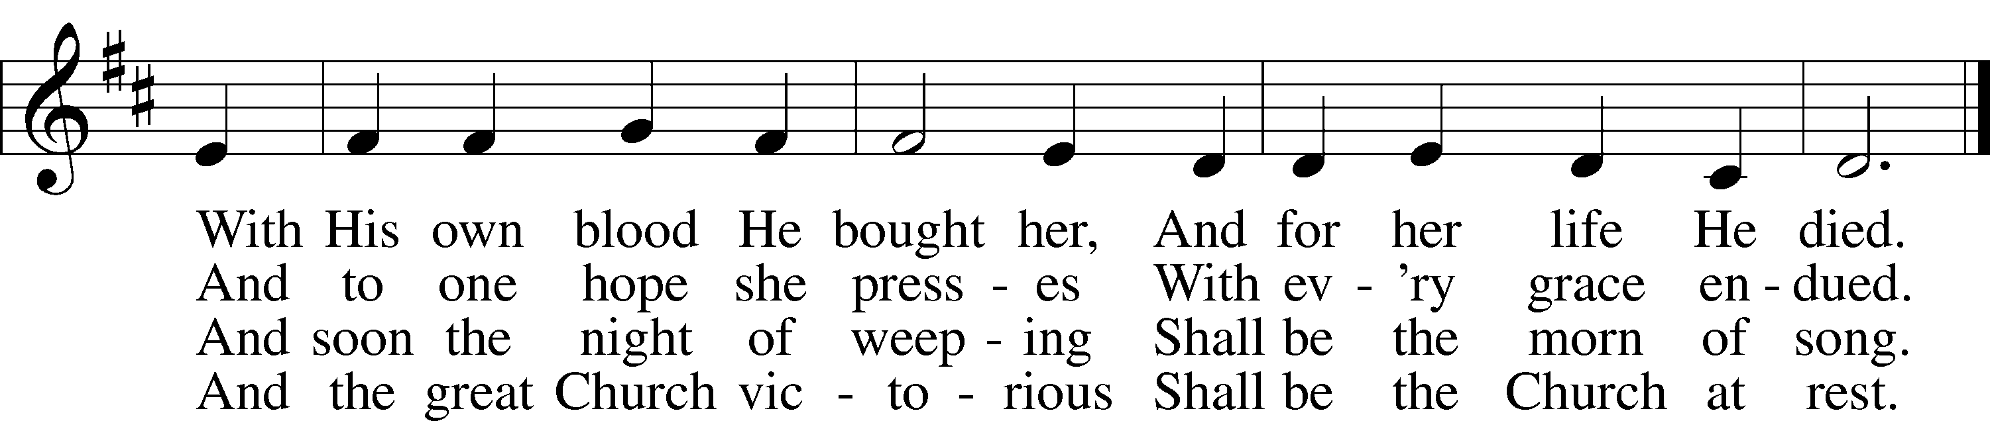

5 Yet she on earth has union  
 With God, the Three in One,  
And mystic sweet communion  
 With those whose rest is won.  
O blessèd heav’nly chorus!  
 Lord, save us by Your grace  
That we, like saints before us,  
 May see You face to face.

Public domain

*(Please stand…)*

**THE LORD’S PRAYER:**

**All: Our Father, who art in heaven, hallowed be thy name, thy kingdom come, thy will be done, on earth as it is in heaven. Give us this day our daily bread; and forgive us our trespasses as we forgive those who trespass against us; and lead us not into temptation, but deliver us from evil. For thine is the kingdom, and the power, and the glory, forever and ever. Amen**

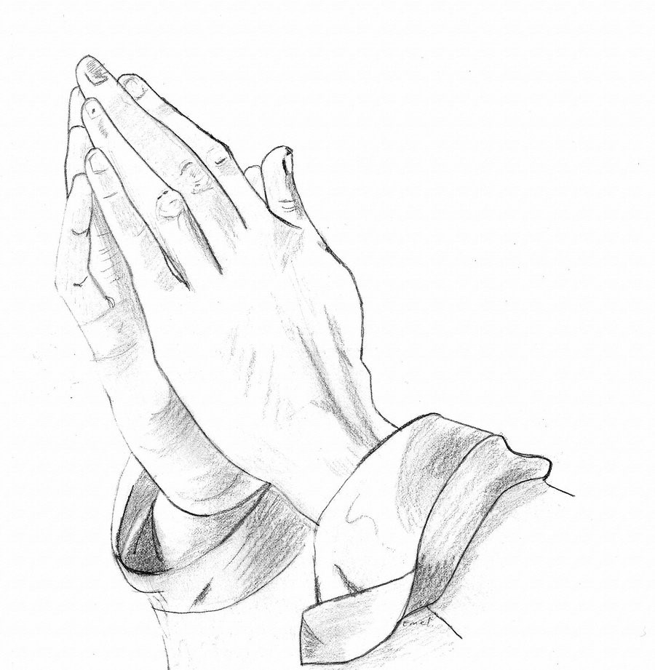

**THE BENEDICTION**

Jesus let the things that break your heart also break our hearts. Amen

**THE CLOSING HYMN: *“Built on the Rock”*  LSB 645**

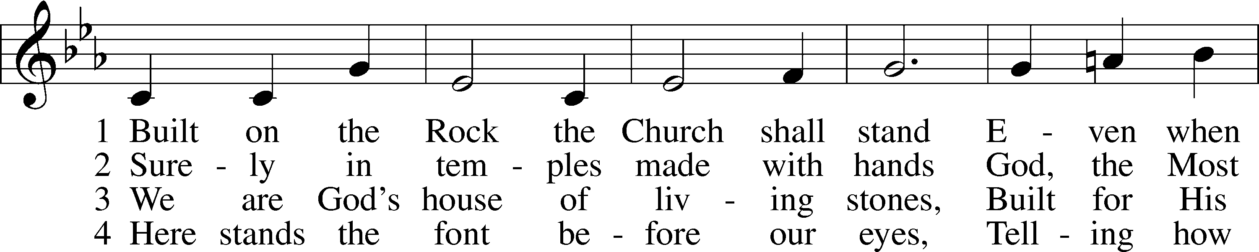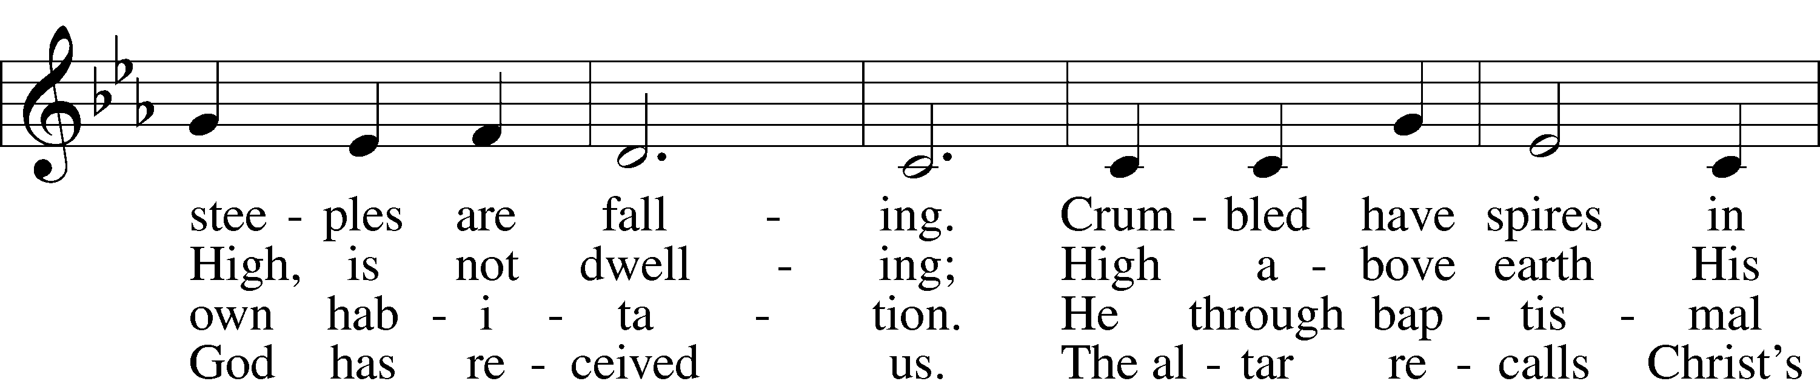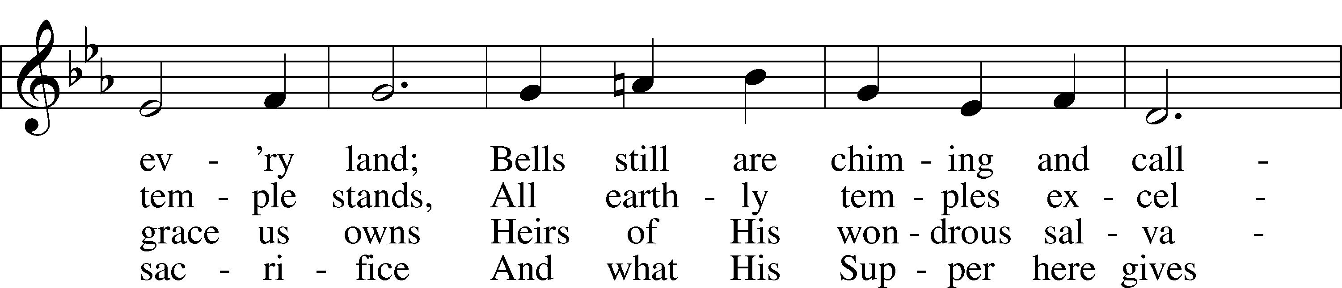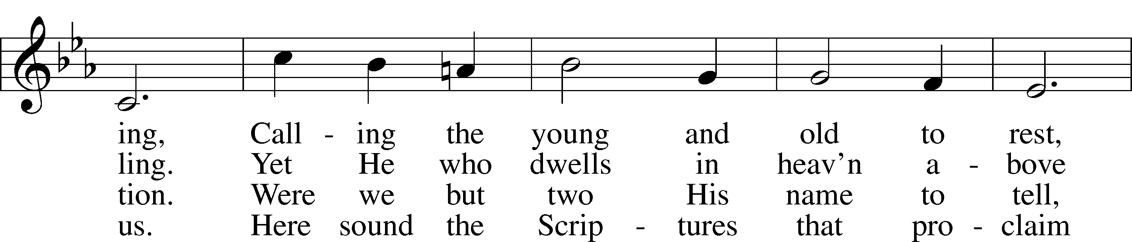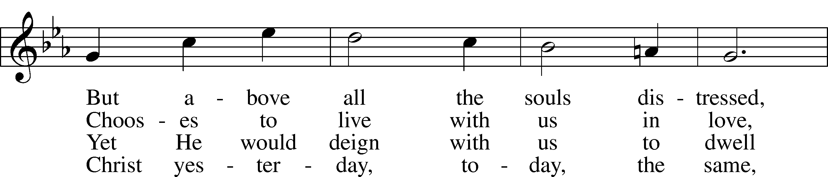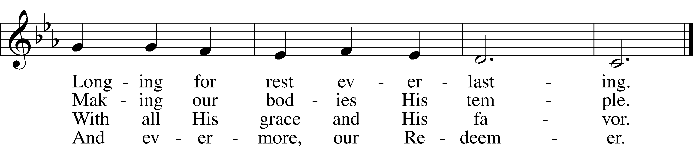

5 Grant, then, O God, Your will be done,  
 That, when the church bells are ringing,  
Many in saving faith may come  
 Where Christ His message is bringing:  
“I know My own; My own know Me.  
You, not the world, My face shall see.  
 My peace I leave with you. Amen.”

Public domain

**POSTLUDE: *“Thy Strong Word”* John Behnke**



**WELCOME TO GRACE LUTHERAN CHURCH:** We are glad that you are here to worship God with us today! We pray that you will enjoy the wonderful fellowship as friends in Christ as God gathers us around His means of grace, the Word and Sacraments, to bless us with His treasured gifts of forgiveness, faith, abundant life and eternal salvation. If you are a guest, please also sign our Guest Book. Please talk to Pastor if you would like **to learn more about becoming a member of Grace. Also, please join us for refreshments** and fellowship after the Service. We invite you to come and worship with us often as God gathers us in His Grace.

**WELCOME TO THE LORD’S TABLE:** We invite and encourage all present who are baptized and faithful Christians, and who confess the Father, Son, and Holy Spirit to be the only true God and who believe that Jesus Christ died for the sins of the World and is our only hope and salvation…to join us in receiving the very and true body and blood of Christ in this Sacrament. The clear liquid cups in the center of the tray are non-alcoholic wine.

Children not yet confirmed in the faith are always welcome to join their parents at the Lord’s Table but should keep their hands folded in front of them. The Pastor will give them a blessing.

**SERVING TODAY:** Acolyte: James Reynolds; Lector: Mary Brady: Communion Assistants: Gene Schlundt and David Walker; Usher: Ed Morris; Altar Care: ___________; Refreshments: The Novak’s.

**SERVING NEXT SUNDAY:** Acolyte: James Reynolds; Lector: Mary Brady; Communion Assistants: Gene Schlundt and David Walker; Usher: Ed Morris;

Altar Care: _________; Refreshments: ________________.

**FLOWERS**: were placed on the altar to the glory of God by Pickings to celebrate Alyssa’s birthday.

THIS WEEK AT A GLANCE:

**Today: March 4th**

9:00 am Worship Service with Communion

10:10 am Jr. Choir Rehearsal

10:15 am          Fellowship

10:30 am Adult Bible Class / Youth Bible Class

**Monday: March 5th**

Pastor’s Day Off

**Tuesday: March 6th**

2:30 pm Jan’s Mobile Gym (Parish Hall)

6:00 pm Weight Watcher’s (Parish Hall)

**Wednesday: March 7th**

12:30 pm Men’s Bible Fellowship (Chico’s)

6:00 pm Potluck Dinner

7:00 pm Lenten Service

**Thursday: March 8th**

2:30 pm Jan’s Mobile Gym (Parish Hall)

4:15 pm Missional Communities (Room 3)

5:45 pm Handbell Choir Rehearsal

6:30 pm Vocal Choir Rehearsal

6:00 pm Book Club (Yacht Club)

**Friday: March 9th**

4:00 pm Touching the Neighborhood with Grace (Pastors Front Yard)

**Next Sunday: March 11th**

9:00 am Worship Service with Communion

10:10 am Jr. Choir Rehearsal

10:15 am          Fellowship

10:30 am Adult Bible Class / Youth Bible Class

**IN YOUR PRAYERS THIS WEEK:** Anna Shuler, Sally Cavanaugh, Larry Cavanaugh, Angie Rose, Alhadeff family, Lyla May, Madison Howard, Westin Family, Cressie, Todd Brabandt, Rita Kemp, Beth, Becky, Billy, Mary Payne, Brittany Howard, Skip Nicholas, Jim Prahst, Michael Willard, Micah Westphalen, Joe Mercurio, Walt Lepperd Rachel Hoppe, Dennis Julson, Alga Odland, Sandra Chrisman, Vernon Julson, Beverly Walker, Ann Barber, Al Schubert, Mary Eschels, Max Broadbent, Peggy Mira, Bud Wrocklage, and those you are praying for at home. If anyone has a special prayer request please submit it in writing in the collection plate; or you may call Pastor Gary Faith at (504-858-8872), or Kris Howard at (305-296-5161).

**GIFTS, TITHES, & ATTENDANCE LAST SUNDAY**: Sunday, February 25th received $4297.96, building fund received $300.00, and the noise offering received $54.26 with an attendance of 85. Wednesday, February 28th received $309.00 with an attendance of 27.

**TO HELP US GROW…** The Bible reading for next Sunday’s service are Numbers 21:4-9, Ephesians 2:1-10, and John 3:14-21.

**OUR LENTEN JOURNEY HAS BEGUN** Once again, we will have potlucks at 6:00 pm and worship at 7:00 pm. This year we will be looking at Psalms and growing in our appreciation of the gifts of prayer.

March 7th Psalm 3

March 14th Psalm 34

March 21st Psalm 16

March 28th Maundy Thursday Psalm 22 (Communion)

March 29th Good Friday Psalm 46 (Tenebrae)

When we make the time to walk the Lenten journey with Jesus, Easter is a more joy filled day.

**HOLY WEEK SCHEDULE**

March 29th Maundy Thursday with Communion 7:00 pm

March 30th Good Friday Tenebrae Service 7:00 pm

April 1st Easter Sonrise Service 6:45 am (church parking lot)

Fellowship and refreshments to follow

Easter Worship Service 9:00 am (in the church sanctuary)

Touch the Neighborhood with Grace Brunch 10:30 am

**REMINDER:** Don’t forget to set your clocks ahead 1 hour on Saturday. Daylight savings time begins Sunday March 11.

**OUR FIRST PHONE CONFERENCE CALL WITH PASTOR GREG FINKE** is scheduled for noon on March 22nd. Everyone is welcome to dial in from wherever they are and listen, share, and grow. We will give you a # to dial when the day approaches.

**IF YOU ARE INTERESTED IN LEARNING** more about what we believe and teach and/or are interested in becoming a member of Grace Please let Pastor know so that he can begin an Adult Information class.

**FUNDS NEEDED** The remainder of the church windows that need to be replaced will be installed in January. We have two donors but will need additional funds to complete the much needed and long-awaited project. The cost of each window is $2700 and 3 out of 13 still need to be funded. Checks can be made out to Grace Lutheran Church and earmarked "windows". Thank you for your consideration.

**THANKS TO ALL OF YOU** for helping your neighbor, listening to others, and being a blessing to the community and to GLCS.

**THERE IS ADDITIONAL PARKING** behind the school. Enter that lot on 10th Street.

**WE HAVE SET THE SCHEDULES** for ushers, acolytes, lectors, and communion assistants for the next three months. If you would like to serve in any of these positions, please let Pastor or Kris know.

**THE GRACE LUTHERAN CHURCH WEB PAGE AND FACE BOOK PAGE** now

contains a vocal recording of last week’s sermon. So, if you are not able to attend church on Sunday please go to our website where you will find a copy of the bulletin and a recording of Pastor Faith’s sermon. <https://gracelutherankw.360unite.com/home>.

**STEWARDSHIP LISTS:** On the bulletin board by the front door of the church you will find the Altar Care, Refreshments, and Flower sign-up sheets **for 2018**. If you are able to help out with any of these please place your name in the spot on the date requested.

**SAVE THE DATE AND MARK ON YOUR CALENDAR**

**GRACIOUS LADIES OF GRACE**: After many reschedules, we finally made it to the Turtle Kraals for lunch.  The weather was perfect, food was good, and the waitperson was very attentive and didn't mind all the separate checks and we got a 30% discount on top of it.  We had 13 ladies and one well behaved little gentleman who enjoyed viewing the harbor with all the yachts and boats docked in front of us.  Our next venture will be happening at Spencer's at the Reach Resort on March 13th 11:30am.

**TOUCHING THE NEIGHBORHOOD WITH GRACE**. We will again be passing out hotdogs on Staples Ave on Friday, March 9th starting at 4pm. Anyone is welcome to join us.



**MUSIC MINISTRY:** "Make a joyful noise to the Lord, all the earth!" Psalm 100:1. Whether you are here year-round or part-time, we invite you to participate in our music ministry. Please speak with Beverly Walker or contact her at beverlywalker@gmail.com

if you have any questions.

Jr. Choir (Grades 2-8): Rehearsal today from 10:10-10:25 by the piano.

Bell Choir: Rehearsal this Thursday from 5:45 - 6:30 pm.

Vocal Choir: Rehearsal this Thursday from 6:30 – 7:30.



**MEN’S BIBLE FELLOWSHIP**: They meet the first and third Wednesday’s of each month at 12:30pm. Their next meeting will be March 7th located at Chico’s on Stock Island. All guys are welcome.

**MISSIONAL COMMUNITIES** will meet this week on Thursday March 2nd at 4:15 pm in room 3. Come and see what Jesus is up to.

**LADIES BIBLE STUDY:** Are there any ladies who would be interested in having a lunchtime study twice a month?  Suggestions include brown bagging or order out lunch in Parish Hall or rm 3. We are open to more suggestions and thoughts on what you might like.  Please contact Monica @305 923-0856 or mimibacle@hotmail.com