December 31st, 2017
9:00 am

FIRST SUNDAY
AFTER
CHRISTMAS

Grace Lutheran Church
2713 Flagler Ave.
Key West, FL 33040
305-296-5161
GraceLutheranKW@att.net
Pastor Faith
(504) 858-8872
garyfaith@aol.com
FIRST SUNDAY AFTER CHRISTMAS
December 31st, 2017 9:00 a.m.
WORSHIP SERVICE
In the Name of Jesus!
Our Mission Statement: Anchored in Christ, each person a missionary.

PRELUDE: “Now Sing We Now Rejoice” Theodore Beck

ANNOUNCEMENTS: We welcome you. We are glad you are here to share with us the joy and peace we have in Jesus Christ. It doesn’t matter whether this is your first time in this church or if you are a lifelong member, you are welcome. We come together today in order to celebrate the gift God has given us-His own Son, Jesus, Our Savior.

PREPARATION

(Please Stand…)
HYMN: “Now Sing We, Now Rejoice” LSB 386
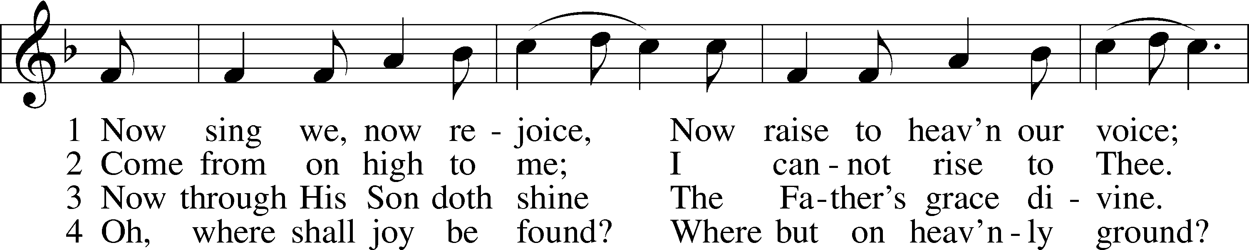
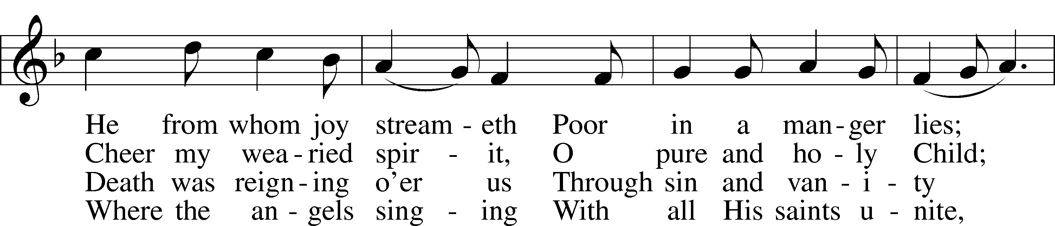
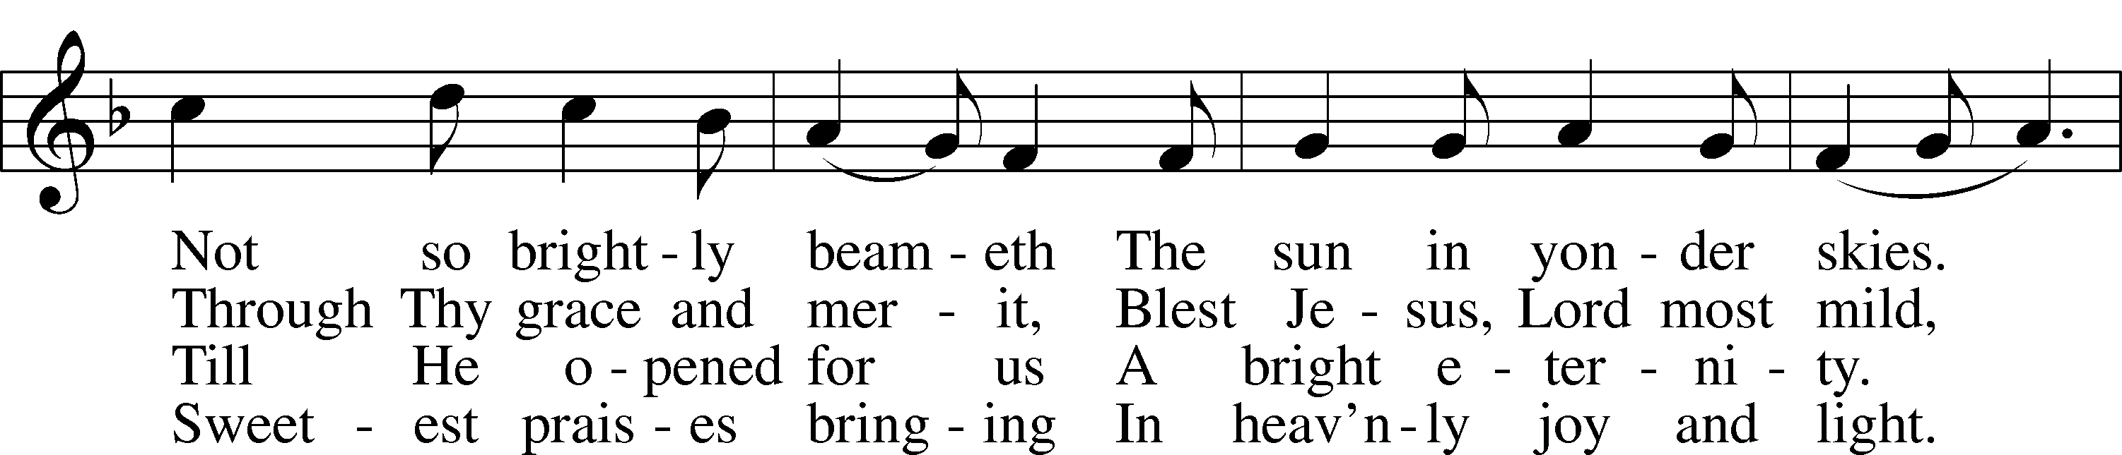
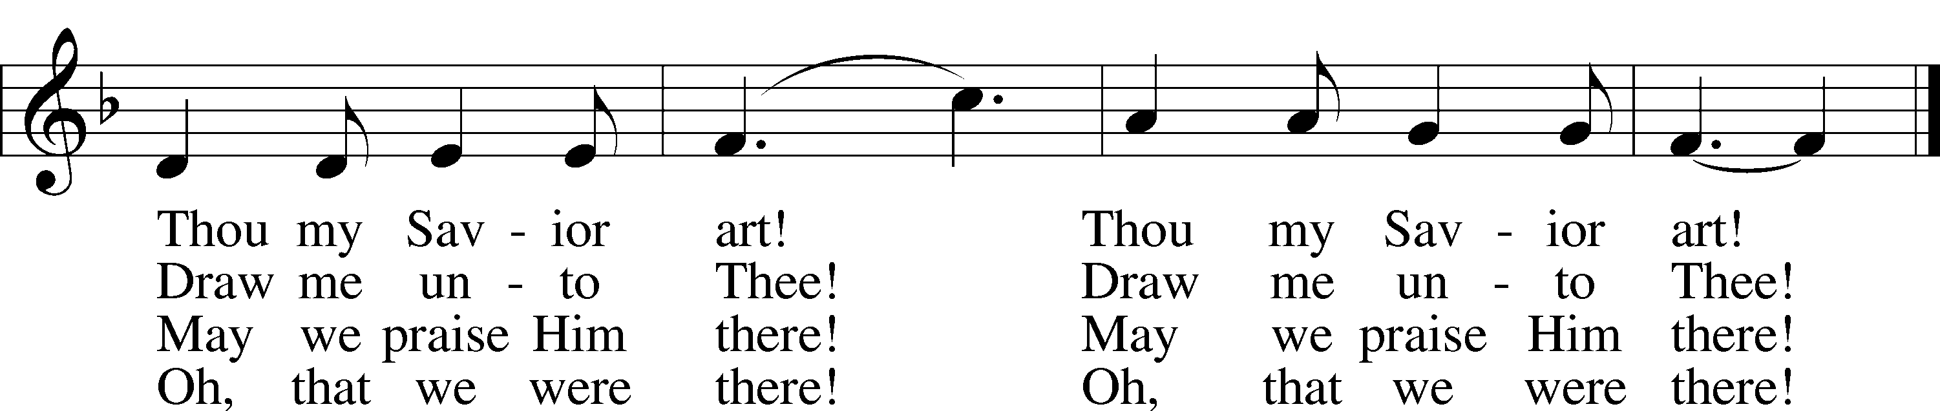
Public domain

Pastor: In the Name of the Father and of the Son and Holy Spirit.
Congregation: Amen.

(Please Remain Standing Or You May Kneel…)
GOD’S PEOPLE CONFESS THEIR SINS:
Pastor: By grace you have been saved, through faith-and this is not from yourselves, it is the gift of God-not of works, so that no man can boast, for we are God’s workmanship, created in Christ Jesus.
Congregation: I know that nothing good lives in me, that is, in my sinful nature, for I have the desire to do what is good, but I cannot carry it out.
Pastor: What I do is not the good I want to do; no, the evil I do not want to do-this I keep doing.
Congregation: In my heart I delight in God’s law, the law that points out what a wretched person I am! Who will rescue me from this body of death?
Pastor: Thanks be to God through Jesus Christ our Lord! Only He can achieve the perfection we fail to achieve. By the forgiveness He purchased on the cross, our forgiveness is complete!

SERVICE OF THE WORD

You may be seated…
THE OLD TESTAMENT READING: Isaiah 61:10-62:3
Lector: This is the Word of the Lord.
People: Thanks be to God.

THE EPISTLE LESSON: Galatians 4:4-7
Lector: This is the Word of the Lord.
People: Thanks be to God.

Please stand…
THE HOLY GOSPEL: Luke 2:22-40
Pastor: The Holy Gospel according to St. Luke the 2nd Chapter
People: Glory to You, O Lord.
Pastor: This is the Gospel of the Lord.
People: Praise to You, O Christ!

CHILDREN’S MESSAGE

NOISE OFFERING: It’s called a noise offering because what we are asking for is pocket change. It will always be used for missions outside of our church and school. It normally also is given to a mission involving children. Thanks for making a joyful noise to the Lord.

Please be seated…
THE SERMON HYMN: “Let Us All with Gladsome Voice” LSB 390
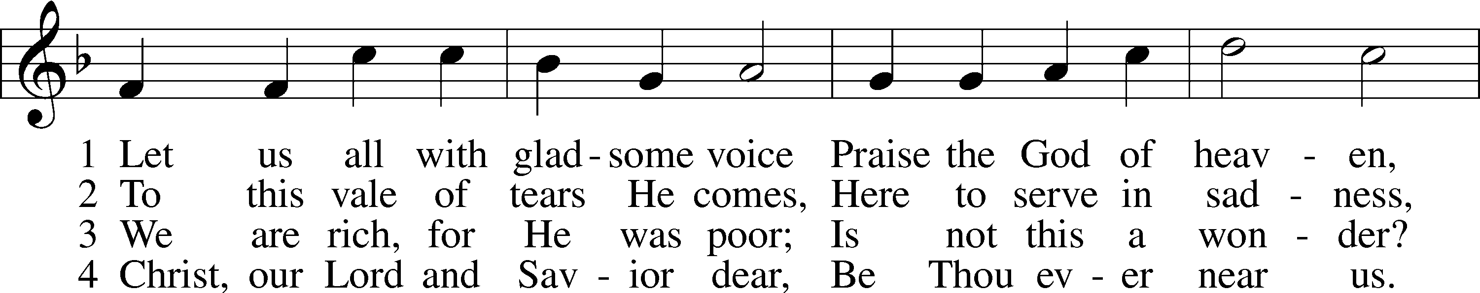
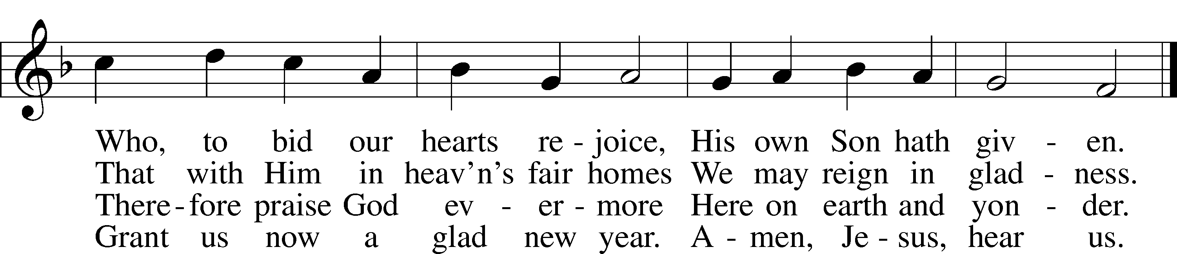
Public domain

SERMON: “There’s More To It” Luke 2:22-40

THE PROFESSION OF FAITH:
Pastor: God has given us a great message to take to His world. Let us remind ourselves and one another of what that message is:
Pastor: I believe in God the Father, Almighty
Congregation: Maker of heaven and earth
Pastor: And in His Son, Jesus Christ our Lord,
Congregation: Who was conceived by the Holy Spirit
Pastor: Born of the Virgin Mary
Congregation: Suffered under Pontius Pilate
Pastor: Was crucified, died and was buried
Congregation: He descended into hell.
Pastor: On the third day He rose again from the dead,
Congregation: And ascended into heaven
Pastor: And sits on the right hand of God, the Father almighty
Congregation: From there He will come to judge the living and the dead
Pastor: I believe in the Holy Spirit,
Congregation: The Holy Christian Church as
All: the communion of saints; the forgiveness of sins, the resurrection of the body, and the life everlasting. Amen.

(You may be seated…)
OFFERING RECEIVED: “Gentle Mary,Laid Her Child" Paul Manz

“Praise God, from Whom All Blessings Flow” LSB 805
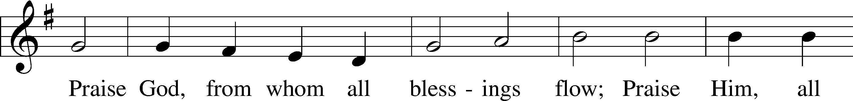
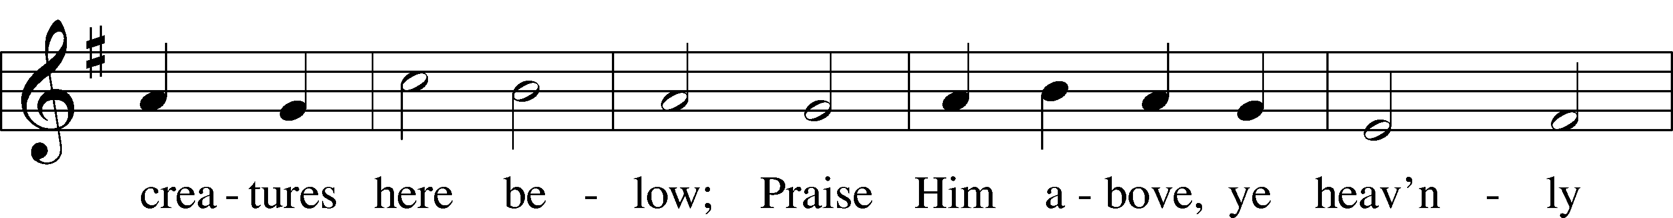
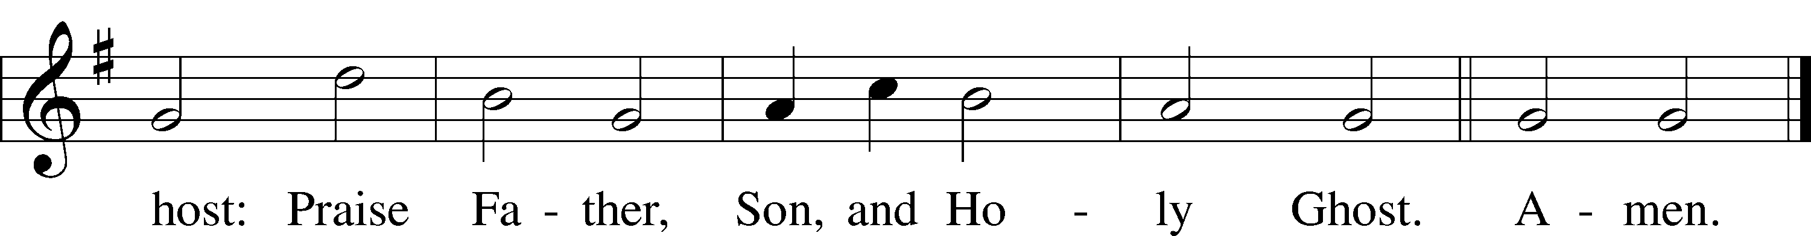
Public domain

(Please stand…)
THE PRAYERS OF THE CHURCH: based on Psalm 98
Pastor: Dear Lord, we thank You for everything You’ve done for us, and most of all for Your own Son, Jesus, our Savior. We will never stop praising You for this wonderful gift.
Congregation: Sing to the Lord a new song, for He has done marvelous things; His right hand and His holy arm have worked salvation for Him.
Pastor: We thank You for those missionaries long ago who brought the Good News to our people. When we were in darkness, You sent men and women to bring us the light. Thank you, Lord.
Congregation: The Lord has made His salvation known and revealed His Righteousness to the nation.
Pastor: O Lord, You are our Savior, we trust in You for all our needs, give healing to the sick, courage to those who are afraid, and peace to those we name in our hearts either silently or out loud. (a moment of silence) We praise You, gracious Lord, for all Your benefits to us. You give us home, friends and family, food, shelter, rest and everything we need. You give us sight and hearing and touch and taste and provide for all of our needs.
Congregation: Shout for joy to the Lord, praise His Name Amen.

SERVICE OF THE SACRAMENT

(Please be seated…)
THE WORDS OF INSTITUTION:

DISTRIBUTION HYMNS: “Once in Royal David's City” LSB 376
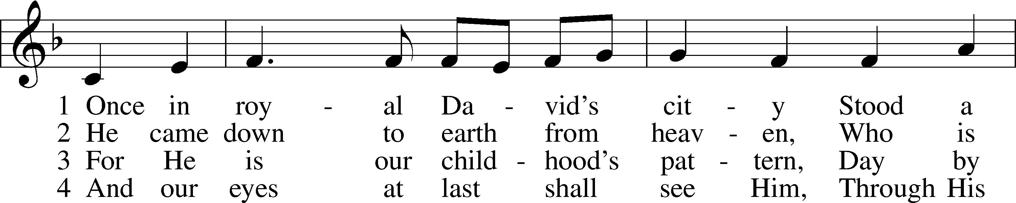
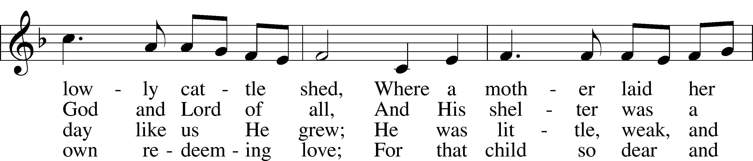
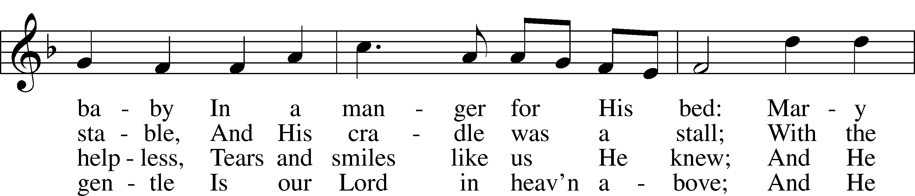
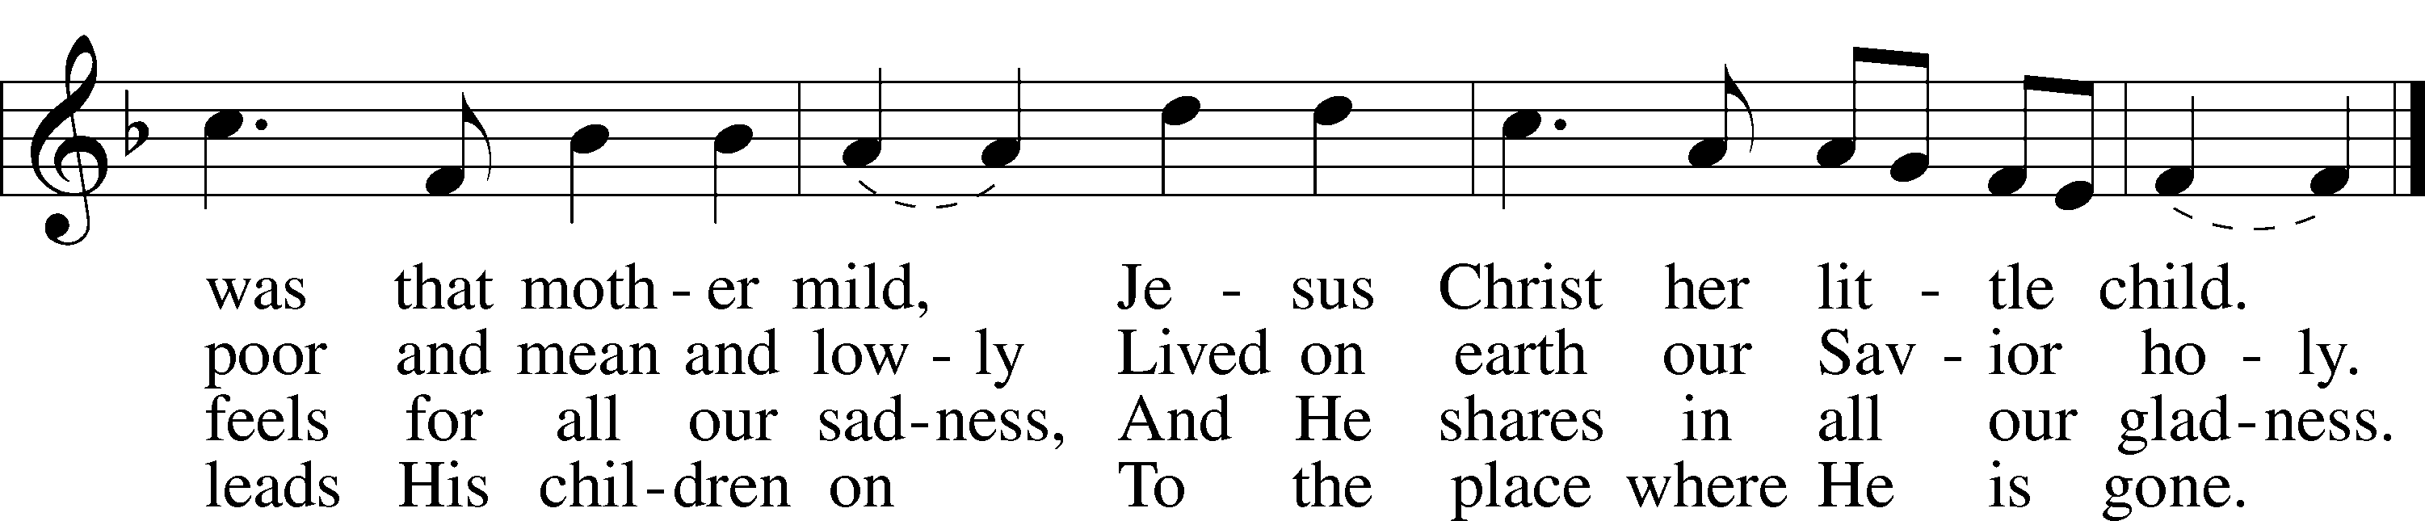

5 Not in that poor, lowly stable
With the oxen standing by
Shall we see Him, but in heaven,
Set at God’s right hand on high.
Then like stars His children, crowned,
All in white, His praise will sound!
Public domain

“What Child Is This” LSB 370
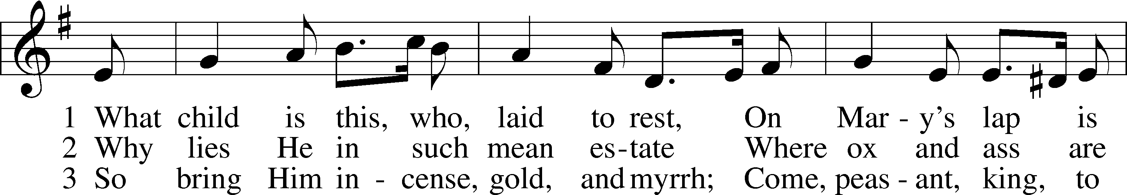
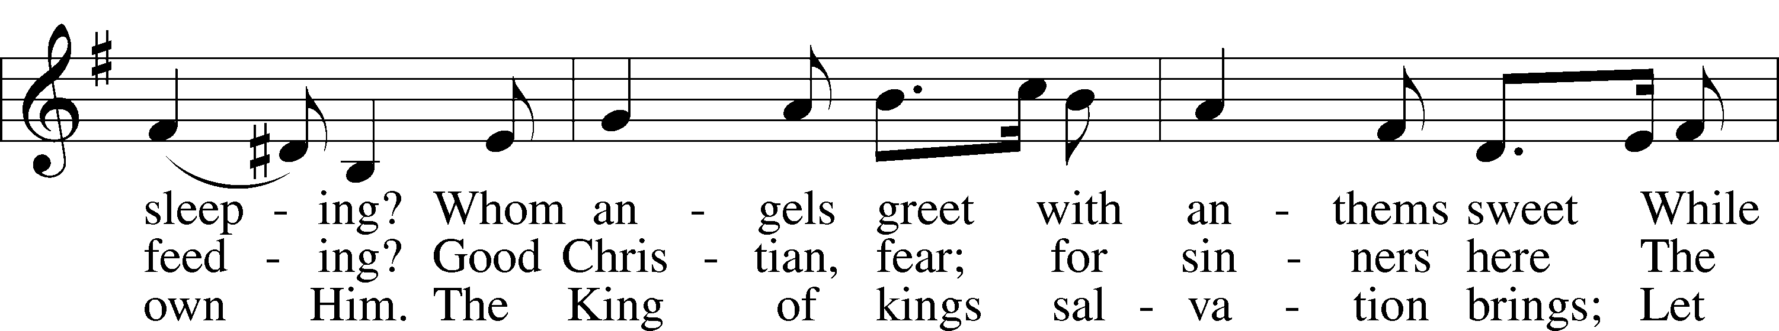
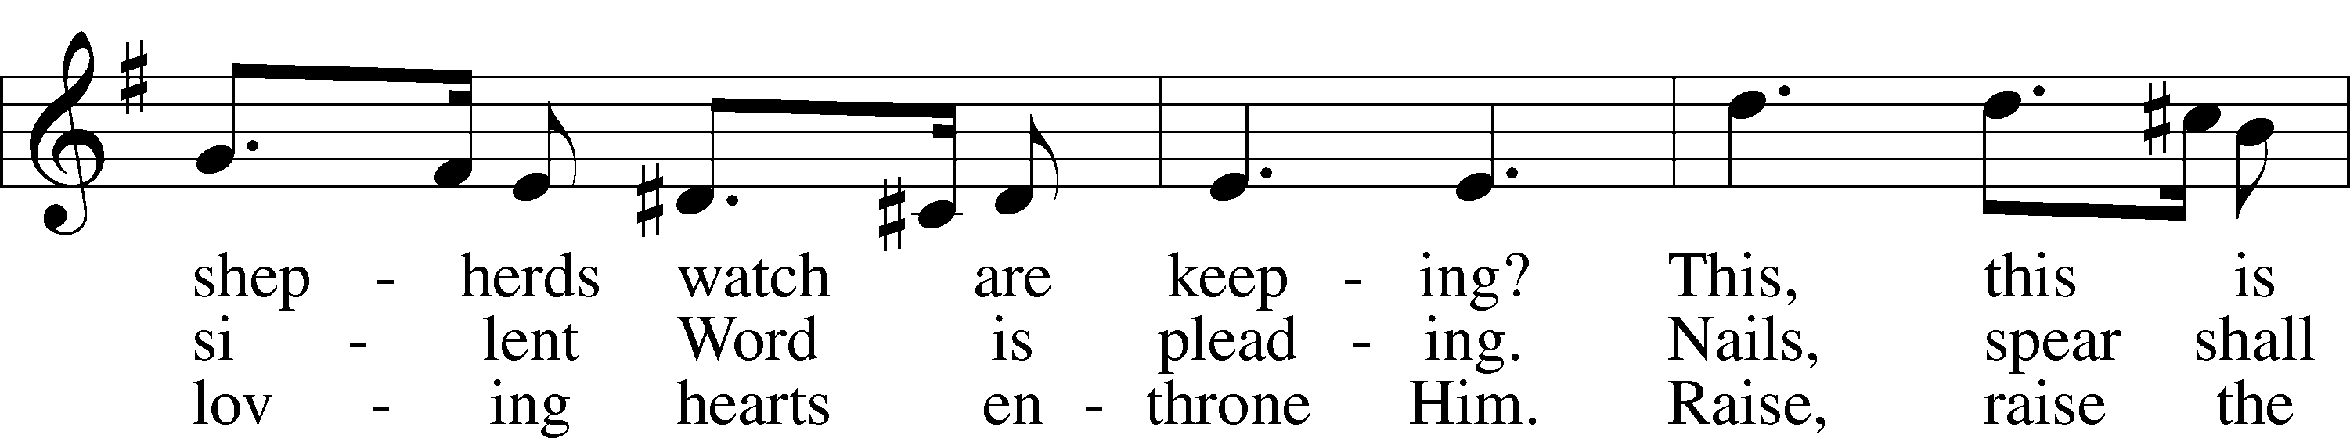
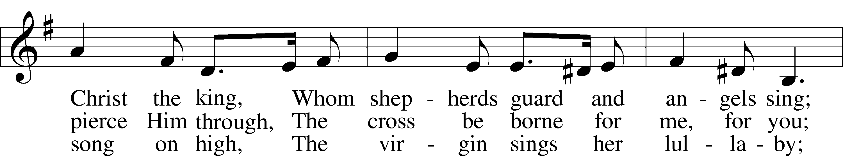
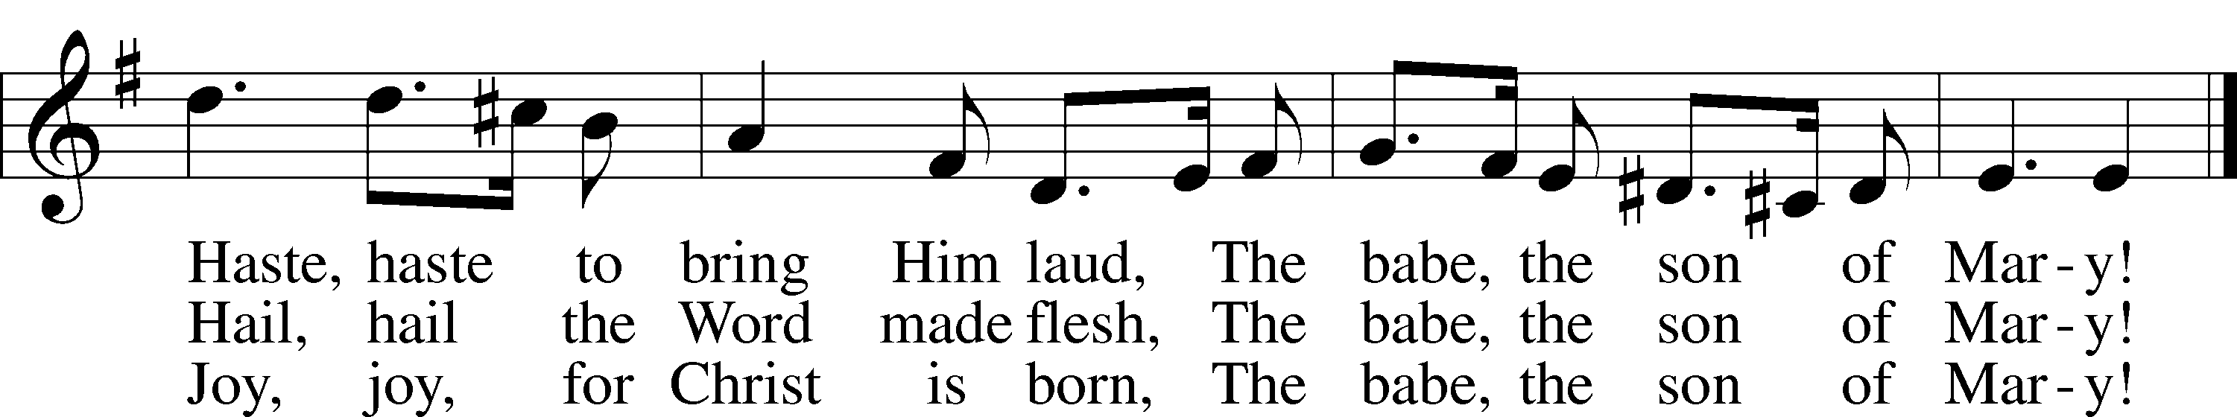
Public domain

“From Heaven Above to Earth I Come” LSB 358
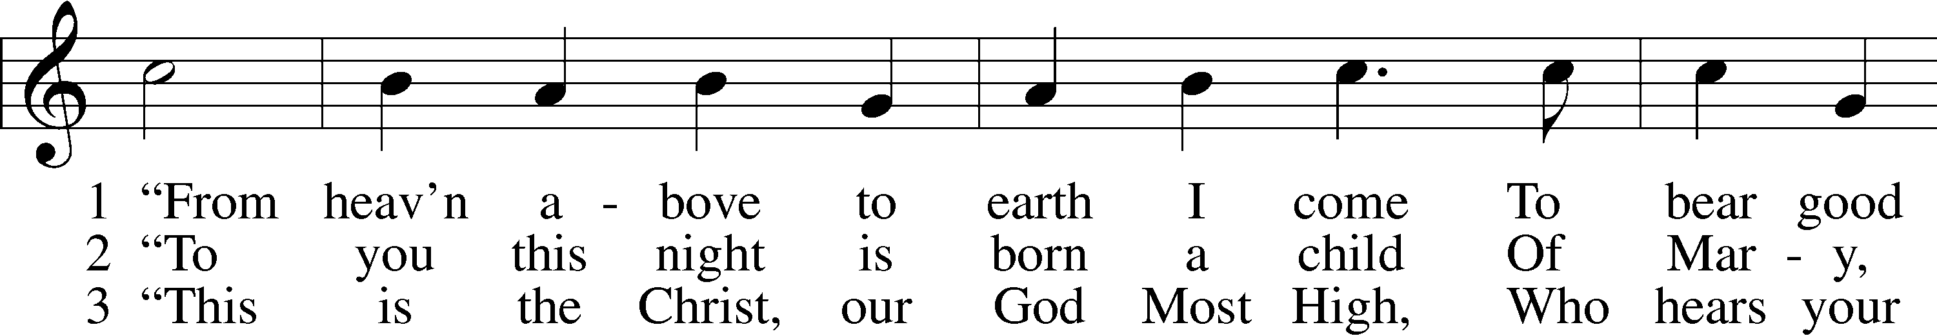
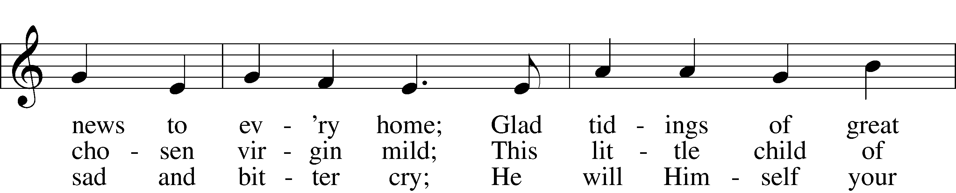
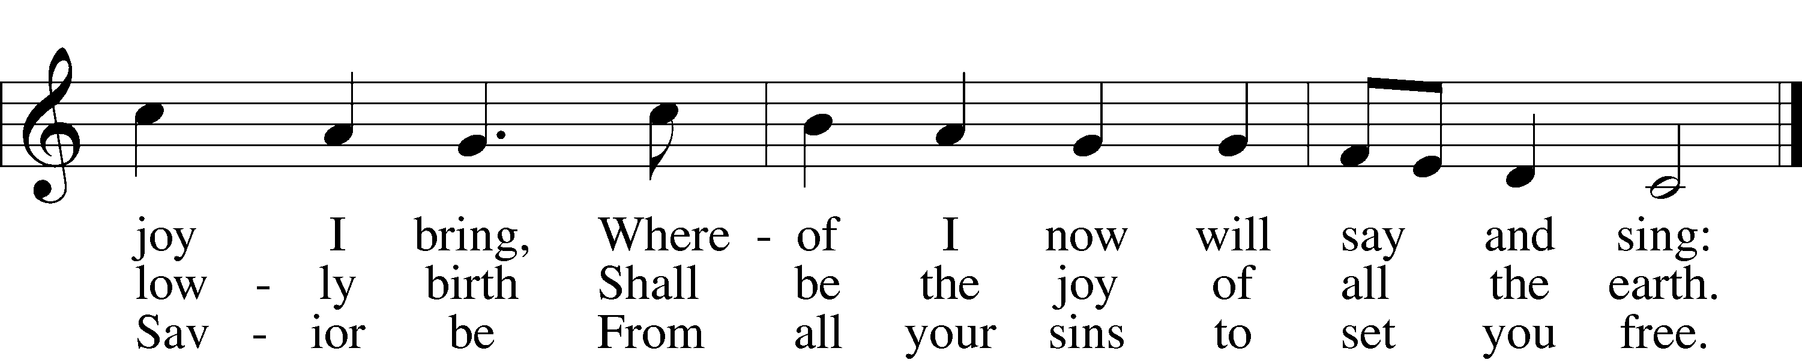

13 Ah, dearest Jesus, holy Child,
Prepare a bed, soft, undefiled,
A quiet chamber set apart
For You to dwell within my heart.

14 My heart for very joy must leap;
My lips no more can silence keep.
I, too, must sing with joyful tongue
That sweetest ancient cradlesong:

15 Glory to God in highest heav’n,
Who unto us His Son has giv’n!
While angels sing with pious mirth
A glad new year to all the earth.
Public domain

(Please stand…)
THE LORD’S PRAYER:
All: Our Father, who art in heaven, hallowed be thy name, thy kingdom come, thy will be done, on earth as it is in heaven. Give us this day our daily bread; and forgive us our trespasses as we forgive those who trespass against us; and lead us not into temptation, but deliver us from evil. For thine is the kingdom, and the power, and the glory, forever and ever. Amen

THE BENEDICTION

THE CLOSING HYMN: “Angels from the Realms of Glory” LSB 367
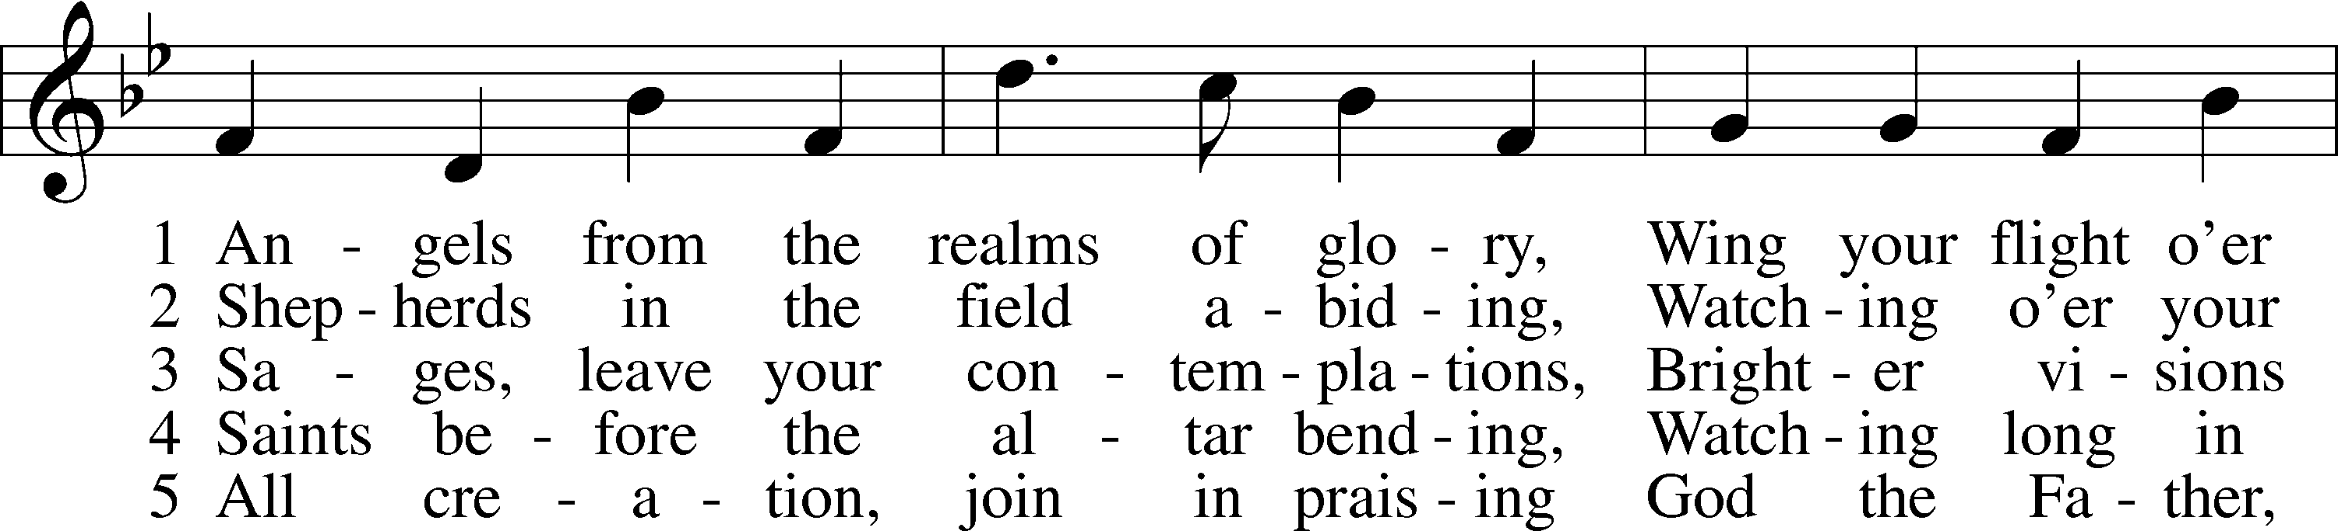
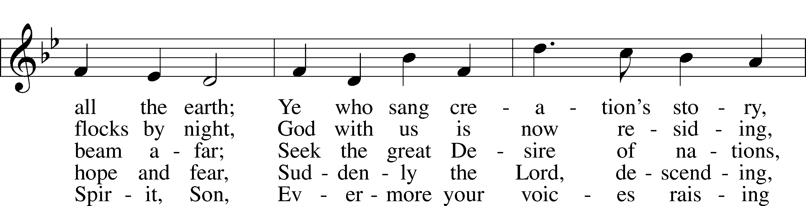
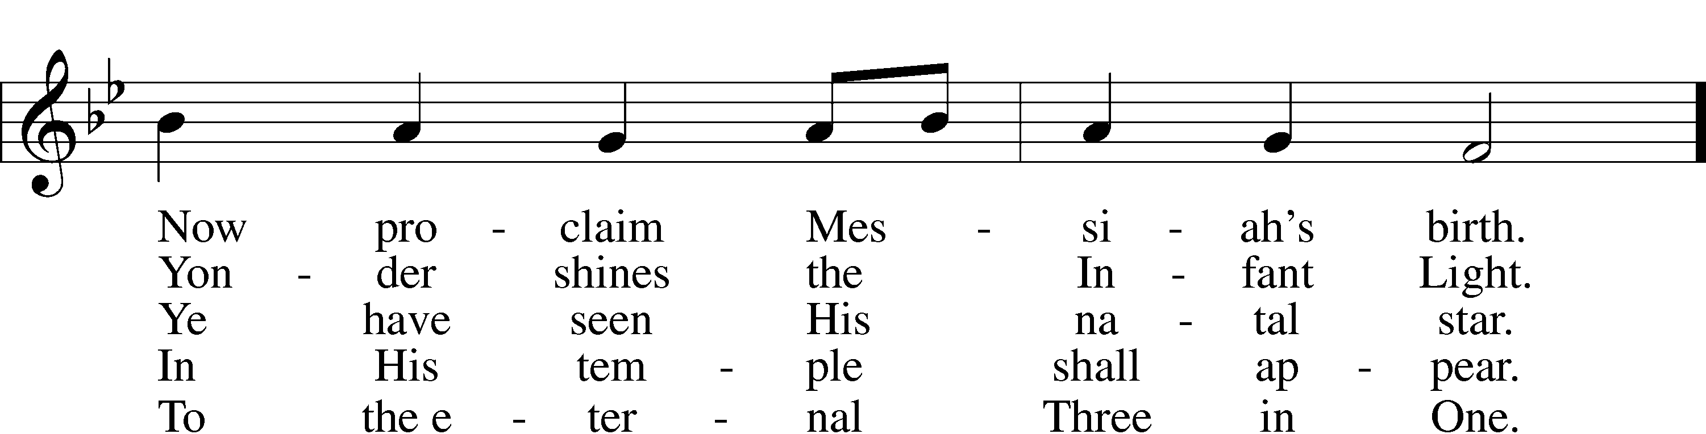
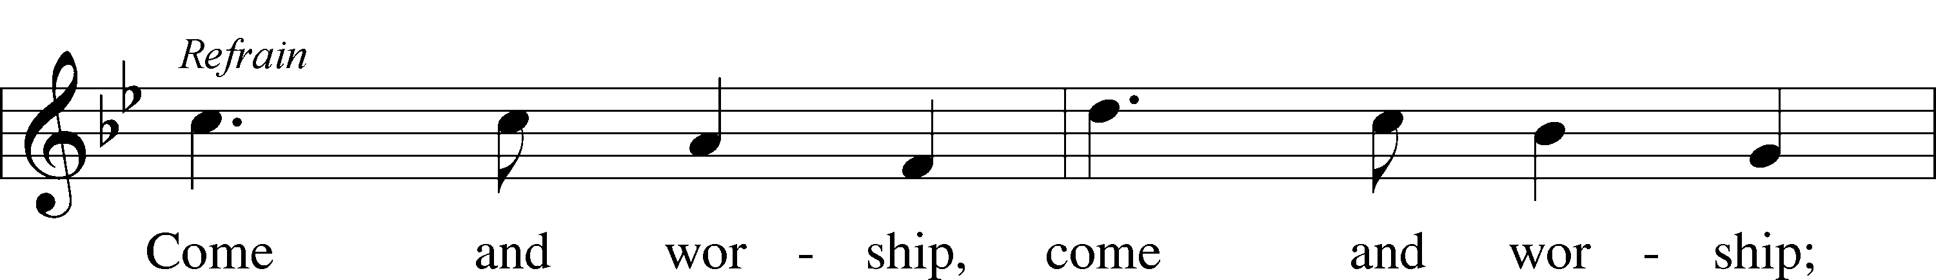
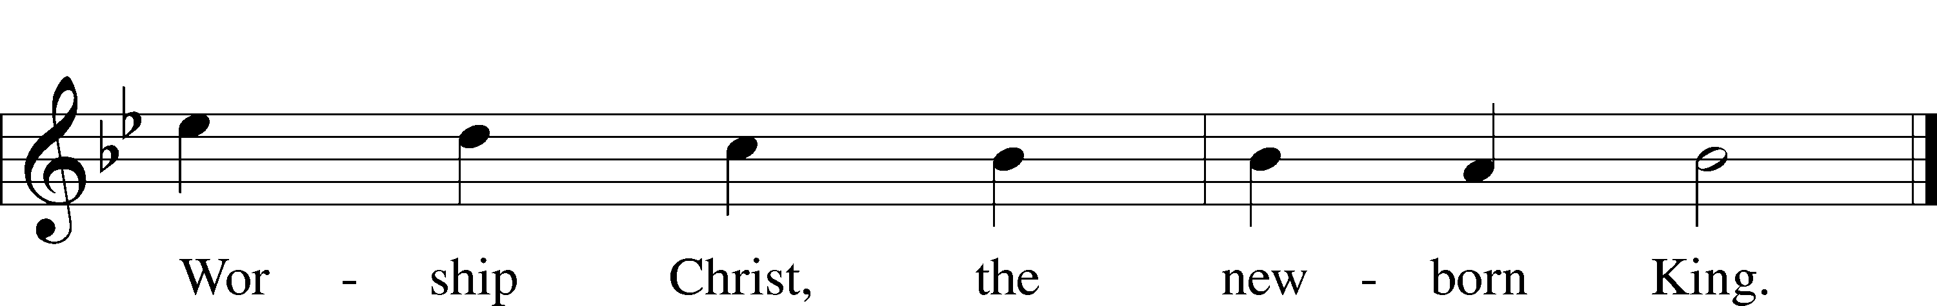
Public domain

POSTLUDE: “God Rest You Merry, Gentlemen” Alfred V.Fedak

WELCOME TO GRACE LUTHERAN CHURCH: We are glad that you are here to worship God with us today! We pray that you will enjoy the wonderful fellowship as friends in Christ as God gathers us around His means of grace, the Word and Sacraments, to bless us with His treasured gifts of forgiveness, faith, abundant life and eternal salvation. If you are a guest, please also sign our Guest Book. Please talk to Pastor if you would like to learn more about becoming a member of Grace. Also, please join us for refreshments and fellowship after the Service. We invite you to come and worship with us often as God gathers us in His Grace.

WELCOME TO THE LORD’S TABLE: We invite and encourage all present who are baptized and faithful Christians, and who confess the Father, Son, and Holy Spirit to be the only true God and who believe that Jesus Christ died for the sins of the World and is our only hope and salvation…to join us in receiving the very and true body and blood of Christ in this Sacrament. The clear liquid cups in the center of the tray are non-alcoholic wine.
Children not yet confirmed in the faith are always welcome to join their parents at the Lord’s Table, but should keep their hands folded in front of them. The Pastor will give them a blessing.

SERVING TODAY: Acolyte: Elizabeth Reynolds; Lector: Monica Bacle: Communion Assistants: David Walker and Mary Brady; Usher: ________; Altar Care: ___________; Refreshments: The Stark Family.

SERVING NEXT SUNDAY: Acolyte: James Reynolds; Lector: Peter Bacle; Communion Assistants: David Walker and Mary Brady; Usher: Ed Morris; Altar Care: _________; Refreshments: _____________.

FLOWERS: were placed on the altar to the glory of God by Debbie and Mike Sattelmeier to celebrate, Mike’s mom, Kay’s 80th Birthday.

THIS WEEK AT A GLANCE:
Today: December 31st
9:00 am Worship Service with Communion
Immediately Fol. Vocal Choir Rehearsal
10:15 am Fellowship

Monday: January 1st
Happy New Years

Tuesday: January 2nd
11:30 pm Gracious Ladies of Grace Luncheon (Turtle Kraals)
6:00 pm Weight Watcher’s (Parish Hall)

Wednesday: January 3rd
12:30 pm Men’s Bible Fellowship (Chico’s)

Saturday: January 6th
10:00 am The Ungreening of the Church

Next Sunday: January 7th
9:00 am Worship Service with Communion
10:10 am Jr. Choir Rehearsal
10:15 am Fellowship
10:30 am Adult Bible Class / Youth Bible Classes

IN YOUR PRAYERS THIS WEEK: Sue Ellen, Jim Prahst, Michael Willard, family of Jim and Gerrie Parker, Micah Westphalen, Joe Mercurio, Walt Lepperd Rachel Hoppe, Dennis Julson, Alga Odland, Sandra Chrisman, Vernon Julson, Brittany Howard, Beverly Walker, Ann Barber, Al and Kathleen Schubert, Mary Eschels, Max Broadbent, Peggy Mira, Bud Wrocklage, and those you are praying for at home. If anyone has a special prayer request please submit it in writing in the collection plate; or you may call Pastor Gary Faith at (504-858-8872), or Kris Howard at (305-296-5161).

GIFTS, TITHES, & ATTENDANCE LAST SUNDAY: Sunday December 24th received $7499.00, the building fund received $250.00 and the noise offering received $44.04 with an attendance of 72. The Children’s Service and Candlelight Service collected $2535.00 with an attendance of 127 at the Children’s Service and 56 at the Candlelight Service.

TO HELP US GROW… The Bible reading for next Sunday’s service are Genesis 1:1-5, Romans 6:1-11, and Mark 1:4-11.

DEB STARK AND HER FAMILY are here visiting today. She is a Director of Christian Education at St. john’s Lutheran Church in Midland Michigan. Under her leadership their Sunday School received $800 to help us with hurricane expenses. They will be presenting the check after the service and want to bless us with Michigan hotdogs (Koegel), Michigan potato chips, and Michigan soda pop. So if you can hang out for a bit please do.

THIS SATURDAY AT 10 AM: We will be taking down the Christmas decorations. If you have the time and the ability to help please come by. Any help is greatly appreciated.

THANK YOU FOR ALL OF THE CARDS, gifts, goodies, and kind words. We truly appreciate them and you. Pastor and Pattie.

STEWARDSHIP LISTS: On the bulletin board by the front door of the church you will find the Altar Care, Refreshments, and Flower sign-up sheets for 2018. If you are able to help out with any of these please place your name in the spot on the date requested.

2018 ENVELOPES ARE IN THE NARTHAX and your yearly tax statements will be mailed next week. Please pick up your envelopes when you have a chance. Thank you all.

FUNDS NEEDED The remainder of the church windows that need to be replaced will be installed in January. We have two donors but will need additional funds to complete the much needed and long-awaited project. The cost of each window is $2700 and 3 out of 13 still need to be funded. Checks can be made out to Grace Lutheran Church and earmarked "windows". Thank you for your consideration.

IF YOU ARE INTERESTED IN LEARNING more about what we believe and teach and/or are interested in becoming a member of Grace Please let Pastor know so that he can begin an Adult Information class.

THANKS TO ALL OF YOU for helping your neighbor, listening to others, and being a blessing to the community and to GLCS.

I HAVE A COUPLE OF COPIES of Pastor Finke’s book, “Joining Jesu on His Mission”. If you would like to get maximum results from Greg and Susan’s visit in January, you are welcome to borrow a copy. See Kris or Pastor.

THERE IS ADDITIONAL PARKING behind the school. Enter that lot on 10th Street.

WE HAVE SET THE SCHEDULES for ushers, acolytes, lectors, and communion assistants for the next three months. If you would like to serve in any of these positions, please let Pastor or Kris know.

THE GRACE LUTHERAN CHURCH WEB PAGE AND FACE BOOK PAGE now
contains a vocal recording of last week’s sermon. So, if you are not able to attend church on Sunday please go to our website where you will find a copy of the bulletin and a recording of Pastor Faith’s sermon. https://gracelutherankw.360unite.com/home.

SAVE THE DATE AND MARK ON YOUR CALENDAR

JANUARY 27TH, 2018: We plan on having the annual “Let’s Get to Know our Snowbird Friends Better” with Susan and Greg as our guests of honor.

JANUARY 28TH, 2018: Mark this day on your calendar. Pastor Greg Finke and his wife Susan are scheduled to join us for worship and training on how to be a neighborhood missionary. The Finke’s travel all over the country helping equip folks for everyday ministry. Don’t miss this opportunity or you will wonder why everyone is more excited about Jesus missing.

Twelve ladies attended our luncheon at Louie's Backyard which is one of a few restaurants on the ocean on that side of the island. I need not tell you how beautiful it was. We had a delightful waitperson and the food was the usual unusual gourmet fare. Never quite know what you’re going to get but that's the fun in it. We forgot to rate it but my guess is a 5*. Our next jaunt will be a new venue for the New Year the Turtle Kraals on Caroline St.. It has a fab view of the harbor and parking right in front. Please join us on Tue. January 2nd at 11:30.

MUSIC MINISTRY: "Make a joyful noise to the Lord, all the earth!" Psalm 100:1. Whether you are here year-round or part-time, we invite you to participate in our music ministry. Please speak with Beverly Walker or contact her at beverlywalker@gmail.com if you have any questions.

Jr. Choir: No rehearsal today.

Bell Choir: No rehearsal this Thursday. The next rehearsal will be Thursday, January 11 from 5:45 pm - 6:30.

Vocal Choir: Rehearsal immediately following the Service today. No rehearsal this Thursday. The next rehearsal will be Thursday, January 11 from 6:30 - 7:30 pm.

MEN’S BIBLE FELLOWSHIP: They meet the first and third Wednesday’s of each month at 12:30pm. Their next meeting will be January 3rd located at Chico’s on Stock Island. All guys are welcome.

MISSIONAL COMMUNITIES will begin meeting again on Thursday January 11th at 4:15 pm in room 3. Please come and see what the Lord has been up to.

