**January 7th, 2018**

**9:00 am**

**THE BAPTISM**

**OF OUR LORD**



**Grace Lutheran Church**

**2713 Flagler Ave.**

**Key West, FL 33040**

**305-296-5161**

**GraceLutheranKW@att.net**

**Pastor Faith**

**(504) 858-8872**

**garyfaith@aol.com**

**THE BAPTISM OF OUR LORD**

**JANUARY 7TH, 2018 9 a.m.**

**WORSHIP SERVICE**

***In the Name of Jesus!***

**Our Mission Statement: Anchored in Christ, each person a missionary.**

**ORGAN PRELUDE: *“O Morning Star, How Fair And Bright"* Michael Burkhardt**

**WELCOME**

**ANNOUNCEMENTS**

**PREPARATION**

*(Please Stand…)*

**HYMN: *“O Morning Star, How Fair and Bright”* LSB 395**

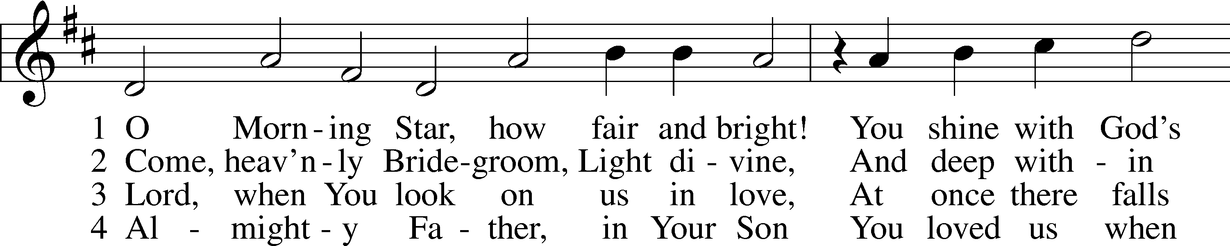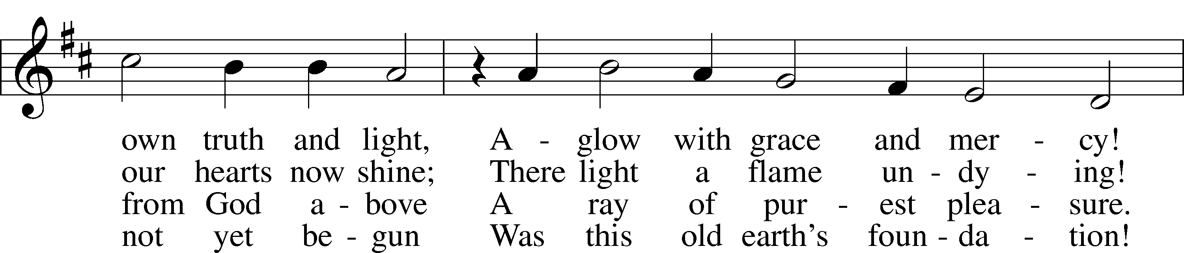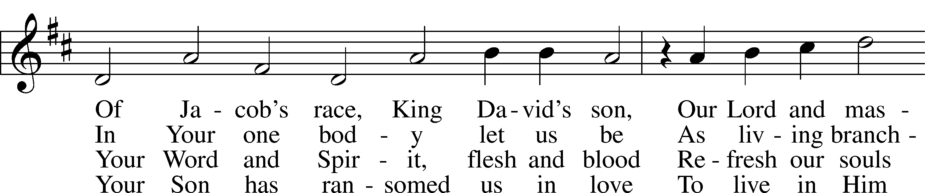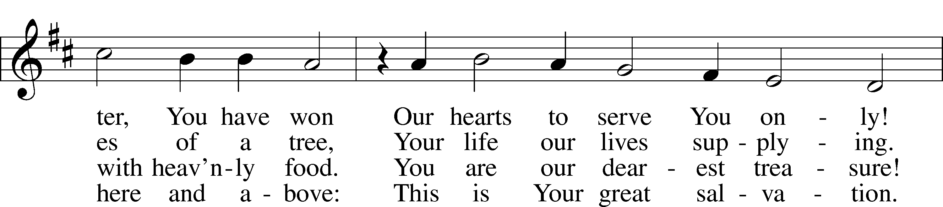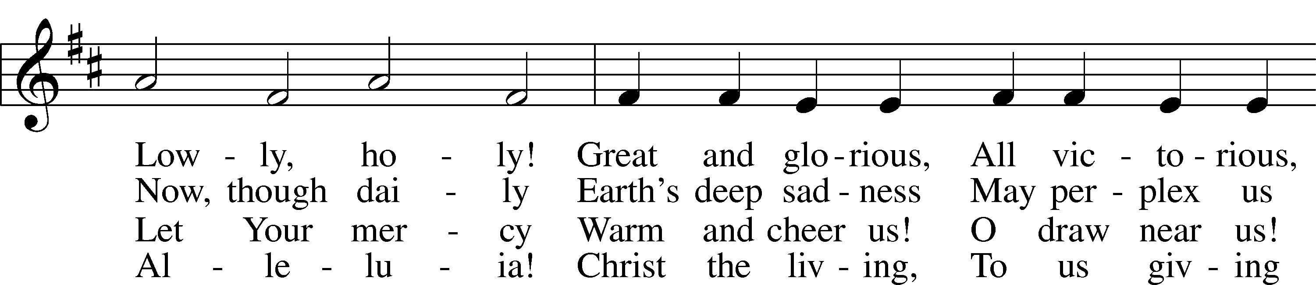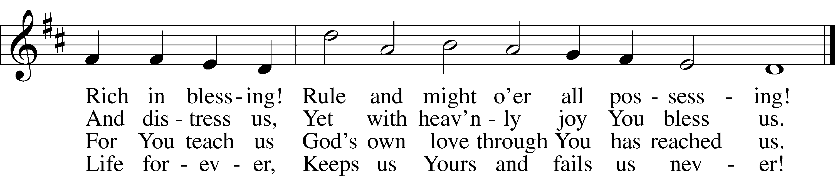

© 1978 Lutheran Book of Worship. Used by permission: LSB Hymn License .NET, no. 100011641.  
Public domain

Pastor: In the Name of the Father and of the Son and Holy Spirit.

**Congregation: Amen.**

*(Please Remain Standing or You May Kneel)*

**CONFESSION AND ABSOLUTION:**

Pastor: Holy God, in your mercy you look with grace and favor upon us, Your people. Hear now, our solemn confession, and as Your Spirit moves us to true repentance, remind us again that You have forgiven us for the sake of Jesus Christ.

**Congregation: Father, how often my sinful nature controls my life! I am easily tempted and fall into sin; I am blind to Your will; I am self-serving, self-seeking, self-righteous and deluded; I am dead in sin. The works of my flesh are demonstrated in my actions and thoughts and words. I have not acted as your baptized child. My heart breaks in my shame and guilt. Gratefully I remember Your blood shed for me to wash me clean. I am forgiven. Holy Spirit, control my life.**

Pastor: God has heard our cry. He is faithful even when we are not. As your called servant of His Word, I announce that we have what we seek; the entire forgiveness of all our sins, as God’s free gift. New life, new sights and a new heart are ours. Live in the freedom of the Spirit.

**Congregation: Amen!**

**THE PRAYERS OF THE DAY:**

**All: Father in heaven, at the Baptism of Jesus in the Jordan River You proclaimed Him Your beloved Son and anointed Him with the Holy Spirit, Make all who are baptized in His name faithful in their calling as Your children and inheritors with Him of everlasting life; through the same Jesus Christ, our Lord, who lives and reigns with You and the Holy Spirit, one God, now and forever. Amen.**

**SERVICE OF THE WORD**

*You may be seated…*

**THE OLD TESTAMENT READING: Genesis 1:1-5**

Lector: This is the Word of the Lord.

**People: Thanks be to God.**

**THE EPISTLE LESSON: Romans 6:1-11**

Lector: This is the Word of the Lord.

**People: Thanks be to God.**

*Please stand…*

**THE HOLY GOSPEL: Mark 1:4-11**

Pastor: The Holy Gospel according to St. Mark the 1st Chapter

**People: Glory to You, O Lord.**

Pastor: This is the Gospel of the Lord.

**People: Praise to You, O Christ!**

*Please be seated…*

**CHILDREN’S MESSAGE**

**NOISE OFERING**



**THE SERMON HYMN: *“Father Welcomes”*  LSB 605**

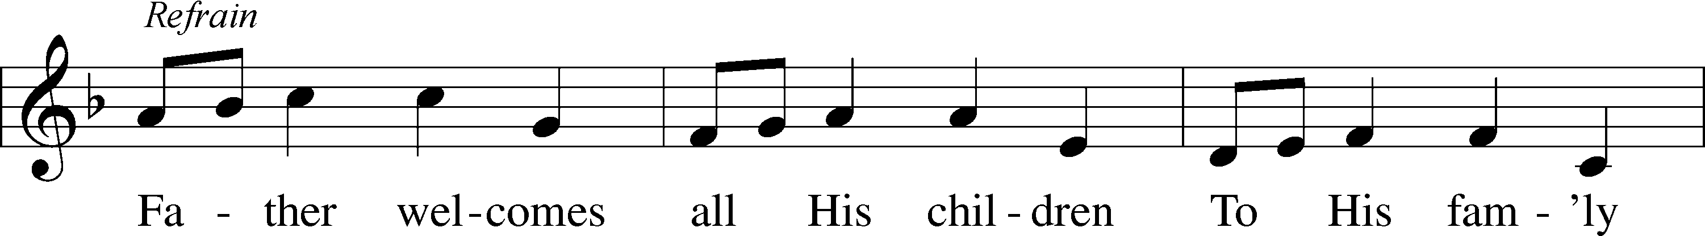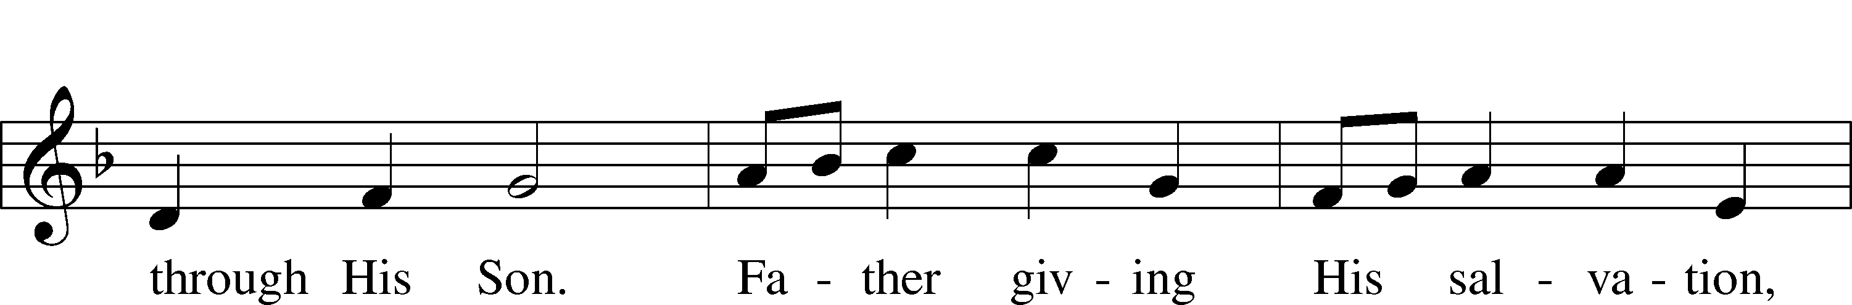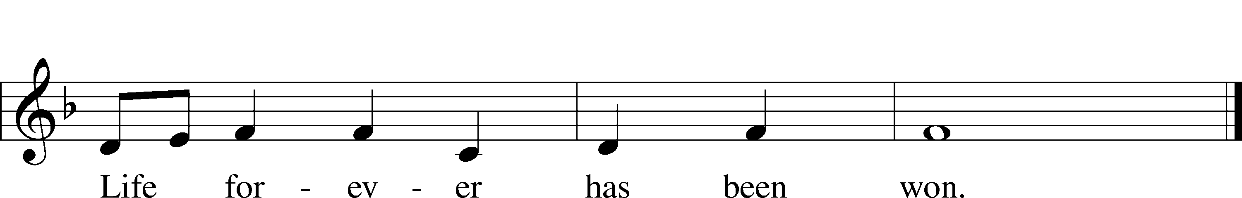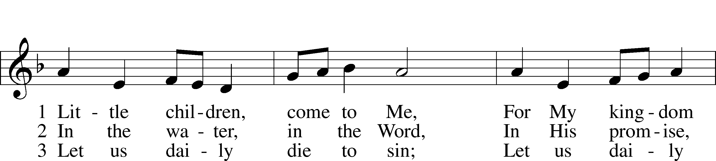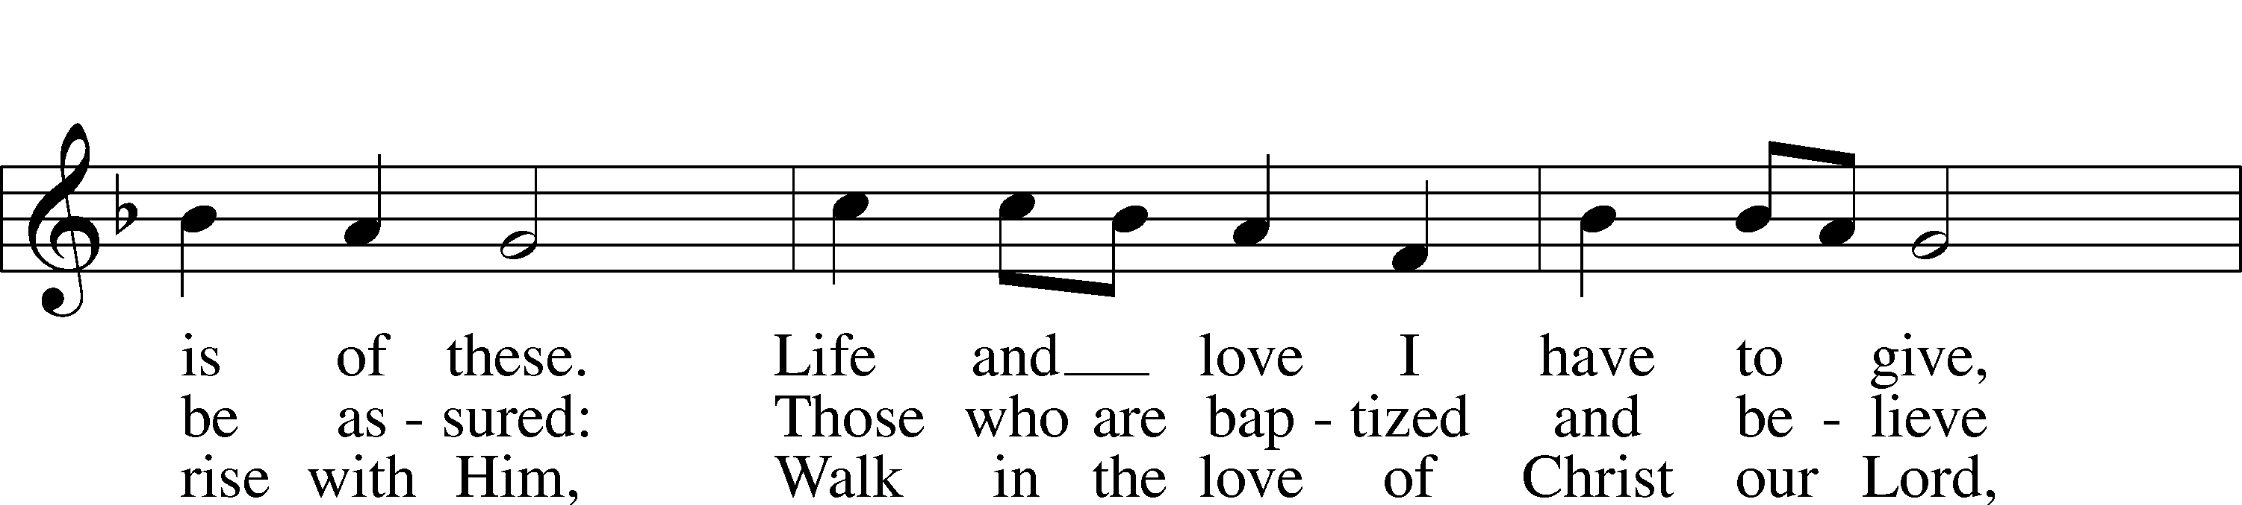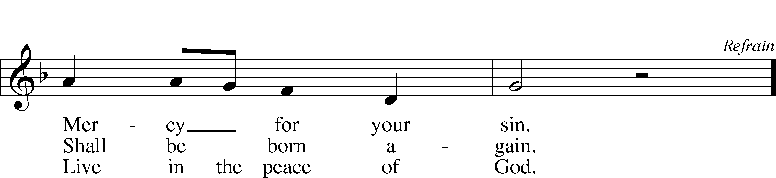

© 1986 Kevin Mayhew Ltd. Used by permission: LSB Hymn License .NET, no. 100011641.

**THE SERMON: *“Why Was Jesus Baptized?”* Mark 1:4-11**

*(Please stand…)*

**THE PROFESSION OF FAITH:**

Pastor: God has given us a great message to take to His world. Let us remind ourselves and one another of what that message is:

Pastor: I believe in God the Father, Almighty

**Congregation: Maker of heaven and earth**

Pastor: And in His Son, Jesus Christ our Lord,

**Congregation: Who was conceived by the Holy Spirit**

Pastor: Born of the Virgin Mary

**Congregation: Suffered under Pontius Pilate**

Pastor: Was crucified, died and was buried

**Congregation: He descended into hell.**

Pastor: On the third day He rose again from the dead,

**Congregation: And ascended into heaven**

Pastor: And sits on the right hand of God, the Father almighty

**Congregation: From there He will come to judge the living and the dead**

Pastor: I believe in the Holy Spirit,

**Congregation: The Holy Christian Church as**

**All: the communion of saints; the forgiveness of sins, the resurrection of the body, and the life everlasting. Amen.**

*(You may be seated…)*

**OFFERING RECEIVED: *“Morning Star”*  Vocal Choir**

**Suzanne Lord**

*(Please stand…)*

**THE PRAYER:**

Pastor: Lord God, Heavenly Father, You are the Light of our life and the Hope of

our salvation.

**Response: With you we have nothing to fear.**

Pastor: You protect us, and are the source of all our joy and happiness.

**Response: Accept our grateful songs of praise.**

Pastor: We pray for those whom we now name silently in our hearts or out loud… According to Your will, heal the sick, strengthen the faith of all who doubt and lift up the depressed. Into Your hands we commend all for whom we pray, trusting in Your mercy, through Your Son, Jesus Christ our Lord.

**All: Amen!**

**SERVICE OF THE SACRAMENT**

*(Please be seated…)*

**THE WORDS OF INSTITUTION**

**DISTRIBUTION HYMNS: “I Want to Walk as a Child of the Light” LSB 411**

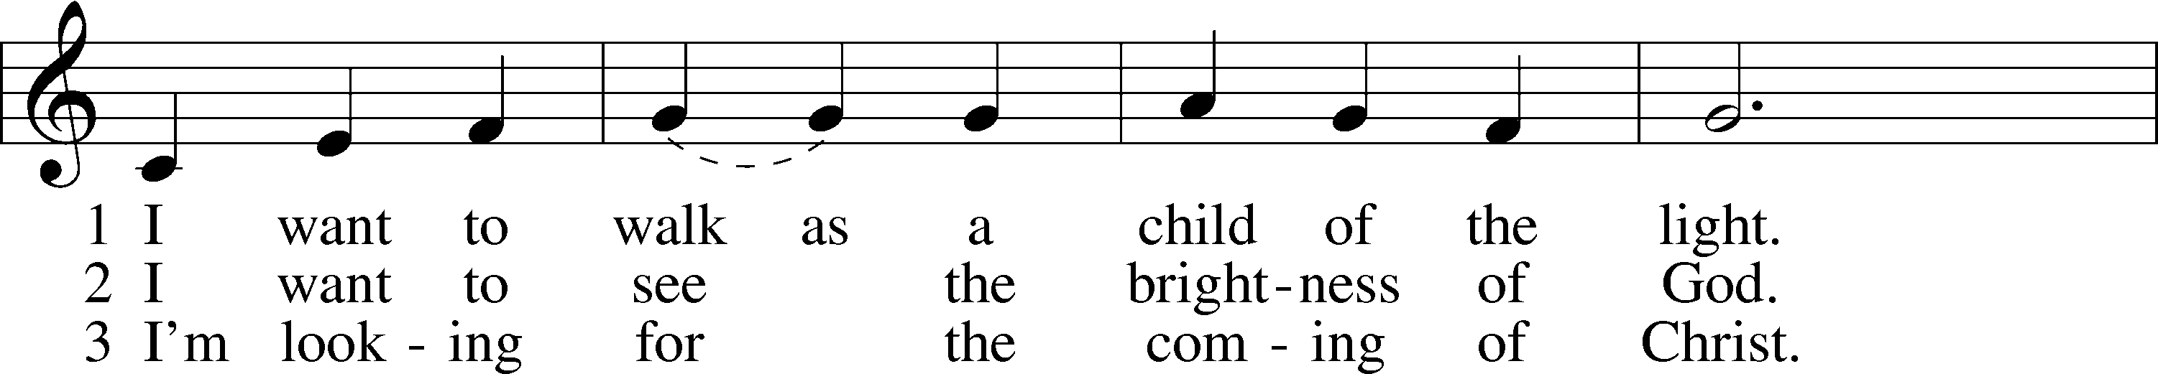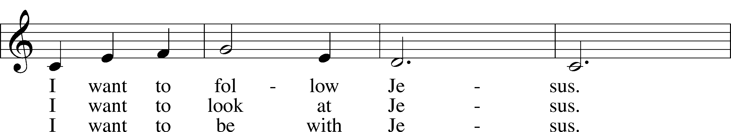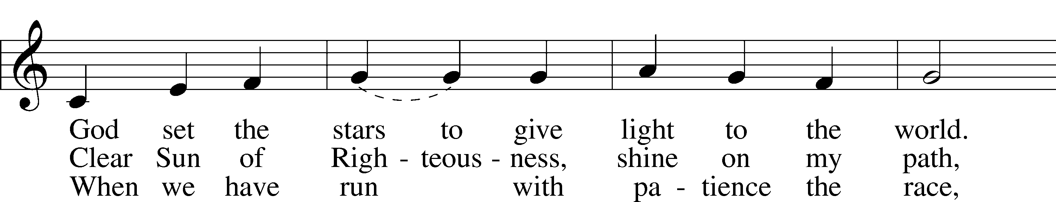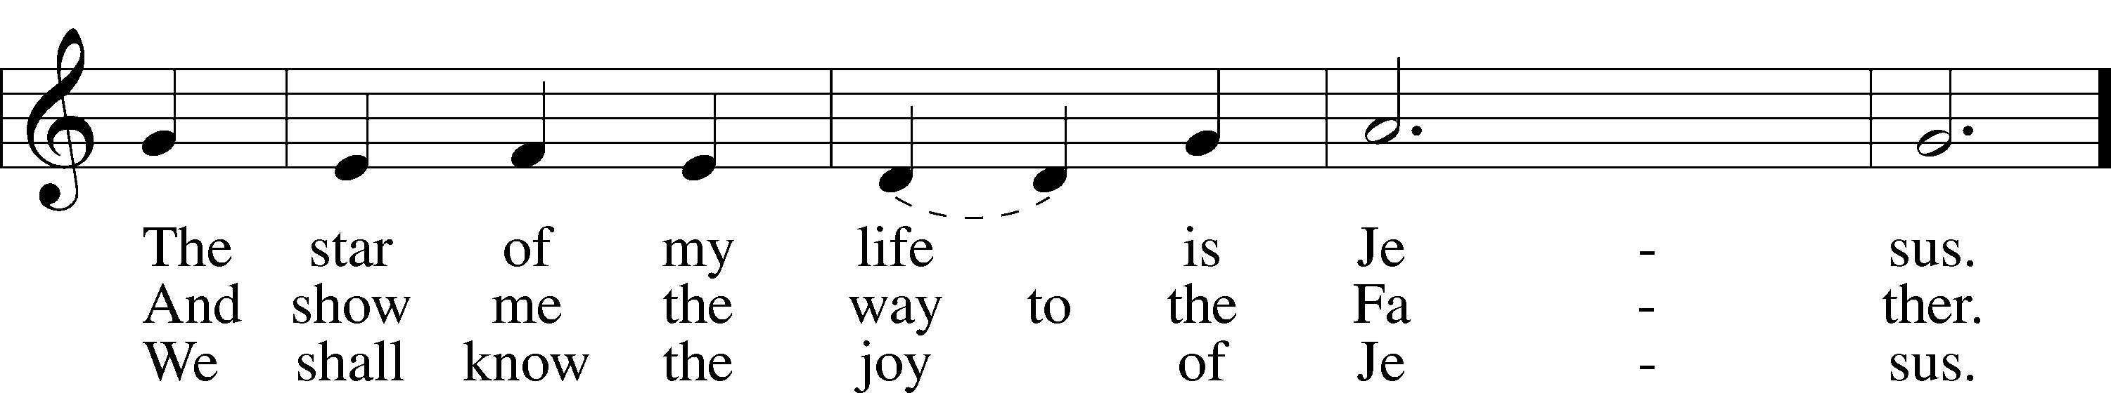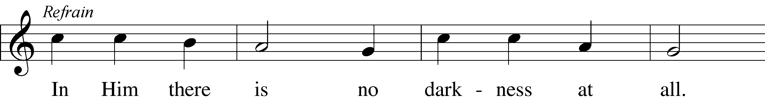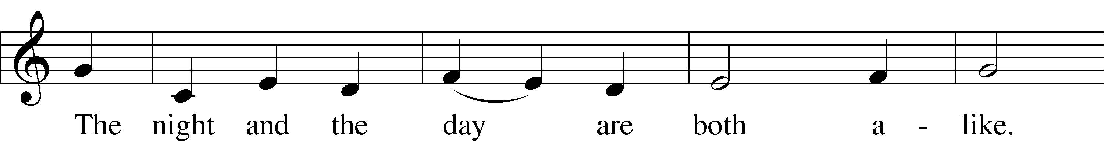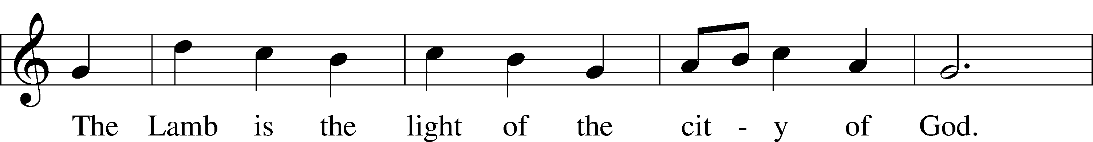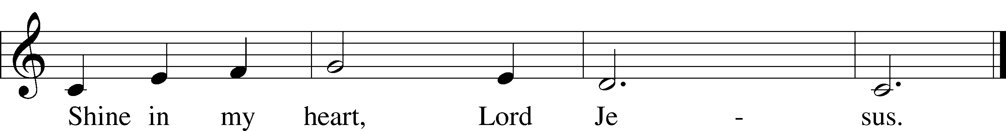

© 1970, 1975 Celebration. Used by permission: LSB Hymn License .NET, no. 100011641.

***“Brightest and Best of the Stars of the Morning”* LSB 400**

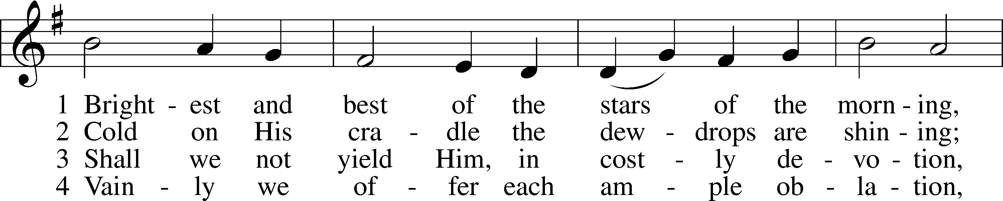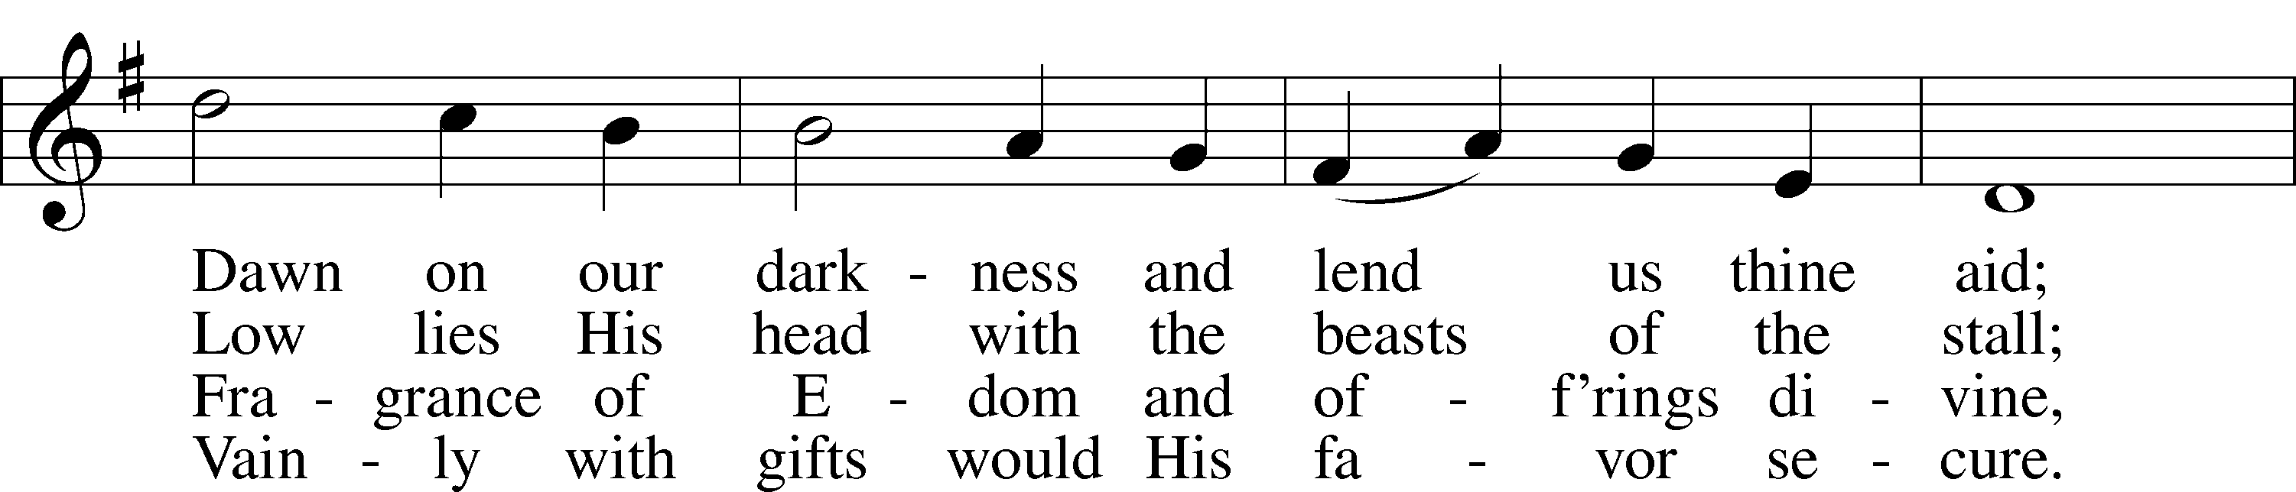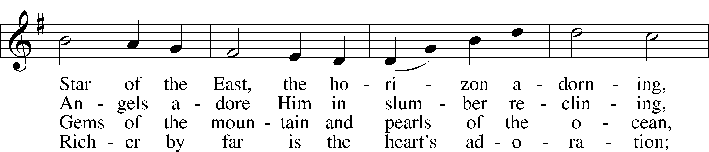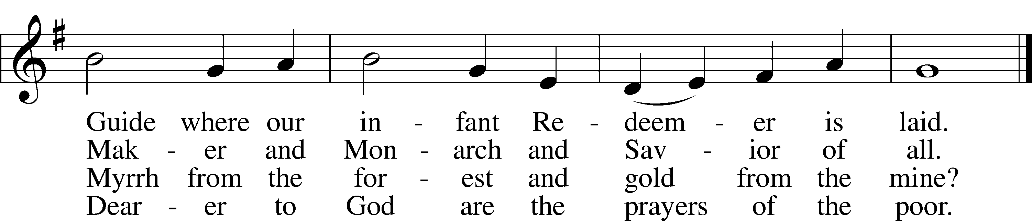

5 Brightest and best of the stars of the morning,  
 Dawn on our darkness and lend us thine aid;  
Star of the East, the horizon adorning,  
 Guide where our infant Redeemer is laid.

Public domain

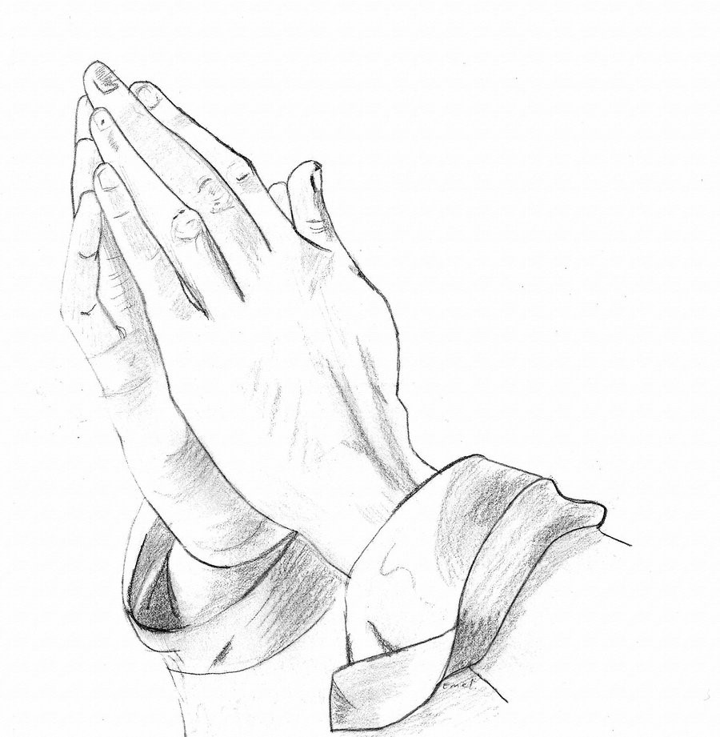

Jesus let the things that break your heart also break our hearts. Amen

***“The Star Proclaims the King Is Here”* LSB 399**

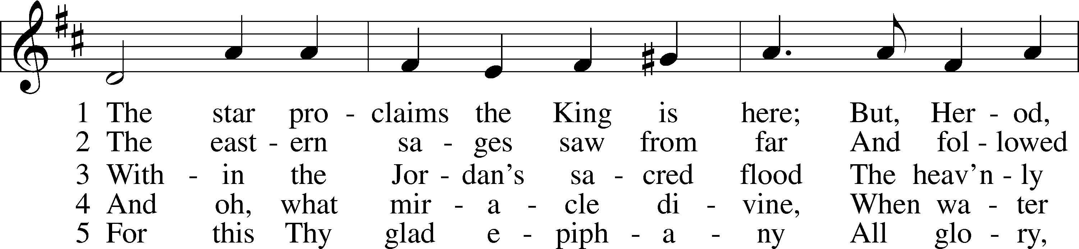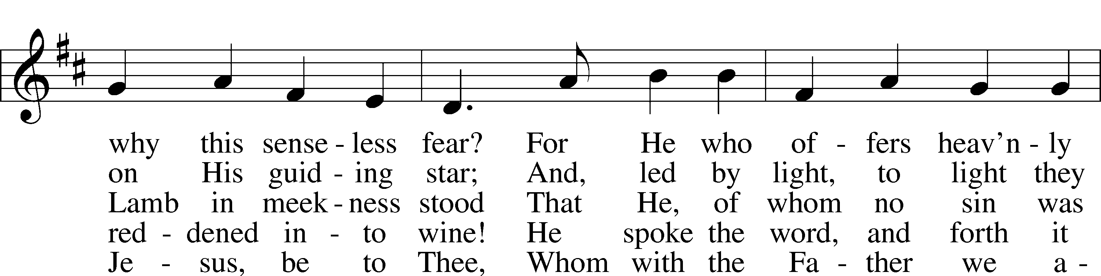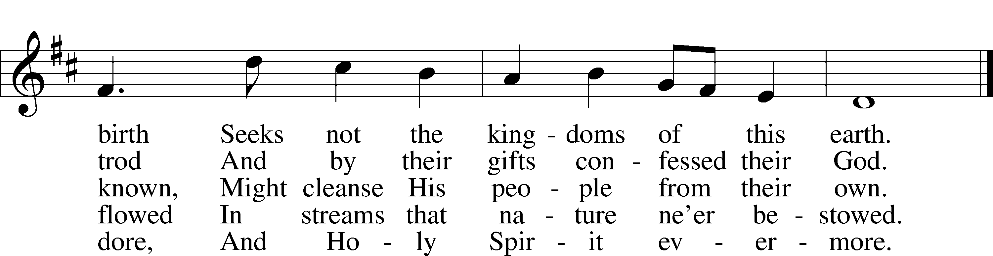

Public domain

*(Please stand…)*

**THE LORD’S PRAYER:**

**All: Our Father, who art in heaven, hallowed be thy name, thy kingdom come, thy will be done, on earth as it is in heaven. Give us this day our daily bread; and forgive us our trespasses as we forgive those who trespass against us; and lead us not into temptation, but deliver us from evil. For thine is the kingdom, and the power, and the glory, forever and ever. Amen**

**THE BENEDICTION**

**THE CLOSING HYMN: *“O Morning Star, How Fair and Bright”* LSB 395**

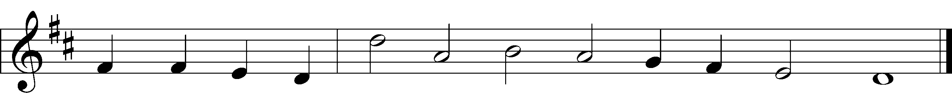

5 O let the harps break forth in sound!  
Our joy be all with music crowned,  
 Our voices gladly blending!  
For Christ goes with us all the way—  
Today, tomorrow, ev’ry day!  
 His love is never ending!  
 Sing out! Ring out!  
 Jubilation!  
 Exultation!  
 Tell the story!  
Great is He, the King of Glory!

6 What joy to know, when life is past,  
The Lord we love is first and last,  
 The end and the beginning!  
He will one day, oh, glorious grace,  
Transport us to that happy place  
 Beyond all tears and sinning!  
 Amen! Amen!  
 Come, Lord Jesus!  
 Crown of gladness!  
 We are yearning  
For the day of Your returning!

© 1978 Lutheran Book of Worship. Used by permission: LSB Hymn License .NET, no. 100011641.  
Public domain

**POSTLUDE: *“O Morning Star, How Fair and Bright”* Johann Pachelbel**



**WELCOME TO GRACE LUTHERAN CHURCH:** We are glad that you are here to worship God with us today! We pray that you will enjoy the wonderful fellowship as friends in Christ as God gathers us around His means of grace, the Word and Sacraments, to bless us with His treasured gifts of forgiveness, faith, abundant life and eternal salvation. If you are a guest, please also sign our Guest Book. Please talk to Pastor if you would like **to learn more about becoming a member of Grace. Also, please join us for refreshments** and fellowship after the Service. We invite you to come and worship with us often as God gathers us in His Grace.

**WELCOME TO THE LORD’S TABLE:** We invite and encourage all present who are baptized and faithful Christians, and who confess the Father, Son, and Holy Spirit to be the only true God and who believe that Jesus Christ died for the sins of the World and is our only hope and salvation…to join us in receiving the very and true body and blood of Christ in this Sacrament. The clear liquid cups in the center of the tray are non-alcoholic wine.

Children not yet confirmed in the faith are always welcome to join their parents at the Lord’s Table, but should keep their hands folded in front of them. The Pastor will give them a blessing.

**SERVING TODAY:** Acolyte: James Reynolds; Lector: Peter Bacle: Communion Assistants: Steve Bringle and Don Bly; Usher: Ed Morris; Altar Care: ___________; Refreshments: ____________.

**SERVING NEXT SUNDAY:** Acolyte: James Reynolds; Lector: Peter Bacle; Communion Assistants: Steve Bringle and Don Bly; Usher: Ed Morris; Altar Care: _________; Refreshments: _____________.

**FLOWERS**: were placed on the altar to the glory of God by Jim and Garnet Picking to celebrate their anniversary and Garnet’s birthday.

THIS WEEK AT A GLANCE:

**Today: January 7th**

9:00 am Worship Service with Communion

10:10 am Jr. Choir Rehearsal

10:15 am          Fellowship

10:30 am Adult Bible Class / Youth Bible Classes

**Monday: January 8th**

Pastor’s Day Off

School Starts Back

12:00 pm Last Chance to Sign up for the High School Youth Gathering

**Tuesday: January 9th**

2:30 pm Jan’s Mobile Gym (Parish Hall)

6:00 pm Weight Watcher’s (Parish Hall)

**Thursday: January 11th**

4:15 pm Missional Communities (Room 3)

5:45 pm Hand Bell Choir

6:30 pm Vocal Choir

**Next Sunday: January 7th**

9:00 am Worship Service with Communion

10:10 am Jr. Choir Rehearsal

10:15 am          Fellowship

10:30 am Adult Bible Class / Youth Bible Classes

**IN YOUR PRAYERS THIS WEEK:** Mary Payne, Skip Nicholas, Sue Ellen, Jim Prahst, Michael Willard, family of Jim and Gerrie Parker, Micah Westphalen, Joe Mercurio, Walt Lepperd Rachel Hoppe, Dennis Julson, Alga Odland, Sandra Chrisman, Vernon Julson, Brittany Howard, Beverly Walker, Ann Barber, Al and Kathleen Schubert, Mary Eschels, Max Broadbent, Peggy Mira, Bud Wrocklage, and those you are praying for at home. If anyone has a special prayer request please submit it in writing in the collection plate; or you may call Pastor Gary Faith at (504-858-8872), or Kris Howard at (305-296-5161).

**GIFTS, TITHES, & ATTENDANCE LAST SUNDAY**: Sunday December 31st received $17634.00, the building fund received $300.00 and the noise offering received $36.84 with an attendance of 80.

**TO HELP US GROW…** The Bible reading for next Sunday’s service are 1 Samuel 3:1-10, 1 Corinthians 6:12-20, and John 1:43-51.

**SIGN-UP SHEETS** for the Get to Know Our Snow Birds Better Picnic and the training with Pastor Greg and Susan Finke are on the table in the Narthex/Lobby. Please sign-up so we can prepare food and materials properly. If attending both please sign both sheets. Thanks.

**THANKS TO ALL** who helped take down the Christmas decorations yesterday. It’s always good to see God’s people work together.

**THANK YOU FOR ALL OF THE CARDS,** gifts, goodies, and kind words. We truly appreciate them and you. Pastor and Pattie.

**STEWARDSHIP LISTS:** On the bulletin board by the front door of the church you will find the Altar Care, Refreshments, and Flower sign-up sheets **for 2018**. If you are able to help out with any of these please place your name in the spot on the date requested.

**2018 ENVELOPES ARE IN THE NARTHAX** and your yearly tax statements will be mailed next week. Please pick up your envelopes when you have a chance. Thank you all.

**FUNDS NEEDED** The remainder of the church windows that need to be replaced will be installed in January. We have two donors but will need additional funds to complete the much needed and long-awaited project. The cost of each window is $2700 and 3 out of 13 still need to be funded. Checks can be made out to Grace Lutheran Church and earmarked "windows". Thank you for your consideration.

**IF YOU ARE INTERESTED IN LEARNING** more about what we believe and teach and/or are interested in becoming a member of Grace Please let Pastor know so that he can begin an Adult Information class.

**THANKS TO ALL OF YOU** for helping your neighbor, listening to others, and being a blessing to the community and to GLCS.

**I HAVE 1 COPY** of Pastor Finke’s book, “Joining Jesus on His Mission”. If you would like to get maximum results from Greg and Susan’s visit in January, you are welcome to borrow a copy. See Kris or Pastor.

**THERE IS ADDITIONAL PARKING** behind the school. Enter that lot on 10th Street.

**WE HAVE SET THE SCHEDULES** for ushers, acolytes, lectors, and communion assistants for the next three months. If you would like to serve in any of these positions, please let Pastor or Kris know.

**THE GRACE LUTHERAN CHURCH WEB PAGE AND FACE BOOK PAGE** now

contains a vocal recording of last week’s sermon. So, if you are not able to attend church on Sunday please go to our website where you will find a copy of the bulletin and a recording of Pastor Faith’s sermon. <https://gracelutherankw.360unite.com/home>.

**SAVE THE DATE AND MARK ON YOUR CALENDAR**

**JANUARY 27TH, 2018:** We plan on having the annual “Let’s Get to Know our Snowbird Friends Better” with Susan and Greg as our guests of honor.

**JANUARY 28TH, 2018:** Mark this day on your calendar. Pastor Greg Finke and his wife Susan are scheduled to join us for worship and training on how to be a neighborhood missionary. The Finke’s travel all over the country helping equip folks for everyday ministry. Don’t miss this opportunity or you will wonder why everyone is more excited about Jesus missing.

**SIGN-UP SHEETS FOR BOTH EVENTS ARE IN THE NARTHAX/LOBBY PLEASE SIGN UP SO WE CAN PREPARE FOOD AND MATERIALS PROPERLY. IF ATTENDING BOTH EVENTS PLEASE SIGN-UP ON BOTH SHEETS.**



It was so cold and blustery on Tuesday we had to abandon our Turtle Kraal venue, at one end of the island, and seek warmer fare at our old favorite Roostica, at the other end of the isle. Eight of us gathered at our usual table and enjoyed having Andrea Merritt back with us. Food was delicious as usual and especially the calamari and the yellowtail salad.  We will try once more to dine at The Turtle Kraal restaurant on January 16th at 11:30. It has a beautiful view of the harbor and we'll see about the menu. Come join us ladies.



**MUSIC MINISTRY:** "Make a joyful noise to the Lord, all the earth!" Psalm 100:1. Whether you are here year-round or part-time, we invite you to participate in our music ministry. Please speak with Beverly Walker or contact her at [beverlywalker@gmail.com](mailto:beverlywalker@gmail.com) if you have any questions.

Jr. Choir (Grades 2-8): Rehearsal today from 10:10-10:25 by the piano.

Bell Choir: Rehearsal this Thursday from 5:45 - 6:30 pm.

Vocal Choir: Rehearsal this Thursday from 6:30 - 7:30 pm.



**MEN’S BIBLE FELLOWSHIP**: They meet the first and third Wednesday’s of each month at 12:30pm. Their next meeting will be January 17th located at Chico’s on Stock Island. All guys are welcome.

**MISSIONAL COMMUNITIES** will begin meeting again on Thursday January 11th at 4:15 pm in room 3. Please come and see what the Lord has been up to.