**December 24th, 2017**

**9:00 am**

**Fourth Sunday**

**in**

**Advent**



**Grace Lutheran Church**

**2713 Flagler Ave.**

**Key West, FL 33040**

**305-296-5161**

**GraceLutheranKW@att.net**

**Pastor Faith**

**(504) 858-8872**

**garyfaith@aol.com**

**FOURTH SUNDAY IN ADVENT**

**DECEMBER 24TH, 2017 9:00 a.m.**

**WORSHIP SERVICE**

***In the Name of Jesus!***

**Our Mission Statement: Anchored in Christ, each person a missionary.**

**PRELUDE: *“O Come, O Come Emmanuel”* Hal H. Hopson**

**ANNOUNCEMENTS:**

**We welcome you. We are glad you are here to share with us the joy and peace we have in Jesus Christ. It doesn’t matter whether this is your first time in this church or if you are a lifelong member, you are welcome. We come together today in order to celebrate the gift God has given us-His own Son, Jesus, Our Savior.**

**PREPARATION**

*(Please Stand…)*

**HYMN:  *“O Come, O Come, Emmanuel”* LSB 357**

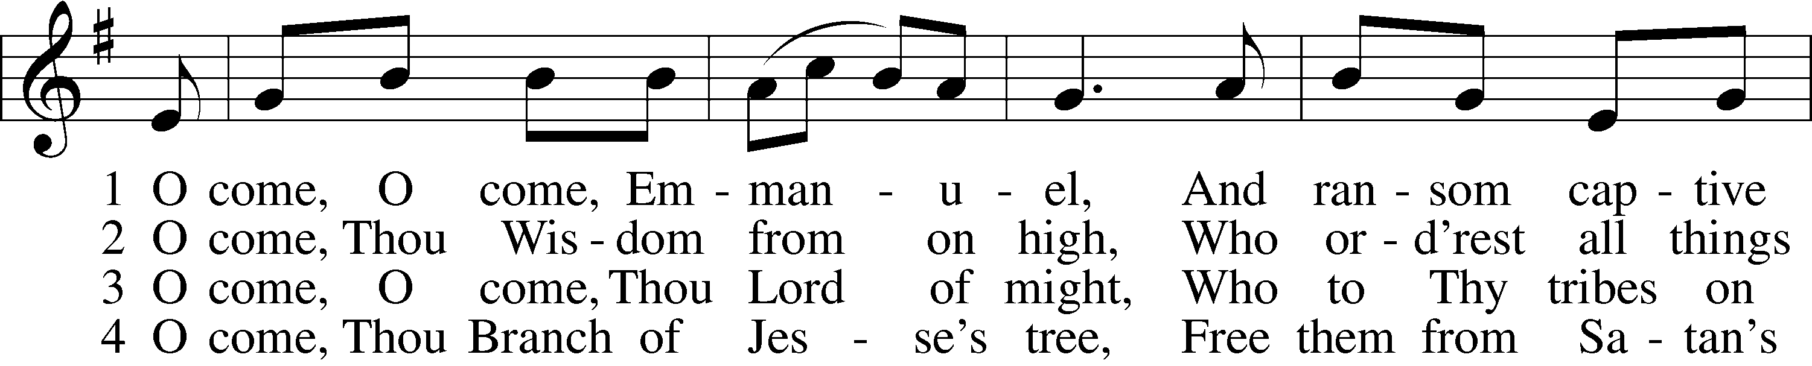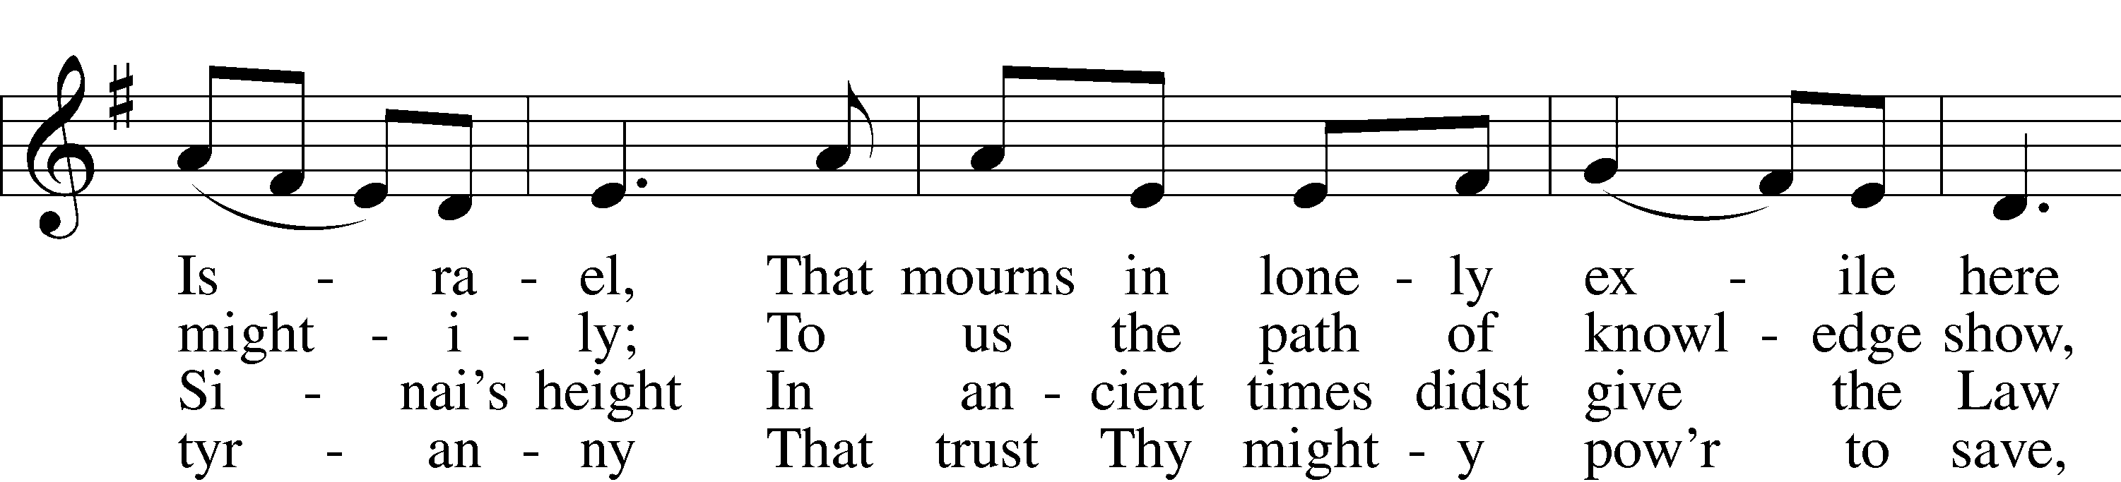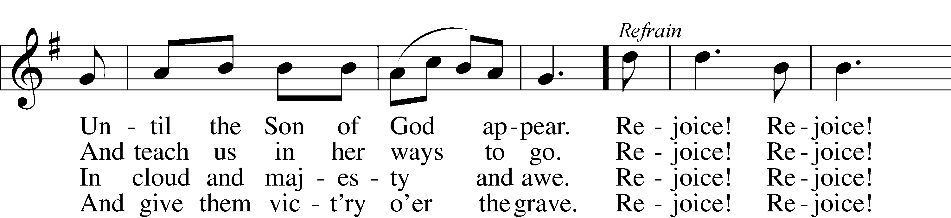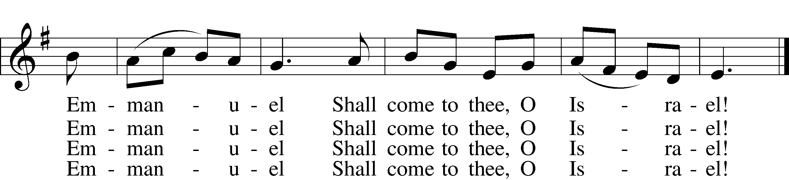

ref Rejoice! Rejoice! Emmanuel  
Shall come to thee, O Israel!

Public domain

Pastor: In the Name of the Father and of the Son and Holy Spirit.

**Congregation: Amen**

*(Please Remain Standing Or You May Kneel…)*

**GOD’S PEOPLE CONFESS THEIR SINS:**

Pastor: By grace you have been saved, through faith-and this is not from yourselves, it is the gift of God-not of works, so that no man can boast, for we are God’s workmanship, created in Christ Jesus.

**Congregation: I know that nothing good lives in me, that is, in my sinful nature, for I have the desire to do what is good, but I cannot carry it out.**

Pastor: What I do is not the good I want to do; no, the evil I do not want to do-this I keep doing.

**Congregation: In my heart I delight in God’s law, the law that points out what a wretched person I am! Who will rescue me from this body of death?**

Pastor: Thanks be to God through Jesus Christ our Lord! Only He can achieve the perfection we fail to achieve. By the forgiveness He purchased on the cross, our forgiveness is complete!

**SERVICE OF THE WORD**

*You may be seated…*

**THE OLD TESTAMENT READING: 2 Samuel 7:1-11, 16**

Lector: This is the Word of the Lord.

**People: Thanks be to God.**

**THE EPISTLE LESSON: Romans 16:25-27**

Lector: This is the Word of the Lord.

**People: Thanks be to God.**

*Please stand…*

**THE HOLY GOSPEL: Luke 1:26-38**

Pastor: The Holy Gospel according to St. Luke the 1st Chapter.

**People: Glory to You, O Lord.**



Pastor: This is the Gospel of the Lord.

**People: Praise to You, O Christ!**

**CHILDREN’S MESSAGE**

**NOISE OFFERING**

***It’s called a noise offering because what we are asking for is pocket change. It will always be used for missions outside of our church and school. It normally also is given to a mission involving children. Thanks for making a joyful noise to the Lord.***

*You may be seated…*

**THE SERMON HYMN: *“Have Thine Own Way, Lord”***

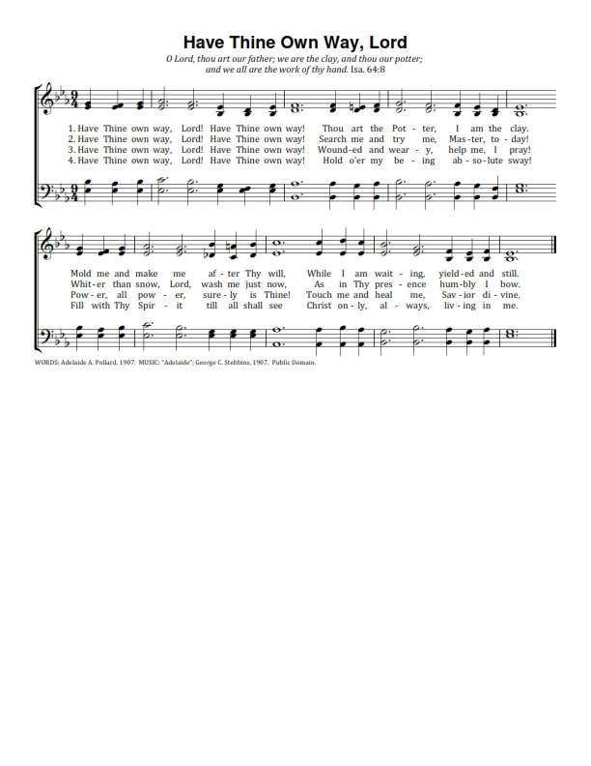

**THE SERMON: *“Have I Got a Deal for You”* Luke 1:26-38**

*(Please stand…)*

**THE PROFESSION OF FAITH:**

Pastor: God has given us a great message to take to His world. Let us remind ourselves and one another of what that message is:

Pastor: I believe in God the Father, Almighty

**Congregation: Maker of heaven and earth**

Pastor: And in His Son, Jesus Christ our Lord,

**Congregation: Who was conceived by the Holy Spirit**

Pastor: Born of the Virgin Mary

**Congregation: Suffered under Pontius Pilate**

Pastor: Was crucified, died and was buried

**Congregation: He descended into hell.**

Pastor: On the third day He rose again from the dead,

**Congregation: And ascended into heaven**

Pastor: And sits on the right hand of God, the Father almighty

**Congregation: From there He will come to judge the living and the dead**

Pastor: I believe in the Holy Spirit,

**Congregation: The Holy Christian Church as**

**All: the communion of saints; the forgiveness of sins, the resurrection of the body, and the life everlasting. Amen.**

*(You may be seated…)*

**OFFERING RECEIVED**

**(***Please stand…)*

***“Praise God, from Whom All Blessings Flow”* LSB 805**

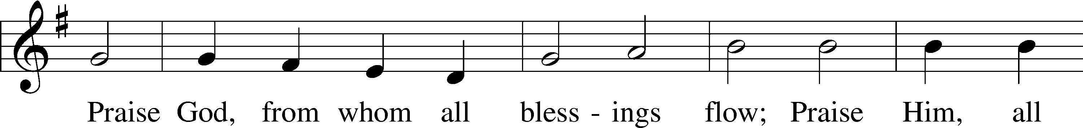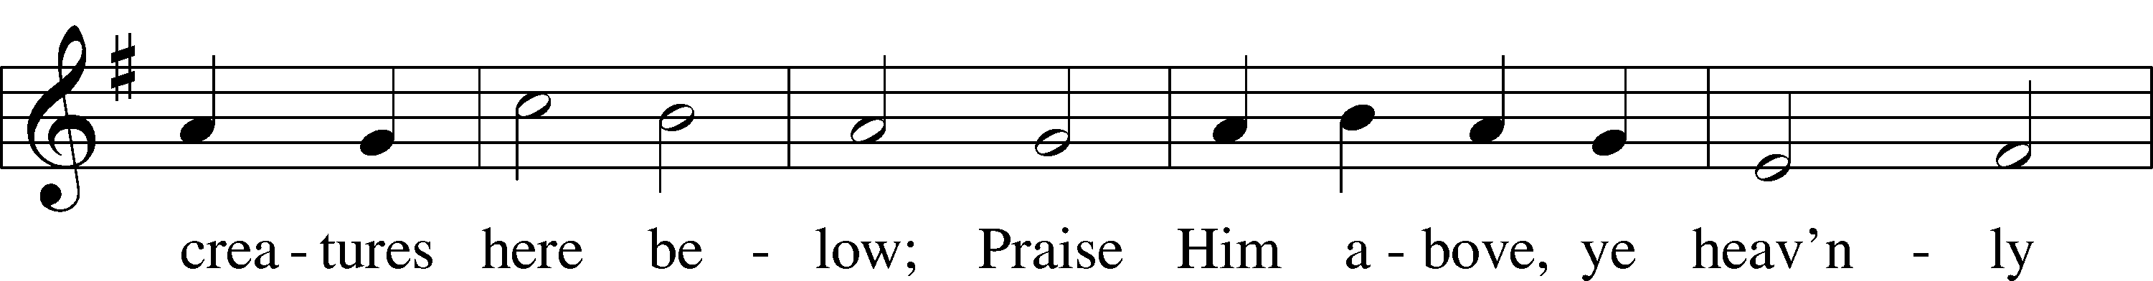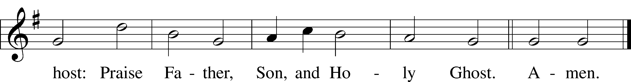

Public domain

**THE PRAYERS OF THE CHURCH: based on Psalm 98**

Pastor: Dear Lord, we thank You for everything You’ve done for us, and most of all for Your own Son, Jesus, our Savior. We will never stop praising You for this wonderful gift.

**Congregation: Sing to the Lord a new song, for He has done marvelous things; His right hand and His holy arm have worked salvation for Him.**

Pastor: We thank You for those missionaries long ago who brought the Good News to our people. When we were in darkness, You sent men and women to bring us the light. Thank you, Lord.

**Congregation: The Lord has made His salvation known and revealed His Righteousness to the nation.**

Pastor: O Lord, You are our Savior, we trust in You for all our needs, give healing to the sick, courage to those who are afraid, and peace to those we name in our hearts either silently or out loud. **(a moment of silence)** We praise You, gracious Lord, for all Your benefits to us. You give us home, friends and family, food, shelter, rest and everything we need. You give us sight and hearing and touch and taste and provide for all of our needs.

**Congregation: Shout for joy to the Lord, praise His Name Amen.**

**SERVICE OF THE SACRAMENT**

**THE WORDS OF INSTITUTION**

*(Please be seated…)*

**DISTRIBUTION HYMNS: *“Once He Came in Blessing”* LSB 333**

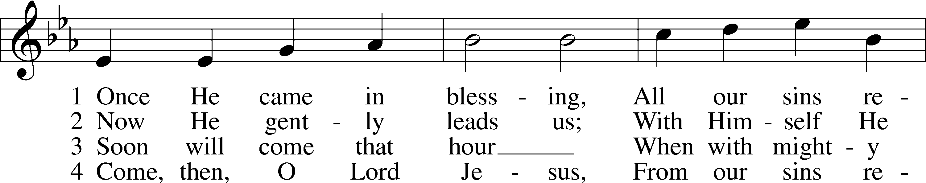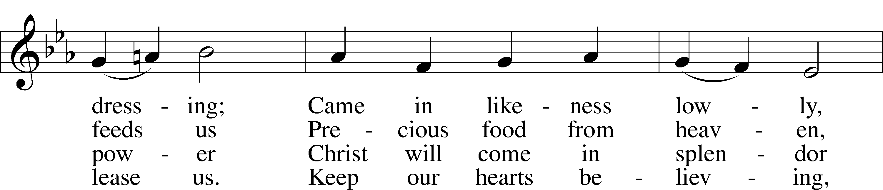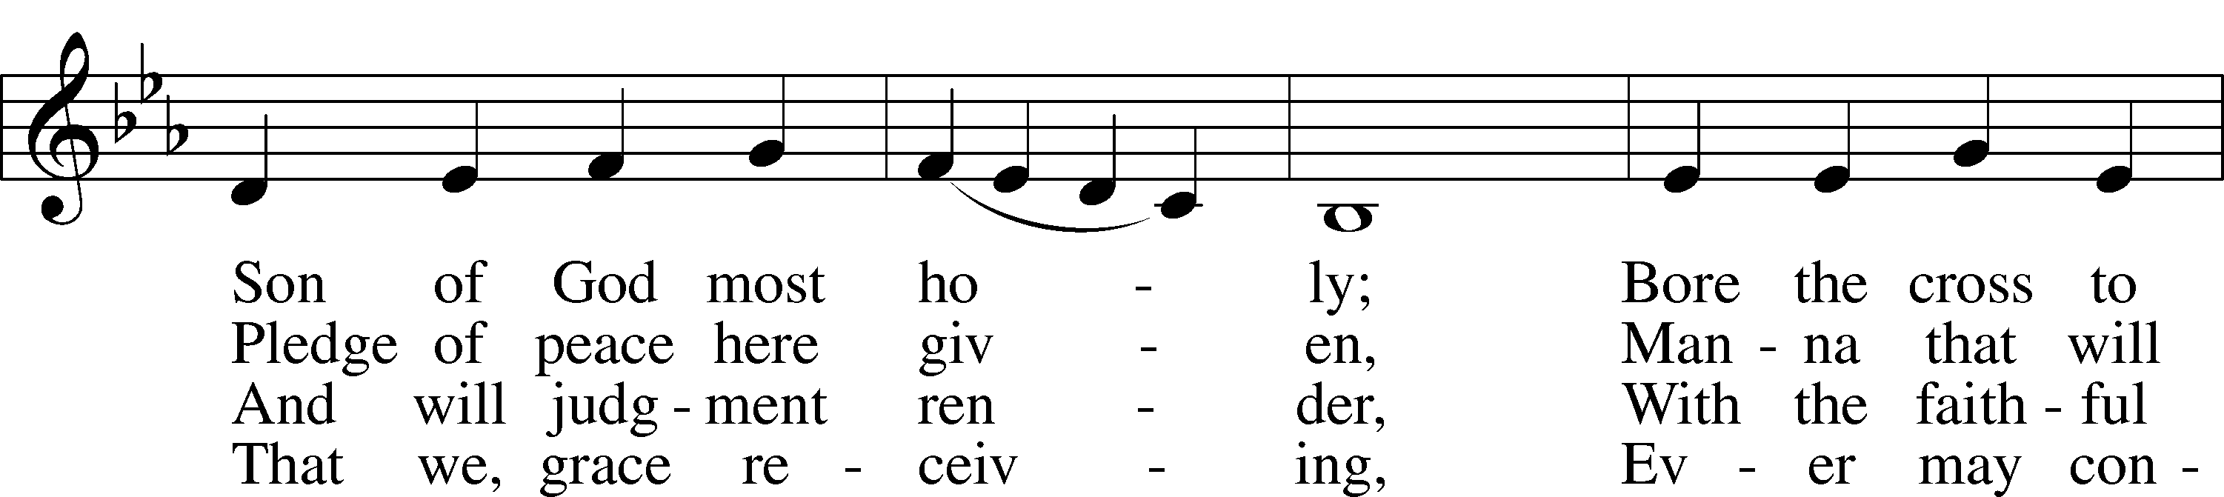

© 2006 Concordia Publishing House. Used by permission: LSB Hymn License .NET, no. 100011641.Public domain

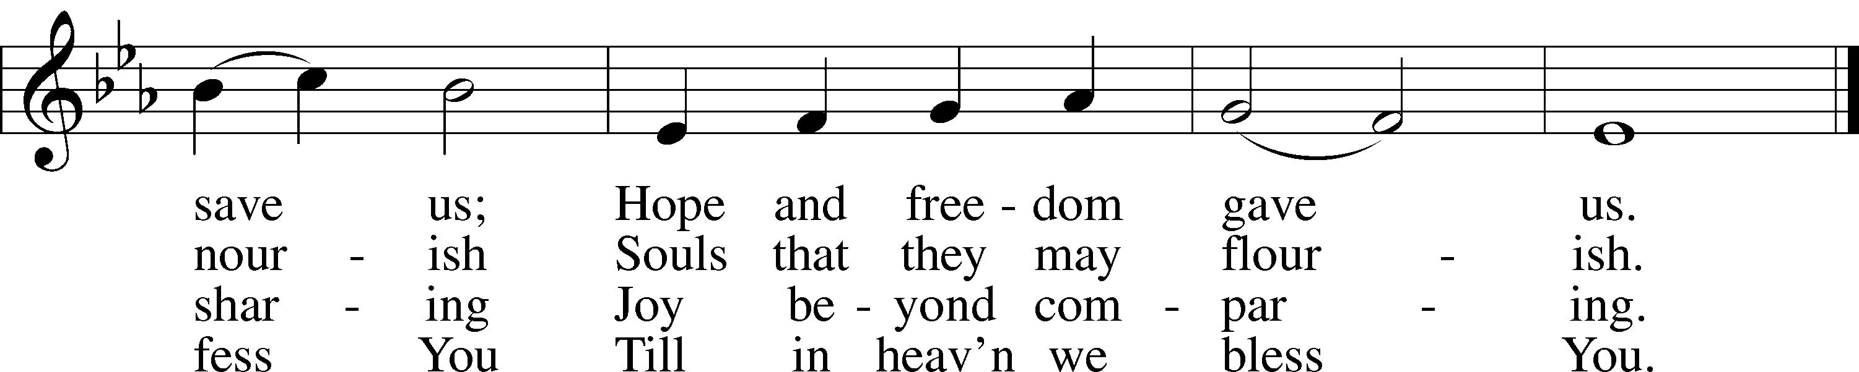

Jesus let the things that break your heart

also break our hearts.

Amen.

***“O Come, O Come, Emmanuel”* LSB 357**

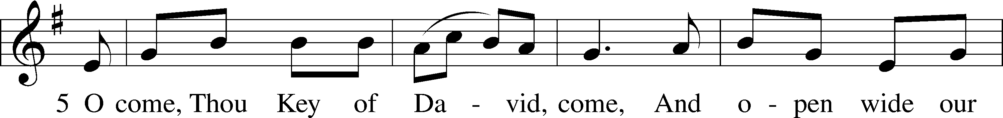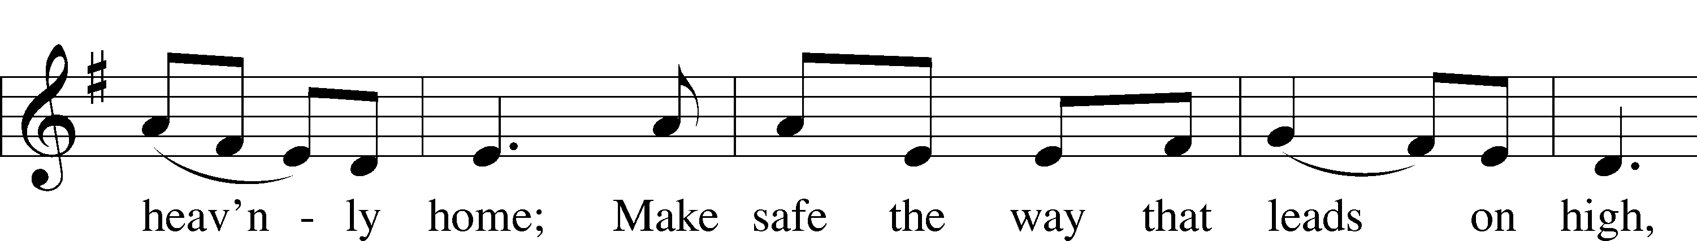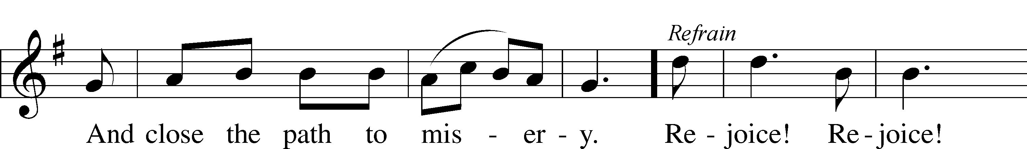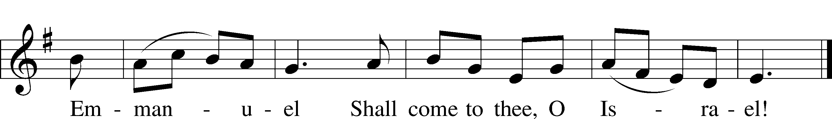

ref Rejoice! Rejoice! Emmanuel  
Shall come to thee, O Israel!

6 O come, Thou Dayspring from on high,  
And cheer us by Thy drawing nigh;  
Disperse the gloomy clouds of night,  
And death’s dark shadows put to flight. Refrain

7 O come, Desire of nations, bind  
In one the hearts of all mankind;  
Bid Thou our sad divisions cease,  
And be Thyself our King of Peace. Refrain

Public domain

***“My Soul Now Magnifies the Lord”* LSB 934**

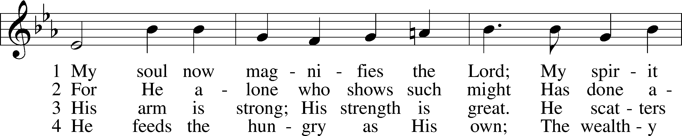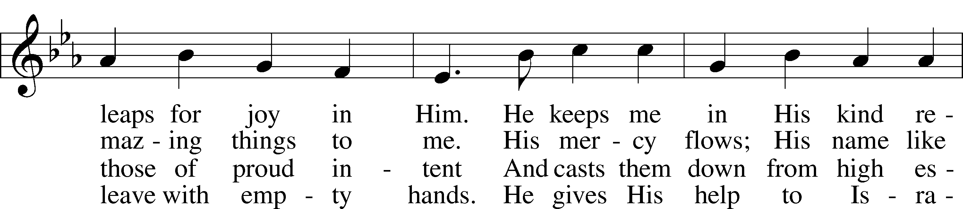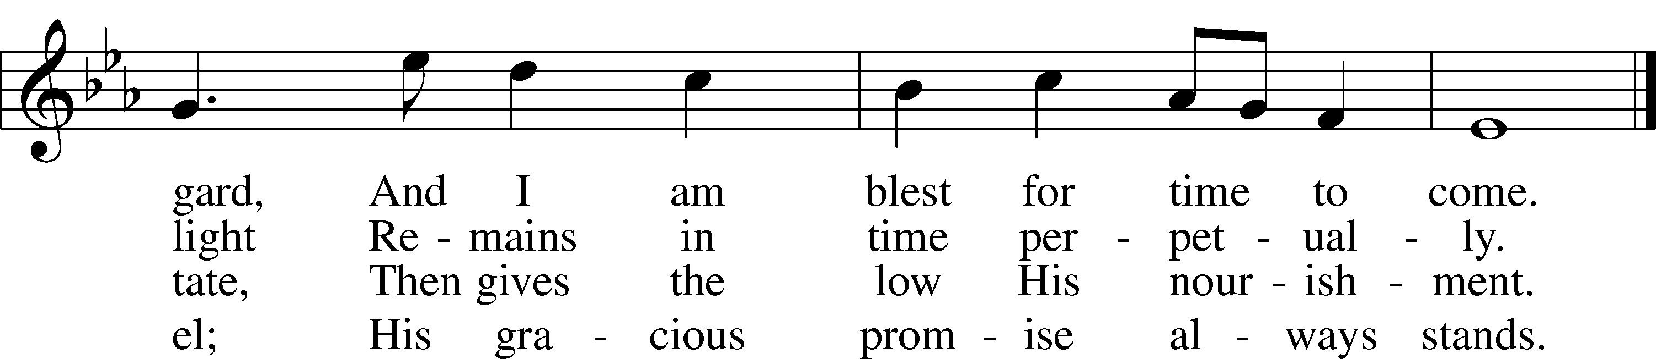

© 1978 Lutheran Book of Worship. Used by permission: LSB Hymn License .NET, no. 100011641.

*(Please stand…)*

**THE LORD’S PRAYER:**

**All: Our Father, who art in heaven, hallowed be thy name, thy kingdom come, thy will be done, on earth as it is in heaven. Give us this day our daily bread; and forgive us our trespasses as we forgive those who trespass against us; and lead us not into temptation, but deliver us from evil. For thine is the kingdom, and the power, and the glory, forever and ever. Amen**

**THE BENEDICTION**

**THE CLOSING HYMN: *“What Child Is This”* LSB 370**

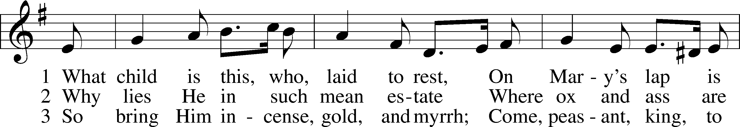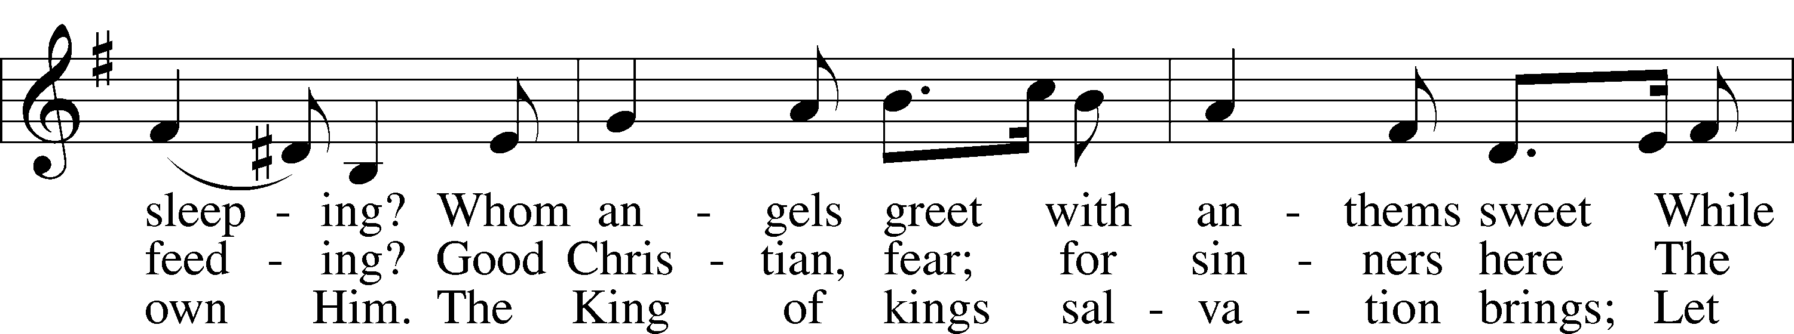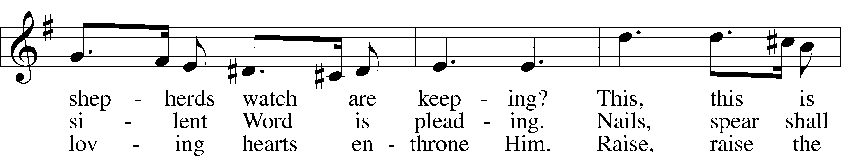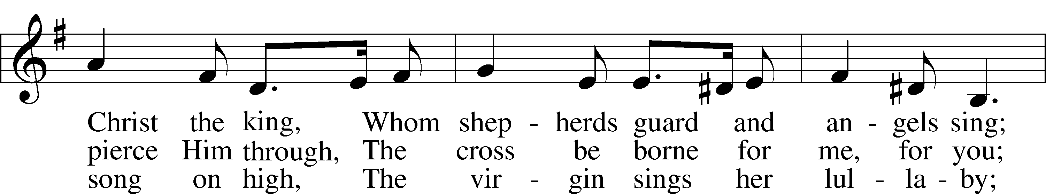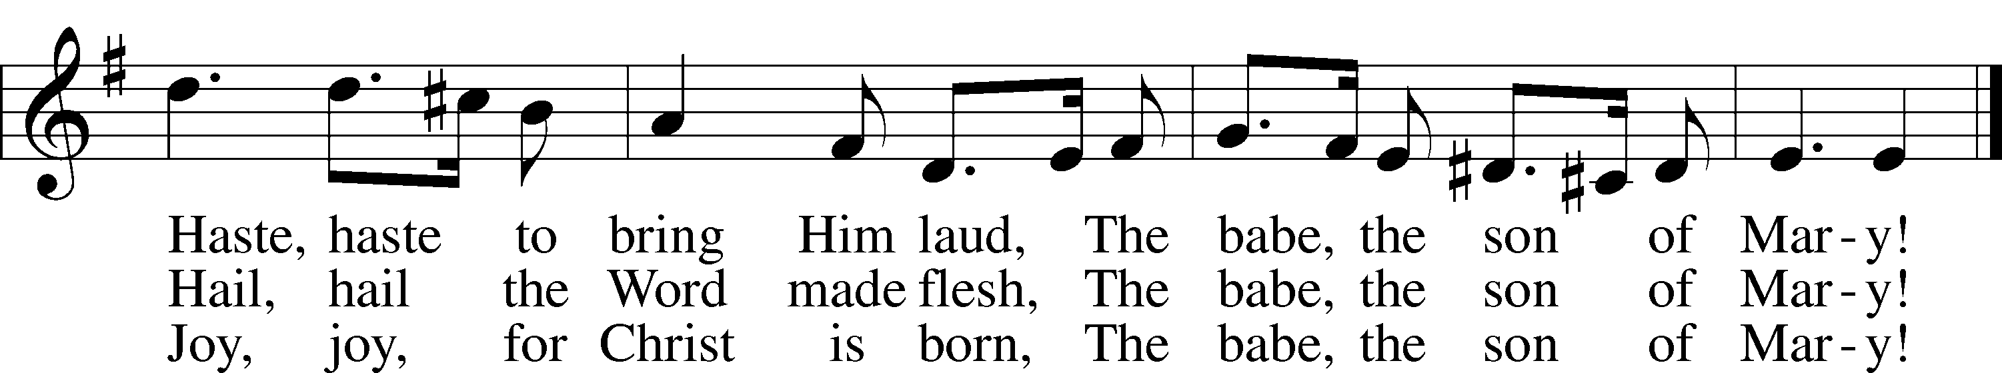

Public domain

**POSTLUDE*: “Hark The Herald Angels Sing”* William H. Bates**



**WELCOME TO GRACE LUTHERAN CHURCH:** We are glad that you are here to worship God with us today! We pray that you will enjoy the wonderful fellowship as friends in Christ as God gathers us around His means of grace, the Word and Sacraments, to bless us with His treasured gifts of forgiveness, faith, abundant life and eternal salvation. If you are a guest, please also sign our Guest Book. Please talk to Pastor if you would like **to learn more about becoming a member of Grace. Also, please join us for refreshments** and fellowship after the Service. We invite you to come and worship with us often as God gathers us in His Grace.

**WELCOME TO THE LORD’S TABLE:** We invite and encourage all present who are baptized and faithful Christians, and who confess the Father, Son, and Holy Spirit to be the only true God and who believe that Jesus Christ died for the sins of the World and is our only hope and salvation…to join us in receiving the very and true body and blood of Christ in this Sacrament. The clear liquid cups in the center of the tray are non-alcoholic wine.

Children not yet confirmed in the faith are always welcome to join their parents at the Lord’s Table, but should keep their hands folded in front of them. The Pastor will give them a blessing.

**SERVING TODAY:** Acolyte: Emily Howard; Lector: David Walker: Communion Assistants: David Walker and Mary Brady; Usher: Ed Morris; Altar Care: ___________; Refreshments: The Morris Family.

**SERVING THIS EVENING AT 10PM:** Acolyte: Amelia Bly; Lector: Jim Picking, Communion Assistants: Steve Bringle and Don Bly; Usher: Vince Winters; Altar Care: _____________

**SERVING NEXT SUNDAY:** Acolyte: Elizabeth Reynolds; Lector: Monica Bacle; Communion Assistants: David Walker and Mary Brady; Usher: ____________; Altar Care: _________; Refreshments: The Stark Family.

**FLOWERS**: were placed on the altar to the glory of God and by the Morris Family.

THIS WEEK AT A GLANCE:

**Today: December 24th**

9:00 am Worship Service with Communion

Immed. Following Vocal Choir Rehearsal

10:05 am Bell Choir Rehearsal

10:20 am Jr. Choir Rehearsal

5:00 pm Children’s Christmas Eve Service

10:00 pm Candlelight Service

**Monday: December 25th**

Merry Christmas

**Tuesday: December 26th**

6:00 pm Weight Watcher’s (Parish Hall)

**Next Sunday: December 31st**

9:00 am Worship Service with Communion

10:10 am Jr. Choir Rehearsal

5:00 pm Children’s Christmas Eve Service

10:00 pm Candlelight Service

**IN YOUR PRAYERS THIS WEEK:** family of Jim and Gerrie Parker, Micah Westphalen, Joe Mercurio, Walt Lepperd Rachel Hoppe, Dennis Julson, Alga Odland, Sandra Chrisman, Vernon Julson, Brittany Howard, Beverly Walker, Ann Barber, Al and Kathleen Schubert, Mary Eschels, Max Broadbent, Peggy Mira, Bud Wrocklage, and those you are praying for at home. If anyone has a special prayer request please submit it in writing in the collection plate; or you may call Pastor Gary Faith at (504-858-8872), or Kris Howard at (305-296-5161).

If you would like the names of family and friends added to the list please contact Kris or Pastor.

**GIFTS, TITHES, & ATTENDANCE LAST SUNDAY**: Sunday December 17th received $3199.00, the building fund received $16200.00 and the noise offering received $55.09 with an attendance of 59. The Wednesday Advent Service collected $234.00 with an attendance of 25.

**TO HELP US GROW…** The Bible reading for next Sunday’s service are Isaiah 61:10-62:3, Galatians 4:4-7, and Luke 2:22-40.

**WE WILL HAVE 3 SERVICES TODAY:**

9 am Sunday Morning Service

5 pm Children’s Program

10 pm Candlelight Service

**“O Come Let Us Adore Him”**

**THANK YOU FOR ALL OF THE CARDS,** gifts, goodies, and kind words. We truly appreciate them and you. Pastor and Pattie.

**DEB STARK AND HER FAMILY** will be visiting us on Dec. 31st. She is a Director of Christian Education at St. john’s Lutheran Church in Midland Michigan. Under her leadership their Sunday School received $800 to help us with hurricane expenses. They will be presenting the check after the service and want to bless us with Michigan hotdogs (Koegel), Michigan potato chips, and Michigan soda pop. In other words, they will be feeding us after the service so bring your smiles and your appetites on New Years Eve morning.

**STEWARDSHIP LISTS:** On the bulletin board by the front door of the church you will find the Altar Care, Refreshments, and Flower sign-up sheets for 2018. If you are able to help out with any of these please place your name in the spot on the date requested.

**FUNDS NEEDED** The remainder of the church windows that need to be replaced will be installed in January. We have two donors but will need additional funds to complete the much needed and long-awaited project. The cost of each window is $2700 and 3 out of 13 still need to be funded. Checks can be made out to Grace Lutheran Church and earmarked "windows". Thank you for your consideration.

**IF YOU ARE INTERESTED IN LEARNING** more about what we believe and teach and/or are interested in becoming a member of Grace Please let Pastor know so that he can begin an Adult Information class.

**THANKS TO ALL OF YOU** for helping your neighbor, listening to others, and being a blessing to the community and to GLCS.

**I HAVE A COUPLE OF COPIES** of Pastor Finke’s book, “Joining Jesu on His Mission”. If you would like to get maximum results from Greg and Susan’s visit in January, you are welcome to borrow a copy. See Kris or Pastor.

**THERE IS ADDITIONAL PARKING** behind the school. Enter that lot on 10th Street.

**WE HAVE SET THE SCHEDULES** for ushers, acolytes, lectors, and communion assistants for the next three months. If you would like to serve in any of these positions, please let Pastor or Kris know.

**THE GRACE LUTHERAN CHURCH WEB PAGE AND FACE BOOK PAGE** now

contains a vocal recording of last week’s sermon. So, if you are not able to attend church on Sunday please go to our website where you will find a copy of the bulletin and a recording of Pastor Faith’s sermon. <https://gracelutherankw.360unite.com/home>.

**SAVE THE DATE AND MARK ON YOUR CALENDAR**

**JANUARY 27TH, 2018:** We plan on having the annual “Let’s Get to Know our Snowbird Friends Better” with Susan and Greg as our guests of honor.

**JANUARY 28TH, 2018:** Mark this day on your calendar. Pastor Greg Finke and his wife Susan are scheduled to join us for worship and training on how to be a neighborhood missionary. The Finke’s travel all over the country helping equip folks for everyday ministry. Don’t miss this opportunity or you will wonder why everyone is more excited about Jesus missing.



Twelve ladies attended our luncheon at Louie's Backyard which is one of a few restaurants on the ocean on that side of the island. I need not tell you how beautiful it was. We had a delightful waitperson and the food was the usual unusual gourmet fare. Never quite know what you going to get but that's the fun in it. We forgot to rate it but my guess is a 5*.  Our next jaunt will be a new venue for the New Year the Turtle Kraals on Caroline St.. It has a fab view of the harbor and parking right in front. Please join us on Tue. January 2nd at 11:30.



**MUSIC MINISTRY:** "Make a joyful noise to the Lord, all the earth!" Psalm 100:1. Whether you are here year-round or part-time, we invite you to participate in our music ministry. Please speak with Beverly Walker or contact her at [beverlywalker@gmail.com](mailto:beverlywalker@gmail.com) if you have any questions.

Vocal Choir: Short rehearsal today in the balcony immediately after the Service. No rehearsal this Thursday.

Bell Choir: Short rehearsal today in the balcony at 10:05. No rehearsal this Thursday.

Jr. Choir: Rehearsal today at 10:20. Please meet at the chime tables at the front of the church.



**MEN’S BIBLE FELLOWSHIP**: They meet the first and third Wednesday’s of each month at 12:30pm. Their next meeting will be January 3rd located at Chico’s on Stock Island. All guys are welcome.

**MISSIONAL COMMUNITIES** will begin meeting again on Thursday January 11th at 4:15 pm in room 3. Please come and see what the Lord has been up to.

