December 17th, 2017
9:00 am

THIRD SUNDAY
IN
ADVENT

Grace Lutheran Church
2713 Flagler Ave.
Key West, FL 33040
305-296-5161
GraceLutheranKW@att.net
gracelutherankw.360unite
Pastor Faith
(504) 858-8872
garyfaith@aol.com
THE THIRD SUNDAY IN ADVENT
December 17th, 2017 9:00 a.m.
WORSHIP SERVICE
In the Name of Jesus!
Our Mission Statement: Anchored in Christ, each person a missionary.

PRELUDE: “Comfort, Comfort Ye My People” Johann Pachelbel

ANNOUNCEMENTS:
God is with us all during the week, wherever we are and in whatever we are doing. This week, let’s enjoy His presence.

(Please Stand…)
HYMN: “Comfort, Comfort Ye My People” LSB 347
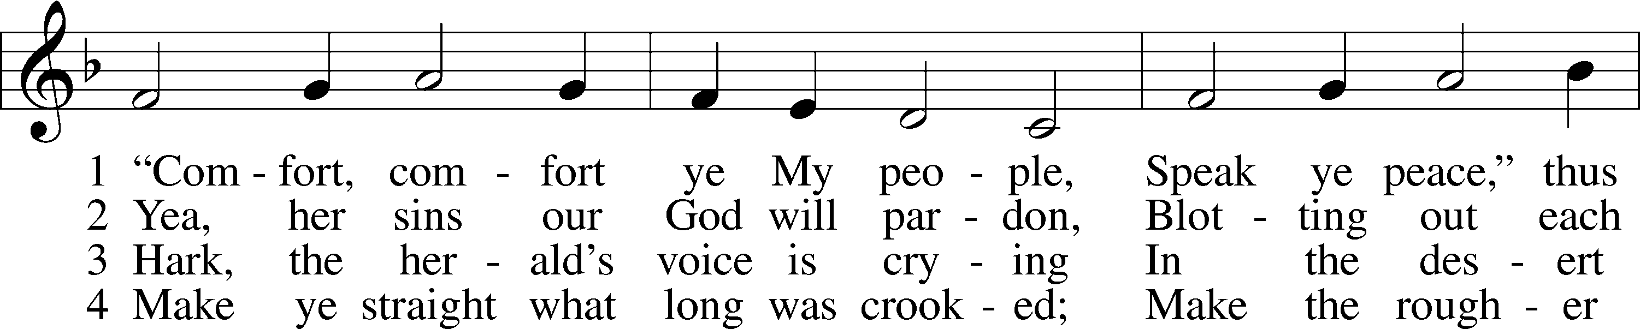
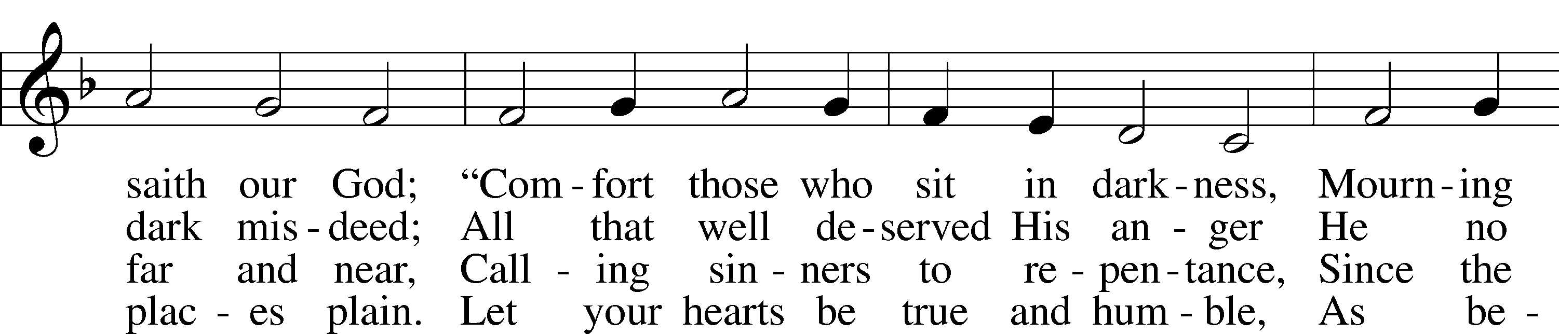
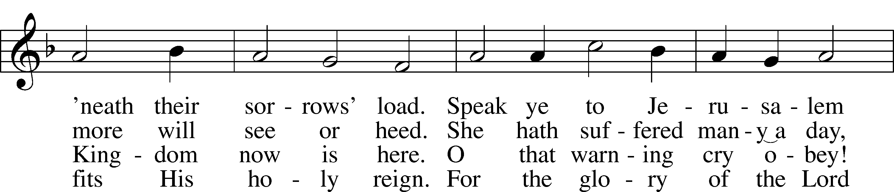
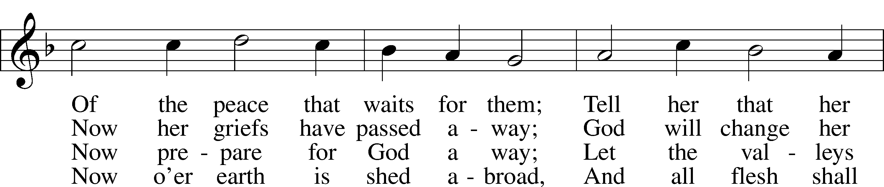
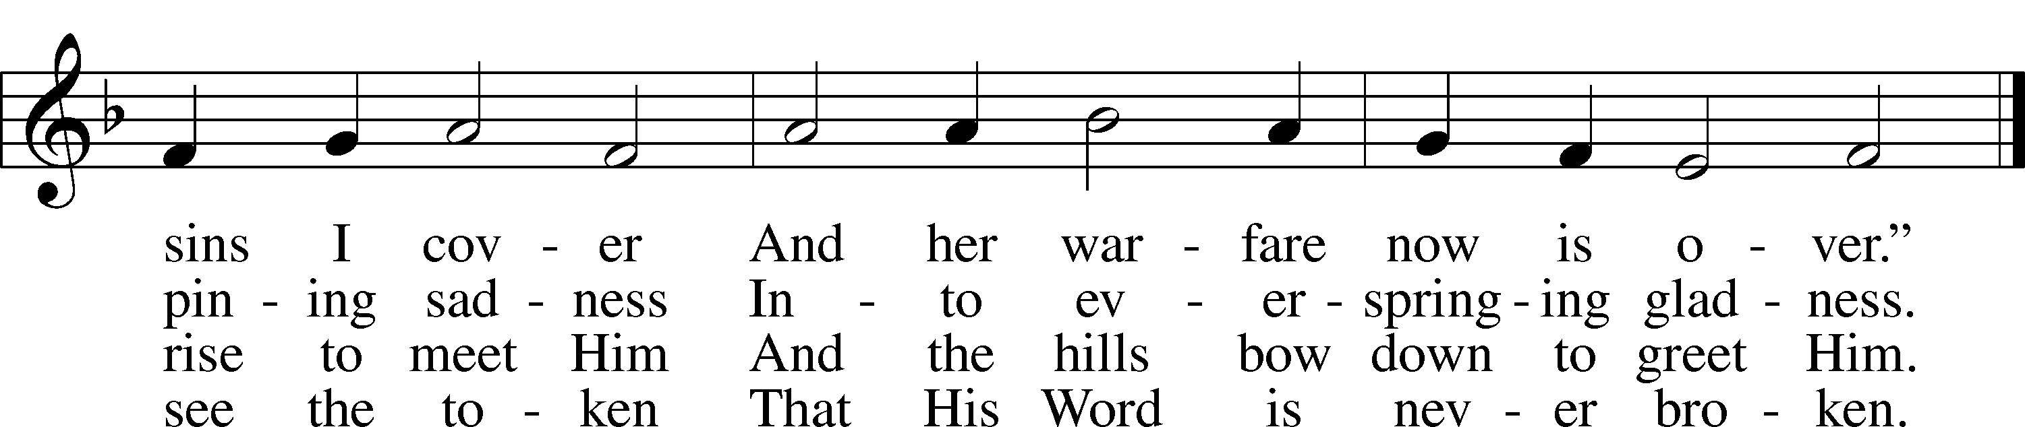
Public domain

Pastor: In the Name of the Father and of the Son and Holy Spirit.
Congregation: Amen.

PREPARATION

(Please Remain Standing Or You May Kneel…)
CONFESSION OF SIN:
All: God, I admit I have broken all of your commandments; I am not holy or sinless even though I often pretend a righteousness I do not have. I offer excuses. I have broken relationships by what I have said, or done. I have not loved either You or my neighbor as I ought. (time for personal confession____)
YOU ARE FORGIVEN:
Pastor: God is merciful and gracious; He has given His Son, Jesus Christ to die and rise again for us, the sinful ones that we might be forgiven and enjoy His Peace. This is also a reminder of God’s gifts and blessing that have become ours in Holy Baptism.
Congregation: thank you God for Your blessing!
Pastor: Yes, the Grace of our Lord Jesus Christ, and the Love of God, and the fellowship of His Holy Spirit is with you all.
Congregation: And also with you.
Pastor: In peace and as His forgiven people, we can pray to the Lord:
Congregation: He is gracious to us and hears our prayers.
Pastor: For the peace of the whole world and our involvement in Christ’s Mission in the world, we pray:
Congregation: Keep us mindful of our purpose as Christians and our ability to share your blessings of peace and forgiveness with others.
Pastor: We are the children of the Risen Christ. His victory is Our Victory!

THE PRAYERS OF THE CHURCH:
All: Lord Jesus Christ, we implore You to hear our prayers and to lighten the darkness of our hearts by Your gracious visitation; for You live and reign with the Father and the Holy Spirit, one God now and forever. Amen

SERVICE OF THE WORD

God speaks to us through his word, the Bible:

You may be seated…
THE OLD TESTAMENT READING: Isaiah 61:1-4, 8-11
Lector: This is the Word of the Lord.
People: Thanks be to God.

THE EPISTLE LESSON: 1 Thessalonians 5:16-24
Lector: This is the Word of the Lord.
People: Thanks be to God.

SPECIAL MUSIC: “O Come, O Come Emmanuel” arr. John Behnke

Please stand…
THE HOLY GOSPEL: John 1:6-8, 19-28
Pastor: The Holy Gospel according to St. John the 1st Chapter
People: Glory to You, O Lord.
Pastor: This is the Gospel of the Lord.
People: Praise to You, O Christ!

CHILDREN’S MESSAGE

NOISE OFFERING
It’s called a noise offering because what we are asking for is pocket change. It will always be used for missions outside of our church and school. It normally also is given to a mission involving children. Thanks for making a joyful noise to the Lord.

Please be seated…
SERMON HYMN: “O Little Town of Bethlehem” LSB 361
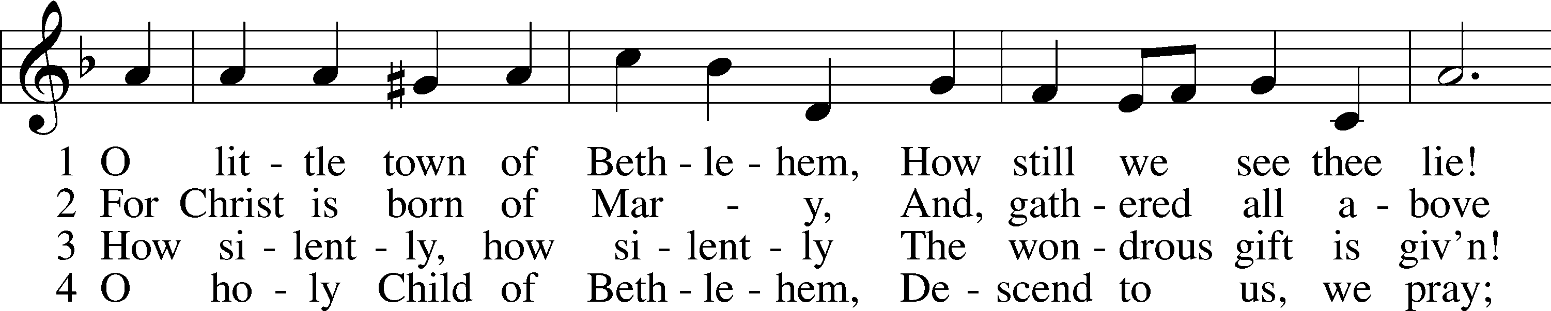
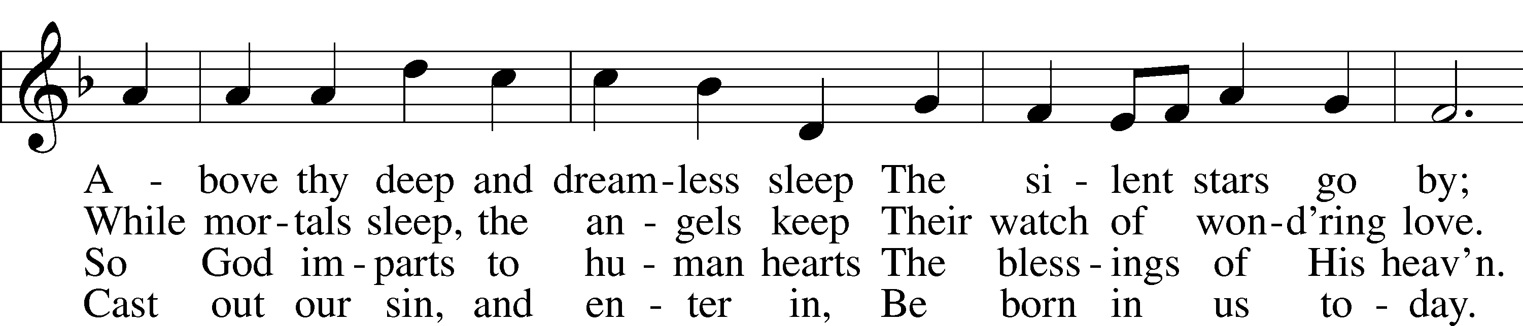
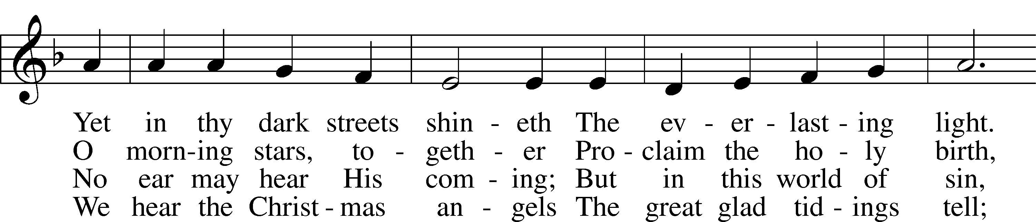
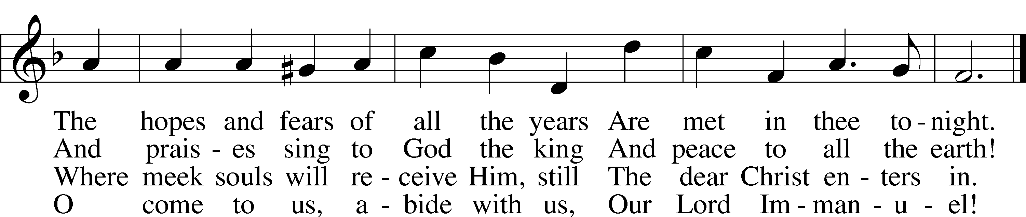
Public domain
“What are we doing that nobody
else is doing to reach people that
nobody else is reaching?”

THE SERMON: “A growing relationship with Jesus” All 3 Lessons
(Please stand…)

THE PROFESSION OF FAITH:
Pastor: God has given us a great message to take to His world. Let us remind ourselves and one another of what that message is:
Pastor: I believe in God the Father, Almighty
Congregation: Maker of heaven and earth
Pastor: And in His Son, Jesus Christ our Lord,
Congregation: Who was conceived by the Holy Spirit
Pastor: Born of the Virgin Mary
Congregation: Suffered under Pontius Pilate
Pastor: Was crucified, died and was buried
Congregation: He descended into hell.
Pastor: On the third day He rose again from the dead,
Congregation: And ascended into heaven
Pastor: And sits on the right hand of God, the Father almighty
Congregation: From there He will come to judge the living and the dead
Pastor: I believe in the Holy Spirit,
Congregation: The Holy Christian Church as
All: the communion of saints; the forgiveness of sins, the resurrection of the body, and the life everlasting. Amen.

(You may be seated…)
OFFERING RECEIVED: “We Look for the Star” - Hal H. Hopson Vocal Choir

(Please stand…)
“Praise God, from Whom All Blessings Flow” LSB 805
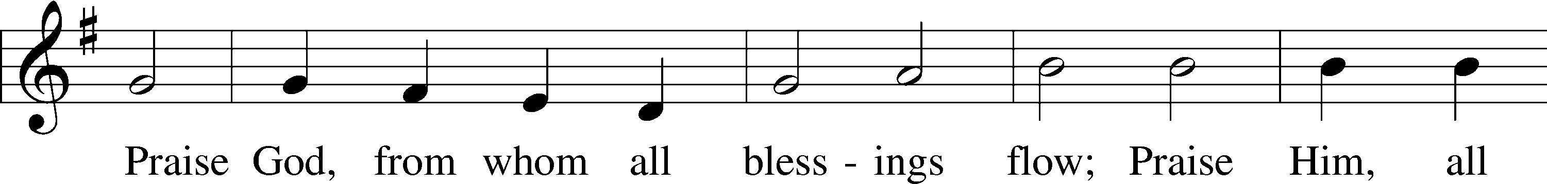
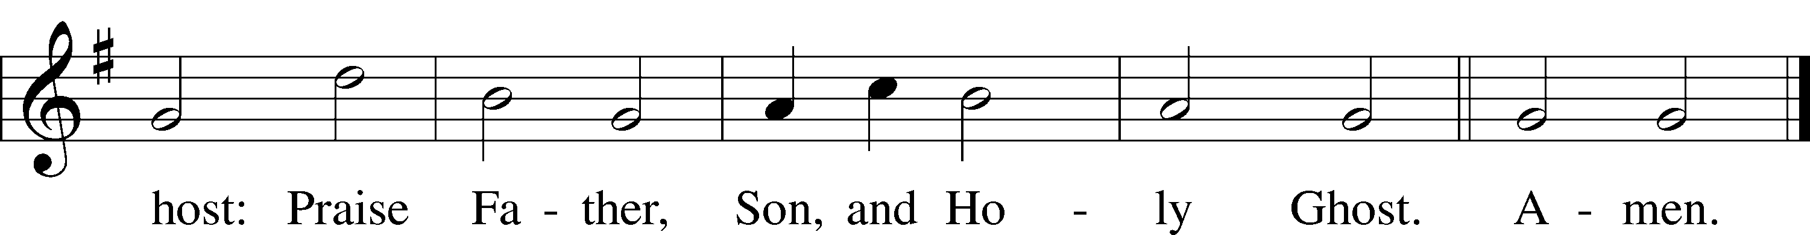
Public domain

SERVICE OF THE SACRAMENT
(Please stand…)
PREPARE FOR THE LORD’S SUPPER:
Pastor: We begin with the reminder: “The Lord is with you.”
Congregation: We are mindful and thankful for His presence.
Pastor: Let your life reflect the joy of your salvation.
Congregation: We do give Him thanks and praise. We will share His blessing with others.
Pastor: It is proper that we should at all times and in all places…(prayer)… we praise your name and join others in singing:
All: (sing) “Holy, holy, holy Lord God of pow’r and might:
Heaven and earth are full of your glory.
Hosanna, Hosanna, Hosanna in the highest.
Blessed is he who comes in the name of the Lord.
Hosanna in the highest.”

(Please be seated…)
THE WORDS OF INSTITUTION

DISTRIBUTION HYMNS: “Come, Thou Long-Expected Jesus” LSB 338
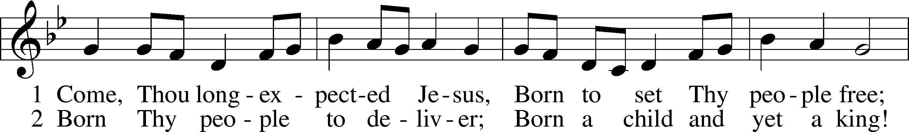
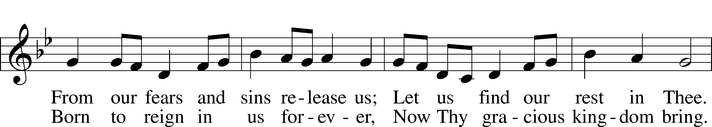
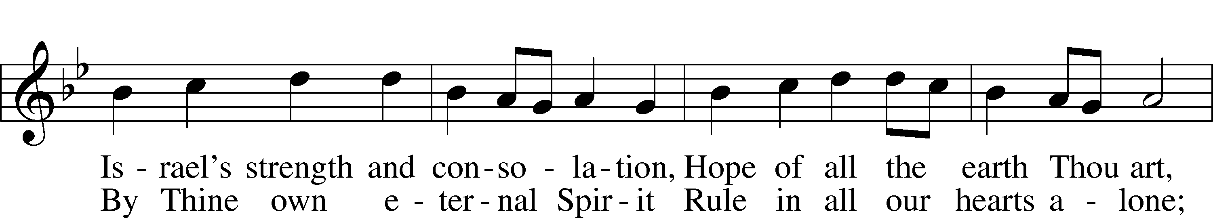
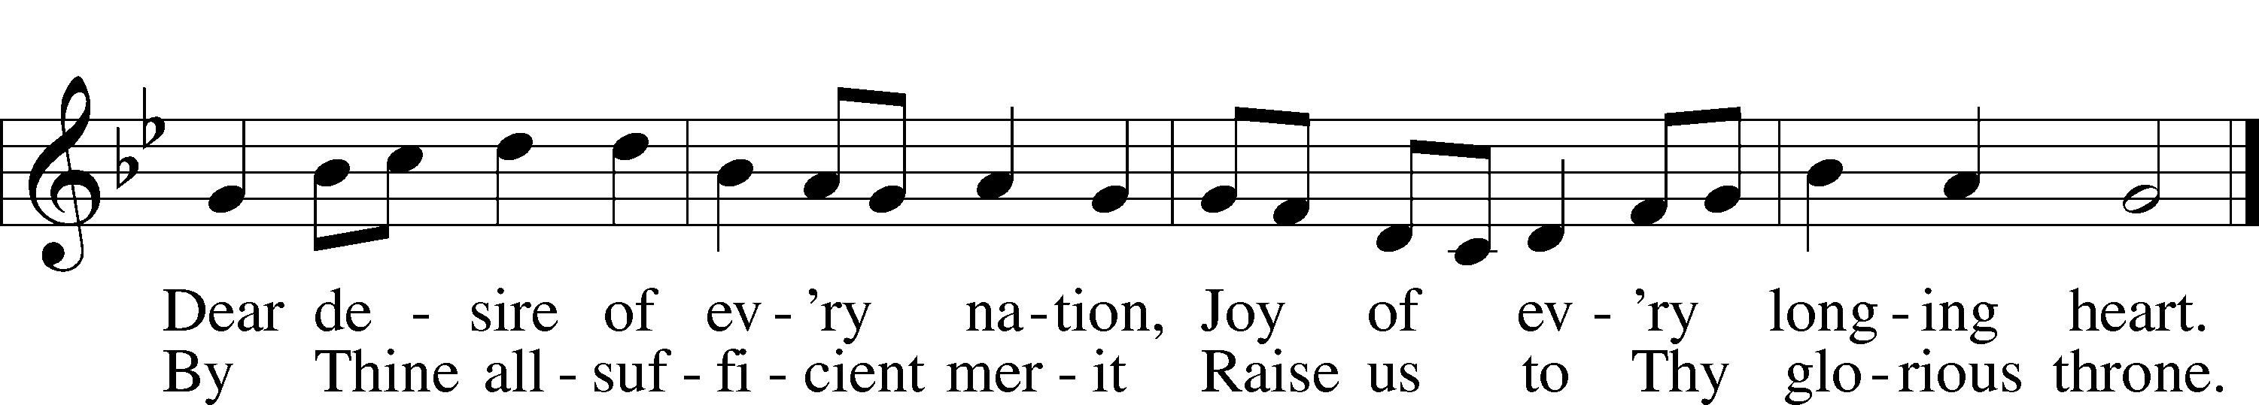
Public domain

“People Look to the East” Vocal Choir

“Hark the Glad Sound” LSB 349
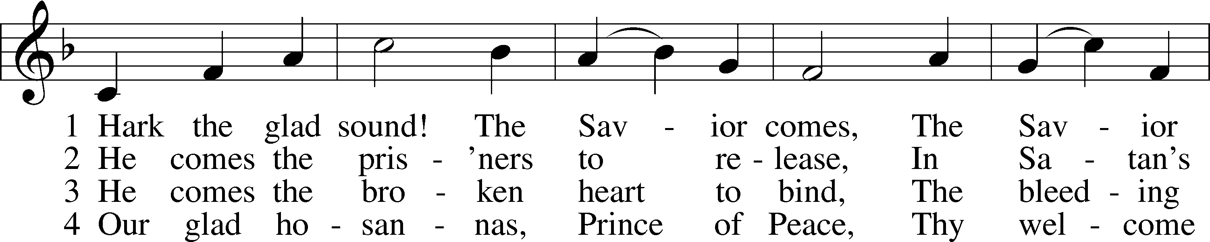
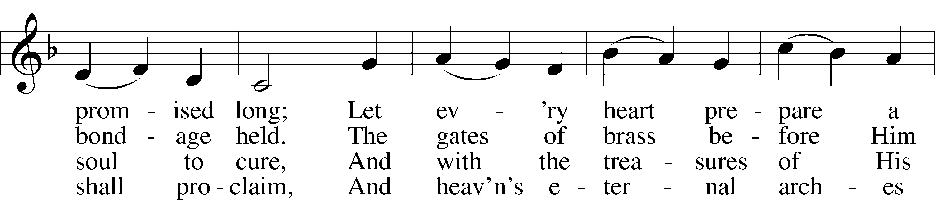
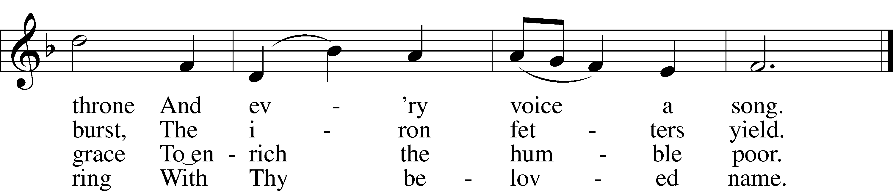
Public domain

(Please stand…)
THE LORD’S PRAYER:
All: Our Father, who art in heaven, hallowed be thy name, thy kingdom come, thy will be done, on earth as it is in heaven. Give us this day our daily bread; and forgive us our trespasses as we forgive those who trespass against us; and lead us not into temptation, but deliver us from evil. For thine is the kingdom, and the power, and the glory, forever and ever. Amen

THE BLESSING AND BENEDICTION:
Pastor: The Lord Blesses you and keeps you, the Lord makes His face to shine upon you and He is Gracious to you. The Lord looks upon you with His favor and gives you His peace.
Congregation: God blesses us so that we can be a blessing to others.
Pastor: Go in His peace and serve the Lord by serving others.
Congregation: Amen

THE CLOSING HYMN: “Lift Up Your Heads, Ye Mighty Gates” LSB 341
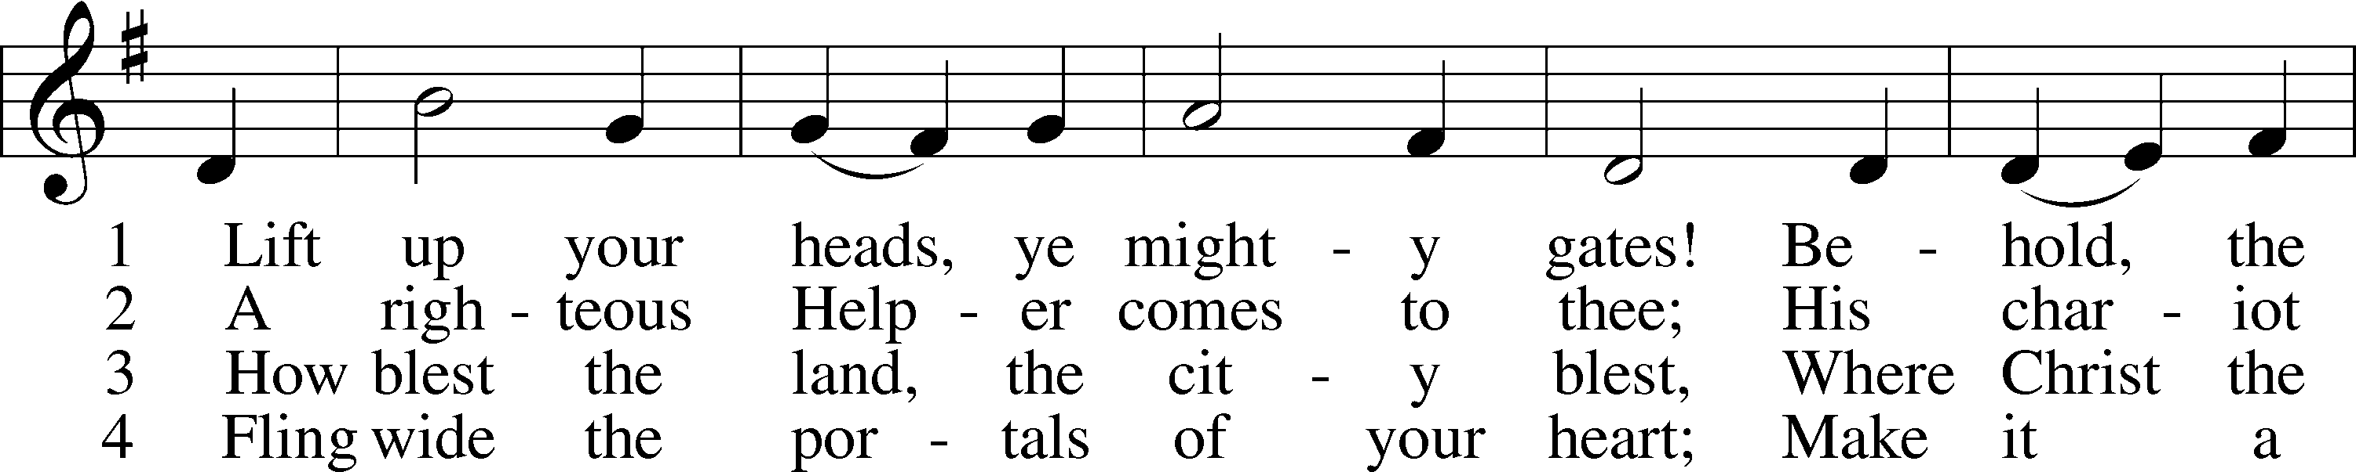
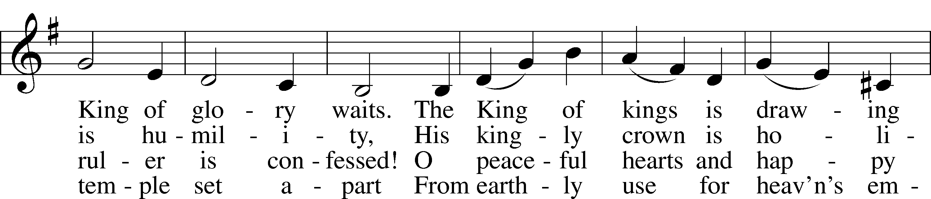
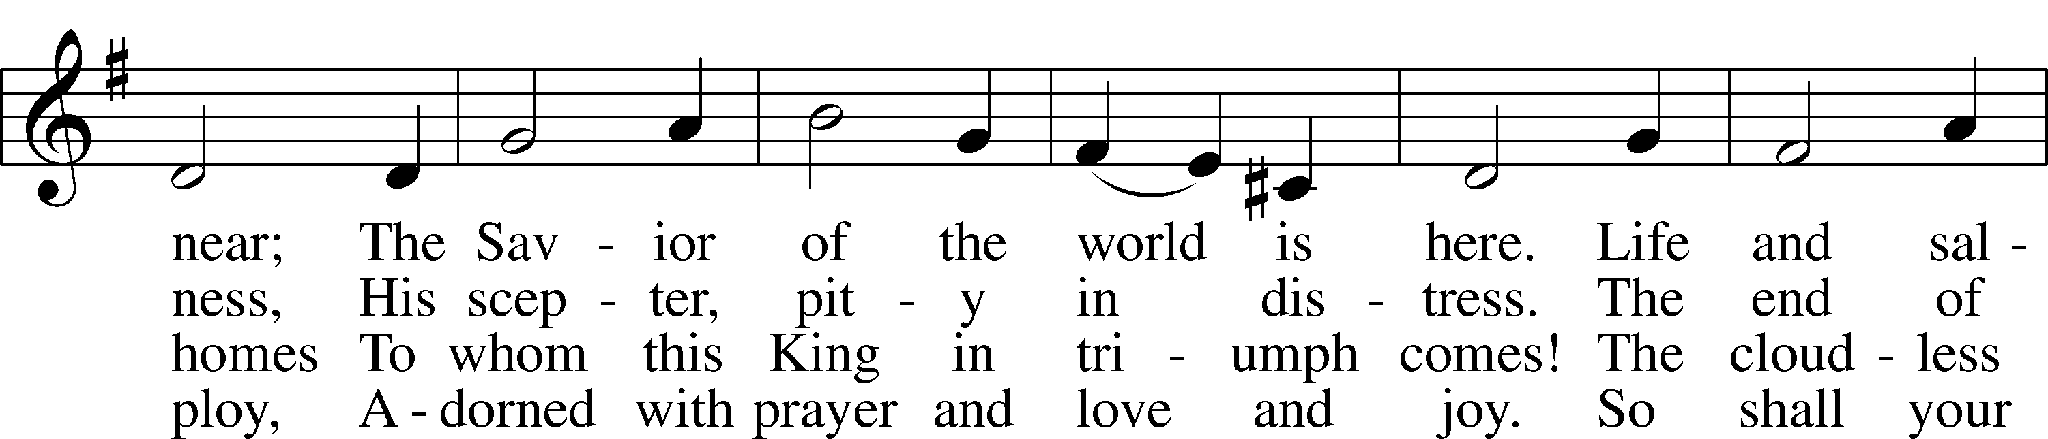
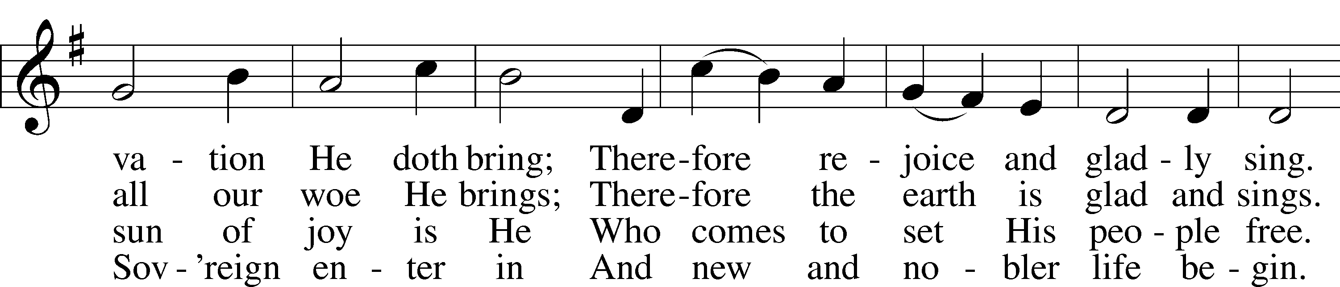
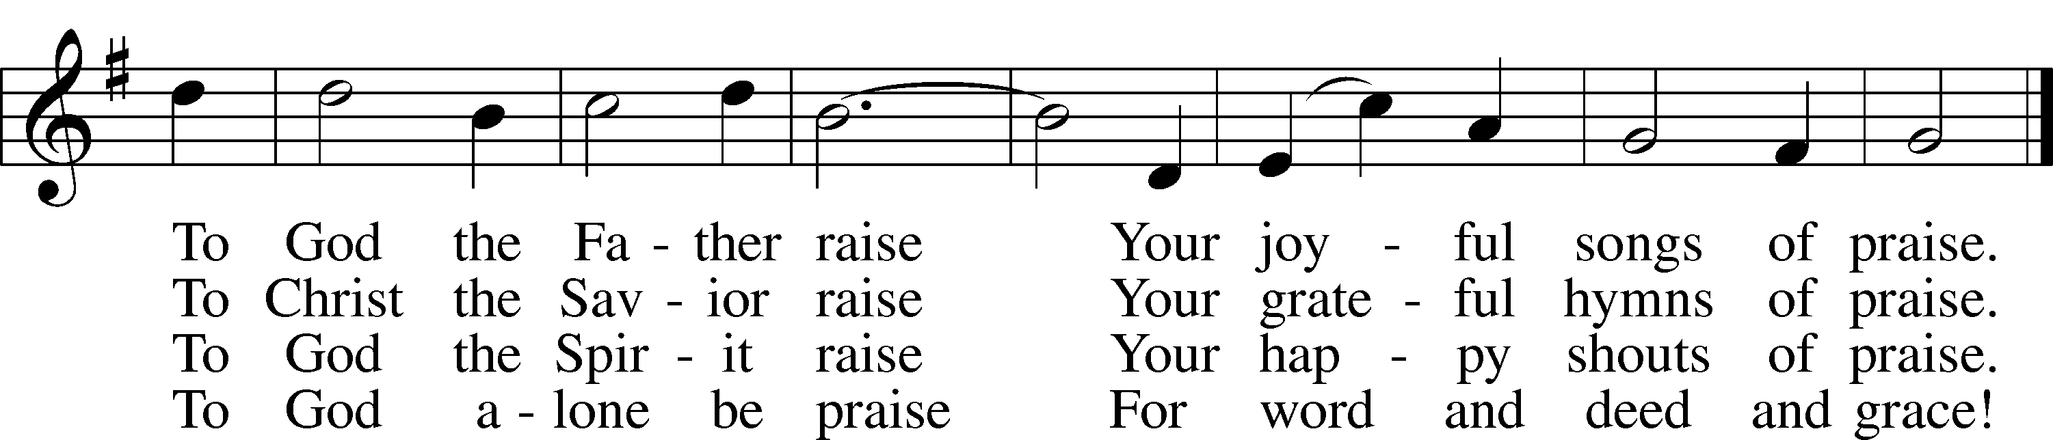

5 Redeemer, come and open wide
My heart to Thee; here, Lord, abide!
O enter with Thy grace divine;
Thy face of mercy on me shine.
Thy Holy Spirit guide us on
Until our glorious goal is won.
Eternal praise and fame
We offer to Thy name. Public domain

POSTLUDE: “Lift Up Your Heads, Ye Mighty Gates" - John Behnke

WELCOME TO GRACE LUTHERAN CHURCH: We are glad that you are here to worship God with us today! We pray that you will enjoy the wonderful fellowship as friends in Christ as God gathers us around His means of grace, the Word and Sacraments, to bless us with His treasured gifts of forgiveness, faith, abundant life and eternal salvation. If you are a guest, please also sign our Guest Book. Please talk to Pastor if you would like to learn more about becoming a member of Grace. Also, please join us for refreshments and fellowship after the Service. We invite you to come and worship with us often as God gathers us in His Grace.

WELCOME TO THE LORD’S TABLE: We invite and encourage all present who are baptized and faithful Christians, and who confess the Father, Son, and Holy Spirit to be the only true God and who believe that Jesus Christ died for the sins of the World and is our only hope and salvation…to join us in receiving the very and true body and blood of Christ in this Sacrament. The clear liquid cups in the center of the tray are non-alcoholic wine.
Children not yet confirmed in the faith are always welcome to join their parents at the Lord’s Table, but should keep their hands folded in front of them. The Pastor will give them a blessing.

SERVING TODAY: Acolyte: Eli Morris; Lector: Mike Sattelmeier: Communion Assistants: David Walker and Mary Brady; Usher: Bill Chalmers; Altar Care: ___________; Refreshments: ________________.

SERVING WEDNESDAY: Acolyte: Emily Howard; Usher: Vince Winters

SERVING NEXT SUNDAY: Acolyte: Eli Morris; Lector: Mike Sattelmeier; Communion Assistants: David Walker and Mary Brady; Usher: Bill Chalmers; Altar Care: _________; Refreshments: _____________.

FLOWERS: were placed on the altar to the glory of God and by Noelle in loving memory of her husband, Will Plagens.
THIS WEEK AT A GLANCE:
Today: December 17th
9:00 am Worship Service with Communion
10:10 am Jr. Choir Rehearsal
10:15 am Fellowship and Christmas Eve Service Practice
10:30 am Adult Bible Study

Monday: December 18th
Pastor’s Day Off

Tuesday: December 19th
11:30 pm Gracious Ladies of Grace (Louie’s Backyard)
2:30 pm Jan’s Gym
4:15 pm Book Club (Room 3)
6:00 pm Weight Watcher’s (Parish Hall)

Wednesday: December 20th
12:30 pm Men’s Bible Fellowship (Chico’s)
5:00 pm Women’s Bible Study (Room 3)
6:00 pm Potluck Dinner
7:00 pm Advent Service

Thursday: December 21st
4:15 pm Missional Communities (Room 30)
6:00 pm Bell Choir Rehearsal
6:30 pm Vocal Choir Rehearsal

Next Sunday: December 24th
9:00 am Worship Service with Communion
10:10 am Jr. Choir Rehearsal
5:00 pm Children’s Christmas Eve Service
10:00 pm Candlelight Service

IN YOUR PRAYERS THIS WEEK: family of Jim and Gerrie Parker, Micah Westphalen, Joe Mercurio, Walt Lepperd Rachel Hoppe, Dennis Julson, Alga Odland, Sandra Chrisman, Vernon Julson, Brittany Howard, Beverly Walker, Ann Barber, Al and Kathleen Schubert, Mary Eschels, Max Broadbent, Peggy Mira, Bud Wrocklage, and those you are praying for at home. If anyone has a special prayer request please submit it in writing in the collection plate; or you may call Pastor Gary Faith at (504-858-8872), or Kris Howard at (305-296-5161).

If you would like the names of family and friends added to the list please contact Kris or Pastor.

GIFTS, TITHES, & ATTENDANCE LAST SUNDAY: Sunday December 10th received $4568.00, the window fund received $16200.00 and the noise offering received $42.17 with an attendance of 70. The Wednesday Advent Service collected $202.00 with an attendance of 21.

TO HELP US GROW… The Bible reading for next Sunday’s service are 2 Samuel 7:1-11,16, Romans 16:25-27, and Luke 1:26-38.

THIS WEDNESDAY our school children will be sharing the message of Christmas wit h their families during our chapel service at 8:30. You are welcome to join us.

FUNDS NEEDED The remainder of the church windows that need to be replaced will be installed in January. We have two donors but will need additional funds to complete the much needed and long-awaited project. The cost of each window is $2700 and 3 out of 13 still need to be funded. Checks can be made out to Grace Lutheran Church and earmarked "windows". Thank you for your consideration.

OUR CHILDREN’S REHEARSALS for the 5:00 pm Christmas Eve Service have begun. If your child is interested, please meet in the sanctuary at 10:30 today. We would love to have as many participants as possible.

ADVENT SERVICES WILL CONTINUE ON 20th at 7 pm. Our second service will focus on Luke 2:1-20. Christmas as told by Luke.

WE WILL HAVE 3 SERVICES DECEMBER 24TH:
9 am Sunday Morning Service
5 pm Children’s Program
10 pm Candlelight Service

IF YOU ARE INTERESTED IN LEARNING more about what we believe and teach and/or are interested in becoming a member of Grace Please let Pastor know so that he can begin an Adult Information class.

THANKS TO ALL OF YOU for helping your neighbor, listening to others, and being a blessing to the community and to GLCS.

I HAVE A COUPLE OF COPIES of Pastor Finke’s book, “Joining Jesu on His Mission”. If you would like to get maximum results from Greg and Susan’s visit in January, you are welcome to borrow a copy. See Kris or Pastor.

THERE IS ADDITIONAL PARKING behind the school. Enter that lot on 10th Street.

WE HAVE SET THE SCHEDULES for ushers, acolytes, lectors, and communion assistants for the next three months. If you would like to serve in any of these positions, please let Pastor or Kris know.

STEWARDSHIP LISTS: On the bulletin board by the front door of the church you will find the Altar Care, Refreshments, and Flower sign-up sheets for 2017. If you are able to help out with any of these please place your name in the spot on the date requested.

THE GRACE LUTHERAN CHURCH WEB PAGE AND FACE BOOK PAGE now
contains a vocal recording of last week’s sermon. So, if you are not able to attend church on Sunday please go to our website where you will find a copy of the bulletin and a recording of Pastor Faith’s sermon. https://gracelutherankw.360unite.com/home.

SAVE THE DATE AND MARK ON YOUR CALENDAR

JANUARY 27TH, 2018: We plan on having the annual “Let’s Get to Know our Snowbird Friends Better” with Susan and Greg as our guests of honor.

JANUARY 28TH, 2018: Mark this day on your calendar. Pastor Greg Finke and his wife Susan are scheduled to join us for worship and training on how to be a neighborhood missionary. The Finke’s travel all over the country helping equip folks for everyday ministry. Don’t miss this opportunity or you will wonder why everyone is more excited about Jesus missing.

Yum, Yum, Yum was all I heard as the ladies were digging into their lunch plates. Shrimp salad, fish cakes mussels in an unbelievably scrumptious wine, garlic and butter sauce with crusty bread to dip in it (can't you tell this was my lunch, I also was using my spoon to get even more of this delight into my body). Elaine scooped up what I couldn't finish. We were all pleased that we finally got a table where you couldn't hear or smell the garbage truck that always shows up when we're there. We had our usual efficient and accommodating wait-person who seems to somewhat like us and puts up with our sometimes-peculiar demands. All in all, I think we are a great lunch bunch. As usual we gave Salute a 5*****. Our next gathering will be at Louie's Back Yard on Dec.19th at 11:30.

MUSIC MINISTRY: "Make a joyful noise to the Lord, all the earth!" Psalm 100:1. Whether you are here year-round or part-time, we invite you to participate in our music ministry. Please speak with Beverly Walker or contact her at beverlywalker@gmail.com if you have any questions.

Jr. Choir: Rehearsal today from 10:10-10:25.

Bell Choir: Rehearsal on Thursday from 6:00-6:30 pm.

Vocal Choir: Rehearsal today at 10:30 am and Thursday at 6:30 pm

MEN’S BIBLE FELLOWSHIP: They meet the first and third Wednesday’s of each month at 12:30pm. Their next meeting will be December 20th located at Chico’s on Stock Island. All guys are welcome.

WOMEN’S BIBLE STUDY: Our study on Abigail concluded this Wednesday and we were inspired and encouraged by her godly example. We will meet again after the first of the year with a new study and time TBD at a later time.

