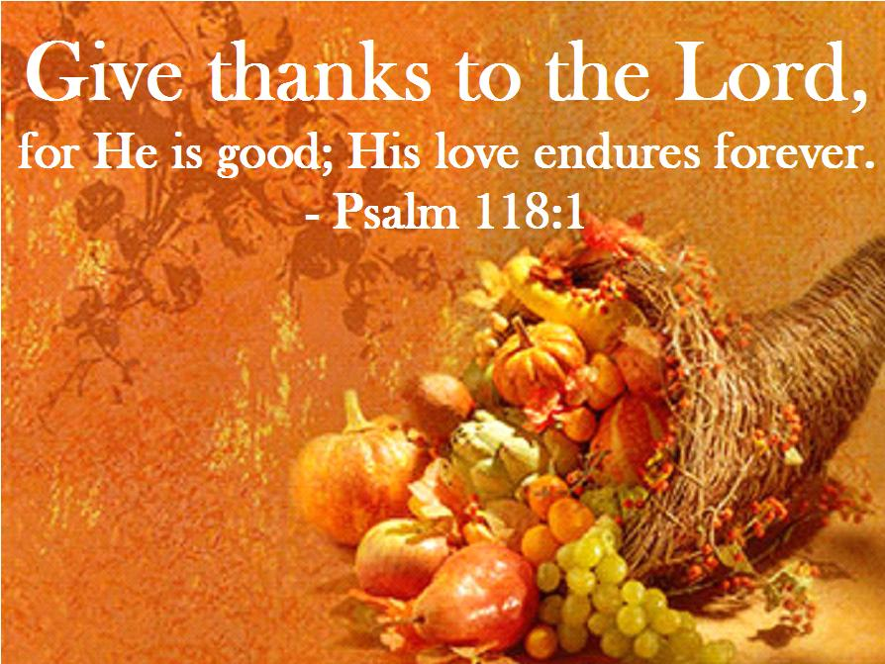

Worship for Thanksgiving Celebration

November 19th, 2017

Grace Lutheran Church
2713 Flagler Ave.
Key West, FL 33040

305-296-5161
GraceLutheranKW@att.net

Pastor Faith
(504) 858-8872
garyfaith@aol.com
WORSHIP FOR THANKSGIVING CELEBRATION
NOVEMBER 19, 2017 9:00 a.m.
WORSHIP SERVICE
In the Name of Jesus!
Our Mission Statement: Anchored in Christ, each person a missionary.

PRELUDE: “We Praise You, O God” Michael Graham

THE CALL TO WORSHIP

Pastor: O Lord how marvelous are Your works! In wisdom You have made them all; the earth is full of Your riches.
Congregation: Bless the Lord, O my soul, and forget not all His benefits.
Pastor: We will offer to you our words of Praise and Thanksgiving.

(Please stand…)
OPENING HYMN: “We Praise You, O God” LSB 785
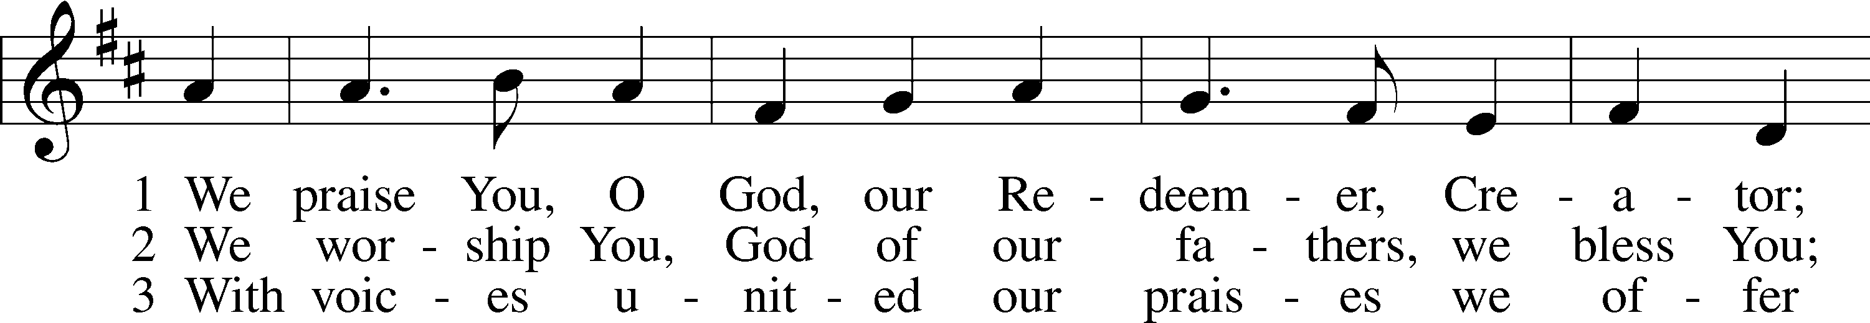
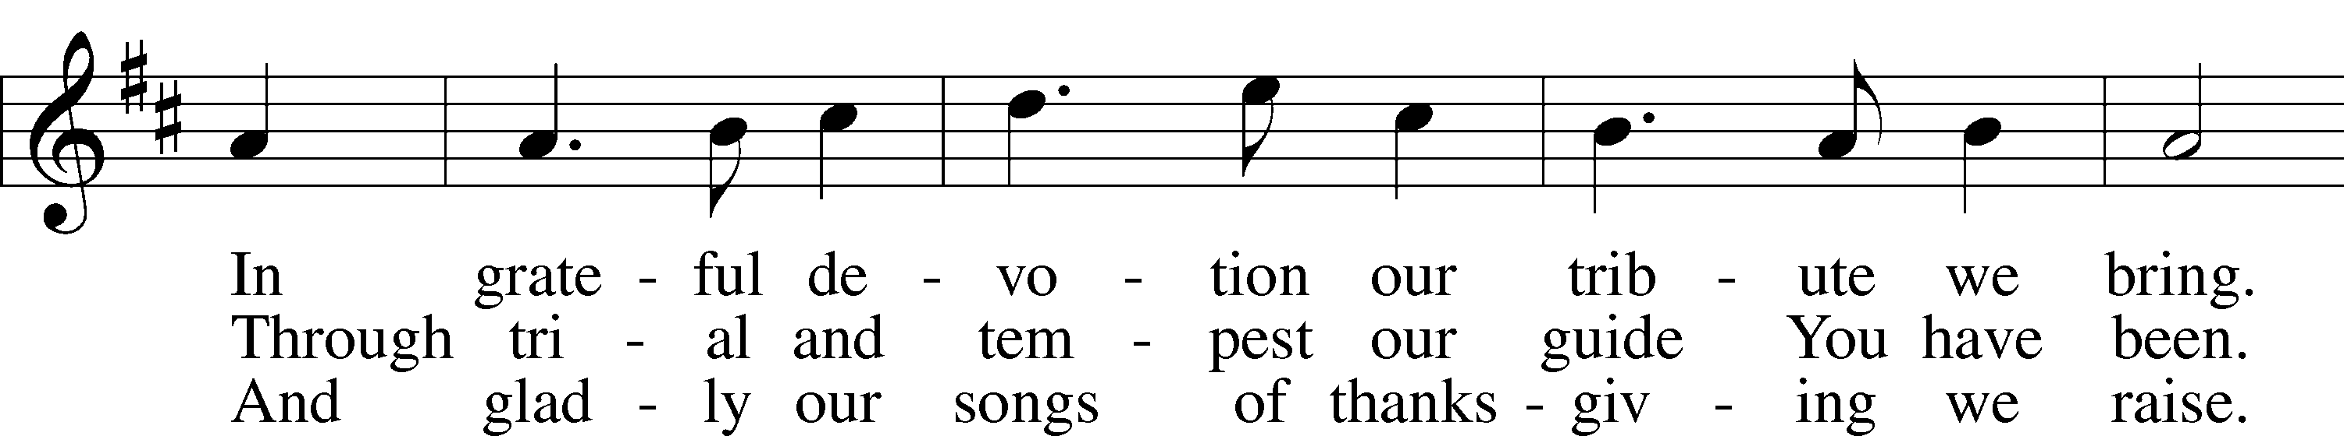
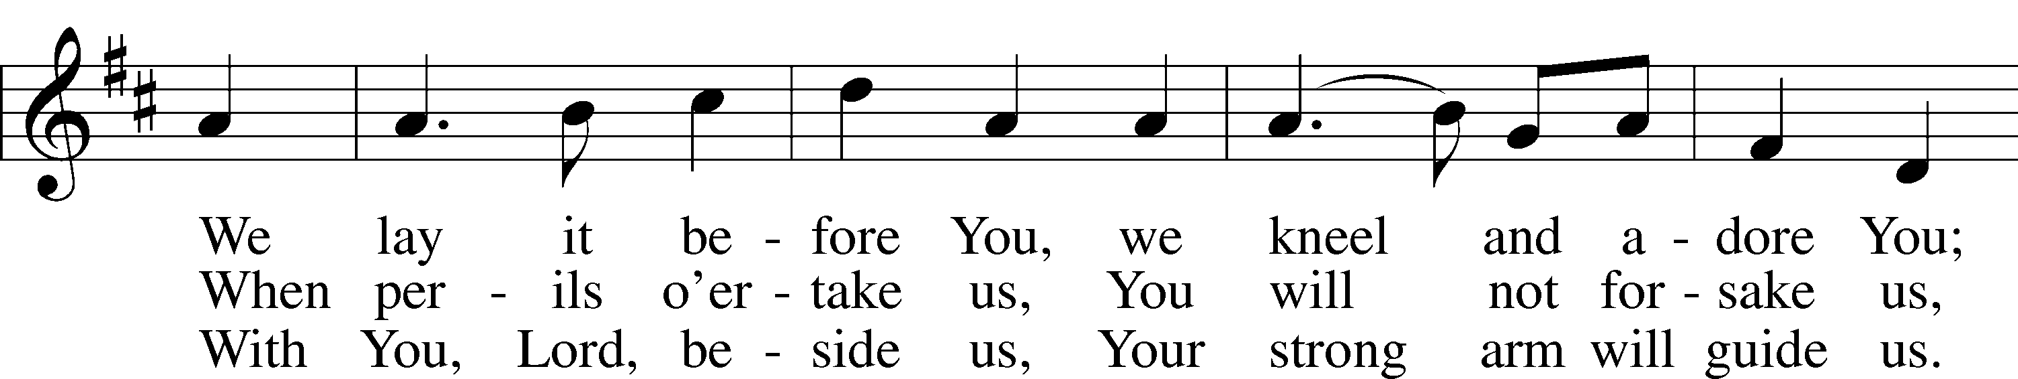
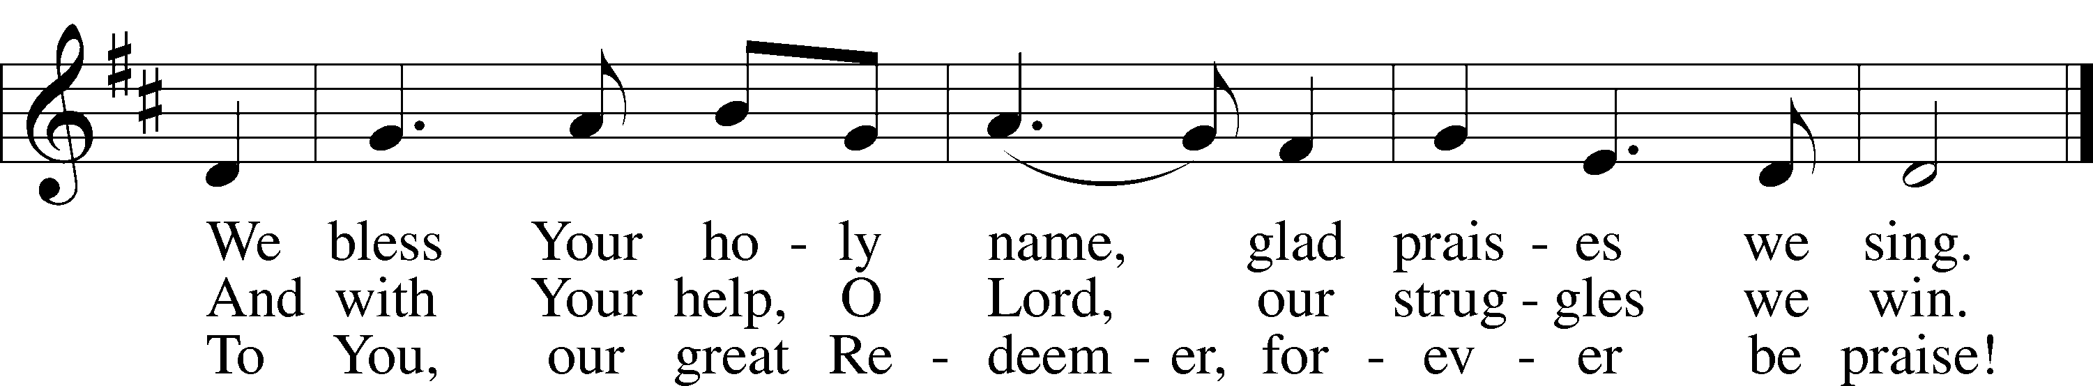
Public domain

Pastor: In the Name of the Father and of Son and of the Holy Spirit.
Congregation: Amen

(Please Remain Standing or You May Kneel)
CONFESSION AND ABSOLUTION:
All: We repent Lord, for failing to recognize the greatness of Your many blessings, for thinking that man can live by bread alone; and for assuming that we have earned the harvest merely because we have planted the seed. We have often lacked mercy and love in our relationships with others.
Pastor: I have Good News for you. Our sins are already forgiven. Jesus paid for them at Calvary. It is His forgiveness that enables us to live a life of thanksgiving
Congregation: Thanks be to God the Father, God the Son, and God the Holy Spirit. Amen..
.
SERVICE OF THE WORD

(You may be seated…)
THE FIRST READING: Deuteronomy 8:1-10
Lector: This is the Word of the Lord.
People: Thanks be to God.

THE SECOND READING: Philippians 4:2-7
Lector: This is the Word of the Lord.
People: Thanks be to God.

(Please stand…)
THE HOLY GOSPEL: Luke 12:13-21
Pastor: The Holy Gospel according to St. Luke the 12th Chapter.
People: Glory to You, O Lord.
Pastor: This is the Gospel of the Lord.
People: Praise to You, O Christ!

(You may be seated…)
CHILDREN’S MESSAGE

NOISE OFFERING
It’s called a noise offering because what we are asking for is pocket change. It will always be used for missions outside of our church and school. It normally also is given to a mission involving children. Thanks for making a joyful noise to the Lord.
THE SERMON HYMN: “Come, Ye Thankful People, Come” LSB 892
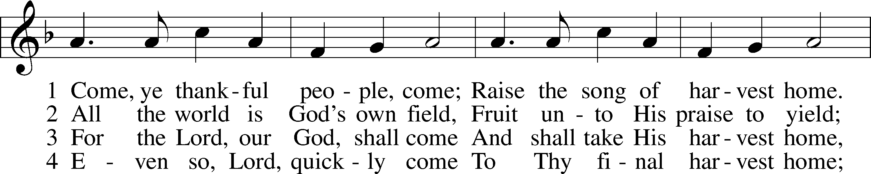
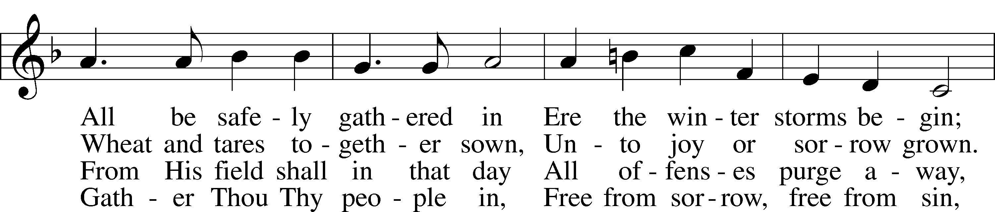
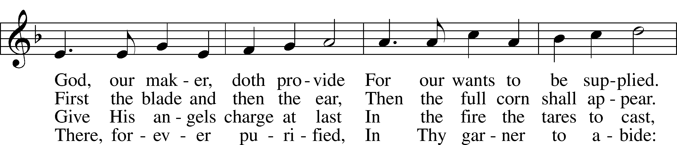
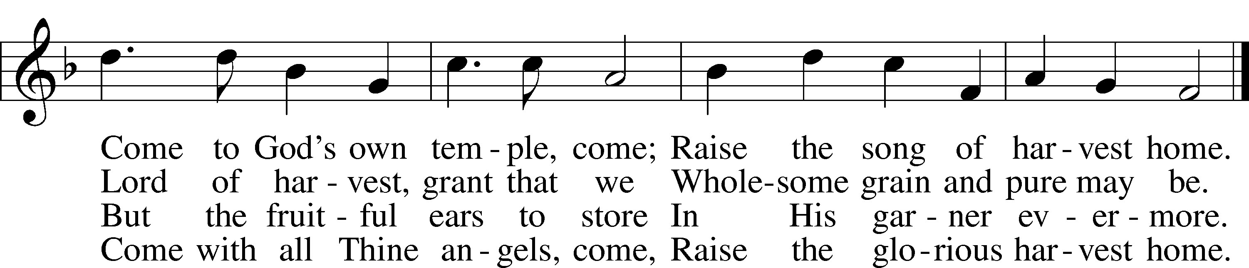
Public domain

THE SERMON: “Is it really that simple?” Deuteronomy 8:1-10

CREATION

Pastor: I believe in God the Father Almighty, Maker of heaven and earth.
What does this mean?
Congregation: I believe that God has made me and all creatures; that He has given me my body and soul, eyes, ears, and all my members, my reason and all my senses, and still preserves them;
Pastor: also clothing and shoes, meat and drink, house and home, wife and children fields, cattle, and all my goods; that He richly and daily provides me with all that I need to support this body and life;
Congregation: that He defends me against all danger, and guards and protects me from all evil;
Pastor: and all this purely out of fatherly, divine goodness and mercy, without any merit or worthiness in me;
Congregation: for all which it is my duty to thank and praise, to serve and obey Him.
All: This is most certainly true.
THE OFFERING: “Praise The Lord of Harvest” Vocal Choir
David Catherwood

“Praise God, from Whom All Blessings Flow” LSB 805
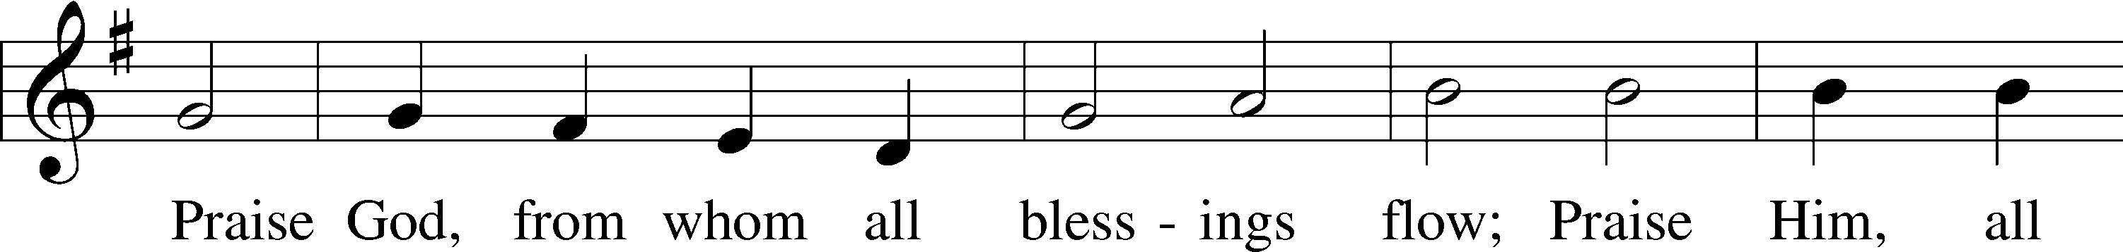
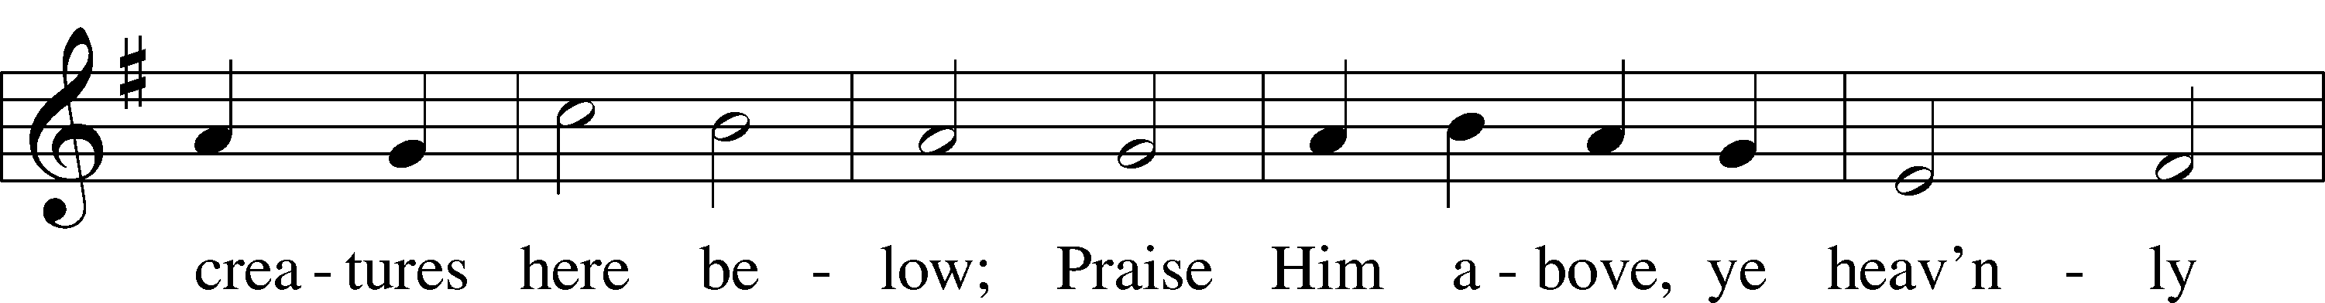
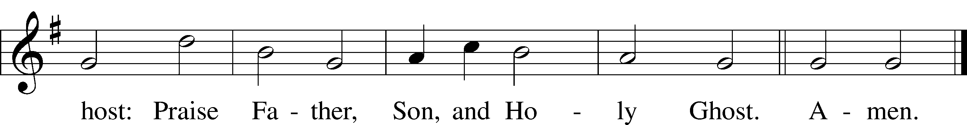
Public domain

THE THANKSGIVING LITANY

Pastor: O give thanks unto the Lord, for He is good.
Congregation: Make us joyful in our thanksgiving.
Pastor: For the down moments in our lives when we see only what we do not have, and for the many demands we direct at you and others;
Congregation: Make us humble in our thanksgiving.
Pastor: For those who have suffered loss and for those who will be separated from their loved ones at this holiday time for those we now Name silently or out loud be their comfort, O Lord.
Congregation: Make us compassionate in our thanksgiving.
Pastor: For those who travel to join a family celebration, and for those who labor to make these celebrations possible, keep them safe, O Lord.
Congregation: Make us caring in our thanksgiving.
Pastor: For the country of which we are a part, and for the goals of peace and brotherhood toward which we strive, bless us, Good Lord.
Congregation: Make us concerned in our thanksgiving.
Pastor: Receive our overflowing thanks, for the life which You have given to us in Jesus Christ.
Congregation: Oh give thanks unto the Lord, for He is good.

THE WORDS OF INSTITUTION

(You may be seated…)
Distribution Hymns: “Father, We Thank Thee” LSB 652
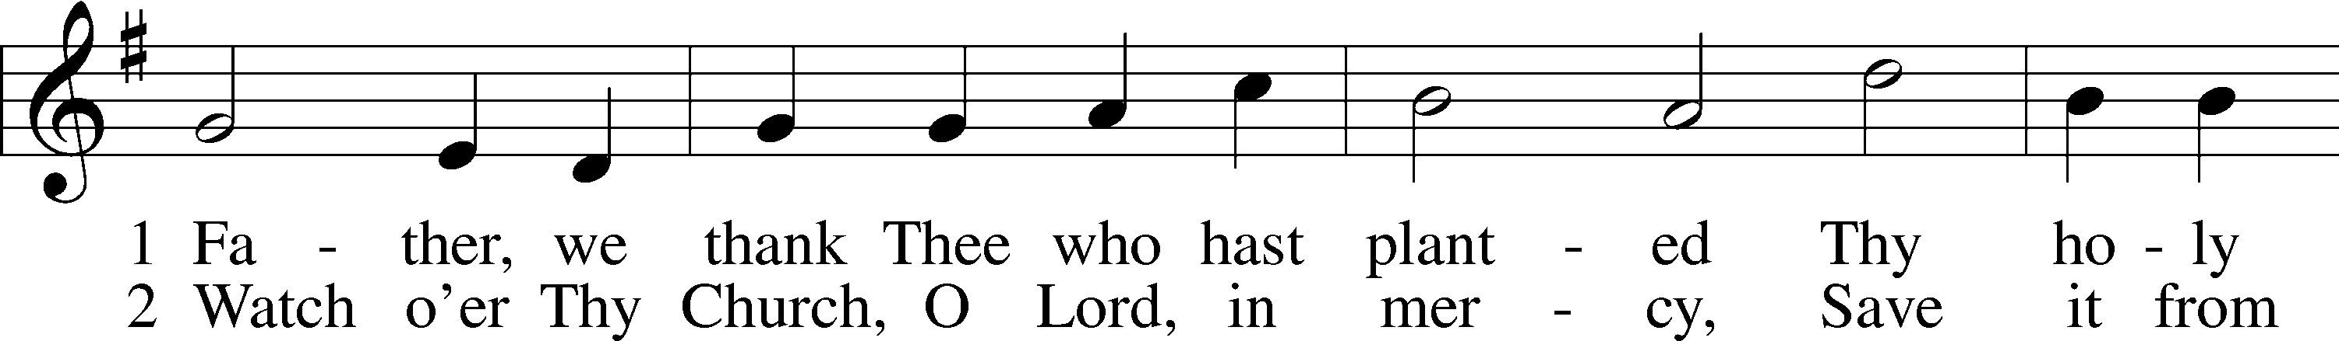
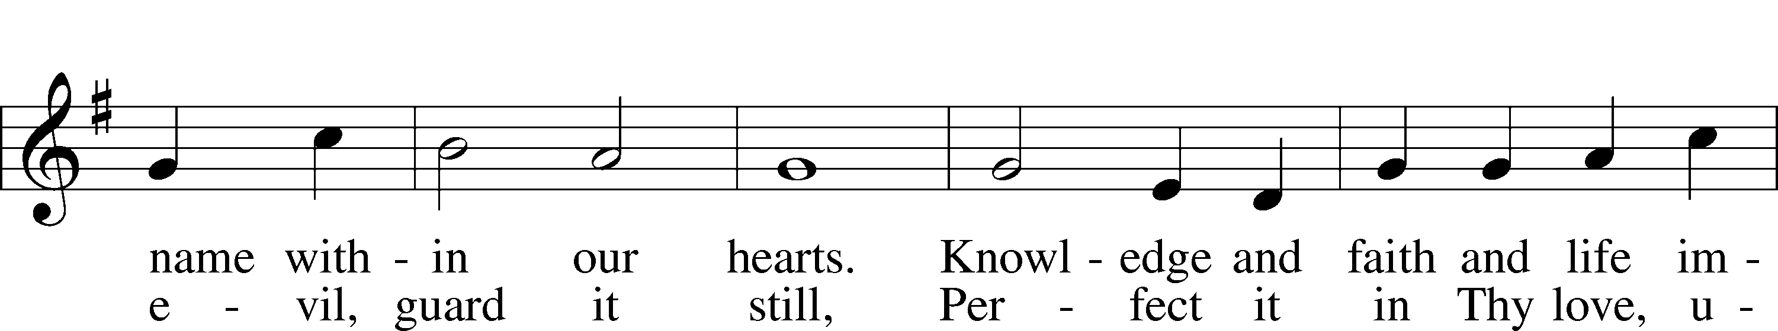
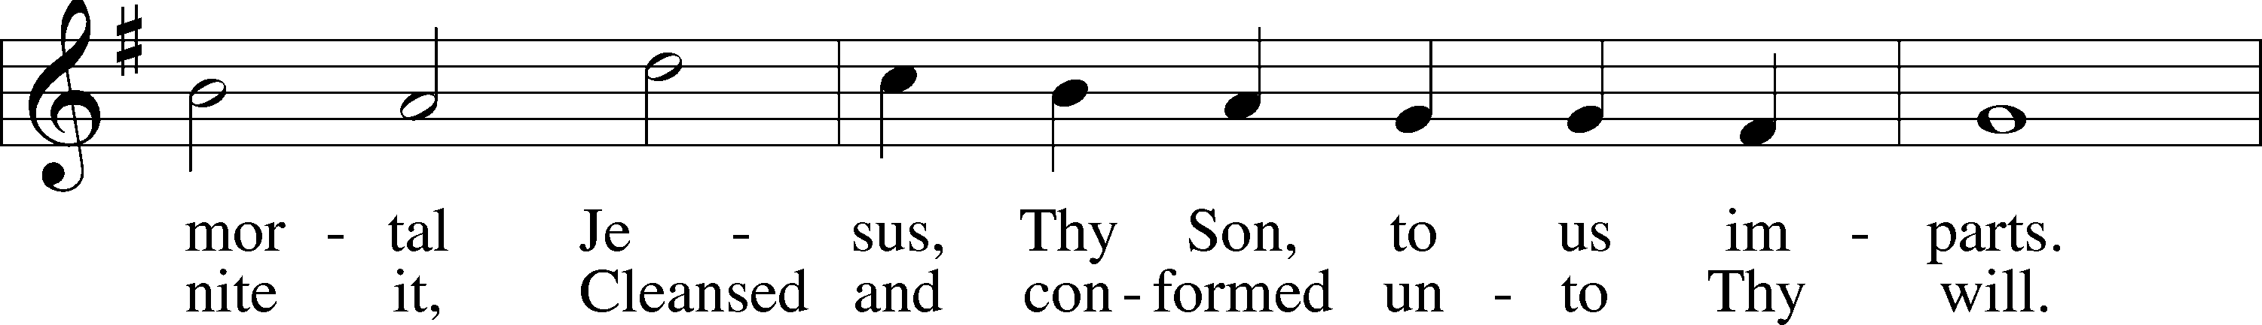
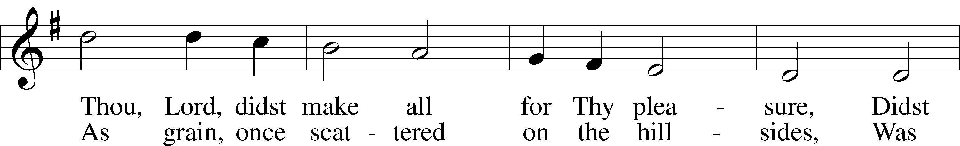
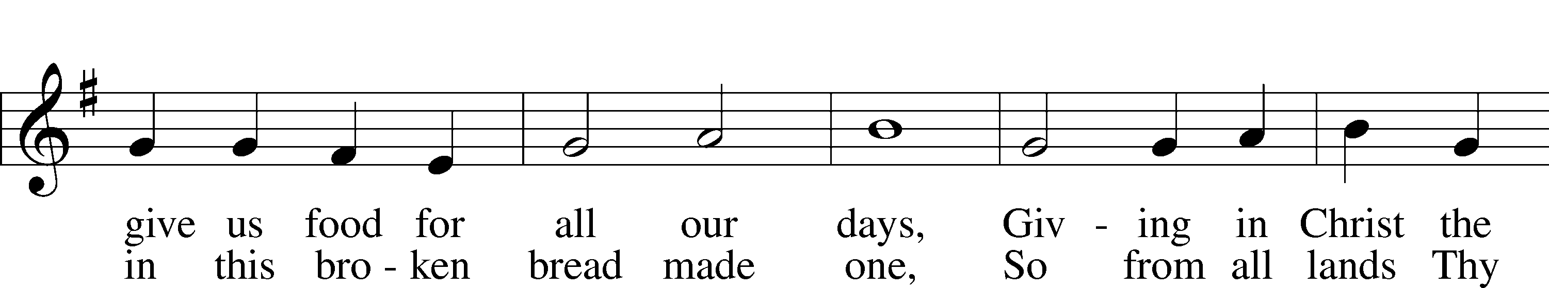
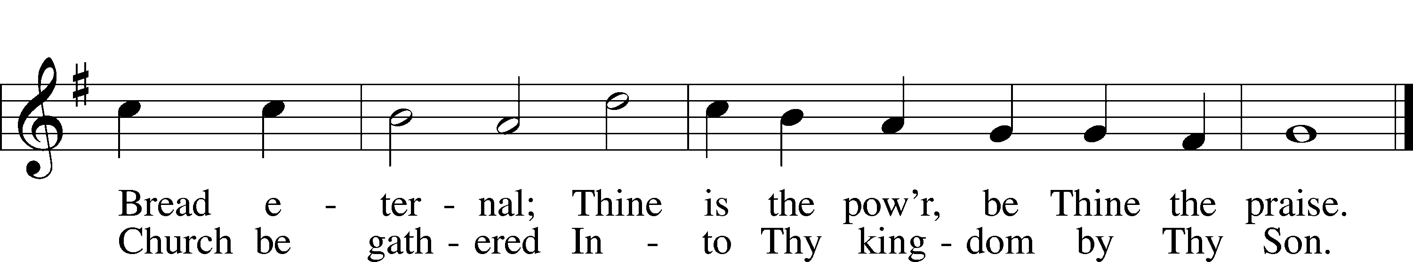
© The Church Pension Fund. Used by permission: LSB Hymn License .NET, no. 100011641.
Public domain

“Praise and Thanksgiving” LSB 789
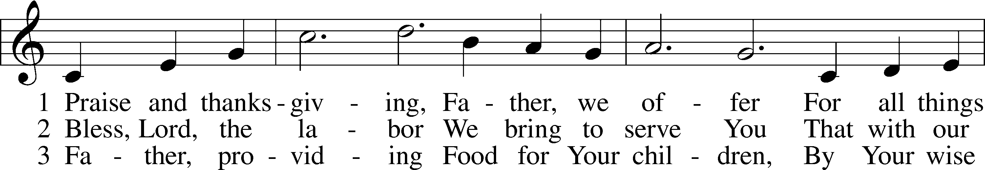
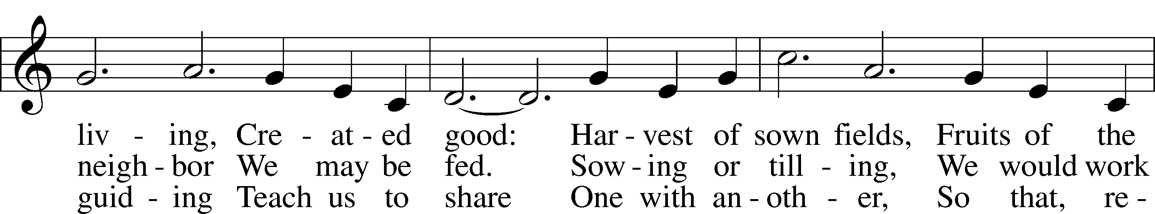
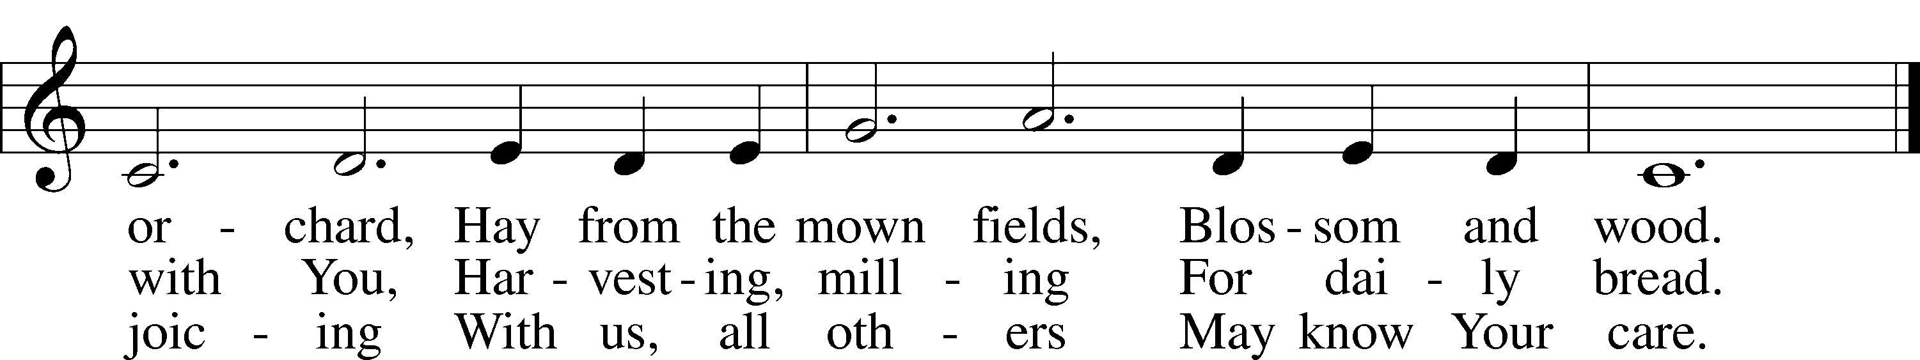
© 1987 Oxford University Press. Used by permission: LSB Hymn License .NET, no. 100011641.
Public domain

“For the Fruits of His Creation” LSB 894
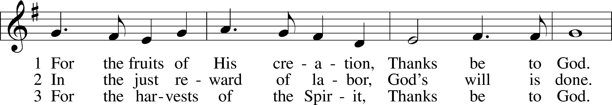
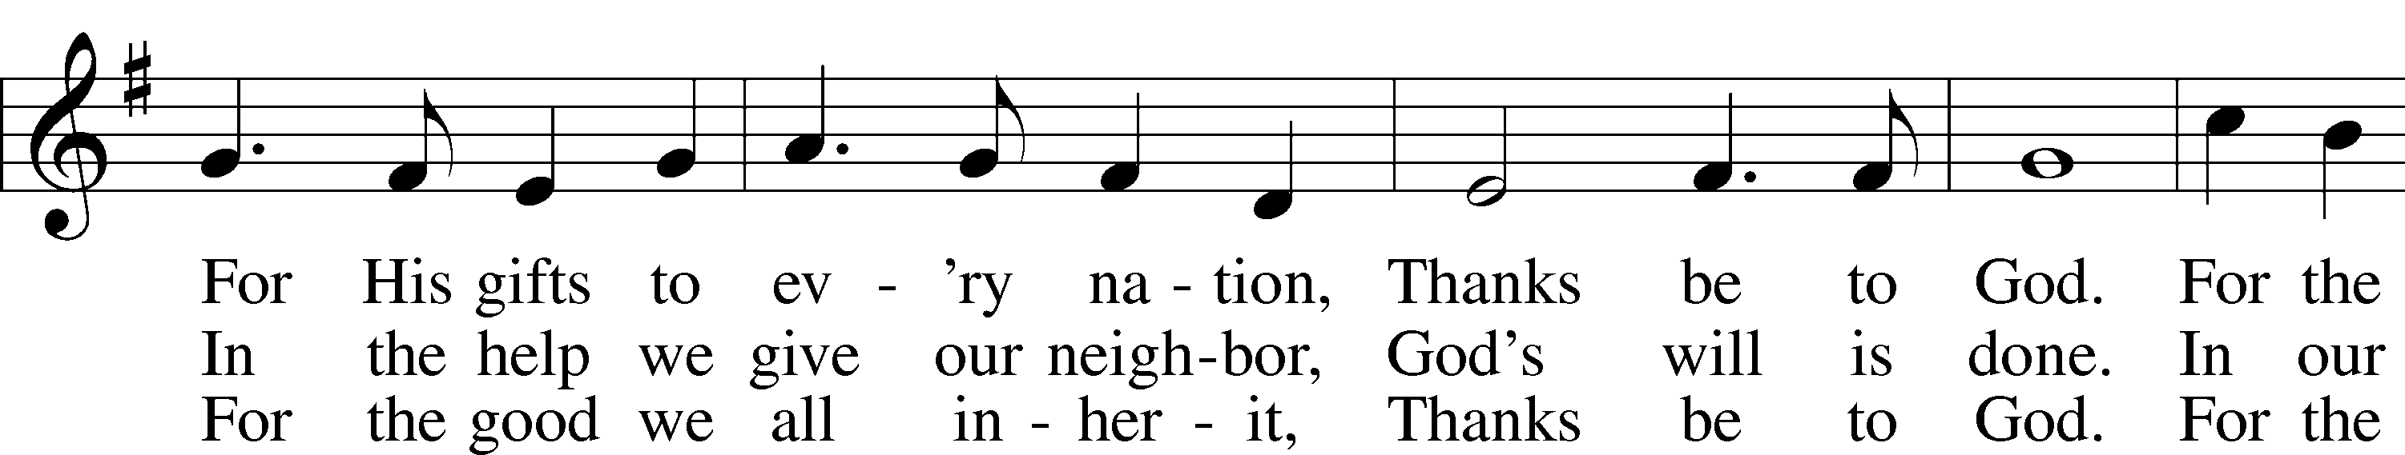
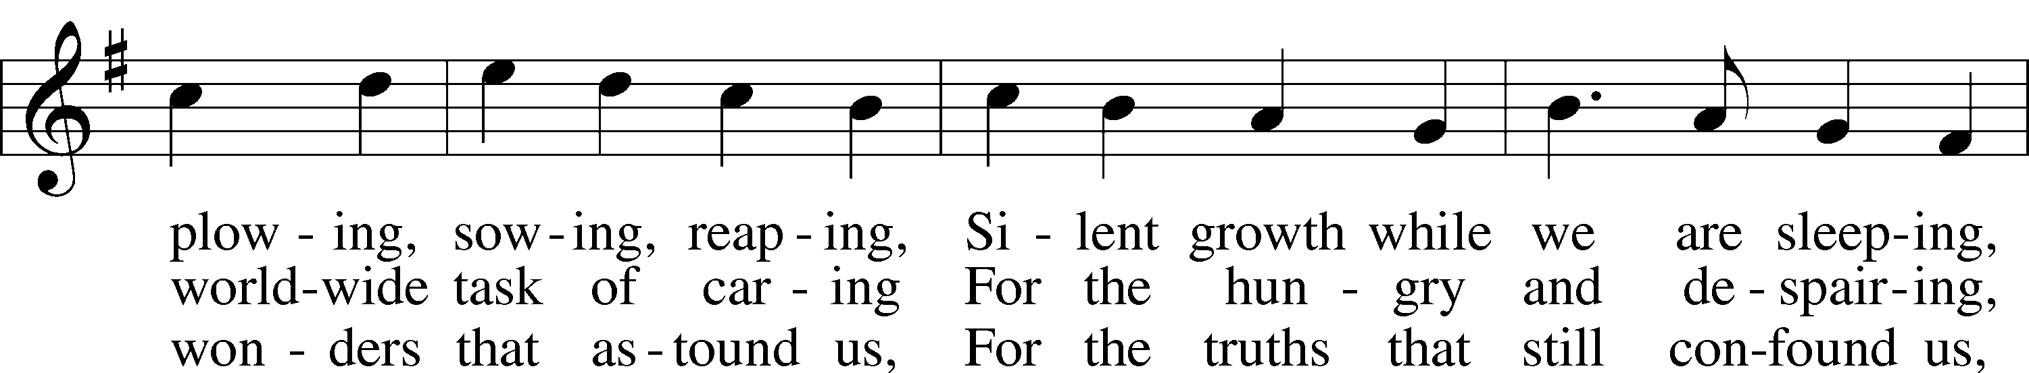
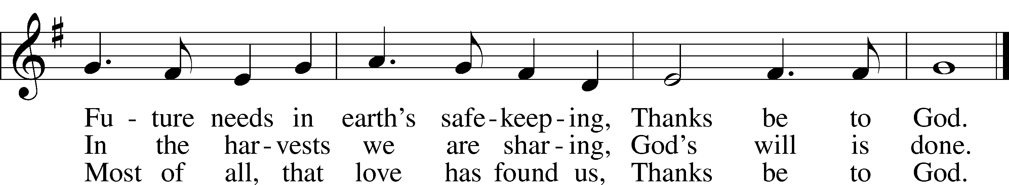
© 1970 Hope Publishing Co. Used by permission: LSB Hymn License .NET, no. 100011641.
Public domain

Jesus let the things that break your heart
also break our hearts.
Amen

(Please stand…)
THE LORD’S PRAYER:
Congregation: Our Father, who art in heaven, Hallowed be thy name, thy kingdom come, thy will be done, on earth as it is in heaven. Give us this day our daily bread; and forgive us our trespasses, as we forgive those who trespass against us; and lead us not into temptation, but deliver us from evil. For thine is the kingdom, and the power, and the glory, forever and ever. Amen.

BENEDICTION

THE CLOSING HYMN: “Now Thank We All Our God” LSB 895
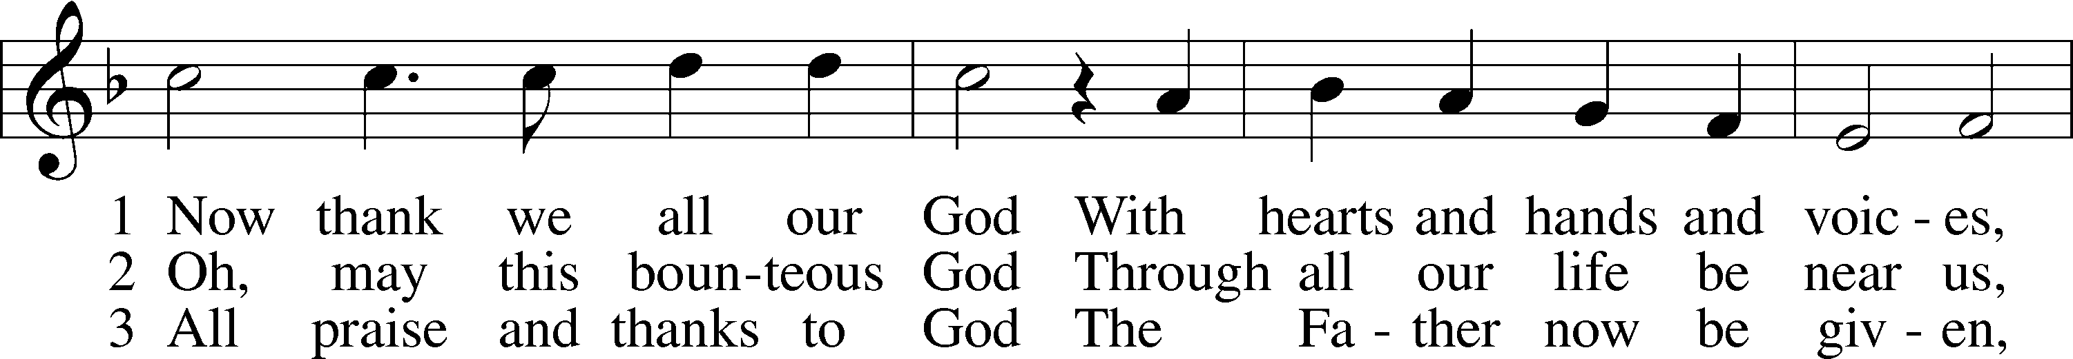
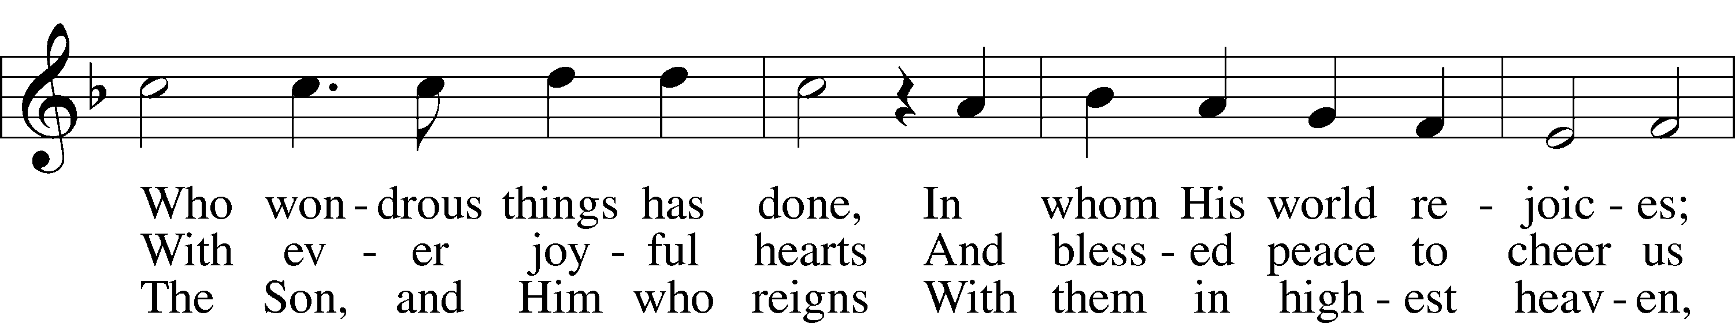
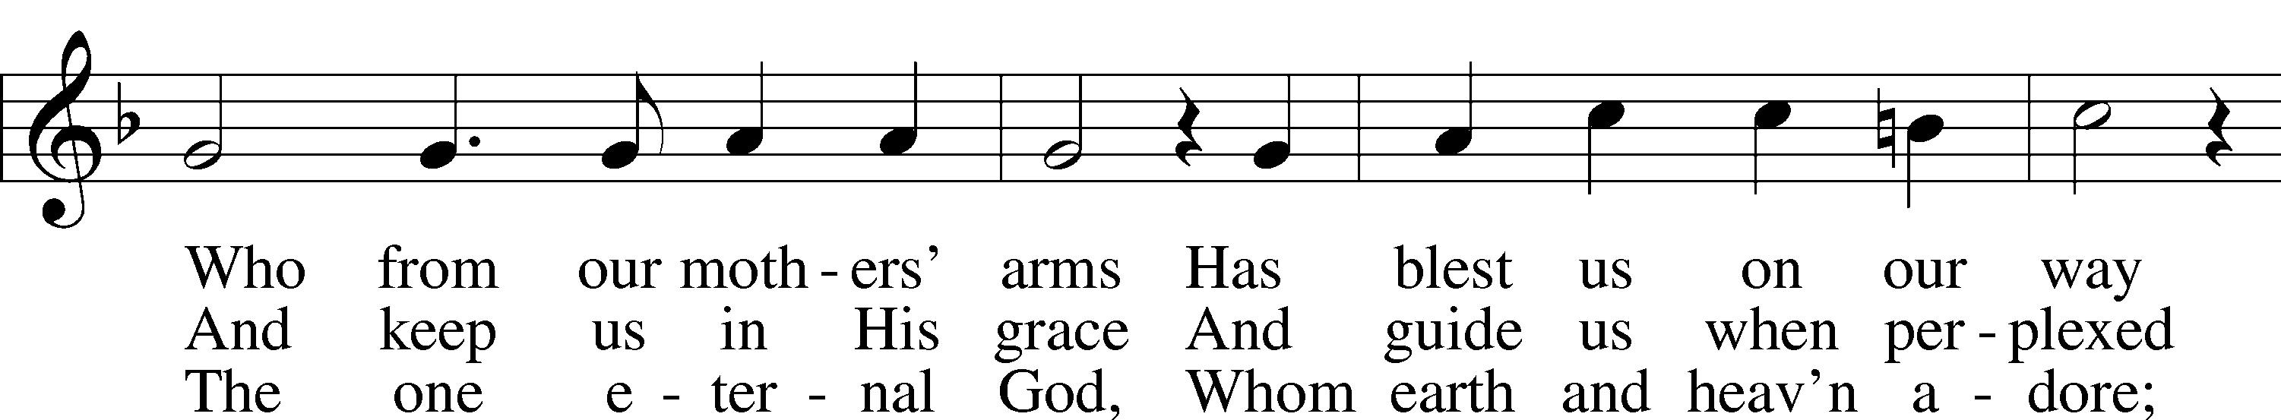
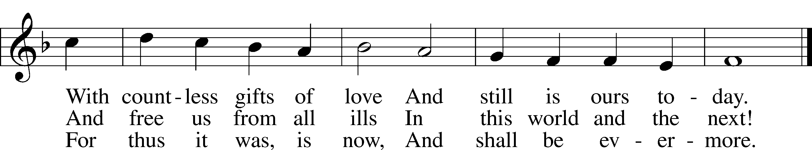
Public domain

POSTLUDE: “Now Thanks We All Our God” Sigfrid Karg-Elert

WELCOME TO GRACE LUTHERAN CHURCH: We are glad that you are here to worship God with us today! We pray that you will enjoy the wonderful fellowship as friends in Christ as God gathers us around His means of grace, the Word and Sacraments, to bless us with His treasured gifts of forgiveness, faith, abundant life and eternal salvation. If you are a guest, please also sign our Guest Book. Please talk to Pastor if you would like to learn more about becoming a member of Grace. Also, please join us for refreshments and fellowship after the Service. We invite you to come and worship with us often as God gathers us in His Grace.

WELCOME TO THE LORD’S TABLE: We invite and encourage all present who are baptized and faithful Christians, and who confess the Father, Son, and Holy Spirit to be the only true God and who believe that Jesus Christ died for the sins of the World and is our only hope and salvation…to join us in receiving the very and true body and blood of Christ in this Sacrament. The clear liquid cups in the center of the tray are non-alcoholic wine.
Children not yet confirmed in the faith are always welcome to join their parents at the Lord’s Table, but should keep their hands folded in front of them. The Pastor will give them a blessing.

SERVING TODAY: Acolyte: Elizabeth Reynolds; Lector: Amelia Bly: Communion Assistants: Vince Winters and Ed Morris; Usher: Terry Richardson; Altar Care: ___________; Refreshments: Thanksgiving Potluck.

SERVING NEXT SUNDAY: Acolyte: Eli Morris; Lector: JoAnn Broadbent; Communion Assistants: Vince Winters and Ed Morris; Usher: Terry Richardson; Altar Care: _________; Refreshments: _____________.

FLOWERS: were placed on the altar to the glory of God.

THIS WEEK AT A GLANCE:
Today: November 19th
9:00 am Worship Service with Communion
10:15 am Thanksgiving Pot Luck in the Parish Hall

Monday: November 20th
Pastor’s Day Off

Tuesday: November 21st
11:30 am Gracious Ladies of Grace Luncheon (Latitudes on Sunset Key)
4:15 pm Book Club (Room 3)
6:00 pm Weight Watcher’s (Parish Hall)

Next Sunday: November 26th
9:00 am Worship Service with Communion
10:10 am Jr. Choir Rehearsal
10:15 am Fellowship
10:30 am Greening of the Church

IN YOUR PRAYERS THIS WEEK: Beverly Walker, Ann Barber, Al and Kathleen Schubert, Mary Eschels, Max Broadbent, Peggy Mira, Bud Wrocklage, and those you are praying for at home. If anyone has a special prayer request please submit it in writing in the collection plate; or you may call Pastor Gary Faith at (504-858-8872), or Kris Howard at (305-296-5161).

If you would like the names of family and friends added to the list please contact Kris or Pastor.

GIFTS, TITHES, & ATTENDANCE LAST SUNDAY: Sunday November 12th received $3319.00 with an attendance of 58.

TO HELP US GROW… The Bible reading for next Sunday’s service are Ezekiel 34:11-16, 1 Corinthians 15:20-28, and Matthew 25:31-46.

TO MY GRACE LUTHERAN FAMILY: Thank you to all of you who helped me last Sunday when I fell. I was so blessed to be immediately surrounded by caring people who took charge of the situation. May God continue to bless our wonderful congregation!
Your Sister in Christ, Beverly

GREENING OF THE CHURCH will take place after services next Sunday November 26th, 2017. If you have time come and join in the decorating fun.

OUR CHILDREN’S REHEARSALS for the 5:00 pm Christmas Eve Service have begun. If your child is interested, please meet in the sanctuary at 10:30 on Sunday December 3rd. We would love to have as many participants as possible.

ADVENT SERVICES WILL BE HELD December 6th, 13th, and 20th at 7 pm. Our first service will be The Key West Chamber Orchestra Concert/Carol Sing.

WE WILL HAVE 3 SERVICES DECEMBER 24TH:
9 am Sunday Morning Service
5 pm Children’s Program
10 pm Candlelight Service

IF YOU ARE INTERESTED IN LEARNING more about what we believe and teach and/or are interested in becoming a member of Grace Please let Pastor know so that he can begin an Adult Information class.

THANKS TO ALL OF YOU for helping your neighbor, listening to others, and being a blessing to the community and to GLCS.

I HAVE A COUPLE OF COPIES of Pastor Finke’s book, “Joining Jesu on His Mission”. If you would like to get maximum results from Greg and Susan’s visit in January, you are welcome to borrow a copy. See Kris or Pastor.

THERE IS ADDITIONAL PARKING behind the school. Enter that lot on 10th Street.

WE HAVE SET THE SCHEDULES for ushers, acolytes, lectors, and communion assistants for the next three months. If you would like to serve in any of these positions, please let Pastor or Kris know.

STEWARDSHIP LISTS: On the bulletin board by the front door of the church you will find the Altar Care, Refreshments, and Flower sign-up sheets for 2017. If you are able to help out with any of these please place your name in the spot on the date requested.

THE GRACE LUTHERAN CHURCH WEB PAGE AND FACE BOOK PAGE now
contains a vocal recording of last week’s sermon. So, if you are not able to attend church on Sunday please go to our website where you will find a copy of the bulletin and a recording of Pastor Faith’s sermon. https://gracelutherankw.360unite.com/home.

SAVE THE DATE AND MARK ON YOUR CALENDAR

JANUARY 27TH, 2018: We plan on having the annual “Let’s Get to Know our Snowbird Friends Better” with Susan and Greg as our guests of honor.

JANUARY 28TH, 2018: Mark this day on your calendar. Pastor Greg Finke and his wife Susan are scheduled to join us for worship and training on how to be a neighborhood missionary. The Finke’s travel all over the country helping equip folks for everyday ministry. Don’t miss this opportunity or you will wonder why everyone is more excited about Jesus missing.

MUSIC MINISTRY: "Make a joyful noise to the Lord, all the earth!" Psalm 100:1. Whether you are here year-round or part-time, we invite you to participate in our music ministry. Please speak with Beverly Walker or contact her at beverlywalker@gmail.com if you have any questions.

Jr. Choir - No rehearsal today
Bell Choir - No rehearsal this Thursday
Vocal choir - No rehearsal this Thursday

MEN’S BIBLE FELLOWSHIP: They meet the first and third Wednesday’s of each month at 12:30pm. Their next meeting will be December 6th located at Chico’s on Stock Island. All guys are welcome.

WOMEN’S BIBLE STUDY: The Ladies Bible study will be meet again Wednesday the 29th of November at 5pm. We will be studying Abigail's Story by Sarah Young. It's a story about a godly woman who responded with strength and faith even as she encountered some very difficult circumstances. This study also explores how her character qualities and actions originate from the very heart of God and you will be challenged, motivated and blessed by the example of Abigail.

GRACIOUS LADIES OF GRACE: It took awhile for the 10 of us to find our table at the Hyatt as our usual Shor dining room had not reopened after Irma (her again!) deposited a sailboat in it! We had a delicious lunch on the covered veranda with a breezy view unsurpassed. The lobster sliders were a hit as well as the fish tacos and pork sandwiches. It is so nice to have Pam back with us but she always rushes off with her lunch in a box to play bridge. That's OK. Peggy has never been to Latitudes on Sunset Key so that will be our next destination. Please join in the fun and the great food on November 21st at 11:30.

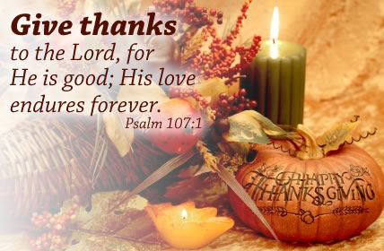

THANKSGIVING CELEBRATION

The Old Testament Reading:
Deuteronomy 8:1-10

8 Be careful to follow every command I am giving you today, so that you may live and increase and may enter and possess the land the Lord promised on oath to your ancestors. ² Remember how the Lord your God led you all the way in the wilderness these forty years, to humble and test you in order to know what was in your heart, whether or not you would keep his commands. ³ He humbled you, causing you to hunger and then feeding you with manna, which neither you nor your ancestors had known, to teach you that man does not live on bread alone but on every word that comes from the mouth of the Lord. ⁴ Your clothes did not wear out and your feet did not swell during these forty years. ⁵ Know then in your heart that as a man disciplines his son, so the Lord your God disciplines you.
⁶ Observe the commands of the Lord your God, walking in obedience to him and revering him. ⁷ For the Lord your God is bringing you into a good land—a land with brooks, streams, and deep springs gushing out into the valleys and hills; ⁸ a land with wheat and barley, vines and fig trees, pomegranates, olive oil and honey; ⁹ a land where bread will not be scarce and you will lack nothing; a land where the rocks are iron and you can dig copper out of the hills.
¹⁰ When you have eaten and are satisfied, praise the Lord your God for the good land he has given you.

The Epistle Reading:
Philippians 4:2-7

² I plead with Euodia and I plead with Syntyche to be of the same mindin the Lord. ³ Yes, and I ask you, my true companion, help these women since they have contended at my side in the cause of the gospel, along with Clement and the rest of my co-workers, whose names are in the book of life.
⁴ Rejoice in the Lord always. I will say it again: Rejoice! ⁵ Let your gentleness be evident to all. The Lord is near. ⁶ Do not be anxious about anything, but in every situation, by prayer and petition, with thanksgiving, present your requests to God. ⁷ And the peace of God, which transcends all understanding, will guard your hearts and your minds in Christ Jesus.

The Holy Gospel:
Luke 12:13-21

¹³ Someone in the crowd said to him, “Teacher, tell my brother to divide the inheritance with me.”
¹⁴ Jesus replied, “Man, who appointed me a judge or an arbiter between you?” ¹⁵ Then he said to them, “Watch out! Be on your guard against all kinds of greed; life does not consist in an abundance of possessions.”
¹⁶ And he told them this parable: “The ground of a certain rich man yielded an abundant harvest. ¹⁷ He thought to himself, ‘What shall I do? I have no place to store my crops.’
¹⁸ “Then he said, ‘This is what I’ll do. I will tear down my barns and build bigger ones, and there I will store my surplus grain. ¹⁹ And I’ll say to myself, “You have plenty of grain laid up for many years. Take life easy; eat, drink and be merry.”’
²⁰ “But God said to him, ‘You fool! This very night your life will be demanded from you. Then who will get what you have prepared for yourself?’
²¹ “This is how it will be with whoever stores up things for themselves but is not rich toward God.

