**November 12th, 2017**

**9:00 am**

**THE**

**TWENTY-THIRD**

**SUNDAY**

**OF PENTECOST**



**Grace Lutheran Church**

**2713 Flagler Ave.**

**Key West, FL 33040**

**305-296-5161**

[**GraceLutheranKW@att.net**](mailto:GraceLutheranKW@att.net)

gracelutherankw.360unite

**Pastor Faith**

**(504) 858-8872**

**garyfaith@aol.com**

**THE TWENTY-THIRD SUNDAY OF PENTECOST**

**November 12th, 2017 9:00 a.m.**

**WORSHIP SERVICE**

***In the Name of Jesus!***

**Our Mission Statement: Anchored in Christ, each person a missionary.**

**PRELUDE: *“Wake, Awake”* Behnke/Nanz/Walther**

**ANNOUNCEMENTS:**

**God is with us all during the week, wherever we are and in whatever we are doing. This week, let’s enjoy His presence.**

*(Please Stand…)*

**HYMN:** ***“Wake, Awake, for Night Is Flying”* LSB 516**

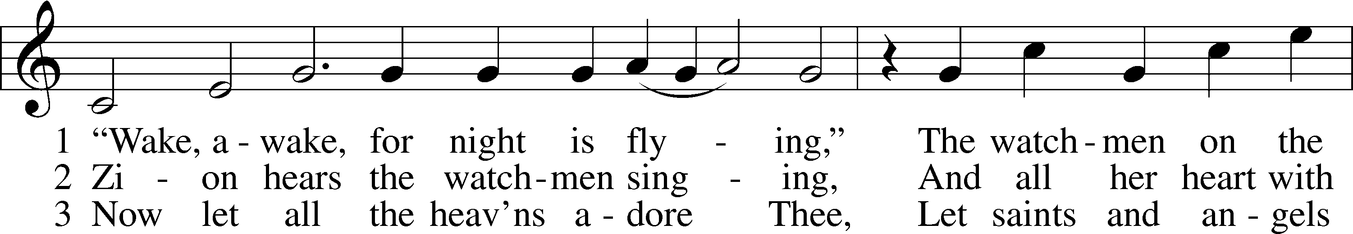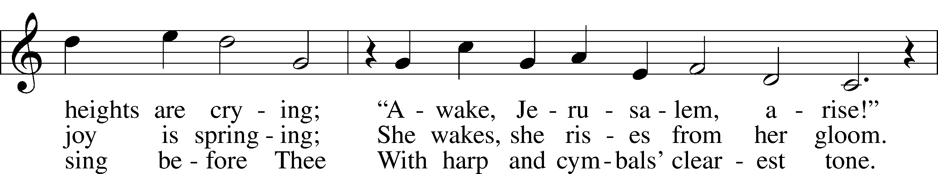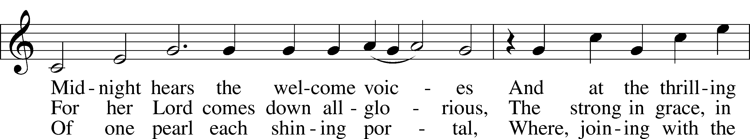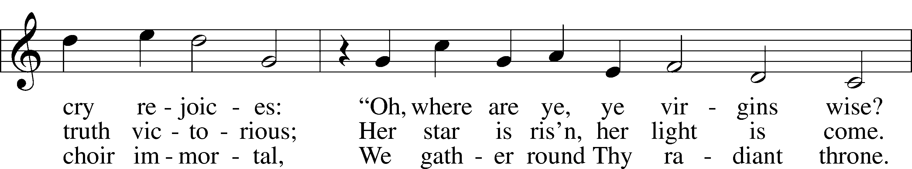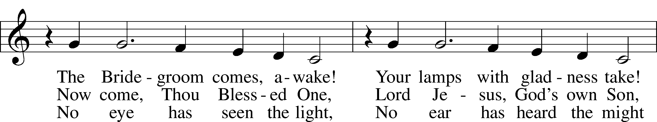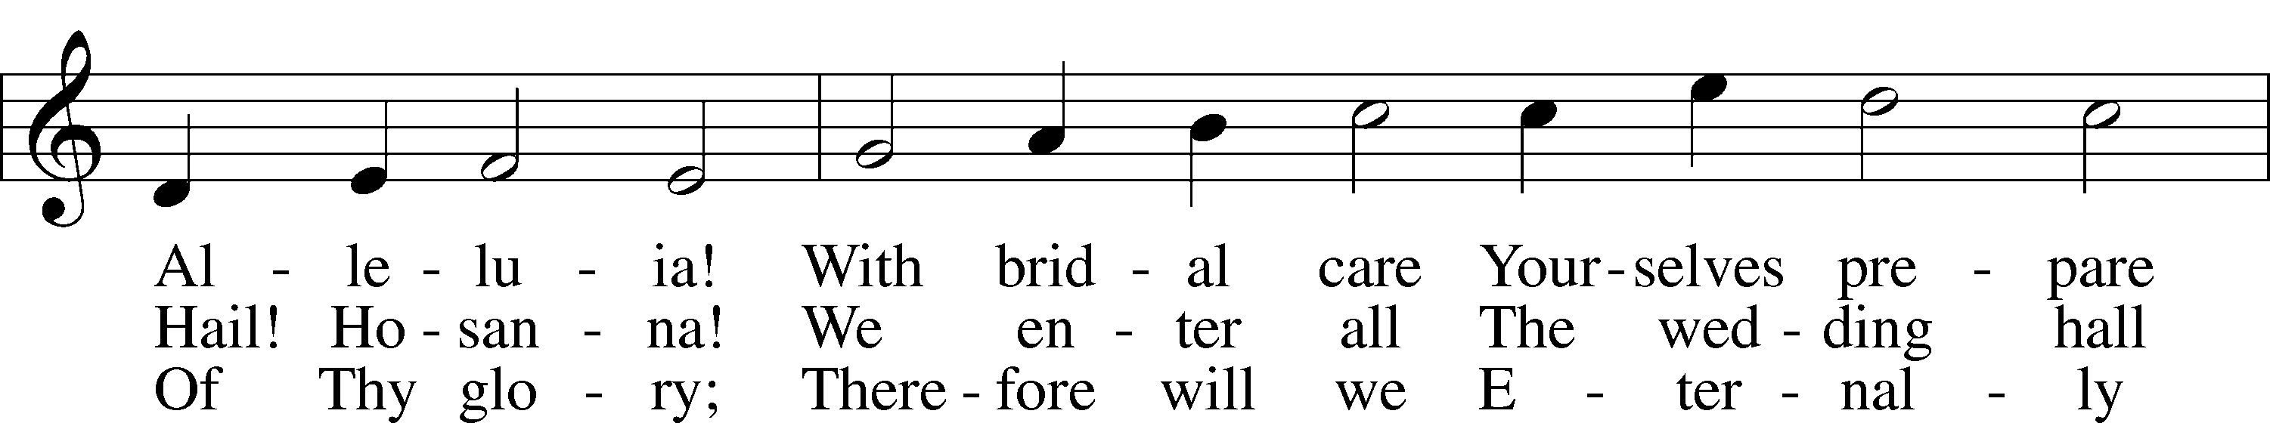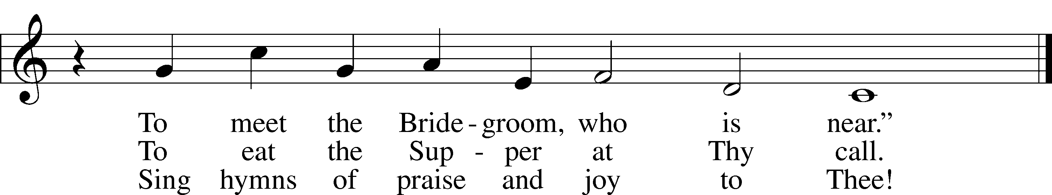

Public domain

Pastor: In the Name of the Father and of the Son and Holy Spirit.

**Congregation: Amen.**

**PREPARATION**

*(Please Remain Standing Or You May Kneel…)*

**CONFESSION OF SIN:**

**All: God, I admit I have broken all of your commandments; I am not holy or sinless even though I often pretend a righteousness I do not have. I offer excuses. I have broken relationships by what I have said, or done. I have not loved either You or my neighbor as I ought. (time for personal confession____)**

**YOU ARE FORGIVEN:**

Pastor: God is merciful and gracious; He has given His Son, Jesus Christ to die and rise again for us, the sinful ones that we might be forgiven and enjoy His Peace. This is also a reminder of God’s gifts and blessing that have become ours in Holy Baptism.

**Congregation: thank you God for Your blessing!**

Pastor: Yes, the Grace of our Lord Jesus Christ, and the Love of God, and the fellowship of His Holy Spirit is with you all.

**Congregation: And also with you.**

Pastor: In peace and as His forgiven people, we can pray to the Lord:

**Congregation: He is gracious to us and hears our prayers.**

Pastor: For the peace of the whole world and our involvement in Christ’s Mission in the world, we pray:

**Congregation: Keep us mindful of our purpose as Christians and our ability to share your blessings of peace and forgiveness with others.**

Pastor: We are the children of the Risen Christ. His victory is Our Victory!

**THE PRAYERS OF THE CHURCH:**

**All: Almighty God, whom to know is everlasting life, grant us to know Your Son, Jesus, to be the way, the truth, and the life that we may boldly confess Him to be the Christ and steadfastly walk in the way that leads to life eternal; through the same Jesus Christ, our Lord, who lives and reigns with You and the Holy Spirit, one God, now and forever. Amen**

**SERVICE OF THE WORD**

**God speaks to us through his word, the Bible:**

*You may be seated…*

**THE OLD TESTAMENT READING: Amos 5:18-24**

Lector: This is the Word of the Lord.

**People: Thanks be to God.**

**THE EPISTLE LESSON: 1 Thessalonians 4:13-18**

Lector: This is the Word of the Lord.

**People: Thanks be to God.**

**SPECIAL MUSIC: *“My Heart Ever Faithful”* Johann Sebastian Bach**

**(arr. Sharon Elery Rogers)**

*Please stand…*

**THE HOLY GOSPEL: Matthew 25:1-13**

Pastor: The Holy Gospel according to St. Matthew the 25th Chapter

**People: Glory to You, O Lord.**

Pastor: This is the Gospel of the Lord.

**People: Praise to You, O Christ!**

**CHILDREN’S MESSAGE**

**NOISE OFFERING**

***It’s called a noise offering because what we are asking for is pocket change. It will always be used for missions outside of our church and school. It normally also is given to a mission involving children. Thanks for making a joyful noise to the Lord.***

*Please be seated…*

**SERMON HYMN: *“My Hope Is Built on Nothing Less”* LSB 576**

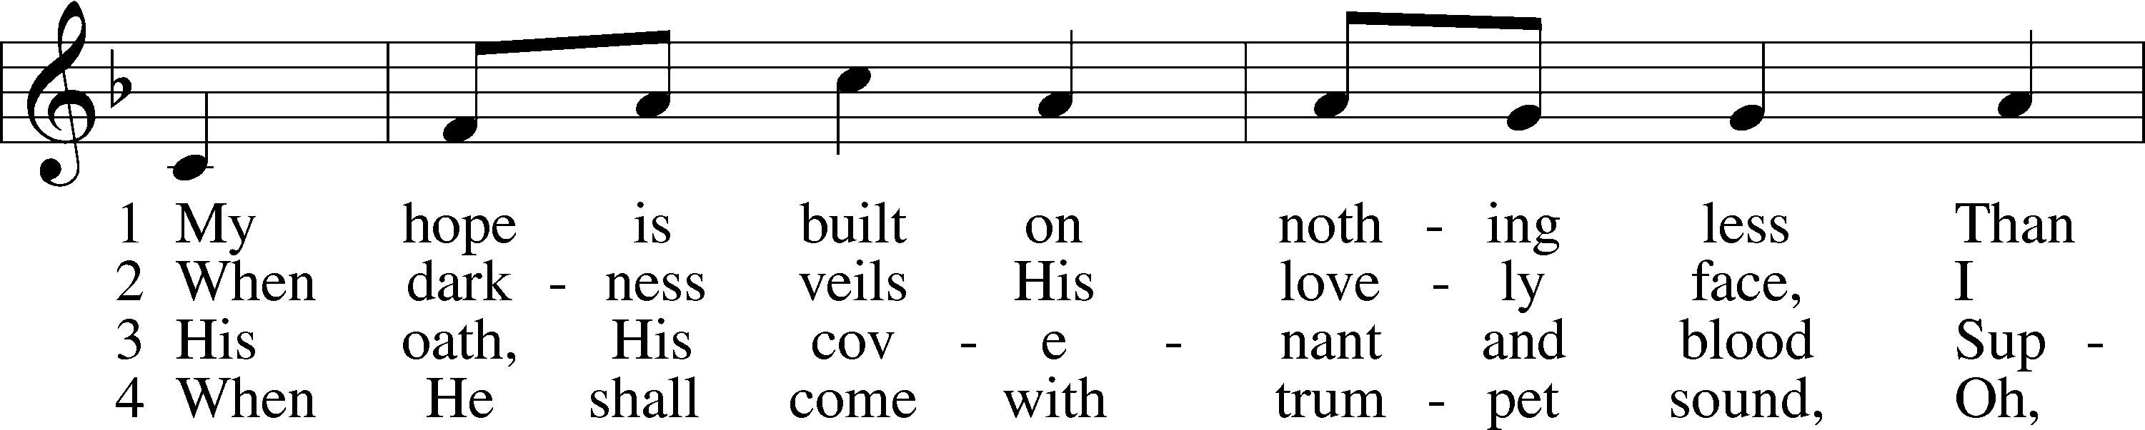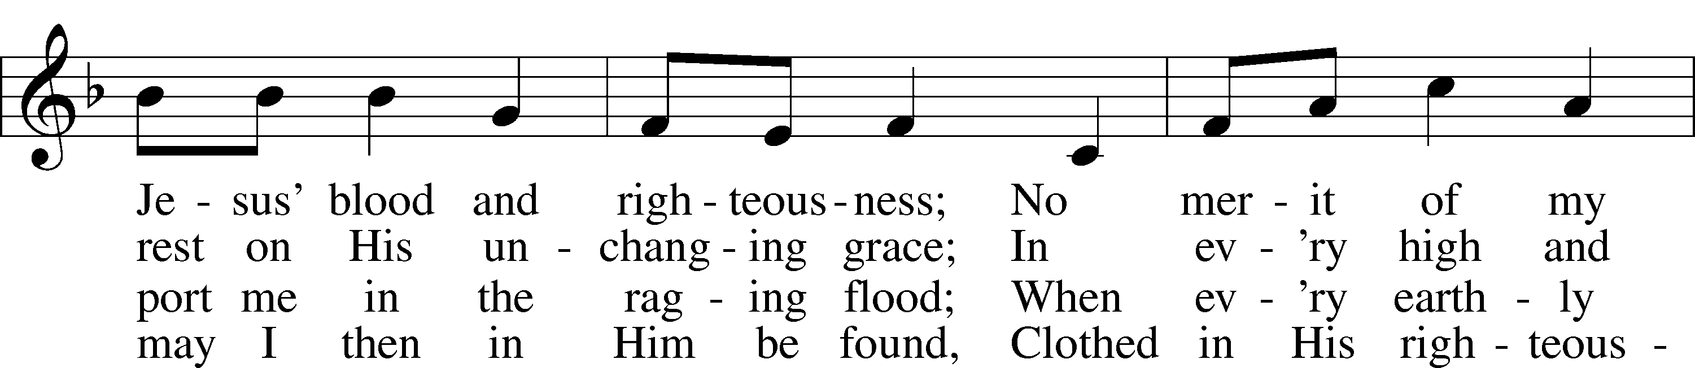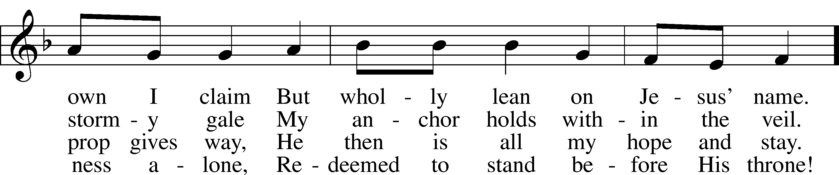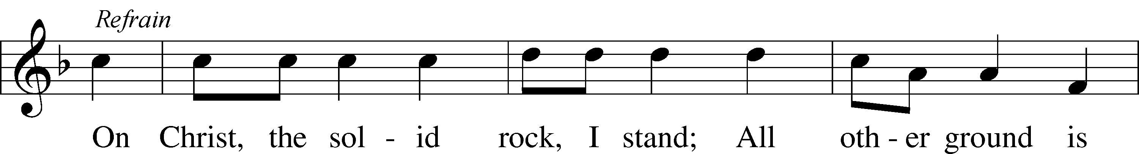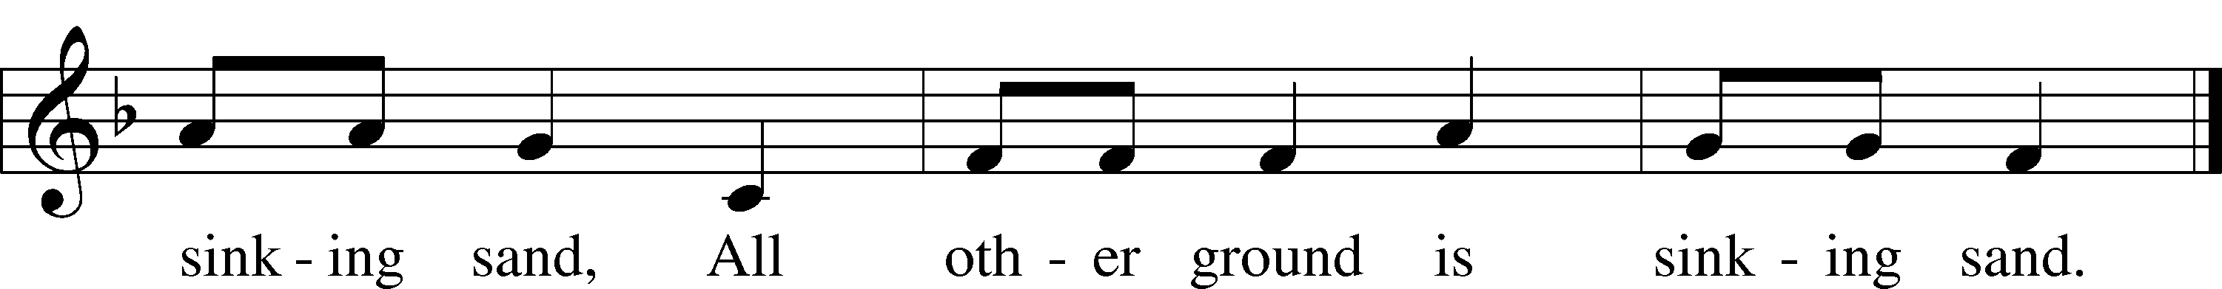

Public domain

**THE SERMON:**

*(Please stand…)*

**THE PROFESSION OF FAITH:**

Pastor: God has given us a great message to take to His world. Let us remind ourselves and one another of what that message is:

Pastor: I believe in God the Father, Almighty

**Congregation: Maker of heaven and earth**

Pastor: And in His Son, Jesus Christ our Lord,

**Congregation: Who was conceived by the Holy Spirit**

Pastor: Born of the Virgin Mary

**Congregation: Suffered under Pontius Pilate**

Pastor: Was crucified, died and was buried

**Congregation: He descended into hell.**

Pastor: On the third day He rose again from the dead,

**Congregation: And ascended into heaven**

Pastor: And sits on the right hand of God, the Father almighty

**Congregation: From there He will come to judge the living and the dead**

Pastor: I believe in the Holy Spirit,

**Congregation: The Holy Christian Church as**

**All: the communion of saints; the forgiveness of sins, the resurrection of the body, and the life everlasting. Amen.**

*(You may be seated…)*

**OFFERING RECEIVED: *“My Lord, What a Morning”* Vocal Choir**

**(***Please stand…)*

***“Praise God, from Whom All Blessings Flow”* LSB 805**

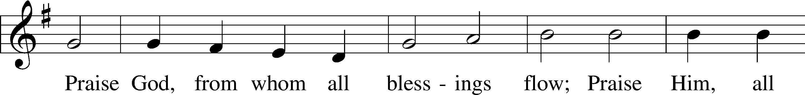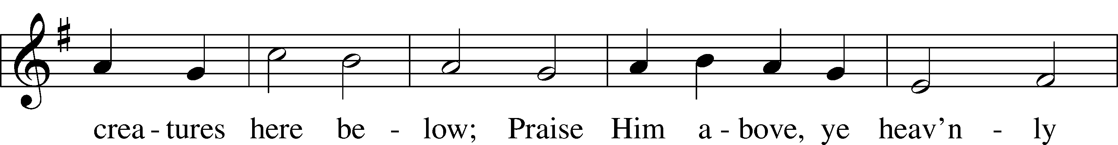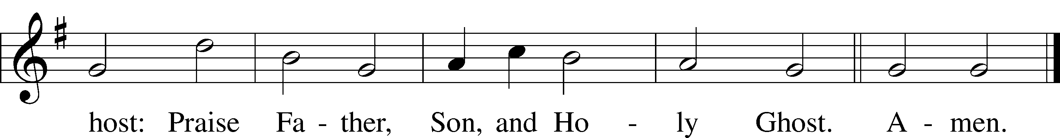

Public domain

**“What are we doing that nobody**



**else is doing to reach people that**

**nobody else is reaching?”**

**SERVICE OF THE SACRAMENT**

*(Please stand…)*

**PREPARE FOR THE LORD’S SUPPER:**

Pastor: We begin with the reminder: “The Lord is with you.”

**Congregation: We are mindful and thankful for His presence.**

Pastor: Let your life reflect the joy of your salvation.

**Congregation: We do give Him thanks and praise. We will share His blessing with others.**

Pastor: It is proper that we should at all times and in all places…(prayer)… we praise your name and join others in singing:

**All: (sing) “Holy, holy, holy Lord God of pow’r and might:**

**Heaven and earth are full of your glory.**

**Hosanna, Hosanna, Hosanna in the highest.**

**Blessed is he who comes in the name of the Lord.**

**Hosanna in the highest.”**

*(Please be seated…)*

**THE WORDS OF INSTITUTION**

**DISTRIBUTION HYMNS: *“Rejoice, Rejoice, Believers”* LSB 515**

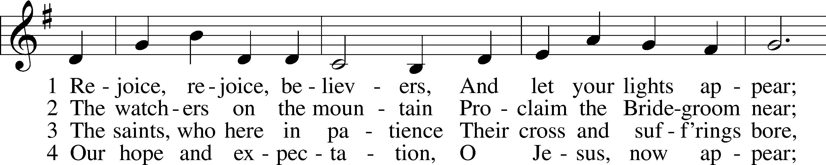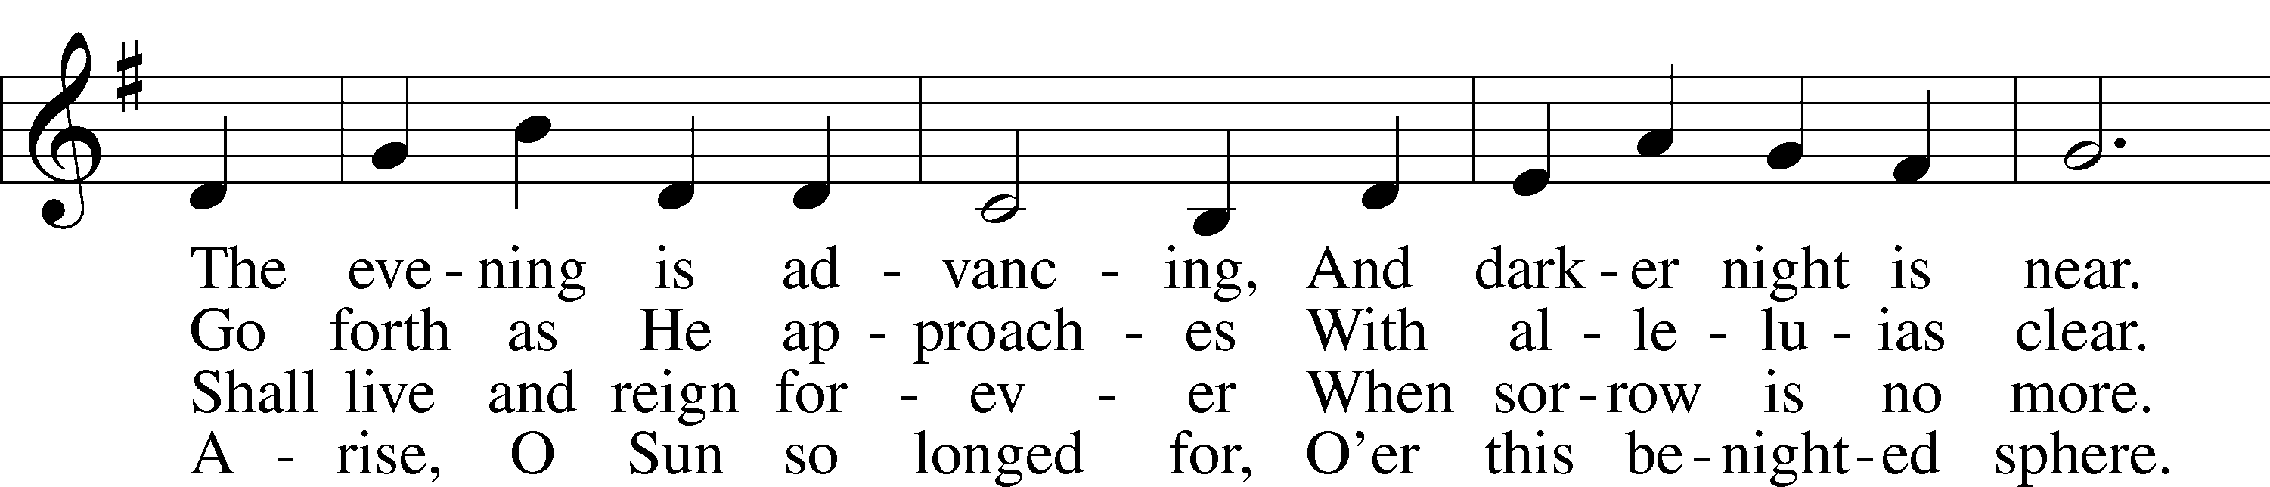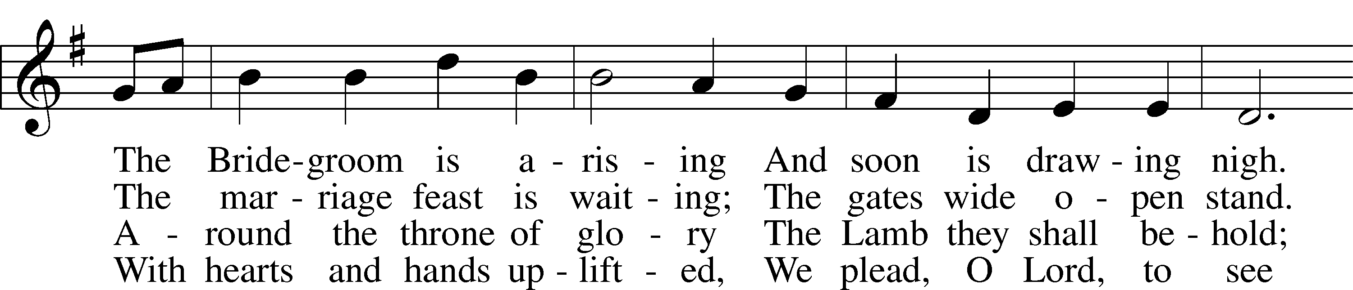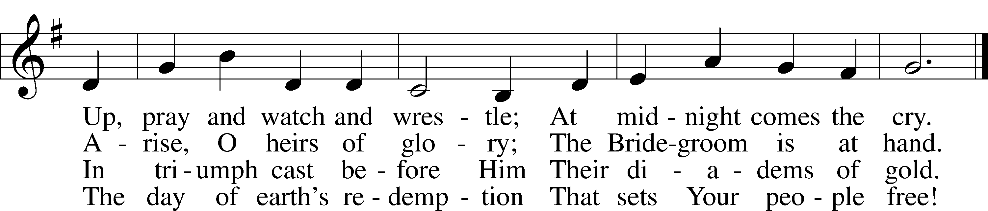

Public domain

***“Give Me Oil in My Lamp”***

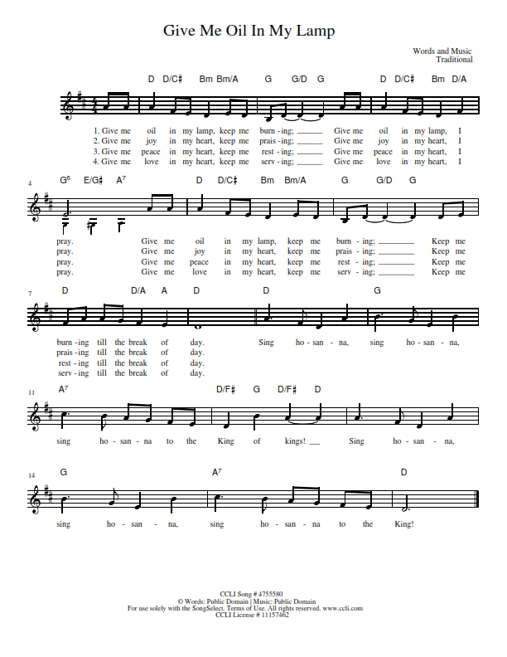

***“Alleluia! Jesus Is Risen”* LSB 474**

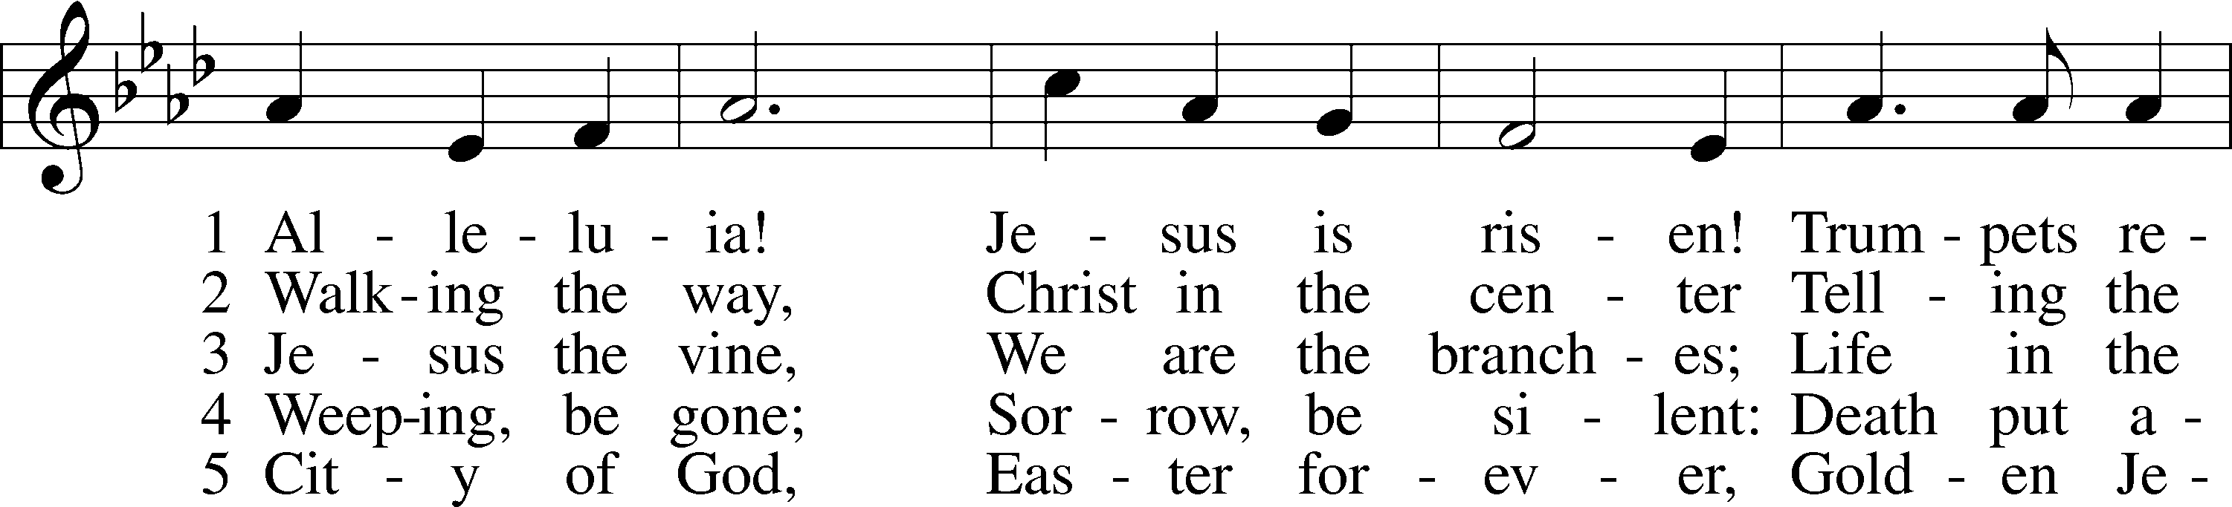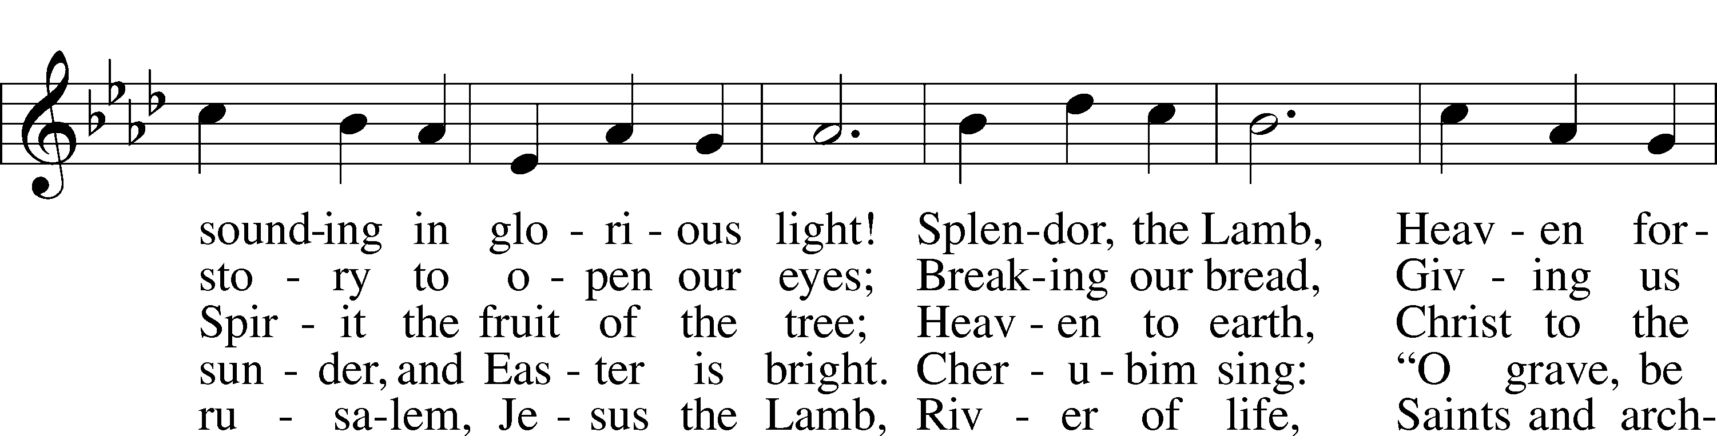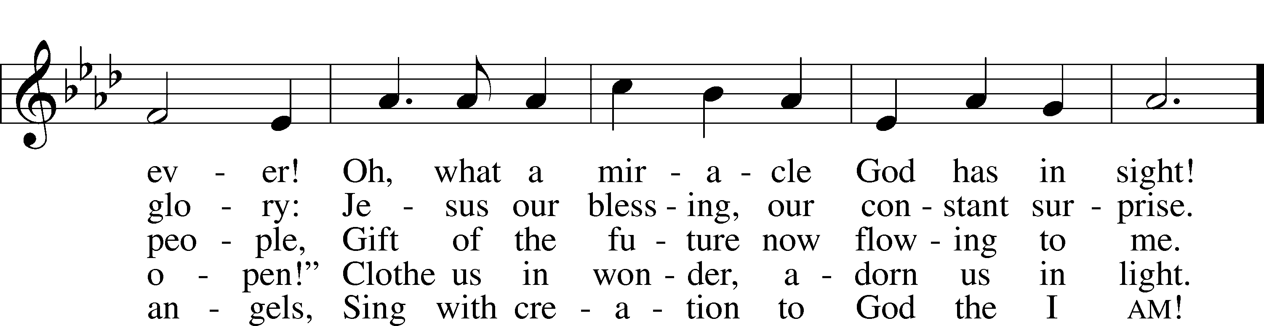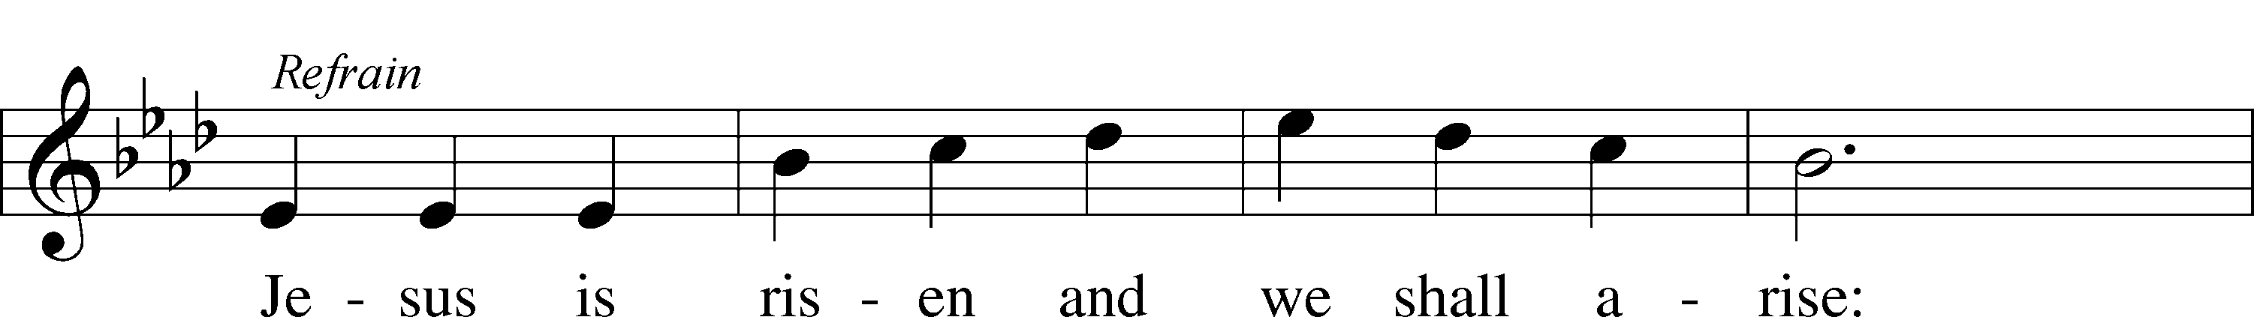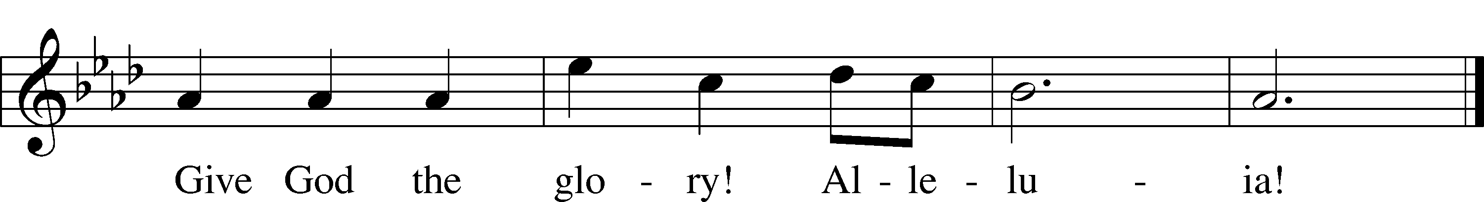

© 1995 Augsburg Fortress. Used by permission: LSB Hymn License .NET, no. 100011641.



Jesus let the things that break

your heart also break our hearts.

Amen

*(Please stand…)*

**THE LORD’S PRAYER:**

**All: Our Father, who art in heaven, hallowed be thy name, thy kingdom come, thy will be done, on earth as it is in heaven. Give us this day our daily bread; and forgive us our trespasses as we forgive those who trespass against us; and lead us not into temptation, but deliver us from evil. For thine is the kingdom, and the power, and the glory, forever and ever. Amen**

**THE BLESSING AND BENEDICTION:**

Pastor: The Lord Blesses you and keeps you, the Lord makes His face to shine upon you and He is Gracious to you. The Lord looks upon you with His favor and gives you His peace.

**Congregation: God blesses us so that we can be a blessing to others.**

Pastor: Go in His peace and serve the Lord by serving others.

**Congregation: Amen**

**RECOGNITION OF VETERAN’S**

**VETERAN’S DAY READING: *“In Flander’s Field”* Don Bly**

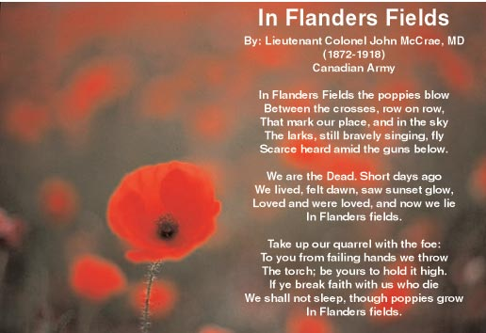

**THE CLOSING HYMN:  *“Battle Hymn of the Republic”***

***Words by Julia Ward Howe Music by William Steffe***

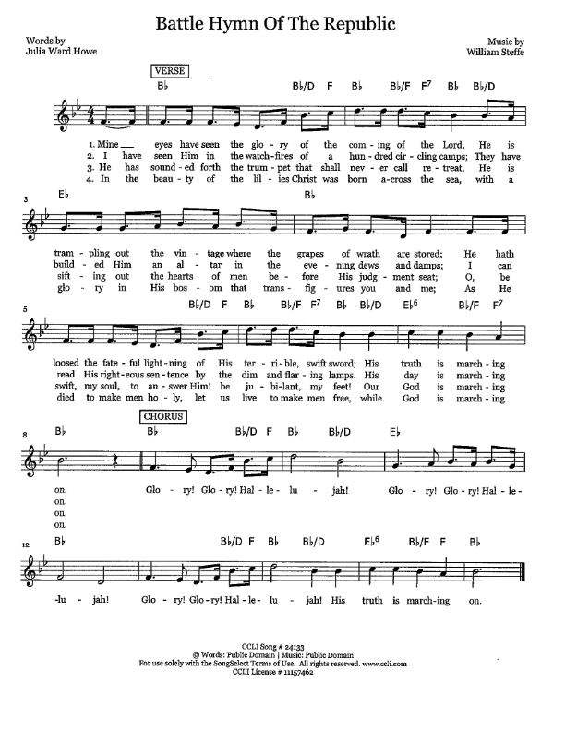

**POSTLUDE: *“God Of Our Fathers”* Donald Busarow**



**WELCOME TO GRACE LUTHERAN CHURCH:** We are glad that you are here to worship God with us today! We pray that you will enjoy the wonderful fellowship as friends in Christ as God gathers us around His means of grace, the Word and Sacraments, to bless us with His treasured gifts of forgiveness, faith, abundant life and eternal salvation. If you are a guest, please also sign our Guest Book. Please talk to Pastor if you would like **to learn more about becoming a member of Grace. Also, please join us for refreshments** and fellowship after the Service. We invite you to come and worship with us often as God gathers us in His Grace.

**WELCOME TO THE LORD’S TABLE:** We invite and encourage all present who are baptized and faithful Christians, and who confess the Father, Son, and Holy Spirit to be the only true God and who believe that Jesus Christ died for the sins of the World and is our only hope and salvation…to join us in receiving the very and true body and blood of Christ in this Sacrament. The clear liquid cups in the center of the tray are non-alcoholic wine.

Children not yet confirmed in the faith are always welcome to join their parents at the Lord’s Table, but should keep their hands folded in front of them. The Pastor will give them a blessing.

**SERVING TODAY:** Acolyte: Elizabeth Reynolds; Lector: Peter Bacle: Communion Assistants: Vince Winters and Ed Morris; Usher: Terry Richardson; Altar Care: The Bly’s; Refreshments: The Bly Family.

**SERVING NEXT SUNDAY:** Acolyte: Eli Morris; Lector: Mary Brady; Communion Assistants: Vince Winters and Ed Morris; Usher: Terry Richardson; Altar Care: _________; Refreshments: _____________.

**FLOWERS**: were placed on the altar to the glory of God and by the Bly family for Remembrance Day.

THIS WEEK AT A GLANCE:

**Today: November 12th**

9:00 am Worship Service with Communion

10:10 am Jr. Choir Rehearsal

10:15 am Fellowship

10:30 am Adult Bible Class/High School Bible Class/Children’s Bible Class

**Monday: November 13th**

Pastor’s Day Off

**Tuesday: November 14th**

2:30 pm Jan’s Mobile Gym

4:15 pm Book Club (Room 3)

6:00 pm Weight Watcher’s (Parish Hall)

**Wednesday: November 15th**

12:30 pm Men’s Bible Fellowship (Chico’s)

5:00 pm Women’s Bible Study (Room 3)

**Thursday: November 16th**

4:15 pm Missional Communities (Room 3)

5:45 pm Bell Choir Rehearsal

6:30 pm Vocal Choir Rehearsal

**Next Sunday: November 19th**

9:00 am Worship Service with Communion

10:10 am Jr. Choir Rehearsal

10:15 am Fellowship

10:30 am Adult Bible Class/High School Bible Class/Children’s Bible Class

**IN YOUR PRAYERS THIS WEEK:** Ann Barber, Al and Kathleen Schubert, Mary Eschels, Max Broadbent, Peggy Mira, Bud Wrocklage, and those you are praying for at home. If anyone has a special prayer request please submit it in writing in the collection plate; or you may call Pastor Gary Faith at (504-858-8872), or Kris Howard at (305-296-5161).

**WE ARE STARTING OVER** with the prayer list today. If you would like the names of family and friends to be listed please contact Kris.

**GIFTS, TITHES, & ATTENDANCE LAST SUNDAY**: Sunday November 5th received $4450.00 and the building fund received $370.00 with an attendance of 67.

**NOISE OFFERING** for the next several weeks will go to support the Autism support group that meets here at Grace monthly.

**TO HELP US GROW…** The Bible reading for next Sunday’s service are Deuteronomy 8:1-10, Philippians 4:2-7, and Luke 12:13-21.



**OUR THANKSGIVING SERVICE** will be held next Sunday, November 19th during our regular worship time. We will have a pot luck dinner after the service.



**OUR CHILDREN’S REHEARSALS** for the 5:00 pm Christmas Eve Service will begin today. If your child is interested, please meet in the sanctuary at 10:30. We will be assigning parts and reviewing the service.

**ADULT BIBLE CLASS** will meet in classroom #3 so that the children can practice for the Christmas Eve Service.

**ADVENT SERVICES WILL BE HELD** December 6th, 13th, and 20th at 7 pm. Our first service will be The Key West Chamber OrchestraConcert/Carol Sing.

**WE WILL HAVE 3 SERVICES DECEMBER 24TH:**

9 am Sunday Morning Service

5 pm Children’s Program

10 pm Candlelight Service



**IF YOU ARE INTERESTED IN LEARNING** more about what we believe and teach and/or are interested in becoming a member of Grace Please let Pastor know so that he can begin an Adult Information class.

**THANKS TO ALL OF YOU** for helping your neighbor, listening to others, and being a blessing to the community and to GLCS.

**I HAVE SEVERAL COPIES** of Pastor Finke’s book, “Joining Jesu on His Mission”. If you would like to get maximum results from Greg and Susan’s visit in January, you are welcome to borrow a copy. See Kris or Pastor.

**THERE IS ADDITIONAL PARKING** behind the school. Enter that lot on 10th Street.

**WE HAVE SET THE SCHEDULES** for ushers, acolytes, lectors, and communion assistants for the next three months. If you would like to serve in any of these positions, please let Pastor or Kris know.

**STEWARDSHIP LISTS:** On the bulletin board by the front door of the church you will find the Altar Care, Refreshments, and Flower sign-up sheets for 2017. If you are able to help out with any of these please place your name in the spot on the date requested.

**THE GRACE LUTHERAN CHURCH WEB PAGE AND FACE BOOK PAGE** now

contains a vocal recording of last week’s sermon. So, if you are not able to attend church on Sunday please go to our website where you will find a copy of the bulletin and a recording of Pastor Faith’s sermon. <https://gracelutherankw.360unite.com/home>.

**A NUMBER OF CAPITAL IMPROVEMENTS** are needed to keep our facilities in good health for the future. Roof repairs are needed on school buildings and the parsonage. If you can help it would be much appreciated! A big thanks to all who have contributed to these repairs.

**SAVE THE DATE AND MARK ON YOUR CALENDAR**

**JANUARY 27TH, 2018:** We plan on having the annual “Let’s Get to Know our Snowbird Friends Better” with Susan and Greg as our guests of honor.

**JANUARY 28TH, 2018:** Mark this day on your calendar. Pastor Greg Finke and his wife Susan are scheduled to join us for worship and training on how to be a neighborhood missionary. The Finke’s travel all over the country helping equip folks for everyday ministry. Don’t miss this opportunity or you will wonder why everyone is more excited about Jesus missing.



**MUSIC MINISTRY:** "Make a joyful noise to the Lord, all the earth!" Psalm 100:1. Whether you are here year-round or part-time, we invite you to participate in our music ministry. Please speak with Beverly Walker or contact her at [beverlywalker@gmail.com](mailto:beverlywalker@gmail.com) if you have any questions.

Jr. Choir for grades 2nd – 8th will rehearse today from 10:10- 10:25 by the piano.

Bell Choir: Rehearsal this Thursday from 5:45-6:30 pm.

Vocal Choir: Rehearsal this Thursday from 6:30-7:30 pm. There will also be a short rehearsal today immediately after the service by the piano.



**MEN’S BIBLE FELLOWSHIP**: They meet the first and third Wednesday’s of each month at 12:30pm. Their next meeting will be November 15th located at Chico’s on Stock Island. All guys are welcome.

**WOMEN’S BIBLE STUDY**: The Ladies Bible study will be meeting on Wednesday's in Rm.3 at 5:00. We will be studying Abigail's Story by Sarah Young.  It's a story about a godly woman who responded with strength and faith even as she encountered some very difficult circumstances.  This study also explores how her character qualities and actions originate from the very heart of God and you will be challenged, motivated and blessed by the example of Abigail.

**MISSIONAL COMMUNITIES** will meet this Thursday at 4:15 pm in the classroom 3. I’m looking forward to hearing how you have seen Jesus at work in your life.



**GRACIOUS LADIES OF GRACE:** It took awhile for the 10 of us to find our table at the Hyatt as our usual Shor dining room had not reopened after Irma (her again!) deposited a sailboat in it! We had a delicious lunch on the covered veranda with a breezy view unsurpassed. The lobster sliders were a hit as well as the fish tacos and pork sandwiches.  It is so nice to have Pam back with us but she always rushes off with her lunch in a box to play bridge. That's OK. Peggy has never been to Latitudes on Sunset Key so that will be our next destination. Please join in the fun and the great food on November 21st at 11:30.

**SCHOOL NEWS**

Attention Moms (and Dads too):

"Motherhood sometimes feels like a list of expectations. You may be busy or even overwhelmed. But you are also strong and brilliant. And here's a secret: a lot of those things on your list of expectations are things Jesus never expected you to do on your own." ~Out of the Spin Cycle: Devotions to Lighten Your Mother Load by Jen Hatmaker

Please join us for a 7-week Book Club to encourage and empower one another!

When: Next Meeting, Tuesday, September 14th and meeting each Tuesday at 4:15.

Where: Grace Lutheran Church and School (Rm 3)

Please contact Amy Donaldson with any questions that you may have at [acunninghamkw@gmail.com](mailto:acunninghamkw@gmail.com).

