**October 22nd, 2017**

**9:00 am**

**TWENTIETH**

**SUNDAY**

**AFTER**

**PENTECOST**



**Grace Lutheran Church**

**2713 Flagler Ave.**

**Key West, FL 33040**

**305-296-5161**

**GraceLutheranKW@att.net**

**Pastor Faith**

**(504) 858-8872**

**garyfaith@aol.com**

**TWENTIETH SUNDAY AFTER PENTECOST**

**OCTOBER 22ND, 2017 9:00 a.m.**

**WORSHIP SERVICE**

***In the Name of Jesus!***

**Our Mission Statement: Anchored in Christ, each person a missionary.**

**PRELUDE: *“O God, Our Help in Ages Past”* Jan Bender**

**ANNOUNCEMENTS:**

**We welcome you. We are glad you are here to share with us the joy and peace we have in Jesus Christ. It doesn’t matter whether this is your first time in this church or if you are a lifelong member, you are welcome. We come together today in order to celebrate the gift God has given us-His own Son, Jesus, Our Savior.**

**PREPARATION**

*(Please Stand…)*

**HYMN:  *“O God, Our Help in Ages Past”* LSB 733**

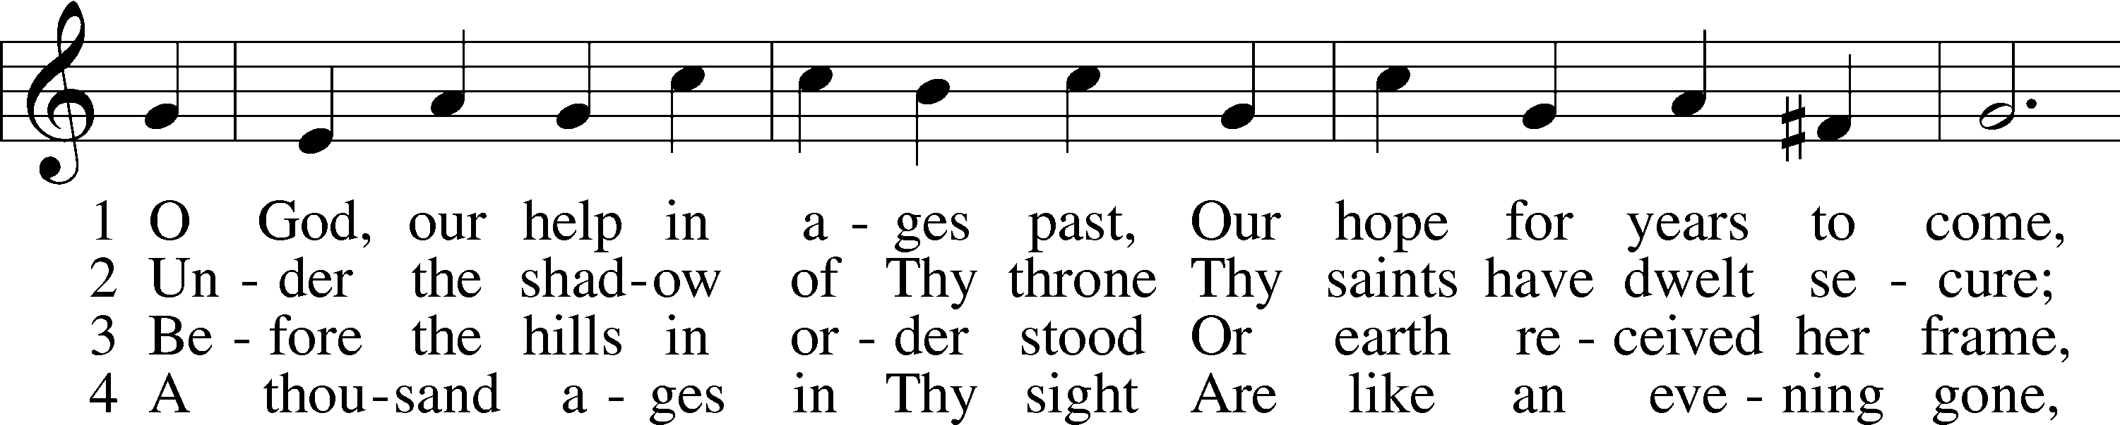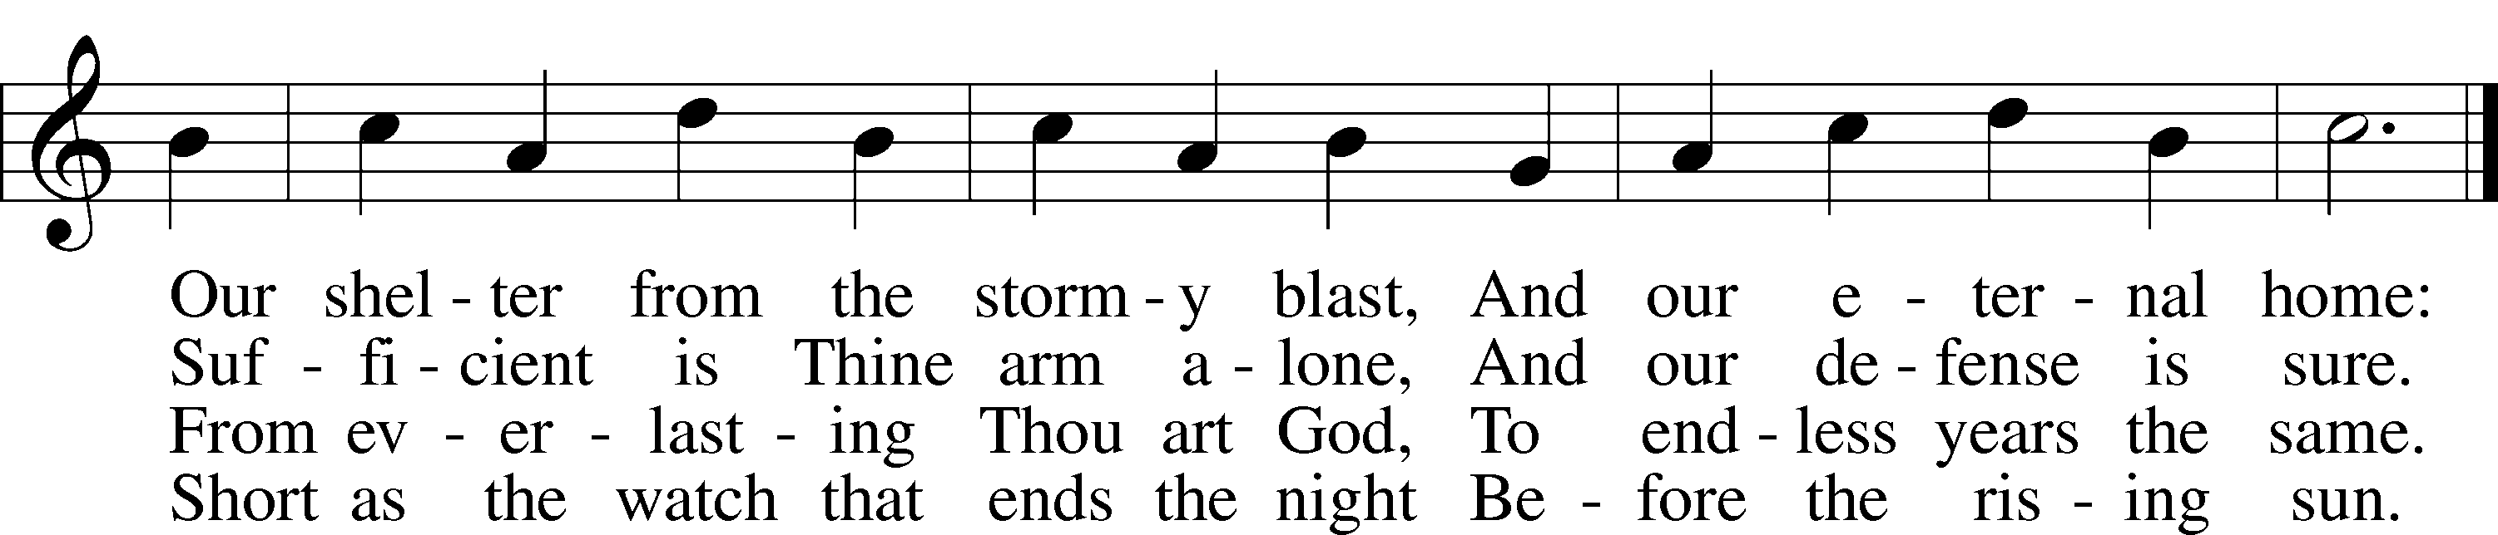

5 Time, like an ever-rolling stream,  
 Soon bears us all away;  
We fly forgotten as a dream  
 Dies at the op’ning day.

6 O God, our help in ages past,  
 Our hope for years to come,  
Be Thou our guard while troubles last  
 And our eternal home! Public domain

**RECEPTION OF NEW MEMBERS**

Pastor: In the Name of the Father and of the Son and Holy Spirit.

**Congregation: Amen**

*(Please Remain Standing Or You May Kneel…)*

**GOD’S PEOPLE CONFESS THEIR SINS:**

Pastor: By grace you have been saved, through faith-and this is not from yourselves, it is the gift of God-not of works, so that no man can boast, for we are God’s workmanship, created in Christ Jesus.

**Congregation: I know that nothing good lives in me, that is, in my sinful nature, for I have the desire to do what is good, but I cannot carry it out.**

Pastor: What I do is not the good I want to do; no, the evil I do not want to do-this I keep doing.

**Congregation: In my heart I delight in God’s law, the law that points out what a wretched person I am! Who will rescue me from this body of death?**

Pastor: Thanks be to God through Jesus Christ our Lord! Only He can achieve the perfection we fail to achieve. By the forgiveness He purchased on the cross, our forgiveness is complete!

**SERVICE OF THE WORD**

*You may be seated…*

**THE OLD TESTAMENT READING: Isaiah 45:1-7**

Lector: This is the Word of the Lord.

**People: Thanks be to God.**

**THE EPISTLE LESSON: 1 Thessalonians 1:1-10**

Lector: This is the Word of the Lord.

**People: Thanks be to God.**

*Please stand…*

**THE HOLY GOSPEL: Matthew 22:15-22**

Pastor: The Holy Gospel according to St. Matthew the 22nd Chapter

**People: Glory to You, O Lord.**

Pastor: This is the Gospel of the Lord.

**People: Praise to You, O Christ!**

*Please be seated…*

**CHILDREN’S MESSAGE**

**NOISE OFERING**

*You may be seated…*

**THE SERMON HYMN: *“What a Friend We Have in Jesus”* LSB 770**

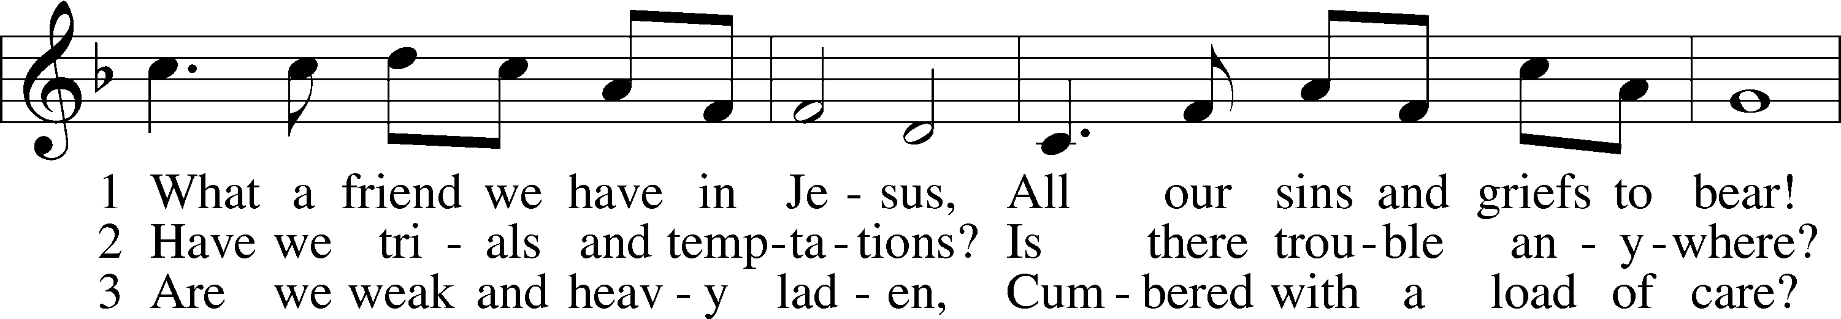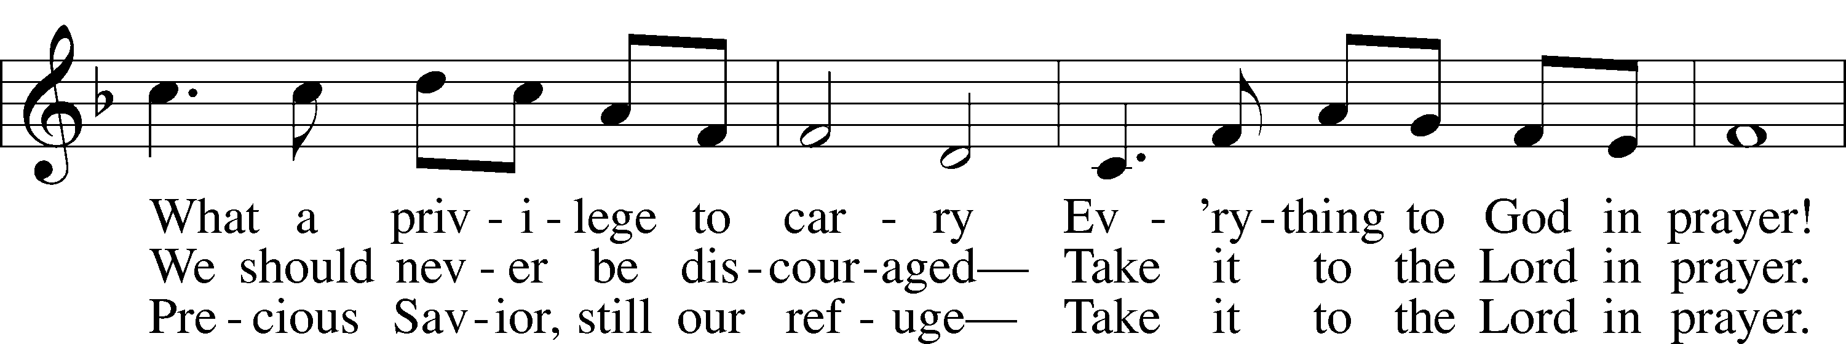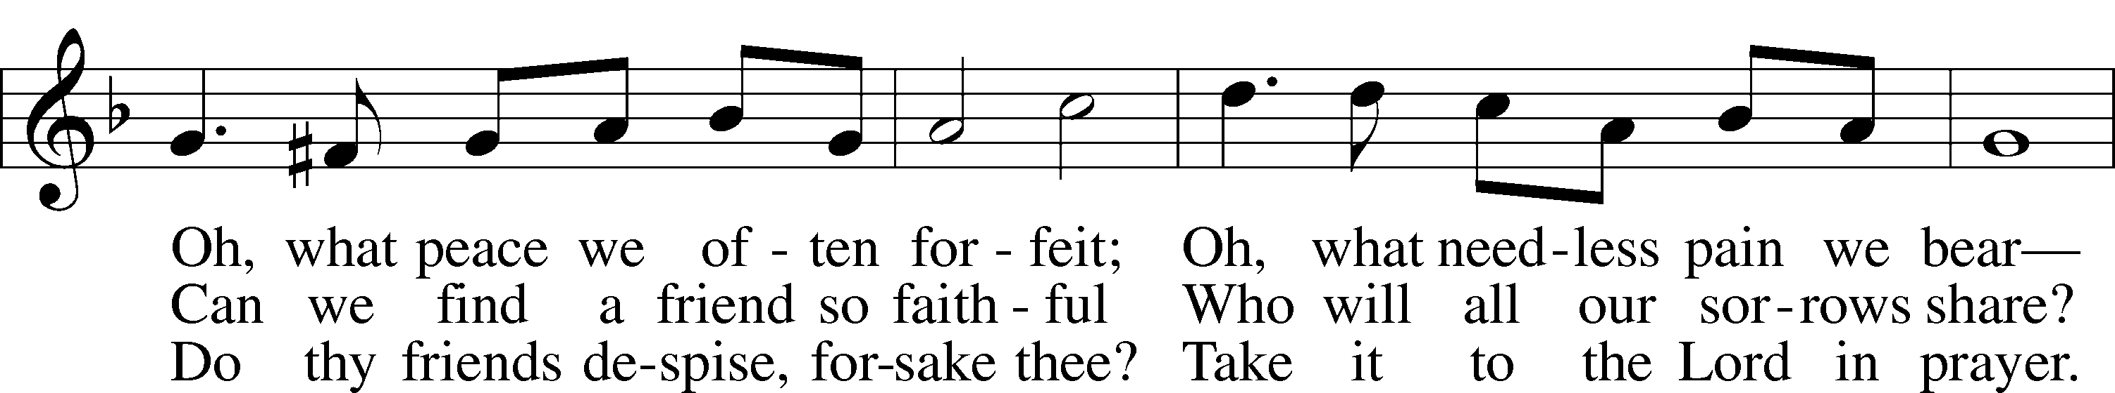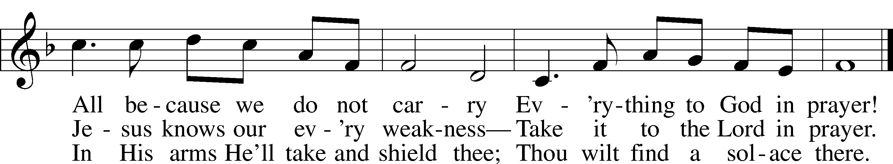

Public domain

**THE SERMON: *“God Is Setting Things Up”* Isaiah 45:1-7**



*(Please stand…)*

**THE PROFESSION OF FAITH:**

Pastor: God has given us a great message to take to His world. Let us remind ourselves and one another of what that message is:

Pastor: I believe in God the Father, Almighty

**Congregation: Maker of heaven and earth**

Pastor: And in His Son, Jesus Christ our Lord,

**Congregation: Who was conceived by the Holy Spirit**

Pastor: Born of the Virgin Mary

**Congregation: Suffered under Pontius Pilate**

Pastor: Was crucified, died and was buried

**Congregation: He descended into hell.**

Pastor: On the third day He rose again from the dead,

**Congregation: And ascended into heaven**

Pastor: And sits on the right hand of God, the Father almighty

**Congregation: From there He will come to judge the living and the dead**

Pastor: I believe in the Holy Spirit,

**Congregation: The Holy Christian Church as**

**All: the communion of saints; the forgiveness of sins, the resurrection of the body, and the life everlasting. Amen.**

*(You may be seated…)*

**OFFERING RECEIVED: *“All Glory Be to God on High”* Michael Burkhardt**

**(***Please stand…)*

***“Praise God, from Whom All Blessings Flow”* LSB 805**

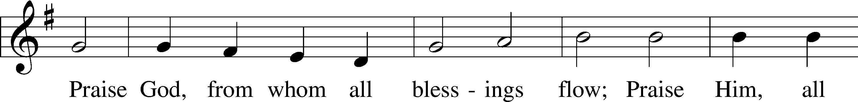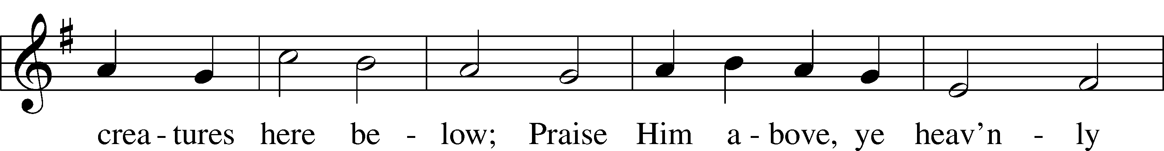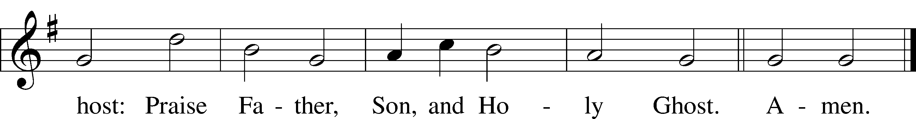

Public domain

**(***Please stand…)*

**THE PRAYERS OF THE CHURCH: based on Psalm 98**

Pastor: Dear Lord, we thank You for everything You’ve done for us, and most of all for Your own Son, Jesus, our Savior. We will never stop praising You for this wonderful gift.

**Congregation: Sing to the Lord a new song, for He has done marvelous things; His right hand and His holy arm have worked salvation for Him.**

Pastor: We thank You for those missionaries long ago who brought the Good News to our people. When we were in darkness, You sent men and women to bring us the light. Thank you, Lord.

**Congregation: The Lord has made His salvation known and revealed His Righteousness to the nation.**

Pastor: O Lord, You are our Savior, we trust in You for all our needs, give healing to the sick, courage to those who are afraid, and peace to those we name in our hearts either silently or out loud. **(a moment of silence)** We praise You, gracious Lord, for all Your benefits to us. You give us home, friends and family, food, shelter, rest and everything we need. You give us sight and hearing and touch and taste and provide for all of our needs.

**Congregation: Shout for joy to the Lord, praise His Name Amen.**

**SERVICE OF THE SACRAMENT**

**THE WORDS OF INSTITUTION**

*(Please be seated…)*

**DISTRIBUTION HYMNS: *“Give Thanks with a Grateful Heart”* LSB 806**

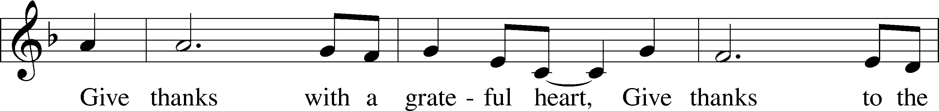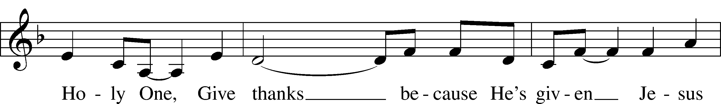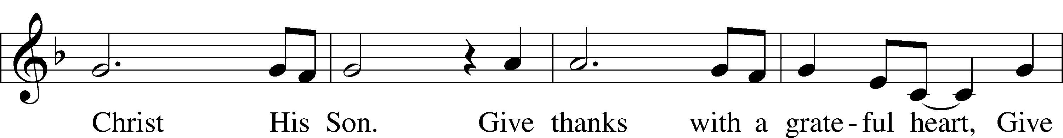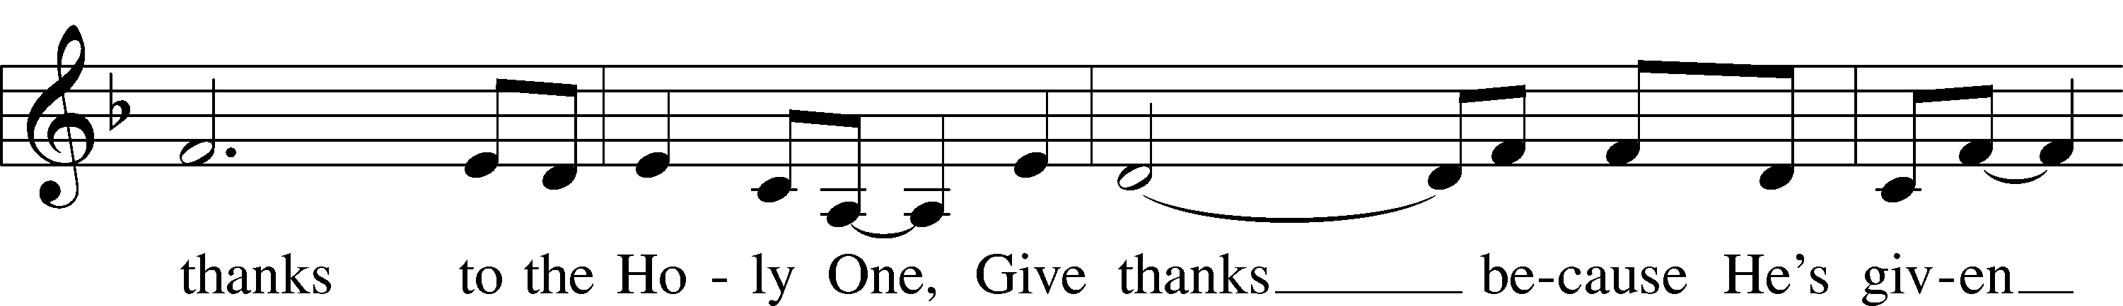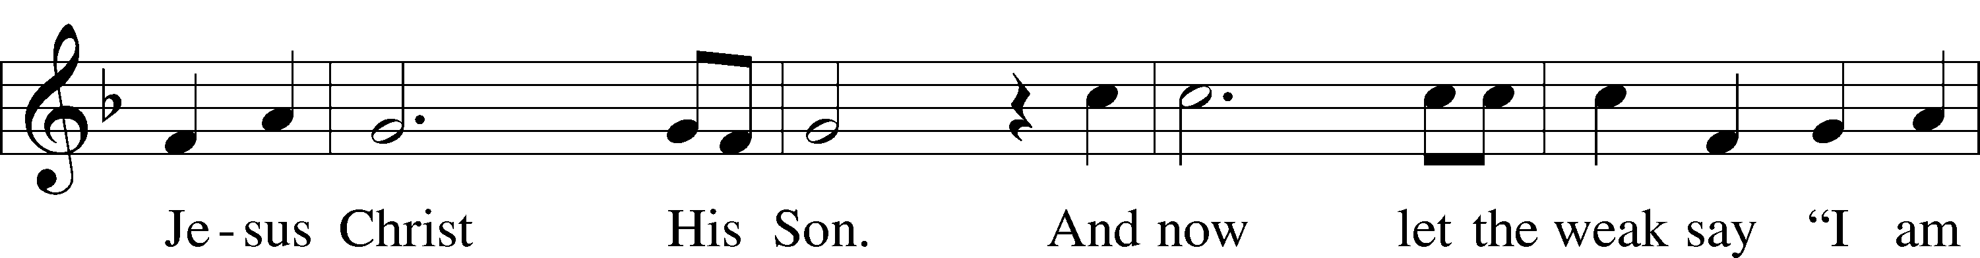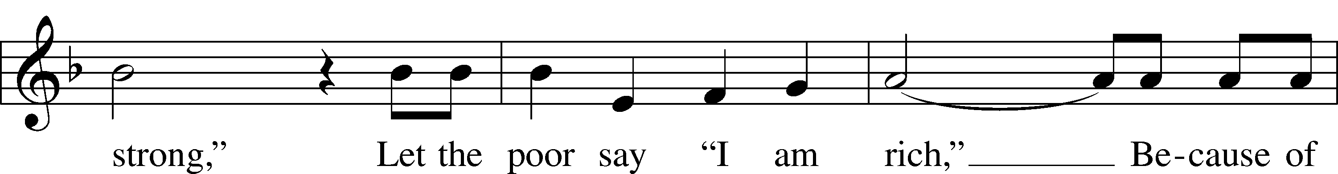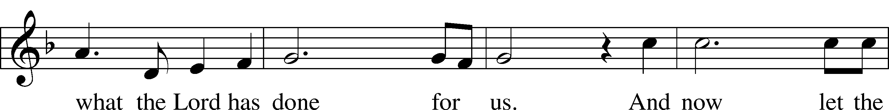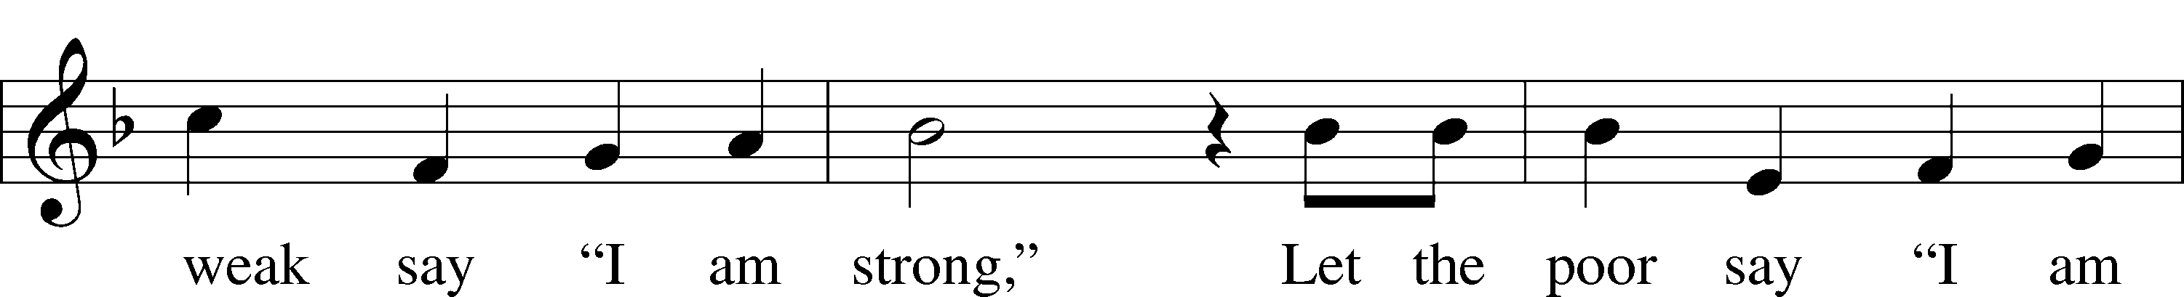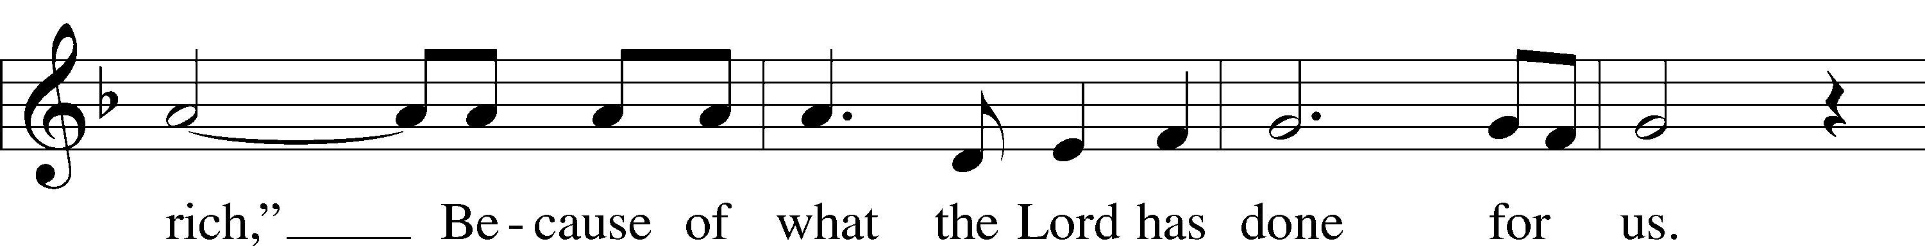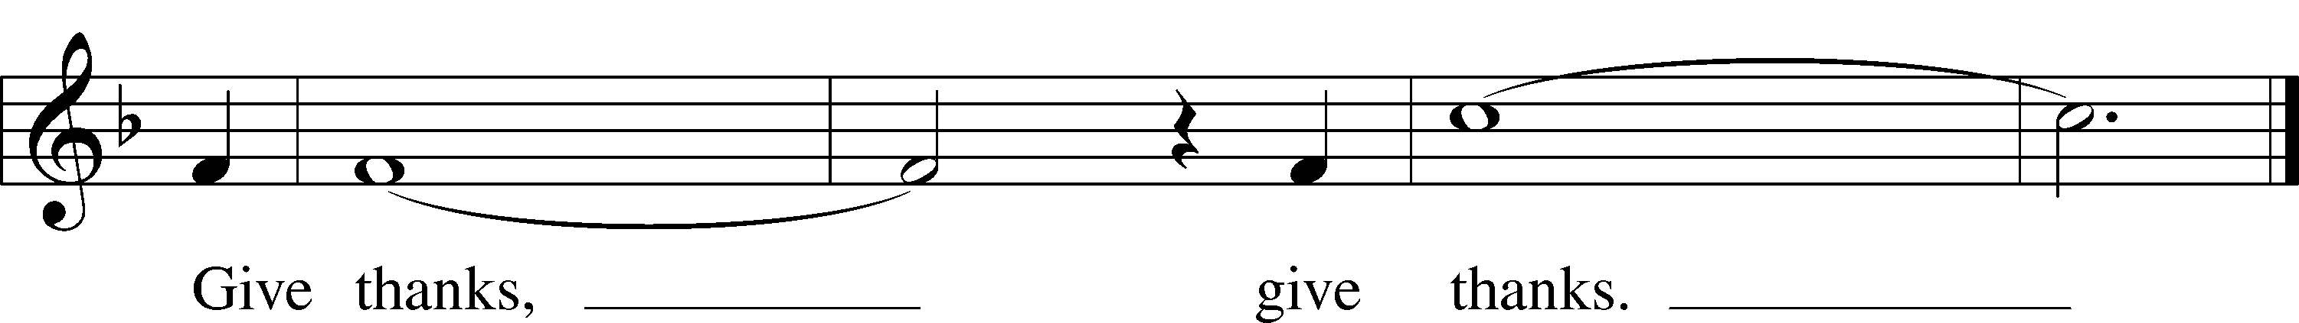

© 1978 Integrity’s Hosanna! Music. Used by permission: LSB Hymn License .NET, no. 100011641.



Jesus let the things that break your heart

also break our hearts.

Amen.

***“Just as I Am, without One Plea”* LSB 570**

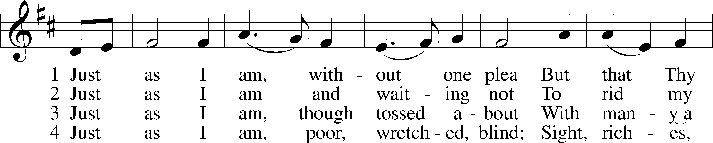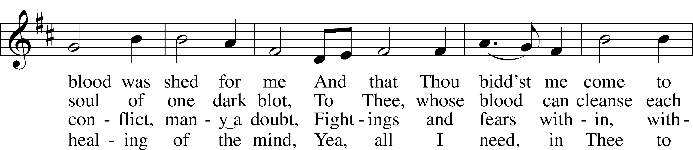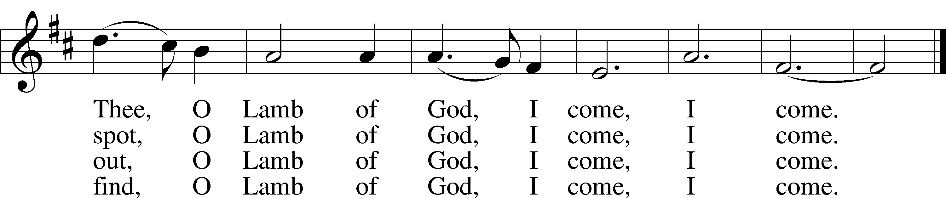

5 Just as I am, Thou wilt receive,  
Wilt welcome, pardon, cleanse, relieve;  
Because Thy promise I believe,  
 O Lamb of God, I come, I come.

6 Just as I am; Thy love unknown  
Has broken ev’ry barrier down;  
Now to be Thine, yea, Thine alone,  
 O Lamb of God, I come, I come. Public Domain

***“Take My Life and Let It Be”* LSB 784**

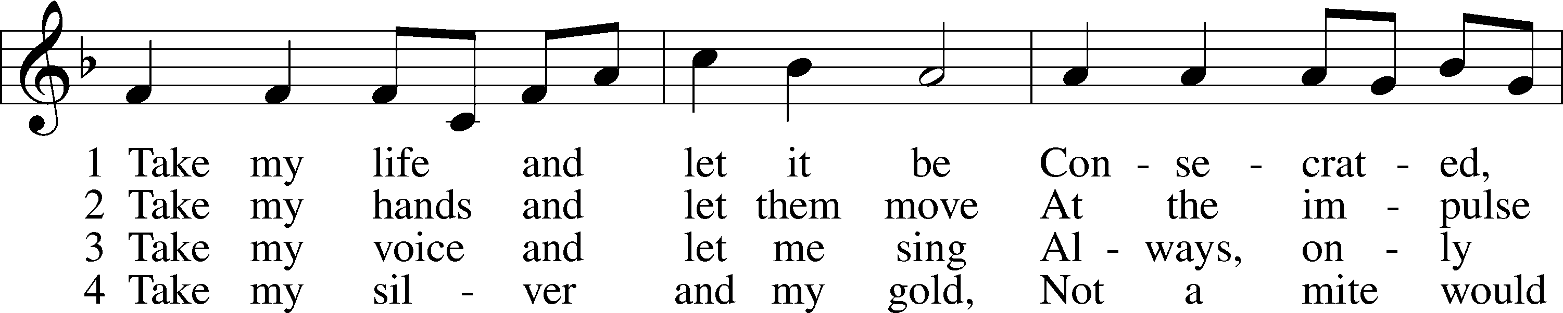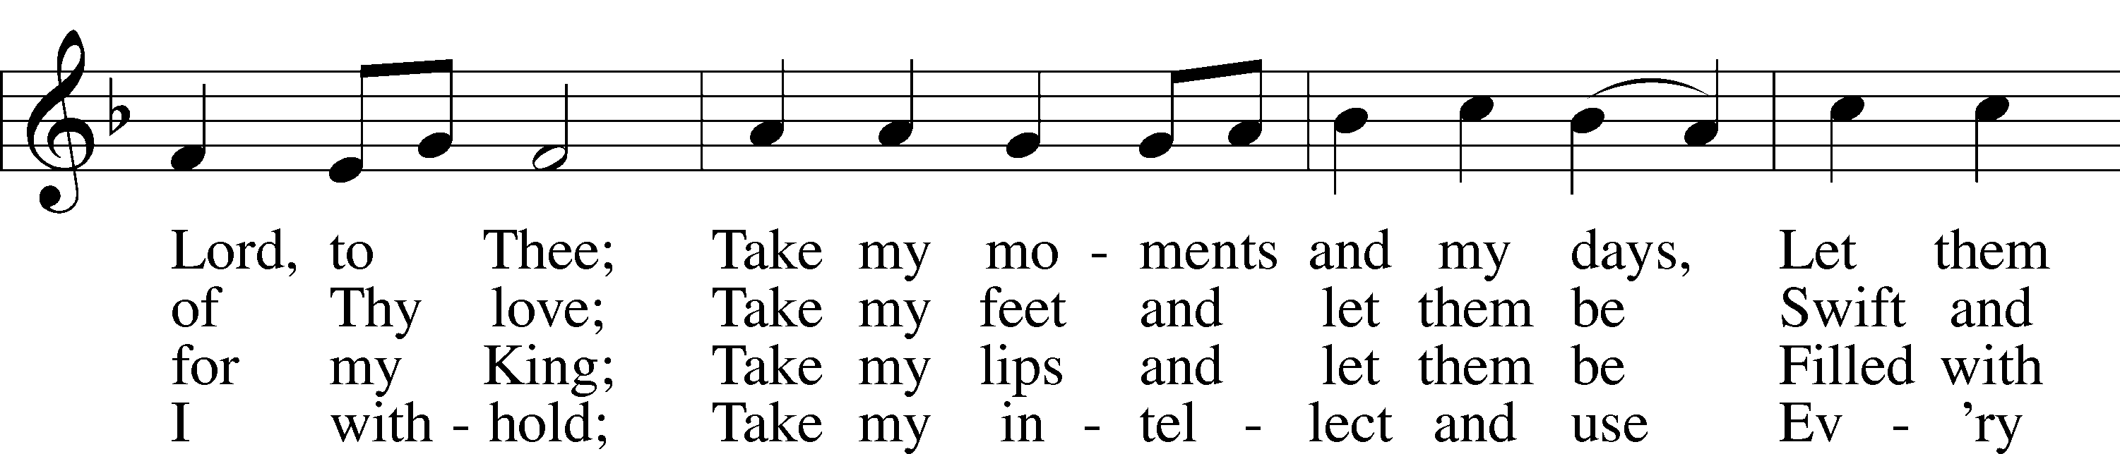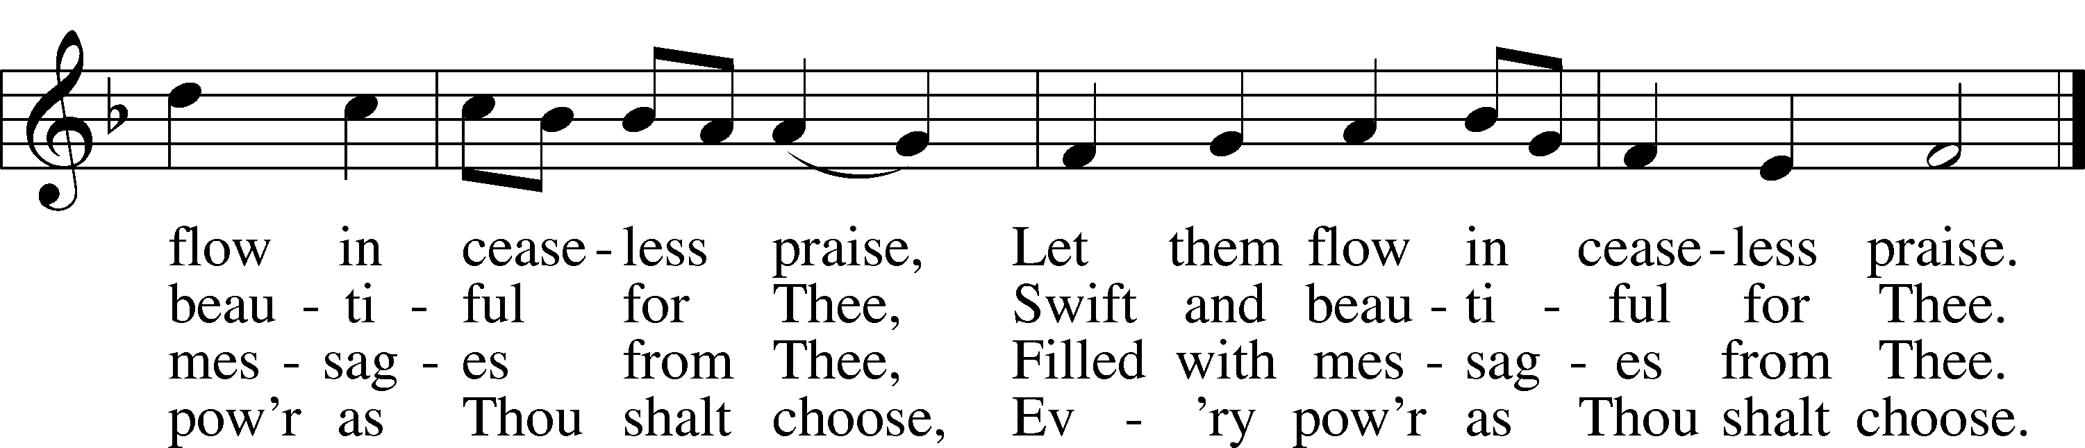

5 Take my will and make it Thine,  
It shall be no longer mine;  
Take my heart, it is Thine own,  
It shall be Thy royal throne.

6 Take my love, my Lord, I pour  
At Thy feet its treasure store;  
Take myself, and I will be  
Ever, only, all for Thee.

Public domain

*(Please stand…)*

**THE LORD’S PRAYER:**

**All: Our Father, who art in heaven, hallowed be thy name, thy kingdom come, thy will be done, on earth as it is in heaven. Give us this day our daily bread; and forgive us our trespasses as we forgive those who trespass against us; and lead us not into temptation, but deliver us from evil. For thine is the kingdom, and the power, and the glory, forever and ever. Amen**

**THE BENEDICTION**

**THE CLOSING HYMN: *“Holy God, We Praise Thy Name”* LSB 940**

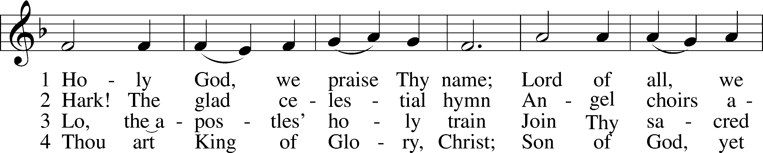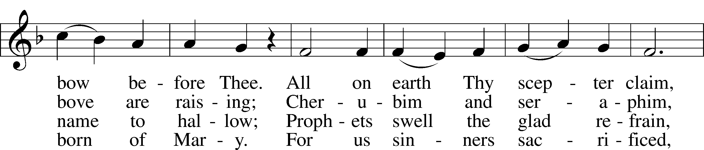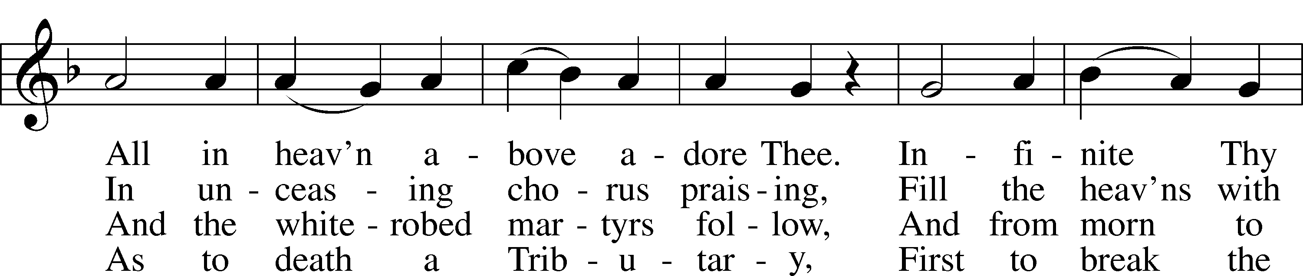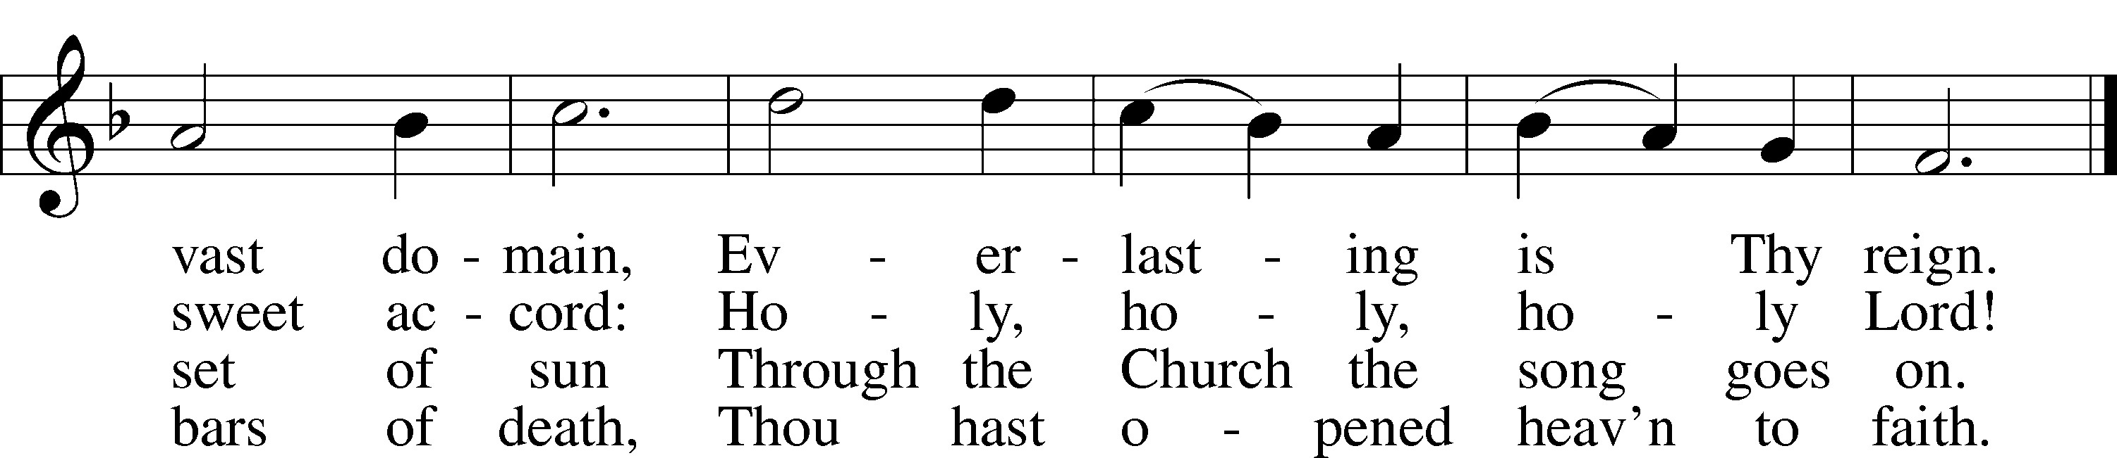

5 Holy Father, holy Son,  
 Holy Spirit, three we name Thee;  
Though in essence only one,  
 Undivided God we claim Thee  
And, adoring, bend the knee  
While we own the mystery.

Public domain

**POSTLUDE*: “Holy God, We Praise Thy Name”* Henry Kihlken**



**WELCOME TO GRACE LUTHERAN CHURCH:** We are glad that you are here to worship God with us today! We pray that you will enjoy the wonderful fellowship as friends in Christ as God gathers us around His means of grace, the Word and Sacraments, to bless us with His treasured gifts of forgiveness, faith, abundant life and eternal salvation. If you are a guest, please also sign our Guest Book. Please talk to Pastor if you would like **to learn more about becoming a member of Grace. Also, please join us for refreshments** and fellowship after the Service. We invite you to come and worship with us often as God gathers us in His Grace.

**WELCOME TO THE LORD’S TABLE:** We invite and encourage all present who are baptized and faithful Christians, and who confess the Father, Son, and Holy Spirit to be the only true God and who believe that Jesus Christ died for the sins of the World and is our only hope and salvation…to join us in receiving the very and true body and blood of Christ in this Sacrament. The clear liquid cups in the center of the tray are non-alcoholic wine.

Children not yet confirmed in the faith are always welcome to join their parents at the Lord’s Table, but should keep their hands folded in front of them. The Pastor will give them a blessing.

**SERVING TODAY:** Acolyte: Emily Howard; Lector: Mary Brady: Communion Assistants: Peter Bacle and Dean Thompson; Usher: Terry Richardson; Altar Care: __________; Refreshments: Pastor Faith and Pattie.

**SERVING NEXT SUNDAY:** Acolyte: __________; Lector: ____________; Communion Assistants: Peter Bacle and Dean Thompson; Usher: __________; Altar Care: _____________; Refreshments: ________.

**FLOWERS**: were placed on the altar to the glory of God.

THIS WEEK AT A GLANCE:

**Today: October 22nd**

9:00 am Worship Service with Communion

10:10 am Jr. Choir and Vocal Choir Rehearsal

10:15 am Fellowship

10:30 am Adult Bible Class/High School Bible Class/Children’s Bible Class

**Monday: October 23rd**

Pastor’s Day Off

**Tuesday: October 24th**

2:30 pm Jan’s Mobile Gym

6:00 pm Weight Watcher’s (Parish Hall)

**Thursday: October 26th**

4:15 pm Missional Communities (Pastor’s Office)

5:00 pm Women’s Bible Study (Room 3)

**Next Sunday: October 29th**

9:00 am Worship Service with Communion

10:15 am Fellowship

10:30 am Adult Bible Class/High School Bible Class/Children’s Bible Class

**IN YOUR PRAYERS THIS WEEK:** Max Broadbent, Bill and Mary Chalmers, family and friends of Florence Hovel, family and friends of Auwina Weed, Peggy Mira, Bud Wrocklage, Walt Lepperd, Michael Gillis, Wayne Kruer, Michael McPherson, Micah Westphalen, Capt. Zachary (Bo) Henry (Ret.), family of Sam Vinci, family and friends of Frank Deford, Larry Vandivier, Carl Vandivier, Bobby Meck, family and friends of Elaine Wavehime, Linda Mullis, Joe Lamberson, Michael Willard, France Vandivier, Katie Hoffman, Pastor Ray Peters, Family and friends of Will Plagens, Kay Sattelmeier, Dennis Julson, Vernon Julson, Olga Odland, the family of Jean Grafsgaard, Jenie Howard, Jenny Dean, Charles, Braydon, Champ, Amy, Elsie Hamilton, Mary Ellen Jessel, Marcos Diaz, Kaci Doran, Sandy Harris, and those you are praying for at home. If anyone has a special prayer request please submit it in writing in the collection plate; or you may call Pastor Gary Faith at (504-858-8872), or Kris Howard at (305-296-5161).

**WE WILL BE STARTING OVER** with the prayer list in November. If you would like the names of family and friends listed to continue to be listed please let Kris know.

**GIFTS, TITHES, & ATTENDANCE LAST SUNDAY**: Sunday October 15th received $1711.00 with an attendance of 68.

**NOISE OFFERING** for the next several weeks will go to support the Autism support group that meets here at Grace monthly.

**TO HELP US GROW…** The Bible reading for next Sunday’s service are Revelation 14:6-7, Romans 3:19-28, and John 8:31-36.

**TODAY WE ARE BLESSED** to receive into membership by transfer Tim and Gail Sunderman. We thank God for them and pray we will be a blessing to them and all of us will be a blessing to the community.

**NEXT SUNDAY IS REFORMATION SUNDAY**. Feel free to wear red.

**TOUCHING THE COMMUNITY WITH GRACE:** If you are interest in helping organize our Halloween Celebration this October the 31st please plan to stick around at 3pm following the Octoberfest at Pastor’s home.

**IF YOU ARE INTERESTED IN LEARNING** more about what we believe and teach and/or are interested in becoming a member of Grace Please let Pastor know so that he can begin an Adult Information class.

**THANKS TO ALL OF YOU** for helping your neighbor, listening to others, and being a blessing to the community and to GLCS.

**I HAVE ORDERED SEVERAL COPIES** of Pastor Finke’s book. If you would like to get maximum results from Greg and Susan’s visit in January you are welcome to borrow a copy. See Kris or Pastor.

**THERE IS ADDITIONAL PARKING** behind the school. Enter that lot on 10th Street.

**WE HAVE SET THE SCHEDULES** for ushers, acolytes, lectors, and communion assistants for the next three months. If you would like to serve in any of these positions, please let Pastor or Kris know.

**STEWARDSHIP LISTS:** On the bulletin board by the front door of the church you will find the Altar Care, Refreshments, and Flower sign-up sheets for 2017. If you are able to help out with any of these please place your name in the spot on the date requested.

**THE GRACE LUTHERAN CHURCH WEB PAGE AND FACE BOOK PAGE** now

contains a vocal recording of last week’s sermon. So, if you are not able to attend church on Sunday please go to our website where you will find a copy of the bulletin and a recording of Pastor Faith’s sermon. <https://gracelutherankw.360unite.com/home>.

**A NUMBER OF CAPITAL IMPROVEMENTS** are needed to keep our facilities in good health for the future. Roof repairs are needed on school buildings and the parsonage. If you can help it would be much appreciated! A big thanks to all who have contributed to these repairs.

**SAVE THE DATE AND MARK ON YOUR CALENDAR**

**GRACIOUS LADIES OF GRACE:** A small but fun group of ladies gathered for lunch at Salute on the beach. Salute is one of our very favorites and they didn't disappoint us on Tuesday afternoon. In fact, the grouper shrimp cake served over greens with a citrus dressing was so enticing everyone ordered it and it was a 5*delicious. We forgot to decide where to meet next time so I'm making an executive decision to try Blue Heaven in Old Town with the cats and roosters.  Parking will be challenging but I think worth the try. Please join us ladies on October 24th at 11:30 am. If you need a ride contact Monica at 305 923-0856.

**TOUCHING THE COMMUNITY WITH GRACE**: Halloween celebration, October 31st, 2017 on the black top.

**JANUARY 28TH, 2018:** Mark this day on your calendar. Pastor Greg Finke and his wife Susan are scheduled to join us for worship and training on how to be a neighborhood missionary. The Finke’s travel all over the country helping equip folks for everyday ministry. Don’t miss this opportunity or you will wonder why everyone is more excited about Jesus missing.

**JANUARY 27TH, 2018:** We plan on having the annual “Let’s Get to Know our Snowbird Friends Better” with Susan and Greg as our guests of honor.



**MUSIC MINISTRY:** "Make a joyful noise to the Lord, all the earth!" Psalm 100:1. It is time for our choirs to begin rehearsing again. Please speak with Beverly Walker or contact her at [beverlywalker@gmail.com](mailto:beverlywalker@gmail.com) if you have any questions.

Jr. Choir and Vocal Choir: There will be a combined rehearsal today from 10:10- 10:25 by the piano.

Bell Choir: No rehearsal this Thursday. The next rehearsal will be Thursday, November 2 from 5:45-6:30 pm.

Vocal Choir: No rehearsal this Thursday. The next rehearsal will be Thursday, November 2 from 6:30-7:30 pm.

**MEN’S BIBLE FELLOWSHIP**: They meet the first and third Wednesday’s of each month at 12:30pm. Their next meeting will be October 18th located at Chico’s on Stock Island. All guys are welcome.

**WOMEN’S BIBLE STUDY**: We will have a short get together on Oct. 26 at 5:00 in rm 3 to pass out books and make plans for the next study sessions. We will be studying Abigail's Story by Sarah Young.  It's a story about a godly woman who responded with strength and faith even as she encountered some very difficult circumstances.  This study also explores how her character qualities and actions originate from the very heart of God and you will be challenged, motivated and blessed by the example of Abigail.

**MISSIONAL COMMUNITIES** will meet this Thursday at 4:15 pm in the classroom 3. I’m looking forward to hearing how you have seen Jesus at work in your life.