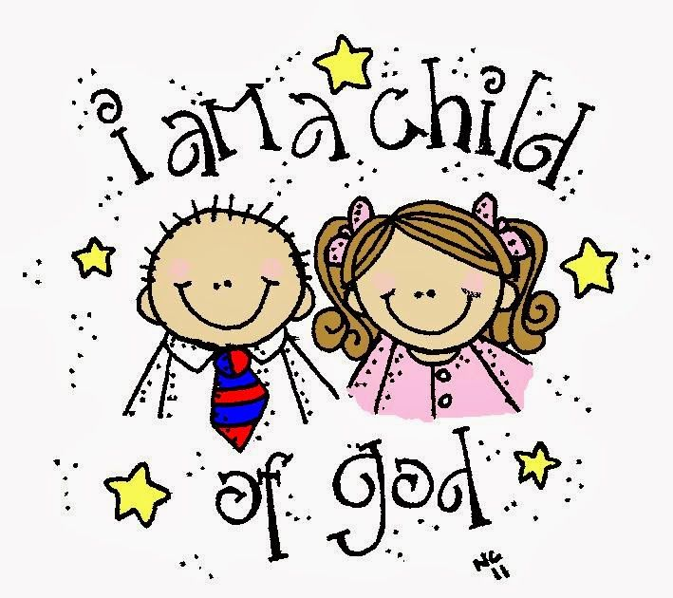

October 15st, 2017
9:00 am
NINETEENTH SUNDAY AFTER PENTECOST
Grace Lutheran Church
2713 Flagler Ave.
Key West, FL 33040
305-296-5161
GraceLutheranKW@att.net
gracelutherankw.360unite
Pastor Faith
(504) 858-8872
garyfaith@aol.com

NINETEENTH SUNDAY AFTER PENTECOST
OCTOBER 15TH, 2017 9:00 a.m.
WORSHIP SERVICE
In the Name of Jesus!
Our Mission Statement: Anchored in Christ, each person a missionary.

PRELUDE: "Dearest Jesus,We Are Here" Piet Post

ANNOUNCEMENTS:
God is with us all during the week, wherever we are and in whatever we are doing. This week, let’s enjoy His presence.

OPENING HYMN: “Dearest Jesus, We Are Here” LSB 592
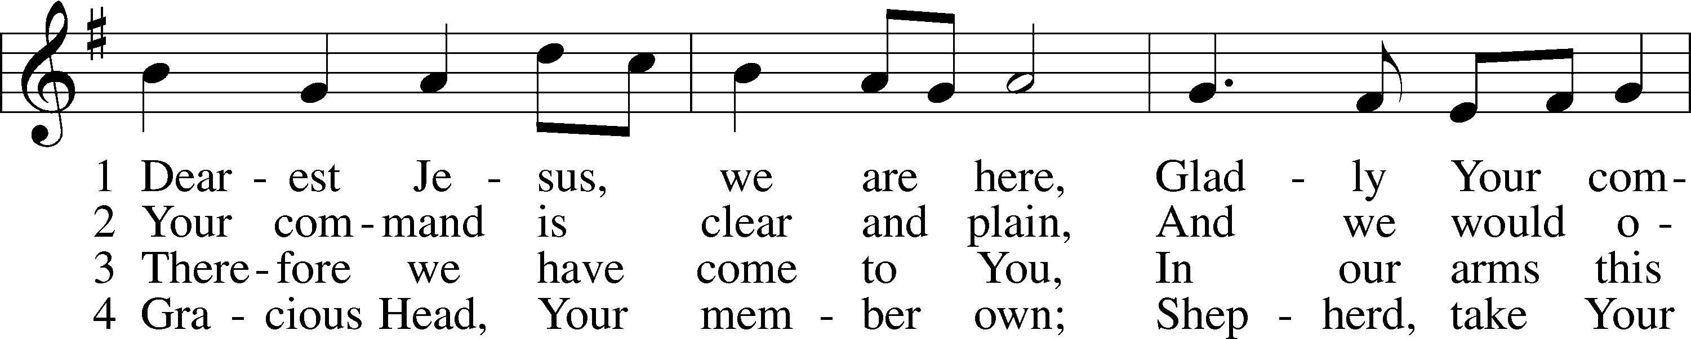
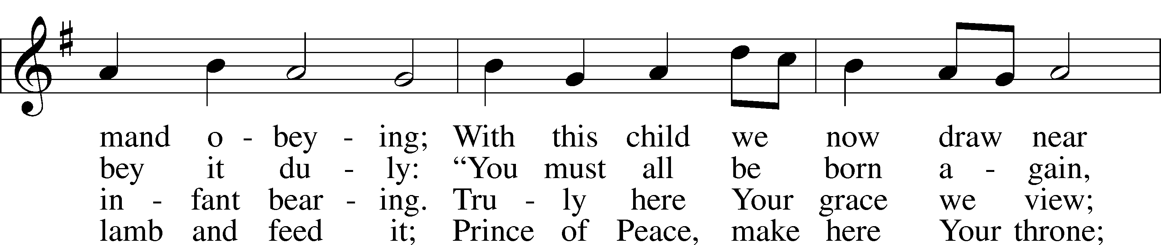
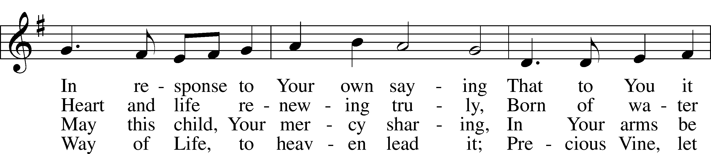
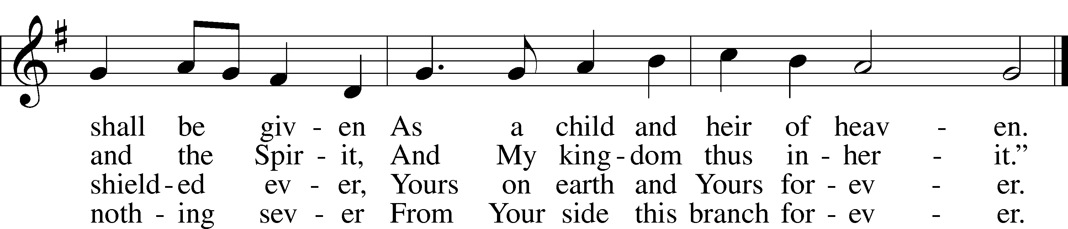

5 Now into Your heart we pour
Prayers that from our hearts proceeded.
Our petitions heav’nward soar;
May our hearts’ desires be heeded!
Write the name we now have given;
Write it in the book of heaven!
Public domain

Pastor: In the Name of the Father and of the Son and of the Holy Spirit.
Congregation: Amen

SERVICE OF HOLY BAPTISM: John Solomon Castro

HYMN: “Father Welcomes” LSB 605
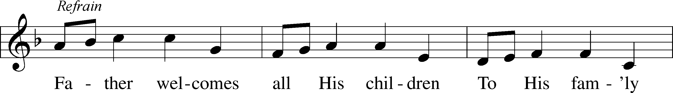
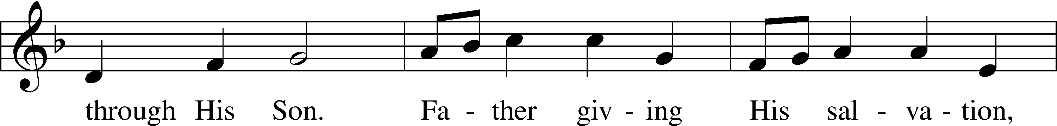
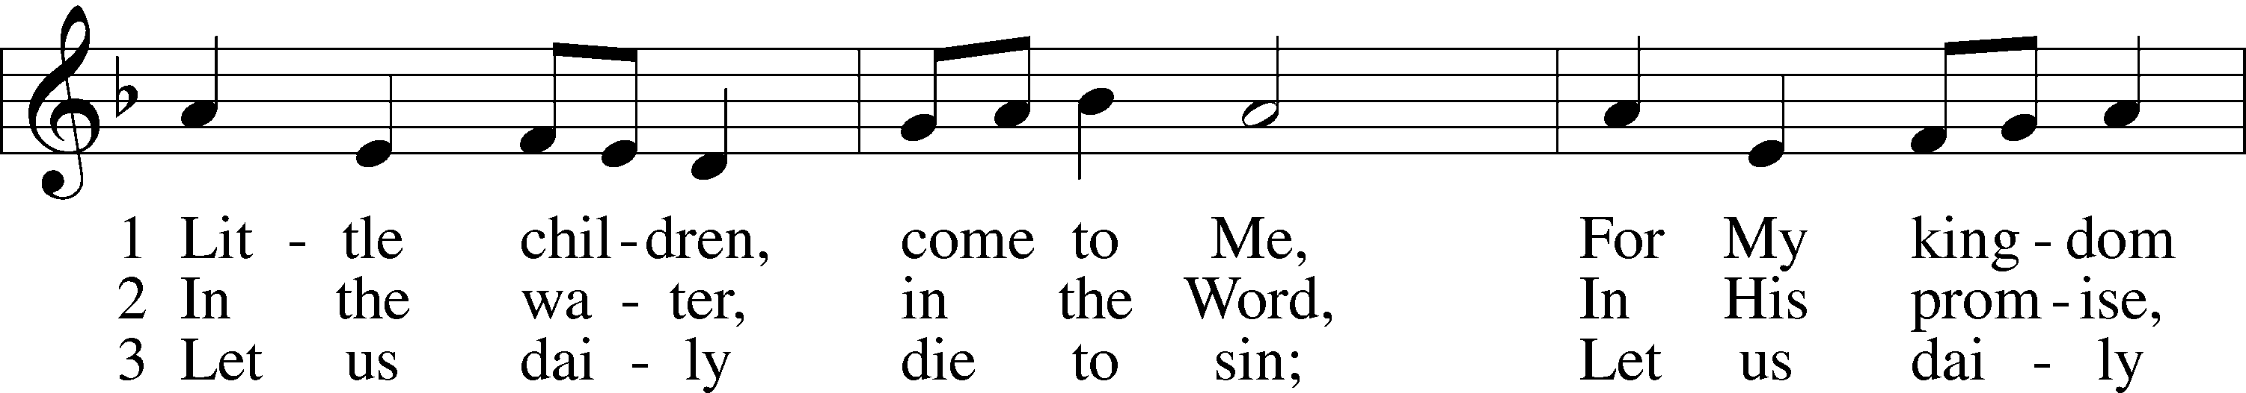
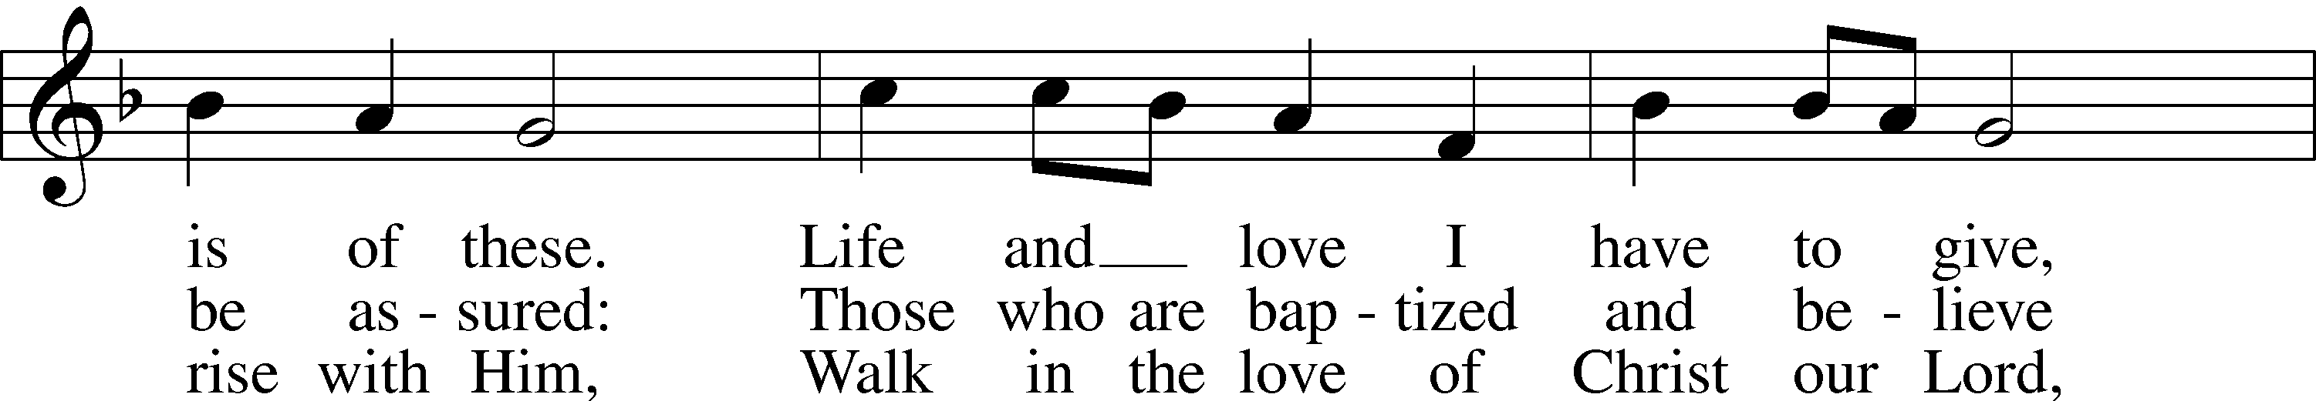
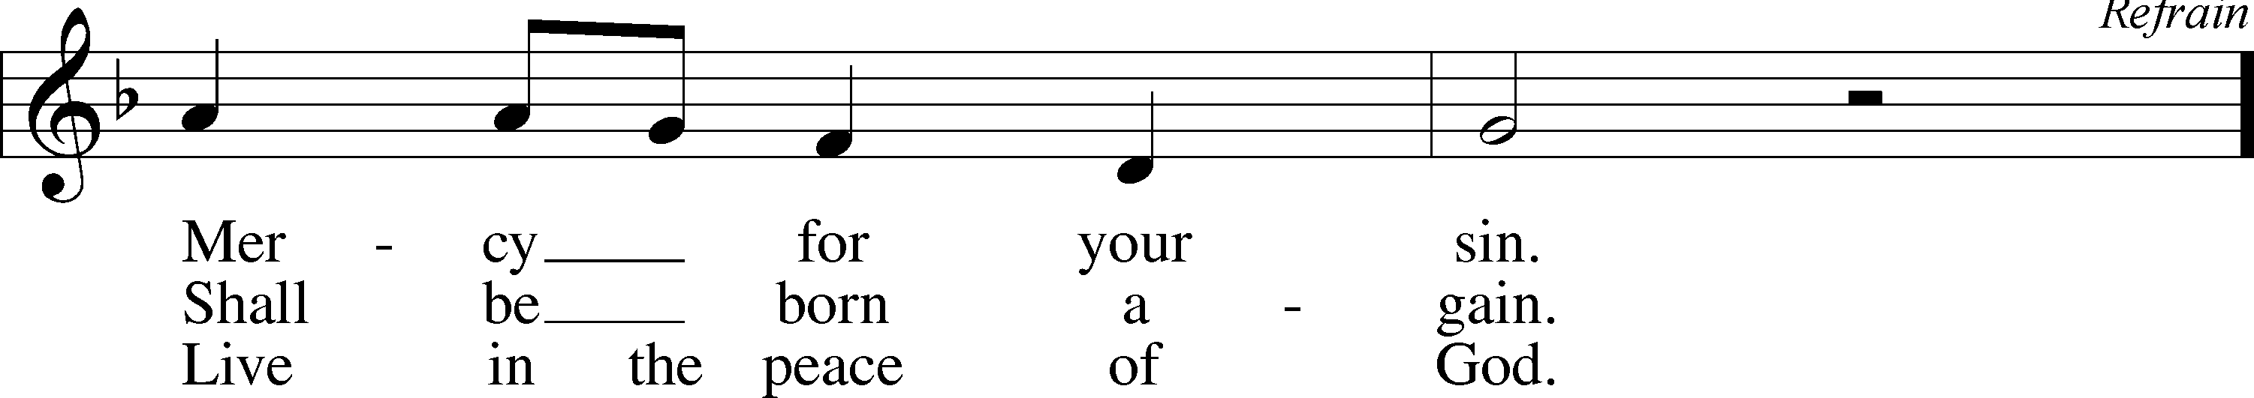
© 1986 Kevin Mayhew Ltd. Used by permission: LSB Hymn License .NET, no. 100011641.

PREPARATION

(Please Remain Standing Or You May Kneel…)
CONFESSION OF SIN:
All: God, I admit I have broken all of your commandments; I am not holy or sinless even though I often pretend a righteousness I do not have. I offer excuses. I have broken relationships by what I have said, or done. I have not loved either You or my neighbor as I ought. (time for personal confession____)

YOU ARE FORGIVEN:
Pastor: God is merciful and gracious; He has given His Son, Jesus Christ to die and rise again for us, the sinful ones that we might be forgiven and enjoy His Peace. This is also a reminder of God’s gifts and blessing that have become ours in Holy Baptism.
Congregation: thank you God for Your blessing!
Pastor: Yes, the Grace of our Lord Jesus Christ, and the Love of God, and the fellowship of His Holy Spirit is with you all.
Congregation: And also with you.
Pastor: In peace and as His forgiven people, we can pray to the Lord:
Congregation: He is gracious to us and hears our prayers.
Pastor: For the peace of the whole world and our involvement in Christ’s Mission in the world, we pray:
Congregation: Keep us mindful of our purpose as Christians and our ability to share your blessings of peace and forgiveness with others.
Pastor: We are the children of the Risen Christ. His victory is Our Victory!

THE PRAYERS OF THE CHURCH:
All: Almighty God, You invite us to trust in You for our salvation. Deal with us not in the severity of Your judgement but by the greatness of Your mercy; through Jesus Christ, Your Son, our Lord, who lives and reigns with You and the Holy Spirit., one God , now and forever. Amen

SERVICE OF THE WORD

God speaks to us through his word, the Bible:

(You may be seated…)
THE OLD TESTAMENT LESSON: Isaiah 25:6-9
Lector: This is the Word of the Lord.
People: Thanks be to God.

THE EPISTLE LESSON: Hebrews 13:7-8
Lector: This is the Word of the Lord.
People: Thanks be to God.

(Please stand…)
THE HOLY GOSPEL: Matthew 22:1-14
Pastor: The Holy Gospel according to St. Matthew Chapter 22.
People: Glory to You, O Lord.
Pastor: This is the Gospel of the Lord.
People: Praise to You, O Christ!

(Please be seated…)
CHILDREN’S MESSAGE:

NOISE OFFERING
It’s called a noise offering because what we are asking for is pocket change. It will always be used for missions outside of our church and school. It normally also is given to a mission involving children. Thanks for making a joyful noise to the Lord.

THE SERMON HYMN: “Standing on the Promises”
Words and Music by Russell Kelso Carter
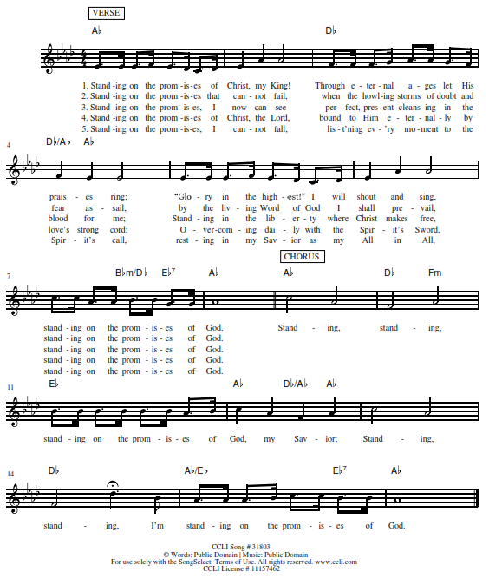
THE SERMON:

SUNDAY SCHOOL TEACHER INSTALLATION

(Please be seated…)
OFFERING: "Old 100th" J.Pachelbel

(Please stand…)
“Praise God, from Whom All Blessings Flow” LSB 805
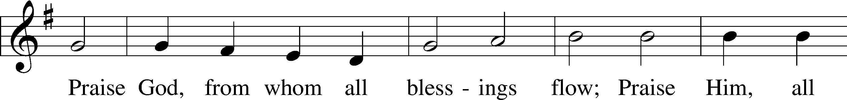
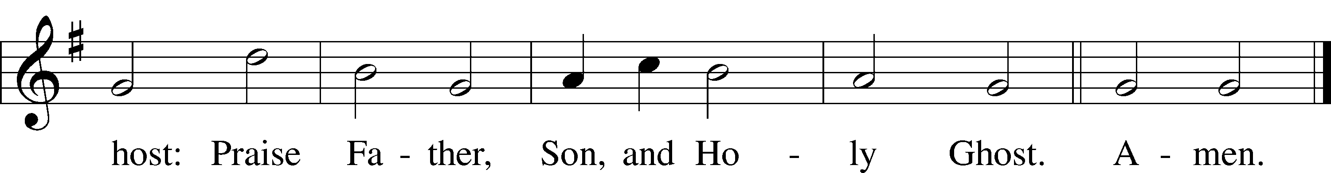
Public domain

SERVICE OF THE SACRAMENT

(Please stand…)
PREPARE FOR THE LORD’S SUPPER:
Pastor: We begin with the reminder: “The Lord is with you.”
Congregation: We are mindful and thankful for His presence.
Pastor: Let your life reflect the joy of your salvation.
Congregation: We do give Him thanks and praise. We will share His blessing with others.
Pastor: It is proper that we should at all times and in all places…(prayer)… we praise your name and join others in singing:

All: (sing) “Holy, holy, holy Lord God of pow’r and might:
Heaven and earth are full of your glory.
Hosanna, Hosanna, Hosanna in the highest.
Blessed is he who comes in the name of the Lord.
Hosanna in the highest.”

(Please be seated…)
THE CONSECRATION AND DISTRIBUTION:
DISTRIBUTION HYMNS: “I Love to Tell the Story”
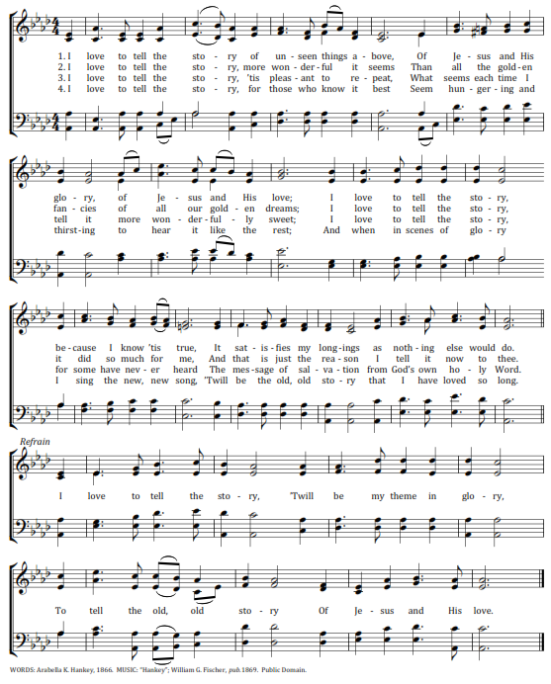
“I Am Jesus' Little Lamb” LSB 740
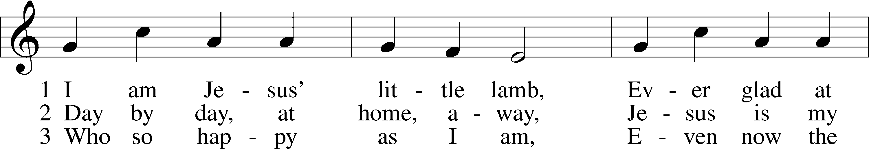
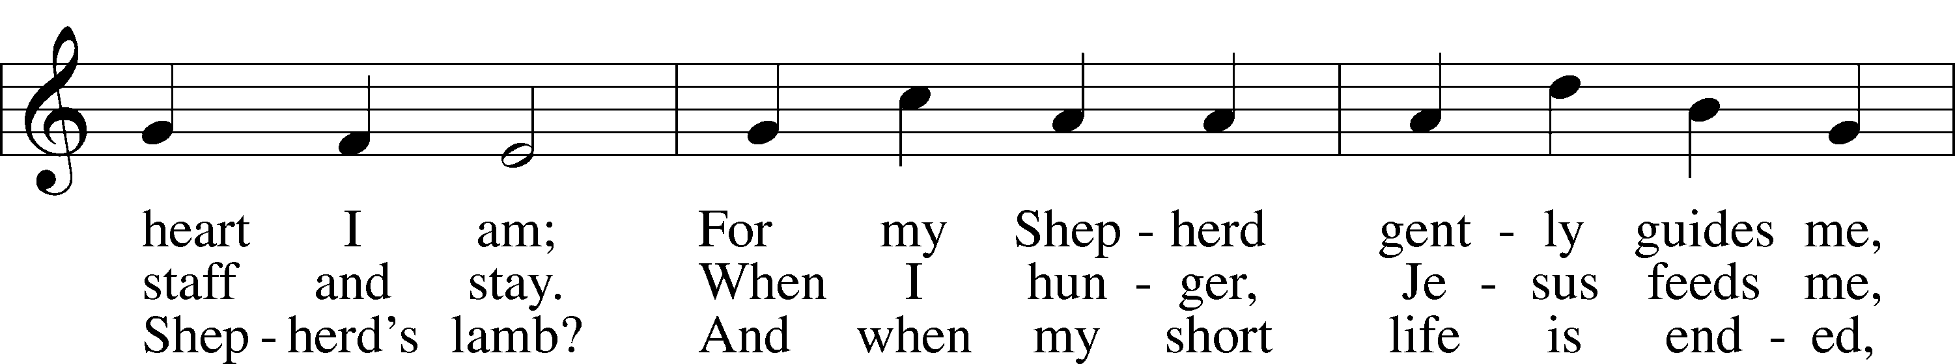
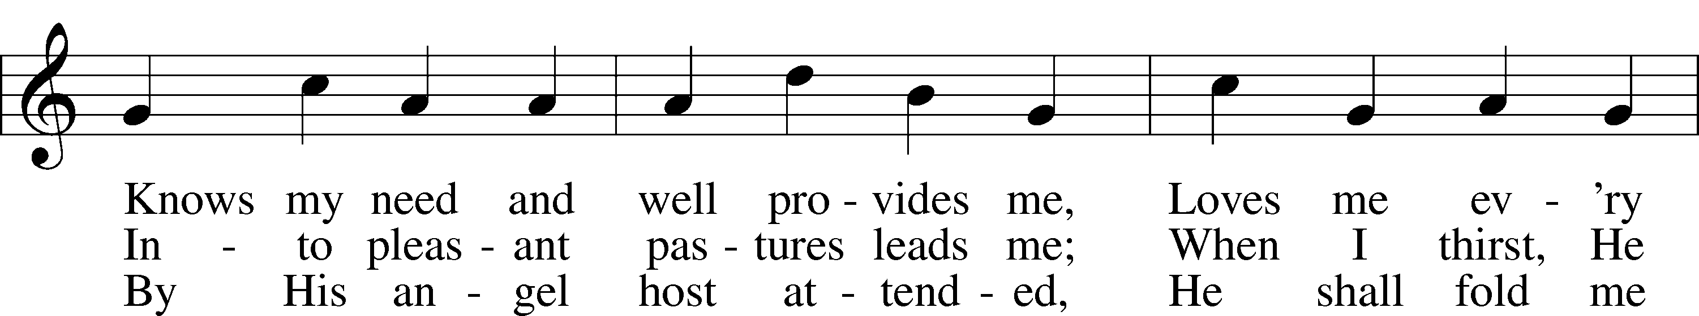
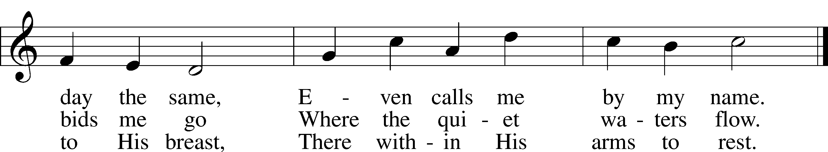
Public domain

“Children of the Heavenly Father” LSB 725
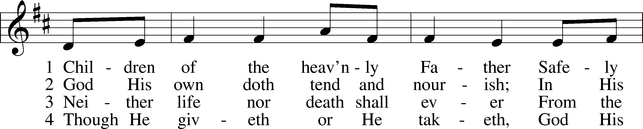
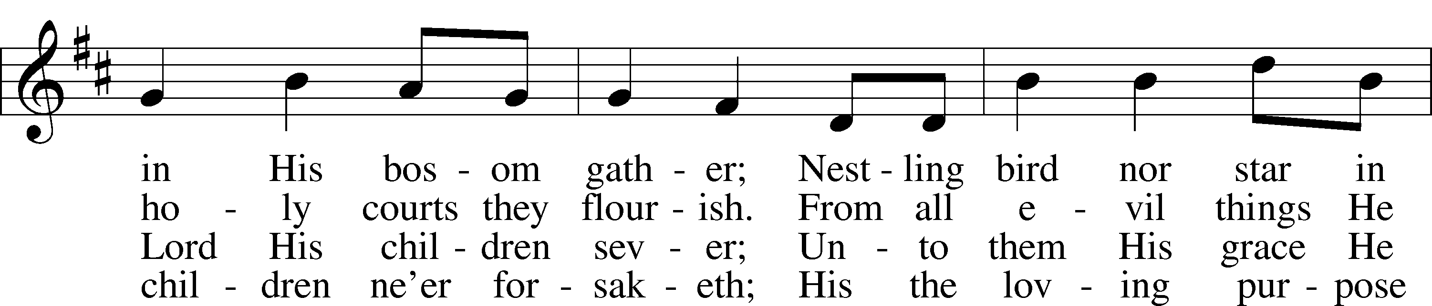
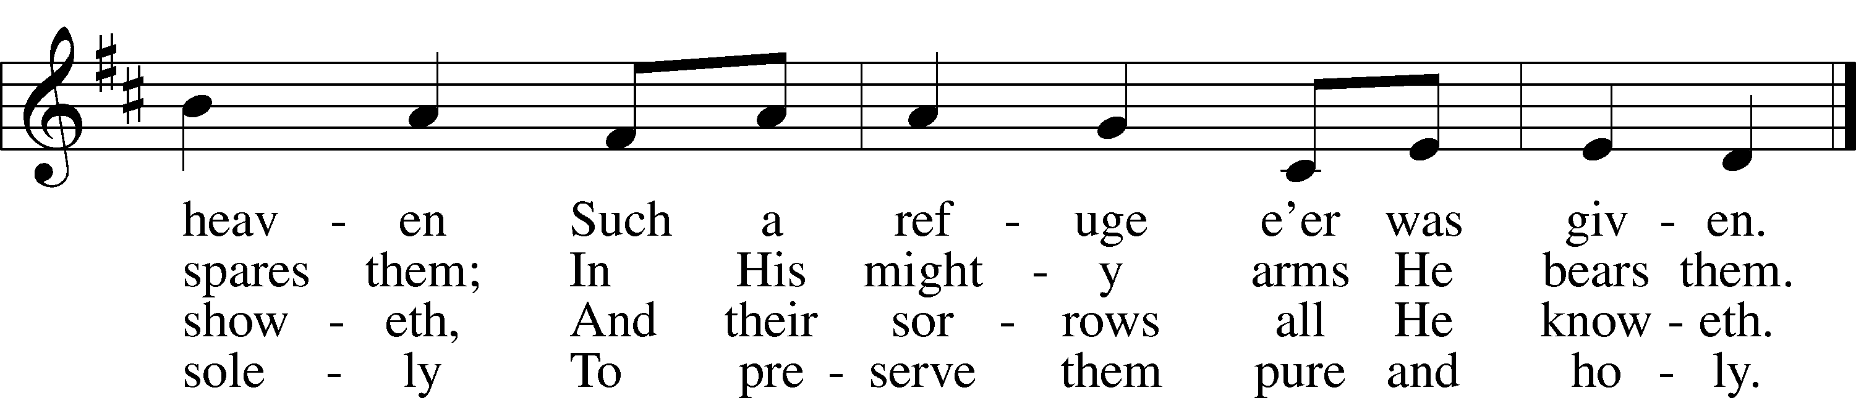
© Augsburg Publishing House. Used by permission: LSB Hymn License .NET, no. 100011641.Public domain

(Please stand…)
THE LORD’S PRAYER:
All: Our Father, who art in heaven, Hallowed be thy name, thy kingdom come, thy will be done, on earth as it is in heaven. Give us this day our daily bread; and forgive us our trespasses, as we forgive those who trespass against us; and lead us not into temptation, but deliver us from evil. For thine is the kingdom, and the power, and the glory, forever and ever. Amen.

THE BLESSING AND BENEDICTION:
Pastor: The Lord Blesses you and keeps you, the Lord makes His face to shine upon you and He is Gracious to you. The Lord looks upon you with His favor and gives you His peace.
Congregation: God blesses us so that we can be a blessing to others.
Pastor: Go in His peace and serve the Lord by serving others.
Congregation: Amen

CLOSING HYMN: “Go, My Children, with My Blessing” LSB 922
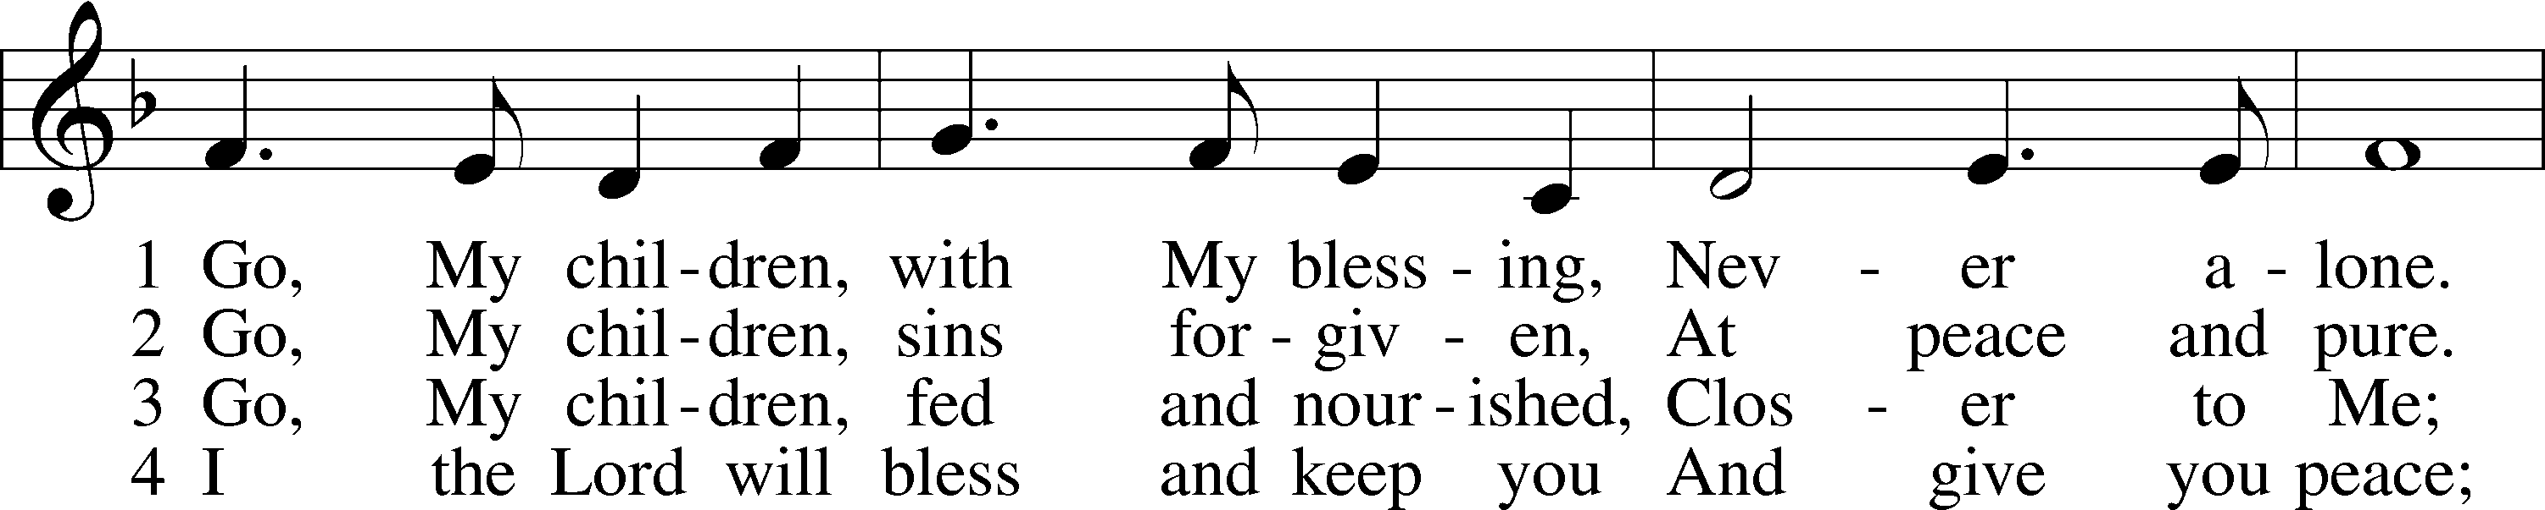
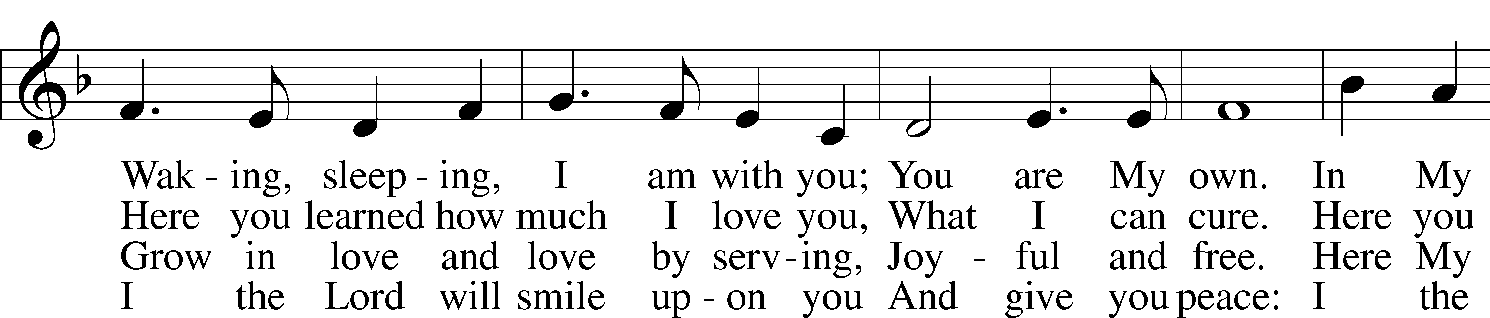
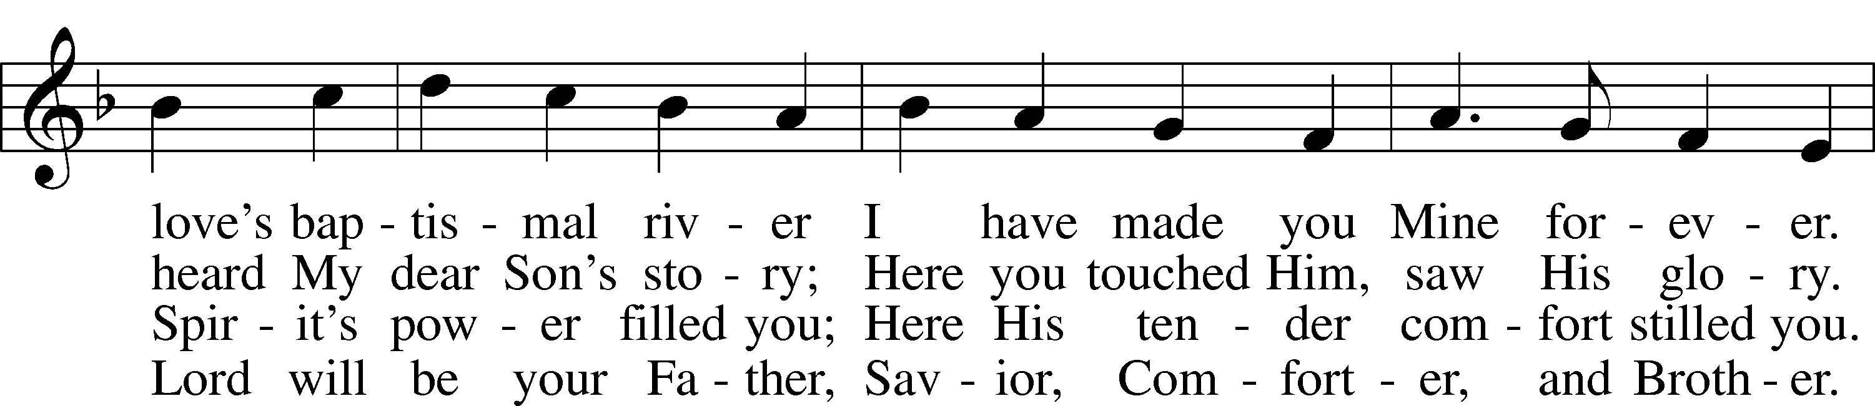
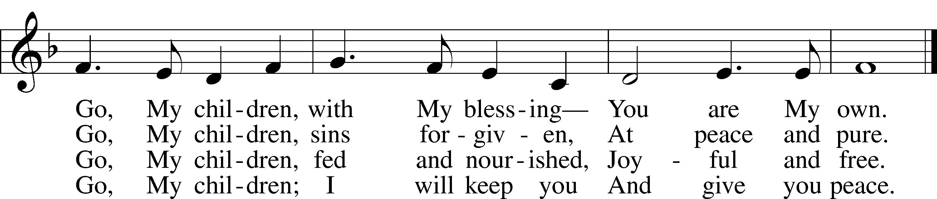
© 1983 Concordia Publishing House. Used by permission: LSB Hymn License .NET, no. 100011641.Public domain
POSTLUDE: "Prelude and Fugue in G" J.S.Bach

WELCOME TO GRACE LUTHERAN CHURCH: We are glad that you are here to worship God with us today! We pray that you will enjoy the wonderful fellowship as friends in Christ as God gathers us around His means of grace, the Word and Sacraments, to bless us with His treasured gifts of forgiveness, faith, abundant life and eternal salvation. If you are a guest, please also sign our Guest Book. Please talk to Pastor if you would like to learn more about becoming a member of Grace. Also, please join us for refreshments and fellowship after the Service. We invite you to come and worship with us often as God gathers us in His Grace.

WELCOME TO THE LORD’S TABLE: We invite and encourage all present who are baptized and faithful Christians, and who confess the Father, Son, and Holy Spirit to be the only true God and who believe that Jesus Christ died for the sins of the World and is our only hope and salvation…to join us in receiving the very and true body and blood of Christ in this Sacrament. The clear liquid cups in the center of the tray are non-alcoholic wine.
Children not yet confirmed in the faith are always welcome to join their parents at the Lord’s Table, but should keep their hands folded in front of them. The Pastor will give them a blessing.

SERVING TODAY: Acolyte: Eli Morris; Lector: Kris Bly: Communion Assistants: Peter Bacle and Dean Thompson; Usher: ____________; Altar Care: __________; Refreshments: Monica Bacle.

SERVING NEXT SUNDAY: Acolyte: __________; Lector: ____________; Communion Assistants: Peter Bacle and Dean Thompson; Usher: Bill Chalmers; Altar Care: _____________; Refreshments: ________.

FLOWERS: were placed on the altar to the glory of God.

THIS WEEK AT A GLANCE:
Today: October 15th
9:00 am Worship Service with Communion
10:15 am Fellowship
10:30 am Adult Bible Class/High School Bible Class/Children’s Bible Class

Monday: October 16th
Pastor’s Day Off

Tuesday: October 17th
2:30 pm Jan’s Mobile Gym
6:00 pm Weight Watcher’s (Parish Hall)

Wednesday: October 18th
12:30 pm Men’s Bible Fellowship (Chico’s)

Thursday: October 19th
4:15 pm Missional Communities (Pastor’s Office)
5:30 pm Hand Bell Choir
6:30 pm Vocal Choir

Saturday: October 21st
12:00 pm Oktoberfest (Pastor and Pattie’s Home)
3:00 pm Touching the Community with Grace Meeting (Pastor and Pattie’s Home)

Next Sunday: October 22nd
9:00 am Worship Service with Communion
10:00 am Little Singers
10:10 am Jr. Choir
10:15 am Fellowship
10:30 am Adult Bible Class/High School Bible Class/Children’s Bible Class

IN YOUR PRAYERS THIS WEEK: Max Broadbent, Bill and Mary Chalmers, family and friends of Florence Hovel, family and friends of Auwina Weed, Peggy Mira, Bud Wrocklage, Walt Lepperd, Michael Gillis, Wayne Kruer, Michael McPherson, Micah Westphalen, Capt. Zachary (Bo) Henry (Ret.), family of Sam Vinci, family and friends of Frank Deford, Larry Vandivier, Carl Vandivier, Bobby Meck, family and friends of Elaine Wavehime, Linda Mullis, Joe Lamberson, Michael Willard, France Vandivier, Katie Hoffman, Pastor Ray Peters, Family and friends of Will Plagens, Kay Sattelmeier, Dennis Julson, Vernon Julson, Olga Odland, the family of Jean Grafsgaard, Jenie Howard, Jenny Dean, Charles, Braydon, Champ, Amy, Elsie Hamilton, Mary Ellen Jessel, Marcos Diaz, Kaci Doran, Sandy Harris, and those you are praying for at home. If anyone has a special prayer request please submit it in writing in the collection plate; or you may call Pastor Gary Faith at (504-858-8872), or Kris Howard at (305-296-5161).

WE WILL BE STARTING OVER with the prayer list in November. If you would like the names of family and friends listed to continue to be listed please let Kris know.

GIFTS, TITHES, & ATTENDANCE LAST SUNDAY: Sunday October 8th received $5249.00, the building fund received $500.00, and the noise offering received $131.73 with an attendance of 79.

NOISE OFFERING for the next several weeks will go to support the Autism support group that meets here at Grace monthly.

TO HELP US GROW… The Bible reading for next Sunday’s service are Isaiah 45:1-7, 1 Thessalonians 1:1-10, Matthew 22:15-22.

TODAY WE WELCOME JOHN SOLOMON CASTRO into the kingdom of God through the washing of holy baptism. John is the son of John Paul and Jenny Castro and the grandson of Peter and Monica Bacle. We thank God for the gift of baptism and the grace God gives through this gift.

TODAY WE INSTALL install our Sunday School Staff for the 2017-2018 school year. Please keep these teachers and the children in your prayers. JoAnn Broadbent (Pre K – 2nd Grade), Pattie Faith and Kris Howard (3rd – Middle School), Mitch Cook and Kris Bly (High School).

TOUCHING THE COMMUNITY WITH GRACE: If you are interest in helping organize our Halloween Celebration this October the 31st please plan to stick around at 3pm following the Octoberfest at Pastor’s home.

IF YOU ARE INTERESTED IN LEARNING more about what we believe and teach and/or are interested in becoming a member of Grace Please let Pastor know so that he can begin an Adult Information class.

THANKS TO ALL OF YOU for helping your neighbor, listening to others, and being a blessing to the community and to GLCS.

I HAVE ORDERED SEVERAL COPIES of Pastor Finke’s book. If you would like to get maximum results from Greg and Susan’s visit in January you are welcome to borrow a copy. See Kris or Pastor.

THERE IS ADDITIONAL PARKING behind the school. Enter that lot on 10th Street.

WE HAVE SET THE SCHEDULES for ushers, acolytes, lectors, and communion assistants for the next three months. If you would like to serve in any of these positions, please let Pastor or Kris know.

STEWARDSHIP LISTS: On the bulletin board by the front door of the church you will find the Altar Care, Refreshments, and Flower sign-up sheets for 2017. If you are able to help out with any of these please place your name in the spot on the date requested.

THE GRACE LUTHERAN CHURCH WEB PAGE AND FACE BOOK PAGE now
contains a vocal recording of last week’s sermon. So, if you are not able to attend church on Sunday please go to our website where you will find a copy of the bulletin and a recording of Pastor Faith’s sermon. https://gracelutherankw.360unite.com/home.

A NUMBER OF CAPITAL IMPROVEMENTS are needed to keep our facilities in good health for the future. Roof repairs are needed on school buildings and the parsonage. If you can help it would be much appreciated! A big thanks to all who have contributed to these repairs.

SAVE THE DATE AND MARK ON YOUR CALENDAR

GRACIOUS LADIES OF GRACE: A small but fun group of ladies gathered for lunch at Salute on the beach. Salute is one of our very favorites and they didn't disappoint us on Tuesday afternoon. In fact, the grouper shrimp cake served over greens with a citrus dressing was so enticing everyone ordered it and it was a 5*delicious. We forgot to decide where to meet next time so I'm making an executive decision to try Blue Heaven in Old Town with the cats and roosters. Parking will be challenging but I think worth the try. Please join us ladies on October 24th at 11:30 am. If you need a ride contact Monica at 305 923-0856.

OCTOBERFEST: an opportunity to build relationships. SIGN UP TODAY for Saturday October 21st noon til 3pm. We will be celebrating our annual Oktoberfest at the parsonage. Meat, baked beans, and drinks will be provided. If you like, bring a side dish and lawn chair. There is a sign-up sheet in the Narthex so that Pastor knows how much food to buy. Please sign your name and the guestimated number of people who will be coming with you.

TOUCHING THE COMMUNITY WITH GRACE: Halloween celebration, October 31st, 2017 on the black top.

JANUARY 28TH, 2018: Mark this day on your calendar. Pastor Greg Finke and his wife Susan are scheduled to join us for worship and training on how to be a neighborhood missionary. The Finke’s travel all over the country helping equip folks for everyday ministry. Don’t miss this opportunity or you will wonder why everyone is more excited about Jesus missing.

JANUARY 27TH, 2018: We plan on having the annual “Let’s Get to Know our Snowbird Friends Better” with Susan and Greg as our guests of honor.

MUSIC MINISTRY: "Make a joyful noise to the Lord, all the earth!" Psalm 100:1. It is time for our choirs to begin rehearsing again. Please speak with Beverly Walker or contact her at beverlywalker@gmail.com if you have any questions.

Little Singers: No rehearsal today. Next Sunday, infants through first grade children and their parents are invited to meet by the piano immediately after the Service for a few minutes of hymn singing.
Jr. Choir for grades 2 through 8: No rehearsal today. We will rehearse next Sunday from 10:10 - 10:25 by the piano.
Bell Choir for grade 5 through adult will rehearse on Thursday from 5:45 to 6:30 pm.
Vocal Choir will rehearse on Thursday from 6:30 to 7:30 pm.

MEN’S BIBLE FELLOWSHIP: They meet the first and third Wednesday’s of each month at 12:30pm. Their next meeting will be October 18th located at Chico’s on Stock Island. All guys are welcome.

WOMEN’S BIBLE STUDY: We will have a short get together on Oct. 26 at 5:00 in rm 3 to pass out books and make plans for the next study sessions. We will be studying Abigail's Story by Sarah Young. It's a story about a godly woman who responded with strength and faith even as she encountered some very difficult circumstances. This study also explores how her character qualities and actions originate from the very heart of God and you will be challenged, motivated and blessed by the example of Abigail.

MISSIONAL COMMUNITIES will meet this Thursday at 4:15 pm in the Pastor’s office. I’m looking forward to hearing how you have seen Jesus at work in your life.

EIGHTEENTH SUNDAY AFTER PENTECOST

Old Testament Reading:
Isaiah 25:6-9

⁶On this mountain the Lord of hosts will make for all peoples
a feast of rich food, a feast of well-aged wine,
of rich food full of marrow, of aged wine well refined.
⁷ And he will swallow up on this mountain
the covering that is cast over all peoples,
the veil that is spread over all nations.
⁸ He will swallow up death forever;
and the Lord God will wipe away tears from all faces,
and the reproach of his people he will take away from all the earth,
for the Lord has spoken.
⁹ It will be said on that day,
“Behold, this is our God; we have waited for him, that he might save us.
This is the Lord; we have waited for him;
let us be glad and rejoice in his salvation.”

Epistle: Hebrews 13:7-8

⁷ Remember your leaders, those who spoke to you the word of God. Consider the outcome of their way of life, and imitate their faith. ⁸ Jesus Christ is the same yesterday and today and forever.

Holy Gospel: Matthew 22:1-14

22 And again Jesus spoke to them in parables, saying, ² “The kingdom of heaven may be compared to a king who gave a wedding feast for his son, ³ and sent his servants^{[a]} to call those who were invited to the wedding feast, but they would not come. ⁴ Again he sent other servants, saying, ‘Tell those who are invited, “See, I have prepared my dinner, my oxen and my fat calves have been slaughtered, and everything is ready. Come to the wedding feast.”’ ⁵ But they paid no attention and went off, one to his farm, another to his business, ⁶ while the rest seized his servants, treated them shamefully, and killed them. ⁷ The king was angry, and he sent his troops and destroyed those murderers and burned their city. ⁸ Then he said to his servants, ‘The wedding feast is ready, but those invited were not worthy. ⁹ Go therefore to the main roads and invite to the wedding feast as many as you find.’ ¹⁰ And those servants went out into the roads and gathered all whom they found, both bad and good. So the wedding hall was filled with guests.
¹¹ “But when the king came in to look at the guests, he saw there a man who had no wedding garment. ¹² And he said to him, ‘Friend, how did you get in here without a wedding garment?’ And he was speechless.¹³ Then the king said to the attendants, ‘Bind him hand and foot and cast him into the outer darkness. In that place there will be weeping and gnashing of teeth.’ ¹⁴ For many are called, but few are chosen.

