October 1st, 2017
9:00 am

SEVENTEENTH
SUNDAY
AFTER PENTECOST

Grace Lutheran Church
2713 Flagler Ave.
Key West, FL 33040
305-296-5161
GraceLutheranKW@att.net
gracelutherankw.360unite
Pastor Faith
(504) 858-8872
garyfaith@aol.com

SEVENTEENTH SUNDAY AFTER PENTECOST
October 1st, 2017 9:00 a.m.
In the Name of Jesus!
Our Mission Statement: Anchored in Christ, each person a missionary.

PRELUDE: "All Hail The Power Of Jesus Name" Janet Linker

ANNOUNCEMENTS:
We welcome you. We are glad you are here to share with us the joy and peace we have in Jesus Christ. It doesn’t matter whether this is your first time in this church or if you are a lifelong member, you are welcome. We come together today in order to celebrate the gift God has given us-His own Son, Jesus, Our Savior.

PREPARATION
(Please Stand…)
HYMN: “All Hail the Power of Jesus' Name” LSB 549
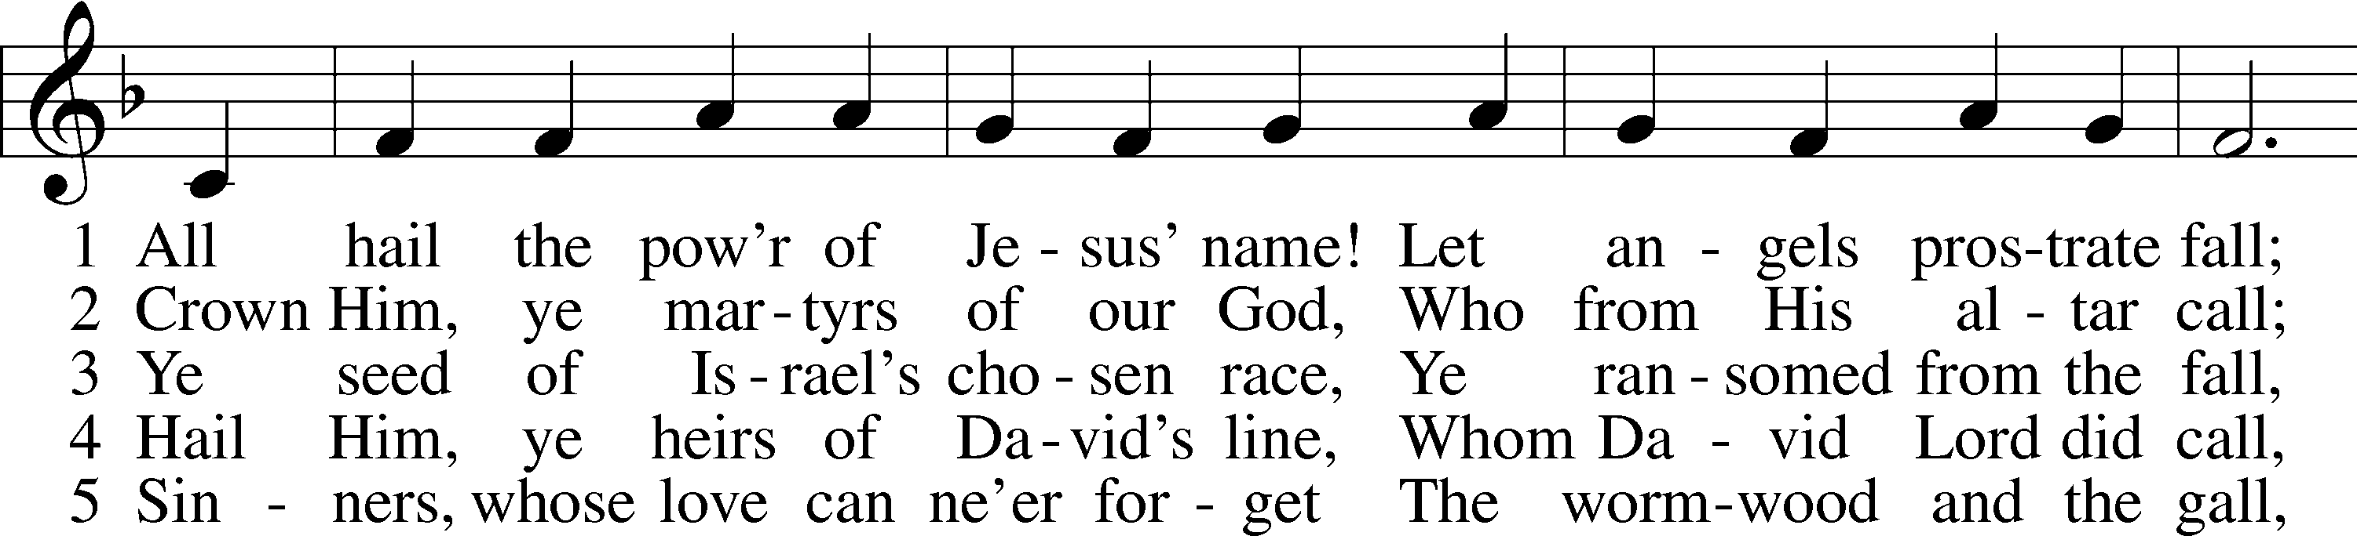
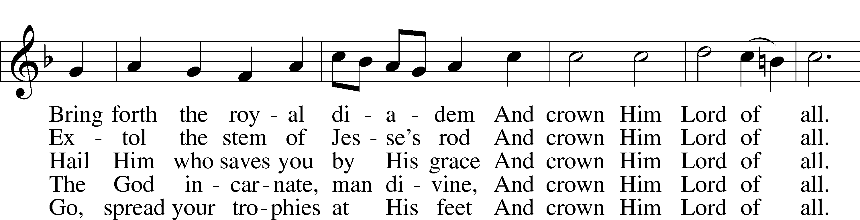
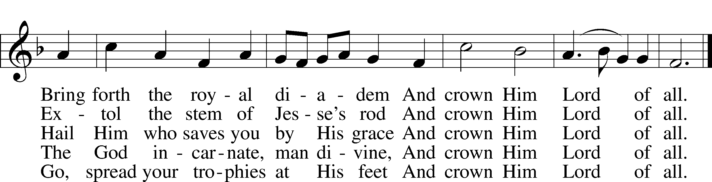

6 Let ev’ry kindred, ev’ry tribe,
On this terrestrial ball
To Him all majesty ascribe
And crown Him Lord of all.
[To Him all majesty ascribe
And crown Him Lord of all.]

7 Oh, that with yonder sacred throng
We at His feet may fall!
We’ll join the everlasting song
And crown Him Lord of all.
[We’ll join the everlasting song
And crown Him Lord of all.]
Public domain

Pastor: In the Name of the Father and of the Son and Holy Spirit.
Congregation: Amen.

(Please Remain Standing Or You May Kneel…)
GOD’S PEOPLE CONFESS THEIR SINS:
Pastor: By grace you have been saved, through faith-and this is not from yourselves, it is the gift of God-not of works, so that no man can boast, for we are God’s workmanship, created in Christ Jesus.
Congregation: I know that nothing good lives in me, that is, in my sinful nature, for I have the desire to do what is good, but I cannot carry it out.
Pastor: What I do is not the good I want to do; no, the evil I do not want to do-this I keep doing.
Congregation: In my heart I delight in God’s law, the law that points out what a wretched person I am! Who will rescue me from this body of death?
Pastor: Thanks be to God through Jesus Christ our Lord! Only He can achieve the perfection we fail to achieve. By the forgiveness He purchased on the cross, our forgiveness is complete!

SERVICE OF THE WORD

You may be seated…
THE FIRST READING: Ezekiel 18:1–4, 25–32
Lector: This is the Word of the Lord.
People: Thanks be to God.

THE EPISTLE LESSON: Philippians 2:1–4, 14–18
Lector: This is the Word of the Lord.
People: Thanks be to God.

Please stand…
THE HOLY GOSPEL: Matthew 21:23–27 Pastor: The Holy Gospel according to St. Matthew the 21st Chapter.
People: Glory to You, O Lord.
Pastor: This is the Gospel of the Lord.
People: Praise to You, O Christ!

CHILDREN’S MESSAGE

NOISE OFFERING

Please be seated…
THE SERMON HYMN: “Jesus, Savior, Pilot Me” LSB 715
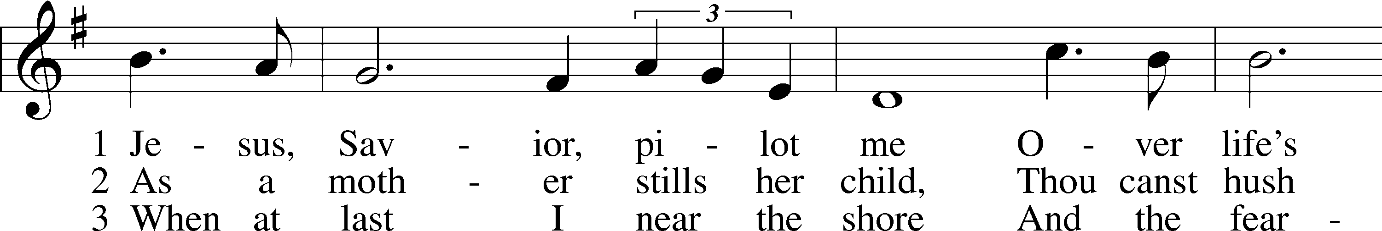
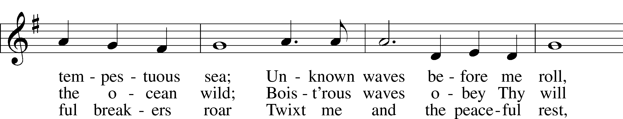
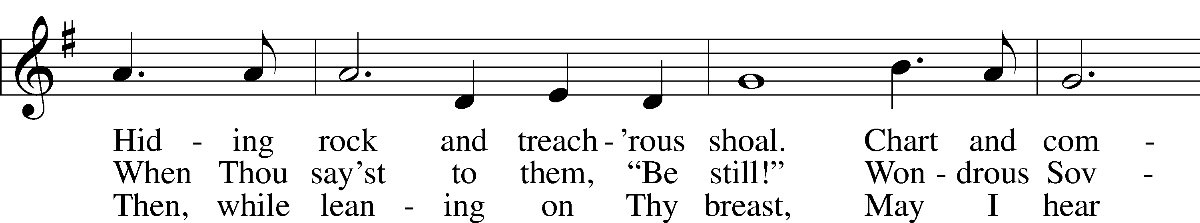
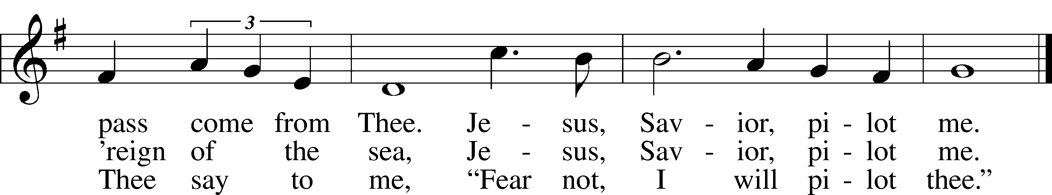
Public domain

THE SERMON: “Passionate about what really matters.” Ezekiel 18:1-4, 25-32
(Please stand…)
THE PROFESSION OF FAITH:
Pastor: God has given us a great message to take to His world. Let us remind ourselves and one another of what that message is:
Pastor: I believe in God the Father, Almighty
Congregation: Maker of heaven and earth
Pastor: And in His Son, Jesus Christ our Lord,
Congregation: Who was conceived by the Holy Spirit
Pastor: Born of the Virgin Mary
Congregation: Suffered under Pontius Pilate
Pastor: Was crucified, died and was buried
Congregation: He descended into hell.
Pastor: On the third day He rose again from the dead,
Congregation: And ascended into heaven
Pastor: And sits on the right hand of God, the Father almighty
Congregation: From there He will come to judge the living and the dead
Pastor: I believe in the Holy Spirit,
Congregation: The Holy Christian Church as
All: the communion of saints; the forgiveness of sins, the resurrection of the body, and the life everlasting. Amen.

(You may be seated…)
OFFERING RECEIVED: "God Himself Is Present" Michael Burkhardt

(Please stand…)
“Praise God, from Whom All Blessings Flow” LSB 805
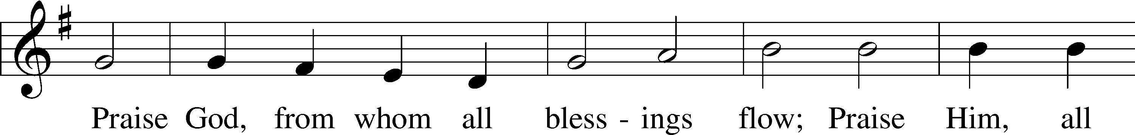
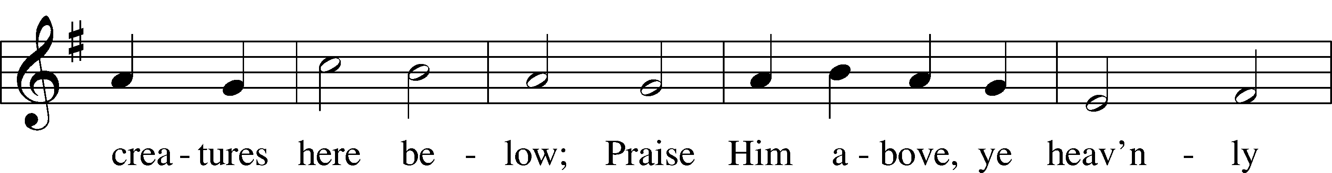
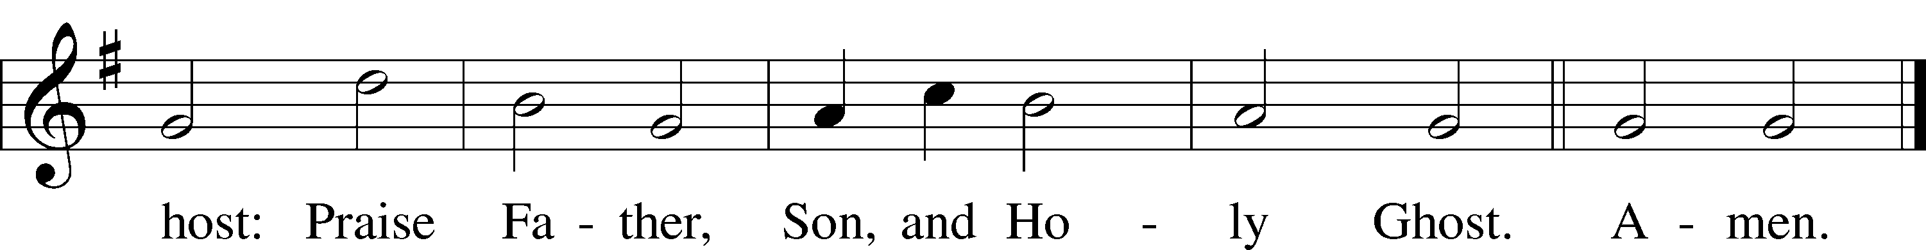
Public domain

THE PRAYERS OF THE CHURCH: based on Psalm 98
Pastor: Dear Lord, we thank You for everything You’ve done for us, and most of all for Your own Son, Jesus, our Savior. We will never stop praising You for this wonderful gift.
Congregation: Sing to the Lord a new song, for He has done marvelous things; His right hand and His holy arm have worked salvation for Him.
Pastor: We thank You for those missionaries long ago who brought the Good News to our people. When we were in darkness, You sent men and women to bring us the light. Thank you, Lord.
Congregation: The Lord has made His salvation known and revealed His Righteousness to the nation.
Pastor: O Lord, You are our Savior, we trust in You for all our needs, give healing to the sick, courage to those who are afraid, and peace to those we name in our hearts either silently or out loud. (a moment of silence) We praise You, gracious Lord, for all Your benefits to us. You give us home, friends and family, food, shelter, rest and everything we need. You give us sight and hearing and touch and taste and provide for all of our needs.
Congregation: Shout for joy to the Lord, praise His Name Amen.

SERVICE OF THE SACRAMENT

(Please be seated…)
THE WORDS OF INSTITUTION

DISTRIBUTION HYMNS: “Lord, Keep Us Steadfast in Your Word” LSB 655
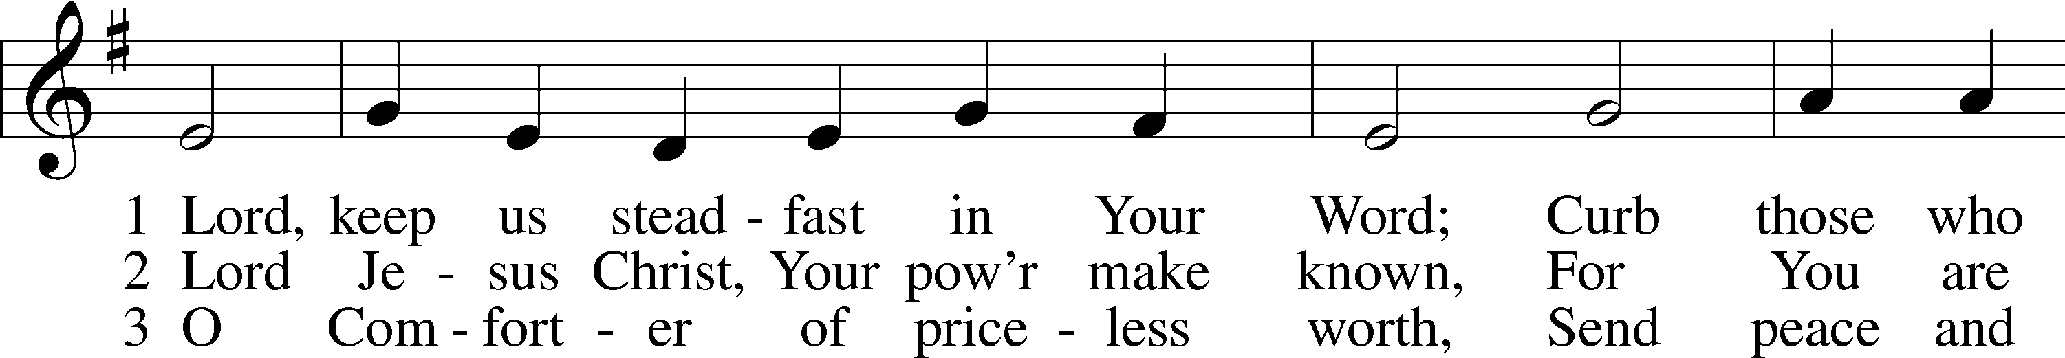
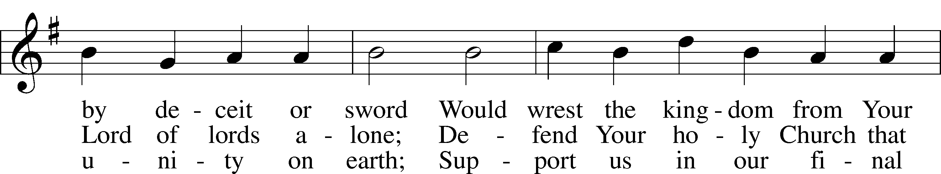
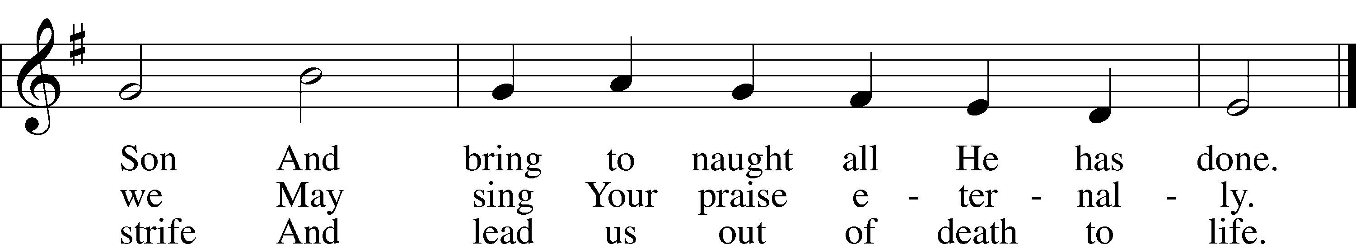
Public domain

Jesus let the things that break
your heart also break our hearts.
Amen

“Jesus Shall Reign” LSB 832
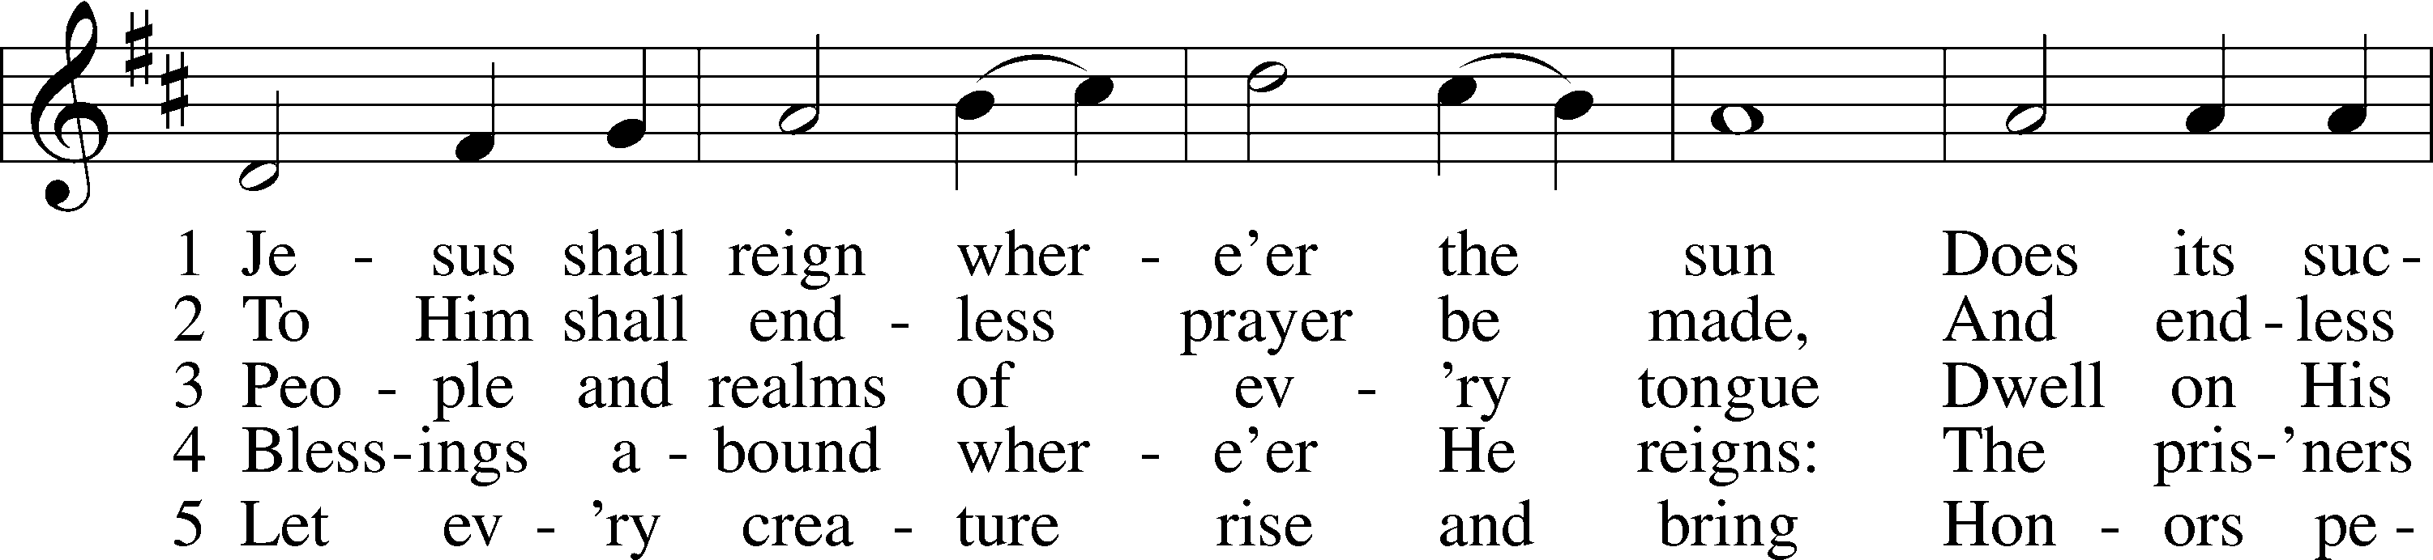
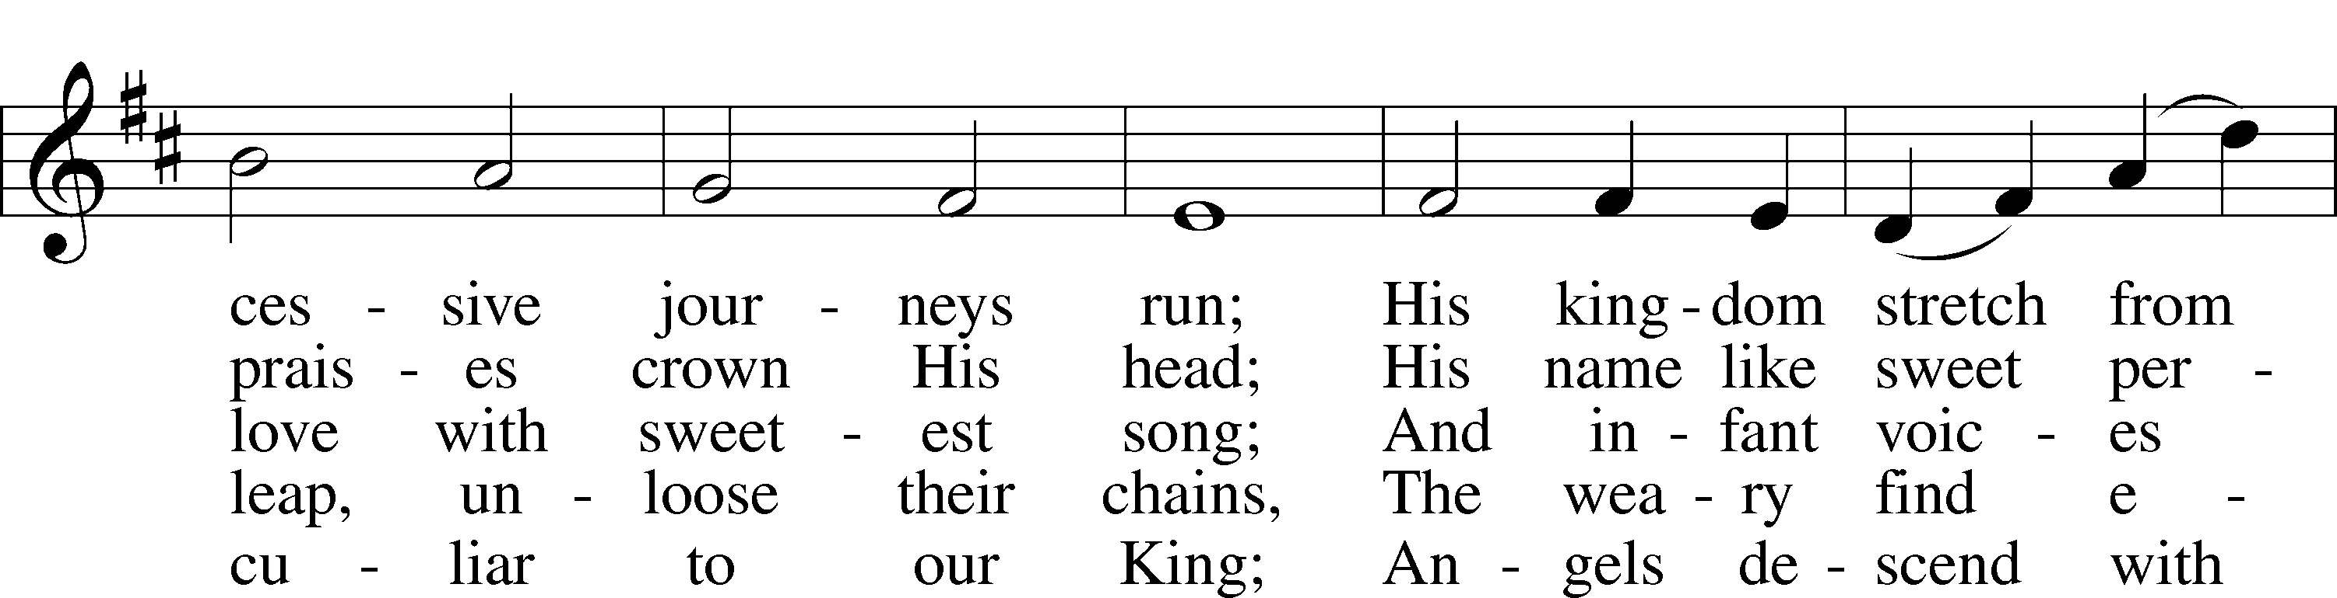
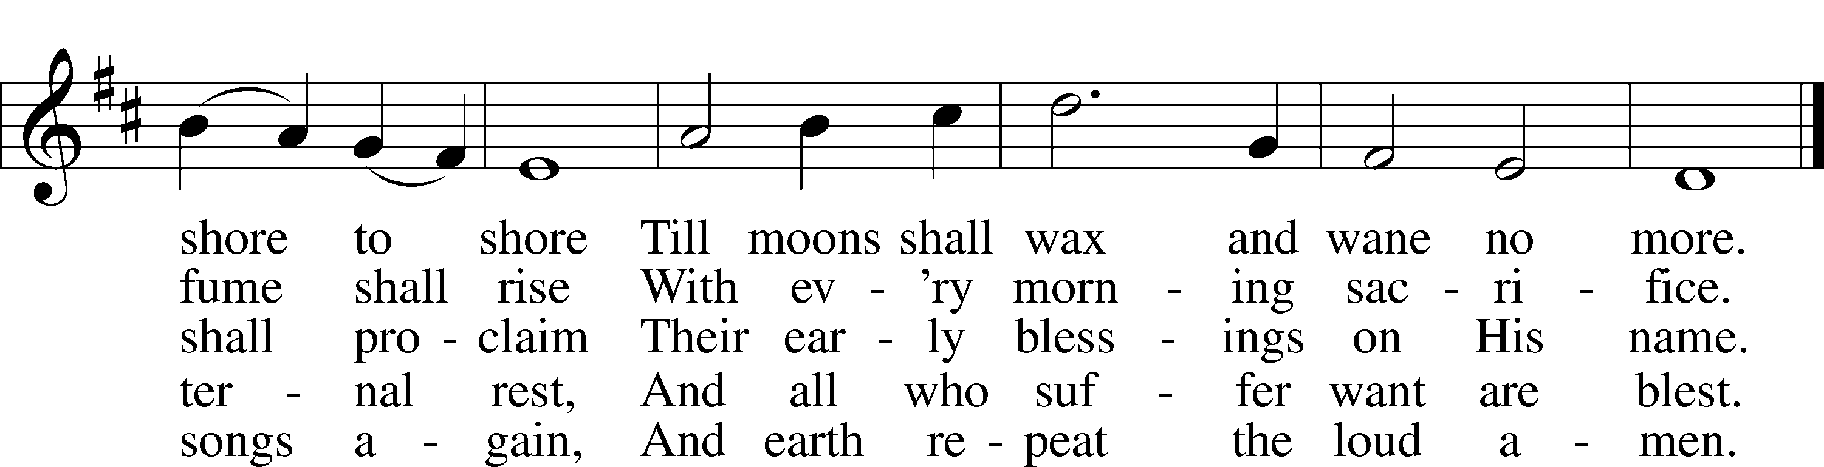
Public domain
“Crown Him with Many Crowns” LSB 525
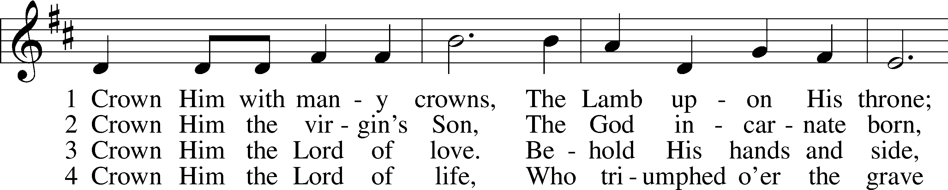
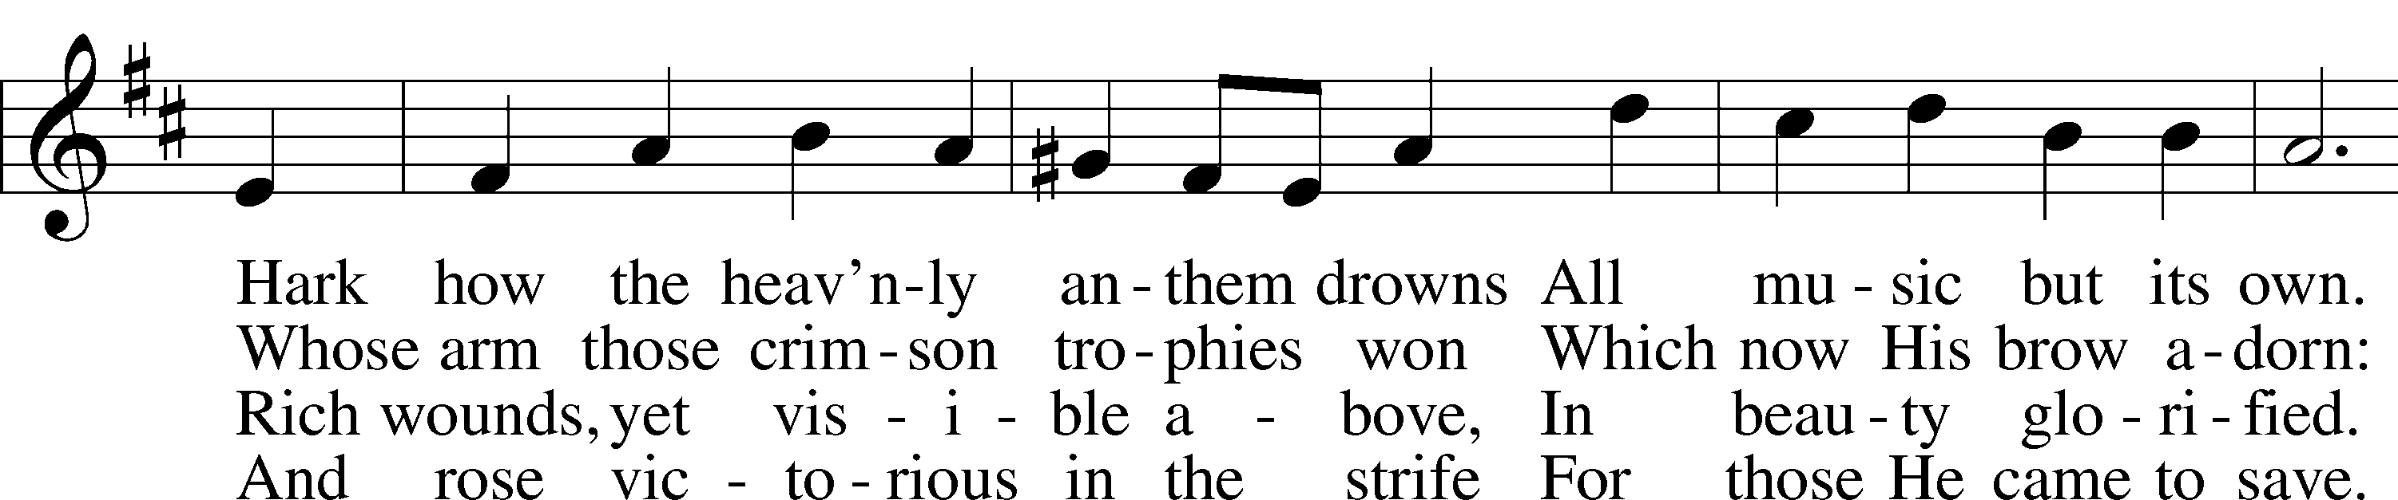
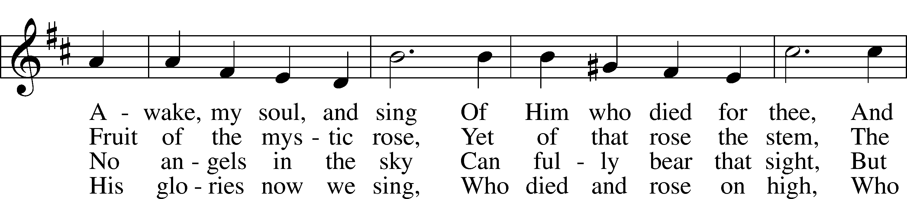
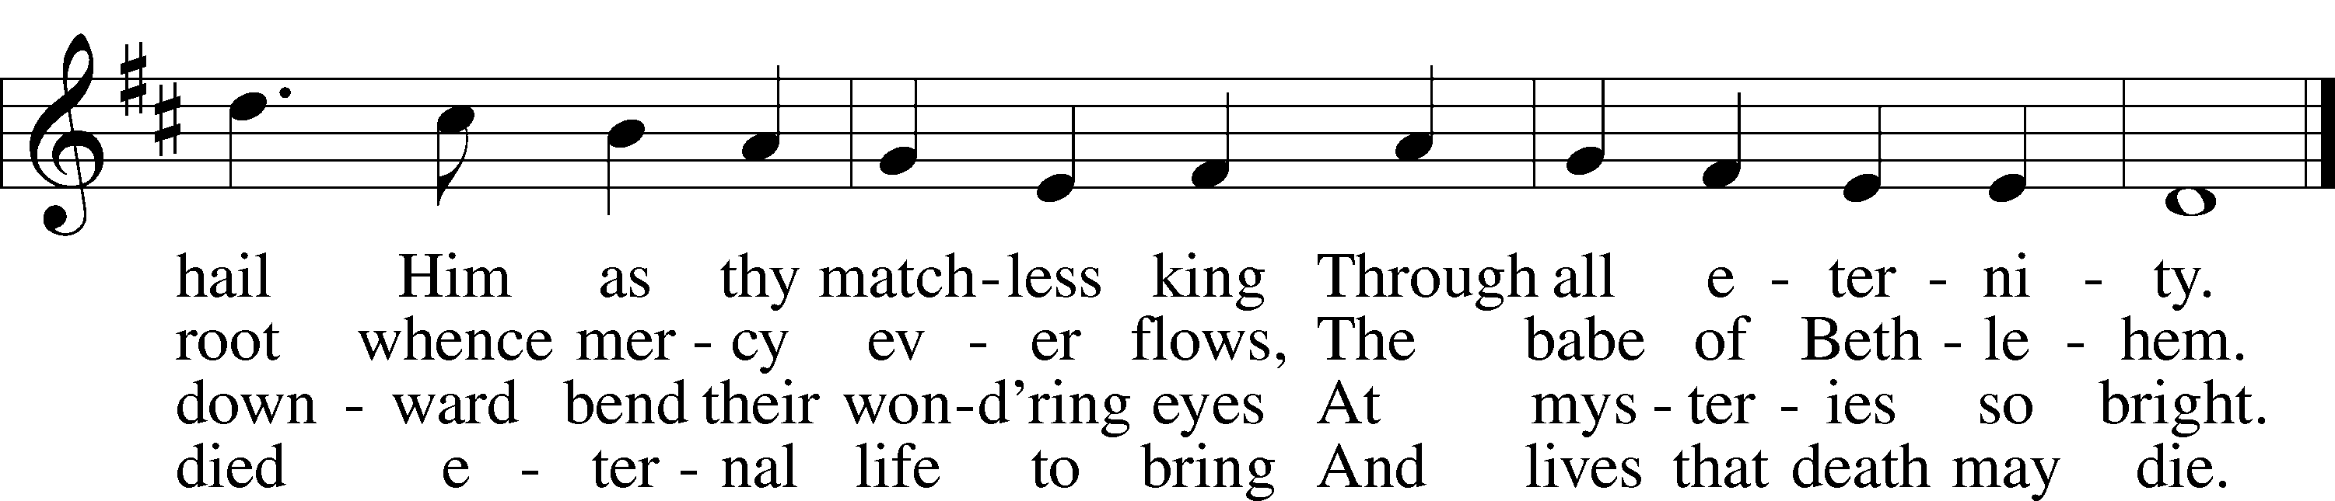

5 Crown Him the Lord of heav’n,
Enthroned in worlds above,
Crown Him the king to whom is giv’n
The wondrous name of Love.
Crown Him with many crowns
As thrones before Him fall;
Crown Him, ye kings, with many crowns,
For He is king of all.
Public domain

(Please stand…)
THE LORD’S PRAYER:
All: Our Father, who art in heaven, hallowed be thy name, thy kingdom come, thy will be done, on earth as it is in heaven. Give us this day our daily bread; and forgive us our trespasses as we forgive those who trespass against us; and lead us not into temptation, but deliver us from evil. For thine is the kingdom, and the power, and the glory, forever and ever. Amen.

THE BENEDICTION

“What are we doing that nobody
else is doing to reach people that
nobody else is reaching?”

THE CLOSING HYMN: “Rejoice, O Pilgrim Throng” LSB 813
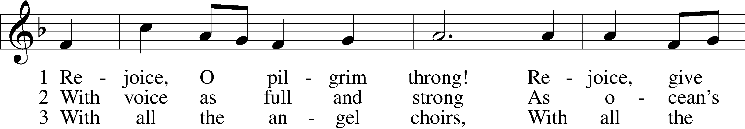
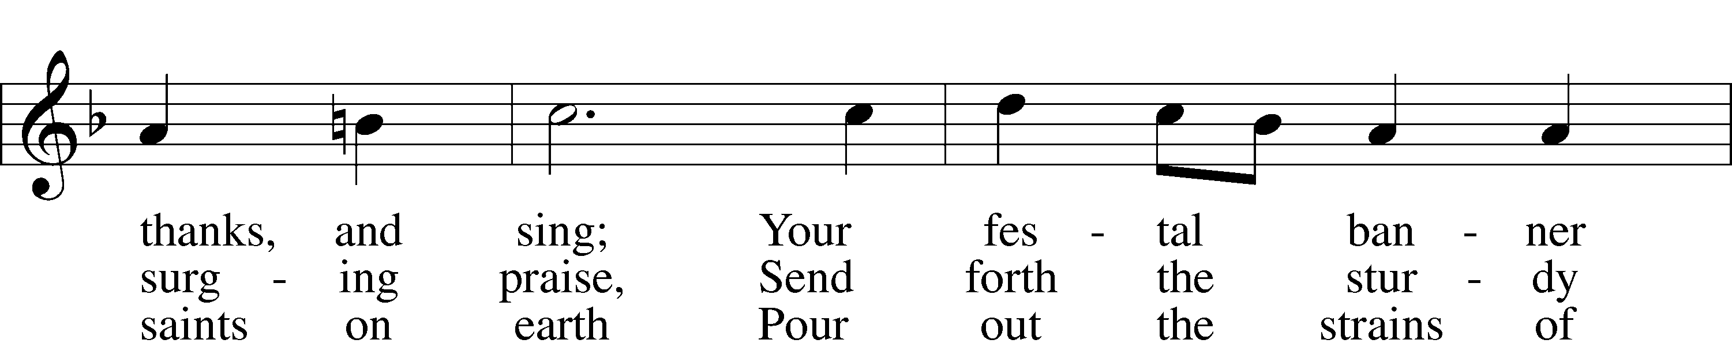
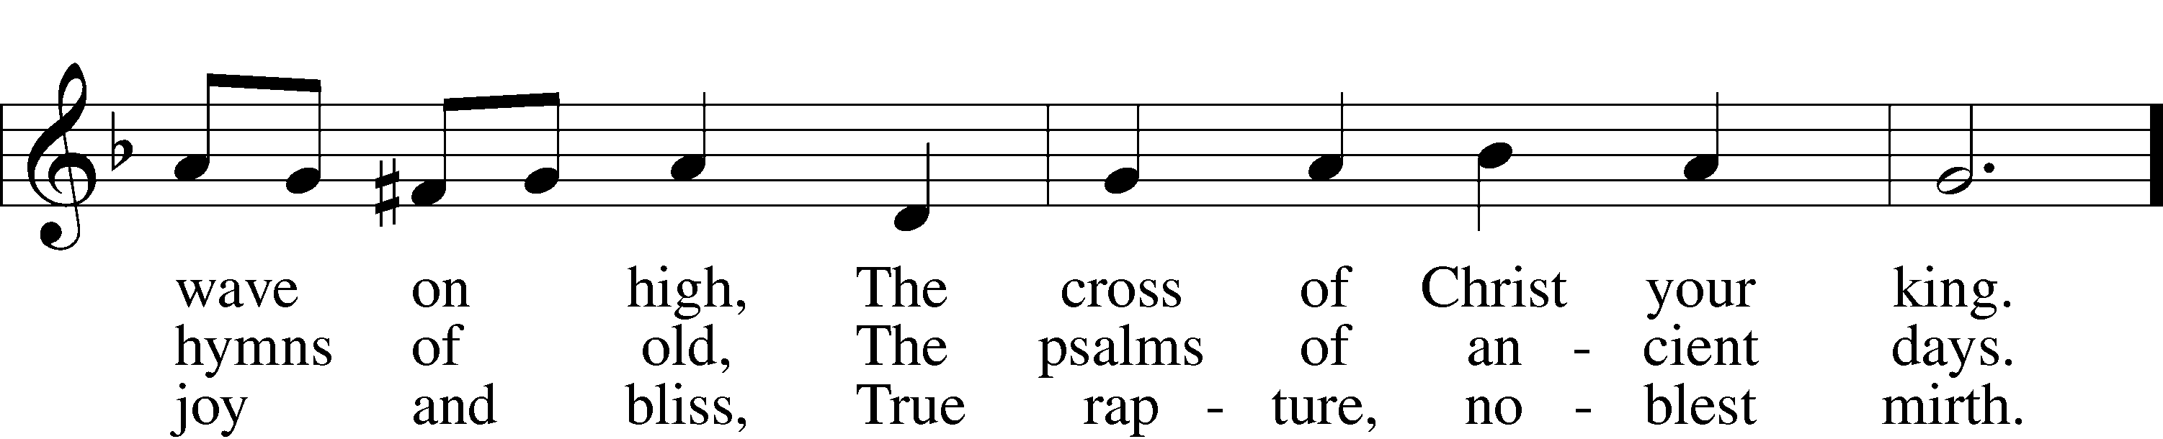
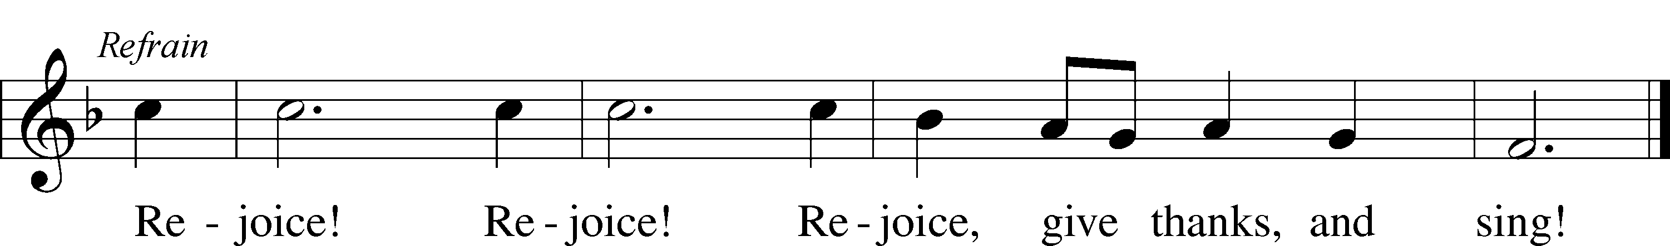

6 At last the march shall end;
The wearied ones shall rest;
The pilgrims find their home at last,
Jerusalem the blest. Refrain
Public domain

POSTLUDE: "Rejoice, O Pilgrim Throng" Michael Burkhardt

WELCOME TO GRACE LUTHERAN CHURCH: We are glad that you are here to worship God with us today! We pray that you will enjoy the wonderful fellowship as friends in Christ as God gathers us around His means of grace, the Word and Sacraments, to bless us with His treasured gifts of forgiveness, faith, abundant life and eternal salvation. If you are a guest, please also sign our Guest Book. Please talk to Pastor if you would like to learn more about becoming a member of Grace. Also, please join us for refreshments and fellowship after the Service. We invite you to come and worship with us often as God gathers us in His Grace.

WELCOME TO THE LORD’S TABLE: We invite and encourage all present who are baptized and faithful Christians, and who confess the Father, Son, and Holy Spirit to be the only true God and who believe that Jesus Christ died for the sins of the World and is our only hope and salvation…to join us in receiving the very and true body and blood of Christ in this Sacrament. The clear liquid cups in the center of the tray are non-alcoholic wine.
Children not yet confirmed in the faith are always welcome to join their parents at the Lord’s Table, but should keep their hands folded in front of them. The Pastor will give them a blessing.

SERVING TODAY: Acolyte: Emily Howard; Lector: Mary Brady: Communion Assistants: ________________; Usher: Bill Chalmers; Altar Care: The Greenwoods; Refreshments: The Greenwoods.

SERVING NEXT SUNDAY: Acolyte: __________; Lector: ____________; Communion Assistants: ______________; Usher: ___________; Altar Care: _____________; Refreshments: ________.

FLOWERS: were placed on the altar to the glory of God by the Broadbent’s to celebrate their birthdays.

THIS WEEK AT A GLANCE:
Today: October 1st
9:00 am Worship Service with Communion
10:00 am Little Singers
10:10 am Jr. Choir
10:15 am Fellowship
10:30 am Adult Bible Class

Monday: October 2nd
Pastor’s Day Off

Tuesday: October 3rd
2:30 pm Jan’s Mobile Gym
6:00 pm Weight Watcher’s (Parish Hall)

Wednesday: October 4th
12:30 pm Men’s Bible Fellowship (Chico’s)

Thursday: October 5th
4:15 pm Missional Communities (Pastor’s Office)

Next Sunday: October 8th
9:00 am Worship Service with Communion (Teacher Installation)
10:00 am Little Singers
10:10 am Jr. Choir
10:15 am Fellowship
10:30 am Adult Bible Class

IN YOUR PRAYERS THIS WEEK: family and friends of Auwina Weed, Peggy Mira, Bud Wrocklage, Walt Lepperd, Michael Gillis, Wayne Kruer, Michael McPherson, Micah Westphalen, Capt. Zachary (Bo) Henry (Ret.), family of Sam Vinci, family and friends of Frank Deford, Larry Vandivier, Carl Vandivier, Bobby Meck, family and friends of Elaine Wavehime, Linda Mullis, Joe Lamberson, Michael Willard, France Vandivier, Katie Hoffman, Pastor Ray Peters, Family and friends of Will Plagens, Kay Sattelmeier, Dennis Julson, Vernon Julson, Olga Odland, the family of Jean Grafsgaard, Jenie Howard, Jenny Dean, Charles, Braydon, Champ, Amy, Elsie Hamilton, Mary Ellen Jessel, Marcos Diaz, Kaci Doran, Sandy Harris, and those you are praying for at home. If anyone has a special prayer request please submit it in writing in the collection plate; or you may call Pastor Gary Faith at (504-858-8872), or Kris Howard at (305-296-5161).

GIFTS, TITHES, & ATTENDANCE LAST SUNDAY: Sunday September 24th received $5668.15, the building fund received $500.00 with an attendance of 45.

We also received $1201.27 for the Hurricane Harvey mission project.

NOISE OFFERING for the next several weeks will go to support the Autism support group that meets here at Grace monthly.

TO HELP US GROW… The Bible reading for next Sunday’s service are Isaiah 5:1-7, Philippians 3:4b–14, and Matthew 21:33-46.

DEBBIE SATTELMEIER is asking once again for your help to reach her goal with donations for the Breast Cancer Walk. Our team is the American Legion Auxiliary “The Wonder Women of Unit 28”. Please make checks payable to “the American Cancer Society.” Thank you for your support.

OUR FORMER ORGANIST AUWINA WEED passed away yesterday. We thank God for the gift she was to Grace, Trinity, and Key West. We thank God even more that she was blessed with faith in Jesus as her Savior. “Blessed are the dead who die in the Lord from now on” Revelations 14:13

THANKS TO ALL OF YOU for helping your neighbor, listening to others, and being a blessing to the community and to GLCS.

I HAVE ORDERED SEVERAL COPIES of Pastor Finke’s book. If you would like to get maximum results from Greg and Susan’s visit in January you are welcome to borrow a copy. See Kris or Pastor.

THERE IS ADDITIONAL PARKING behind the school. Enter that lot on 10th Street.

WE HAVE SET THE SCHEDULES for ushers, acolytes, lectors, and communion assistants for the next three months. If you would like to serve in any of these positions, please let Pastor or Kris know.

STEWARDSHIP LISTS: On the bulletin board by the front door of the church you will find the Altar Care, Refreshments, and Flower sign-up sheets for 2017. If you are able to help out with any of these please place your name in the spot on the date requested.

THE GRACE LUTHERAN CHURCH WEB PAGE AND FACE BOOK PAGE now
contains a vocal recording of last week’s sermon. So, if you are not able to attend church on Sunday please go to our website where you will find a copy of the bulletin and a recording of Pastor Faith’s sermon. https://gracelutherankw.360unite.com/home.

A NUMBER OF CAPITAL IMPROVEMENTS are needed to keep our facilities in good health for the future. Roof repairs are needed on school buildings and the parsonage. If you can help it would be much appreciated! A big thanks to all who have contributed to these repairs.

SAVE THE DATE AND MARK ON YOUR CALENDAR

GRACIOUS LADIES OF GRACE: Our last luncheon was at the Key West Yacht Club on the 5th of September "before Irma" with 5 brave ladies who ventured out amidst news of doom and gloom with an impending monster storm advancing on us. We had a lot of anxious talk of preparations for the storm and evacuating. I'm glad to report that God is good and we all survived and have some stories to tell about our Irma adventures. Please come join us on Oct.10 at 11:30 am at Salute to catch up on all the happenings since our last get together.

SAVE THE DATE: Saturday October 21st: Octoberfest at the Faith’s. Noon until 3.

JANUARY 28TH, 2018: Mark this day on your calendar. Pastor Greg Finke and his wife Susan are scheduled to join us for worship and training on how to be a neighborhood missionary. The Finke’s travel all over the country helping equip folks for everyday ministry. Don’t miss this opportunity or you will wonder why everyone is more excited about Jesus missing.

JANUARY 27TH, 2018: We plan on having the annual “Let’s Get to Know our Snowbird Friends Better” with Susan and Greg as our guests of honor.

MUSIC MINISTRY: "Make a joyful noise to the Lord, all the earth!" Psalm 100:1. It is time for our choirs to begin rehearsing again. Please speak with Beverly Walker or contact her at beverlywalker@gmail.com if you have any questions.

Little Singers: Infants through first grade children and their parents are invited to meet by the piano immediately after the Service for a few minutes of hymn singing.

Jr. Choir for grades 2 through 8 will meet from 10:10 - 10:25 by the piano.

Bell Choir for grade 5 through adult will begin Thursday, October 12 from 5:45 to 6:30 pm.

Vocal Choir will begin on Thursday, October 19 from 6:30 to 7:30 pm.

MEN’S BIBLE FELLOWSHIP: They meet the first and third Wednesday’s of each month at 12:30pm. Their next meeting will be October 4th located at Chico’s on Stock Island. All guys are welcome.

WOMEN’S BIBLE STUDY: will meet again in the fall.

MISSIONAL COMMUNITIES will meet this Thursday at 4:15 pm in the Pastor’s office. I’m looking forward to hearing how you have seen Jesus at work in your life.

