SIXTEENTH SUNDAY AFTER PENTECOST

September 24th, 2017
9:00 am
Grace Lutheran Church
2713 Flagler Ave.
Key West, FL 33040
GraceLutheranKW@att.net
Pastor Gary Faith
(504) 858-8872
garyfaith@aol.com

TENTH SUNDAY AFTER PENTECOST
AUGUST 13TH, 2017 9:00 a.m.
WORSHIP SERVICE
In the Name of Jesus!
Our Mission Statement: Anchored in Christ, each person a missionary.

PRELUDE: “Now Thank We all Our God” Michael Burkhardt

ANNOUNCEMENTS: We welcome you. We are glad you are here to share with us the joy and peace we have in Jesus Christ. It doesn’t matter whether this is your first time in this church or if you are a lifelong member, you are welcome. We come together today in order to celebrate the gift God has given us-His own Son, Jesus, Our Savior.

PREPARATION

(Please Stand…)

HYMN: “In Days of Grief or Storm and Loss”

Pastor: In the Name of the Father and of the Son and Holy Spirit.
Congregation: Amen.

(Please Remain Standing Or You May Kneel…)
GOD’S PEOPLE CONFESS THEIR SINS:
Pastor: By grace you have been saved, through faith-and this is not from yourselves, it is the gift of God-not of works, so that no man can boast, for we are God’s workmanship, created in Christ Jesus.
Congregation: I know that nothing good lives in me, that is, in my sinful nature, for I have the desire to do what is good, but I cannot carry it out.
Pastor: What I do is not the good I want to do; no, the evil I do not want to do-this I keep doing.
Congregation: In my heart I delight in God’s law, the law that points out what a wretched person I am! Who will rescue me from this body of death?
Pastor: Thanks be to God through Jesus Christ our Lord! Only He can achieve the perfection we fail to achieve. By the forgiveness He purchased on the cross, our forgiveness is complete!

SERVICE OF THE WORD

You may be seated…
THE OLD TESTAMENT READING: Psalm 107:23-32
²³ Some went out on the sea in ships;
they were merchants on the mighty waters.
²⁴ They saw the works of the Lord,
his wonderful deeds in the deep.
²⁵ For he spoke and stirred up a tempest
that lifted high the waves.
²⁶ They mounted up to the heavens and went down to the depths;
in their peril their courage melted away.
²⁷ They reeled and staggered like drunkards;
they were at their wits’ end.
²⁸ Then they cried out to the Lord in their trouble,
and he brought them out of their distress.
²⁹ He stilled the storm to a whisper;
the waves of the sea^{[a]} were hushed.
³⁰ They were glad when it grew calm,
and he guided them to their desired haven.
³¹ Let them give thanks to the Lord for his unfailing love
and his wonderful deeds for mankind.
³² Let them exalt him in the assembly of the people
and praise him in the council of the elders.
Lector: This is the Word of the Lord.
People: Thanks be to God.

THE EPISTLE LESSON: Psalm 46
¹ God is our refuge and strength,
an ever-present help in trouble.
² Therefore we will not fear, though the earth give way
and the mountains fall into the heart of the sea,
³ though its waters roar and foam
and the mountains quake with their surging.
⁴ There is a river whose streams make glad the city of God,
the holy place where the Most High dwells.
⁵ God is within her, she will not fall;
God will help her at break of day.
⁶ Nations are in uproar, kingdoms fall;
he lifts his voice, the earth melts.
⁷ The Lord Almighty is with us;
the God of Jacob is our fortress.
⁸ Come and see what the Lord has done,
the desolations he has brought on the earth.
⁹ He makes wars cease
to the ends of the earth.
He breaks the bow and shatters the spear;
he burns the shields with fire.
¹⁰ He says, “Be still, and know that I am God;
I will be exalted among the nations,
I will be exalted in the earth.”
¹¹ The Lord Almighty is with us;
the God of Jacob is our fortress.

Lector: This is the Word of the Lord.
People: Thanks be to God.

Please stand…
THE HOLY GOSPEL: Mark 4:35-41
Pastor: The Holy Gospel according to St. Matthew the 14th Chapter
People: Glory to You, O Lord.

³⁵ That day when evening came, he said to his disciples, “Let us go over to the other side.” ³⁶ Leaving the crowd behind, they took him along, just as he was, in the boat. There were also other boats with him. ³⁷ A furious squall came up, and the waves broke over the boat, so that it was nearly swamped. ³⁸ Jesus was in the stern, sleeping on a cushion. The disciples woke him and said to him, “Teacher, don’t you care if we drown?”
³⁹ He got up, rebuked the wind and said to the waves, “Quiet! Be still!”Then the wind died down and it was completely calm.
⁴⁰ He said to his disciples, “Why are you so afraid? Do you still have no faith?”
⁴¹ They were terrified and asked each other, “Who is this? Even the wind and the waves obey him!”

Pastor: This is the Gospel of the Lord.
People: Praise to You, O Christ!

Please be seated…
SERMON

THE PROFESSION OF FAITH:
Pastor: God has given us a great message to take to His world. Let us remind ourselves and one another of what that message is:
Pastor: I believe in God the Father, Almighty
Congregation: Maker of heaven and earth
Pastor: And in His Son, Jesus Christ our Lord,
Congregation: Who was conceived by the Holy Spirit
Pastor: Born of the Virgin Mary
Congregation: Suffered under Pontius Pilate
Pastor: Was crucified, died and was buried
Congregation: He descended into hell.
Pastor: On the third day He rose again from the dead,
Congregation: And ascended into heaven
Pastor: And sits on the right hand of God, the Father almighty
Congregation: From there He will come to judge the living and the dead
Pastor: I believe in the Holy Spirit,
Congregation: The Holy Christian Church as
All: the communion of saints; the forgiveness of sins, the resurrection of the body, and the life everlasting. Amen.

(You may be seated…)
OFFERING RECEIVED

“Praise God, from Whom All Blessings Flow” LSB 805
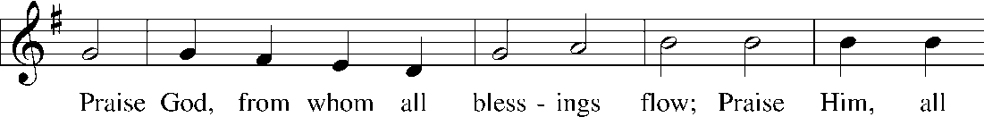
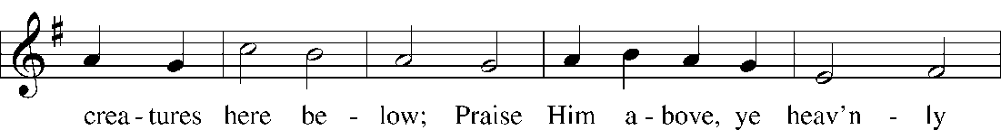
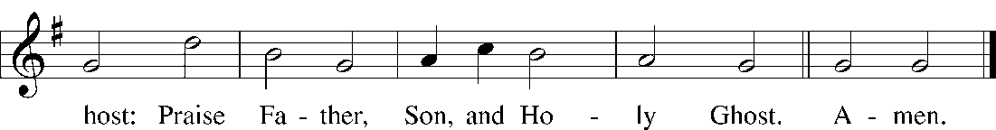
Public domain

(Please stand…)
THE PRAYERS OF THE CHURCH: based on Psalm 98
Pastor: Dear Lord, we thank You for everything You’ve done for us, and most of all for Your own Son, Jesus, our Savior. We will never stop praising You for this wonderful gift.
Congregation: Sing to the Lord a new song, for He has done marvelous things; His right hand and His holy arm have worked salvation for Him.
Pastor: We thank You for those missionaries long ago who brought the Good News to our people. When we were in darkness, You sent men and women to bring us the light. Thank you, Lord.
Congregation: The Lord has made His salvation known and revealed His Righteousness to the nation.
Pastor: O Lord, You are our Savior, we trust in You for all our needs, give healing to the sick, courage to those who are afraid, and peace to those we name in our hearts either silently or out loud. (a moment of silence) We praise You, gracious Lord, for all Your benefits to us. You give us home, friends and family, food, shelter, rest and everything we need. You give us sight and hearing and touch and taste and provide for all of our needs.
Congregation: Shout for joy to the Lord, praise His Name Amen.

SERVICE OF THE SACRAMENT

(Please be seated…)
THE WORDS OF INSTITUTION:
“What are we doing that nobody else is doing
to reach people that nobody else is reaching?

DISTRIBUTION HYMNS: “When Peace, like a River” LSB 763
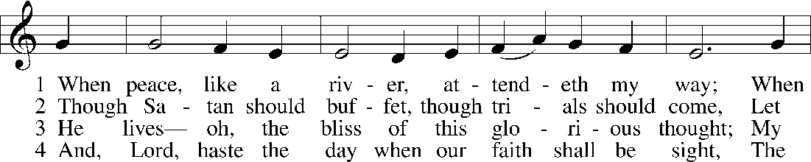
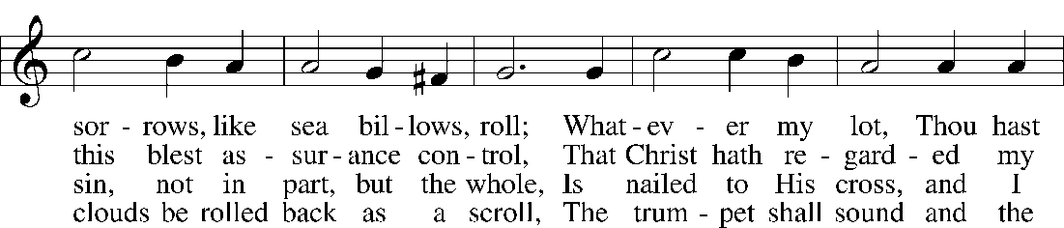
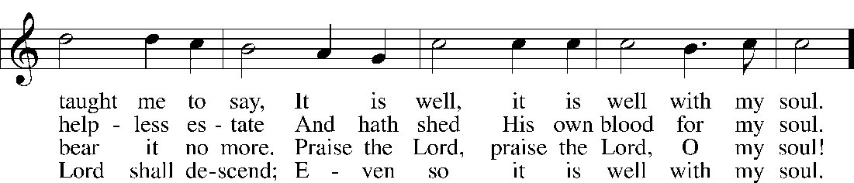
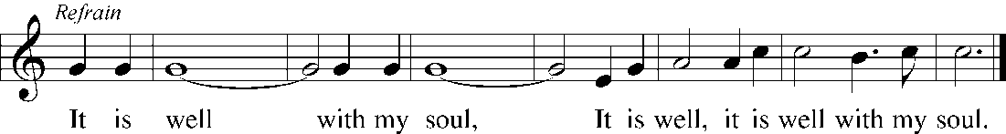
Public domain

“Be Still, My Soul” LSB 752
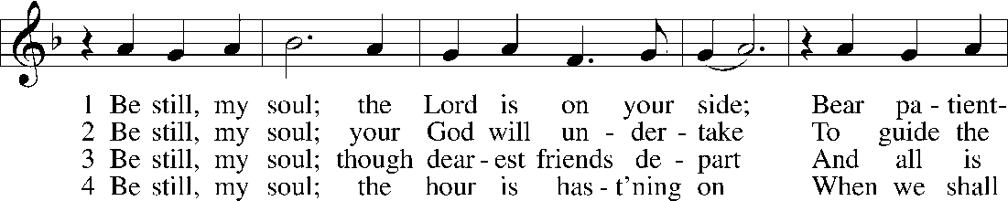
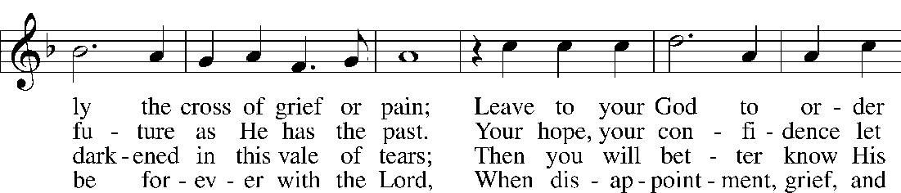
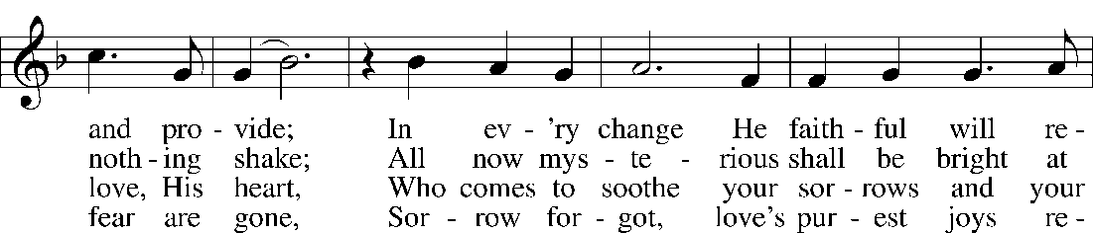
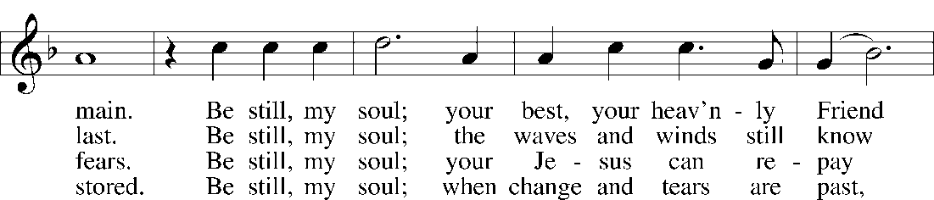
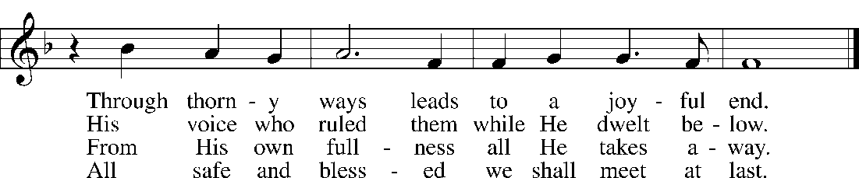
Public domain
“We Praise You, O God” LSB 785
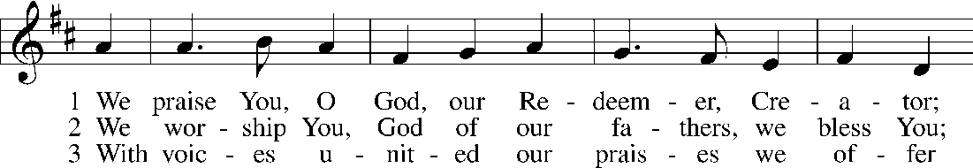
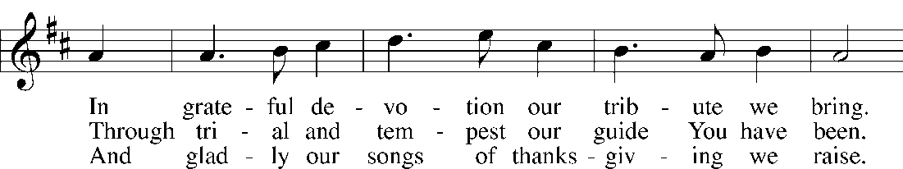
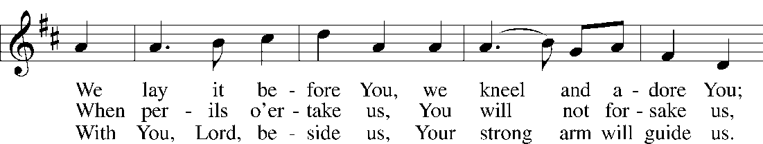
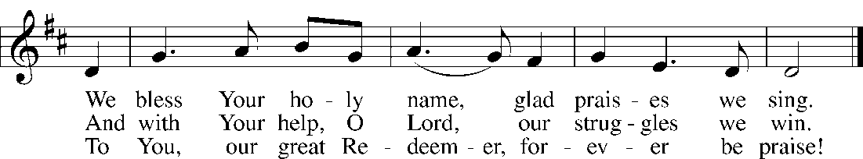
Public domain

(Please stand…)
THE LORD’S PRAYER:
All: Our Father, who art in heaven, hallowed be thy name, thy kingdom come, thy will be done, on earth as it is in heaven. Give us this day our daily bread; and forgive us our trespasses as we forgive those who trespass against us; and lead us not into temptation, but deliver us from evil. For thine is the kingdom, and the power, and the glory, forever and ever. Amen

THE BENEDICTION

Jesus let the things that break your heart
also break our hearts.
Amen

THE CLOSING HYMN: “Eternal Father, Strong to Save” LSB 717
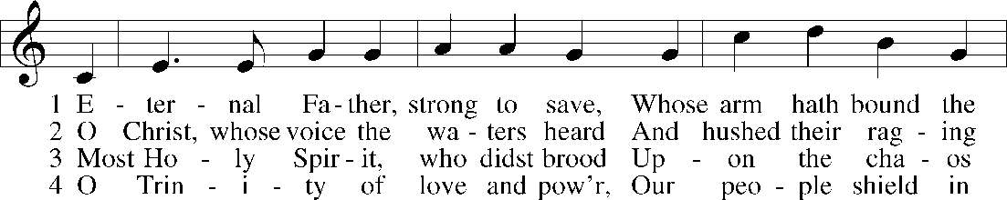
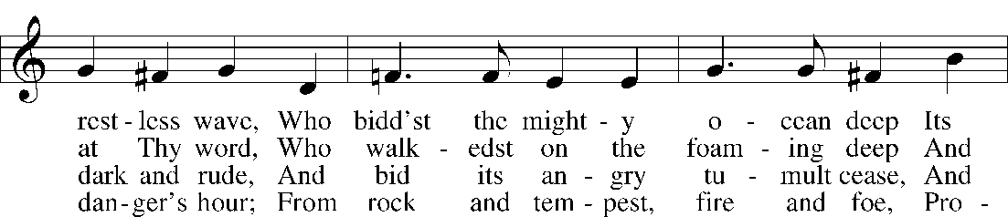
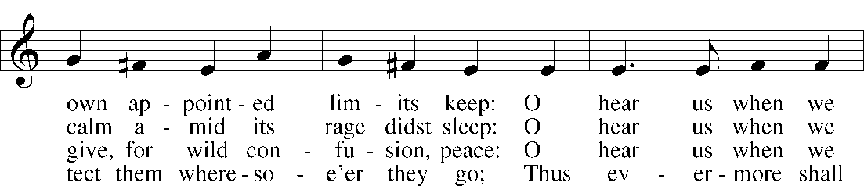
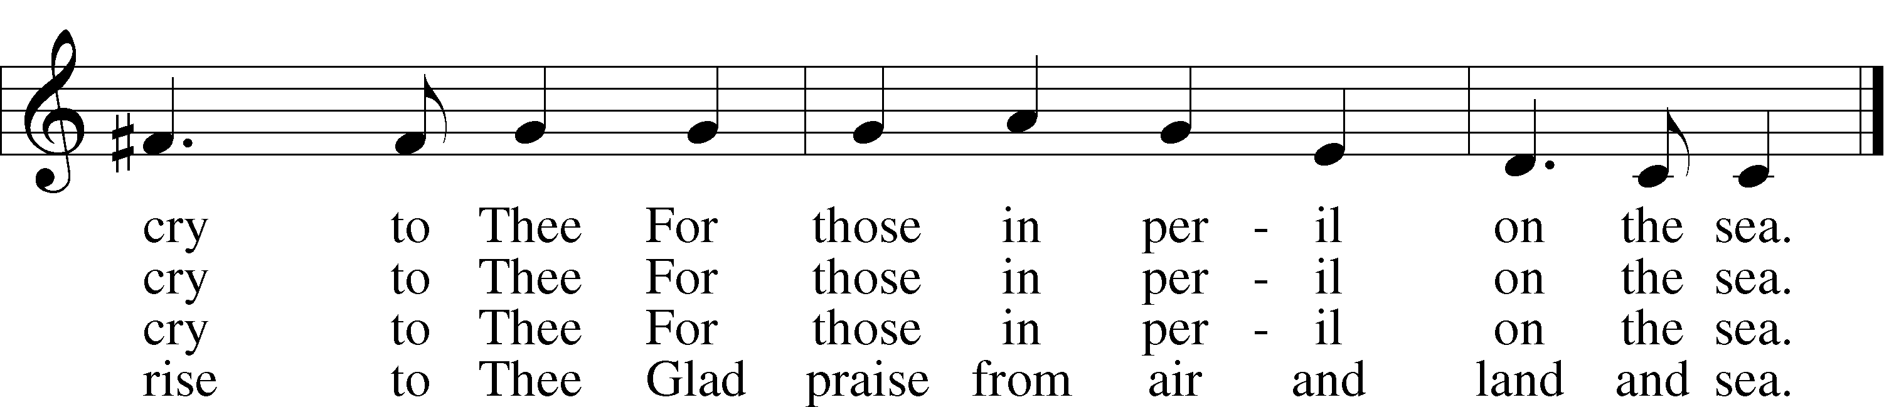
© The Church Pension Fund. Used by permission: LSB Hymn License .NET, no. 100011641.
Public domain

Postlude: “Now Thank We all Our God” David Johnson

