July 23rd, 2017
9:00 am

SEVENTH SUNDAY
AFTER PENTECOST

Grace Lutheran Church
2713 Flagler Ave.
Key West, FL 33040
305-296-5161
GraceLutheranKW@att.net
gracelutherankw.360unite
Pastor Faith
(504) 858-8872
garyfaith@aol.com

SEVENTH SUNDAY AFTER PENTECOST
July 23rd, 2017 9:00 a.m.
In the Name of Jesus!
Our Mission Statement: Anchored in Christ, each person a missionary.

PRELUDE

ANNOUNCEMENTS:
We welcome you. We are glad you are here to share with us the joy and peace we have in Jesus Christ. It doesn’t matter whether this is your first time in this church or if you are a lifelong member, you are welcome. We come together today in order to celebrate the gift God has given us-His own Son, Jesus, Our Savior.

PREPARATION
(Please Stand…)
HYMN: “Amazing Grace” LSB 744
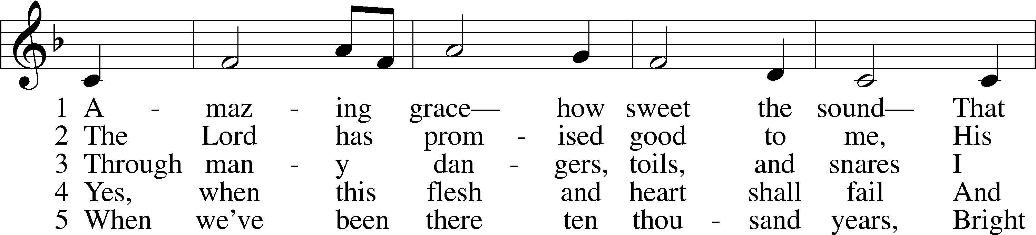
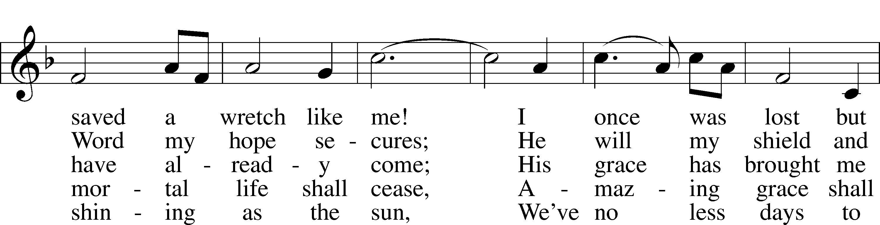
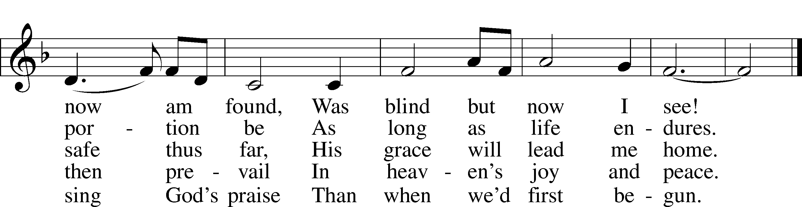
© 1991 Editorial Concordia. Used by permission: LSB Hymn License .NET, no. 100011641.
Public domain

Pastor: In the Name of the Father and of the Son and Holy Spirit.
Congregation: Amen.

(Please Remain Standing Or You May Kneel…)
GOD’S PEOPLE CONFESS THEIR SINS:
Pastor: By grace you have been saved, through faith-and this is not from yourselves, it is the gift of God-not of works, so that no man can boast, for we are God’s workmanship, created in Christ Jesus.
Congregation: I know that nothing good lives in me, that is, in my sinful nature, for I have the desire to do what is good, but I cannot carry it out.
Pastor: What I do is not the good I want to do; no, the evil I do not want to do-this I keep doing.
Congregation: In my heart I delight in God’s law, the law that points out what a wretched person I am! Who will rescue me from this body of death?
Pastor: Thanks be to God through Jesus Christ our Lord! Only He can achieve the perfection we fail to achieve. By the forgiveness He purchased on the cross, our forgiveness is complete!

SERVICE OF THE WORD

You may be seated…
THE FIRST READING: Isaiah 44:6-8
Lector: This is the Word of the Lord.
People: Thanks be to God.

THE EPISTLE LESSON: Romans 8:18-27 Lector: This is the Word of the Lord.
People: Thanks be to God.

Please stand…
THE HOLY GOSPEL: Matthew 13:24-30, 36-43
Pastor: The Holy Gospel according to St. Matthew the 13th Chapter.
People: Glory to You, O Lord.
Pastor: This is the Gospel of the Lord.
People: Praise to You, O Christ!

Please be seated…
CHILDREN’S MESSAGE

NOISE OFERING
It’s called a noise offering because what we are asking for is pocket change. It will always be used for missions outside of our church and school. It normally also is given to a mission involving children. Thanks for making a joyful noise to the Lord.

Please be seated…
THE SERMON HYMN: “Were You There” LSB 456
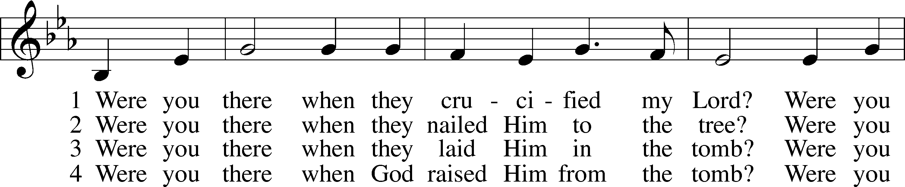
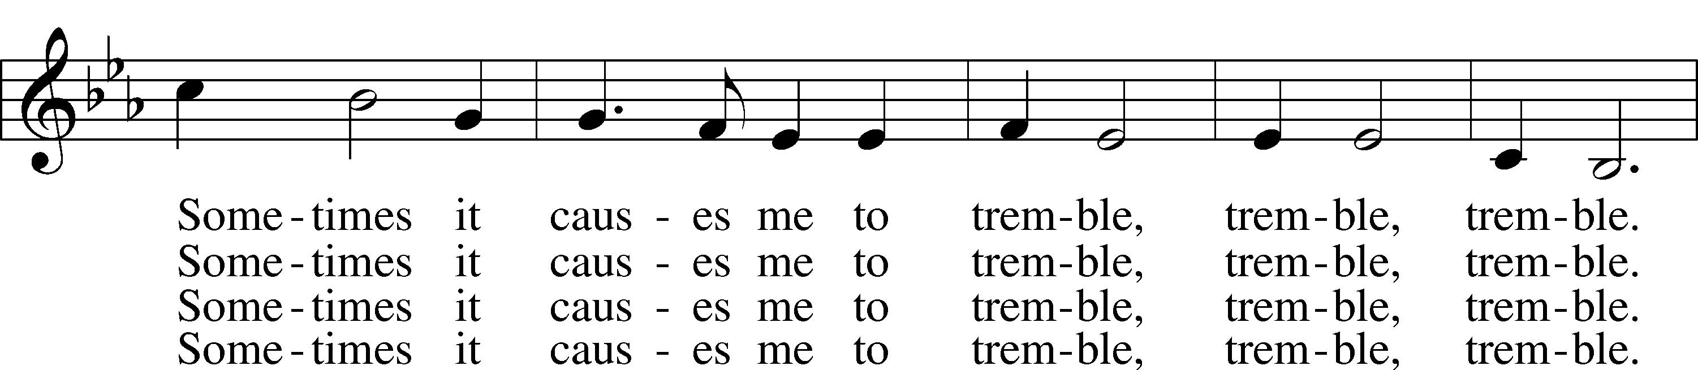
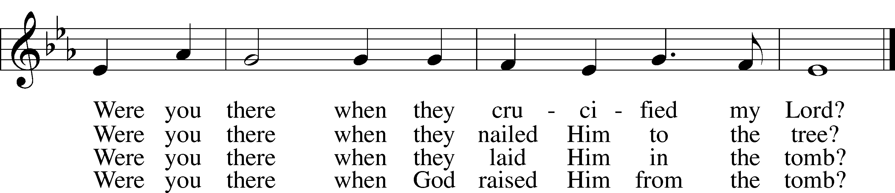
Public domain

THE SERMON: “First or Last?” Isaiah 44:6-8

“What are we doing that nobody
else is doing to reach people that
nobody else is reaching?”
(Please stand…)
THE PROFESSION OF FAITH:
All: I believe in God the Father, Almighty
maker of heaven and earth.

And in His Son, Jesus Christ our Lord,
who was conceived by the Holy Spirit
born of the Virgin Mary
suffered under Pontius Pilate
was crucified, died and was buried
He descended into hell.
On the third day He rose again from the dead,
and ascended into heaven
and sits on the right hand of God, the Father almighty.
From there He will come to judge the living and the dead.

I believe in the Holy Spirit,
the Holy Christian Church as
the communion of saints;
the forgiveness of sins,
the resurrection of the body,
and the life everlasting. Amen.

(You may be seated…)
OFFERING RECEIVED

(Please stand…)
“Praise God, from Whom All Blessings Flow” LSB 805
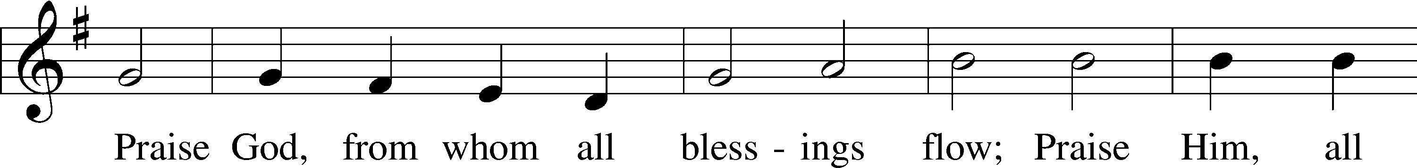
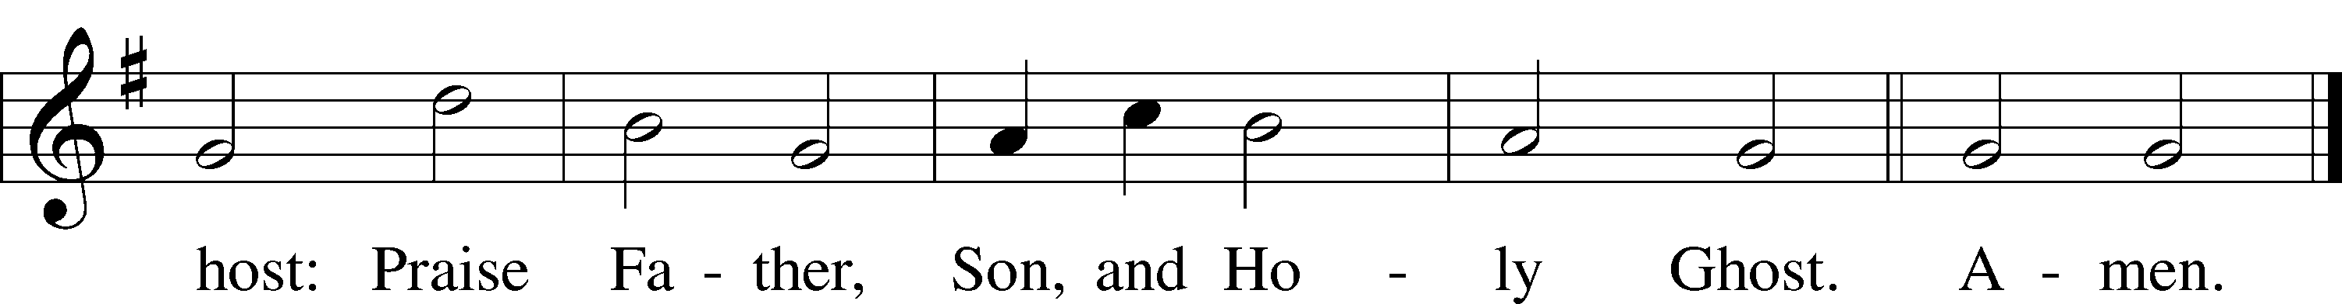
Public domain

THE PRAYERS OF THE CHURCH: based on Psalm 98
Pastor: Dear Lord, we thank You for everything You’ve done for us, and most of all for Your own Son, Jesus, our Savior. We will never stop praising You for this wonderful gift.
Congregation: Sing to the Lord a new song, for He has done marvelous things; His right hand and His holy arm have worked salvation for Him.
Pastor: We thank You for those missionaries long ago who brought the Good News to our people. When we were in darkness, You sent men and women to bring us the light. Thank you, Lord.
Congregation: The Lord has made His salvation known and revealed His Righteousness to the nation.
Pastor: O Lord, You are our Savior, we trust in You for all our needs, give healing to the sick, courage to those who are afraid, and peace to those we name in our hearts either silently or out loud. (a moment of silence) We praise You, gracious Lord, for all Your benefits to us. You give us home, friends and family, food, shelter, rest and everything we need. You give us sight and hearing and touch and taste and provide for all of our needs.
Congregation: Shout for joy to the Lord, praise His Name Amen.

SERVICE OF THE SACRAMENT

(Please be seated…)
THE WORDS OF INSTITUTION

Jesus let the things that break
your heart also break our hearts.
Amen

(Please stand…)
THE LORD’S PRAYER:
All: Our Father, who art in heaven, hallowed be thy name, thy kingdom come, thy will be done, on earth as it is in heaven. Give us this day our daily bread; and forgive us our trespasses as we forgive those who trespass against us; and lead us not into temptation, but deliver us from evil. For thine is the kingdom, and the power, and the glory, forever and ever. Amen.

THE BENEDICTION

THE CLOSING HYMN: “Jesus Loves Me” LSB 588
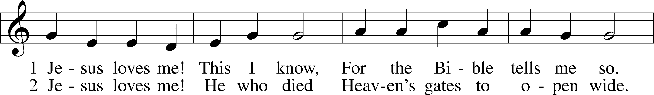
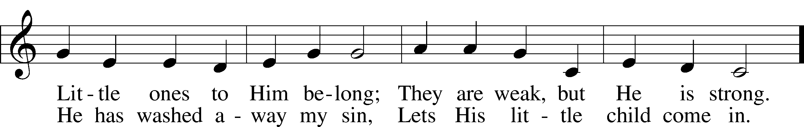
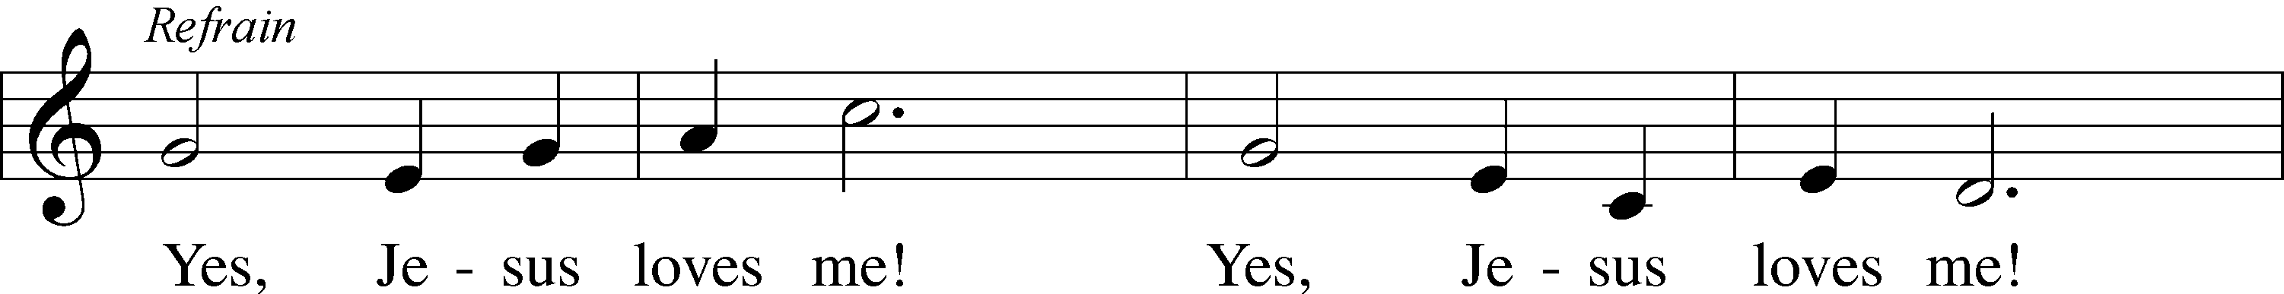
Public domain

WELCOME TO GRACE LUTHERAN CHURCH: We are glad that you are here to worship God with us today! We pray that you will enjoy the wonderful fellowship as friends in Christ as God gathers us around His means of grace, the Word and Sacraments, to bless us with His treasured gifts of forgiveness, faith, abundant life and eternal salvation. If you are a guest, please also sign our Guest Book. Please talk to Pastor if you would like to learn more about becoming a member of Grace. Also, please join us for refreshments and fellowship after the Service. We invite you to come and worship with us often as God gathers us in His Grace.

WELCOME TO THE LORD’S TABLE: We invite and encourage all present who are baptized and faithful Christians, and who confess the Father, Son, and Holy Spirit to be the only true God and who believe that Jesus Christ died for the sins of the World and is our only hope and salvation…to join us in receiving the very and true body and blood of Christ in this Sacrament. The clear liquid cups in the center of the tray are non-alcoholic wine.

Children not yet confirmed in the faith are always welcome to join their parents at the Lord’s Table, but should keep their hands folded in front of them. The Pastor will give them a blessing.

SERVING TODAY: Acolyte: Emily Howard; Lector: Mike Sattelmeier: Communion Assistants: Vince Winters and Max Broadbent; Usher: Terry Richardson; Altar Care: Monica Bacle; Refreshments: _________.

SERVING NEXT SUNDAY: Acolyte: Emily Howard; Lector: David Walker; Communion Assistants: Vince Winters and Max Broadbent; Usher: Terry Richardson; Altar Care: _____________; Refreshments: The Bringle Family.

FLOWERS: were placed on the altar to the glory of God by Jim and Garnet Picking in grateful appreciation for the gift of family.

THIS WEEK AT A GLANCE:
Today: July 23rd
9:00 am Worship Service with Communion
10:15 am Fellowship
10:30 am Adult Bible Class/High School Bible Class

Monday: July 24th
Pastor’s Day Off
5:30 pm Zumba

Tuesday: July 25th
11:30 am Gracious Ladies of Grace Luncheon (Brewery)
2:30 pm Jan’s Mobile Gym
6:00 pm Weight Watcher’s (Parish Hall)
Wednesday: July 26th
1:00 pm Jan’s Gym Summer Camp

Thursday: July 27th
12:00 pm Missional Communities (Brown Bag Lunch)

Next Sunday: July 30th
9:00 am Worship Service with Communion
10:15 am Fellowship
10:30 am Adult Bible Class/High School Bible Class

IN YOUR PRAYERS THIS WEEK: Walt Lepperd, Michael Gillis, Wayne Kruer, Michael McPherson, Micah Westphalen, family and friends of Odalis Klepaski, Capt. Zachary (Bo) Henry (Ret.), family of Sam Vinci, family and friends of Frank Deford, Larry Vandivier, Carl Vandivier, Bobby Meck, family and friends of Elaine Wavehime, Linda Mullis, Joe Lamberson, Michael Willard, France Vandivier, Katie Hoffman, Pastor Ray Peters, Family and friends of Will Plagens, Kay Sattelmeier, Dennis Julson, Vernon Julson, Olga Odland, the family of Jean Grafsgaard, Jenie Howard, Jenny Dean, Charles, Braydon, Champ, Amy, Elsie Hamilton, Mary Ellen Jessel, Marcos Diaz, Kaci Doran, Auwina Weed, Sandy Harris, and those you are praying for at home. If anyone has a special prayer request please submit it in writing in the collection plate; or you may call Pastor Gary Faith at (504-858-8872), or Kris Howard at (305-296-5161).

GIFTS, TITHES, & ATTENDANCE LAST SUNDAY: Sunday July 16th received $1850.00 and the building fund received $250.00 with an attendance of 52.

TO HELP US GROW… The Bible reading for next Sunday’s service are Deuteronomy 7:6-9, Romans 8:28-39, Matthew 13:44-52.

THANK YOU TO MIKE SATTELMEIER for providing our music today. We appreciate you using your gifts to God’s glory.

IN ORDER TO SAVE MONEY we want to register for the President’s Equip Conference by Aug.10th. If you would like to go please let Kris or Pastor know. We will register everyone on Aug. 10th, BUT please make your own motel reservation. It was recommended that you do this soon. Word is that it is filling up.

THERE IS ADDITIONAL PARKING behind the school. Enter that lot on 10th Street.

WE HAVE SET THE SCHEDULES for ushers, acolytes, lectors, and communion assistants for the next three months. If you would like to serve in any of these positions, please let Pastor or Kris know.

STEWARDSHIP LISTS: On the bulletin board by the front door of the church you will find the Altar Care, Refreshments, and Flower sign-up sheets for 2017. If you are able to help out with any of these please place your name in the spot on the date requested.

THE GRACE LUTHERAN CHURCH WEB PAGE AND FACE BOOK PAGE now
contains a vocal recording of last week’s sermon. So, if you are not able to attend church on Sunday please go to our website where you will find a copy of the bulletin and a recording of Pastor Faith’s sermon. https://gracelutherankw.360unite.com/home.

A NUMBER OF CAPITAL IMPROVEMENTS are needed to keep our facilities in good health for the future. Roof repairs are needed on school buildings and the parsonage. If you can help it would be much appreciated! A big thanks to all who have contributed to these repairs.

SAVE THE DATE AND MARK ON YOUR CALENDAR

GRACIOUS LADIES OF GRACE: Well we had mixed reviews about the Rusty Anchor. The fish special which was a whole fried yellowtail was very good and the salads with fish were also a hit. The shrimp tacos were a very generous portion for an appetizer and looked delicious also. The quesadilla wasn’t up to par and the fried fish was kind of skimpy but good. So, the 9 of us ladies rated this experience a 4*. Pretty good for only being open for a short while. We will try it again at a later day. Ladies please join us at the Brewery on July 25th at 11:30. Lots of parking, it’s nice and cool, and the food is pretty good.

JANUARY 27TH, 2018: We plan on having the annual “Let’s Get to Know our Snowbird Friends Better” with Susan and Greg as our guests of honor.

JANUARY 28TH, 2018: Mark this day on your calendar. Pastor Greg Fink and his wife Susan are scheduled to join us for worship and training on how to be a neighborhood missionary. The Finke’s travel l over the country helping equip folks for everyday ministry. It might sound scary but it’s really fun.

SUNDAY SCHOOL:

Sunday School for the elementary children is taking the summer off. We will not meet in June, July, and August. We will resume in September. High Schoolers are welcome this Sunday to explore what a missional community might look like.

MUSIC MINISTRY: Thank you to everyone who participated in our Children's Choir, Bell Choir, and Vocal Choir this year. Rehearsals will begin again in the Fall.

MEN’S BIBLE FELLOWSHIP: They meet the first and third Wednesday’s of each month at 12:30pm. Their next meeting will be August 2nd located at Chico’s on Stock Island. All guys are welcome.

MISSIONAL COMMUNITIES: will have its next meeting Thursday July 27th at noon in the teacher’s workroom. Bring your lunch and your stories of how you have seen Jesus at work in your daily life.

WOMEN’S BIBLE STUDY: will meet again in the fall.

