July 2nd, 2017
9:00 am

THE FOURTH
SUNDAY
OF PENTECOST

Grace Lutheran Church
2713 Flagler Ave.
Key West, FL 33040
305-296-5161
GraceLutheranKW@att.net
gracelutherankw.360unite
Pastor Faith
(504) 858-8872
garyfaith@aol.com

THE FOURTH SUNDAY OF PENTECOST
July 2nd, 2017 9:00 a.m.
WORSHIP SERVICE
In the Name of Jesus!
Our Mission Statement: Anchored in Christ, each person a missionary.

PRELUDE

ANNOUNCEMENTS:
God is with us all during the week, wherever we are and in whatever we are doing. This week, let’s enjoy His presence.

(Please Stand…)
HYMN: “Before You, Lord, We Bow” LSB 966
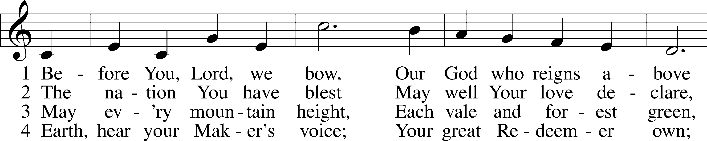
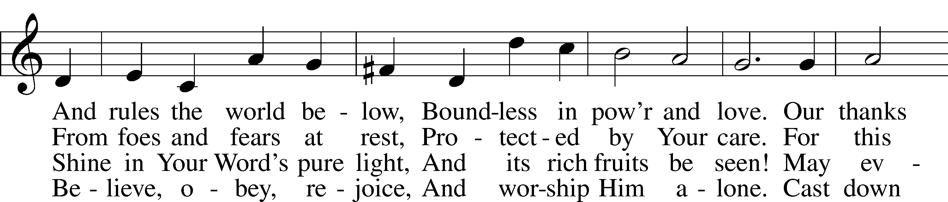
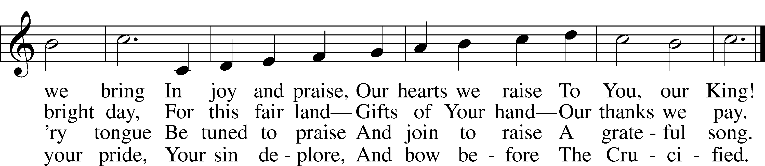

5 And when in pow’r He comes,
Oh, may our native land
From all its rending tombs
Send forth a glorious band,
A countless throng,
With joy to sing
To heav’n’s high King
Salvation’s song! Public domain
Pastor: In the Name of the Father and of the Son and Holy Spirit.
Congregation: Amen.

PREPARATION

(Please Remain Standing Or You May Kneel…)
CONFESSION OF SIN:
All: God, I admit I have broken all of your commandments; I am not holy or sinless even though I often pretend a righteousness I do not have. I offer excuses. I have broken relationships by what I have said, or done. I have not loved either You or my neighbor as I ought. (time for personal confession____)
YOU ARE FORGIVEN:
Pastor: God is merciful and gracious; He has given His Son, Jesus Christ to die and rise again for us, the sinful ones that we might be forgiven and enjoy His Peace. This is also a reminder of God’s gifts and blessing that have become ours in Holy Baptism.
Congregation: thank you God for Your blessing!
Pastor: Yes, the Grace of our Lord Jesus Christ, and the Love of God, and the fellowship of His Holy Spirit is with you all.
Congregation: And also with you.
Pastor: In peace and as His forgiven people, we can pray to the Lord:
Congregation: He is gracious to us and hears our prayers.
Pastor: For the peace of the whole world and our involvement in Christ’s Mission in the world, we pray:
Congregation: Keep us mindful of our purpose as Christians and our ability to share your blessings of peace and forgiveness with others.
Pastor: We are the children of the Risen Christ. His victory is Our Victory!

THE PRAYERS OF THE CHURCH:
All: Almighty God, by the working of Your Holy Spirit, grant that we may gladly hear Your Word proclaimed among us and follow its directing; through Jesus Christ, Your Son, our Lord, who lives and reigns with You and the Holy Spirit, one God, now and forever. Amen.

SERVICE OF THE WORD

God speaks to us through his word, the Bible:

You may be seated…
THE OLD TESTAMENT READING: Jeremiah 28:5-9
Lector: This is the Word of the Lord.
People: Thanks be to God.

THE EPISTLE LESSON: Romans 7:1-13
Lector: This is the Word of the Lord.
People: Thanks be to God.

Please stand…
THE HOLY GOSPEL: Matthew 10:34-42
Pastor: The Holy Gospel according to St. Matthew the 10th Chapter
People: Glory to You, O Lord.
Pastor: This is the Gospel of the Lord.
People: Praise to You, O Christ!

Please be seated…
CHILDREN’S MESSAGE

NOISE OFERING
It’s called a noise offering because what we are asking for is pocket change. It will always be used for missions outside of our church and school. It normally also is given to a mission involving children. Thanks for making a joyful noise to the Lord.

Please be seated…
SERMON HYMN: “I Surrender All”
Words by Judson Wheeler Van DeVenter, Music by Winfield Scott Weeden

THE SERMON: “Say What?!” Matthew 10:39

(Please stand…)
THE PROFESSION OF FAITH:
Pastor: God has given us a great message to take to His world. Let us remind ourselves and one another of what that message is:
Pastor: I believe in God the Father, Almighty
Congregation: Maker of heaven and earth
Pastor: And in His Son, Jesus Christ our Lord,
Congregation: Who was conceived by the Holy Spirit
Pastor: Born of the Virgin Mary
Congregation: Suffered under Pontius Pilate
Pastor: Was crucified, died and was buried
Congregation: He descended into hell.
Pastor: On the third day He rose again from the dead,
Congregation: And ascended into heaven
Pastor: And sits on the right hand of God, the Father almighty
Congregation: From there He will come to judge the living and the dead
Pastor: I believe in the Holy Spirit,
Congregation: The Holy Christian Church as
All: the communion of saints; the forgiveness of sins, the resurrection of the body, and the life everlasting. Amen.

(You may be seated…)
OFFERING RECEIVED

(Please stand…)
“Praise God, from Whom All Blessings Flow” LSB 805
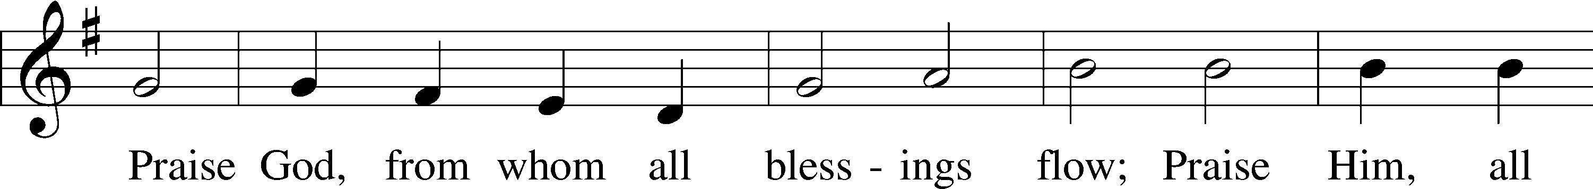
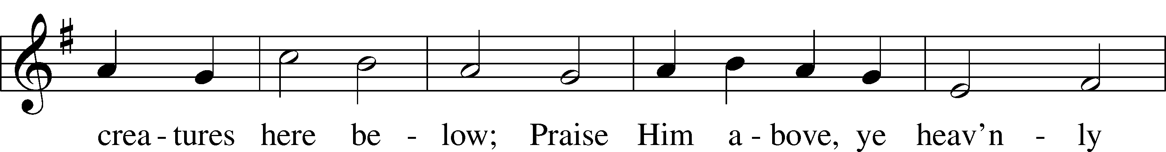
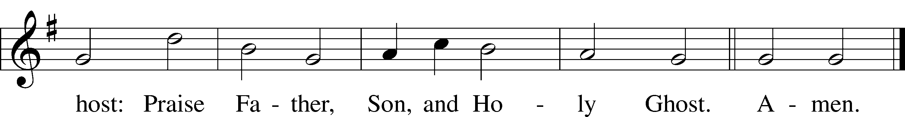
Public domain

SERVICE OF THE SACRAMENT
(Please stand…)
PREPARE FOR THE LORD’S SUPPER:
Pastor: We begin with the reminder: “The Lord is with you.”
Congregation: We are mindful and thankful for His presence.
Pastor: Let your life reflect the joy of your salvation.
Congregation: We do give Him thanks and praise. We will share His blessing with others.

A prayer for our nation attributed to St. Frances

Pastor: Lord, make us instruments of your peace. Where there is hatred,
Congregation: let us sow love;
Pastor: where there is injury,
Congregation: pardon;
Pastor: where there is discord,
Congregation: union;
Pastor: where there is doubt,
Congregation: faith;
Pastor: where there is despair,
Congregation: hope;
Pastor: where there is darkness,
Congregation: light;
Pastor: where there is sadness:
Congregation: joy.
Pastor: Grant that we may not so much seek to be consoled
Congregation: as to console;
Pastor: to be understood
Congregation: as to understand;
Pastor: to be loved
Congregation: as to love.
Pastor: For it is in giving
Congregation: that we receive;
Pastor: it is in pardoning
Congregation: that we are pardoned;
Pastor: and it is in dying
Congregation: that we are born to eternal life.

(Please be seated…)
THE WORDS OF INSTITUTION

DISTRIBUTION HYMNS: “Lord Jesus Christ, We Humbly Pray” LSB 623
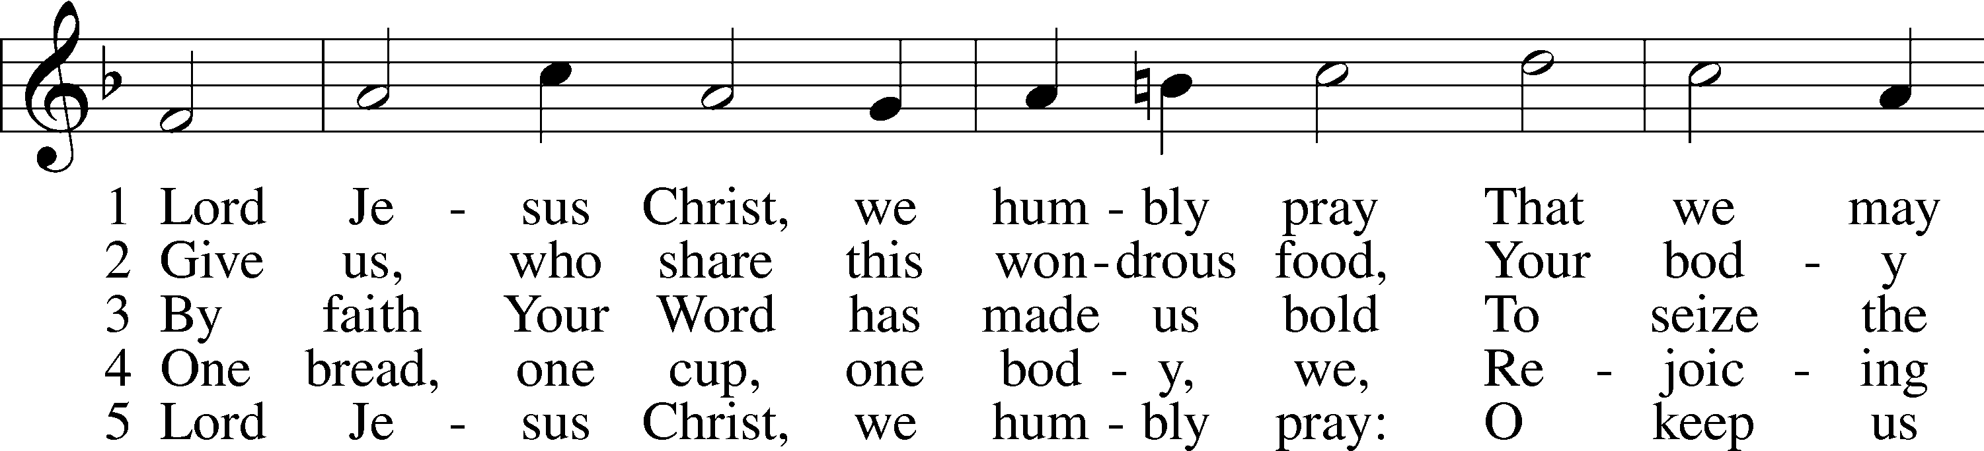
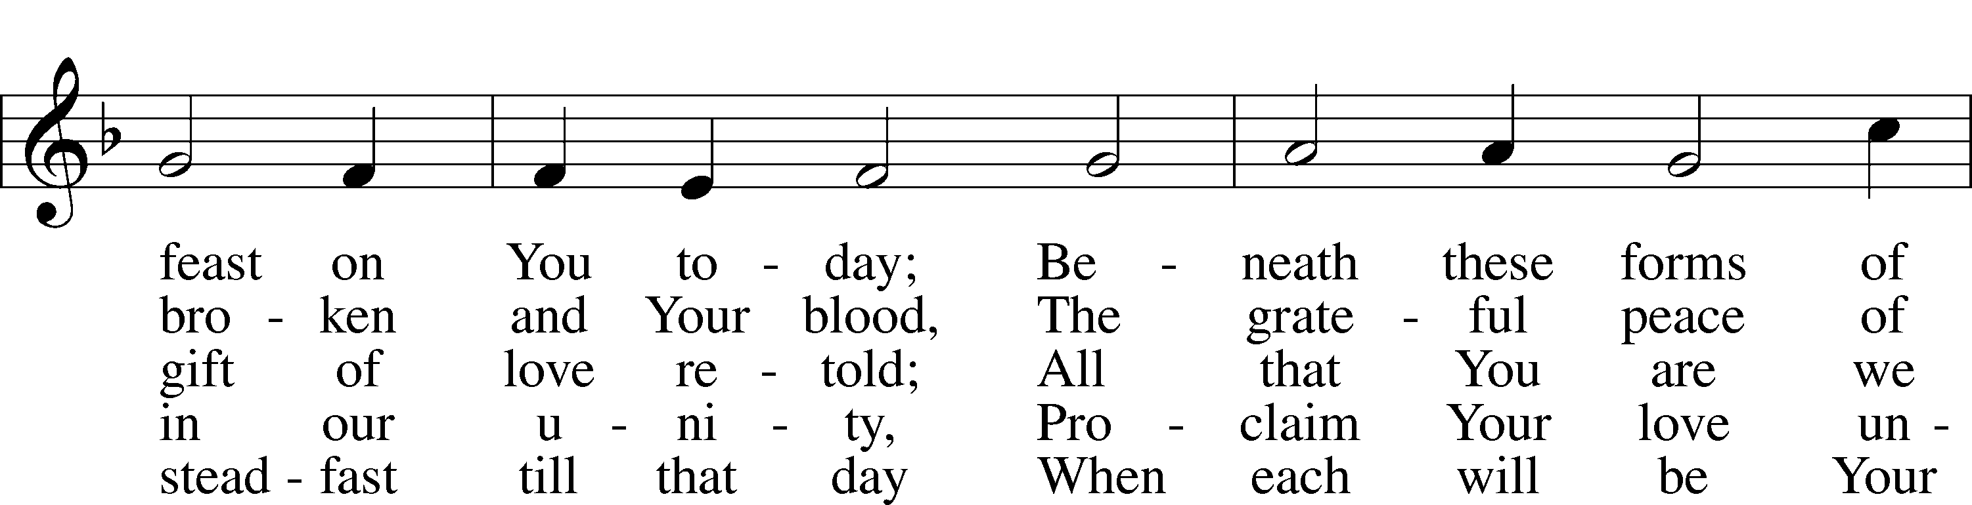
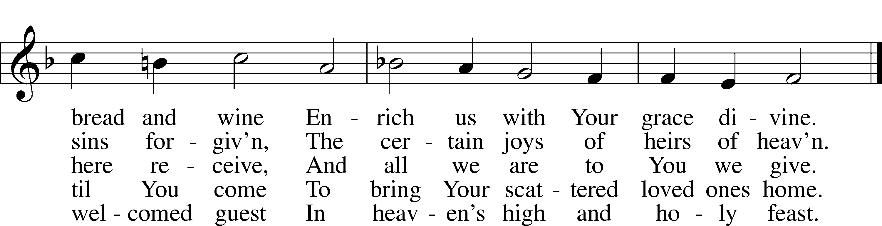
Public domain

“Seek Ye First” LSB 712
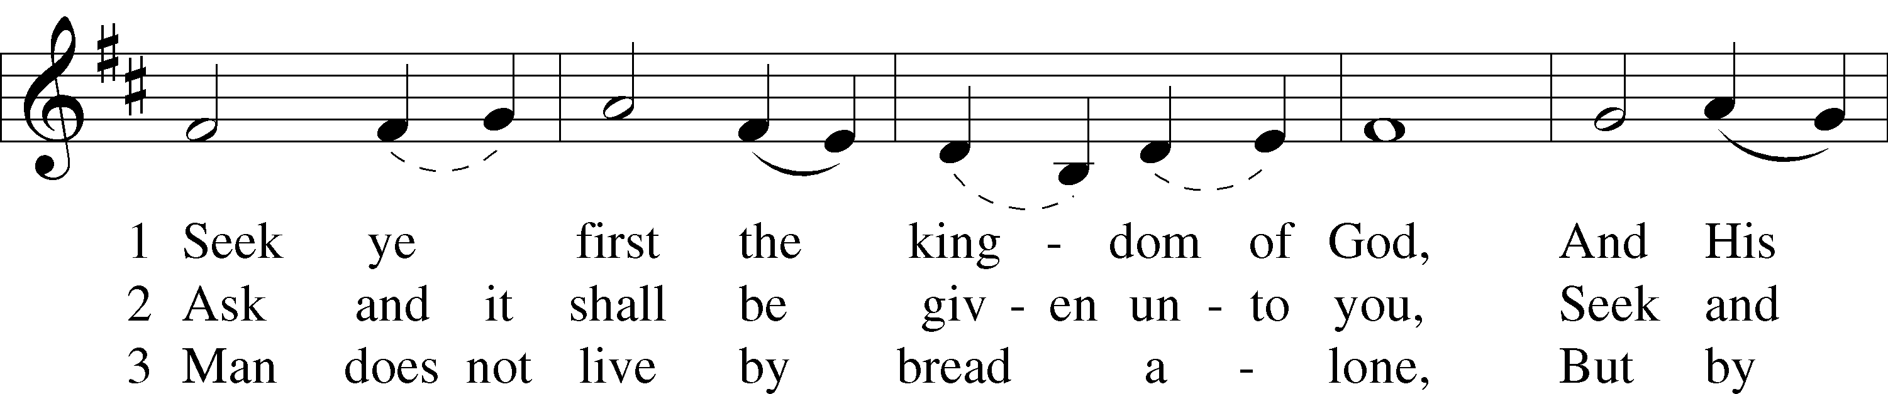
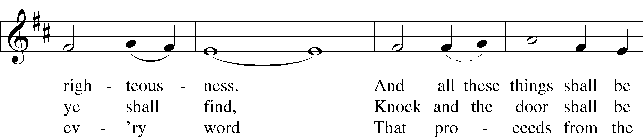
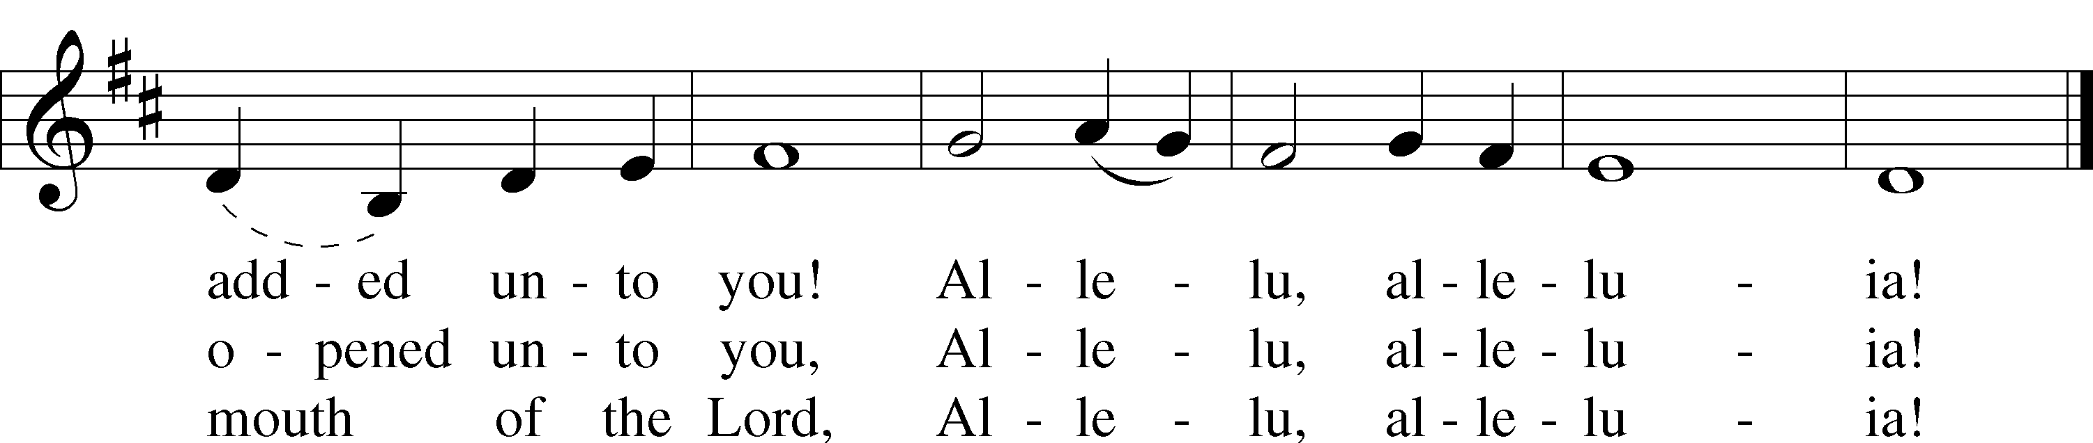
© 1972 Maranatha! Music; admin. Music Services (ASCAP). Used by permission: New License, no. 11157462
“Lord of Glory, You Have Bought Us” LSB 851
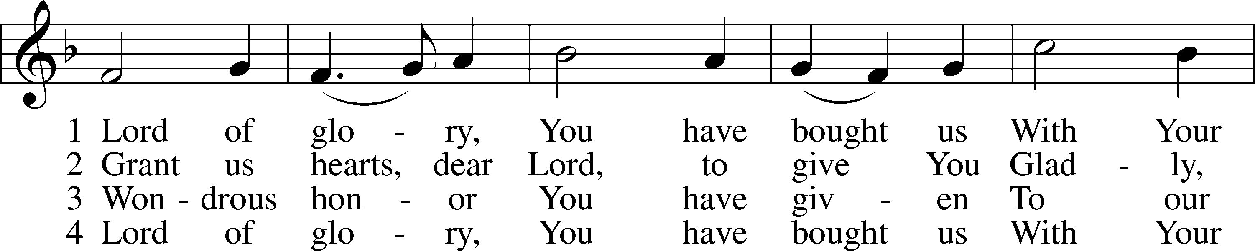
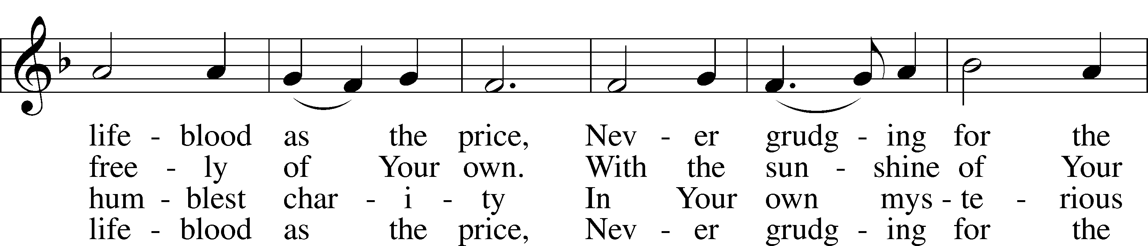
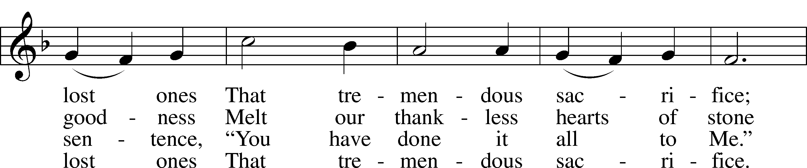
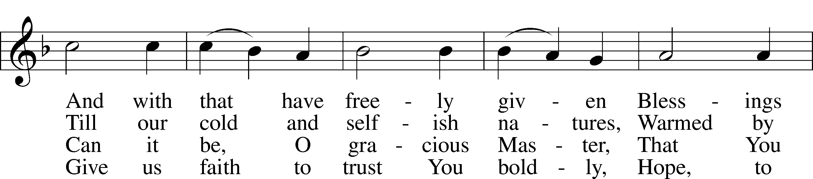
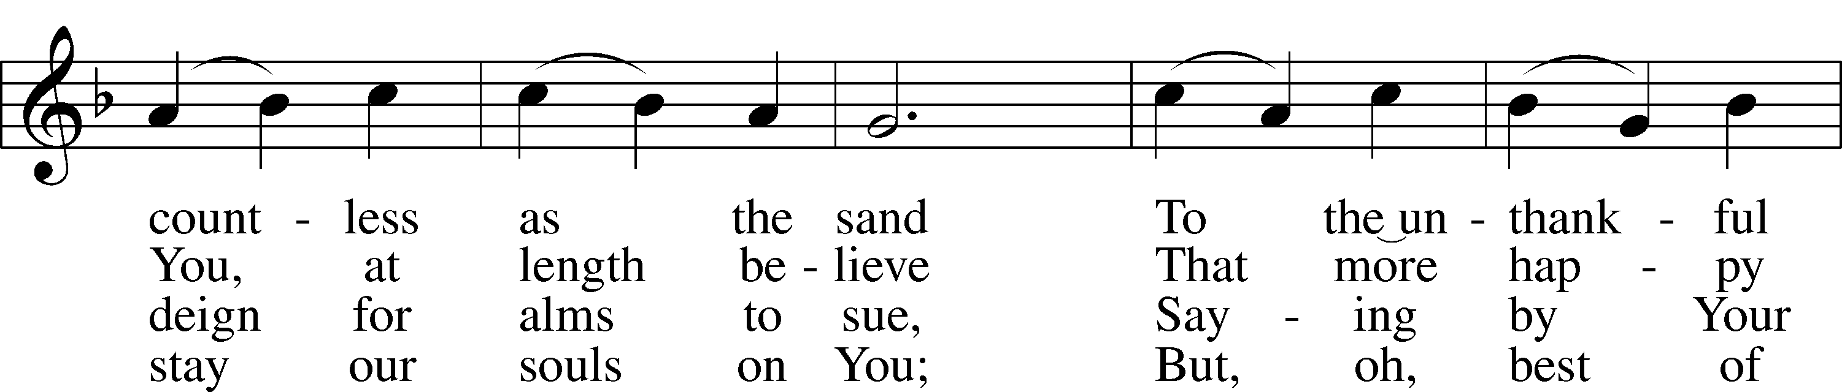
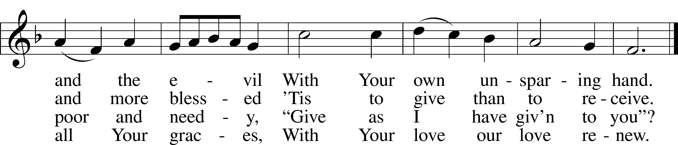
Public domain

(Please stand…)
THE LORD’S PRAYER:
All: Our Father, who art in heaven, hallowed be thy name, thy kingdom come, thy will be done, on earth as it is in heaven. Give us this day our daily bread; and forgive us our trespasses as we forgive those who trespass against us; and lead us not into temptation, but deliver us from evil. For thine is the kingdom, and the power, and the glory, forever and ever. Amen

THE BLESSING AND BENEDICTION:
Pastor: The Lord Blesses you and keeps you, the Lord makes His face to shine upon you and He is Gracious to you. The Lord looks upon you with His favor and gives you His peace.
Congregation: God blesses us so that we can be a blessing to others.
Pastor: Go in His peace and serve the Lord by serving others.
Congregation: Amen

THE CLOSING HYMN: “God Bless Our Native Land” LSB 965
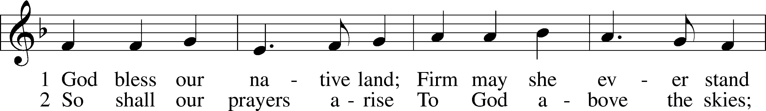
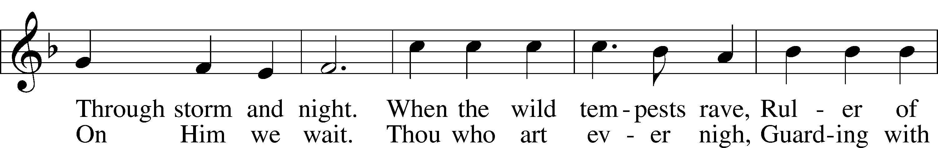
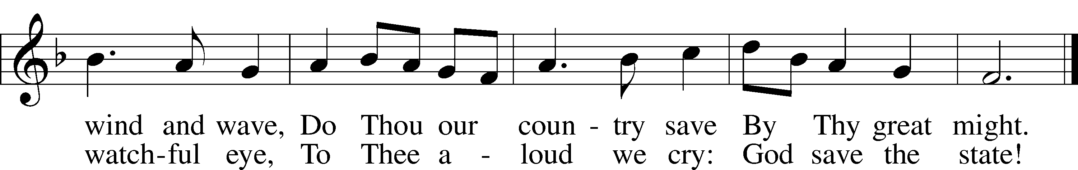
Public domain

Jesus let the things that break
your heart also break our hearts.

Amen

WELCOME TO GRACE LUTHERAN CHURCH: We are glad that you are here to worship God with us today! We pray that you will enjoy the wonderful fellowship as friends in Christ as God gathers us around His means of grace, the Word and Sacraments, to bless us with His treasured gifts of forgiveness, faith, abundant life and eternal salvation. If you are a guest, please also sign our Guest Book. Please talk to Pastor if you would like to learn more about becoming a member of Grace. Also, please join us for refreshments and fellowship after the Service. We invite you to come and worship with us often as God gathers us in His Grace.

WELCOME TO THE LORD’S TABLE: We invite and encourage all present who are baptized and faithful Christians, and who confess the Father, Son, and Holy Spirit to be the only true God and who believe that Jesus Christ died for the sins of the World and is our only hope and salvation…to join us in receiving the very and true body and blood of Christ in this Sacrament. The clear liquid cups in the center of the tray are non-alcoholic wine.

Children not yet confirmed in the faith are always welcome to join their parents at the Lord’s Table, but should keep their hands folded in front of them. The Pastor will give them a blessing.

SERVING TODAY: Acolyte: Maddie Schoepf; Lector: JoAnn Broadbent: Communion Assistants: Vince Winters and Max Broadbent; Usher: Terry Richardson; Altar Care: The Pickings; Refreshments: The Pickings.

SERVING NEXT SUNDAY: Acolyte: __________; Lector: Garnet Picking; Communion Assistants: Vince Winters and Max Broadbent; Usher: Terry Richardson; Altar Care: _____________; Refreshments: _____________.

FLOWERS: were placed on the altar to the glory of God and to celebrate Emmie Thompson’s birthday.

THIS WEEK AT A GLANCE:
Today: July 2nd
9:00 am Worship Service with Communion
10:15 am Fellowship
10:30 am Adult Bible Class/ High Schoolers Bible Class

Monday: July 3rd
Pastor’s Day Off
5:30 pm Zumba

Tuesday: July 4th
Happy 4th of July
6:00 pm Weight Watcher’s (Parish Hall)

Wednesday: July 5th
12:30 pm Men’s Bible Fellowship (Chico’s)

Next Sunday: July 9th
9:00 am Worship Service with Communion
10:15 am Fellowship
10:30 am Adult Bible Class

IN YOUR PRAYERS THIS WEEK: Wayne Kruer, Michael McPherson, Micah Westphalen, family and friends of Odalis Klepaski, Capt. Zachary (Bo) Henry (Ret.), family of Sam Vinci, family and friends of Frank Deford, Larry Vandivier, Carl Vandivier, Bobby Meck, family and friends of Elaine Wavehime, Linda Mullis, Joe Lamberson, Michael Willard, France Vandivier, Katie Hoffman, Pastor Ray Peters, Family and friends of Will Plagens, Kay Sattelmeier, Dennis Julson, Vernon Julson, Olga Odland, the family of Jean Grafsgaard, Jenie Howard, Jenny Dean, Charles, Braydon, Champ, Amy, Elsie Hamilton, Mary Ellen Jessel, Marcos Diaz, Kaci Doran, Auwina Weed, Sandy Harris, and those you are praying for at home. If anyone has a special prayer request please submit it in writing in the collection plate; or you may call Pastor Gary Faith at (504-858-8872), or Kris Howard at (305-296-5161).

GIFTS, TITHES, & ATTENDANCE LAST SUNDAY: Sunday June 11th received $2263.84 with an attendance of 66, Sunday June 18th received $3225.00 with an attendance of 64, and Sunday June 25th received $2174.50 with an attendance of 50. The noise offering received $100.14 for Sunday June 4th and June 11th, on Sunday June 18th it received $36.05.

TO HELP US GROW… The Bible reading for next Sunday’s service are Jeremiah Zechariah 9:9-12, Romans 7:14-25a, and Matthew 11:25-30.

6 SO FAR: So far, we have six people committed to attending the Presidents Equip Conference Reforming Living Stones. I believe this will be an experience that can impact not only the participants but our effectiveness as missionaries. There is still room, if interested contact Kris Howard.

THERE IS ADDITIONAL PARKING behind the school. Enter that lot on 10th Street.

WE HAVE SET THE SCHEDULES for ushers, acolytes, lectors, and communion assistants for the next three months. If you would like to serve in any of these positions, please let Pastor or Kris know.

STEWARDSHIP LISTS: On the bulletin board by the front door of the church you will find the Altar Care, Refreshments, and Flower sign-up sheets for 2017. If you are able to help out with any of these please place your name in the spot on the date requested.

THE GRACE LUTHERAN CHURCH WEB PAGE AND FACE BOOK PAGE now
contains a vocal recording of last week’s sermon. So, if you are not able to attend church on Sunday please go to our website where you will find a copy of the bulletin and a recording of Pastor Faith’s sermon. https://gracelutherankw.360unite.com/home.

A NUMBER OF CAPITAL IMPROVEMENTS are needed to keep our facilities in good health for the future. Roof repairs are needed on school buildings and the parsonage. If you can help it would be much appreciated! A big thanks to all who have contributed to these repairs.

SOME DATES TO MARK ON YOUR CALENDAR

GRACIOUS LADIES OF GRACE: had a great lunch at the Key West Harbor Yacht Club out on the porch with a wonderful view of the ocean. We will be meeting at the new and improved Rusty Anchor on July 11th at 11:30am.

SUNDAY SCHOOL:

Sunday School for the elementary children is taking the summer off. We will not meet in June, July, and August. We will resume in September. High Schoolers are welcome this Sunday to explore what a missional community might look like.

“What are we doing that nobody else is
doing to reach people that nobody else
is reaching?

MUSIC MINISTRY: Thank you to everyone who participated in our Children's Choir, Bell Choir, and Vocal Choir this year. Rehearsals will begin again in the Fall.

MEN’S BIBLE FELLOWSHIP: They meet the first and third Wednesday’s of each month at 12:30pm. Their next meeting will be July 5th located at Chico’s on Stock Island. All guys are welcome.

MISSIONAL COMMUNITIES: will have its next meeting Thursday July 27th at noon in the teacher’s workroom. Bring your lunch and your stories of how you have seen Jesus at work in you daily life.

WOMEN’S BIBLE STUDY: will meet again in the fall.

