June 25th, 2017
9:00 am

THIRD SUNDAY
AFTER PENTECOST

Grace Lutheran Church
2713 Flagler Ave.
Key West, FL 33040
305-296-5161
GraceLutheranKW@att.net
gracelutherankw.360unite
Pastor Faith
(504) 858-8872
garyfaith@aol.com

THIRD SUNDAY AFTER PENTECOST
June 25th, 2017 9:00 a.m.
In the Name of Jesus!
Our Mission Statement: Anchored in Christ, each person a missionary.

PRELUDE

ANNOUNCEMENTS:
We welcome you. We are glad you are here to share with us the joy and peace we have in Jesus Christ. It doesn’t matter whether this is your first time in this church or if you are a lifelong member, you are welcome. We come together today in order to celebrate the gift God has given us-His own Son, Jesus, Our Savior.

PREPARATION
(Please Stand…)
HYMN: “Amazing Grace” LSB 744
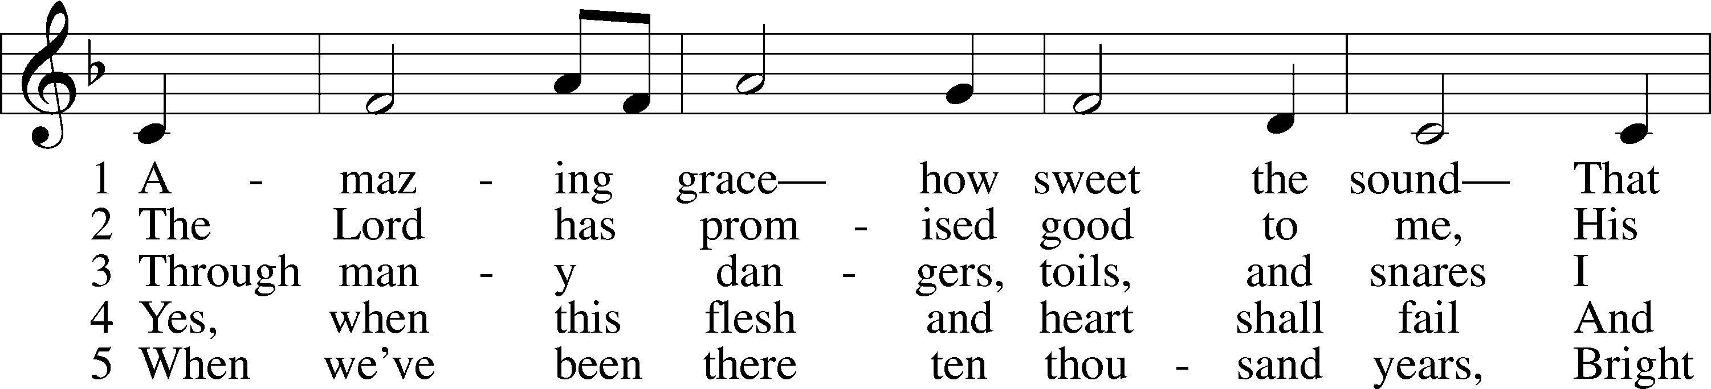
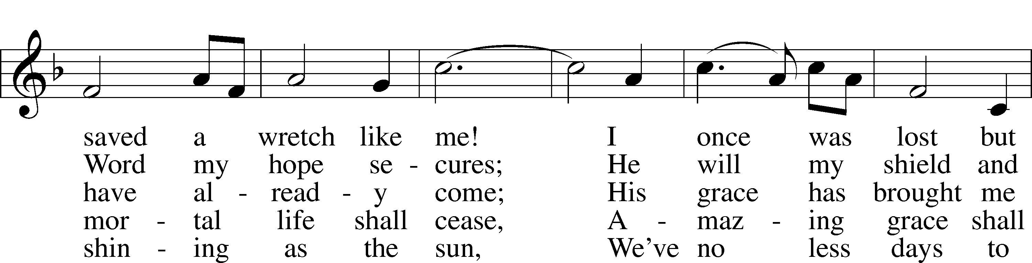
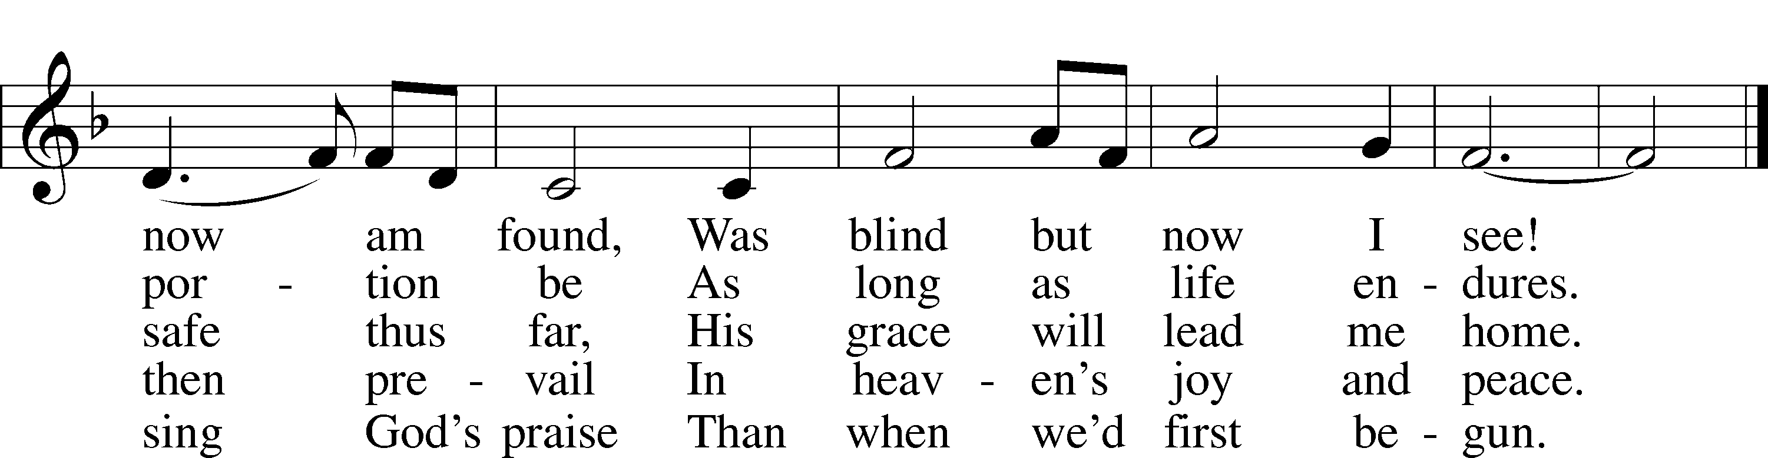
© 1991 Editorial Concordia. Used by permission: LSB Hymn License .NET, no. 100011641.
Public domain

Pastor: In the Name of the Father and of the Son and Holy Spirit.
Congregation: Amen.

(Please Remain Standing Or You May Kneel…)
GOD’S PEOPLE CONFESS THEIR SINS:
Pastor: By grace you have been saved, through faith-and this is not from yourselves, it is the gift of God-not of works, so that no man can boast, for we are God’s workmanship, created in Christ Jesus.
Congregation: I know that nothing good lives in me, that is, in my sinful nature, for I have the desire to do what is good, but I cannot carry it out.
Pastor: What I do is not the good I want to do; no, the evil I do not want to do-this I keep doing.
Congregation: In my heart I delight in God’s law, the law that points out what a wretched person I am! Who will rescue me from this body of death?
Pastor: Thanks be to God through Jesus Christ our Lord! Only He can achieve the perfection we fail to achieve. By the forgiveness He purchased on the cross, our forgiveness is complete!

SERVICE OF THE WORD

You may be seated…
THE FIRST READING: Jeremiah 20:7-13
Lector: This is the Word of the Lord.
People: Thanks be to God.

THE EPISTLE LESSON: Romans 6:12-23 Lector: This is the Word of the Lord.
People: Thanks be to God.

Please stand…
THE HOLY GOSPEL: Matthew 10:5a, 21-33
Pastor: The Holy Gospel according to St. Matthew the 10th Chapter.
People: Glory to You, O Lord.
Pastor: This is the Gospel of the Lord.
People: Praise to You, O Christ!

Please be seated…
THE SERMON HYMN: “When Peace, like a River”
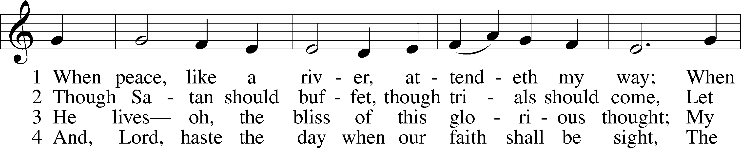
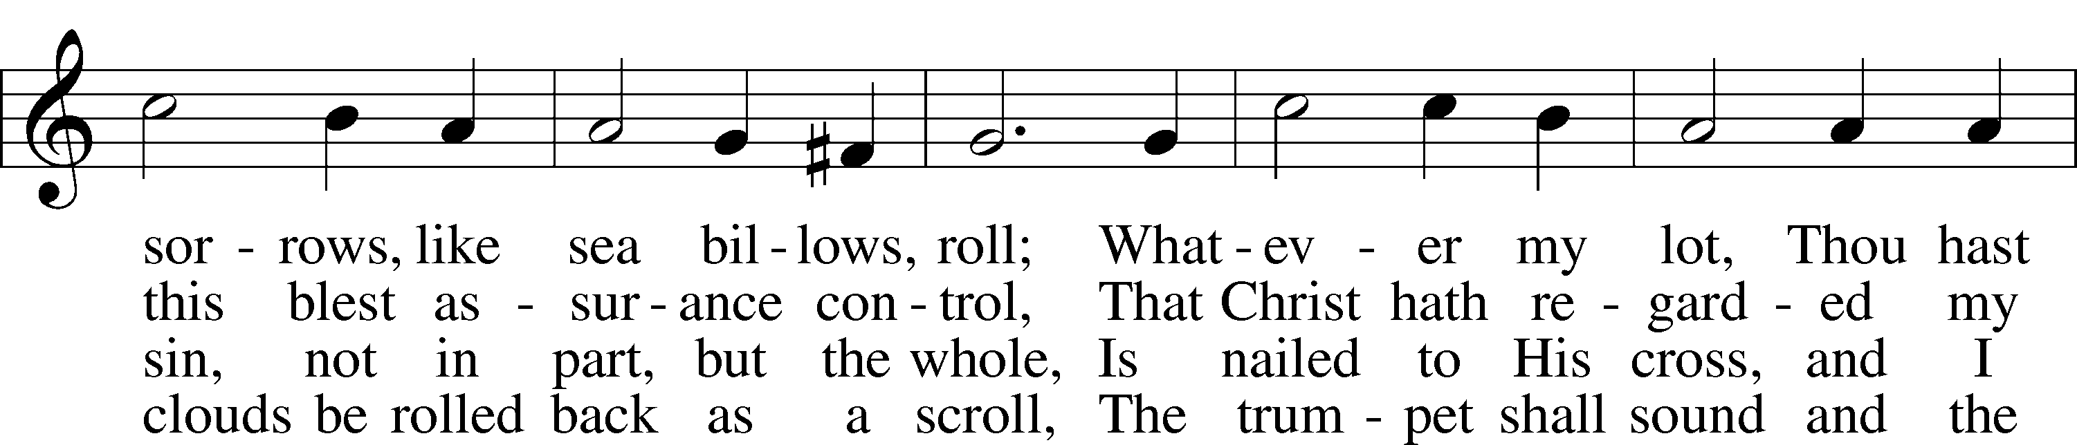
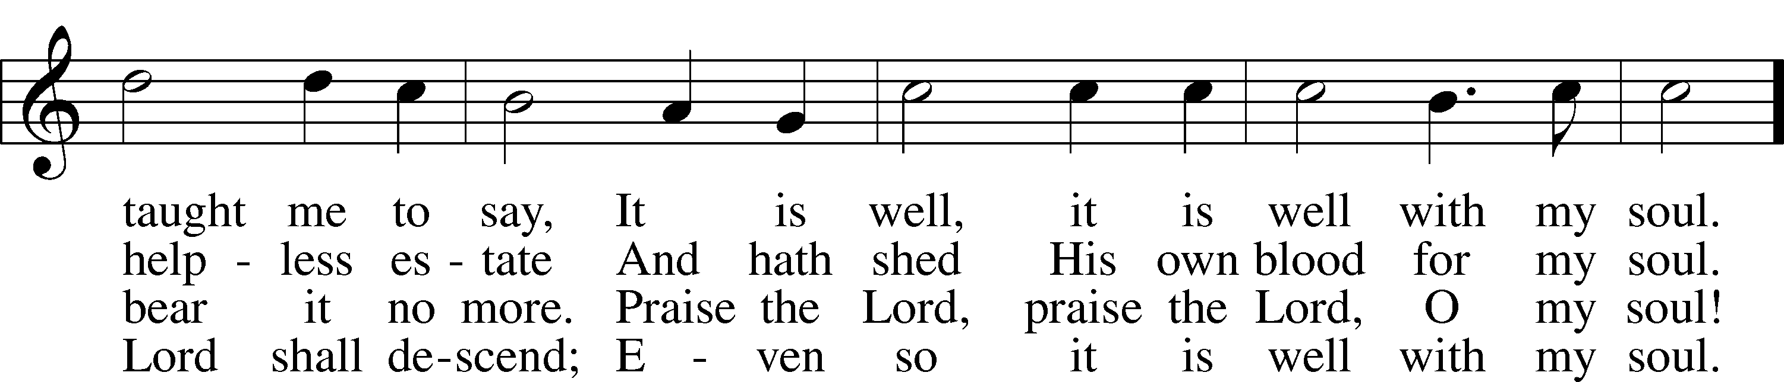
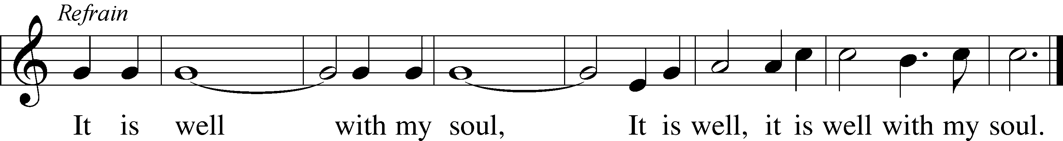
Public domain

THE SERMON

(Please stand…)
THE PROFESSION OF FAITH:
Pastor: God has given us a great message to take to His world. Let us remind ourselves and one another of what that message is:
Pastor: I believe in God the Father, Almighty
Congregation: Maker of heaven and earth
Pastor: And in His Son, Jesus Christ our Lord,
Congregation: Who was conceived by the Holy Spirit
Pastor: Born of the Virgin Mary
Congregation: Suffered under Pontius Pilate
Pastor: Was crucified, died and was buried
Congregation: He descended into hell.
Pastor: On the third day He rose again from the dead,
Congregation: And ascended into heaven
Pastor: And sits on the right hand of God, the Father almighty
Congregation: From there He will come to judge the living and the dead
Pastor: I believe in the Holy Spirit,
Congregation: The Holy Christian Church as
All: the communion of saints; the forgiveness of sins, the resurrection of the body, and the life everlasting. Amen.

(You may be seated…)
OFFERING RECEIVED

(Please stand…)
“Praise God, from Whom All Blessings Flow” LSB 805
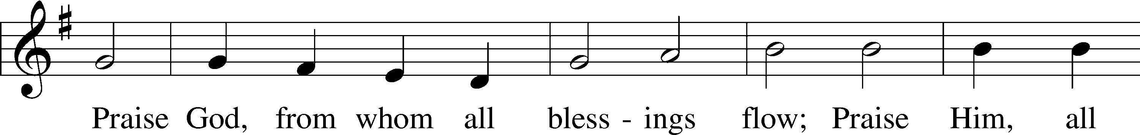
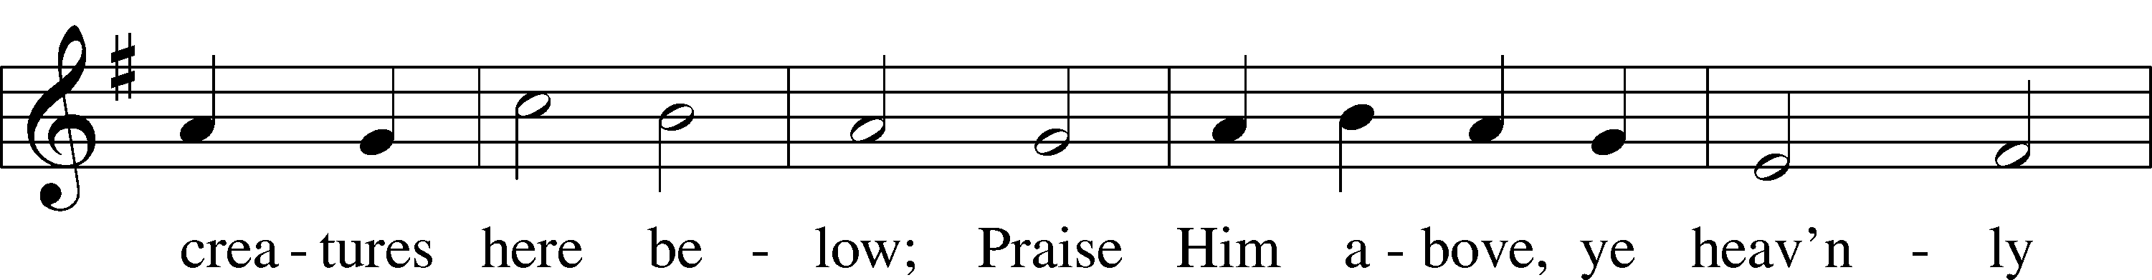
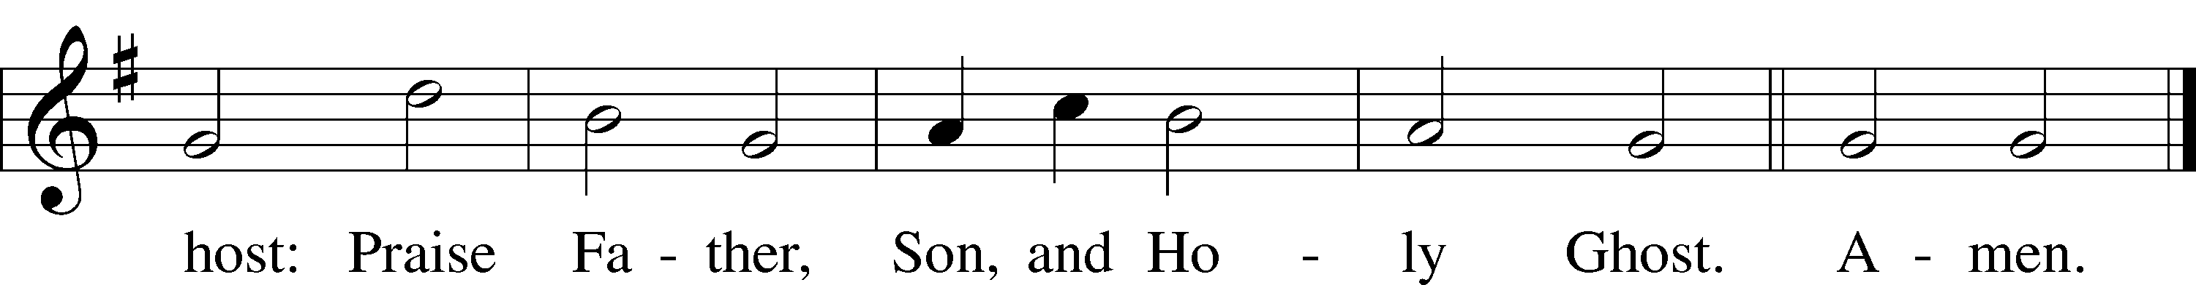
Public domain

THE PRAYERS OF THE CHURCH: based on Psalm 98
Pastor: Dear Lord, we thank You for everything You’ve done for us, and most of all for Your own Son, Jesus, our Savior. We will never stop praising You for this wonderful gift.
Congregation: Sing to the Lord a new song, for He has done marvelous things; His right hand and His holy arm have worked salvation for Him.
Pastor: We thank You for those missionaries long ago who brought the Good News to our people. When we were in darkness, You sent men and women to bring us the light. Thank you, Lord.
Congregation: The Lord has made His salvation known and revealed His Righteousness to the nation.
Pastor: O Lord, You are our Savior, we trust in You for all our needs, give healing to the sick, courage to those who are afraid, and peace to those we name in our hearts either silently or out loud. (a moment of silence) We praise You, gracious Lord, for all Your benefits to us. You give us home, friends and family, food, shelter, rest and everything we need. You give us sight and hearing and touch and taste and provide for all of our needs.
Congregation: Shout for joy to the Lord, praise His Name Amen.

SERVICE OF THE SACRAMENT

(Please be seated…)
THE WORDS OF INSTITUTION

DISTRIBUTION HYMNS: “Make Me A Servant”
Words and Music by Kelly Willard

Repeat Once

“Just as I Am, without One Plea” LSB 570
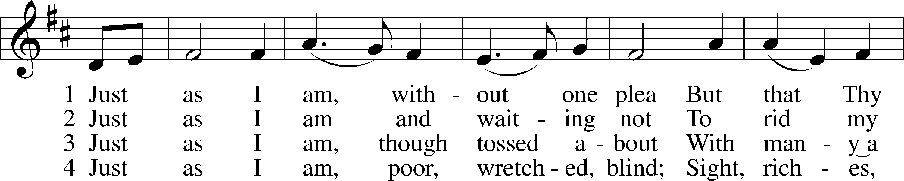
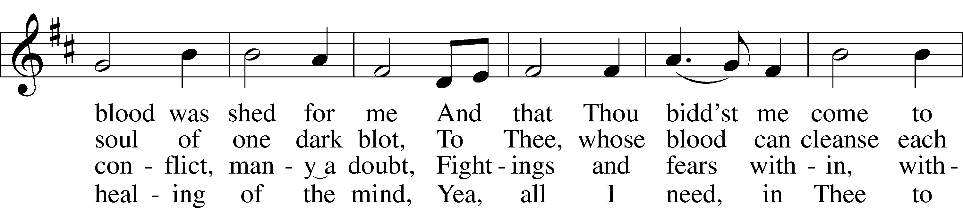
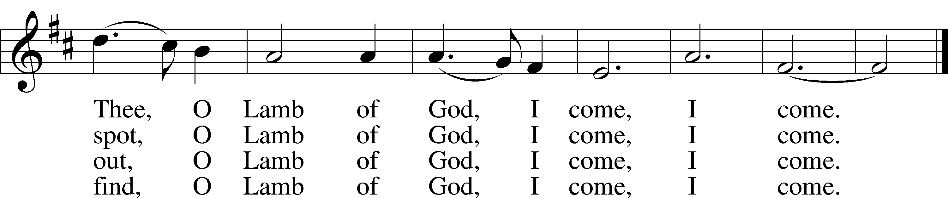

5 Just as I am, Thou wilt receive,
Wilt welcome, pardon, cleanse, relieve;
Because Thy promise I believe,
O Lamb of God, I come, I come.

6 Just as I am; Thy love unknown
Has broken ev’ry barrier down;
Now to be Thine, yea, Thine alone,
O Lamb of God, I come, I come.
Public domain

“What are we doing that nobody
else is doing to reach people that
nobody else is reaching?”

“Take My Life and Let It Be” LSB 784
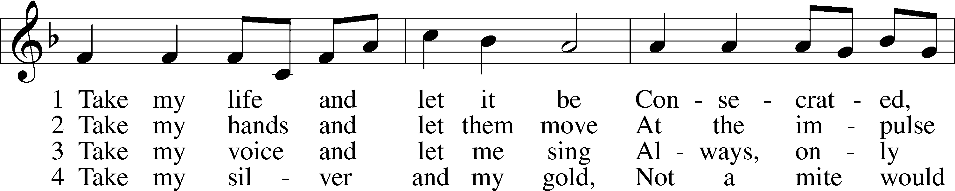
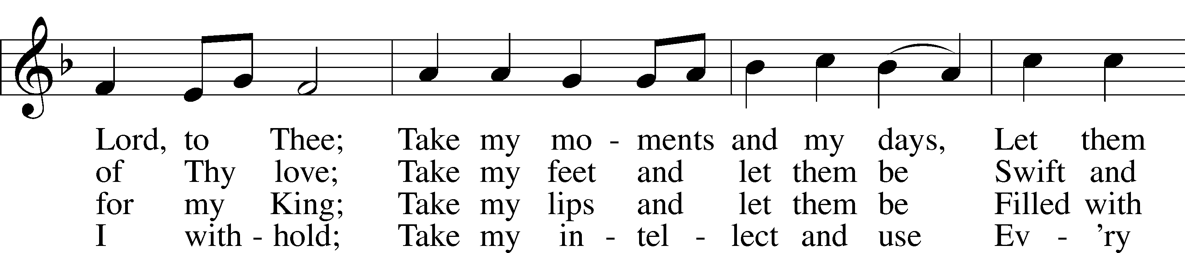
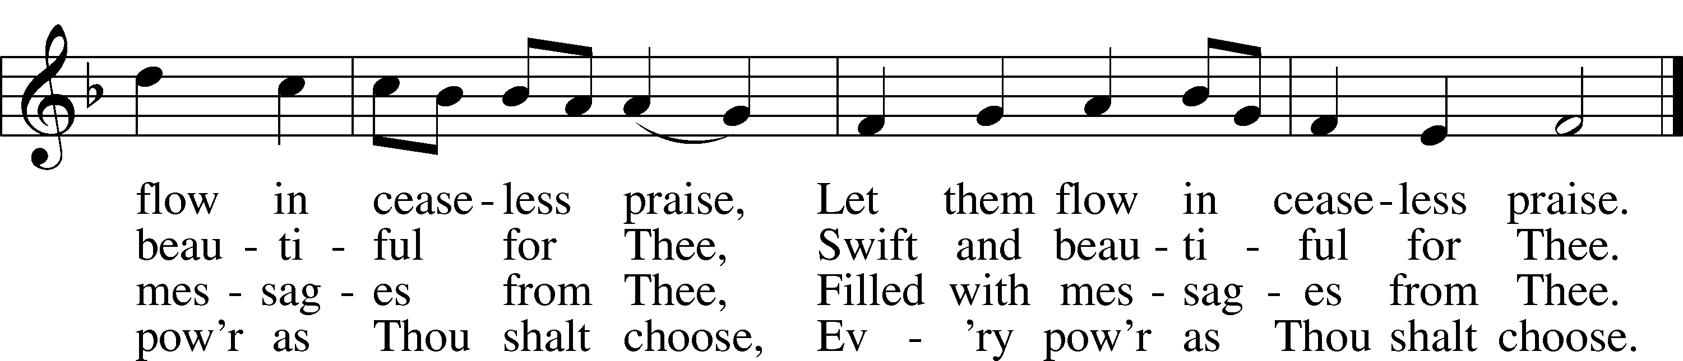

5 Take my will and make it Thine,
It shall be no longer mine;
Take my heart, it is Thine own,
It shall be Thy royal throne.

6 Take my love, my Lord, I pour
At Thy feet its treasure store;
Take myself, and I will be
Ever, only, all for Thee.
Public domain

Jesus let the things that break
your heart also break our hearts.
Amen

(Please stand…)
THE LORD’S PRAYER:
All: Our Father, who art in heaven, hallowed be thy name, thy kingdom come, thy will be done, on earth as it is in heaven. Give us this day our daily bread; and forgive us our trespasses as we forgive those who trespass against us; and lead us not into temptation, but deliver us from evil. For thine is the kingdom, and the power, and the glory, forever and ever. Amen.

THE BENEDICTION

THE CLOSING HYMN: “Lift High the Cross”
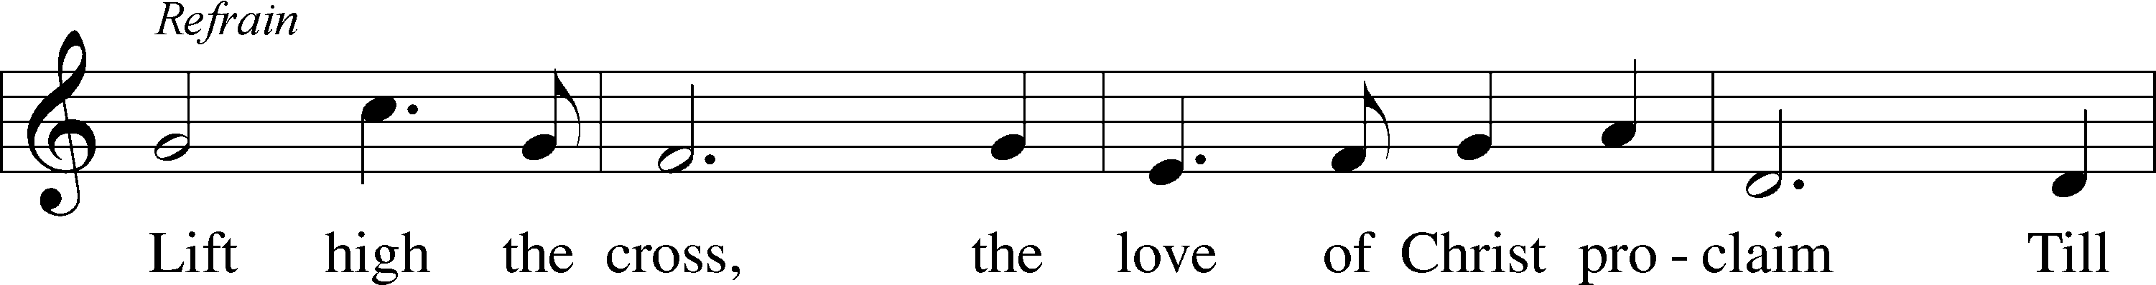
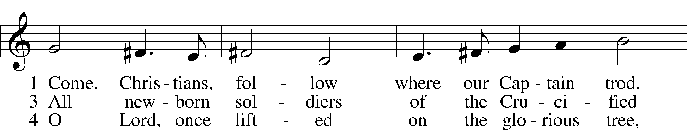
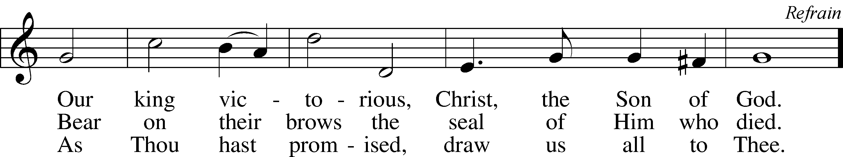

6 So shall our song of triumph ever be:
Praise to the Crucified for victory! Refrain
© 1997 Hope Publishing Co. Used by permission: LSB Hymn License .NET, no. 100011641.
© 1974 Hope Publishing Co. Used by permission: LSB Hymn License .NET, no. 100011641.

WELCOME TO GRACE LUTHERAN CHURCH: We are glad that you are here to worship God with us today! We pray that you will enjoy the wonderful fellowship as friends in Christ as God gathers us around His means of grace, the Word and Sacraments, to bless us with His treasured gifts of forgiveness, faith, abundant life and eternal salvation. If you are a guest, please also sign our Guest Book. Please talk to Pastor if you would like to learn more about becoming a member of Grace. Also, please join us for refreshments and fellowship after the Service. We invite you to come and worship with us often as God gathers us in His Grace.

WELCOME TO THE LORD’S TABLE: We invite and encourage all present who are baptized and faithful Christians, and who confess the Father, Son, and Holy Spirit to be the only true God and who believe that Jesus Christ died for the sins of the World and is our only hope and salvation…to join us in receiving the very and true body and blood of Christ in this Sacrament. The clear liquid cups in the center of the tray are non-alcoholic wine.

Children not yet confirmed in the faith are always welcome to join their parents at the Lord’s Table, but should keep their hands folded in front of them. The Pastor will give them a blessing.

SERVING TODAY: Acolyte: _____________; Lector: Mary Brady: Communion Assistants: David Walker and Mary Brady; Usher: Vince Winters; Altar Care: Anthony Klepaski; Refreshments: Anthony Klepaski and ___________ .

SERVING NEXT SUNDAY: Acolyte: Maddie Schoepf; Lector: JoAnn Broadbent; Communion Assistants: Vince Winters and Max Broadbent; Usher: Terry Richardson; Altar Care: _____________; Refreshments: _____________.

FLOWERS: were placed on the altar to the glory of God and by Henry Hamilton.

THIS WEEK AT A GLANCE:
Today: June 25th
9:00 am Worship Service with Communion
10:15 am Fellowship
10:30 am Adult Bible Class/ High Schoolers Bible Class

Monday: June 26th
Pastor’s Day Off
5:30 pm Zumba

Tuesday: June 27th
3:00 pm Jan’s Mobile Gym
6:00 pm Weight Watcher’s (Parish Hall)

Thursday June 29th
12:00 pm Missional Communites (Bring your Lunch!)

Next Sunday: July 2nd
9:00 am Worship Service with Communion
10:15 am Fellowship
10:30 am Adult Bible Class/ High Schoolers Bible Class

IN YOUR PRAYERS THIS WEEK: Wayne Kruer, Michael McPherson, Micah Westphalen, family and friends of Odalis Klepaski, Capt. Zachary (Bo) Henry (Ret.), family of Sam Vinci, Frank Deford, Larry Vandivier, Carl Vandivier, Bobby Meck, family and friends of Elaine Wavehime, Linda Mullis, Joe Lamberson, Michael Willard, France Vandivier, Katie Hoffman, Pastor Ray Peters, Family and friends of Will Plagens, Kay Sattelmeier, Dennis Julson, Vernon Julson, Olga Odland, the family of Jean Grafsgaard, Jenie Howard, Jenny Dean, Charles, Braydon, Champ, Amy, Elsie Hamilton, Mary Ellen Jessel, Marcos Diaz, Kaci Doran, Auwina Weed, Sandy Harris, and those you are praying for at home. If anyone has a special prayer request please submit it in writing in the collection plate; or you may call Pastor Gary Faith at (504-858-8872), or Kris Howard at (305-296-5161).

GIFTS, TITHES, & ATTENDANCE LAST SUNDAY, for last Sunday June 11th, this Sunday the 18th, and Sunday the 25th will be listed in the July 2nd bulletin.

TO HELP US GROW… The Bible reading for next Sunday’s service are Jeremiah 28:5-9, Romans 7:1-13, Matthew 10:34-42.

THERE IS ADDITIONAL PARKING behind the school. Enter that lot on 10th Street.

WE HAVE SET THE SCHEDULES for ushers, acolytes, lectors, and communion assistants for the next three months. If you would like to serve in any of these positions, please let Pastor or Kris know.

STEWARDSHIP LISTS: On the bulletin board by the front door of the church you will find the Altar Care, Refreshments, and Flower sign-up sheets for 2017. If you are able to help out with any of these please place your name in the spot on the date requested.

THE GRACE LUTHERAN CHURCH WEB PAGE AND FACE BOOK PAGE now
contains a vocal recording of last week’s sermon. So, if you are not able to attend church on Sunday please go to our website where you will find a copy of the bulletin and a recording of Pastor Faith’s sermon. https://gracelutherankw.360unite.com/home.

A NUMBER OF CAPITAL IMPROVEMENTS are needed to keep our facilities in good health for the future. Roof repairs are needed on school buildings and the parsonage. If you can help it would be much appreciated! A big thanks to all who have contributed to these repairs.

SUNDAY SCHOOL:

Sunday School for the elementary children is taking the summer off. We will not meet in June, July, and August. We will resume in September. High Schoolers are welcome to meet with pastor on June 11th, 18th, 25th and July 2 to explore what a missional community might look like.

MUSIC MINISTRY: Thank you to everyone who participated in our Children's Choir, Bell Choir, and Vocal Choir this year. Rehearsals will begin again in the Fall.

MEN’S BIBLE FELLOWSHIP: They meet the first and third Wednesday’s of each month at 12:30pm. Their next meeting will be July 5th located at Chico’s on Stock Island. All guys are welcome.

MISSIONAL COMMUNITIES: We will meet for lunch (brown bag) at noon of Thursday June 29th. Join us and grow in relationships.

WOMEN’S BIBLE STUDY: will meet again in the fall.

