**June 4th, 2017**

**9:00 am**

**THE DAY OF PENTECOST**



**Grace Lutheran Church**

**2713 Flagler Ave.**

**Key West, FL 33040**

**305-296-5161**

[**GraceLutheranKW@att.net**](mailto:GraceLutheranKW@att.net)

gracelutherankw.360unite

**Pastor Faith**

**(504) 858-8872**

**garyfaith@aol.com**

**THE DAY OF PENTECOST**

**June 4th, 2017 9:00 a.m.**

**WORSHIP SERVICE**

***In the Name of Jesus!***

**Our Mission Statement: Anchored in Christ, each person a missionary.**

**PRELUDE**

**ANNOUNCEMENTS:**

**God is with us all during the week, wherever we are and in whatever we are doing. This week, let’s enjoy His presence.**

*(Please Stand…)*

**HYMN:** ***“Holy Spirit, Light Divine”* LSB 496**

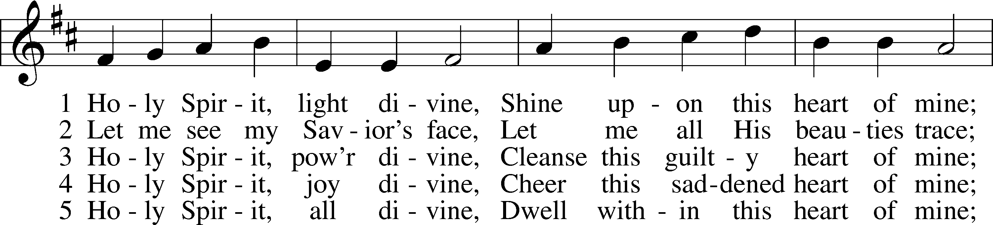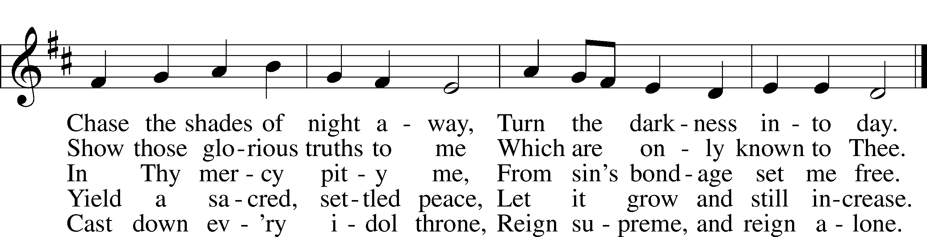

Public domain

Pastor: In the Name of the Father and of the Son and Holy Spirit.

**Congregation: Amen.**



**SACRAMENT OF HOLY BAPTISM**

***“Father Welcomes”* LSB 605**

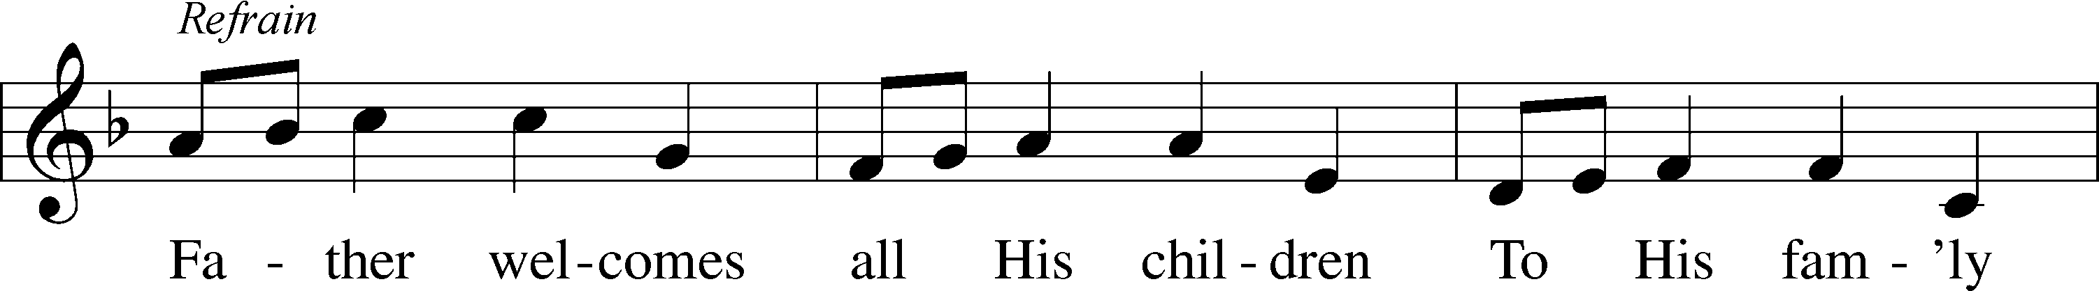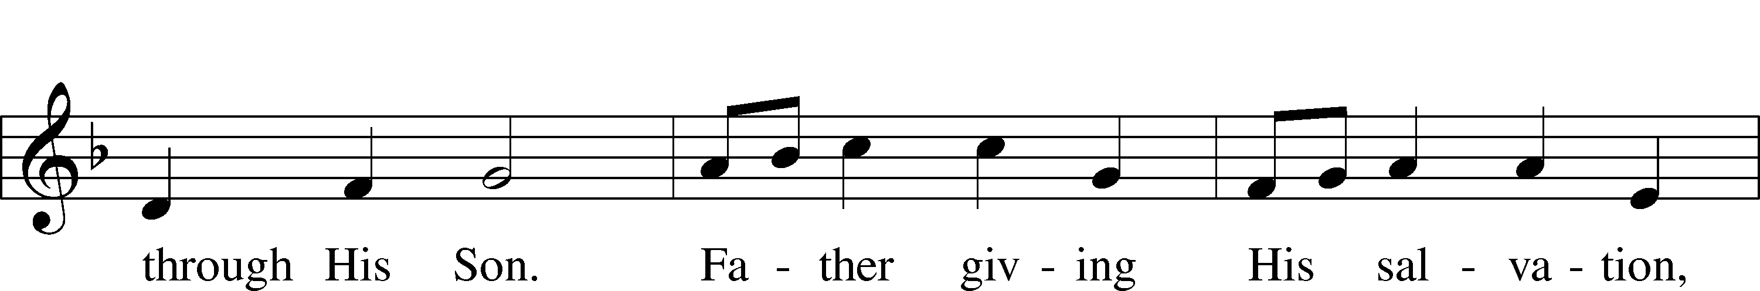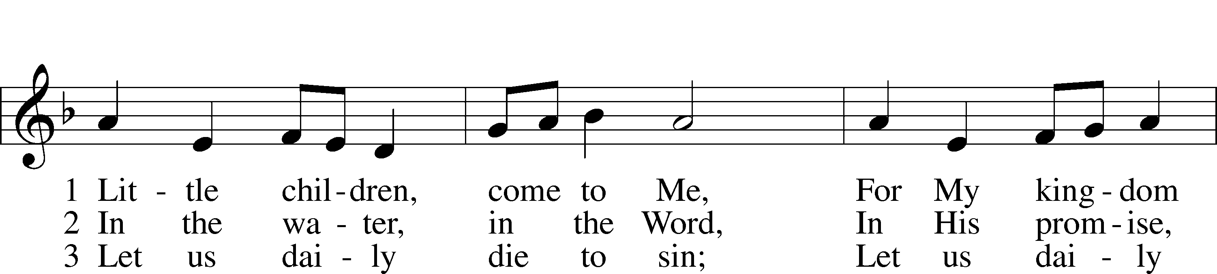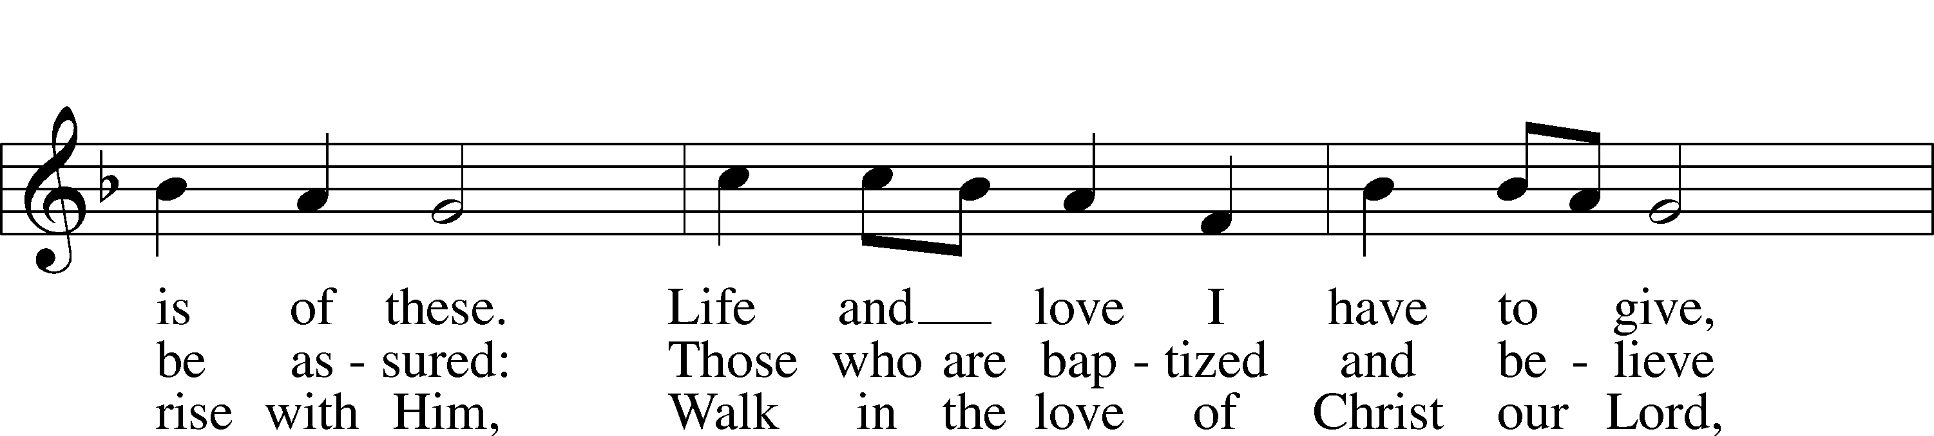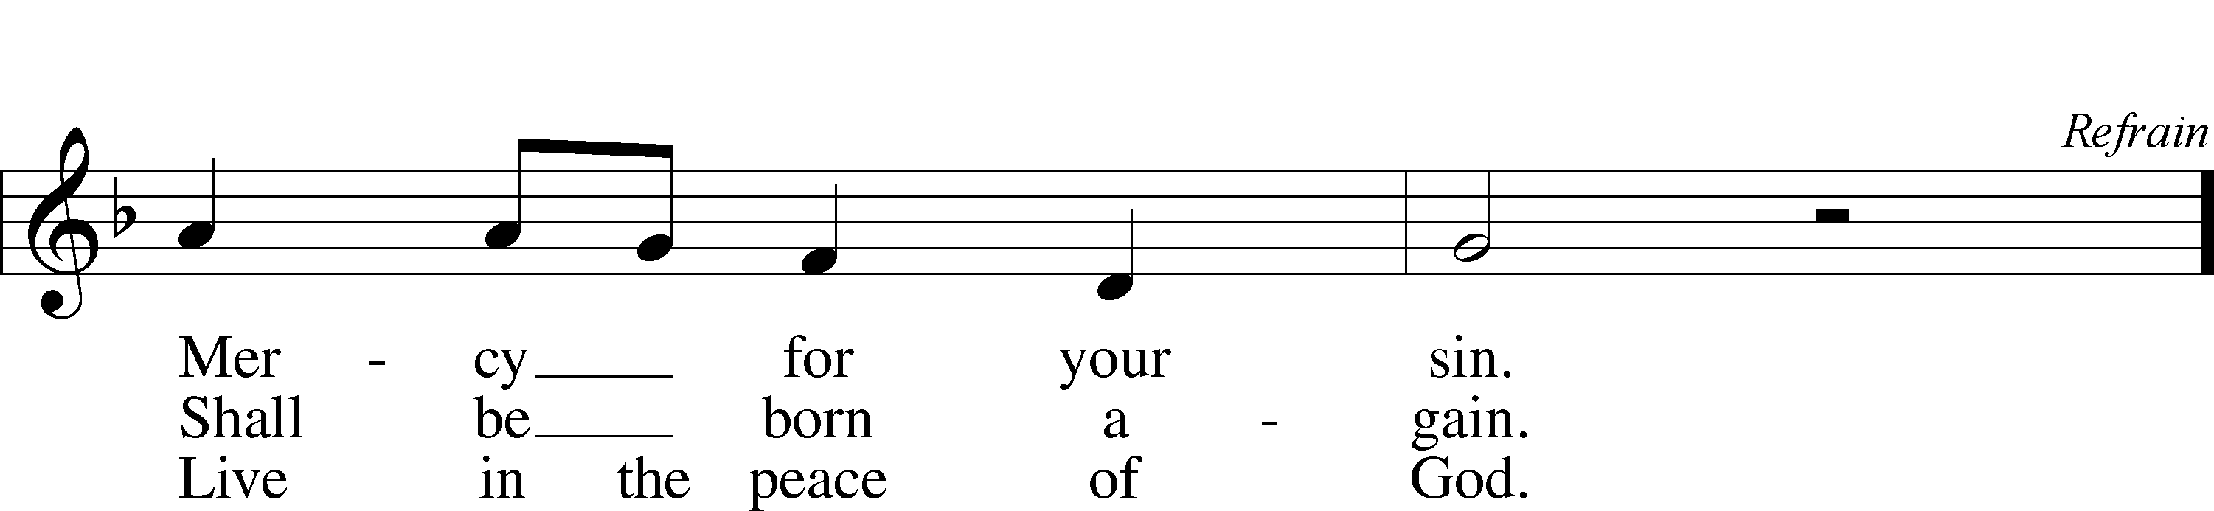

© 1986 Kevin Mayhew Ltd. Used by permission: LSB Hymn License .NET, no. 100011641.

**PREPARATION**

*(Please Remain Standing Or You May Kneel…)*

**CONFESSION OF SIN:**

**All: God, I admit I have broken all of your commandments; I am not holy or sinless even though I often pretend a righteousness I do not have. I offer excuses. I have broken relationships by what I have said, or done. I have not loved either You or my neighbor as I ought. (time for personal confession____)**

**YOU ARE FORGIVEN:**

Pastor: God is merciful and gracious; He has given His Son, Jesus Christ to die and rise again for us, the sinful ones that we might be forgiven and enjoy His Peace. This is also a reminder of God’s gifts and blessing that have become ours in Holy Baptism.

**Congregation: thank you God for Your blessing!**

Pastor: Yes, the Grace of our Lord Jesus Christ, and the Love of God, and the fellowship of His Holy Spirit is with you all.

**Congregation: And also with you.**

Pastor: In peace and as His forgiven people, we can pray to the Lord:

**Congregation: He is gracious to us and hears our prayers.**

Pastor: For the peace of the whole world and our involvement in Christ’s Mission in the world, we pray:

**Congregation: Keep us mindful of our purpose as Christians and our ability to share your blessings of peace and forgiveness with others.**

Pastor: We are the children of the Risen Christ. His victory is Our Victory!

**THE PRAYERS OF THE CHURCH:**

**All: O God, on this day You once taught the hearts of Your faithful people by sending them the light of Your Holy Spirit. Grant us in our day by the same Spirit to have a right understanding in all things and evermore to rejoice in His holy consolation; through Jesus Christ, Your Son, our Lord, who lives and reigns with Your and the Holy Spirit, one God, now and forever. Amen.**

**SERVICE OF THE WORD**

**God speaks to us through his word, the Bible:**

*You may be seated…*

**THE FIRST READING: Numbers 11:24-30**

Lector: This is the Word of the Lord.

**People: Thanks be to God.**

**THE EPISTLE LESSON: Acts 2:1-21**

Lector: This is the Word of the Lord.

**People: Thanks be to God.**

**Special Music:** "The miracle of Pentecost is not merely a past historical event. The Holy Spirit’s wondrous activity goes on in the Church today. The Spirit works among people of every nation and language—among all to whom the Church is sent to proclaim the Gospel. Through the Holy Spirit, the Gospel is amazingly translatable, crossing languages, cultures, and ethnic borders. On Pentecost Christians rejoice in the gift of the Spirit to God’s people from all times and all places." (Lutheran Witness, May 2008)

In recognition of the Holy Spirit’s work throughout the world, the Bell Choir will play the Dakota Indian Hymn **“Many and Great.”**

*Please stand…*

**THE HOLY GOSPEL: John 7:37-39**

Pastor: The Holy Gospel according to St. John the 7th Chapter

**People: Glory to You, O Lord.**



Pastor: This is the Gospel of the Lord.

**People: Praise to You, O Christ!**

*Please be seated…*

**CHILDREN’S MESSAGE**

**NOISE OFERING**

***It’s called a noise offering because what we are asking for is pocket change. It will always be used for missions outside of our church and school. It normally also is given to a mission involving children. Thanks for making a joyful noise to the Lord.***

*Please be seated…*

**SERMON HYMN: *“The Church's One Foundation”* LSB 644**

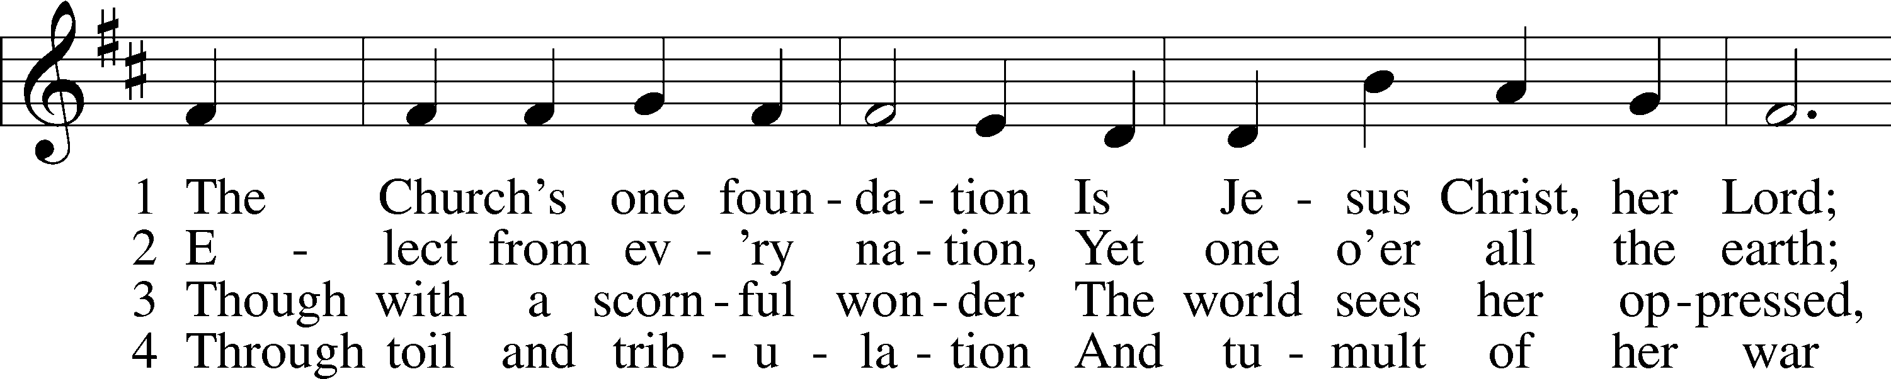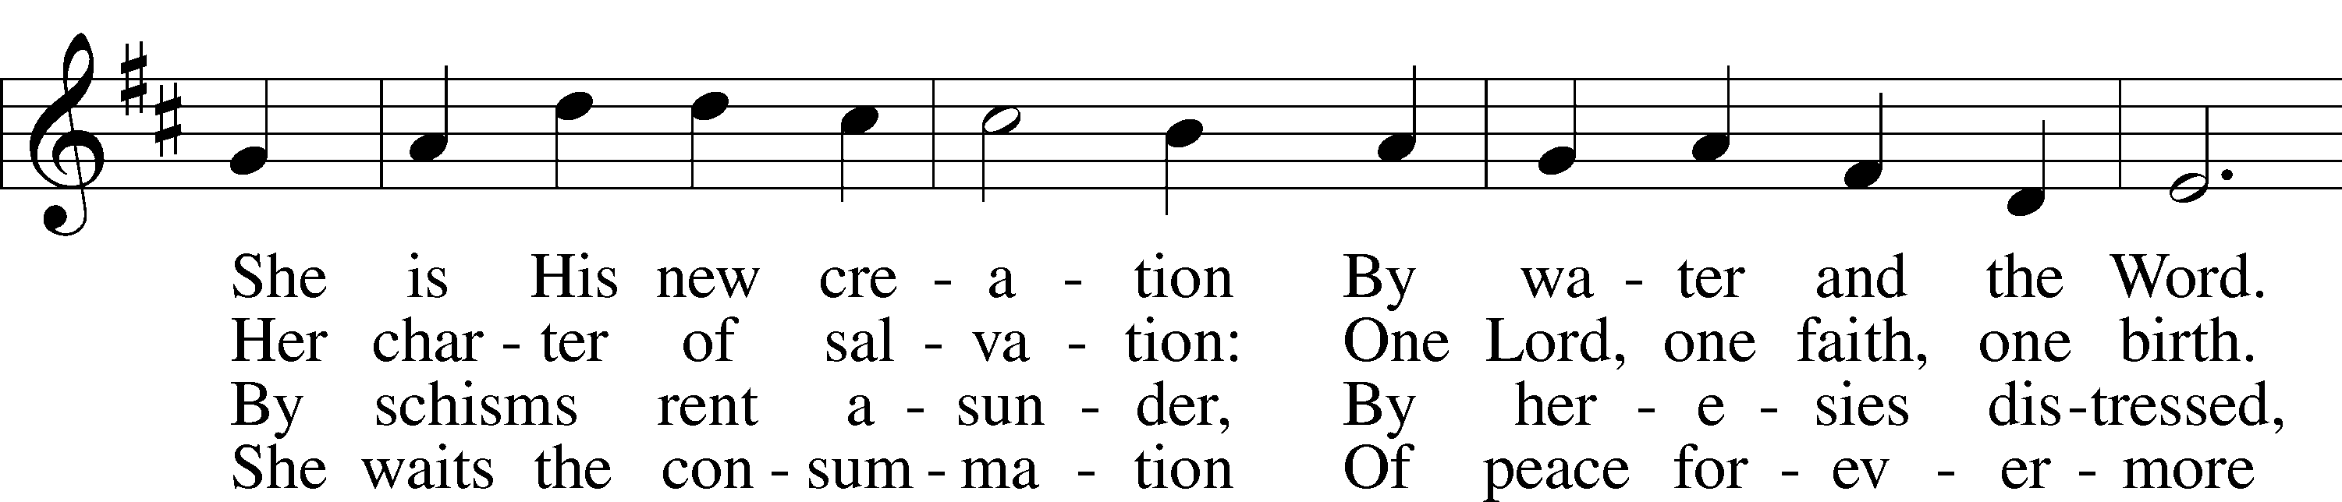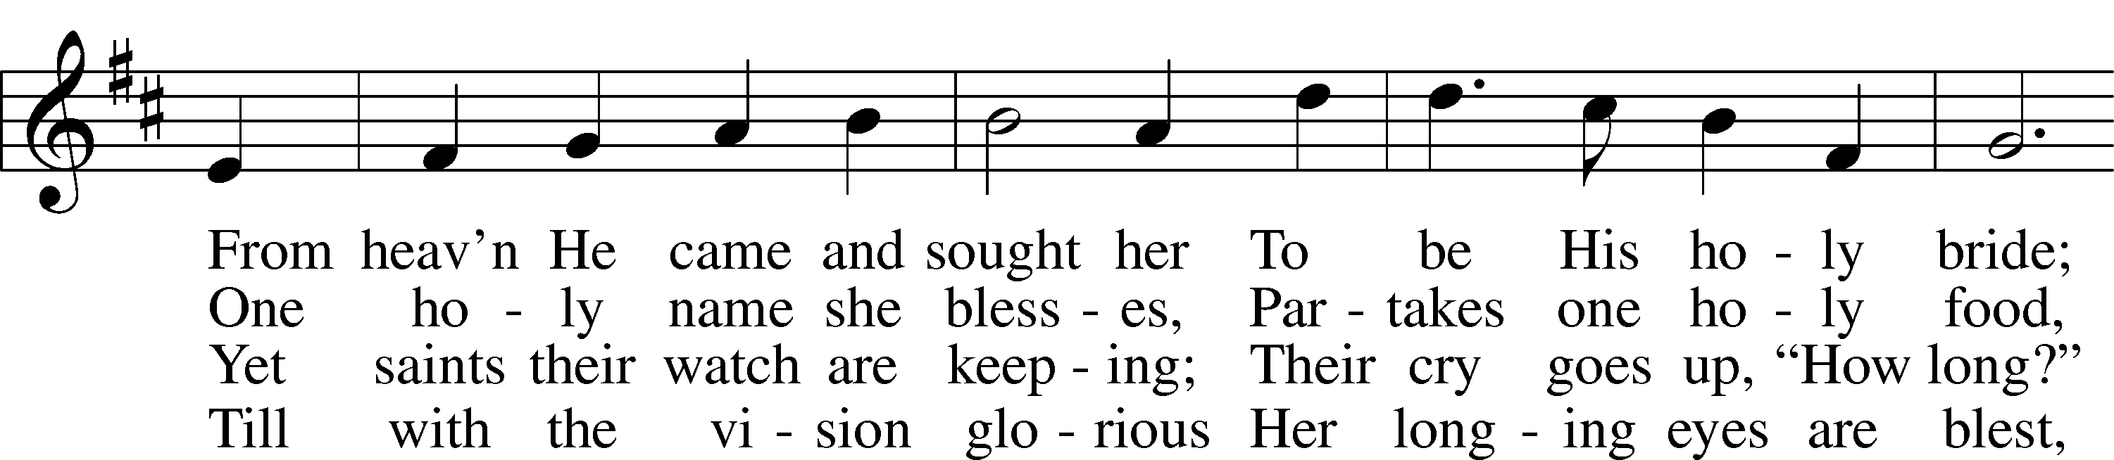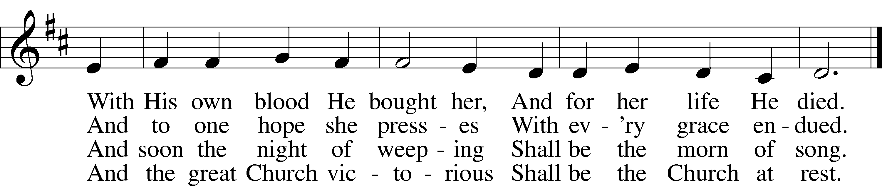

5 Yet she on earth has union  
 With God, the Three in One,  
And mystic sweet communion  
 With those whose rest is won.  
O blessèd heav’nly chorus!  
 Lord, save us by Your grace  
That we, like saints before us,  
 May see You face to face.

Public domain

**THE SERMON: *“I believe in the Holy Spirt and The Holy Christian Church”***

**Numbers 11:24-30**

**RECOGNITION OF GRADUATES**



*(You may be seated…)*

**OFFERING RECEIVED: *“Every Time I Fell the Spirit”* Children’s and Vocal Choir**

**(***Please stand…)*

***“Praise God, from Whom All Blessings Flow”* LSB 805**

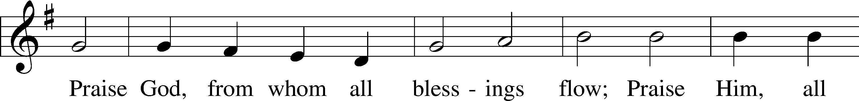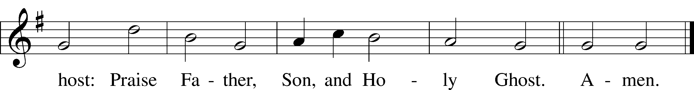

Public domain

**SERVICE OF THE SACRAMENT**

*(Please stand…)*

**PREPARE FOR THE LORD’S SUPPER:**

Pastor: We begin with the reminder: “The Lord is with you.”

**Congregation: We are mindful and thankful for His presence.**

Pastor: Let your life reflect the joy of your salvation.

**Congregation: We do give Him thanks and praise. We will share His blessing with others.**

Pastor: It is proper that we should at all times and in all places…(prayer)… we praise your name and join others in singing:

**All: (sing) “Holy, holy, holy Lord God of pow’r and might:**

**Heaven and earth are full of your glory.**

**Hosanna, Hosanna, Hosanna in the highest.**

**Blessed is he who comes in the name of the Lord.**

**Hosanna in the highest.”**

*(Please be seated…)*

**THE WORDS OF INSTITUTION**

**DISTRIBUTION HYMNS: *“Father I Adore You”* Music and Words by Terrye Coelho**

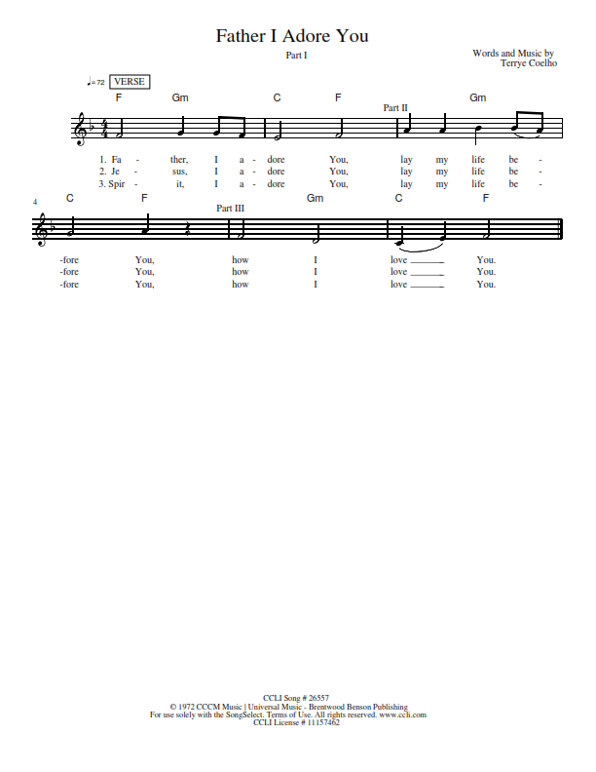

**“O Christ, Who Called the Twelve” LSB 856**

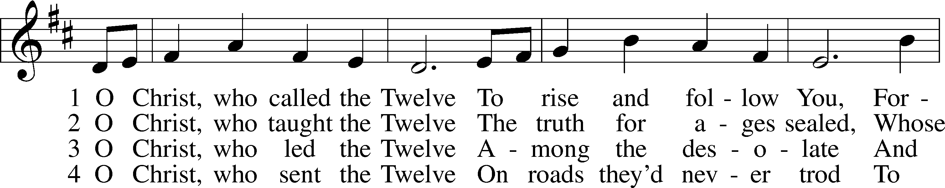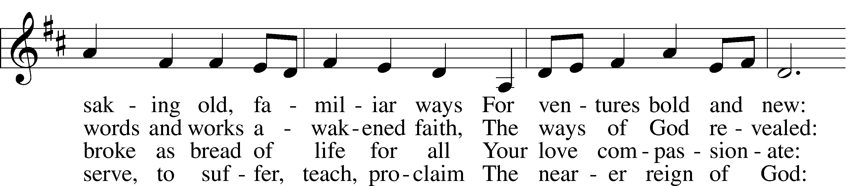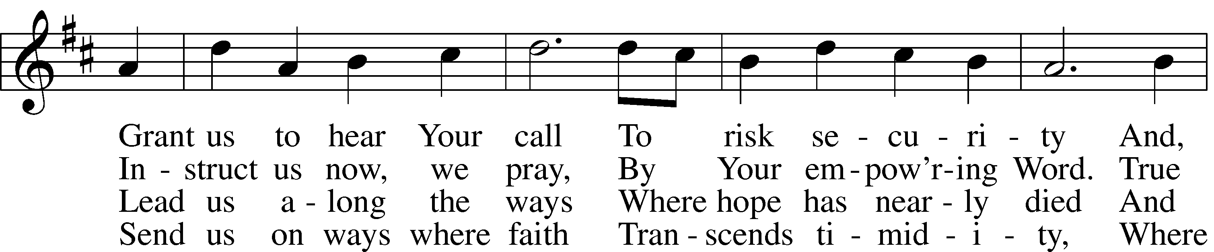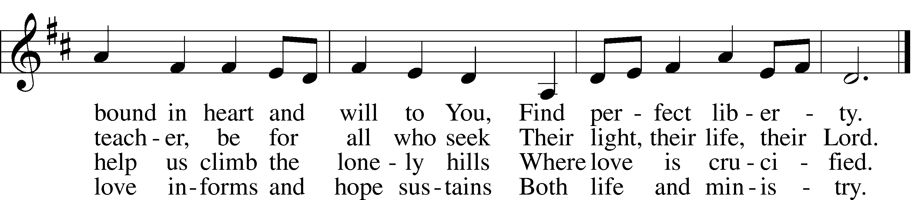

5 O Christ, the_apostles’ Lord,  
 The martyrs’ strength and song,  
The crucified and risen King  
 To whom the saints belong:  
Though generations pass,  
 Our tribute still we bring,  
Our hymns a sacrifice of praise,  
 Our lives an offering.

© 1993 GIA Publications, Inc. Used by permission: LSB Hymn License .NET, no. 100011641.  
Public domain

***“I Love to Tell the Story”***

***Words by Arabelal K. Hankeym 1866. Music: “Hankey” William G. Fischer, pub. 1869. Public Domain***

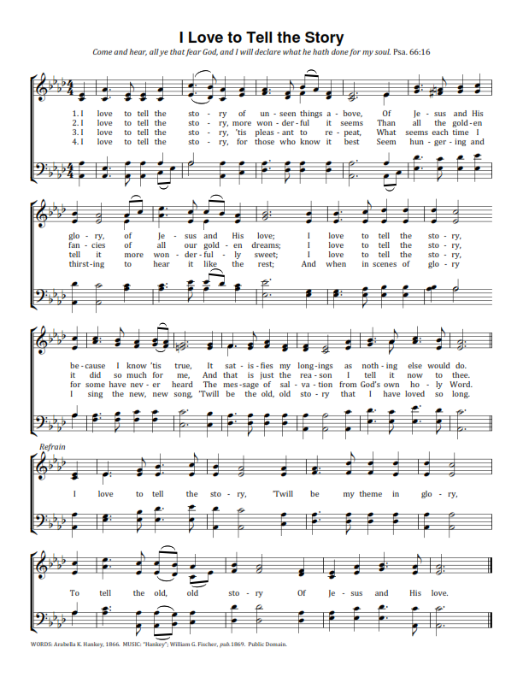

*(Please stand…)*

**THE LORD’S PRAYER:**

**All: Our Father, who art in heaven, hallowed be thy name, thy kingdom come, thy will be done, on earth as it is in heaven. Give us this day our daily bread; and forgive us our trespasses as we forgive those who trespass against us; and lead us not into temptation, but deliver us from evil. For thine is the kingdom, and the power, and the glory, forever and ever. Amen**

**THE BLESSING AND BENEDICTION:**

Pastor: The Lord Blesses you and keeps you, the Lord makes His face to shine upon you and He is Gracious to you. The Lord looks upon you with His favor and gives you His peace.

**Congregation: God blesses us so that we can be a blessing to others.**

Pastor: Go in His peace and serve the Lord by serving others.

**Congregation: Amen**



**“What are we doing that nobody else is**

**doing to reach people that nobody else**

**is reaching?**

**THE CLOSING HYMN:  *“I Am The Church”***

***Words and Music by Richard Kinsley Avery and Donald Stuart Marsh***

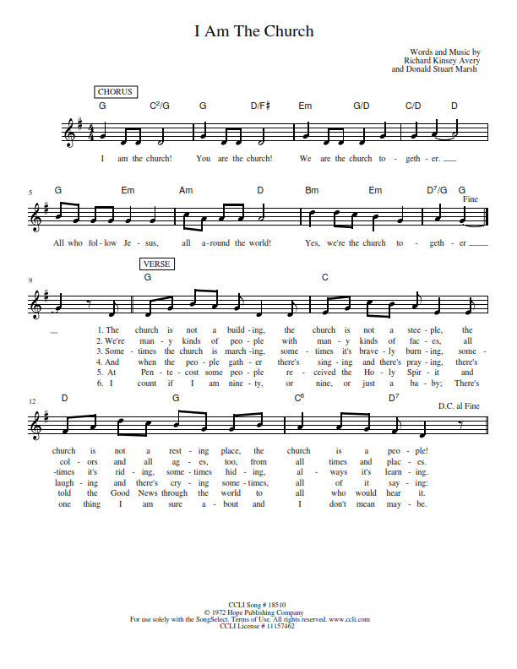

**WELCOME TO GRACE LUTHERAN CHURCH:** We are glad that you are here to worship God with us today! We pray that you will enjoy the wonderful fellowship as friends in Christ as God gathers us around His means of grace, the Word and Sacraments, to bless us with His treasured gifts of forgiveness, faith, abundant life and eternal salvation. If you are a guest, please also sign our Guest Book. Please talk to Pastor if you would like **to learn more about becoming a member of Grace. Also, please join us for refreshments** and fellowship after the Service. We invite you to come and worship with us often as God gathers us in His Grace.

**WELCOME TO THE LORD’S TABLE:** We invite and encourage all present who are baptized and faithful Christians, and who confess the Father, Son, and Holy Spirit to be the only true God and who believe that Jesus Christ died for the sins of the World and is our only hope and salvation…to join us in receiving the very and true body and blood of Christ in this Sacrament. The clear liquid cups in the center of the tray are non-alcoholic wine.

Children not yet confirmed in the faith are always welcome to join their parents at the Lord’s Table, but should keep their hands folded in front of them. The Pastor will give them a blessing.

**SERVING TODAY:** Acolyte: Lillian Howard; Lector: Jessy Archer: Communion Assistants: David Walker and Mary Brady; Usher: Vince Winters; Altar Care: Nancy Swift; Refreshments: Nancy Swift.

**SERVING NEXT SUNDAY:** Acolyte: Amelia Bly; Lector: Monica Bacle; Communion Assistants: David Walker and Mary Brady; Usher: Vince Winters; Altar Care: _____________; Refreshments: ­­­­­­­­­­­­­­­­­­­­­Elaine Roberts.

**FLOWERS**: were placed on the altar to the glory of God and by Elsie Hamilton.

THIS WEEK AT A GLANCE:

**Today: June 4th**

9:00 am Worship Service with Communion (Graduation Recognition)

10:15 am Fellowship

10:30 am Annual Voters Meeting

**Monday: June 5th**

Pastor’s Day Off

5:30 pm Zumba

**Tuesday: June 6th**

11:30 am Gracious Ladies of Grace Luncheon (Ambrosia)

3:00 pm Jan’s Mobile Gym

6:00 pm Weight Watcher’s (Parish Hall)

**Wednesday: June 7th**

12:30 pm Men’s Bible Fellowship (Chico’s)

4:30 pm Women’s Bible Study (Room 3)

**Next Sunday: June 11th**

9:00 am Worship Service with Communion

10:15 am Fellowship

10:30 am Adult Bible Class/ High Schoolers Bible Class

**IN YOUR PRAYERS THIS WEEK:** Michael McPherson, Micah Westphalen, family and friends of Odalis Klepaski, Capt. Zachary (Bo) Henry (Ret.), family of Sam Vinci, Frank Deford, Larry Vandivier, Carl Vandivier, Bobby Meck, family and friends of Elaine Wavehime, Linda Mullis, Joe Lamberson, Michael Willard, France Vandivier, Katie Hoffman, Pastor Ray Peters, Family and friends of Will Plagens, Kay Sattelmeier, Dennis Julson, Vernon Julson, Olga Odland, the family of Jean Grafsgaard, Jenie Howard, Jenny Dean, family and friends of George Licis, Charles, Braydon, Champ, Amy, Elsie Hamilton, Mary Ellen Jessel, Marcos Diaz, Kaci Doran, Auwina Weed, Sandy Harris, and those you are praying for at home. If anyone has a special prayer request please submit it in writing in the collection plate; or you may call Pastor Gary Faith at (504-858-8872), or Kris Howard at (305-296-5161).

**GIFTS, TITHES, & ATTENDANCE LAST SUNDAY** for May 28th were $3590.00 with an attendance of 70, while bible sticks received $280.00 for a total donation of 780.00 from the congregation plus $320.00 that was collected through the noise offering the month of May giving us a total of $1100.00 which will be matched dollar for dollar.

**TO HELP US GROW…** The Bible reading for next Sunday’s service the readings are Genesis 1:1-2:4a, Acts 2:14a, 22-39, Matthew 28:16-20.

**OUR ANNUAL VOTERS MEETING:** will take place at 10:30 am this morning.

**THERE IS ADDITIONAL PARKING** behind the school. Enter that lot on 10th Street.

**WE HAVE SET THE SCHEDULES** for ushers, acolytes, lectors, and communion assistants for the next three months. If you would like to serve in any of these positions, please let Pastor or Kris know.

**STEWARDSHIP LISTS:** On the bulletin board by the front door of the church you will find the Altar Care, Refreshments, and Flower sign-up sheets for 2017. If you are able to help out with any of these please place your name in the spot on the date requested.

**THE GRACE LUTHERAN CHURCH WEB PAGE AND FACE BOOK PAGE** now

contains a vocal recording of last week’s sermon. So, if you are not able to attend church on Sunday please go to our website where you will find a copy of the bulletin and a recording of Pastor Faith’s sermon. <https://gracelutherankw.360unite.com/home>.

**A NUMBER OF CAPITAL IMPROVEMENTS** are needed to keep our facilities in good health for the future. Roof repairs are needed on school buildings and the parsonage. If you can help it would be much appreciated! A big thanks to all who have contributed to these repairs.

**SOME DATES TO MARK ON YOUR CALENDAR**

**GRACIOUS LADIES OF GRACE:** will be lunching at Ambrosia on June 6th at 11:30 am. We will be meeting in Grace Lutheran’s parking lot and carpooling at 11:00 am. If you have any questions call Monica at 305-023-0856 and please rsvp at this #.

**OUR ANNUAL VOTERS MEETING:** is today. It will be held in the sanctuary about 10:30 am after our time of fellowship.



**SUNDAY SCHOOL:** **Sunday School for the elementary children is taking the summer off. We will not meet in June, July, and August. We will resume in September. High Schoolers are welcome to meet with pastor on June 11th, 18th, 25th and July 2 to explore what a missional community might look like.**



**MUSIC MINISTRY:** Thank you to everyone who participated in our Children's Choir, Bell Choir, and Vocal Choir this year. Rehearsals will begin again in the Fall.



**MEN’S BIBLE FELLOWSHIP**: They meet the first and third Wednesday’s of each month at 12:30pm. Their next meeting will be June 7th located at Chico’s on Stock Island. All guys are welcome.

**MISSIONAL COMMUNITIES IN JUNE:** We will meet for lunch (brown bag) at noon on Thursdays June 15th and June 29th. These will be our only meetings in June. Join us and grow in relationships.

**WOMEN’S BIBLE STUDY**:

Aside from the Resurrection, Jesus' feeding of the five thousand is the only miracle recorded in all four Gospels. Jesus dealt with doubting disciples, fatigue, personal grief and limited resources but on that spring day He chose to feed the masses with the Bread of Life.

Through this 6-lesson DVD Bible Study we will dig deep into Scripture to see a compelling picture of our compassionate Savior who when He is present, the weary find rest and the hungry soul is satisfied.  Come and be fed by the only One who provides for your every need and fills you ... body and soul ... with Overflowing Abundance.

Overflowing Abundance by Donna Pyle is our current Ladies Bible study on Wednesday’s at 4:30 in room 3.  For more information call Monica Bacle 305 923-0856.



**GRADUATES:** The following members are graduating from College, High School, 8th grade, or Kindergarten. We are proud of all of them and wish them God’s blessing on the next step of their journey with Jesus.

From Kindergarten going into 1st Grade:

From 8th Grade going into High School 9th Grade:

Elizabeth Reynolds

Graduating High School

Kara McGee

*She plans to attend FKCC for now and wants to be an Orthodontist.

Maddie Thompson

*She plans to attend Stetson University in the fall.

Graduating Florida State University

Angela Kolhagen (Master’s Degree in Exceptional Student Education)

University of Delaware

Olivia Brady (Double Major in International Relations and 3 Languages)

*She plans to return to Virginia and work in an international or language capacity, along with a part-time job of tutoring in all levels in Spanish, French, and Italian. Her long-term goal is to go into human rights law but wants a break from studying for the moment.