**May 14th, 2017**

**9:00 am**

**FIFTH SUNDAY**

**OF EASTER**



**Grace Lutheran Church**

**2713 Flagler Ave.**

**Key West, FL 33040**

**305-296-5161**

**GraceLutheranKW@att.net**

**Pastor Faith**

**(504) 858-8872**

**garyfaith@aol.com**

**FIFTH SUNDAY OF EASTER**

**MAY 14TH, 2017 9:00 a.m.**

**WORSHIP SERVICE**

***In the Name of Jesus!***

**Our Mission Statement: Anchored in Christ, each person a missionary.**

**PRELUDE**

**ANNOUNCEMENTS:**

**We welcome you. We are glad you are here to share with us the joy and peace we have in Jesus Christ. It doesn’t matter whether this is your first time in this church or if you are a lifelong member, you are welcome. We come together today in order to celebrate the gift God has given us-His own Son, Jesus, Our Savior.**

**PREPARATION**

*(Please Stand…)*

**HYMN:  *“Christ the Eternal Lord”*  LSB 829**

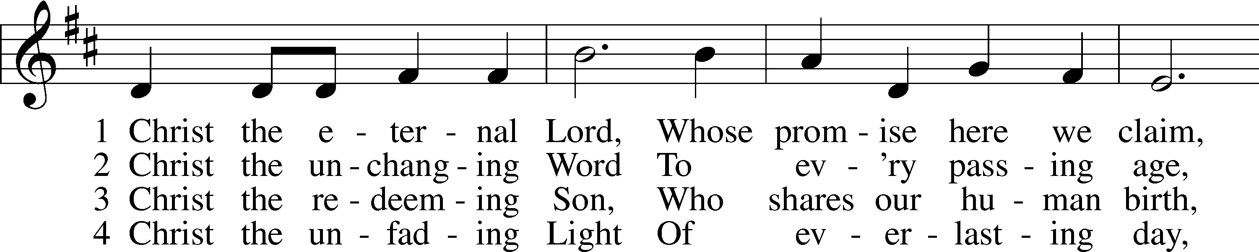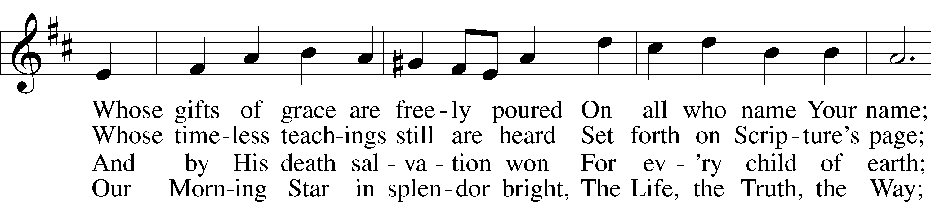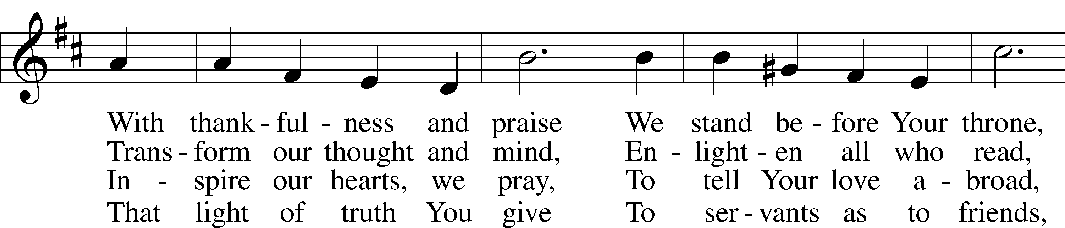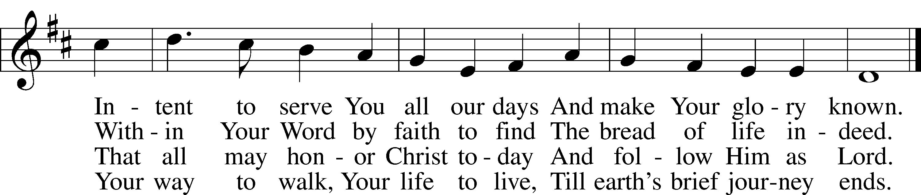

5 Christ the ascended King  
 Exalted high above,  
Whose praise unending ages sing,  
 Whom yet unseen we love;  
When mortal life is past  
 Your voice from heaven’s throne  
Shall call Your children home at last  
 To know as we are known.

© 1999 Hope Publishing Co. Used by permission: LSB Hymn License .NET, no. 100011641.  
Public domain

Pastor: In the Name of the Father and of the Son and Holy Spirit.

**Congregation: Amen**

*(Please Remain Standing Or You May Kneel…)*

**GOD’S PEOPLE CONFESS THEIR SINS:**

Pastor: By grace you have been saved, through faith-and this is not from yourselves, it is the gift of God-not of works, so that no man can boast, for we are God’s workmanship, created in Christ Jesus.

**Congregation: I know that nothing good lives in me, that is, in my sinful nature, for I have the desire to do what is good, but I cannot carry it out.**

Pastor: What I do is not the good I want to do; no, the evil I do not want to do-this I keep doing.

**Congregation: In my heart I delight in God’s law, the law that points out what a wretched person I am! Who will rescue me from this body of death?**

Pastor: Thanks be to God through Jesus Christ our Lord! Only He can achieve the perfection we fail to achieve. By the forgiveness He purchased on the cross, our forgiveness is complete!

**SERVICE OF THE WORD**

*You may be seated…*

**THE FIRST READING: Acts 6:1-9, 7:2a, 51-60**

Lector: This is the Word of the Lord.

**People: Thanks be to God.**

**THE EPISTLE LESSON: 1 Peter 2:2-10**

Lector: This is the Word of the Lord.

**People: Thanks be to God.**

*Please stand…*

**THE HOLY GOSPEL: John 14:1-14**

Pastor: The Holy Gospel according to St. John the 14th Chapter

**People: Glory to You, O Lord.**

Pastor: This is the Gospel of the Lord.

**People: Praise to You, O Christ!**

*Please be seated…*

**CHILDREN’S MESSAGE**

**NOISE OFERING**

***It’s called a noise offering because what we are asking for is pocket change. It will always be used for missions outside of our church and school. It normally also is given to a mission involving children. Thanks for making a joyful noise to the Lord.***

**THE SERMON HYMN: *“Oh, Blest the House”* LSB 862**

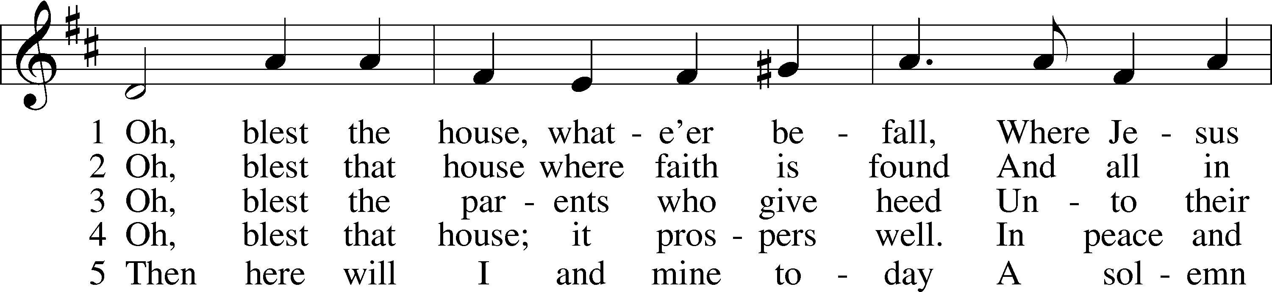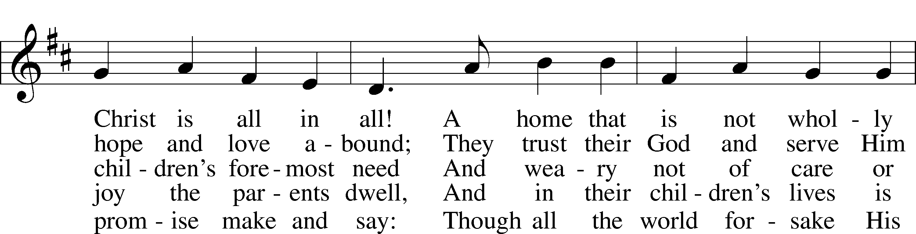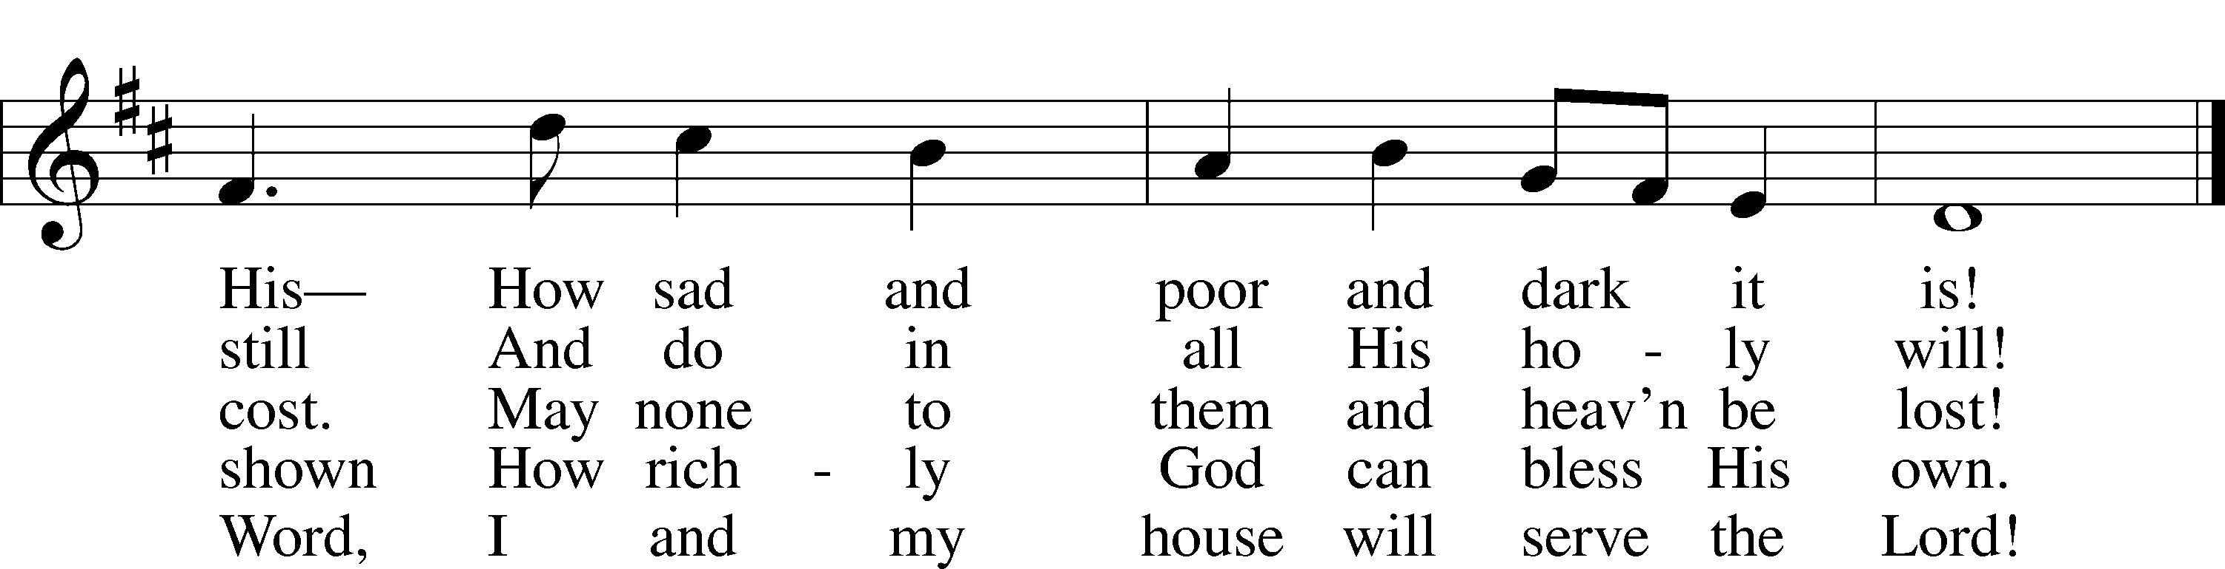

Public domain

**THE SERMON: *“The Cure for the Troubled Hearts”***

*(Please stand…)*

**THE PROFESSION OF FAITH:**

Pastor: God has given us a great message to take to His world. Let us remind ourselves and one another of what that message is:

Pastor: I believe in God the Father, Almighty

**Congregation: Maker of heaven and earth**

Pastor: And in His Son, Jesus Christ our Lord,

**Congregation: Who was conceived by the Holy Spirit**

Pastor: Born of the Virgin Mary

**Congregation: Suffered under Pontius Pilate**

Pastor: Was crucified, died and was buried

**Congregation: He descended into hell.**

Pastor: On the third day He rose again from the dead,

**Congregation: And ascended into heaven**

Pastor: And sits on the right hand of God, the Father almighty

**Congregation: From there He will come to judge the living and the dead**

Pastor: I believe in the Holy Spirit,

**Congregation: The Holy Christian Church as**

**All: the communion of saints; the forgiveness of sins, the resurrection of the body, and the life everlasting. Amen.**

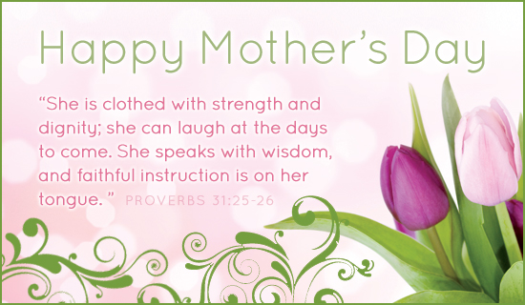

*(You may be seated…)*

**OFFERING RECEIVED**

**(***Please stand…)*

***“Praise God, from Whom All Blessings Flow”* LSB 805**

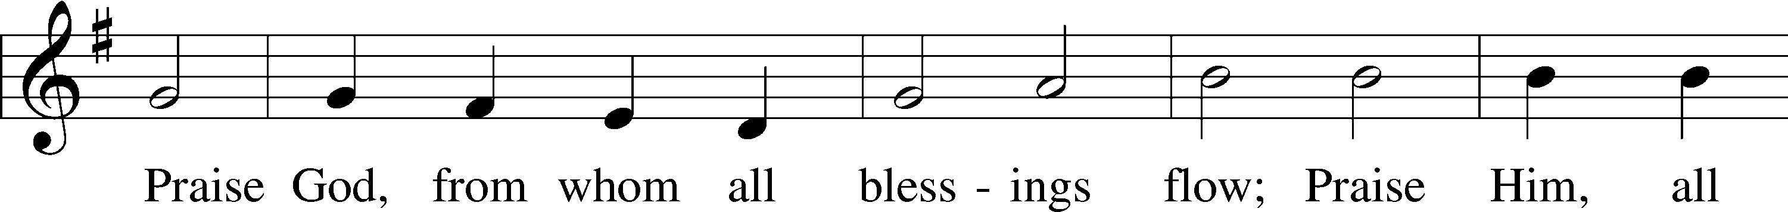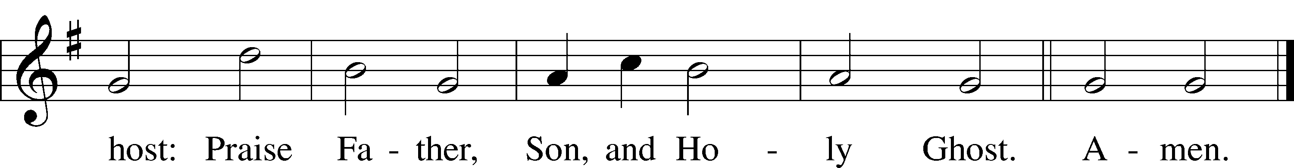

Public domain

**(***Please stand…)*

**LITURGY OF UNITY ACKNOWLEDING THE WIDE CONTINUUM OF MOTHERING:**

Pastor: For those who gave birth this year

**Congregation: We celebrate and thank God with you**

Pastor: For those who lost a child

**Congregation: We mourn with you and ask God to grant you His peace**

Pastor: For those who are in the trenches with little ones every day and

wear the badge of food stain

**Congregation: We appreciate you and pray for patience and joy**

Pastor: For those who experienced loss through miscarriage, failed adoptions, or running way

**Congregation: We mourn with you and pray for healing**

Pastor: For those who walk the hard path of infertility, fraught with pokes, prods, tears, and disappointment

**Congregation: We walk with you**

Pastor: Forgive us when we say foolish things

**Congregation: and we pray that you will find strength in Jesus**

Pastor: For those who are foster moms, mentors, spiritual moms

**Congregation: We need you and thank God for you**

Pastor: For those who have warm and close relationships with your children

**Congregation: We praise God for this gift**

Pastor: For moms who have disappointment, heartache and distance with their children

**Congregation: We pray for peace and healing**

Pastor: For those who have lost their mother

**Congregation: We grieve with you and look forward to a happy reunion in heaven for all who die with faith in Jesus**

Pastor: For those who experienced abuse at the hands of their mother

**Congregation: We acknowledge your hurt and pray for healing**

Pastor: For those who are single and long to be married and mother your own children

**Congregation: We mourn that life has not turned out as you longed for it to be and pray for comfort, peace, and love**

Pastor: For those who step-parent

**Congregation: We acknowledge the complex path you are on and pray for wisdom and grace**

Pastor: For those who envisioned lavishing love on grandchildren and yet the dream is not to be

**Congregation: We pray for peace and finding joy in filling that role of grandparent with children who have lost their grandparents or who’s grandparents are far away**

Pasto: For any empty nesters

**Congregation: We thank God for your past sacrifice of time and celebrate your ongoing gift of prayer and love to your grown children**

Pastor: For those who placed children up for adoption

**Congregation: We commend you for your selflessness**

Pastor: And remember how you hold that child in your heart.

**Congregation: Lord bless those children and birth mothers with peace and grace**

Pastor: For those who are pregnant with new life, both expected and surprising

**Congregation: We thank God for this great gift**

Pastor: And commit him and her to the Lord’s keeping

**Congregation: Until He claims them as His own through the washing of holy baptism**

Pastor: This Mother’s day we walk with you

**Congregation: Mothering is not for the faint of heart**

Pastor: And we have real warriors in our midst

**Congregation: We remember you and thank God for you**

Pastor: In Jesus name

**Congregation: Amen**

**SERVICE OF THE SACRAMENT**

*(Please be seated…)*

**THE WORDS OF INSTITUTION**

**DISTRIBUTION HYMNS: *“Give Thanks with a Grateful Heart”* LSB 806**

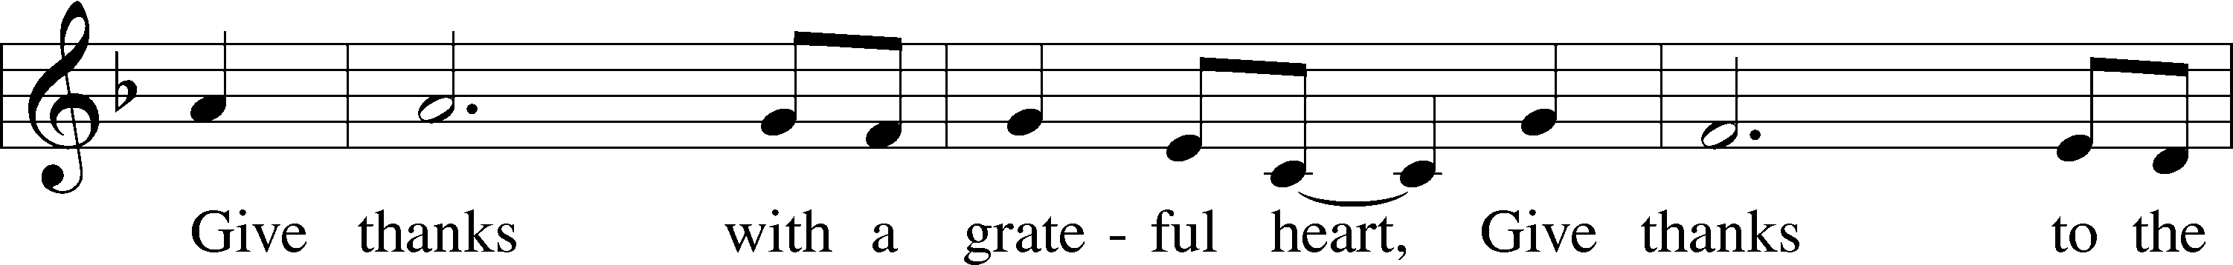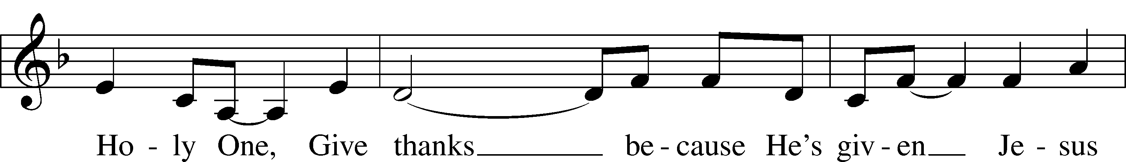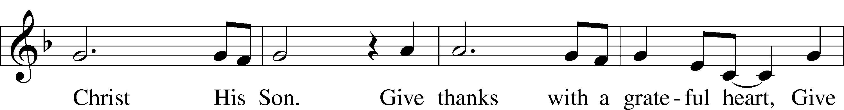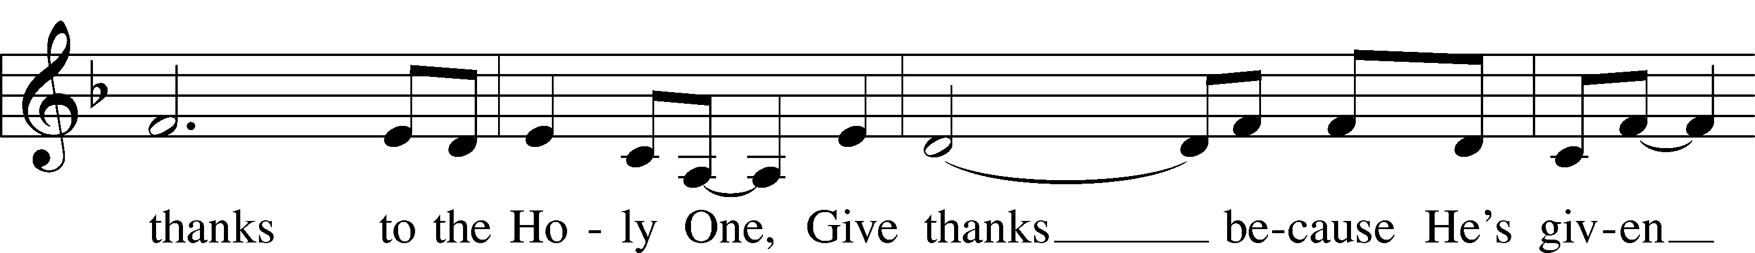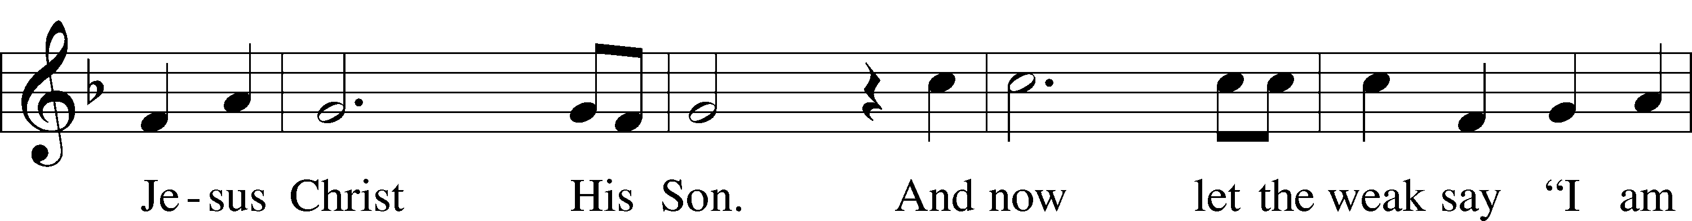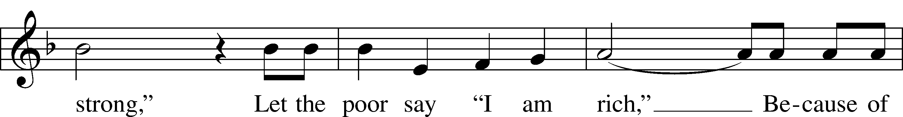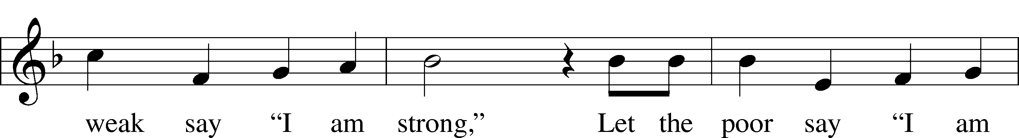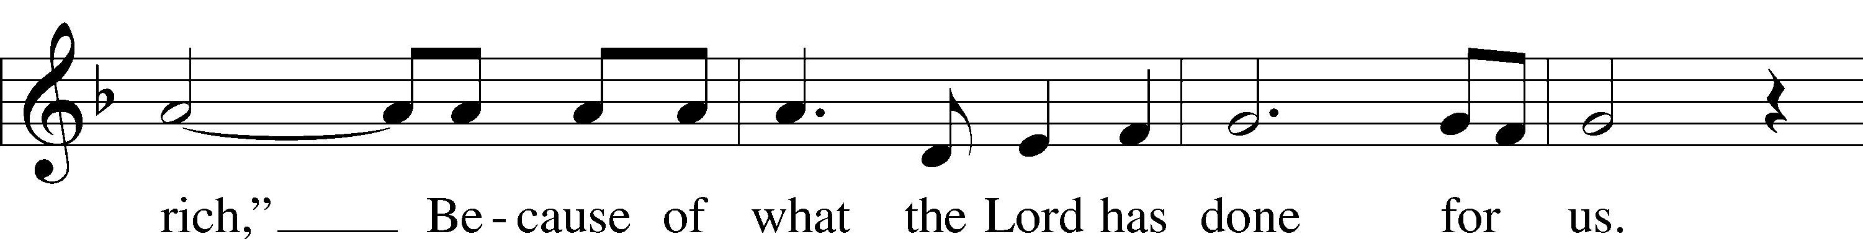

© 1978 Integrity’s Hosanna! Music. Used by permission: LSB Hymn License .NET, no. 100011641.

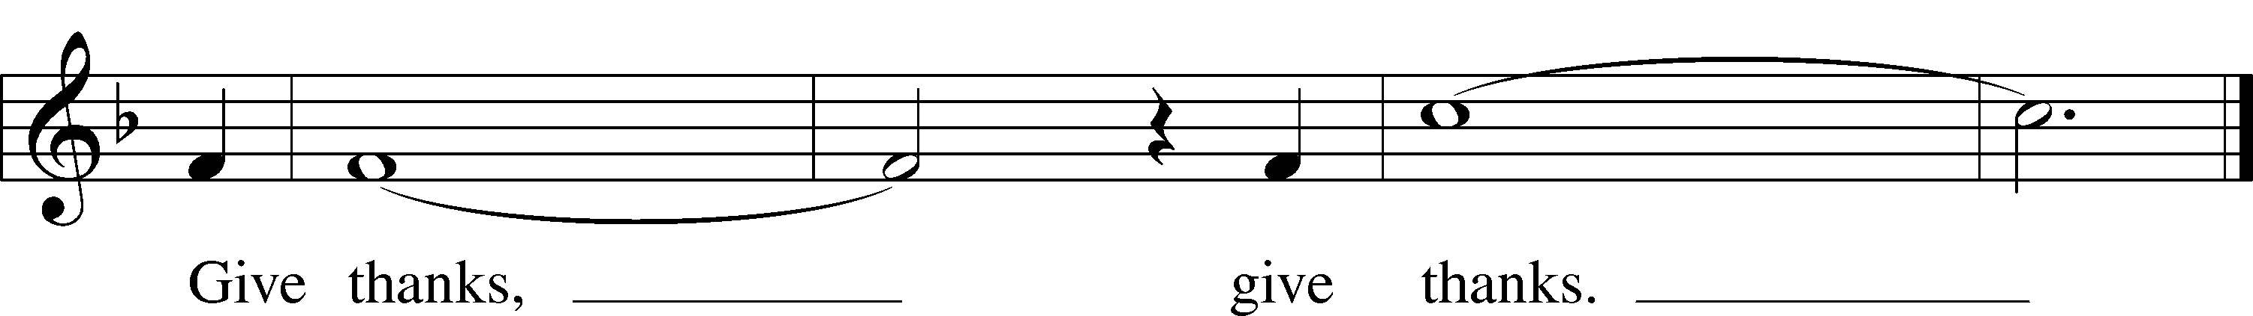

***“I Want to Walk as a Child of the Light”* LSB 411**

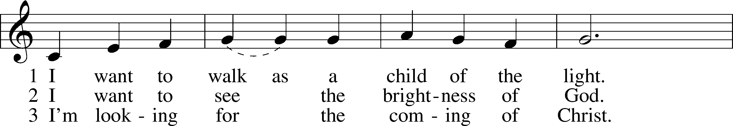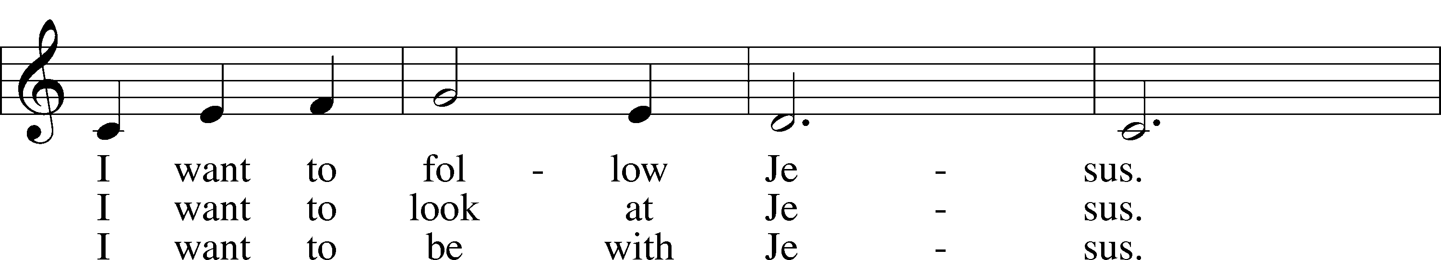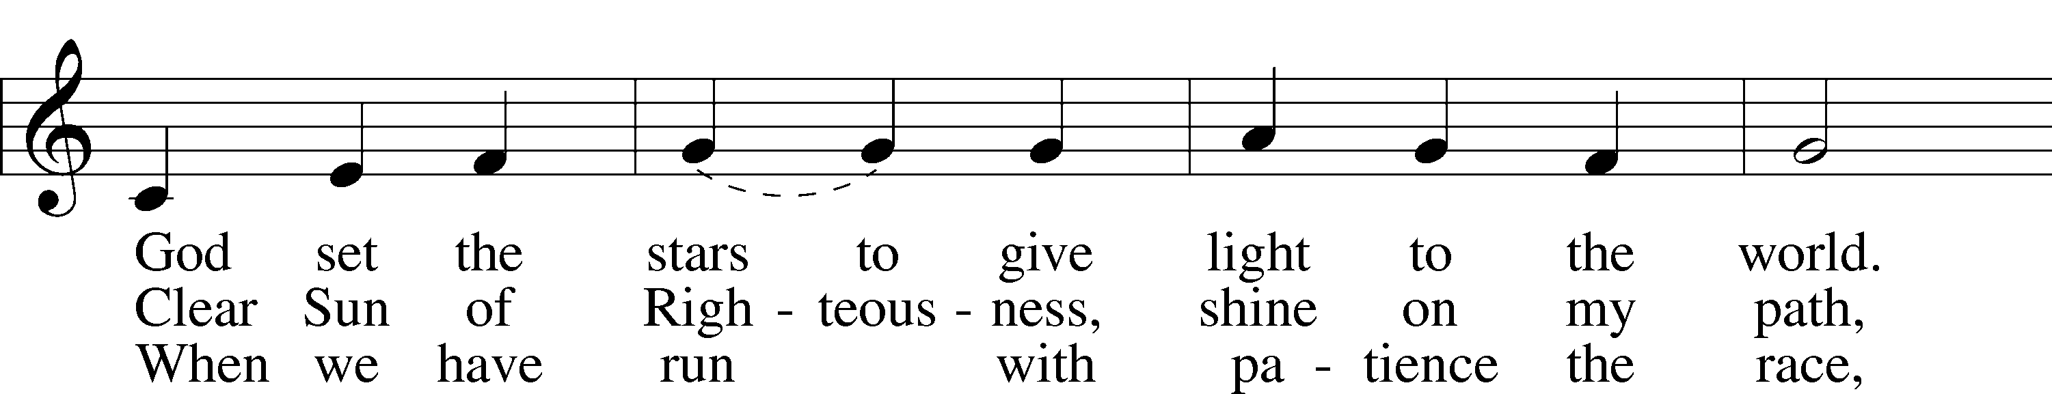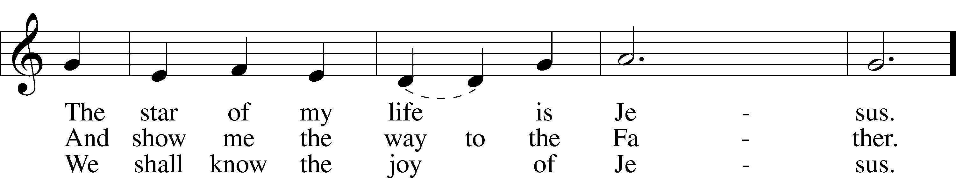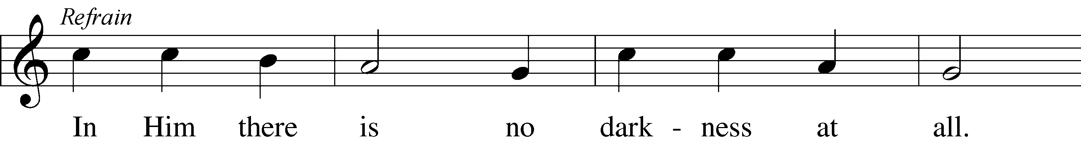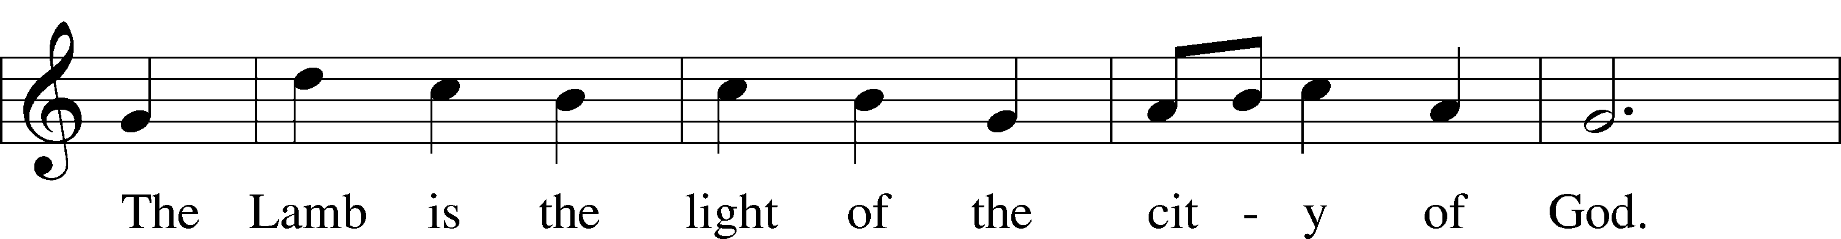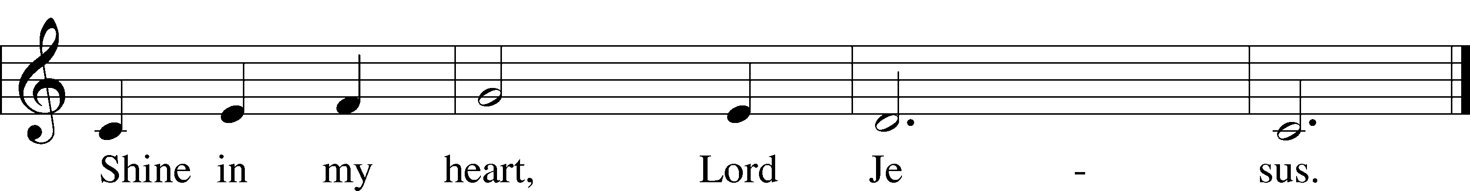

© 1970, 1975 Celebration. Used by permission: LSB Hymn License .NET, no. 100011641.

***“Precious Lord, Take My Hand”* LSB 739**

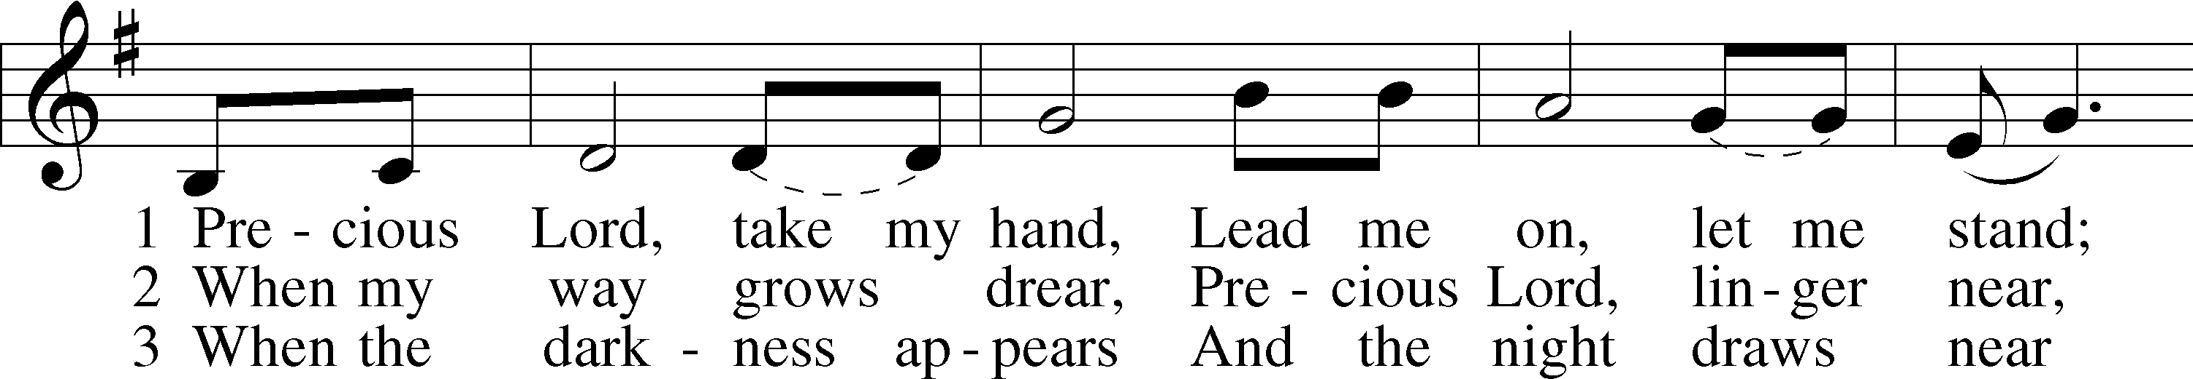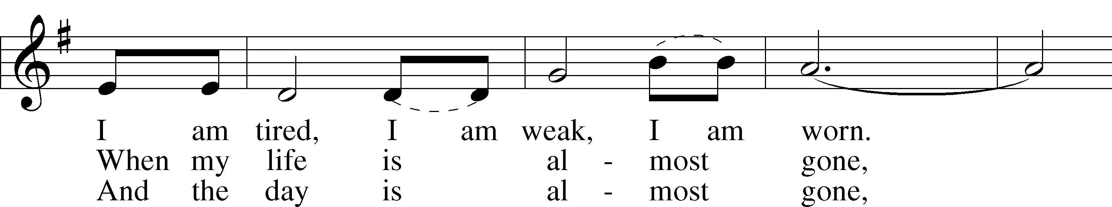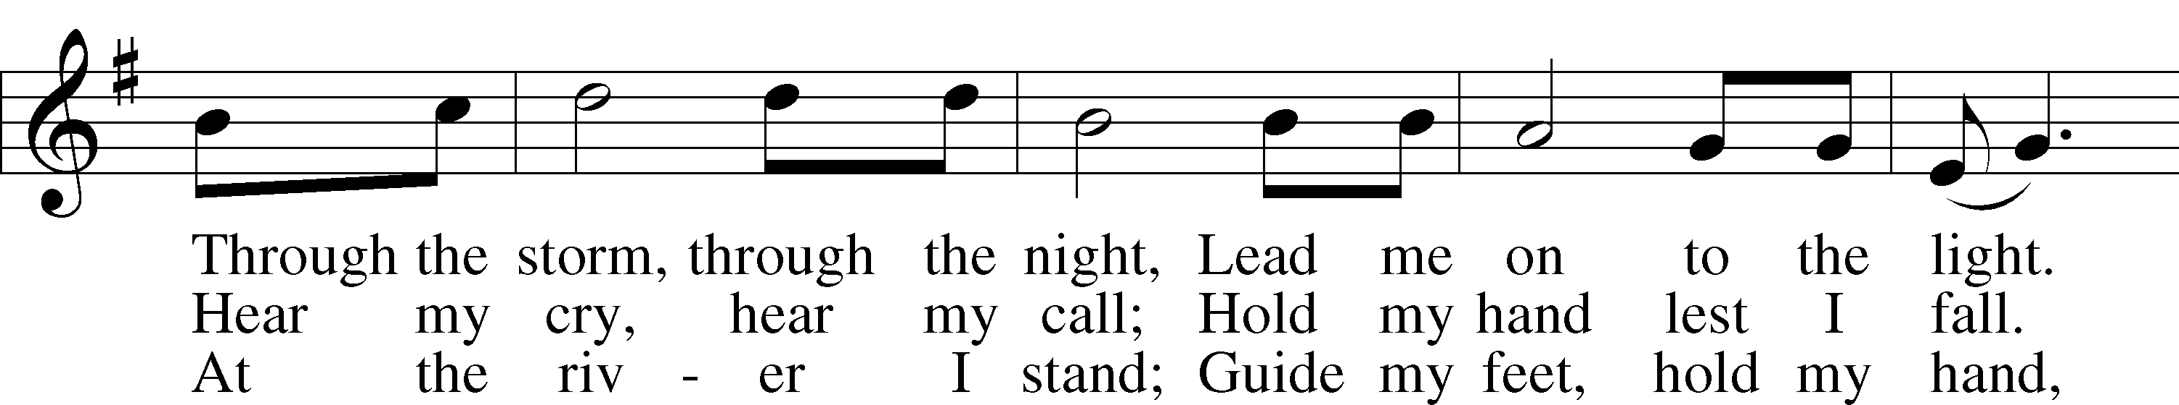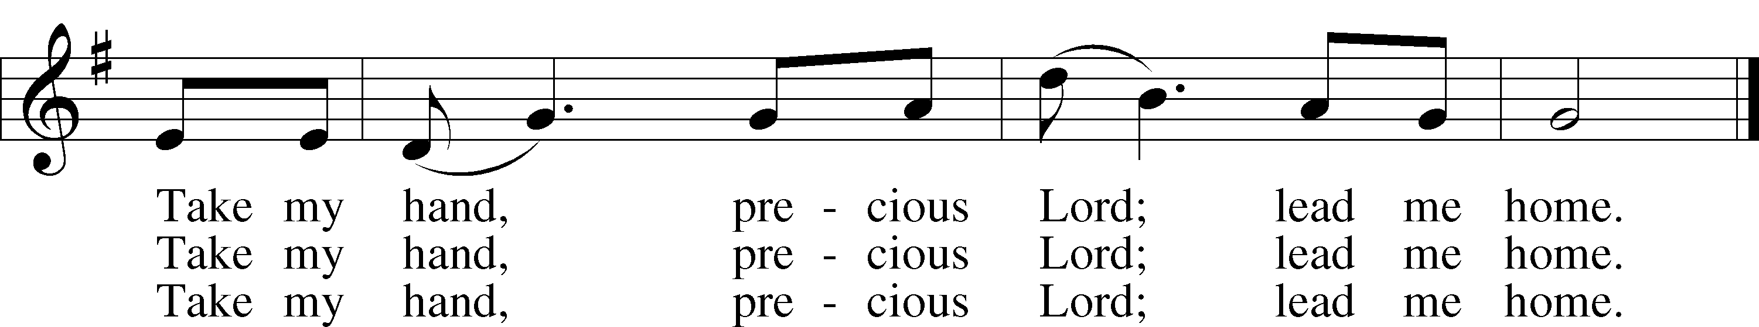

© 1938 Unichappell Music; admin. Alfred Publishing Co., Inc. Used by permission: LSB Hymn License .NET, no. 100011641.



Jesus let the things that break your heart

also break our hearts.

Amen.

***“Christ Be My Leader”* LSB 861**

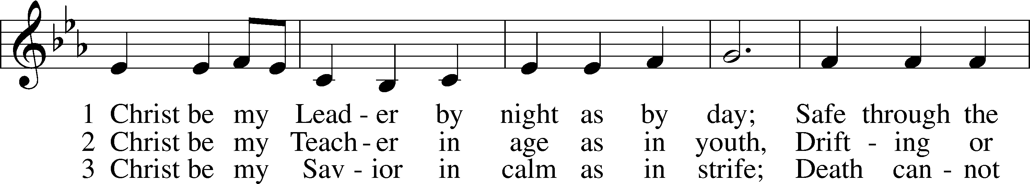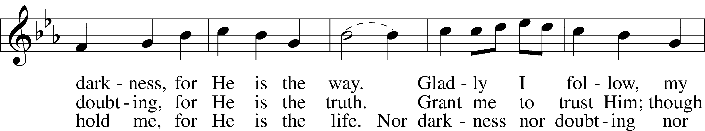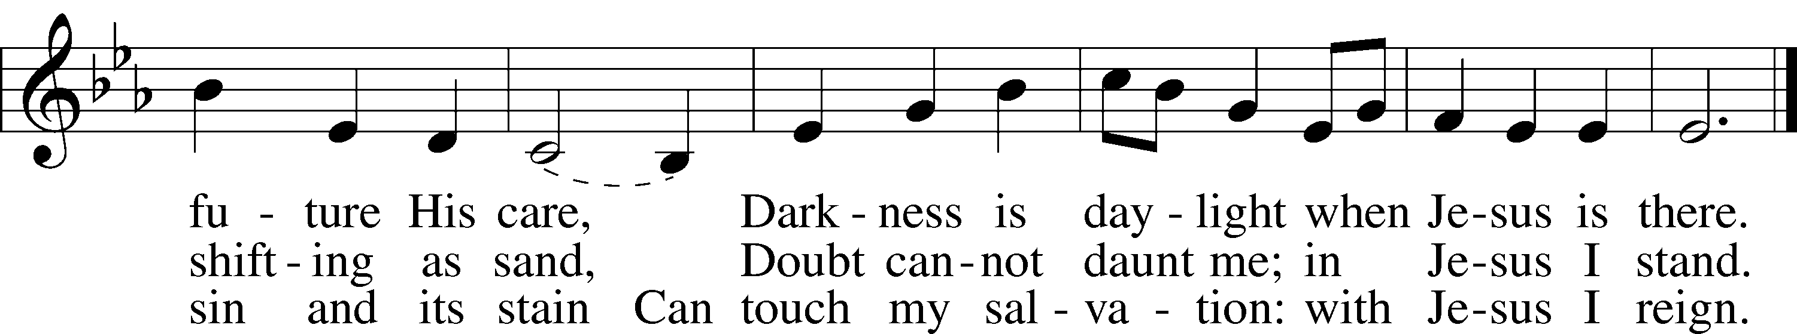

© 1964, renewed 1992 Hope Publishing Co. Used by permission: LSB Hymn License .NET, no. 100011641.  
Public domain

*(Please stand…)*

**THE LORD’S PRAYER:**

**All: Our Father, who art in heaven, hallowed be thy name, thy kingdom come, thy will be done, on earth as it is in heaven. Give us this day our daily bread; and forgive us our trespasses as we forgive those who trespass against us; and lead us not into temptation, but deliver us from evil. For thine is the kingdom, and the power, and the glory, forever and ever. Amen**

**THE BENEDICTION**

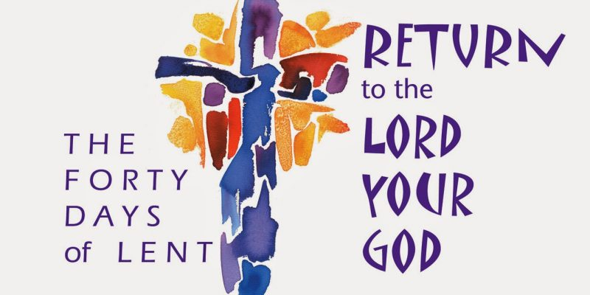

**THE CLOSING HYMN: *“Christ Is Our Cornerstone”*  LSB 912**

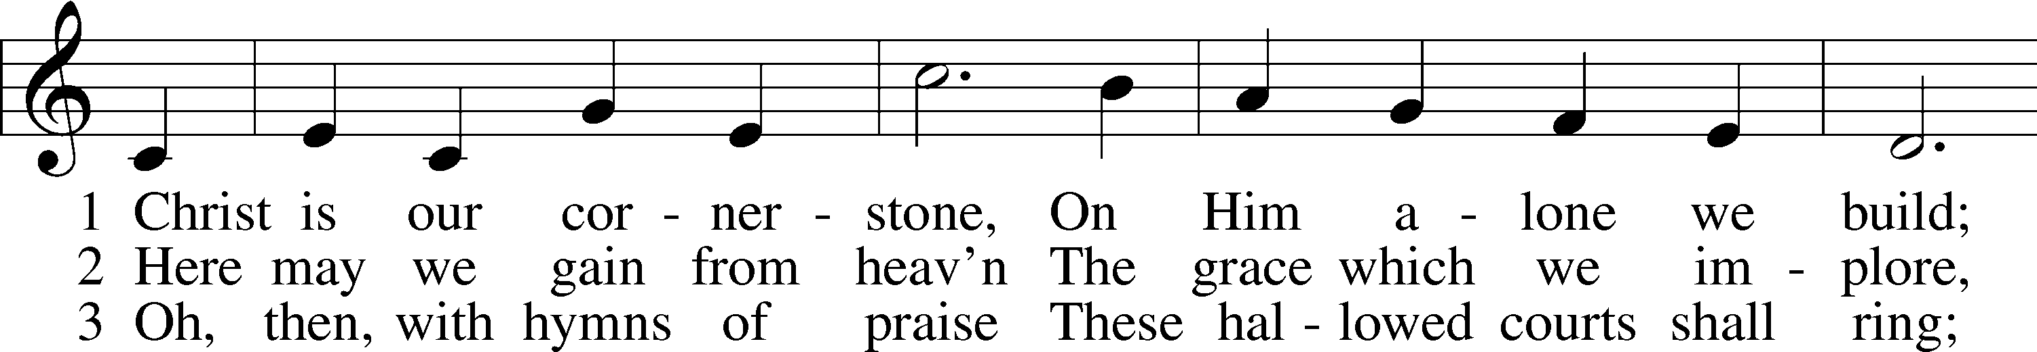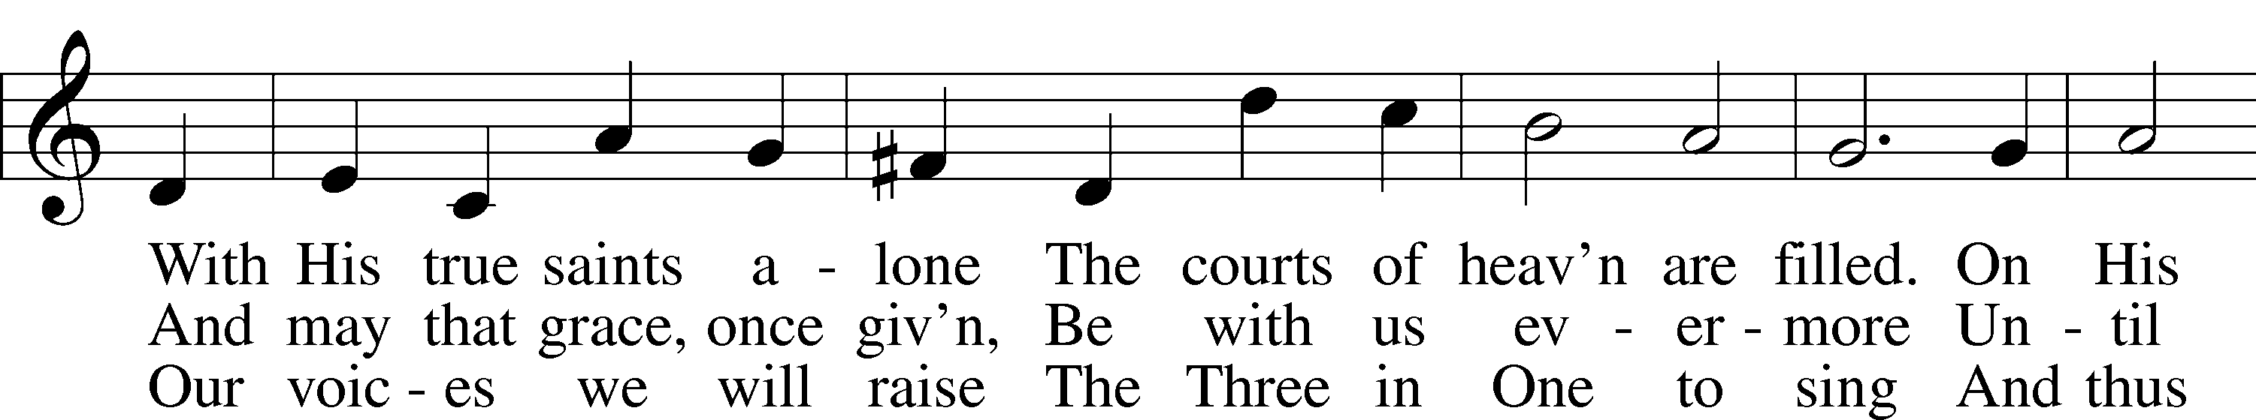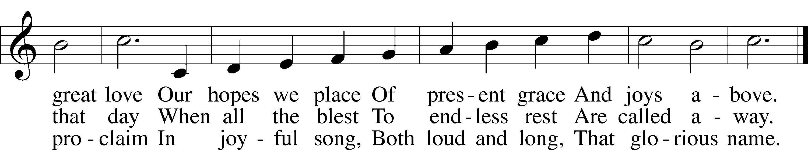

Public domain



**“What are we doing that nobody else is**

**doing to reach people that nobody else**

**is reaching?**



**WELCOME TO GRACE LUTHERAN CHURCH:** We are glad that you are here to worship God with us today! We pray that you will enjoy the wonderful fellowship as friends in Christ as God gathers us around His means of grace, the Word and Sacraments, to bless us with His treasured gifts of forgiveness, faith, abundant life and eternal salvation. If you are a guest, please also sign our Guest Book. Please talk to Pastor if you would like **to learn more about becoming a member of Grace. Also, please join us for refreshments** and fellowship after the Service. We invite you to come and worship with us often as God gathers us in His Grace.

**WELCOME TO THE LORD’S TABLE:** We invite and encourage all present who are baptized and faithful Christians, and who confess the Father, Son, and Holy Spirit to be the only true God and who believe that Jesus Christ died for the sins of the World and is our only hope and salvation…to join us in receiving the very and true body and blood of Christ in this Sacrament. The clear liquid cups in the center of the tray are non-alcoholic wine.

Children not yet confirmed in the faith are always welcome to join their parents at the Lord’s Table, but should keep their hands folded in front of them. The Pastor will give them a blessing.

**SERVING TODAY:** Acolyte: Maddie Schoeph; Lector: Jim Picking: Communion Assistants: Peter Bacle and Dean Thompson; Usher: Ed Morris; Altar Care: Pastor Faith and Pattie; Refreshments: Pastor Faith and Pattie.

**SERVING NEXT SUNDAY:** Acolyte: Amelia Bly; Lector: Mike Sattelmeier; Communion Assistants: Peter Bacle and Dean Thompson; Usher: Ed Morris; Altar Care: Kathy Greenwood; Refreshments: Tiffany Lopez.

**FLOWERS**: were placed on the altar to the glory of God to celebrate the memory of Odalis Klepaski.

THIS WEEK AT A GLANCE:

**Today: May 14th**

9:00 am Worship Service with Communion

10:15 am Fellowship

10:30 am Adult Bible Study / Children’s Sunday School

**Monday: May 15th**

Pastor’s Day Off

5:30 pm Zumba

**Tuesday: May 16th**

3:00 pm Jan’s Mobile Gym

6:00 pm Weight Watcher’s (Parish Hall)

**Wednesday: May 17th**

12:30 pm Men’s Bible Fellowship (Chico’s)

4:30 pm Women’s Bible Study (room 3)

5:45 pm Bell Choir Rehearsal

**Thursday: May 18th**

4:30 pm Missional Communities

**Next Sunday: May 21st**

9:00 am Worship Service with Communion

10:10 am Children’s Choir and Vocal Rehearsal

10:15 am Fellowship

10:30 am All About Relationships

**IN YOUR PRAYERS THIS WEEK:** Micah Westphalen, family and friends of Odalis Klepaski, Capt. Zachary (Bo) Henry (Ret.), family of Sam Vinci, Frank Deford, Larry Vandivier, Carl Vandivier, Bobby Meck, family and friends of Elaine Wavehime, Linda Mullis, Joe Lamberson, Kathy Greenwood, Michael Willard, France Vandivier, Katie Hoffman, Pastor Ray Peters, Family and friends of Will Plagens, Kay Sattelmeier, Dennis Julson, Vernon Julson, Olga Odland, the family of Jean Grafsgaard, Jenie Howard, Jenny Dean, Katie Higgs Wyrwicki, family and friends of George Licis, Charles, Braydon, Champ, Amy, Elsie Hamilton, Mary Ellen Jessel, Marcos Diaz, Kaci Doran, Auwina Weed, Sandy Harris, and those you are praying for at home. If anyone has a special prayer request please submit it in writing in the collection plate; or you may call Pastor Gary Faith at (504-858-8872), or Kris Howard at (305-296-5161).

**GIFTS, TITHES, & ATTENDANCE LAST SUNDAY** for May 7th were $3914.00 and the building fund received $120.00 with an attendance of 64. Our Bible Stick mission received $250.00.

**TO HELP US GROW…** The Bible reading for next Sunday’s service the readings are Acts 17:16-31, 1 Peter 3:13-22, John 14:15-21.

**A BLESSED MOTHER’S DAY:** to all of you Moms and to all who fill that role by nurturing and praying for children.

**CALLING ALL GRADUATES**: If you are graduating from college, high School, Middle School, or Kindergarten please let Kris know and we will include your names and accomplishments in our bulletin on June 4th, 2017 and those who are present will be called forward for a time of prayer.

**OUR ANNUAL VOTERS MEETING:** is scheduled for June 4th. It will be held in the sanctuary about 10:30 am after our time of fellowship.

**IT’S ALL ABOUT RELATIONSHIPS**: has been rescheduled for next Sunday May 21st, 2017. We will have an opportunity to grow in our relationship with each other and with Jesus. We will be served a meal and I’m predicting we will have fun in the process. Please register on the signup sheet in the back of the church so that enough food can be ordered.

**HANDY MAN FOR THE SCHOOL:** If anyone is interested in applying for the part time, flexible hours’ job of handy man for our school please contact our school secretary Judy Whitney at 305-296-8262.

**IT HAS BEEN BROUGHT TO MY ATTENTION** that the mothers of our younger children would like the option of having their children taken to a nursery after the children sermon. If you know of anyone who has the gifts and the desire to make this happen have them contact Kris Howard or myself.

**A PROBLEM OR A BLESSING?** Praise the Lord, we are starting to run out of room in our parking lot on Flagler. If you are healthy and see the parking lot getting full, please consider parking in our lot behind our school. Thanks.

**WE HAVE SET THE SCHEDULES** for ushers, acolytes, lectors, and communion assistants for the next three months. If you would like to serve in any of these positions, please let Pastor or Kris know.

**STEWARDSHIP LISTS:** On the bulletin board by the front door of the church you will find the Altar Care, Refreshments, and Flower sign-up sheets for 2017. If you are able to help out with any of these please place your name in the spot on the date requested.

**SOME DATES TO MARK ON YOUR CALENDAR**

**GRACIOUS LADIES OF GRACE:** 5*5*5* for Salute on the Beach. We had a nice group of 13 ladies on a beautiful balmy afternoon eating shrimp salads, grouper cakes, and Panko crusted yellowtail over greens with avocado, and washed down with fresh squeezed lemonade tea. Kylie Paradise (a ballet dancer not an exotic dancer she informed us) was our server who remembered us from our last luncheon. She was perfect in every way dancing around the table seeing to our every need. Kudos to Kylie! Lynn took us down memory lane with photos from Girl Scout days she had found in an album from “not long ago”. We enjoyed the reminiscing. Get ready for a delight as we dine at Ambrosia a Japanese Sushi restaurant at the end of Simonton St. on May 23rd at 11:30 am. See you there. RSVP Monica 305-923-0856

**THE GRACE LUTHERAN CHURCH WEB PAGE AND FACE BOOK PAGE** now contains a vocal recording of last week’s sermon. So, if you are not able to attend church on Sunday please go to our website where you will find a copy of the bulletin and a recording of Pastor Faith’s sermon. <https://gracelutherankw.360unite.com/home>.

**A NUMBER OF CAPITAL IMPROVEMENTS** are needed to keep our facilities in good health for the future. Roof repairs are needed on school buildings and the parsonage. If you can help it would be much appreciated! A big thanks to all who have contributed to these repairs.



**SUNDAY SCHOOL:** Sunday school for all ages will follow refreshments from 10:30 until 11:30 in the following rooms.

High school is in room number 1 (just past the adult Bible study room on the right)

Middle school, 6th 7th and 8th grades, in room number 3 with Mike Sattelmeier and Jim Schuetzler. (Turn left down the school hallway to the first room).

3rd, 4th and 5th grades in room 5 with Don and Kris Bly. (third room left down the school hallway).

Preschool through second grade with JoAnn Broadbent in room 7. (Last room on the left down the school hallway)

Hope to see everyone there! Any questions? Ask Kris Bly, Sunday School director, 305-509-1447 or Kris Howard, church Secretary.



**IF YOU ARE INSTRUMENTALLY INCLINED** and would like to share your talents with an instrument during our services or accompany our organist and/or choir, please speak to our organist Debbie Schuetzler.

**MUSIC MINISTRY:** "Make a joyful noise to the Lord, all the earth!" Psalm 100:1. Whether you are here year-round or only part-time, we invite you to participate in our music ministry. Please speak with Beverly Walker or contact her with any questions at [beverlywalker@gmail.com](mailto:beverlywalker@gmail.com) .

Children's Choir and Vocal Choir: No rehearsal today.

Bell Choir: Rehearsal on Wednesday night from 5:45 - 6:30 pm.



**MEN’S BIBLE FELLOWSHIP**: They meet the first and third Wednesday’s of each month at 12:30pm. Their next meeting will be May 17th located at Chico’s on Stock Island. All guys are welcome.

**MISSIONAL COMMUNITIES:** meets at 4:30pm on Thursdays. **All are welcome** to experience an opportunity to grow in our relationships with Jesus and His flock.

**WOMEN’S BIBLE STUDY**:

Aside from the Resurrection, Jesus' feeding of the five thousand is the only miracle recorded in all four Gospels. Jesus dealt with doubting disciples, fatigue, personal grief and limited resources but on that spring day He chose to feed the masses with the Bread of Life.

Through this 6-lesson DVD Bible Study we will dig deep into Scripture to see a compelling picture of our compassionate Savior who when He is present, the weary find rest and the hungry soul is satisfied.  Come and be fed by the only One who provides for your every need and fills you ... body and soul ... with Overflowing Abundance.

Overflowing Abundance by Donna Pyle is our current Ladies Bible study on Wednesday’s at 4:30 in room 3.  For more information call Monica Bacle 305 923-0856.