**April 30th, 2017**

**9:00 am**

**THIRD SUNDAY**

**OF EASTER**



**Grace Lutheran Church**

**2713 Flagler Ave.**

**Key West, FL 33040**

**305-296-5161**

[**GraceLutheranKW@att.net**](mailto:GraceLutheranKW@att.net)

**gracelutherankw.360unite**

**Pastor Faith**

**(504) 858-8872**

**garyfaith@aol.com**

**THIRD SUNDAY OF EASTER**

**APRIL 30TH, 2017 9:00 a.m.**

***In the Name of Jesus!***

**Our Mission Statement: Anchored in Christ, each person a missionary.**

**PRELUDE**

**ANNOUNCEMENTS:**

**We welcome you. We are glad you are here to share with us the joy and peace we have in Jesus Christ. It doesn’t matter whether this is your first time in this church or if you are a lifelong member, you are welcome. We come together today in order to celebrate the gift God has given us-His own Son, Jesus, Our Savior.**

**PREPARATION**

*(Please Stand…)*

**HYMN: *“The Day of Resurrection”* LSB 478**

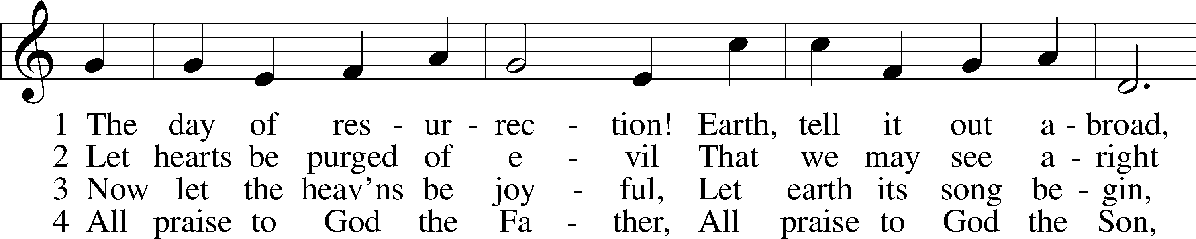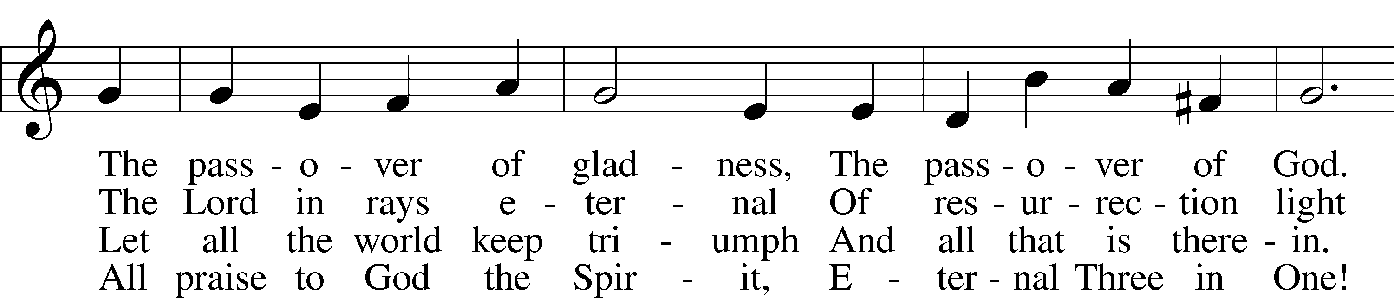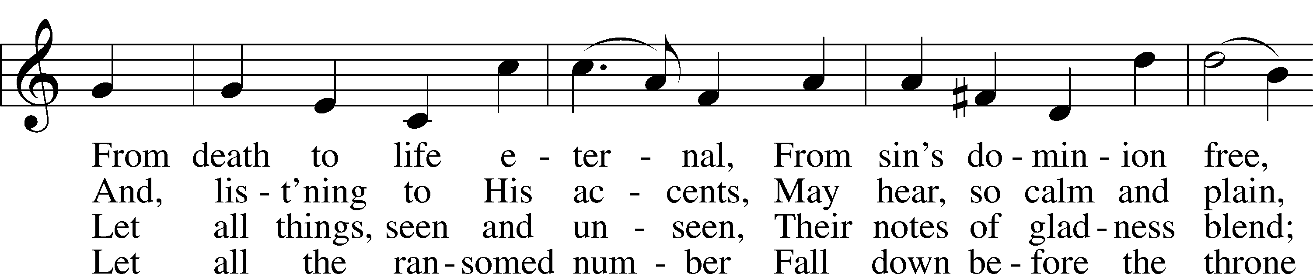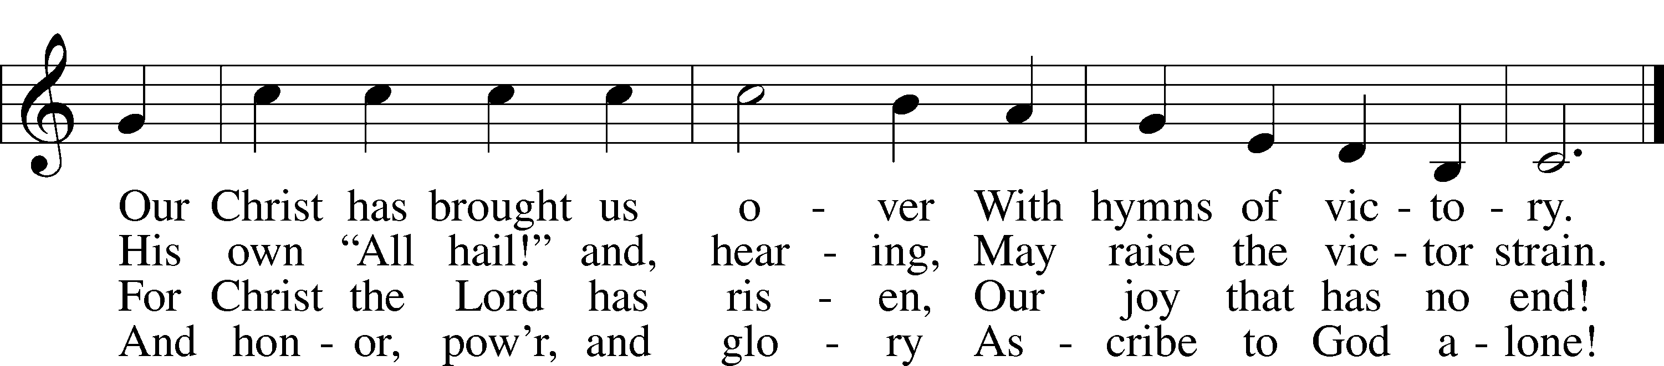

Public domain

**Pastor:**  In the Name of the Father and of the Son and Holy Spirit.

**Congregation: Amen.**

*(Please Remain Standing Or You May Kneel…)*

**GOD’S PEOPLE CONFESS THEIR SINS:**

Pastor: By grace you have been saved, through faith-and this is not from yourselves, it is the gift of God-not of works, so that no man can boast, for we are God’s workmanship, created in Christ Jesus.

**Congregation: I know that nothing good lives in me, that is, in my sinful nature, for I have the desire to do what is good, but I cannot carry it out.**

Pastor: What I do is not the good I want to do; no, the evil I do not want to do-this I keep doing.

**Congregation: In my heart I delight in God’s law, the law that points out what a wretched person I am! Who will rescue me from this body of death?**

Pastor: Thanks be to God through Jesus Christ our Lord! Only He can achieve the perfection we fail to achieve. By the forgiveness He purchased on the cross, our forgiveness is complete!

**SERVICE OF THE WORD**

*You may be seated…*

**THE FIRST READING: Acts 2:14a, 36-41**

Lector: This is the Word of the Lord.

**People: Thanks be to God.**

**THE EPISTLE LESSON: 1 Peter 1:17-25**

Lector: This is the Word of the Lord.

**People: Thanks be to God.**

*Please stand…*

**THE HOLY GOSPEL: Luke 24:13-35**

Pastor: The Holy Gospel according to St. Luke the 24th Chapter

**People: Glory to You, O Lord.**

Pastor: This is the Gospel of the Lord.

**People: Praise to You, O Christ!**

*Please be seated…*

**CHILDREN’S MESSAGE**

**NOISE OFERING**

***It’s called a noise offering because what we are asking for is pocket change. It will always be used for missions outside of our church and school. It normally also is given to a mission involving children. Thanks for making a joyful noise to the Lord.***

**THE SERMON HYMN: *“Abide with Me”* LSB 878**

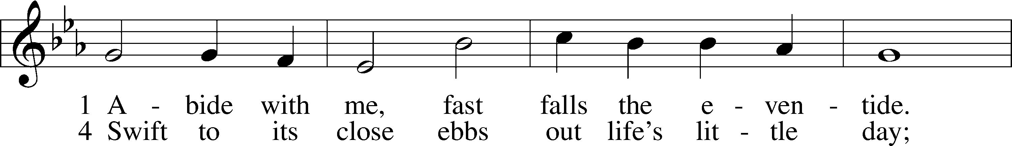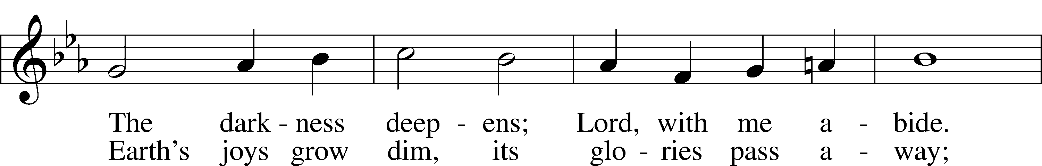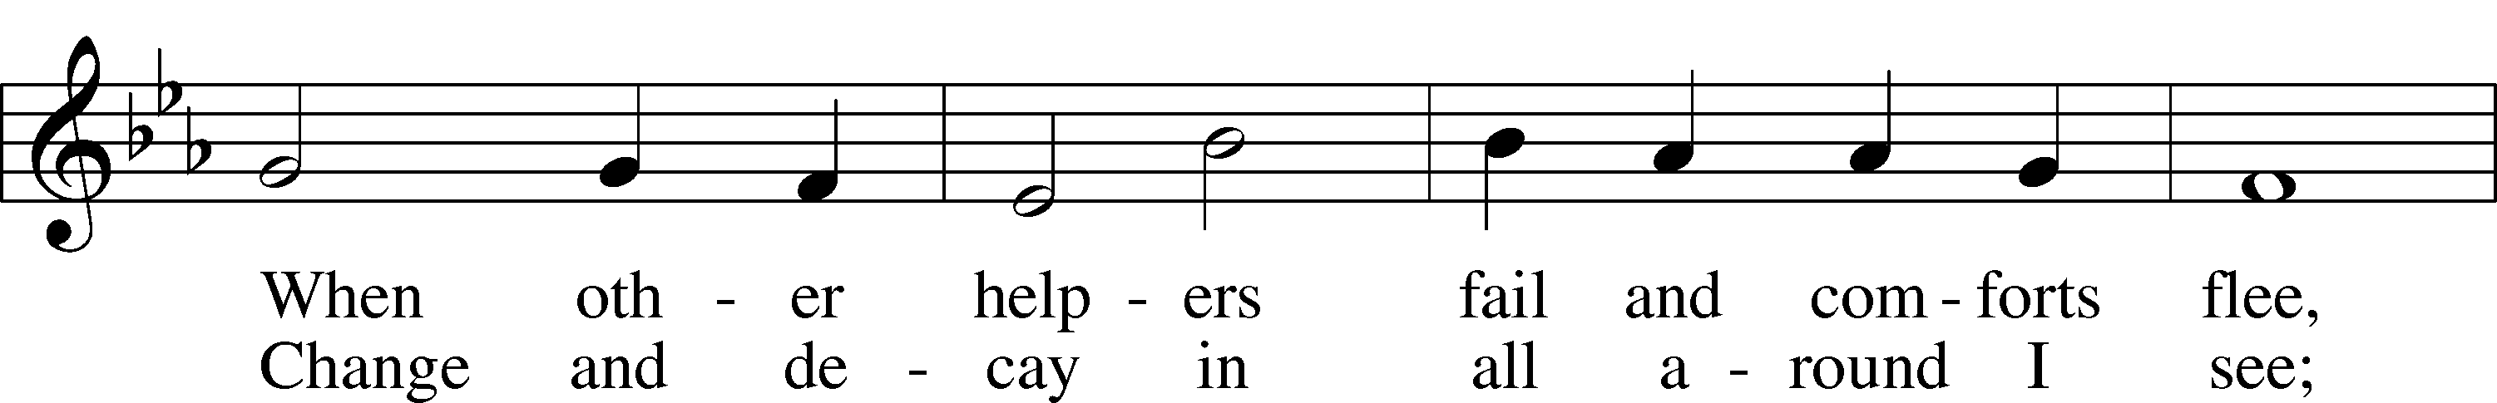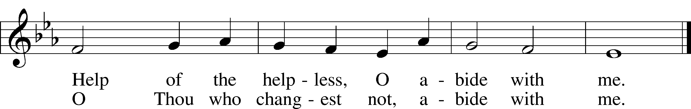

5 I fear no foe with Thee at hand to bless;  
Ills have no weight and tears no bitterness.  
Where is death’s sting? Where, grave, thy victory?  
I triumph still if Thou abide with me!

6 Hold Thou Thy cross before my closing eyes;  
Shine through the gloom, and point me to the skies.  
Heav’n’s morning breaks, and earth’s vain shadows flee;  
In life, in death, O Lord, abide with me.

Public domain

**THE SERMON: *“Heartburn can be a Godly thing”* Luke 24:13-35**

*(Please stand…)*

**THE PROFESSION OF FAITH:**

Pastor: God has given us a great message to take to His world. Let us remind ourselves and one another of what that message is:

Pastor: I believe in God the Father, Almighty

**Congregation: Maker of heaven and earth**

Pastor: And in His Son, Jesus Christ our Lord,

**Congregation: Who was conceived by the Holy Spirit**

Pastor: Born of the Virgin Mary

**Congregation: Suffered under Pontius Pilate**

Pastor: Was crucified, died and was buried

**Congregation: He descended into hell.**

Pastor: On the third day He rose again from the dead,

**Congregation: And ascended into heaven**

Pastor: And sits on the right hand of God, the Father almighty

**Congregation: From there He will come to judge the living and the dead**

Pastor: I believe in the Holy Spirit,

**Congregation: The Holy Christian Church as**

**All: the communion of saints; the forgiveness of sins, the resurrection of the body, and the life everlasting. Amen.**

*(You may be seated…)*

**OFFERING RECEIVED:**

**(***Please stand…)*

***“Praise God, from Whom All Blessings Flow”* LSB 805**

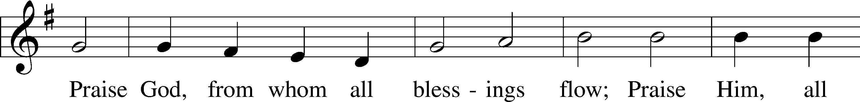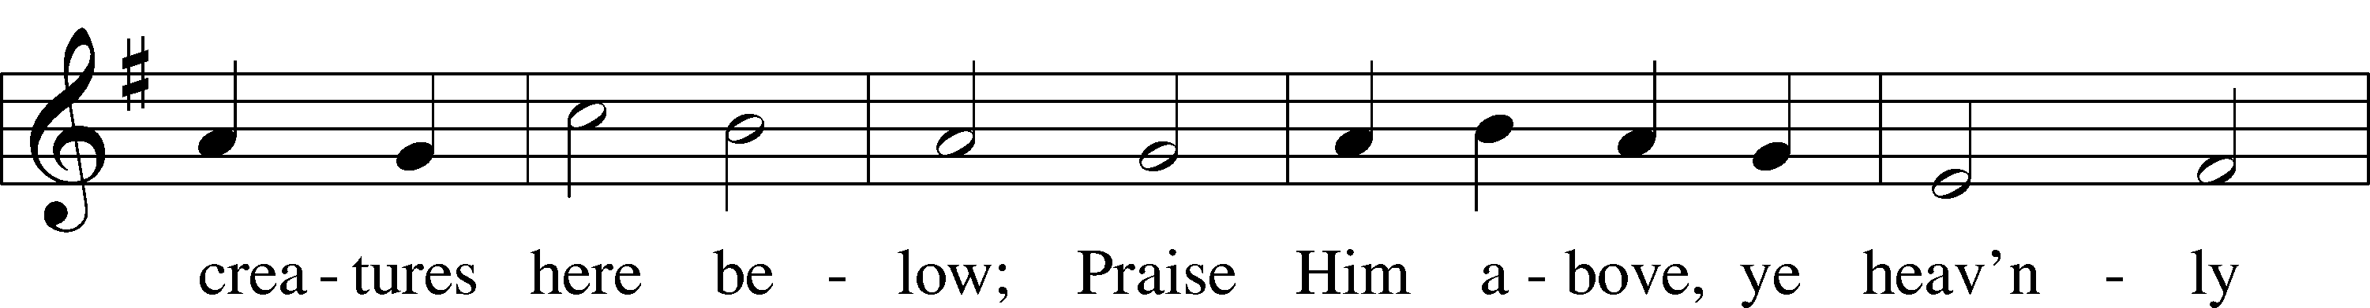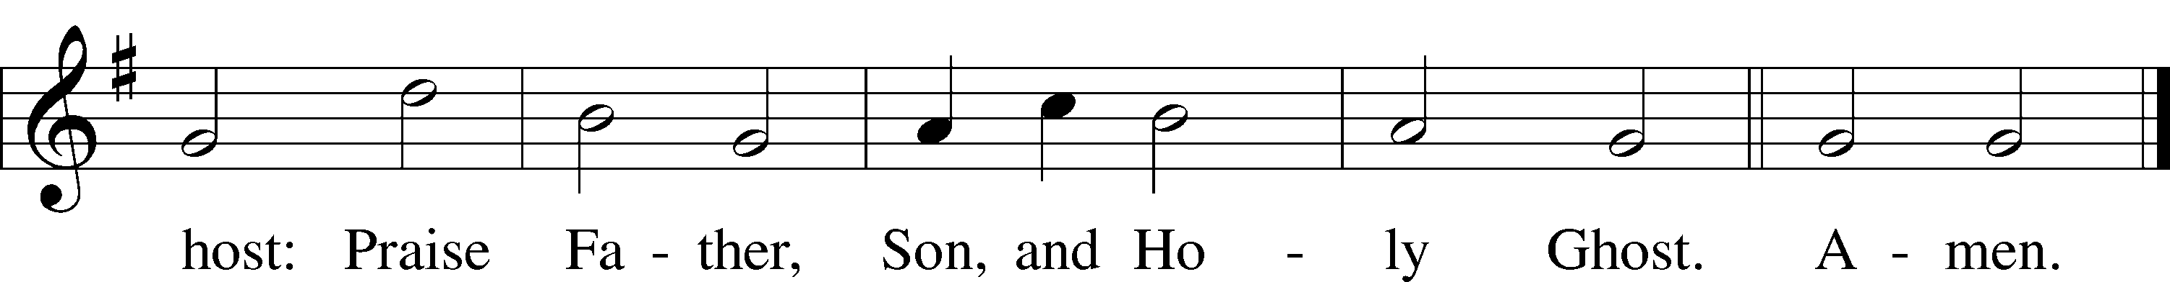

Public domain

**THE PRAYERS OF THE CHURCH: based on Psalm 98**

Pastor: Dear Lord, we thank You for everything You’ve done for us, and most of all for Your own Son, Jesus, our Savior. We will never stop praising You for this wonderful gift.

**Congregation: Sing to the Lord a new song, for He has done marvelous things; His right hand and His holy arm have worked salvation for Him.**

Pastor: We thank You for those missionaries long ago who brought the Good News to our people. When we were in darkness, You sent men and women to bring us the light. Thank you, Lord.

**Congregation: The Lord has made His salvation known and revealed His Righteousness to the nation.**

Pastor: O Lord, You are our Savior, we trust in You for all our needs, give healing to the sick, courage to those who are afraid, and peace to those we name in our hearts either silently or out loud. **(a moment of silence)** We praise You, gracious Lord, for all Your benefits to us. You give us home, friends and family, food, shelter, rest and everything we need. You give us sight and hearing and touch and taste and provide for all of our needs.

**Congregation: Shout for joy to the Lord, praise His Name Amen.**



Jesus let the things that break

your heart also break our hearts.

Amen

**SERVICE OF THE SACRAMENT**

*(Please be seated…)*

**THE WORDS OF INSTITUTION**

**DISTRIBUTION HYMNS: *“Jesus Loves Me”* LSB 588**

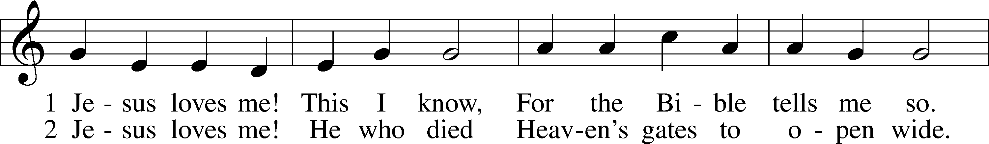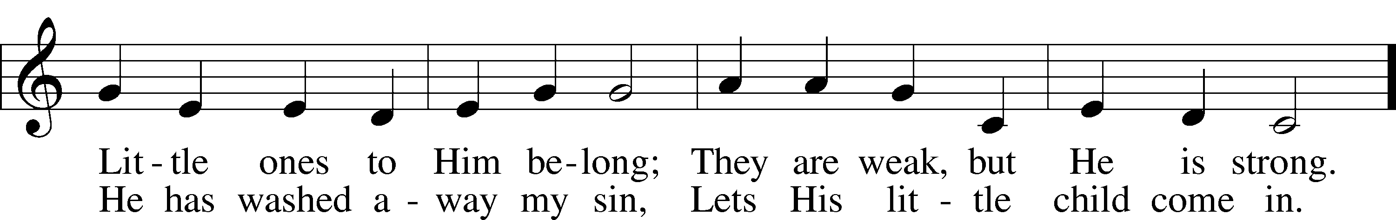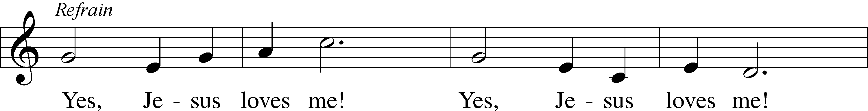

Public domain



**“What are we doing that nobody else is**

**doing to reach people that nobody else**

**is reaching?”**

***“You Satisfy the Hungry Heart”* LSB 641**

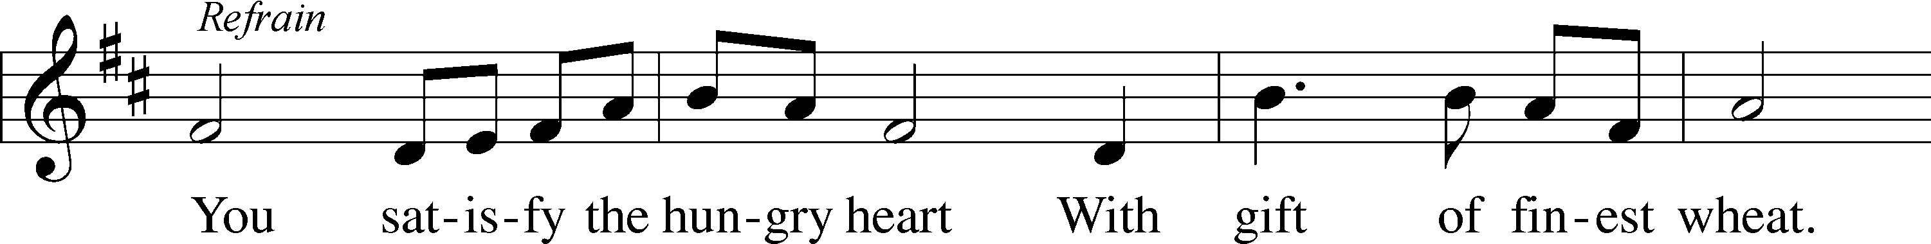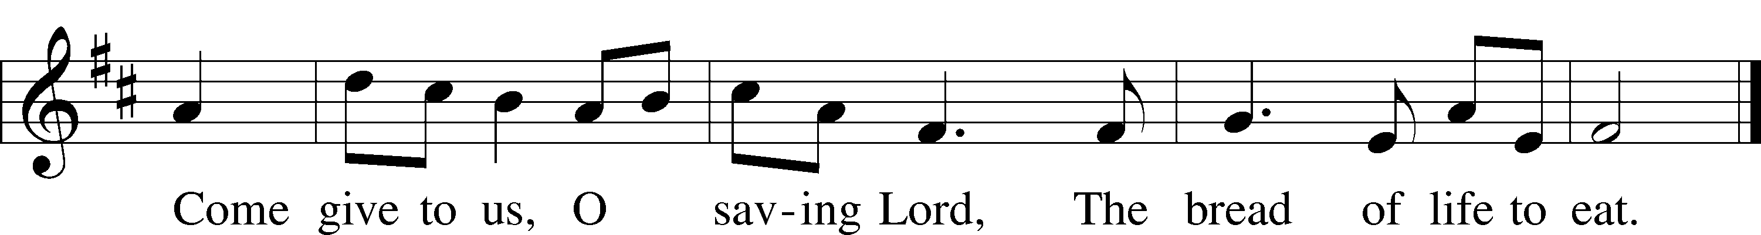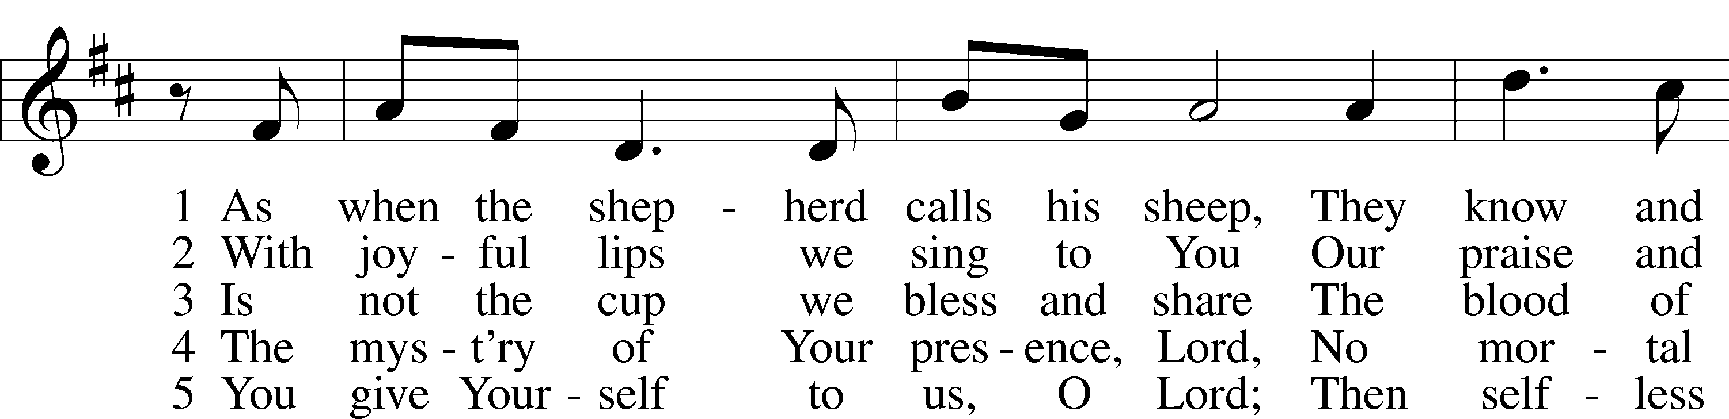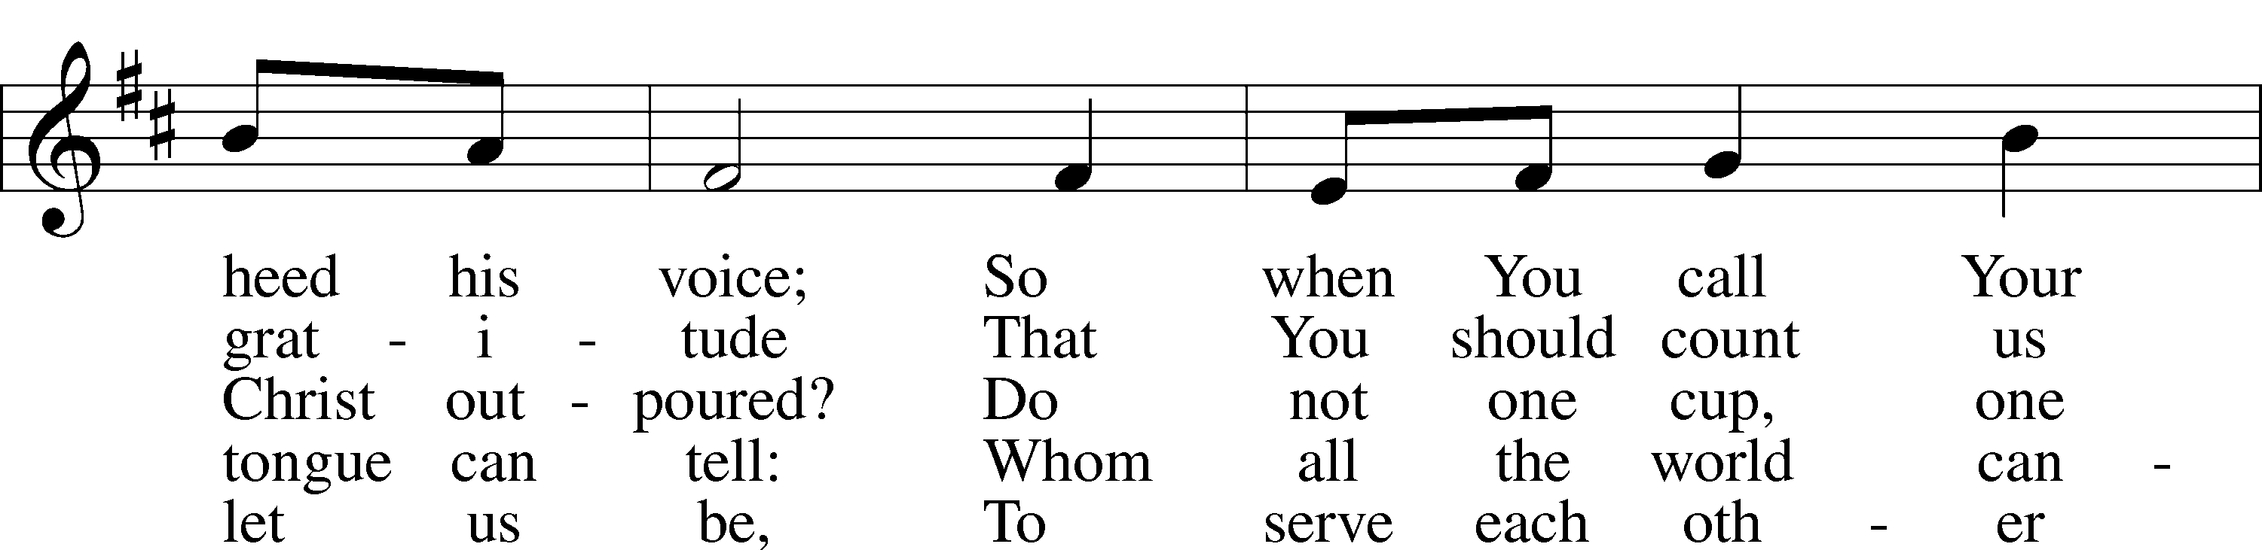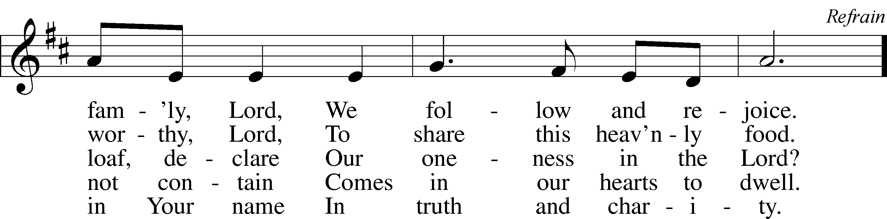

© 1977 Archdiocese of Philadelphia. Used by permission: LSB Hymn License .NET, no. 100011641.

***“Who Are You Who Walk in Sorrow”* LSB 476**

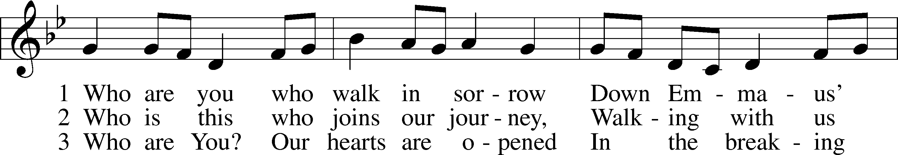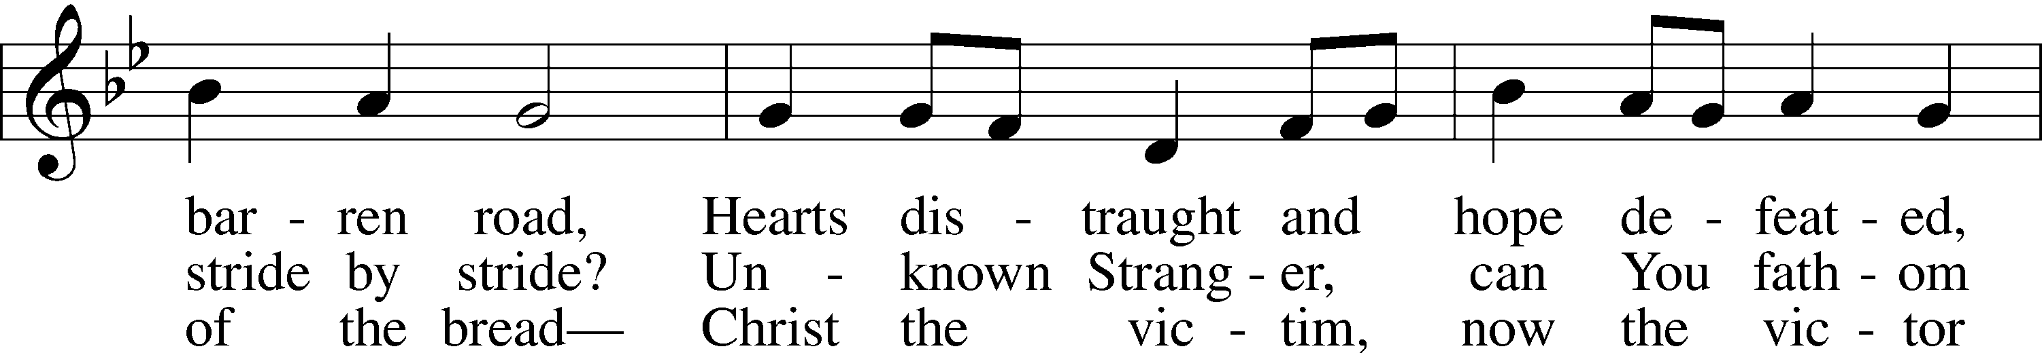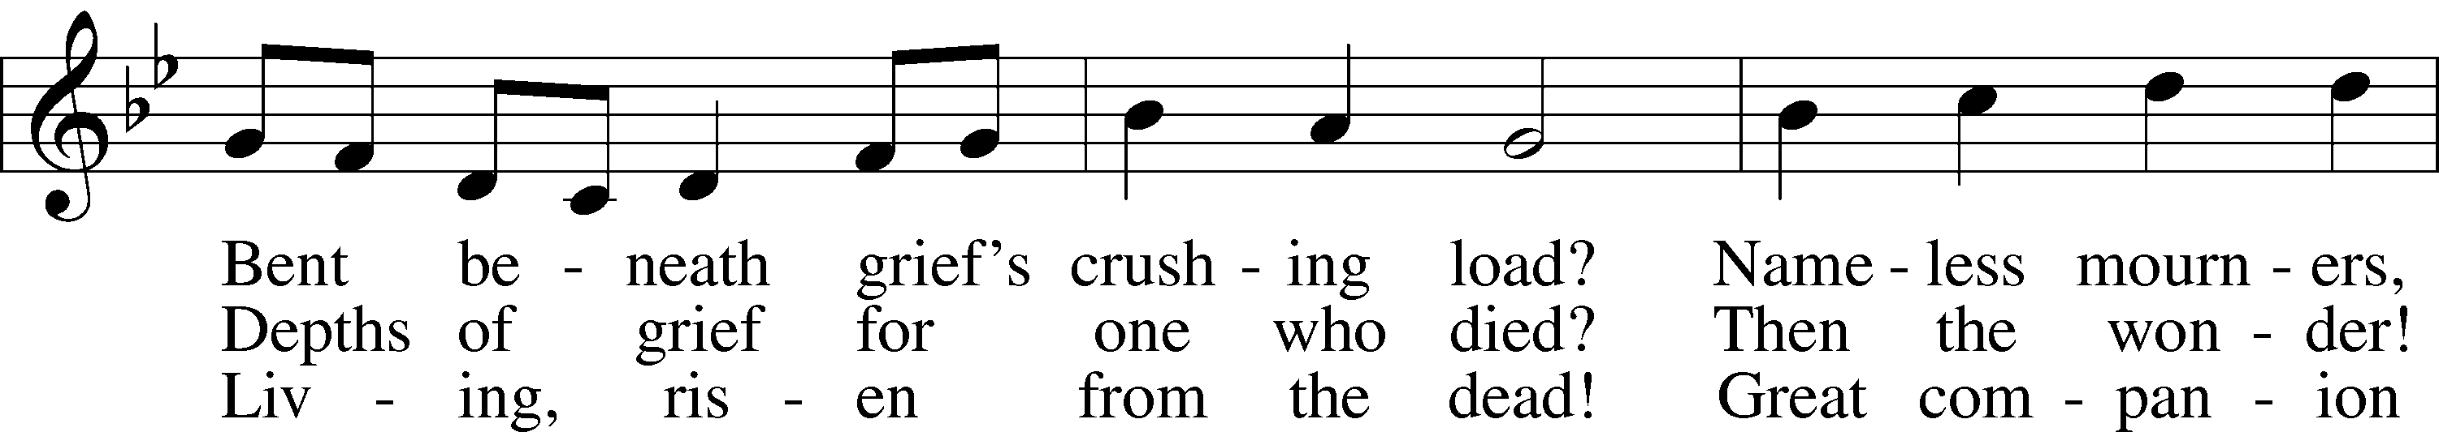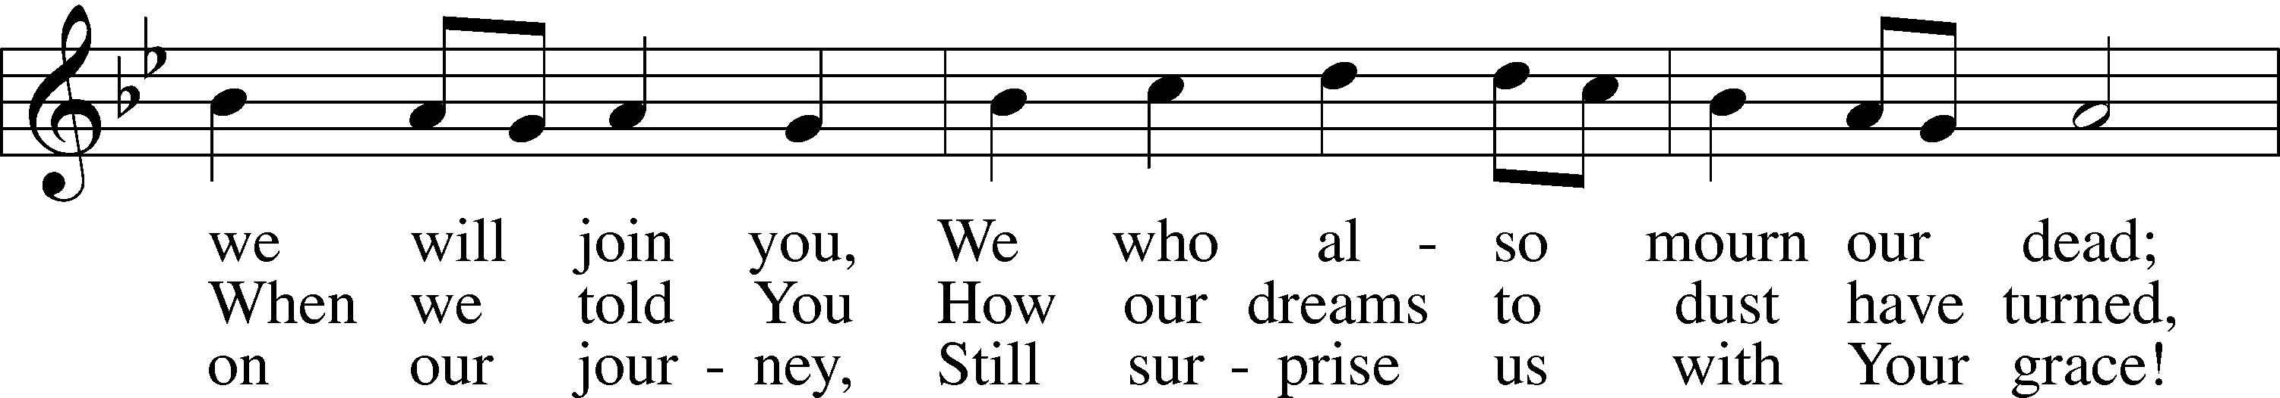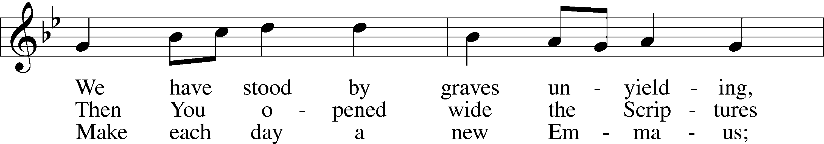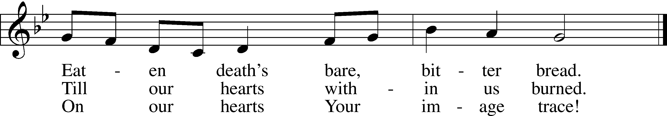

4 Who are we who travel with You  
 On our way through life to death?  
Women, men, the young, the aging,  
 Wakened by the Spirit’s breath!  
At the font You claim and name us,  
 Born of water and the Word;  
At the table still You feed us,  
 Host us as our risen Lord!

5 “Alleluia! Alleluia!”  
 Is the Easter hymn we sing!  
Take our life, our joy, our worship  
 As the gift of love we bring.  
You have formed us all one people  
 Called from ev’ry land and race.  
Make the Church Your servant body,  
 Sent to share Your healing grace!

© 2000 National Association of Pastoral Musicians. Used by permission: LSB Hymn License .NET, no. 100011641.  
Public domain

***“Give Thanks with a Grateful Heart”* LSB 806**

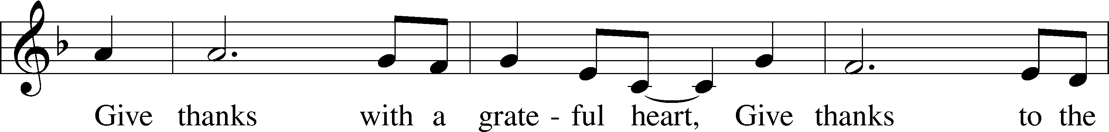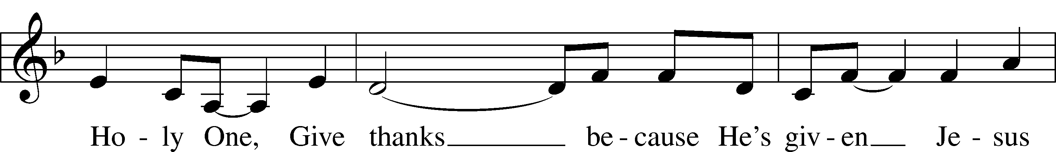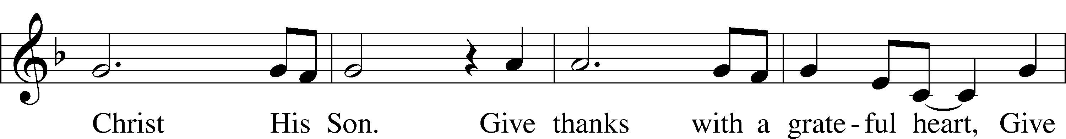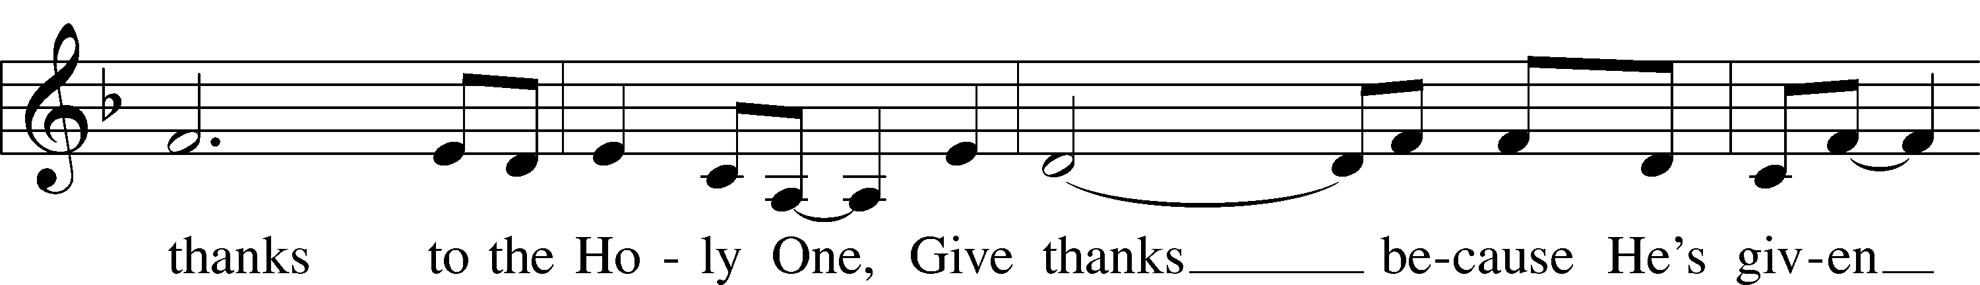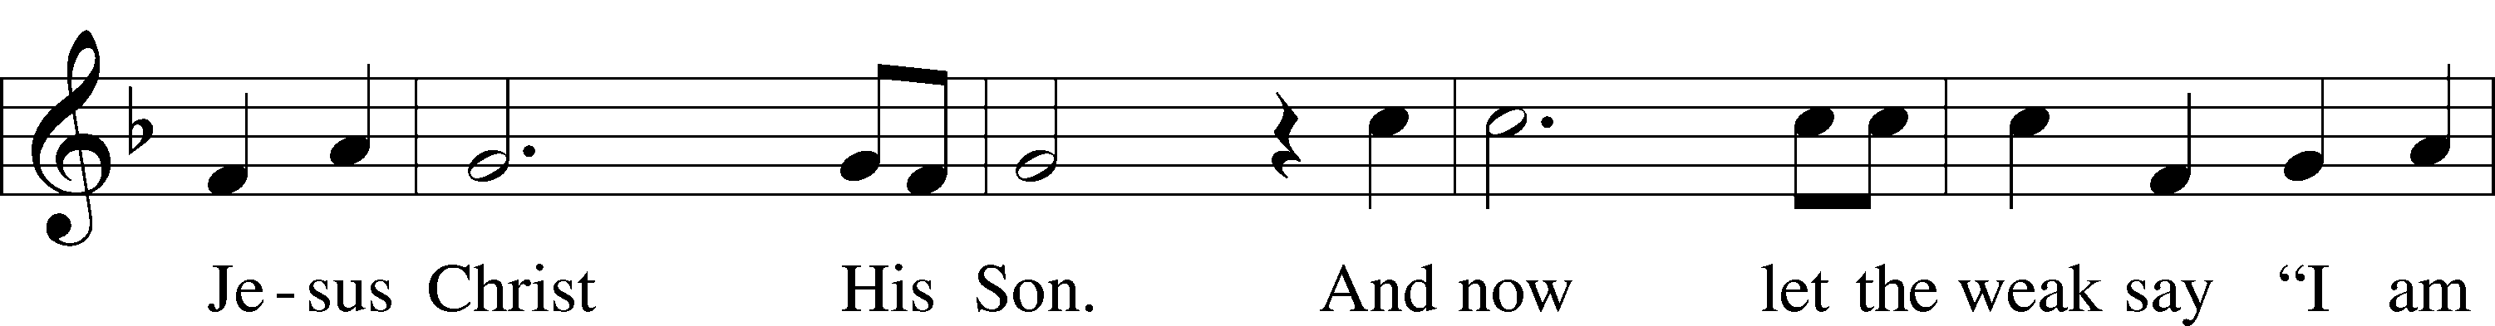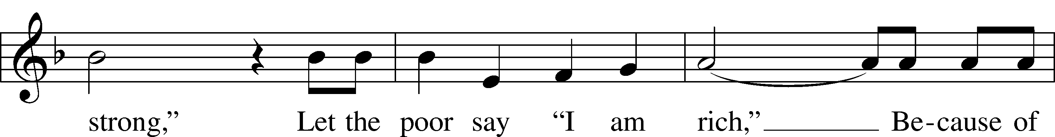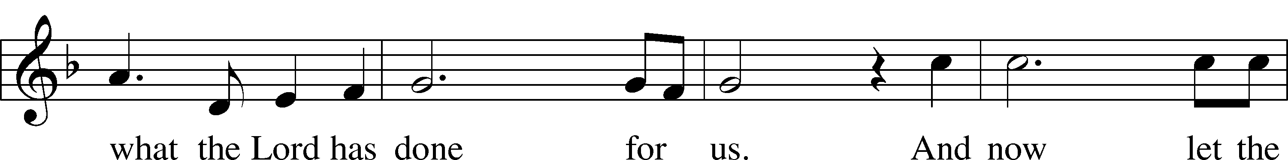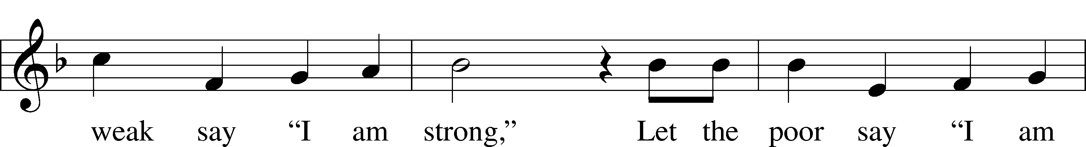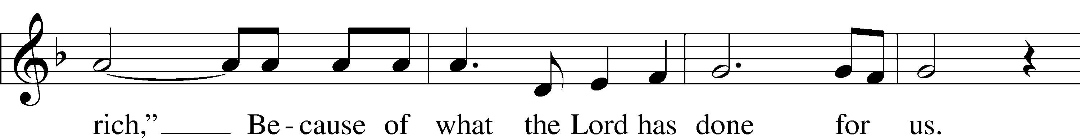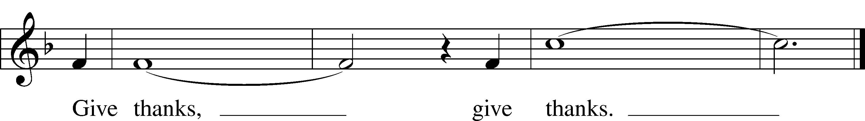

© 1978 Integrity’s Hosanna! Music. Used by permission: LSB Hymn License .NET, no. 100011641.

*(Please stand…)*

**THE LORD’S PRAYER:**

**All: Our Father, who art in heaven, hallowed be thy name, thy kingdom come, thy will be done, on earth as it is in heaven. Give us this day our daily bread; and forgive us our trespasses as we forgive those who trespass against us; and lead us not into temptation, but deliver us from evil. For thine is the kingdom, and the power, and the glory, forever and ever. Amen.**

**THE BENEDICTION**

**THE CLOSING HYMN:  *“Stand Up, Stand Up for Jesus”* LSB 660**

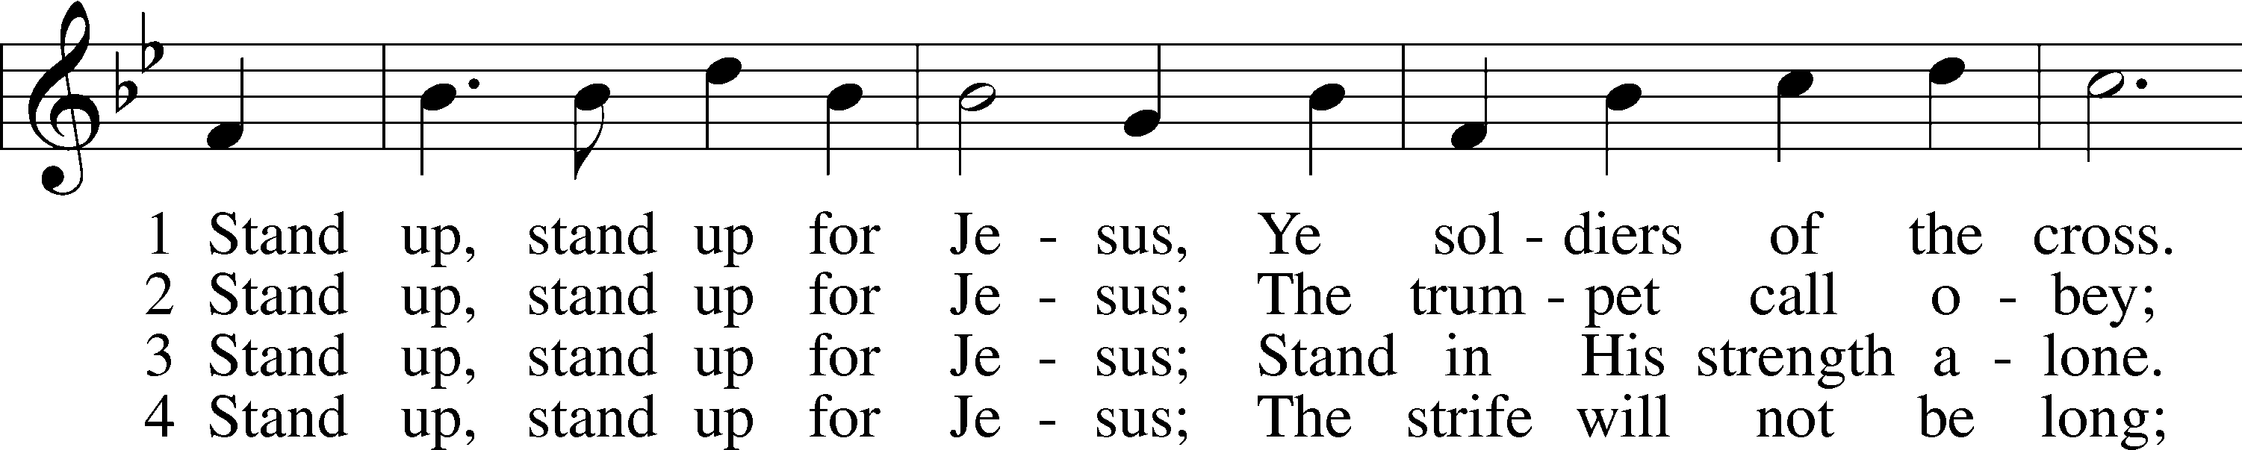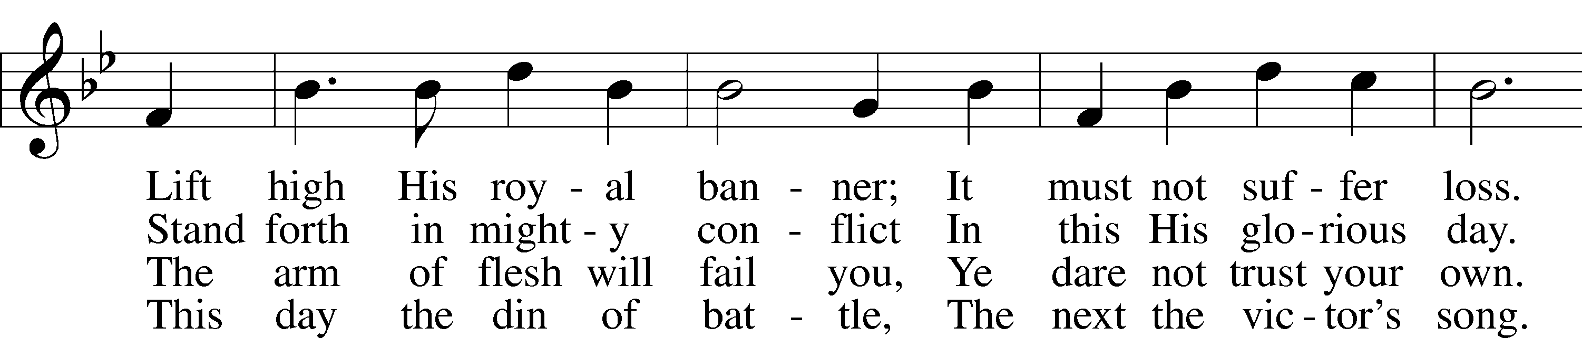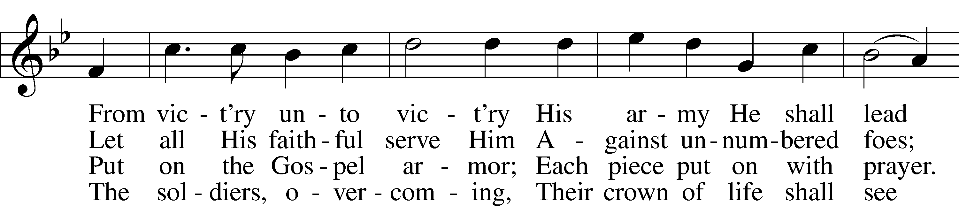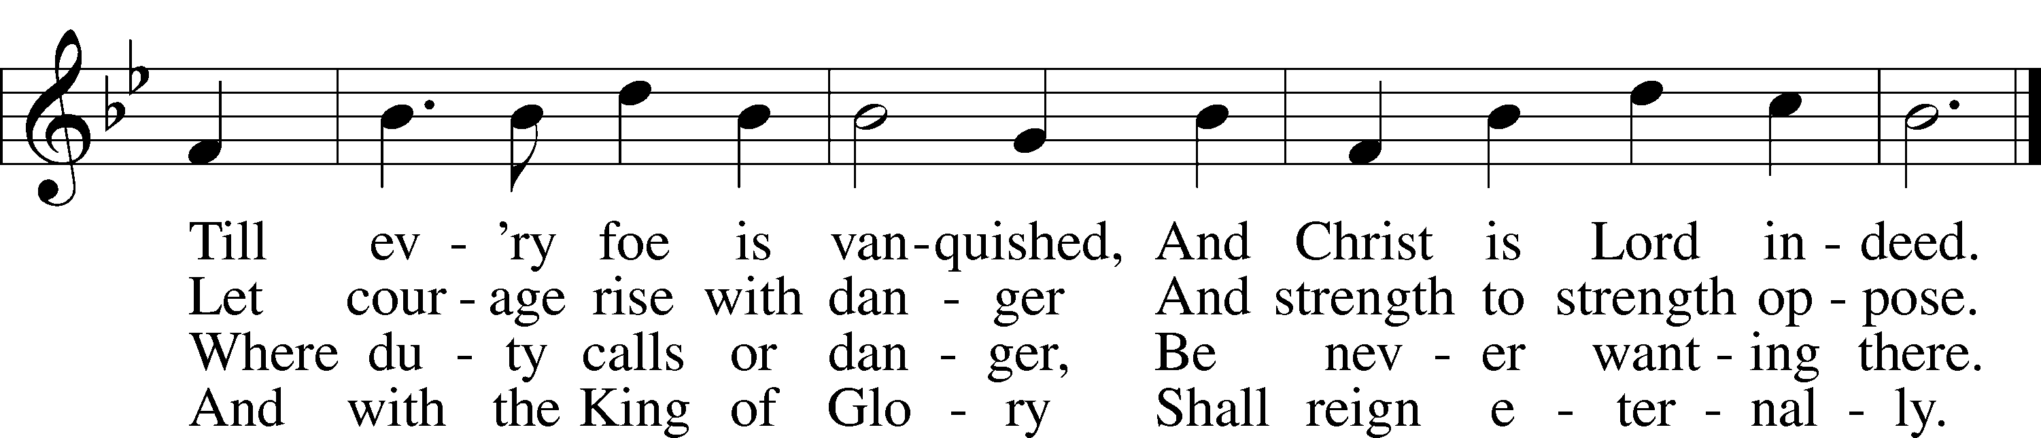

Public domain



**WELCOME TO GRACE LUTHERAN CHURCH:** We are glad that you are here to worship God with us today! We pray that you will enjoy the wonderful fellowship as friends in Christ as God gathers us around His means of grace, the Word and Sacraments, to bless us with His treasured gifts of forgiveness, faith, abundant life and eternal salvation. If you are a guest, please also sign our Guest Book. Please talk to Pastor if you would like **to learn more about becoming a member of Grace. Also, please join us for refreshments** and fellowship after the Service. We invite you to come and worship with us often as God gathers us in His Grace.

**WELCOME TO THE LORD’S TABLE:** We invite and encourage all present who are baptized and faithful Christians, and who confess the Father, Son, and Holy Spirit to be the only true God and who believe that Jesus Christ died for the sins of the World and is our only hope and salvation…to join us in receiving the very and true body and blood of Christ in this Sacrament. The clear liquid cups in the center of the tray are non-alcoholic wine.

Children not yet confirmed in the faith are always welcome to join their parents at the Lord’s Table, but should keep their hands folded in front of them. The Pastor will give them a blessing.

**SERVING TODAY:** Acolyte: Elizabeth Reynolds; Lector: JoAnn Broadbent: Communion Assistants: Don Bly and Ed Morris; Usher: Bill Chalmers; Altar Care: The Bly’s; Refreshments: The Bly’s.

**SERVING NEXT SUNDAY:** Acolyte: James Reynolds; Lector: Garnet Picking; Communion Assistants: Peter Bacle and Dean Thompson; Usher: Ed Morris; Altar Care: ____________; Refreshments: ________________.

**FLOWERS**: were placed on the altar to the glory of God by the Bacle family to celebrate Leah’s birthday.

THIS WEEK AT A GLANCE:

**Today: April 30th**

9:00 am Worship Service with Communion

Immed. After Vocal Choir Rehearsal

10:10 am Children’s Choir Rehearsal

10:15 am Fellowship

10:30 am Adult Bible Study / Children’s Sunday School

**Monday: May 1st**

Pastor’s Day Off

5:30 pm Zumba

**Tuesday: May 2nd**

3:00 pm Jan’s Mobile Gym

6:00 pm Weight Watcher’s (Parish Hall)

**Wednesday: May 3rd**

12:30 pm Men’s Bible Fellowship (Chico’s)

5:45 pm Bell Choir Rehearsal

**Thursday: May 4th**

4:30 pm Missional Communities

**Next Sunday: May 7th**

9:00 am Worship Service with Communion

Immed. After Vocal Choir Rehearsal

10:10 am Children’s Choir Rehearsal

10:15 am Fellowship

10:30 am Adult Bible Study / Children’s Sunday School

**IN YOUR PRAYERS THIS WEEK:** Capt. Zachary (Bo) Henry (Ret.), Sam Vinci, Frank Deford, Larry Vandivier, Carl Vandivier, Bobby Meck, family and friends of Elaine Wavehime, Linda Mullis, Joe Lamberson, Kathy Greenwood, Michael Willard, France Vandivier, Katie Hoffman, Pastor Ray Peters, Family and friends of Will Plagens, Kay Sattelmeier, Dennis Julson, Vernon Julson, Olga Odland, the family of Jean Grafsgaard, Jenie Howard, Jenny Dean, Katie Higgs Wyrwicki, family and friends of George Licis, Charles, Braydon, Champ, Amy, Elsie Hamilton, Sharon Jardas, Mary Ellen Jessel, Marcos Diaz, Kaci Doran, Auwina Weed, Sandy Harris, and those you are praying for at home. If anyone has a special prayer request please submit it in writing in the collection plate; or you may call Pastor Gary Faith at (504-858-8872), or Kris Howard at (305-296-5161).

**GIFTS, TITHES, & ATTENDANCE LAST SUNDAY** for April 23rd were $3516.00 with an attendance of 80.

**TO HELP US GROW…** The Bible reading for next Sunday’s service the readings are Acts 2:42-47, 1 Peter 2:19-25, and John 10:1-10.

**CALLING ALL GRADUATES**: If you are graduating from college, high School, Middle School, or Kindergarten please let Kris know and we will include your names and accomplishments in our bulletin on June 4th, 2017 and those who are present will be called forward for a time of prayer.

**OUR ANNUAL VOTERS MEETING:** is scheduled for June 4th. It will be held in the sanctuary about 10:30 am after our time of fellowship.

**IT’S ALL ABOUT RELATIONSHIPS**: has been rescheduled for May 21st, 2017. We will have an opportunity to grow in our relationship with each other and with Jesus. We will be served a meal and I’m predicting we will have fun in the process. Please register on the signup sheet in the back of the church so that enough food can be ordered.

**HANDY MAN FOR THE SCHOOL:** If anyone is interested in applying for the part time, flexible hours’ job of handy man for our school please contact our school secretary Judy Whitney at 305-296-8262.

**IT HAS BEEN BROUGHT TO MY ATTENTION** that the mothers of our younger children would like the option of having their children taken to a nursery after the children sermon. If you know of anyone who has the gifts and the desire to make this happen have them contact Kris Howard or myself.

**A PROBLEM OR A BLESSING?** Praise the Lord, we are starting to run out of room in our parking lot on Flagler. If you are healthy and see the parking lot getting full, please consider parking in our lot behind our school. Thanks.

**NOISE OFFERING:** Currently we are collecting for the Master Builders Center which is a mission to help children in Ethiopia have a home, food, and a relationship with Jesus. If you are interested in more info on the MBC, help yourself to one of the brochures in the lobby.

**WE HAVE SET THE SCHEDULES** for ushers, acolytes, lectors, and communion assistants for the next three months. If you would like to serve in any of these positions, please let Pastor or Kris know.

**STEWARDSHIP LISTS:** On the bulletin board by the front door of the church you will find the Altar Care, Refreshments, and Flower sign-up sheets for 2017. If you are able to help out with any of these please place your name in the spot on the date requested.

**SOME DATES TO MARK ON YOUR CALENDAR**

**GRACIOUS LADIES OF GRACE:** What a gloriously beautiful day God made last Tuesday and ten of the Ladies got to enjoy it out on the deck facing the ocean at the Key West Harbor Yacht Club. The pub chairs proved to be a challenge as a few of us had to be pushed in by the waiter and you didn't dare get out of it for any reason.  Once up there, the view was lovely with the boats at the marina and the swirling channel leading out to the clear blue and green ocean and the breeze was just right.  It definitely was a 5* affair with the sumptuous food, nice timely waiter, and a great view with lots of camaraderie. Please come to our next event on May 9th at Salute on Higgs Beach at 11:30. We have already rated it a 5* many times, one of our favorites!

**THE GRACE LUTHERAN CHURCH WEB PAGE AND FACE BOOK PAGE** now contains a vocal recording of last week’s sermon. So, if you are not able to attend church on Sunday please go to our website where you will find a copy of the bulletin and a recording of Pastor Faith’s sermon. <https://gracelutherankw.360unite.com/home>.

**A NUMBER OF CAPITAL IMPROVEMENTS** are needed to keep our facilities in good health for the future. Roof repairs are needed on school buildings and the parsonage. If you can help it would be much appreciated! A big thanks to all who have contributed to these repairs.



**SUNDAY SCHOOL:** Sunday school for all ages will follow refreshments from 10:30 until 11:30 in the following rooms.

High school is in room number 1 (just past the adult Bible study room on the right)

Middle school, 6th 7th and 8th grades, in room number 3 with Mike Sattelmeier and Jim Schuetzler. (Turn left down the school hallway to the first room).

3rd, 4th and 5th grades in room 5 with Don and Kris Bly. (third room left down the school hallway).

Preschool through second grade with JoAnn Broadbent in room 7. (Last room on the left down the school hallway)

Hope to see everyone there! Any questions? Ask Kris Bly, Sunday School director, 305-509-1447 or Kris Howard, church Secretary.



**IF YOU ARE INSTRUMENTALLY INCLINED** and would like to share your talents with an instrument during our services or accompany our organist and/or choir, please speak to our organist Debbie Schuetzler.

**MUSIC MINISTRY:** "Make a joyful noise to the Lord, all the earth!" Psalm 100:1. Whether you are here year-round or only part-time, we invite you to participate in our music ministry. Please speak with Beverly Walker or contact her with any questions at [beverlywalker@gmail.com](mailto:beverlywalker@gmail.com) .

Children's Choir: We will rehearse this Sunday from 10:10-10:25.

Bell Choir: The next rehearsal will be Wednesday, May 3 from 5:45-6:30 pm.

Vocal Choir: There will be a short rehearsal next Sunday immediately after the Service.



**MEN’S BIBLE FELLOWSHIP**: They meet the first and third Wednesday’s of each month at 12:30pm. Their next meeting will be May 3rd located at Chico’s on Stock Island. All guys are welcome.

**MISSIONAL COMMUNITIES:** meets at 4:30pm on Thursdays. **All are welcome** to experience an opportunity to grow in our relationships with Jesus and His flock.

**WOMEN’S BIBLE STUDY**:

Aside from the Resurrection, Jesus' feeding of the five thousand is the only miracle recorded in all four Gospels. Jesus dealt with doubting disciples, fatigue, personal grief and limited resources but on that spring day He chose to feed the masses with the Bread of Life.

Through this 6-lesson DVD Bible Study we will dig deep into Scripture to see a compelling picture of our compassionate Savior who when He is present, the weary find rest and the hungry soul is satisfied.  Come and be fed by the only One who provides for your every need and fills you ... body and soul ... with Overflowing Abundance.

Overflowing Abundance by Donna Pyle will be our next Ladies Bible study starting on May 10th at 4:30 in rm 3.  For more information call Monica Bacle 305 923-0856.

