April 23rd, 2017
9:00 am

SECOND SUNDAY
OF EASTER

Grace Lutheran Church
2713 Flagler Ave.
Key West, FL 33040
305-296-5161
GraceLutheranKW@att.net
Pastor Faith
(504) 858-8872
garyfaith@aol.com

SECOND SUNDAY OF EASTER
APRIL 23RD, 2017 9:00 a.m.
WORSHIP SERVICE
In the Name of Jesus!
Our Mission Statement: Anchored in Christ, each person a missionary.

PRELUDE

ANNOUNCEMENTS:
We welcome you. We are glad you are here to share with us the joy and peace we have in Jesus Christ. It doesn’t matter whether this is your first time in this church or if you are a lifelong member, you are welcome. We come together today in order to celebrate the gift God has given us-His own Son, Jesus, Our Savior.

PREPARATION

(Please Stand…)
HYMN: “Alleluia! Jesus Is Risen”
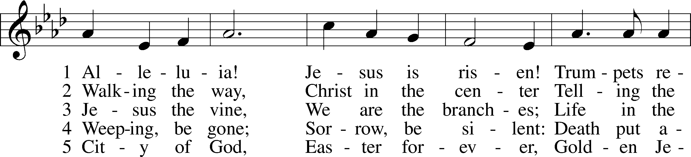
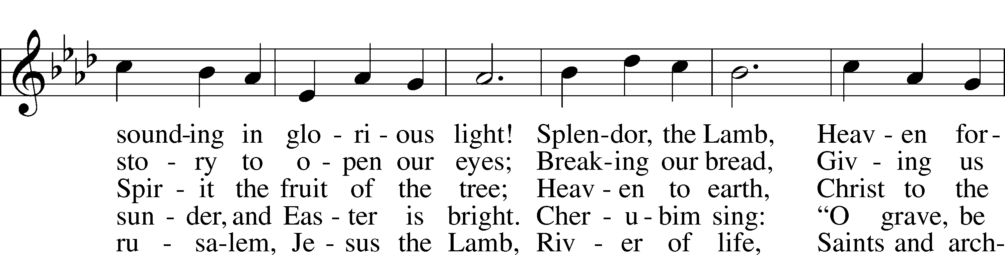
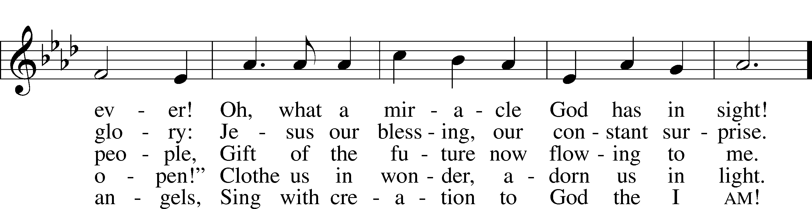
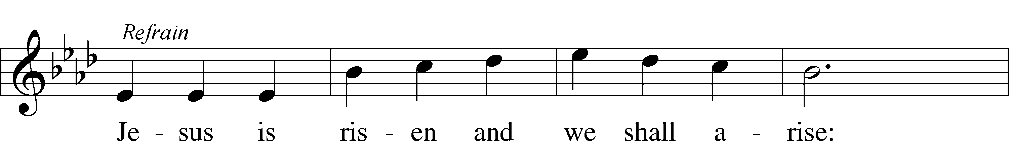
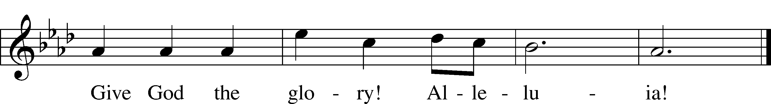
© 1995 Augsburg Fortress. Used by permission: LSB Hymn License .NET, no. 100011641.

Pastor: In the Name of the Father and of the Son and Holy Spirit.
Congregation: Amen.

(Please Remain Standing Or You May Kneel…)
GOD’S PEOPLE CONFESS THEIR SINS:
Pastor: By grace you have been saved, through faith-and this is not from yourselves, it is the gift of God-not of works, so that no man can boast, for we are God’s workmanship, created in Christ Jesus.
Congregation: I know that nothing good lives in me, that is, in my sinful nature, for I have the desire to do what is good, but I cannot carry it out.
Pastor: What I do is not the good I want to do; no, the evil I do not want to do-this I keep doing.
Congregation: In my heart I delight in God’s law, the law that points out what a wretched person I am! Who will rescue me from this body of death?
Pastor: Thanks be to God through Jesus Christ our Lord! Only He can achieve the perfection we fail to achieve. By the forgiveness He purchased on the cross, our forgiveness is complete!

SERVICE OF THE WORD

You may be seated…
THE OLD TESTAMENT READING: Act’s 5:29-42
Lector: This is the Word of the Lord.
People: Thanks be to God.

THE EPISTLE LESSON: 1 Peter 1:3-9
Lector: This is the Word of the Lord.
People: Thanks be to God.
Please stand…
THE HOLY GOSPEL: John 20:19-31
Pastor: The Holy Gospel according to St. John the 20th Chapter
People: Glory to You, O Lord.
Pastor: This is the Gospel of the Lord.
People: Praise to You, O Christ!

Please be seated…
CHILDREN’S MESSAGE

NOISE OFERING
It’s called a noise offering because what we are asking for is pocket change. It will always be used for missions outside of our church and school. It normally also is given to a mission involving children. Thanks for making a joyful noise to the Lord.

THE SERMON HYMN: “How Precious Is the Book Divine”
John Fawcett,1782 / Fred C. Pullin, 1903

SERMON: “So That We May Believe” John 20:19-31

THE PROFESSION OF FAITH:
Pastor: God has given us a great message to take to His world. Let us remind ourselves and one another of what that message is:
Pastor: I believe in God the Father, Almighty
Congregation: Maker of heaven and earth
Pastor: And in His Son, Jesus Christ our Lord,
Congregation: Who was conceived by the Holy Spirit
Pastor: Born of the Virgin Mary
Congregation: Suffered under Pontius Pilate
Pastor: Was crucified, died and was buried
Congregation: He descended into hell.
Pastor: On the third day He rose again from the dead,
Congregation: And ascended into heaven
Pastor: And sits on the right hand of God, the Father almighty
Congregation: From there He will come to judge the living and the dead
Pastor: I believe in the Holy Spirit,
Congregation: The Holy Christian Church as
All: the communion of saints; the forgiveness of sins, the resurrection of the body, and the life everlasting. Amen.

(You may be seated…)
OFFERING RECEIVED

“Praise God, from Whom All Blessings Flow” LSB 805
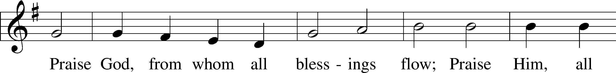
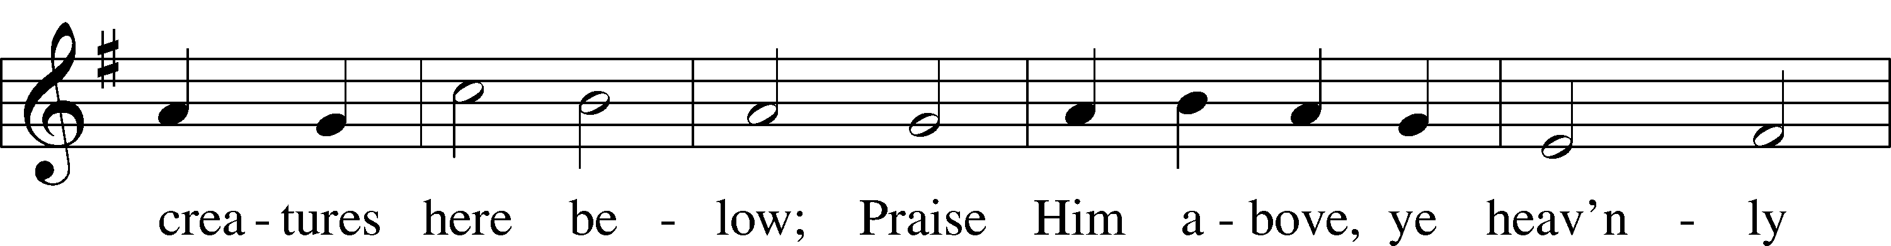
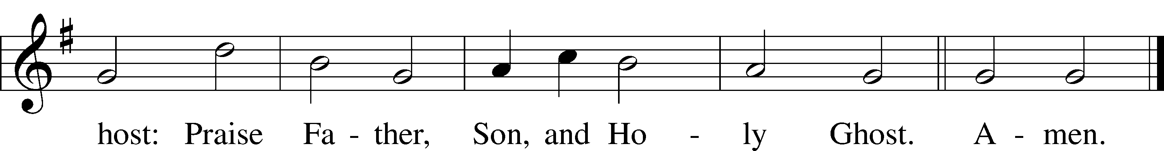
Public domain

(Please stand…)
THE PRAYERS OF THE CHURCH: based on Psalm 98
Pastor: Dear Lord, we thank You for everything You’ve done for us, and most of all for Your own Son, Jesus, our Savior. We will never stop praising You for this wonderful gift.
Congregation: Sing to the Lord a new song, for He has done marvelous things; His right hand and His holy arm have worked salvation for Him.
Pastor: We thank You for those missionaries long ago who brought the Good News to our people. When we were in darkness, You sent men and women to bring us the light. Thank you, Lord.
Congregation: The Lord has made His salvation known and revealed His Righteousness to the nation.
Pastor: O Lord, You are our Savior, we trust in You for all our needs, give healing to the sick, courage to those who are afraid, and peace to those we name in our hearts either silently or out loud. (a moment of silence) We praise You, gracious Lord, for all Your benefits to us. You give us home, friends and family, food, shelter, rest and everything we need. You give us sight and hearing and touch and taste and provide for all of our needs.
Congregation: Shout for joy to the Lord, praise His Name Amen.

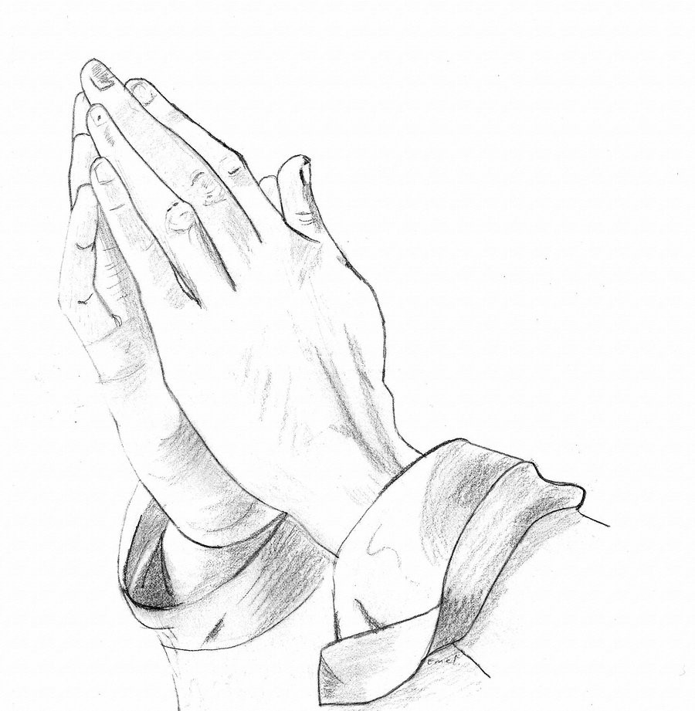

SERVICE OF THE SACRAMENT

(Please be seated…)
THE WORDS OF INSTITUTION:

DISTRIBUTION HYMNS: “Lord Be Glorified”
Words and music by Bob Kilpatrick
“O Sons and Daughters of the King” LSB 471
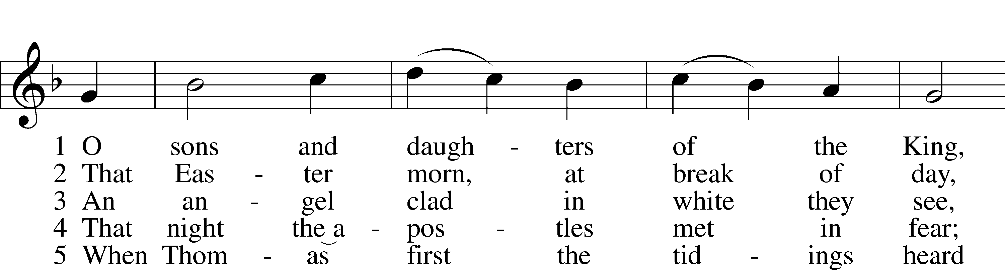
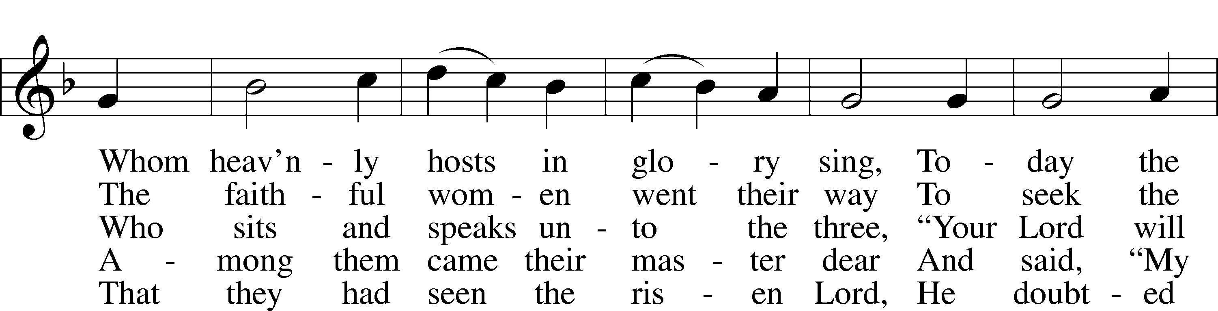
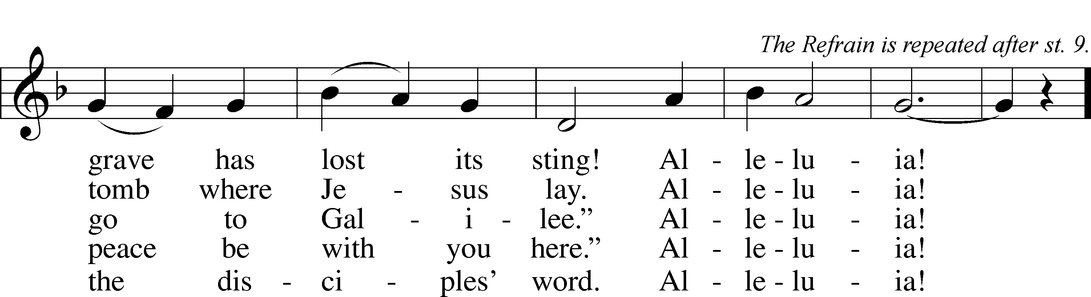

6 “My piercèd side, O Thomas, see,
And look upon My hands, My feet;
Not faithless but believing be.”
Alleluia!

7 No longer Thomas then denied;
He saw the feet, the hands, the side;
“You are my Lord and God!” he cried.
Alleluia!

8 How blest are they who have not seen
And yet whose faith has constant been,
For they eternal life shall win.
Alleluia!

9 On this most holy day of days
Be laud and jubilee and praise:
To God your hearts and voices raise.
Alleluia!
Public domain

“Now All the Vault of Heaven Resounds” LSB 465
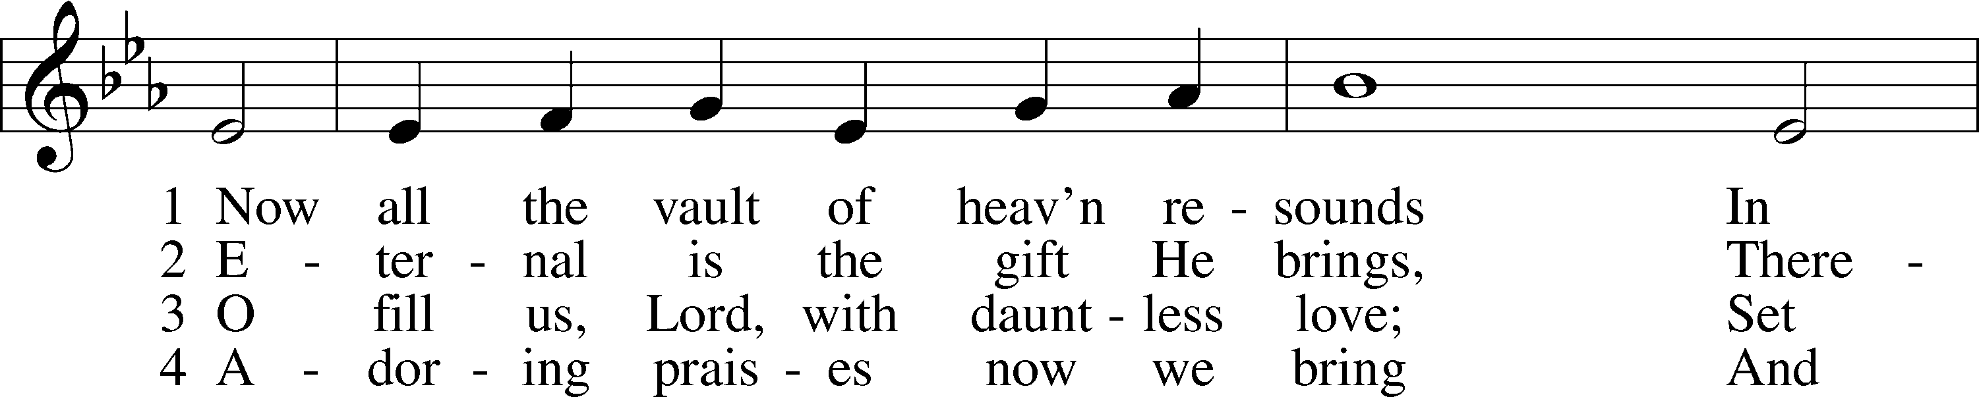
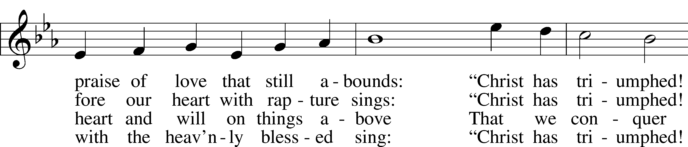
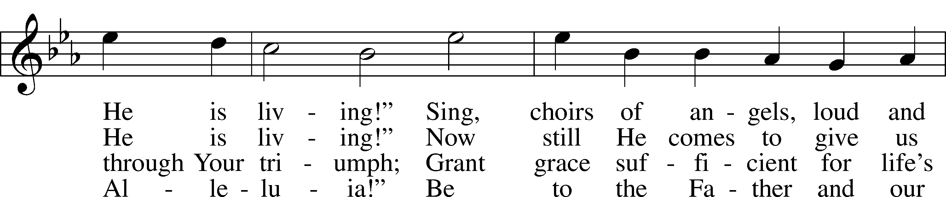
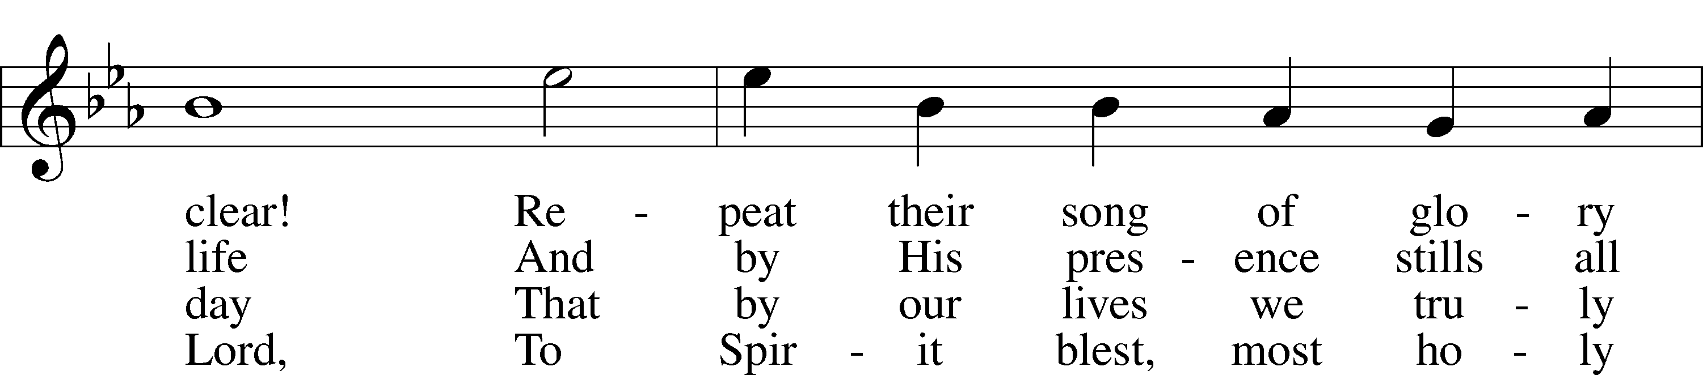
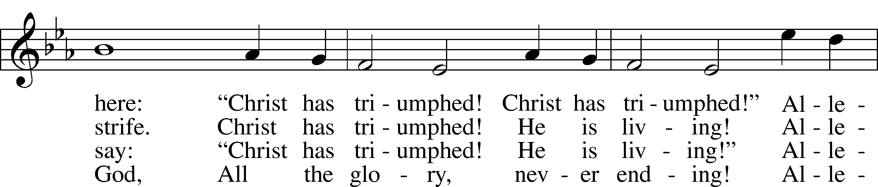
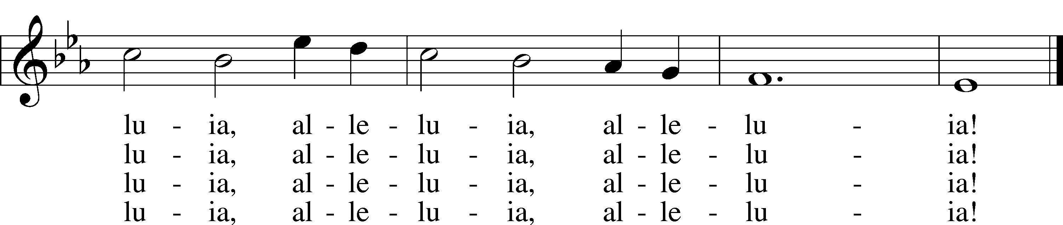
© 1958 Augsburg Publishing House. Used by permission: LSB Hymn License .NET, no. 100011641.
Public domain

Jesus let the things that break your heart
also break our hearts.
Amen

(Please stand…)
THE LORD’S PRAYER:
All: Our Father, who art in heaven, hallowed be thy name, thy kingdom come, thy will be done, on earth as it is in heaven. Give us this day our daily bread; and forgive us our trespasses as we forgive those who trespass against us; and lead us not into temptation, but deliver us from evil. For thine is the kingdom, and the power, and the glory, forever and ever. Amen

THE BENEDICTION

“What are we doing that nobody else is
doing to reach people that nobody else is
reaching?

THE CLOSING HYMN: “To God Be The Glory”
Music by William Howard Doane, Words by Fanny Jane Crosby

WELCOME TO GRACE LUTHERAN CHURCH: We are glad that you are here to worship God with us today! We pray that you will enjoy the wonderful fellowship as friends in Christ as God gathers us around His means of grace, the Word and Sacraments, to bless us with His treasured gifts of forgiveness, faith, abundant life and eternal salvation. If you are a guest, please also sign our Guest Book. Please talk to Pastor if you would like to learn more about becoming a member of Grace. Also, please join us for refreshments and fellowship after the Service. We invite you to come and worship with us often as God gathers us in His Grace.

WELCOME TO THE LORD’S TABLE: We invite and encourage all present who are baptized and faithful Christians, and who confess the Father, Son, and Holy Spirit to be the only true God and who believe that Jesus Christ died for the sins of the World and is our only hope and salvation…to join us in receiving the very and true body and blood of Christ in this Sacrament. The clear liquid cups in the center of the tray are non-alcoholic wine.

Children not yet confirmed in the faith are always welcome to join their parents at the Lord’s Table, but should keep their hands folded in front of them. The Pastor will give them a blessing.

SERVING TODAY: Acolyte: Eli Morris; Lector: Mary Brady : Communion Assistants: Don Bly and Ed Morris; Usher: Bill Chalmers; Altar Care: Madison Howard; Refreshments: Steve and Bobby Bringle.

SERVING NEXT SUNDAY: Acolyte: Elizabeth Reynolds; Lector: JoAnn Broadbent; Communion Assistants: Don Bly and Ed Morris; Usher: Bill Chalmers; Altar Care: The Bly’s; Refreshments: The Bly’s.

FLOWERS: were placed on the altar to the glory of God.

THIS WEEK AT A GLANCE:
Today: April 23rd
9:00 am Worship Service with Communion
Immed. After Vocal Choir Rehearsal
10:10 am Children’s Choir Rehearsal
10:15 am Fellowship
10:30 am Adult Bible Study / Children’s Sunday School

Monday: April 24th
Pastor’s Day Off
5:30 pm Zumba

Tuesday: April 25th
11:30 am Gracious Ladies of Grace Luncheon (Key West Harbor Yacht Club
in downtown Stock Island)
3:00 pm Jan’s Mobile Gym
6:00 pm Weight Watcher’s (Parish Hall)

Wednesday: April 26th
12:30 pm Men’s Bible Fellowship

Thursday: April 27th
4:30 pm Missional Communities

Next Sunday: April 30th
9:00 am Worship Service with Communion
Immed. After Vocal Choir Rehearsal
10:10 am Children’s Choir Rehearsal
10:15 am Fellowship
10:30 am Adult Bible Study / Children’s Sunday School

IN YOUR PRAYERS THIS WEEK: Frank Deford, Larry Vandivier, Carl Vandivier, Bobby Meck, family and friends of Elaine Wavehime, Linda Mullis, Joe Lamberson, Kathy Greenwood, Michael Willard, France Vandivier, Katie Hoffman, Pastor Ray Peters, Family and friends of Will Plagens, Kay Sattelmeier, Dennis Julson, Vernon Julson, Olga Odland, Jean Grafsgaard, Jenie Howard, Jenny Dean, Katie Higgs Wyrwicki, family and friends of George Licis, Charles, Braydon, Champ, Amy, Elsie Hamilton, Sharon Jardas, Mary Ellen Jessel, Marcos Diaz, Kaci Doran, Auwina Weed, Sandy Harris, and those you are praying for at home. If anyone has a special prayer request please submit it in writing in the collection plate; or you may call Pastor Gary Faith at (504-858-8872), or Kris Howard at (305-296-5161).

GIFTS, TITHES, & ATTENDANCE LAST SUNDAY for April 16th were $ 6790.00 with an attendance of 207. The noise offering received $125.49.

TO HELP US GROW… The Bible reading for next Sunday’s service the readings are Acts 2:14a, 36-41, 1 Peter 1:17-25, Luke 24:13-35.

THANK YOU FOR ALL the cards and kind words of sympathy and for the Easter greetings and gifts. All are much appreciated, Pattie and Pastor.

THANK YOU TO TO MANY who went the extra mile to make the Easter celebration a joy. Yal are a blessing to His Kingdom.

HANDY MAN FOR THE SCHOOL: If anyone is interested in applying for the part time, flexible hours’ job of handy man for our school please contact our school secretary Judy Whitney at 305-296-8262.

IT HAS BEEN BROUGHT TO MY ATTENTION that the mothers of our younger children would like the option of having their children taken to a nursery after the children sermon. If you know of anyone who has the gifts and the desire to make this happen have them contact Kris Howard or myself.

A PROBLEM OR A BLESSING? Praise the Lord, we are starting to run out of room in our parking lot on Flagler. If you are healthy and see the parking lot getting full, please consider parking in our lot behind our school. Thanks.

NOISE OFFERING: Currently we are collecting for the Master Builders Center which is a mission to help children in Ethiopia have a home, food, and a relationship with Jesus. If you are interested in more info on the MBC, help yourself to one of the brochures in the lobby.

WE HAVE SET THE SCHEDULES for ushers, acolytes, lectors, and communion assistants for the next three months. If you would like to serve in any of these positions, please let Pastor or Kris know.
STEWARDSHIP LISTS: On the bulletin board by the front door of the church you will find the Altar Care, Refreshments, and Flower sign-up sheets for 2017. If you are able to help out with any of these please place your name in the spot on the date requested.

SOME DATES TO MARK ON YOUR CALENDAR

GRACIOUS LADIES OF GRACE: The Ladies had an intimate lunch at the Sheraton Suites on Tuesday with only 7 attending. The food was good and a nice server but really no ambiance. It was noisy and situated in the middle of all the hotel activity. It was a 4* at best. On the positive side we all got caught up on our news and enjoyed being together. Did I mention it was a gorgeous day, sunny, nice and cool. We said thank you to Jesus and planned the next lunch for April 25th at the Key West Harbor Yacht Club in downtown Stock Island at 11:30. Ahoy mateys wear your blue and white and join us.

THE GRACE LUTHERAN CHURCH WEB PAGE AND FACE BOOK PAGE now contains a vocal recording of last week’s sermon. So, if you are not able to attend church on Sunday please go to our website where you will find a copy of the bulletin and a recording of Pastor Faith’s sermon. https://gracelutherankw.360unite.com/home.

A NUMBER OF CAPITAL IMPROVEMENTS are needed to keep our facilities in good health for the future. Roof repairs are needed on school buildings and the parsonage. If you can help it would be much appreciated! A big thanks to all who have contributed to these repairs.

SUNDAY SCHOOL: Sunday school for all ages will follow refreshments from 10:30 until 11:30 in the following rooms.

High school is in room number 1 (just past the adult Bible study room on the right)

Middle school, 6th 7th and 8th grades, in room number 3 with Mike Sattelmeier and Jim Schuetzler. (Turn left down the school hallway to the first room).

3rd, 4th and 5th grades in room 5 with Don and Kris Bly. (third room left down the school hallway).

Preschool through second grade with JoAnn Broadbent in room 7. (Last room on the left down the school hallway)

Hope to see everyone there! Any questions? Ask Kris Bly, Sunday School director, 305-509-1447 or Kris Howard, church Secretary.

IF YOU ARE INSTRUMENTALLY INCLINED and would like to share your talents with an instrument during our services or accompany our organist and/or choir, please speak to our organist Debbie Schuetzler.

MUSIC MINISTRY: "Make a joyful noise to the Lord, all the earth!" Psalm 100:1. Whether you are here year-round or only part-time, we invite you to participate in our music ministry. Please speak with Beverly Walker or contact her with any questions at beverlywalker@gmail.com .

Children's Choir: There is no rehearsal today. We will rehearse next Sunday from 10:10-10:25.

Bell Choir: The next rehearsal will be Wednesday, May 3 from 5:45-6:30 pm.

Vocal Choir: There will be a short rehearsal next Sunday immediately after the Service.

MEN’S BIBLE FELLOWSHIP: They meet the first and third Wednesday’s of each month at 12:30pm. Their next meeting will be May 3rd located at Chico’s on Stock Island. All guys are welcome.

WOMEN’S BIBLE STUDY: Will meet again after Easter. If there are any questions, please contact Monica Bacle 305 923-0856.

MISSIONAL COMMUNITIES: meets at 4:30pm on Thursdays. All are welcome to experience an opportunity to grow in our relationships with Jesus and His flock.

