**April 2nd, 2016**

**9:00 am**

**FIFTH SUNDAY**

**IN LENT**



**Grace Lutheran Church**

**2713 Flagler Ave.**

**Key West, FL 33040**

**305-296-5161**

[**GraceLutheranKW@att.net**](mailto:GraceLutheranKW@att.net)

gracelutherankw.360unite

**Pastor Faith**

**(504) 858-8872**

**garyfaith@aol.com**

**FIFTH SUNDAY IN LENT**

**April 2nd, 2017 9:00 a.m.**

**WORSHIP SERVICE**

***In the Name of Jesus!***

**Our Mission Statement: Anchored in Christ, each person a missionary.**

**PRELUDE**

**ANNOUNCEMENTS:**

**God is with us all during the week, wherever we are and in whatever we are doing. This week, let’s enjoy His presence.**

*(Please Stand…)*

**HYMN:** ***“Come, Thou Fount of Every Blessing”***

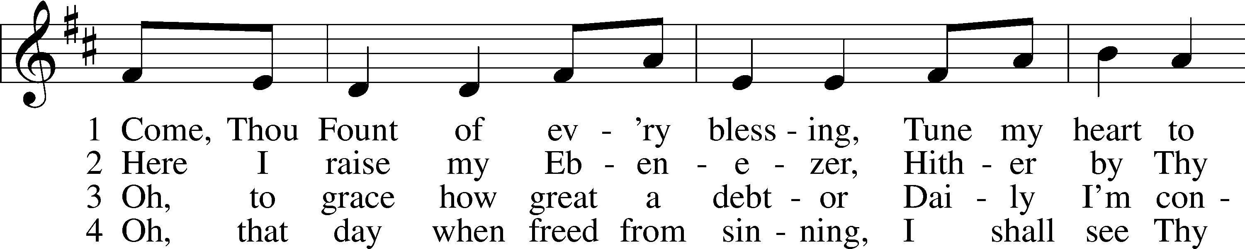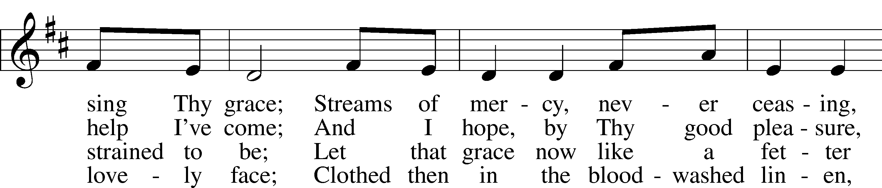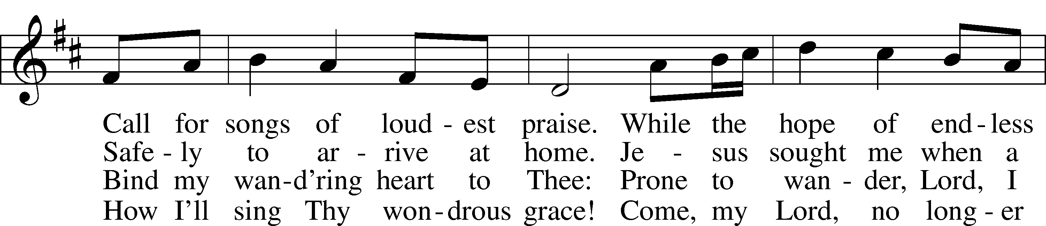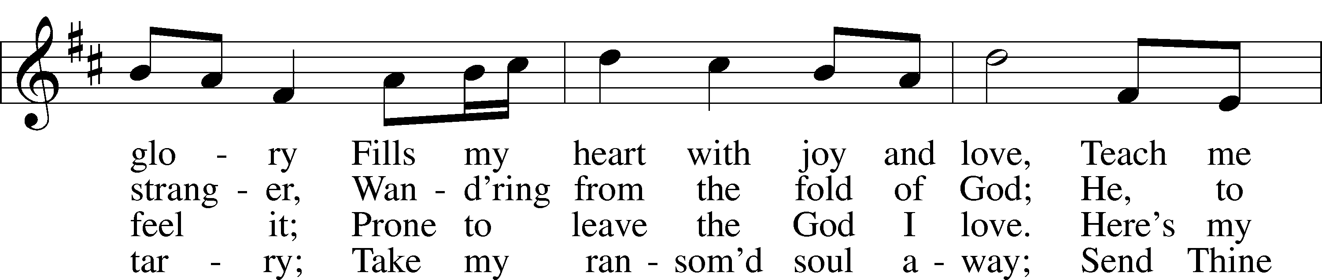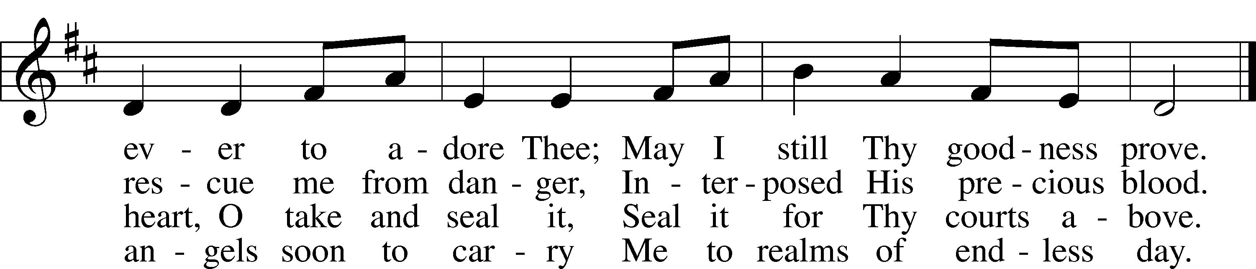

Public domain

Pastor: In the Name of the Father and of the Son and Holy Spirit.

**Congregation: Amen.**

**PREPARATION**

*(Please Remain Standing Or You May Kneel…)*

**CONFESSION OF SIN:**

**All: God, I admit I have broken all of your commandments; I am not holy or sinless even though I often pretend a righteousness I do not have. I offer excuses. I have broken relationships by what I have said, or done. I have not loved either You or my neighbor as I ought. (time for personal confession____)**

**YOU ARE FORGIVEN:**

Pastor: God is merciful and gracious; He has given His Son, Jesus Christ to die and rise again for us, the sinful ones that we might be forgiven and enjoy His Peace. This is also a reminder of God’s gifts and blessing that have become ours in Holy Baptism.

**Congregation: thank you God for Your blessing!**

Pastor: Yes, the Grace of our Lord Jesus Christ, and the Love of God, and the fellowship of His Holy Spirit is with you all.

**Congregation: And also with you.**

Pastor: In peace and as His forgiven people, we can pray to the Lord:

**Congregation: He is gracious to us and hears our prayers.**

Pastor: For the peace of the whole world and our involvement in Christ’s Mission in the world, we pray:

**Congregation: Keep us mindful of our purpose as Christians and our ability to share your blessings of peace and forgiveness with others.**

Pastor: We are the children of the Risen Christ. His victory is Our Victory!

**THE PRAYERS OF THE CHURCH:**

**All: Almighty God, by Your great goodness mercifully look upon Your people that we may be governed and preserved evermore in body and soul; through Jesus Christ, Your Son, our Lord, who lives and reigns with You and the Holy Spirit, one God, now and forever. Amen.**

**SERVICE OF THE WORD**

**God speaks to us through his word, the Bible:**

*You may be seated…*

**THE OLD TESTAMENT LESSON: Ezekiel 37:1-14**

Lector: This is the Word of the Lord.

**People: Thanks be to God.**

**THE EPISTLE LESSON: Romans 8:1-11**

Lector: This is the Word of the Lord.

**People: Thanks be to God.**

*Please stand…*

**THE HOLY GOSPEL: John 11:1-45**

Pastor: The Holy Gospel according to St. John the 11th Chapter

**People: Glory to You, O Lord.**

Pastor: This is the Gospel of the Lord.

**People: Praise to You, O Christ!**

*Please be seated…*

**SERMON HYMN: 861 Christ Be My Leader**

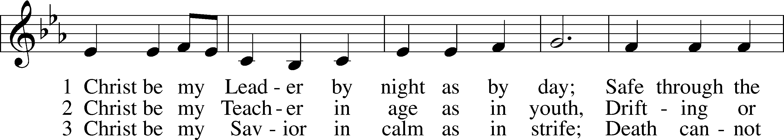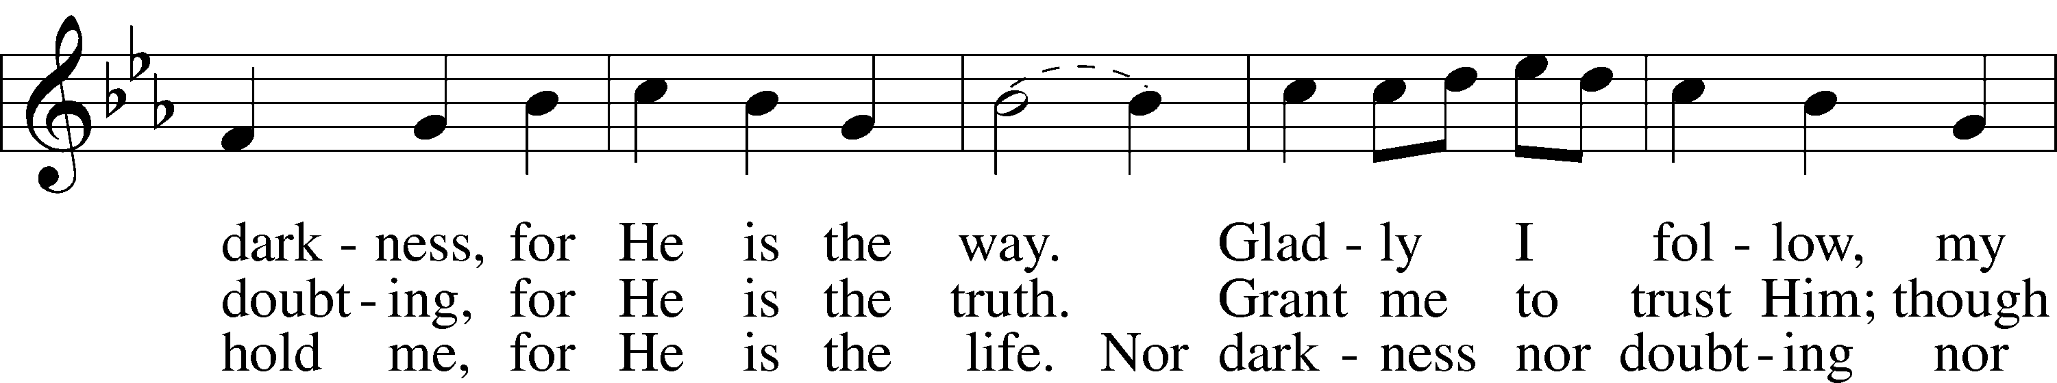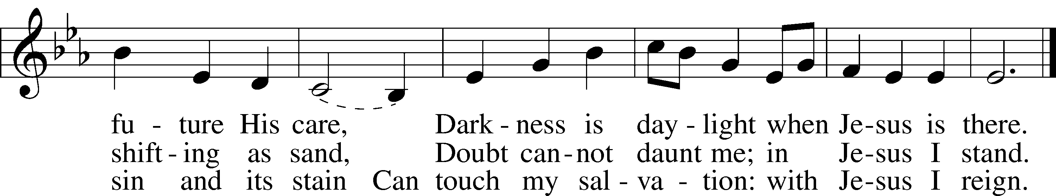

© 1964, renewed 1992 Hope Publishing Co. Used by permission: LSB Hymn License .NET, no. 100011641.Public domain

**THE SERMON: David Walker, Elder**

*(Please stand…)*

**THE PROFESSION OF FAITH:**

Pastor: God has given us a great message to take to His world. Let us remind ourselves and one another of what that message is:

Pastor: I believe in God the Father, Almighty

**Congregation: Maker of heaven and earth**

Pastor: And in His Son, Jesus Christ our Lord,

**Congregation: Who was conceived by the Holy Spirit**

Pastor: Born of the Virgin Mary

**Congregation: Suffered under Pontius Pilate**

Pastor: Was crucified, died and was buried

**Congregation: He descended into hell.**

Pastor: On the third day He rose again from the dead,

**Congregation: And ascended into heaven**

Pastor: And sits on the right hand of God, the Father almighty

**Congregation: From there He will come to judge the living and the dead**

Pastor: I believe in the Holy Spirit,

**Congregation: The Holy Christian Church as**

**All: the communion of saints; the forgiveness of sins, the resurrection of the body, and the life everlasting. Amen.**



*(You may be seated…)*

**OFFERING RECEIVED: *“Taste and See”* Vocal Choir**

**(***Please stand…)*

***“Praise God, from Whom All Blessings Flow”* LSB 805**

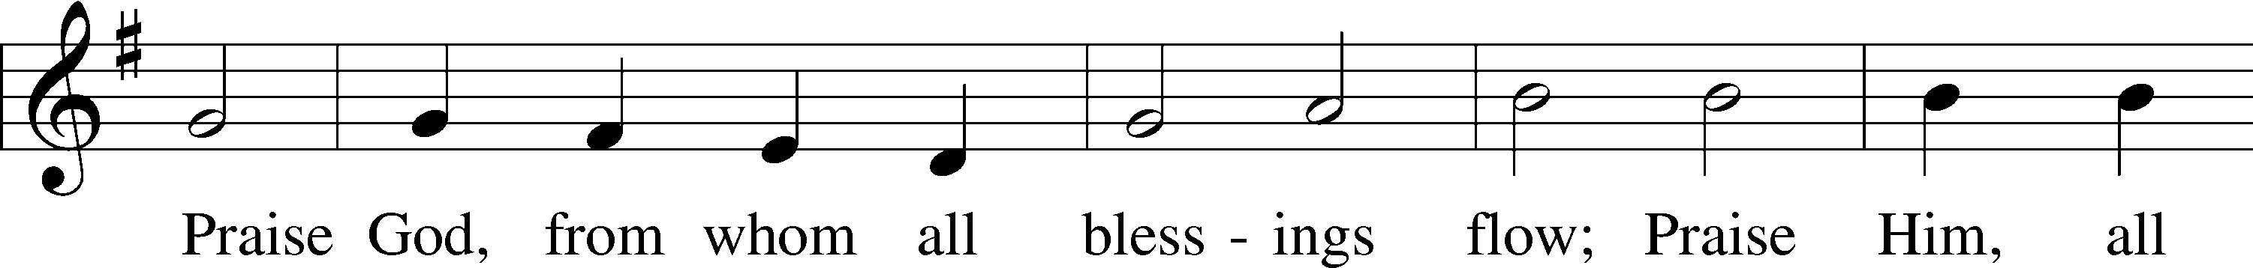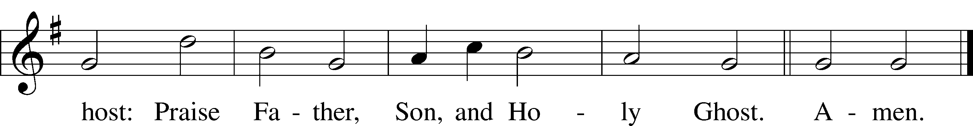

Public domain

**SERVICE OF THE SACRAMENT**

*(Please stand…)*

**PREPARE FOR THE LORD’S SUPPER:**

Pastor: We begin with the reminder: “The Lord is with you.”

**Congregation: We are mindful and thankful for His presence.**

Pastor: Let your life reflect the joy of your salvation.

**Congregation: We do give Him thanks and praise. We will share His blessing with others.**

Pastor: It is proper that we should at all times and in all places…(prayer)… we praise your name and join others in singing:

**All: (sing) “Holy, holy, holy Lord God of pow’r and might:**

**Heaven and earth are full of your glory.**

**Hosanna, Hosanna, Hosanna in the highest.**

**Blessed is he who comes in the name of the Lord.**

**Hosanna in the highest.”**



**“What are we doing that nobody else is**

**doing to reach people that nobody else**

**is reaching?**

*(Please be seated…)*

**THE WORDS OF INSTITUTION**

**DISTRIBUTION HYMNS: *“Father I Adore You”* Music and Words by Terrye Coelho**

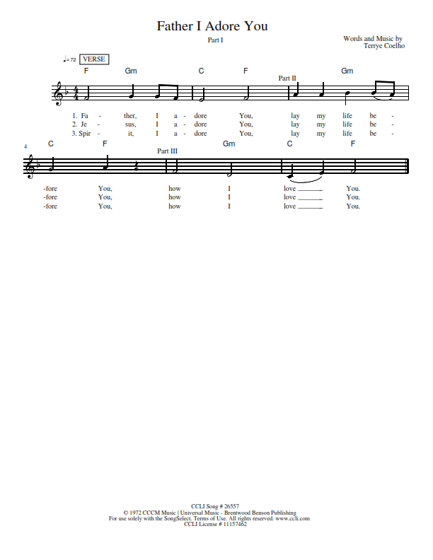

***“I Am The Resurrection”***

**Music and Words by Ray Repp**

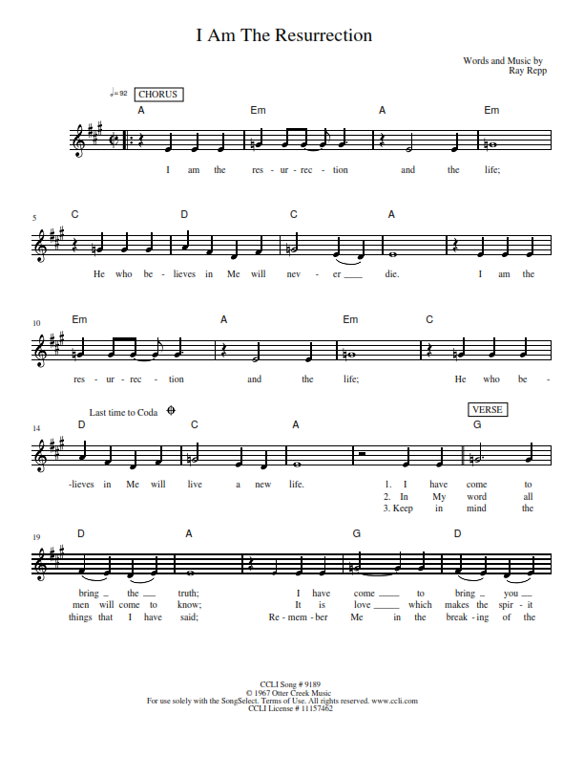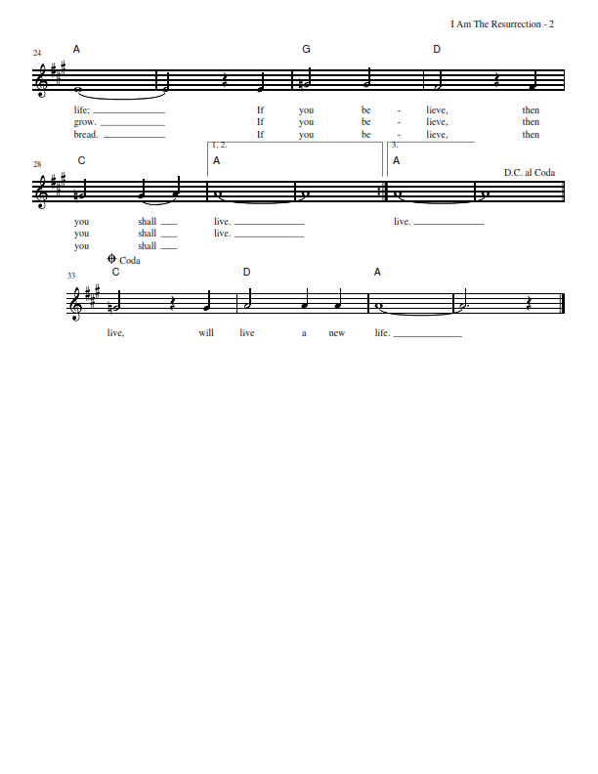

Jesus let the things that break

your heart also break our hearts.

Amen

***“Let Us Ever Walk with Jesus”* LSB 685**

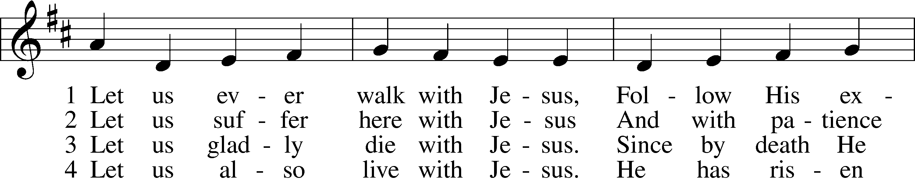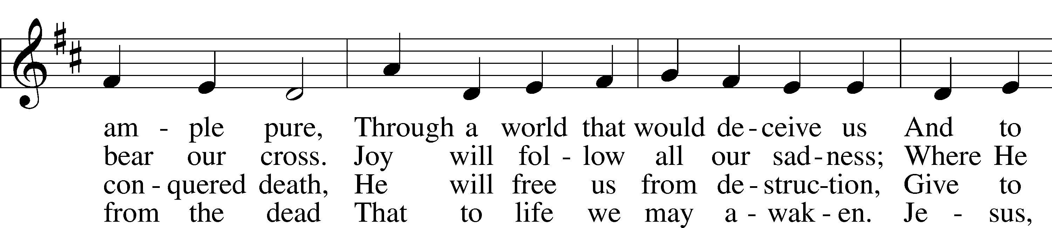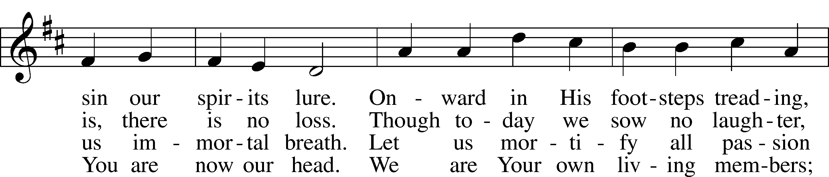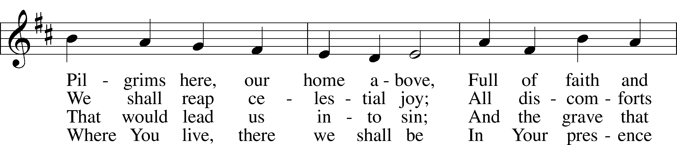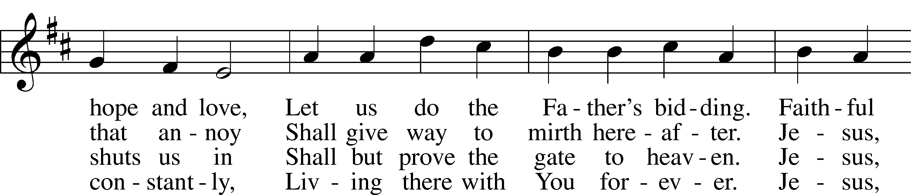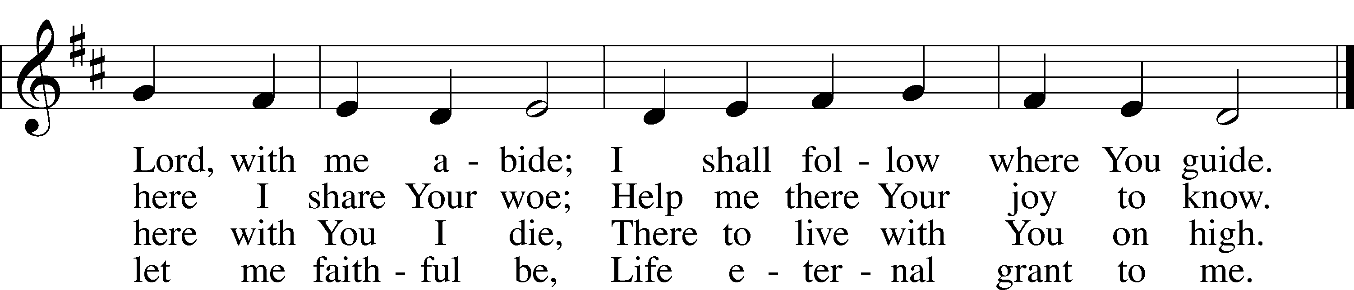

© 1978 Lutheran Book of Worship. Used by permission: LSB Hymn License .NET, no. 100011641.  
Public domain

***“My Hope Is Built on Nothing Less”* LSB 576**

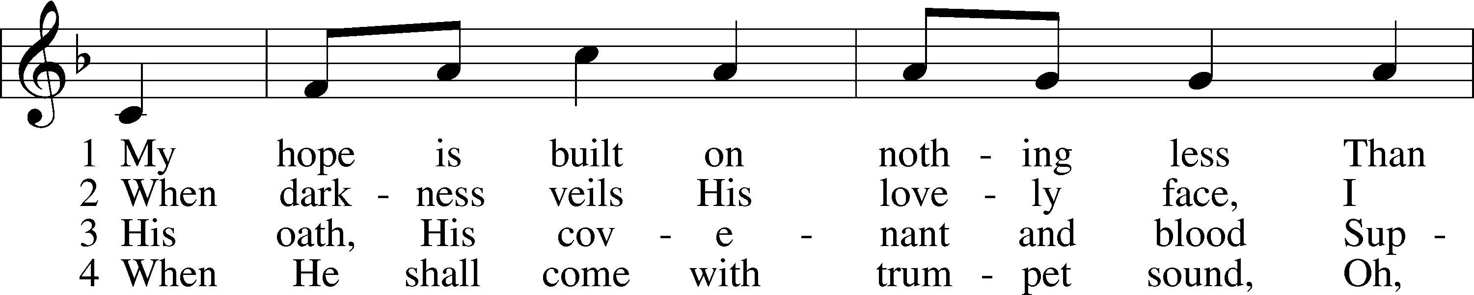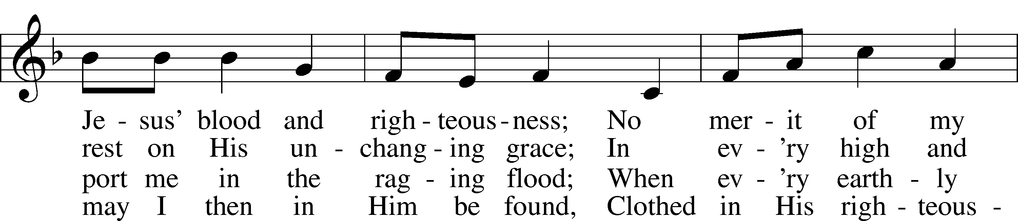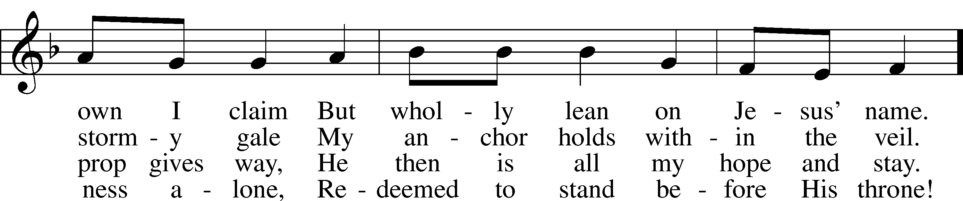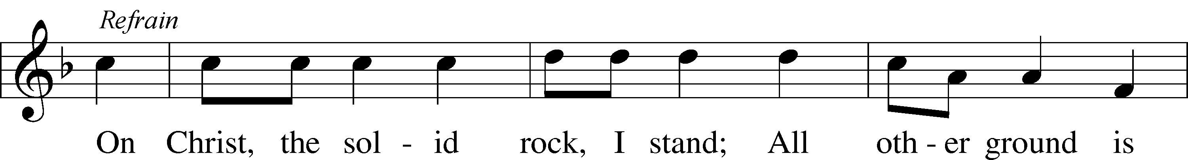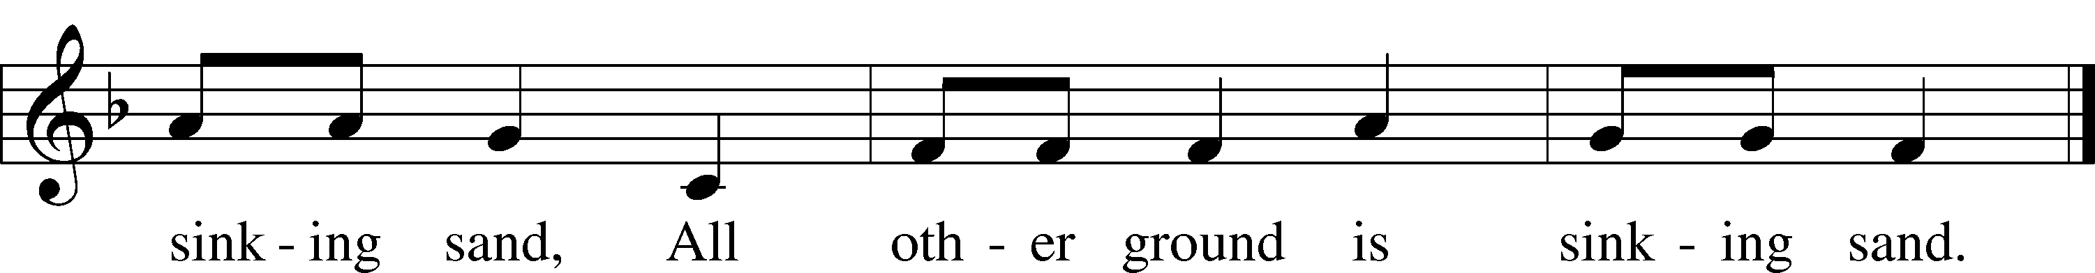

Public domain

*(Please stand…)*

**THE LORD’S PRAYER:**

**All: Our Father, who art in heaven, hallowed be thy name, thy kingdom come, thy will be done, on earth as it is in heaven. Give us this day our daily bread; and forgive us our trespasses as we forgive those who trespass against us; and lead us not into temptation, but deliver us from evil. For thine is the kingdom, and the power, and the glory, forever and ever. Amen**

**THE BLESSING AND BENEDICTION:**

Pastor: The Lord Blesses you and keeps you, the Lord makes His face to shine upon you and He is Gracious to you. The Lord looks upon you with His favor and gives you His peace.

**Congregation: God blesses us so that we can be a blessing to others.**

Pastor: Go in His peace and serve the Lord by serving others.

**Congregation: Amen**

**THE CLOSING HYMN: *“Stand Up, Stand Up for Jesus”*  LSB 660**

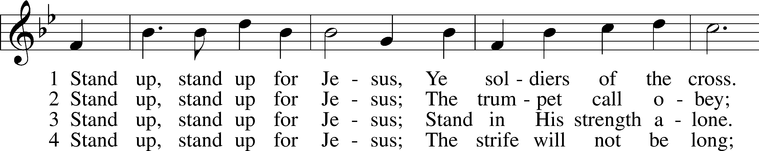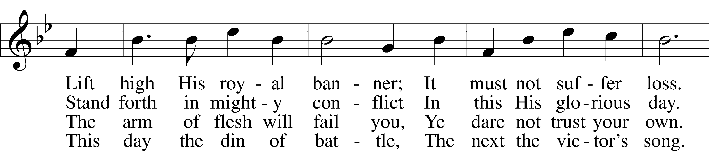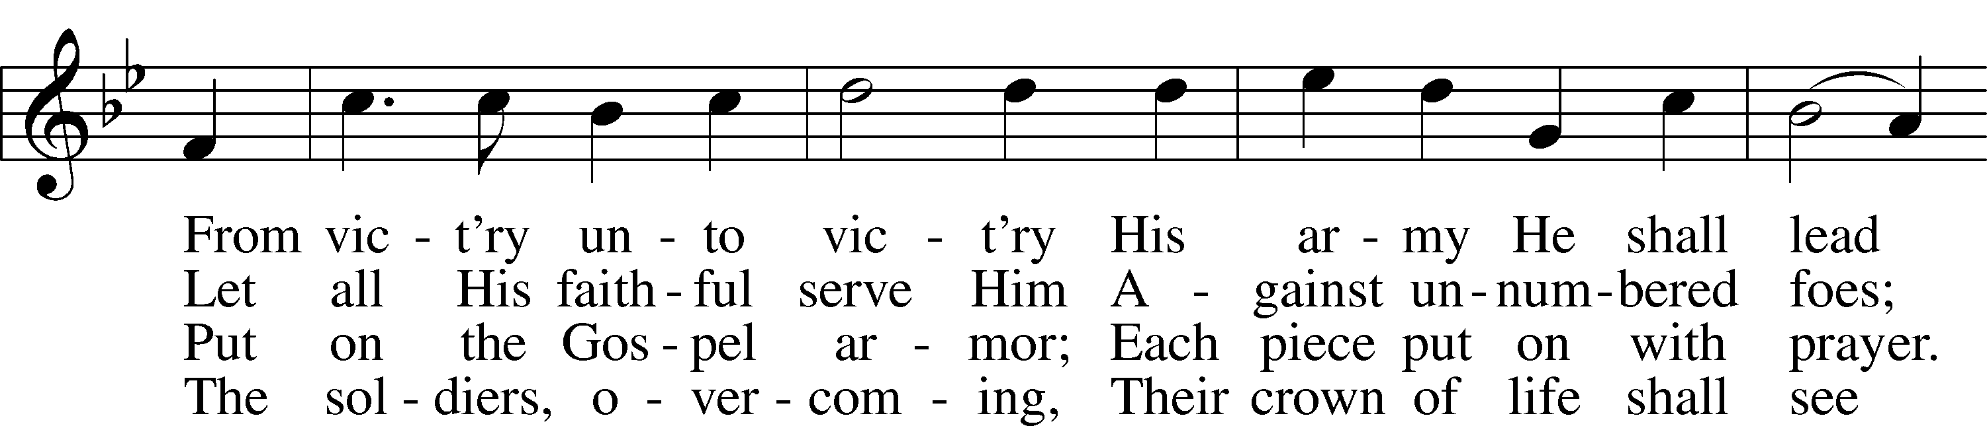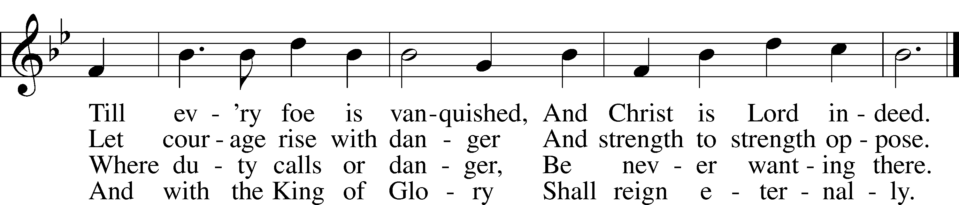

Public domain



**WELCOME TO GRACE LUTHERAN CHURCH:** We are glad that you are here to worship God with us today! We pray that you will enjoy the wonderful fellowship as friends in Christ as God gathers us around His means of grace, the Word and Sacraments, to bless us with His treasured gifts of forgiveness, faith, abundant life and eternal salvation. If you are a guest, please also sign our Guest Book. Please talk to Pastor if you would like **to learn more about becoming a member of Grace. Also, please join us for refreshments** and fellowship after the Service. We invite you to come and worship with us often as God gathers us in His Grace.

**WELCOME TO THE LORD’S TABLE:** We invite and encourage all present who are baptized and faithful Christians, and who confess the Father, Son, and Holy Spirit to be the only true God and who believe that Jesus Christ died for the sins of the World and is our only hope and salvation…to join us in receiving the very and true body and blood of Christ in this Sacrament. The clear liquid cups in the center of the tray are non-alcoholic wine.

Children not yet confirmed in the faith are always welcome to join their parents at the Lord’s Table, but should keep their hands folded in front of them. The Pastor will give them a blessing.

**SERVING TODAY:** Acolyte: Eli Morris; Lector: Garnet Picking; Communion Assistants: Don Bly and Ed Morris; Usher: Bill Chalmers; Altar Care: ___________; Refreshments: __________.

**WEDNESDAY April 5th:** Acolyte: Elizabeth Reynolds

**SERVING NEXT SUNDAY:** Acolyte: James Reynolds; Lector: Mike Sattelmeier; Communion Assistants: Don Bly and Ed Morris; Usher: Bill Chalmers; Altar Care: The Bly Family; Refreshments: The Bly Family.

**FLOWERS**: were placed on the altar to the glory of God by Ed and Nancy Swift in memory of Mary Bacle.

THIS WEEK AT A GLANCE:

**Today: April 2nd**

9:00 am Worship Service with Communion

10:00 am Vocal Choir Rehearsal

10:10 am Children’s Choir Rehearsal

10:15 am Fellowship

10:30 am Adult Bible Study / Children’s Sunday School

**Monday: April 3rd**

Pastor’s Day Off

5:30 pm Zumba

**Tuesday: April 4th**

3:00 pm Jan’s Mobile Gym

6:00 pm Weight Watcher’s (Parish Hall)

**Wednesday: April 5th**

5:45 pm Bell Choir Rehearsal

6:00 pm Potluck

7:00 pm Lenten Wednesday Service

Immediately after Vocal Choir Rehearsal

**Thursday: April 6th**

4:30 pm Missional Communities (Room 3) (Tentative)

**Next Sunday: April 9th**

9:00 am Palm Sunday Worship Service with Communion

10:00 am Children’s Choir Rehearsal

10:15 am Vocal Choir Rehearsal

10:15 am Fellowship

10:30 am Adult Bible Study / Children’s Sunday School

12:00 pm Adult Information Class

**IN YOUR PRAYERS THIS WEEK:** Bobby Meck, family and friends of Elaine Wavehime, Linda Mullis, Joe Lamberson, Kathy Greenwood, Michael Willard, France Vandivier, Katie Hoffman, Pastor Ray Peters, Family and friends of Will Plagens, Kay Sattelmeier, Dennis Julson, Vernon Julson, Olga Odland, Jean Grafsgaard, Jenie Howard, Jenny Dean, Katie Higgs Wyrwicki, family and friends of George Licis, Charles, Braydon, Champ, Amy, Elsie Hamilton, Sharon Jardas, Mary Ellen Jessel, Marcos Diaz, Kaci Doran, Auwina Weed, Sandy Harris, and those you are praying for at home. If anyone has a special prayer request please submit it in writing in the collection plate; or you may call Pastor Gary Faith at (504-858-8872), or Kris Howard at (305-296-5161).

**GIFTS, TITHES, & ATTENDANCE LAST SUNDAY** for March 26th were $4827.00 and the building fund received $200.00 with an attendance of 99. Lenten Wednesday Service the offering was donated to “Jews for Jesus” with an attendance of 37.

**TO HELP US GROW…** The Bible reading for next Sunday’s service the readings are Zechariah 9:9-10, Philippians 2:5-11, and John 12:9-19.

**APRIL 2ND IT’S ALL ABOUT RELATIONSHIPS:** **HAS BEEN POSTPONED UNTIL FURTHER NOTICE**

**SESSION 2 OF THE ADULT INFORMATION CLASS** will be held on April 9th, from noon through 2pm.

**HOLY WEEK SCHEDULE**:

April 13th Maundy Thursday, Communion Service at 7:00 pm

April 14th Good Friday, Tenebrae Service at 7:00 pm

April 16th Easter Sunrise Service in the Parking Lot at 6:30 am

Easter Service at 9:00 am

**Fellowship and Refreshments will follow both Easter Services. There will be no Potlucks on Thursday or Friday.**

**HANDY MAN FOR THE SCHOOL:** If anyone is interested in applying for the part time, flexible hours’ job of handy man for our school please contact our school secretary Judy Whitney at 305-296-8262.

**IT HAS BEEN BROUGH TO MY ATTENTION** that the mothers of our younger children would like the option of having their children taken to a nursery after the children sermon. If you know of anyone who has the gifts and the desire to make this happen have them contact Kris Howard or myself.

**THIS WEEK WE CONTINUE OUR LENTEN JOURNEY FOR 2017** with our Wednesday Service at 7:00pm. Please join us at 6:00pm for fellowship and a Potluck in the parish hall prior to services.

**LENTEN POTLUCKS:** Please come and enjoy our final potluck dinner for the Lenten Season this Wednesday evening at 6:00pm before our weekly Wednesday services at 7:00pm.

**A PROBLEM OR A BLESSING?** Praise the Lord, we are starting to run out of room in our parking lot on Flagler. If you are healthy and see the parking lot getting full, please consider parking in our lot behind our school. Thanks.

**NOISE OFFERING:** Currently we are collecting for the Master Builders Center which is a mission to help children in Ethiopia have a home, food, and a relationship with Jesus. If you are interested in more info on the MBC, help yourself to one of the brochures in the lobby.

**MISSIONAL COMMUNITIES:** meets at 4:30pm on Thursdays. **All are welcome** to experience an opportunity to grow in our relationships with Jesus and His flock.

**WE HAVE SET THE SCHEDULES** for ushers, acolytes, lectors, and communion assistants for the 1st three months. If you would like to serve in any of these positions, please let Pastor or Kris know.

**STEWARDSHIP LISTS:** On the bulletin board by the front door of the church you will find the Altar Care, Refreshments, and Flower sign-up sheets for 2017. If you are able to help out with any of these please place your name in the spot on the date requested.

**SOME DATES TO MARK ON YOUR CALENDAR**

**GRACIOUS LADIES OF GRACE:** The Gracious Ladies dined at the DoubleTree Resort and had a delicious lunch with no complaints only oohs and ahhs. We had the place to ourselves with a very attentive waitperson (don't you just love that term "waitperson") a very nice gentleman who had our separate checks waiting for us and not one mistake. Believe it or not that is a big deal. We were the first recipients of their new menu which we all enjoyed and gave a 5*.  Next big dining adventure is at the Sheraton across from Smather’s Beach on April 11th at 11:30.

**THE GRACE LUTHERAN CHURCH WEB PAGE AND FACE BOOK PAGE** now contains a vocal recording of last week’s sermon. So, if you are not able to attend church on Sunday please go to our website where you will find a copy of the bulletin and a recording of Pastor Faith’s sermon. <https://gracelutherankw.360unite.com/home>.

**A NUMBER OF CAPITAL IMPROVEMENTS** are needed to keep our facilities in good health for the future. Roof repairs are needed on school buildings and the parsonage. If you can help it would be much appreciated! A big thanks to all who

have contributed to these repairs.



**SUNDAY SCHOOL:** Sunday school for all ages will follow refreshments from 10:30 until 11:30 in the following rooms.

High school is in room number 1 (just past the adult Bible study room on the right)

Middle school, 6th 7th and 8th grades, in room number 3 with Mike Sattelmeier and Jim Schuetzler. (Turn left down the school hallway to the first room).

3rd, 4th and 5th grades in room 5 with Don and Kris Bly. (third room left down the school hallway).

Preschool through second grade with JoAnn Broadbent in room 7. (Last room on the left down the school hallway)

Hope to see everyone there! Any questions? Ask Kris Bly, Sunday School director, 305-509-1447 or Kris Howard, church Secretary.



**IF YOU ARE INSTRUMENTALLY INCLINED** and would like to share your talents with an instrument during our services or accompany our organist and/or choir, please speak to our organist Debbie Schuetzler.

**MUSIC MINISTRY:** "Make a joyful noise to the Lord, all the earth!" Psalm 100:1. Whether you are here year-round or only part-time, we invite you to participate in our music ministry. Please speak with Beverly Walker or contact her with any questions at [beverlywalker@gmail.com](mailto:beverlywalker@gmail.com) .

Children's Vocal and Chime Choir for Kindergarten - 5th grade: Rehearsal today from 10:10 - 10:25. Please meet by the piano.

Vocal choir: Rehearses on Wednesday immediately after the Service.  
  
Bell Choir: Rehearsal on Wednesday from 5:45-6:15.



**MEN’S BIBLE FELLOWSHIP**: They meet the first and third Wednesday’s of each month at 12:30pm. Their next meeting will be April 5th located at Chico’s on Stock Island. All guys are welcome.

**WOMEN’S BIBLE STUDY**: Will meet again after Easter. If there are any questions, please contact Monica Bacle 305 923-0856.