**March 26, 2017**

**9:00 am**

**FOURTH SUNDAY**

**IN LENT**



**Grace Lutheran Church**

**2713 Flagler Ave.**

**Key West, FL 33040**

**305-296-5161**

[**GraceLutheranKW@att.net**](mailto:GraceLutheranKW@att.net)

gracelutherankw.360unite

**Pastor Faith**

**(504) 858-8872**

**garyfaith@aol.com**

**FOURTH SUNDAY IN LENT**

**MARCH 26TH, 2017 9:00 a.m.**

**WORSHIP SERVICE**

***In the Name of Jesus!***

**Our Mission Statement: Anchored in Christ, each person a missionary.**

**PRELUDE**

**ANNOUNCEMENTS:**

**God is with us all during the week, wherever we are and in whatever we are doing. This week, let’s enjoy His presence.**

*(Please Stand…)*

**HYMN:** ***“Drawn to the Cross, Which Thou Hast Blessed”*  LSB 560**

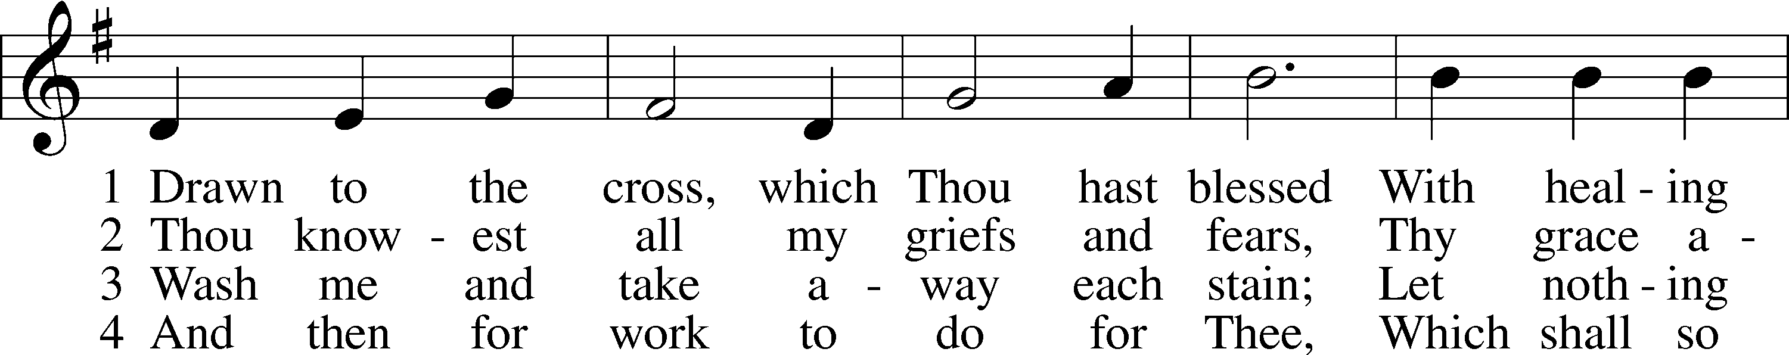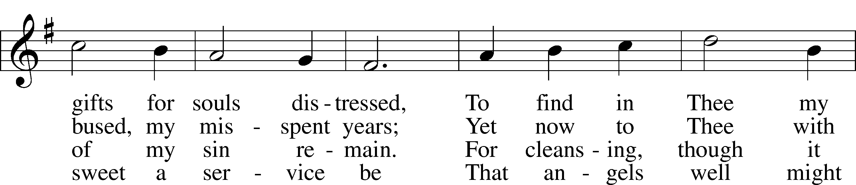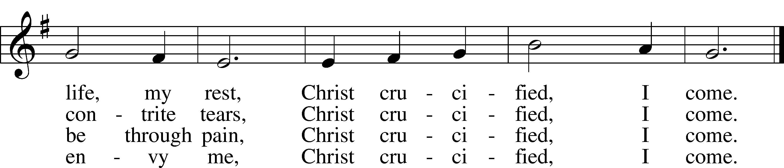

Public domain

Pastor: In the Name of the Father and of the Son and Holy Spirit.

**Congregation: Amen.**

**PREPARATION**

*(Please Remain Standing Or You May Kneel…)*

**CONFESSION OF SIN:**

**All: God, I admit I have broken all of your commandments; I am not holy or sinless even though I often pretend a righteousness I do not have. I offer excuses. I have broken relationships by what I have said, or done. I have not loved either You or my neighbor as I ought. (time for personal confession____)**

**YOU ARE FORGIVEN:**

Pastor: God is merciful and gracious; He has given His Son, Jesus Christ to die and rise again for us, the sinful ones that we might be forgiven and enjoy His Peace. This is also a reminder of God’s gifts and blessing that have become ours in Holy Baptism.

**Congregation: thank you God for Your blessing!**

Pastor: Yes, the Grace of our Lord Jesus Christ, and the Love of God, and the fellowship of His Holy Spirit is with you all.

**Congregation: And also with you.**

Pastor: In peace and as His forgiven people, we can pray to the Lord:

**Congregation: He is gracious to us and hears our prayers.**

Pastor: For the peace of the whole world and our involvement in Christ’s Mission in the world, we pray:

**Congregation: Keep us mindful of our purpose as Christians and our ability to share your blessings of peace and forgiveness with others.**

Pastor: We are the children of the Risen Christ. His victory is Our Victory!

**THE PRAYERS OF THE CHURCH:**

**All: Almighty God, our heavenly Father, Your mercies are new every morning; and though we deserve only punishment, You receive us as Your children and provide for all our needs of body and soul. Grant that we may heartily acknowledge Your merciful goodness, give thanks for all Your benefits and serve You in willing obedience; through Jesus Christ, Our Son , our Lord, who lives and reigns with You and the Holy Spirit, one God, now and forever. Amen.**

**SERVICE OF THE WORD**

**God speaks to us through his word, the Bible:**

*You may be seated…*

**THE OLD TESTAMENT LESSON: Isaiah 42:14-21**

Lector: This is the Word of the Lord.

**People: Thanks be to God.**

**THE EPISTLE LESSON: Ephesians 5:8-14**

Lector: This is the Word of the Lord.

**People: Thanks be to God.**

*Please stand…*

**THE HOLY GOSPEL: John 9:1-41**

Pastor: The Holy Gospel according to St. John the 9th Chapter

**People: Glory to You, O Lord.**

Pastor: This is the Gospel of the Lord.

**People: Praise to You, O Christ!**

*Please be seated…*



**CHILDREN’S MESSAGE**

**NOISE OFERING**



**“What are we doing that nobody else is**

**doing to reach people that nobody else**

**is reaching?**

**SERMON HYMN:  *“Amazing Grace”* LSB 744**

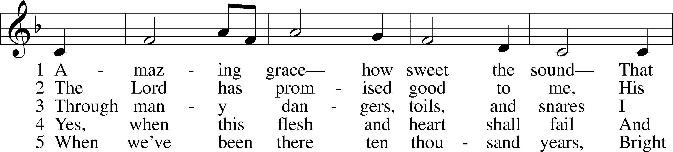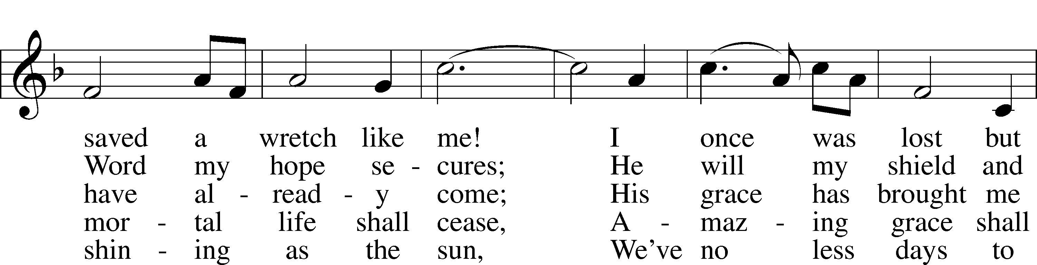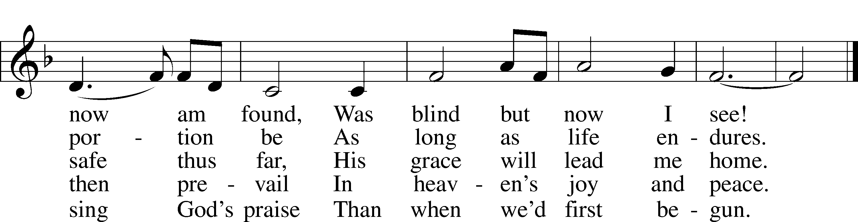

© 1991 Editorial Concordia. Used by permission: LSB Hymn License .NET, no. 100011641.  
Public domain

**THE SERMON: *“Was Blind But Now I See”* John 9:1-41**



*(Please stand…)*

**THE PROFESSION OF FAITH:**

Pastor: God has given us a great message to take to His world. Let us remind ourselves and one another of what that message is:

Pastor: I believe in God the Father, Almighty

**Congregation: Maker of heaven and earth**

Pastor: And in His Son, Jesus Christ our Lord,

**Congregation: Who was conceived by the Holy Spirit**

Pastor: Born of the Virgin Mary

**Congregation: Suffered under Pontius Pilate**

Pastor: Was crucified, died and was buried

**Congregation: He descended into hell.**

Pastor: On the third day He rose again from the dead,

**Congregation: And ascended into heaven**

Pastor: And sits on the right hand of God, the Father almighty

**Congregation: From there He will come to judge the living and the dead**

Pastor: I believe in the Holy Spirit,

**Congregation: The Holy Christian Church as**

**All: the communion of saints; the forgiveness of sins, the resurrection of the body, and the life everlasting. Amen.**

*(You may be seated…)*

**OFFERING RECEIVED: *“Healer of Our Every Ill”* Vocal Choir**

**(***Please stand…)*

***“Praise God, from Whom All Blessings Flow”* LSB 805**

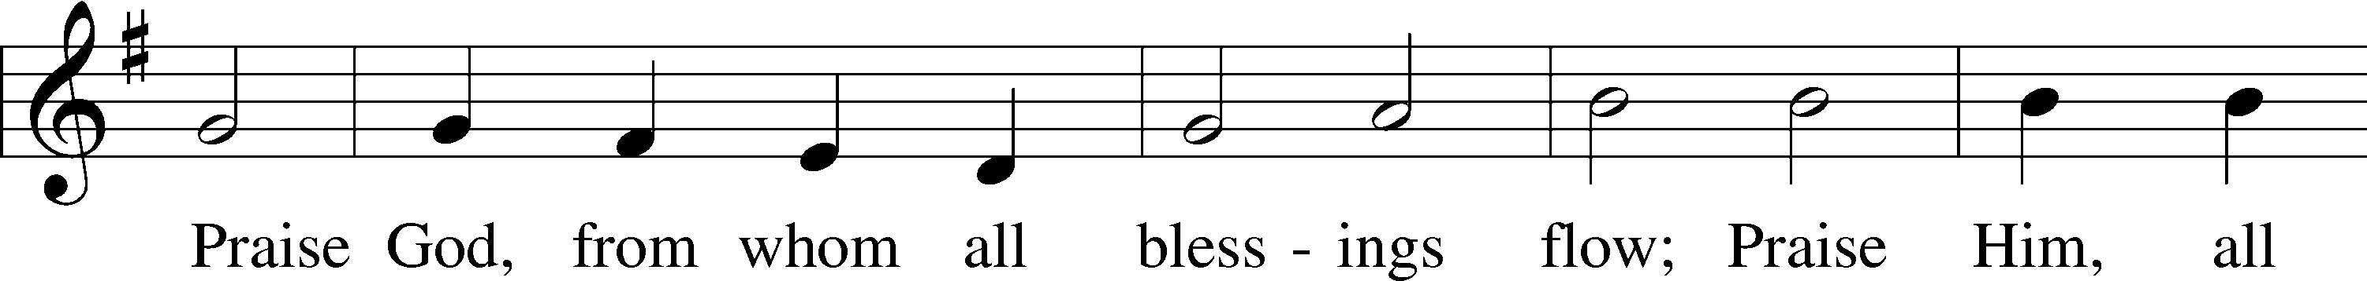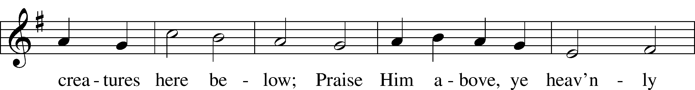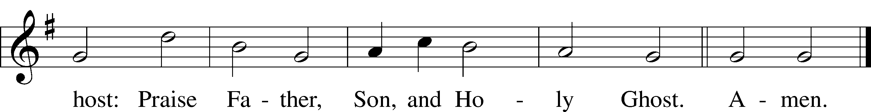

Public domain

**SERVICE OF THE SACRAMENT**

*(Please stand…)*

**PREPARE FOR THE LORD’S SUPPER:**

Pastor: We begin with the reminder: “The Lord is with you.”

**Congregation: We are mindful and thankful for His presence.**

Pastor: Let your life reflect the joy of your salvation.

**Congregation: We do give Him thanks and praise. We will share His blessing with others.**

Pastor: It is proper that we should at all times and in all places…(prayer)… we praise your name and join others in singing:

**All: (sing) “Holy, holy, holy Lord God of pow’r and might:**

**Heaven and earth are full of your glory.**

**Hosanna, Hosanna, Hosanna in the highest.**

**Blessed is he who comes in the name of the Lord.**

**Hosanna in the highest.”**

*(Please be seated…)*

**THE WORDS OF INSTITUTION**

**DISTRIBUTION HYMNS: *“Make Me A Servant”***

**Words and Music by Kelly Willard**

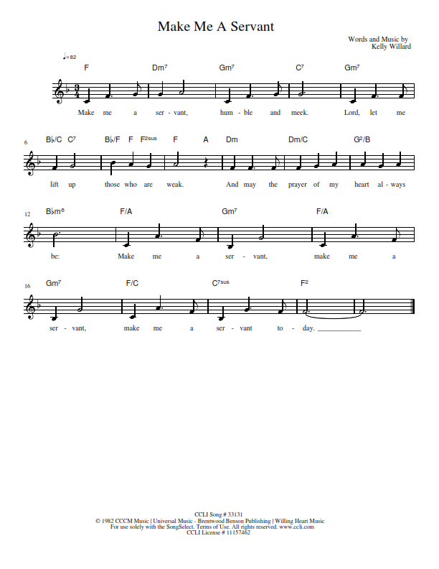

***“I Want to Walk as a Child of the Light”*  LSB 411**

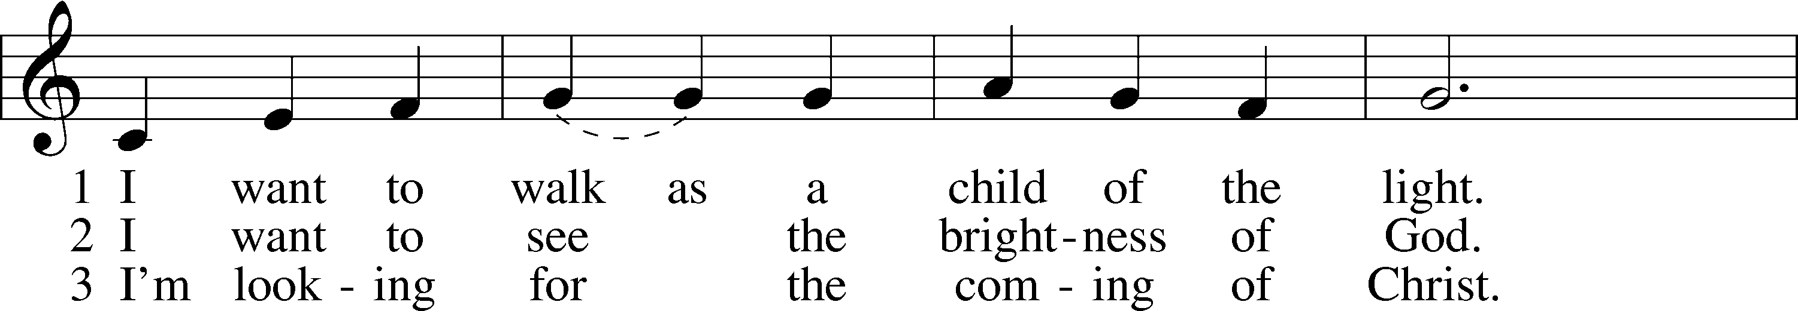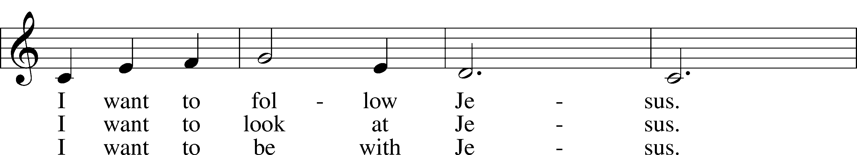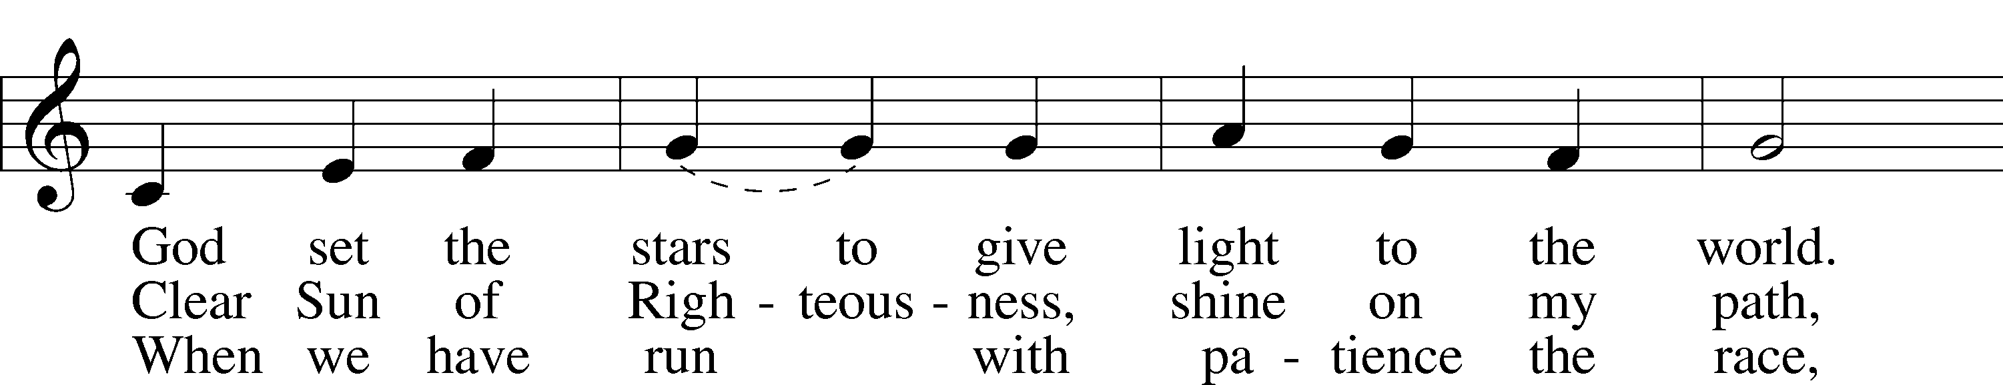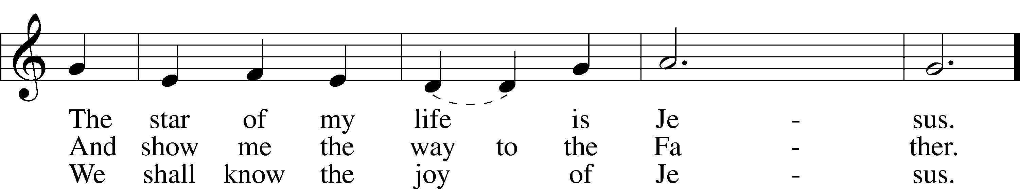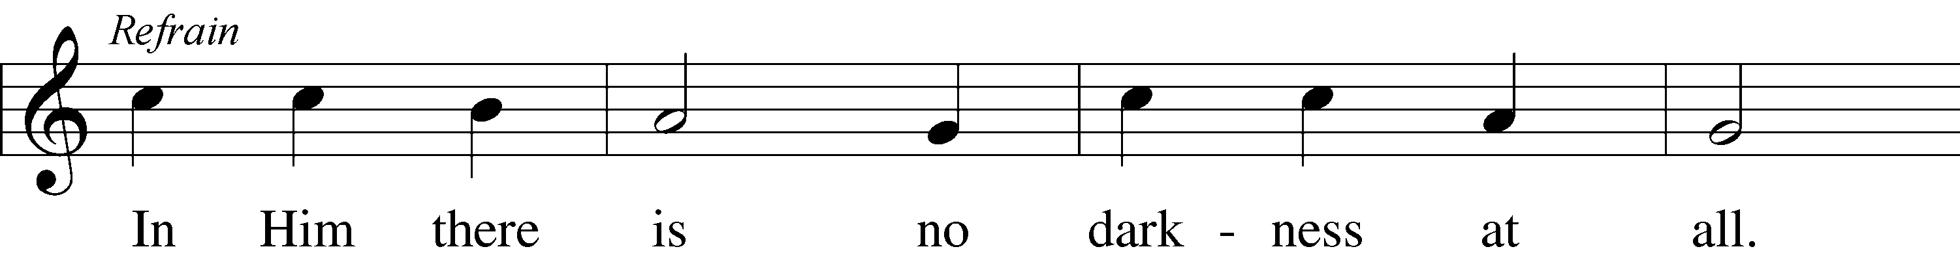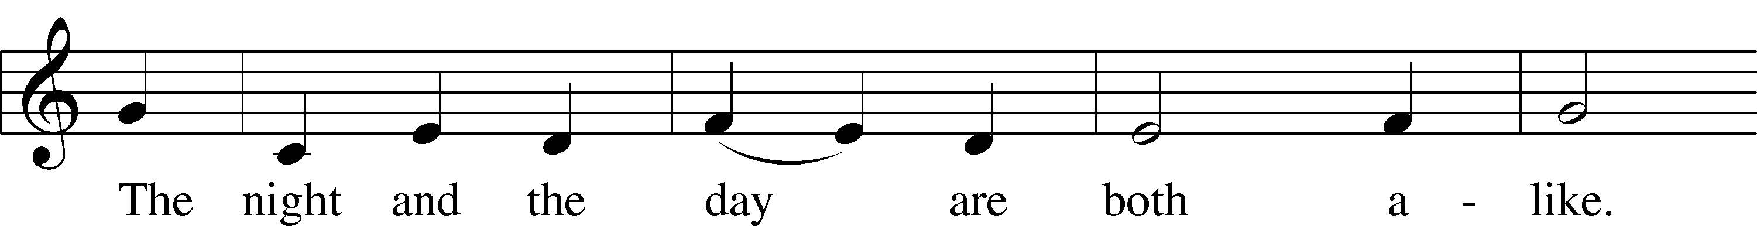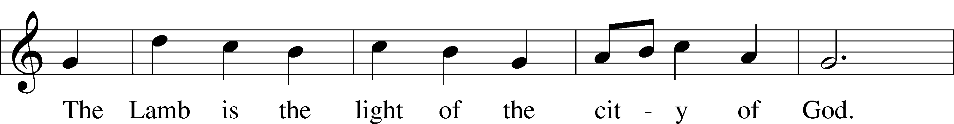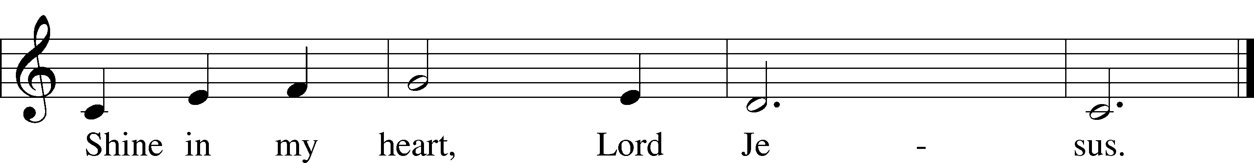

© 1970, 1975 Celebration. Used by permission: LSB Hymn License .NET, no. 100011641.

***“Praise the One Who Breaks the Darkness”* LSB 849**

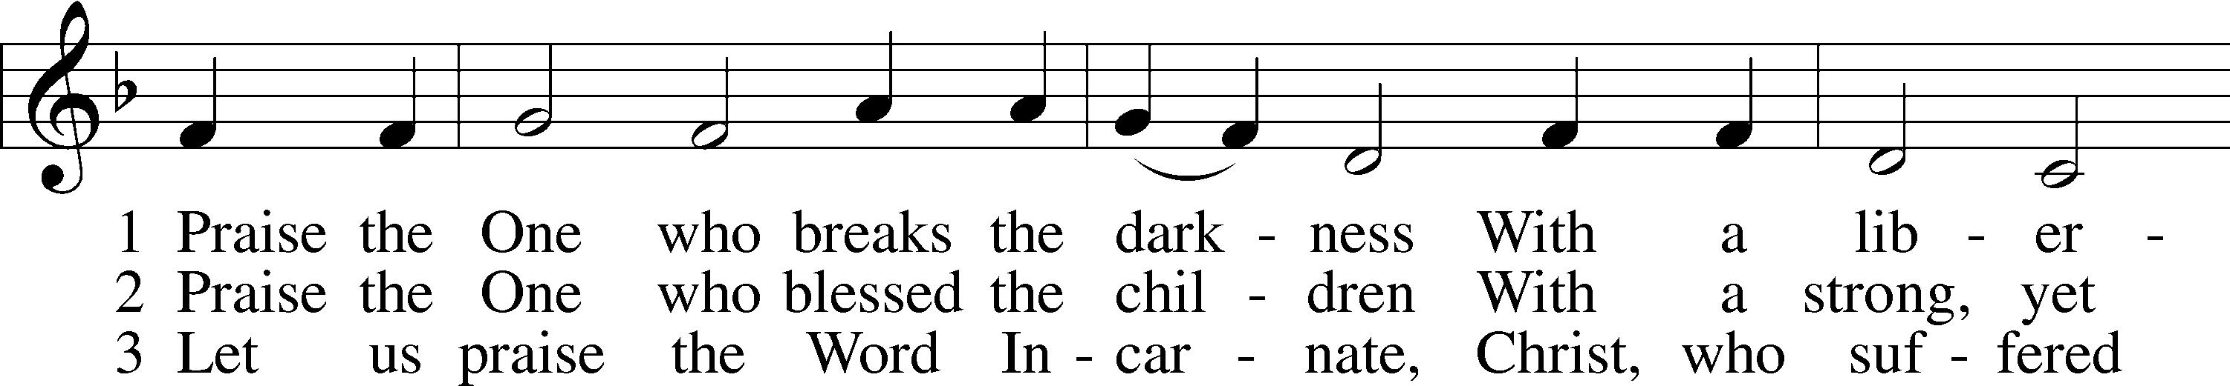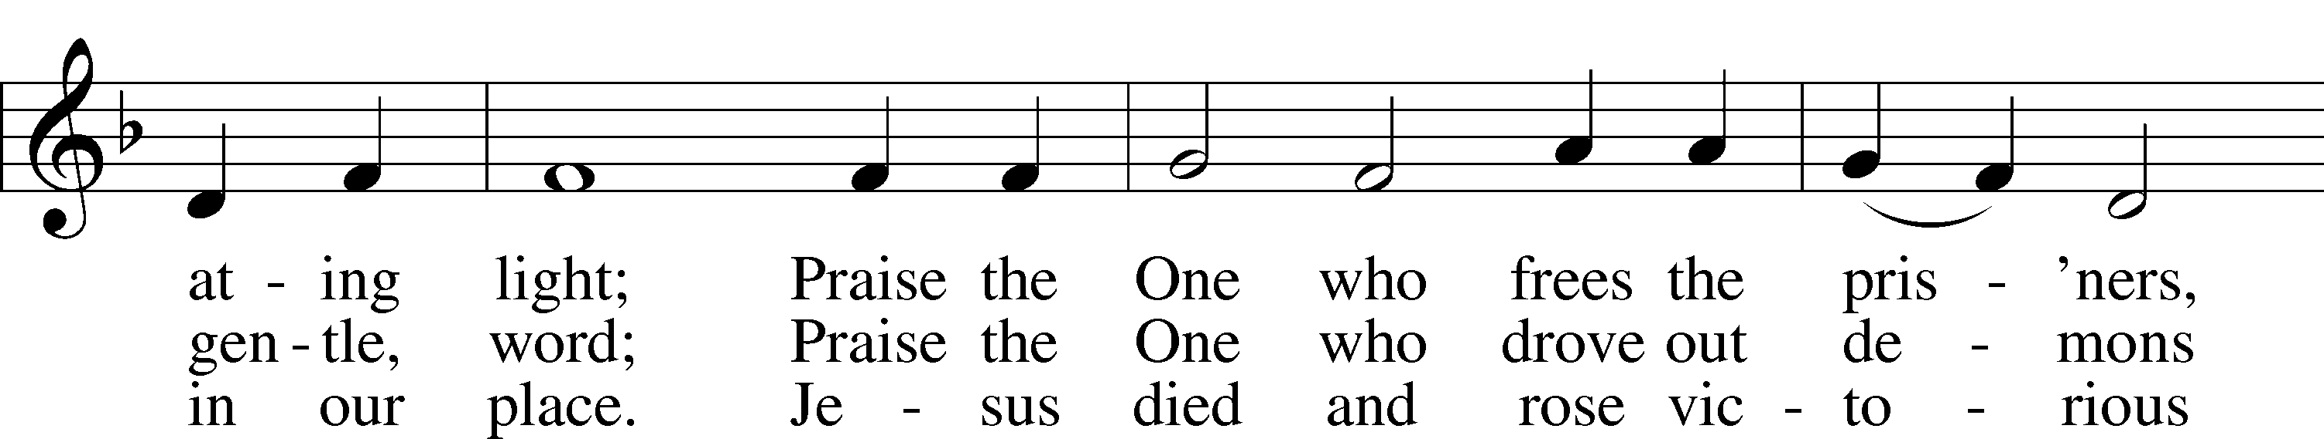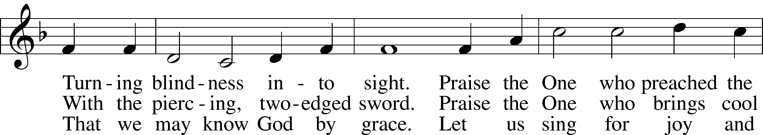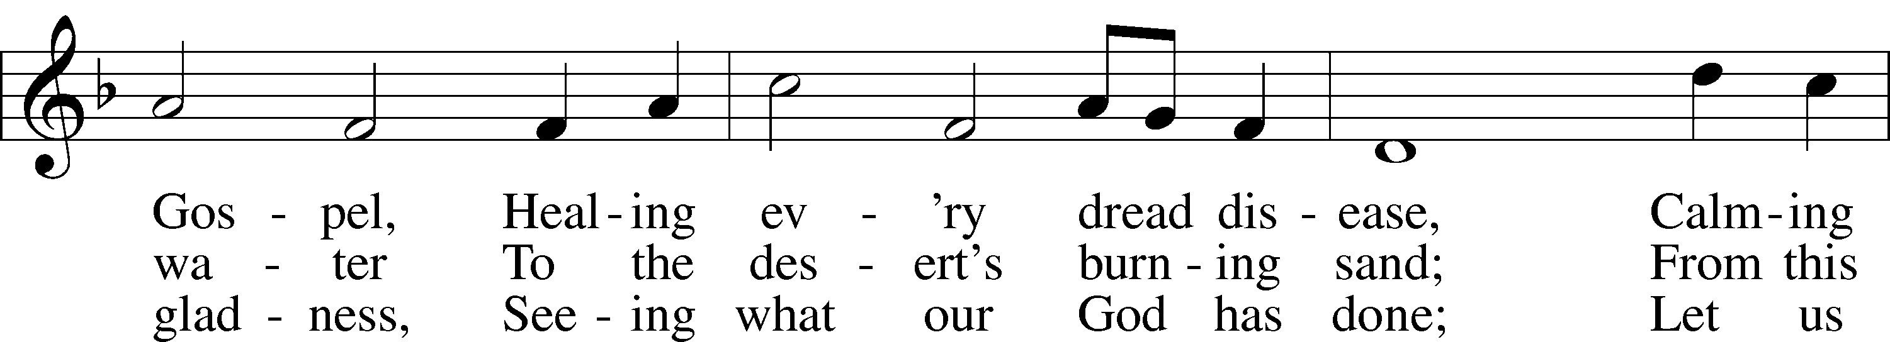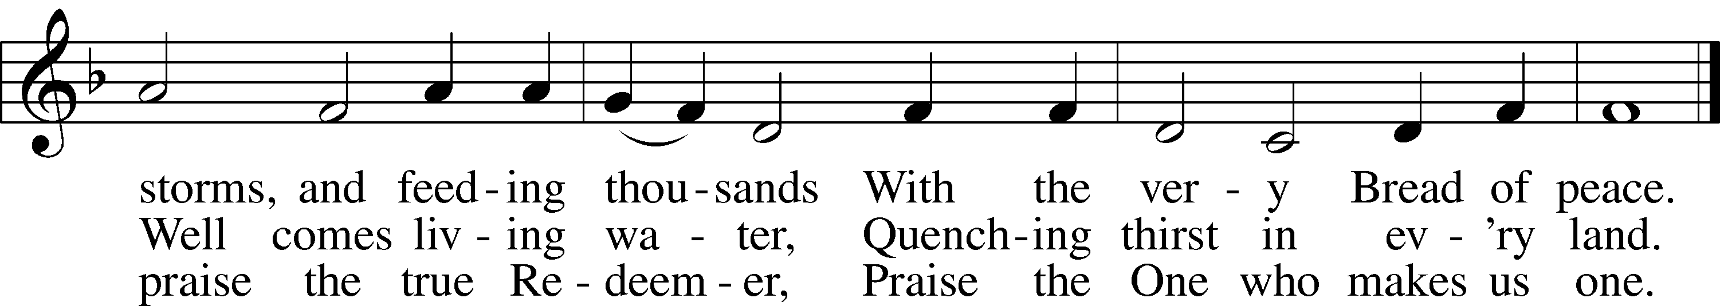

© 1987 Hope Publishing Co. Used by permission: LSB Hymn License .NET, no. 100011641.

Jesus let the things that break



your heart also break our hearts.

Amen

***“Rock of Ages, Cleft for Me”*  LSB 761**

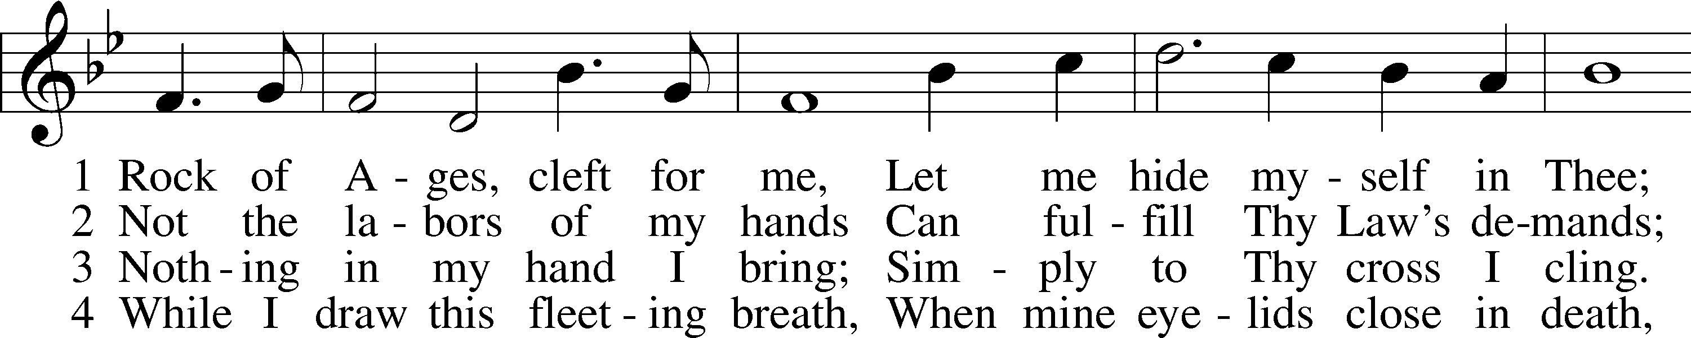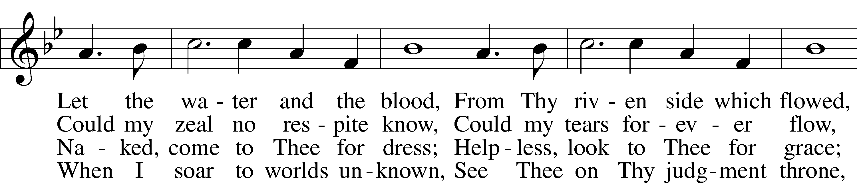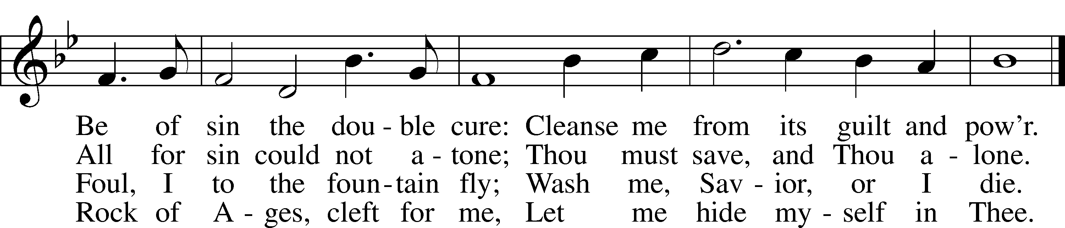

Public domain

*(Please stand…)*

**THE LORD’S PRAYER:**

**All: Our Father, who art in heaven, hallowed be thy name, thy kingdom come, thy will be done, on earth as it is in heaven. Give us this day our daily bread; and forgive us our trespasses as we forgive those who trespass against us; and lead us not into temptation, but deliver us from evil. For thine is the kingdom, and the power, and the glory, forever and ever. Amen**

**THE BLESSING AND BENEDICTION:**

Pastor: The Lord Blesses you and keeps you, the Lord makes His face to shine upon you and He is Gracious to you. The Lord looks upon you with His favor and gives you His peace.

**Congregation: God blesses us so that we can be a blessing to others.**

Pastor: Go in His peace and serve the Lord by serving others.

**Congregation: Amen**

**THE CLOSING HYMN: *“The Old Rugged Cross”***

**Words and Music by George Bennard**

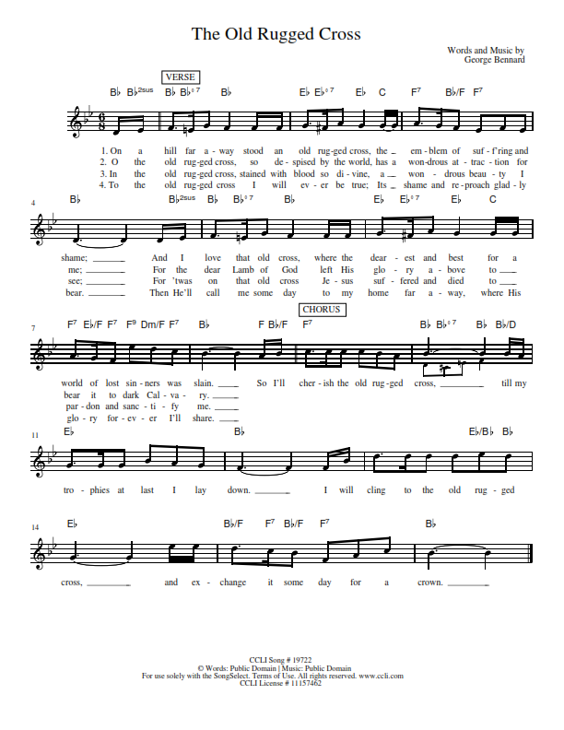

**WELCOME TO GRACE LUTHERAN CHURCH:** We are glad that you are here to worship God with us today! We pray that you will enjoy the wonderful fellowship as friends in Christ as God gathers us around His means of grace, the Word and Sacraments, to bless us with His treasured gifts of forgiveness, faith, abundant life and eternal salvation. If you are a guest, please also sign our Guest Book. Please talk to Pastor if you would like **to learn more about becoming a member of Grace. Also, please join us for refreshments** and fellowship after the Service. We invite you to come and worship with us often as God gathers us in His Grace.

**WELCOME TO THE LORD’S TABLE:** We invite and encourage all present who are baptized and faithful Christians, and who confess the Father, Son, and Holy Spirit to be the only true God and who believe that Jesus Christ died for the sins of the World and is our only hope and salvation…to join us in receiving the very and true body and blood of Christ in this Sacrament. The clear liquid cups in the center of the tray are non-alcoholic wine.

Children not yet confirmed in the faith are always welcome to join their parents at the Lord’s Table, but should keep their hands folded in front of them. The Pastor will give them a blessing.

**SERVING TODAY:** Acolyte: Conary McGee; Lector: Mary Brady; Communion Assistants: David Walker and Steve Bringle; Usher: Terry Richardson; Altar Care: The Pickings; Refreshments: Kim McGee.

**WEDNESDAY MARCH 29th:** Acolyte: Lillian Howard

**SERVING NEXT SUNDAY:** Acolyte: Eli Morris; Lector: Garnet Picking; Communion Assistants: Don Bly and Ed Morris; Usher: Bill Chalmers; Altar Care: __________; Refreshments: ________________.

**FLOWERS**: were placed on the altar to the glory of God from the Bacle family in celebration of Lucas’s birthday.

THIS WEEK AT A GLANCE:

**Today: March 26th**

9:00 am Worship Service with Communion

10:10 am Children’s Vocal and Chime Choir Rehearsal

10:15 am Fellowship

10:30 am Adult Bible Study / Children’s Sunday School

12:00 pm Adult Information Class

**Monday: March 27th**

Pastor’s Day Off

5:30 pm Zumba

**Tuesday: March 28th**

11:30 pm Gracious Ladies of Grace Luncheon (Doubletree)

3:00 pm Jan’s Mobile Gym

6:00 pm Weight Watcher’s (Parish Hall)

**Wednesday: March 29th**

5:45 pm Bell Choir Rehearsal

6:00 pm Potluck

7:00 pm Lenten Wednesday Service (Christ in the Passover)

Immediately after Vocal Choir Rehearsal

**Thursday: March 30th**

4:30 pm Missional Communities (Room 3)

**Next Sunday: April 2nd**

9:00 am Worship Service with Communion

10:10 am Children’s Vocal and Chime Choir Rehearsal

10:15 am Fellowship

10:30 am Children’s Sunday School (if needed)

10:45 am It’s All About Relationships (Parish Hall)

**IN YOUR PRAYERS THIS WEEK:** Bobby Meck, family and friends of Elaine Wavehime, Linda Mullis, Joe Lamberson, Salem Shatwell, Kathy Greenwood, Michael Willard, France Vandivier, Katie Hoffman, Pastor Ray Peters, Walt Lepperd, Family and friends of Will Plagens, Kay Sattelmeier, Dennis Julson, Vernon Julson, Olga Odland, Jean Grafsgaard, Jenie Howard, Jenny Dean, Katie Higgs Wyrwicki, family and friends of George Licis, Charles, Braydon, Champ, Amy, Elsie Hamilton, Sharon Jardas, Mary Ellen Jessel, Marcos Diaz, Kaci Doran, Auwina Weed, Sandy Harris, and those you are praying for at home. If anyone has a special prayer request please submit it in writing in the collection plate; or you may call Pastor Gary Faith at (504-858-8872), or Kris Howard at (305-296-5161).

**GIFTS, TITHES, & ATTENDANCE LAST SUNDAY** for March 19th were $5466.42 with an attendance of 125 and the noise offering was $94.71. Lenten Wednesday Service we received $649.00 and the window fund received $20000.00 with an attendance of 40.

**TO HELP US GROW…** The Bible reading for next Sunday’s service the readings are Ezekiel 17:1-14, Romans 8:1-11, and John 11:1-45.

**AN ADULT INFORMATION CLASS** has been scheduled for those who are interested in learning more about what we believe and teach. If you are interested in joining our church or just reviewing, please let Pastor or Kris know so that enough books can be ordered. It’s a 2-session class. Session 1 is scheduled for today, noon through 2. Session 2 April 9th, noon through 2.

**HOLY WEEK SCHEDULE**:

April 13th Maundy Thursday, Communion Service at 7:00 pm

April 14th Good Friday, Tenebrae Service at 7:00 pm

April 16th Easter Sunrise Service in the Parking Lot at 6:30 am

Easter Service at 9:00 am

**Fellowship and Refreshments will follow both Easter Services. There will be no Potlucks on Thursday or Friday.**

**HANDY MAN FOR THE SCHOOL:** If anyone is interested in applying for the part time, flexible hours’ job of handy man for our school please contact our school secretary Judy Whitney at 305-296-8262.

**IT HAS BEEN BROUGH TO MY ATTENTION** that the mothers of our younger children would like the option of having their children taken to a nursery after the children sermon. If you know of anyone who has the gifts and the desire to make this happen have them contact Kris Howard or myself.

**THIS WEEK WE CONTINUE OUR LENTEN JOURNEY FOR 2017** with our Wednesday Service at 7:00pm. We have been blessed to have Ms. Lisa J. Smolowitz join us to discuss “Christ in the Passover”. Join us for worship and if you have time for a meal before worship.

**LENTEN POTLUCKS:** Please come and enjoy a wonderful potluck dinner every Wednesday evening thru April 5th at 6:00pm before our weekly Wednesday services at 7:00pm.

**A PROBLEM OR A BLESSING?** Praise the Lord, we are starting to run out of room in our parking lot on Flagler. If you are healthy and see the parking lot getting full, please consider parking in our lot behind our school. Thanks.

**NOISE OFFERING:** Currently we are collecting for the Master Builders Center which is a mission to help children in Ethiopia have a home, food, and a relationship with Jesus. If you are interested in more info on the MBC, help yourself to one of the brochures in the lobby.

**MISSIONAL COMMUNITIES:** meets at 4:30pm on Thursdays. **All are welcome** to experience an opportunity to grow in our relationships with Jesus and His flock.

**WE HAVE SET THE SCHEDULES** for ushers, acolytes, lectors, and communion assistants for the 1st three months. If you would like to serve in any of these positions, please let Pastor or Kris know.

**STEWARDSHIP LISTS:** On the bulletin board by the front door of the church you will find the Altar Care, Refreshments, and Flower sign-up sheets for 2017. If you are able to help out with any of these please place your name in the spot on the date requested.

**SOME DATES TO MARK ON YOUR CALENDAR**

**THE GRACIOUS LADIES OF GRACE:** Ole Ole! We took our sombreros off in expectation and it was all we hoped it would be. Lots of chees, beans, sour cream, guacamole, chips, salsa and good fellowship. There were a lot of clean plates and we gave Chicos a 5*. Our next luncheon will be at a new venue, The Doubletree on the boulevard. We are trying to stay away from the downtown spring break madness. Please join us at 11:30 on Tuesday March 28th.

**APRIL 2ND IT’S ALL ABOUT RELATIONSHIPS:** After service on April 2nd we will have an opportunity to grow in our relationships with each other and in our skills at building relationships. We will go from approximately 10:45 til 12:15 with a meal to follow. Please sign up so we know how much food to prepare.

**THE GRACE LUTHERAN CHURCH WEB PAGE AND FACE BOOK PAGE** now contains a vocal recording of last week’s sermon. So, if you are not able to attend church on Sunday please go to our website where you will find a copy of the bulletin and a recording of Pastor Faith’s sermon. <https://gracelutherankw.360unite.com/home>.

**A NUMBER OF CAPITAL IMPROVEMENTS** are needed to keep our facilities in good health for the future. Roof repairs are needed on school buildings and the parsonage. If you can help it would be much appreciated! A big thanks to all who

have contributed to these repairs.

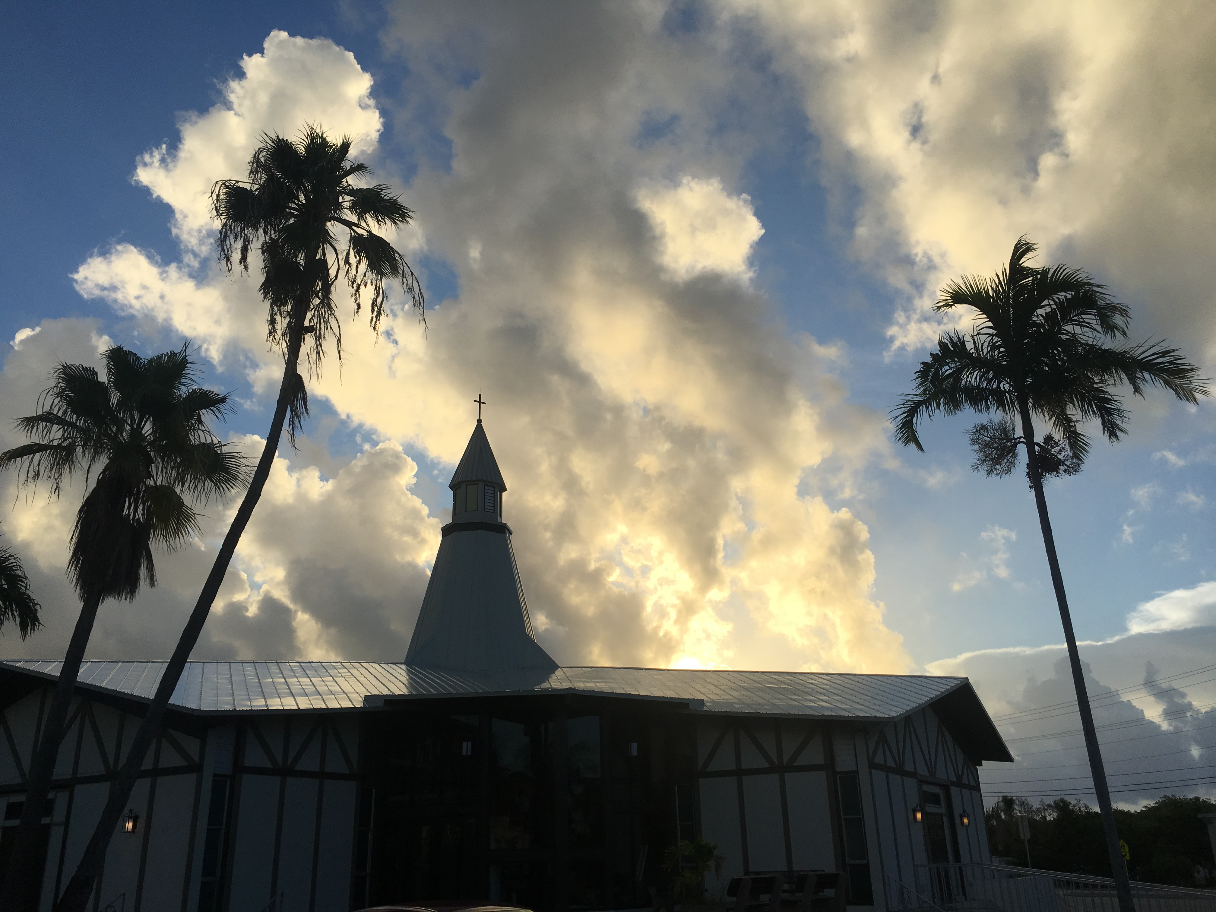

**SUNDAY SCHOOL:** Sunday school for all ages will follow refreshments from 10:30 until 11:30 in the following rooms.

High school is in room number 1 (just past the adult Bible study room on the right)

Middle school, 6th 7th and 8th grades, in room number 3 with Mike Sattelmeier and Jim Schuetzler. (Turn left down the school hallway to the first room).

3rd, 4th and 5th grades in room 5 with Don and Kris Bly. (third room left down the school hallway).

Preschool through second grade with JoAnn Broadbent in room 7. (Last room on the left down the school hallway)

Hope to see everyone there! Any questions? Ask Kris Bly, Sunday School director, 305-509-1447 or Kris Howard, church Secretary.



**IF YOU ARE INSTRUMENTALLY INCLINED** and would like to share your talents with an instrument during our services or accompany our organist and/or choir, please speak to our organist Debbie Schuetzler.

**MUSIC MINISTRY:** "Make a joyful noise to the Lord, all the earth!" Psalm 100:1. Whether you are here year-round or only part-time, we invite you to participate in our music ministry. Please speak with Beverly Walker or contact her with any questions at [beverlywalker@gmail.com](mailto:beverlywalker@gmail.com) .

Children's Vocal and Chime Choir for Kindergarten - 5th grade: Rehearsal today from 10:10 - 10:25. Please meet by the piano.

Vocal choir: Rehearses on Wednesday immediately after the Service.  
  
Bell Choir: Rehearsal on Wednesday from 5:45-6:15.



**MEN’S BIBLE FELLOWSHIP**: They meet the first and third Wednesday’s of each month at 12:30pm. Their next meeting will be April 5th located at Chico’s on Stock Island. All guys are welcome.

**WOMEN’S BIBLE STUDY**: Will meet again after Easter. If there are any questions, please contact Monica Bacle 305 923-0856.

**Spring Break at Grace Lutheran**

**Painting**

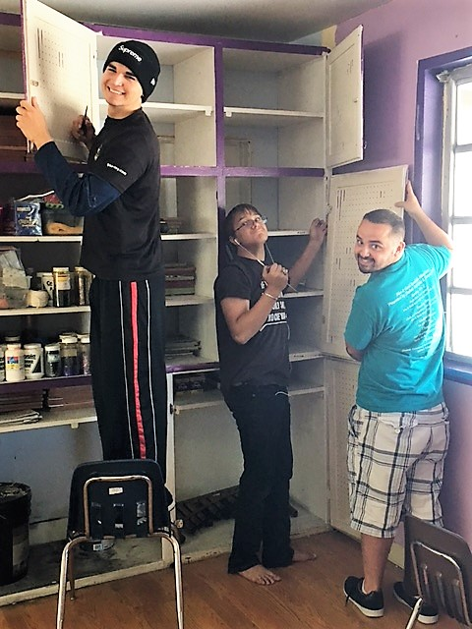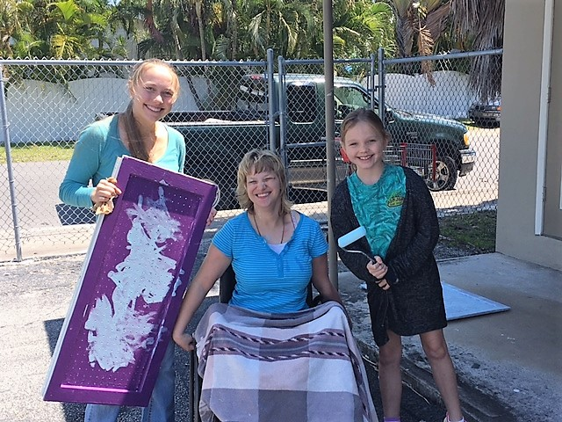

**Swimming**

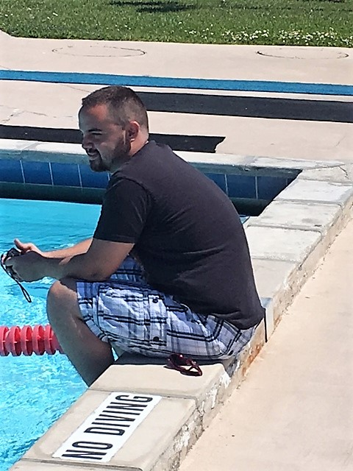

**Children’s Choir**

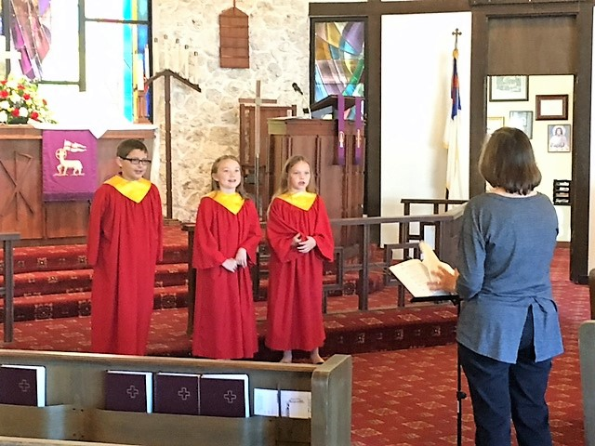

**Children’s Message**

