March 12th, 2017
9:00 am

SECOND SUNDAY
IN LENT

Grace Lutheran Church
2713 Flagler Ave.
Key West, FL 33040
305-296-5161
GraceLutheranKW@att.net
Pastor Faith
(504) 858-8872
garyfaith@aol.com

SECOND SUNDAY IN LENT
MARCH 12TH, 2017 9:00 a.m.
WORSHIP SERVICE
In the Name of Jesus!
Our Mission Statement: Anchored in Christ, each person a missionary.

PRELUDE

ANNOUNCEMENTS:
We welcome you. We are glad you are here to share with us the joy and peace we have in Jesus Christ. It doesn’t matter whether this is your first time in this church or if you are a lifelong member, you are welcome. We come together today in order to celebrate the gift God has given us-His own Son, Jesus, Our Savior.

PREPARATION

(Please Stand…)
HYMN: “Spring Up, O Well”
Mypianoworld.com

Pastor: In the Name of the Father and of the Son and Holy Spirit.
Congregation: Amen.

(Please Remain Standing Or You May Kneel…)
GOD’S PEOPLE CONFESS THEIR SINS:
Pastor: By grace you have been saved, through faith-and this is not from yourselves, it is the gift of God-not of works, so that no man can boast, for we are God’s workmanship, created in Christ Jesus.
Congregation: I know that nothing good lives in me, that is, in my sinful nature, for I have the desire to do what is good, but I cannot carry it out.
Pastor: What I do is not the good I want to do; no, the evil I do not want to do-this I keep doing.
Congregation: In my heart I delight in God’s law, the law that points out what a wretched person I am! Who will rescue me from this body of death?
Pastor: Thanks be to God through Jesus Christ our Lord! Only He can achieve the perfection we fail to achieve. By the forgiveness He purchased on the cross, our forgiveness is complete!
SERVICE OF THE WORD

You may be seated…
THE OLD TESTAMENT READING: Genesis 12:1-9
Lector: This is the Word of the Lord.
People: Thanks be to God.

THE EPISTLE LESSON: Romans 4:1-8,13-17
Lector: This is the Word of the Lord.
People: Thanks be to God.
Please stand…
THE HOLY GOSPEL: John 3:1-17
Pastor: The Holy Gospel according to St. John the 3rd Chapter
People: Glory to You, O Lord.
Pastor: This is the Gospel of the Lord.
People: Praise to You, O Christ!

Please be seated…
CHILDREN’S MESSAGE

NOISE OFERING
It’s called a noise offering because what we are asking for is pocket change. It will always be used for missions outside of our church and school. It normally also is given to a mission involving children. Thanks for making a joyful noise to the Lord.

THE SERMON HYMN: “There is Power in the Blood”
Words and Music by Lewis Ellis Jones

SERMON: “Nick at Night” John 3:1-17

THE PROFESSION OF FAITH:
Pastor: God has given us a great message to take to His world. Let us remind ourselves and one another of what that message is:
Pastor: I believe in God the Father, Almighty
Congregation: Maker of heaven and earth
Pastor: And in His Son, Jesus Christ our Lord,
Congregation: Who was conceived by the Holy Spirit
Pastor: Born of the Virgin Mary
Congregation: Suffered under Pontius Pilate
Pastor: Was crucified, died and was buried
Congregation: He descended into hell.
Pastor: On the third day He rose again from the dead,
Congregation: And ascended into heaven
Pastor: And sits on the right hand of God, the Father almighty
Congregation: From there He will come to judge the living and the dead
Pastor: I believe in the Holy Spirit,
Congregation: The Holy Christian Church as
All: the communion of saints; the forgiveness of sins, the resurrection of the body, and the life everlasting. Amen.

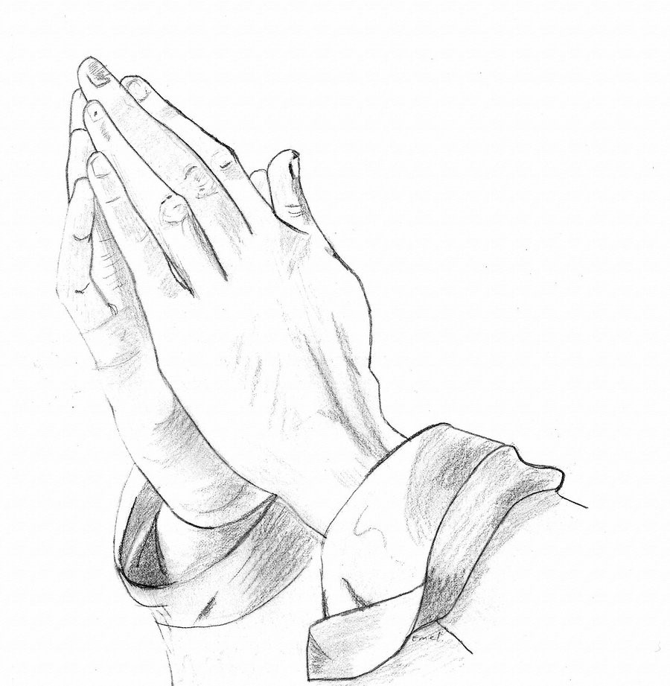
(You may be seated…)
OFFERING RECEIVED

“Praise God, from Whom All Blessings Flow” LSB 805
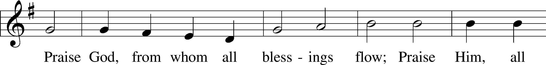
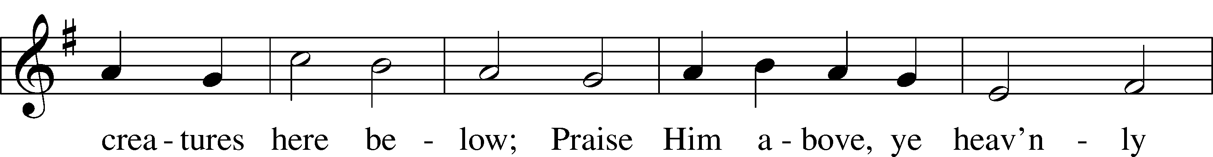
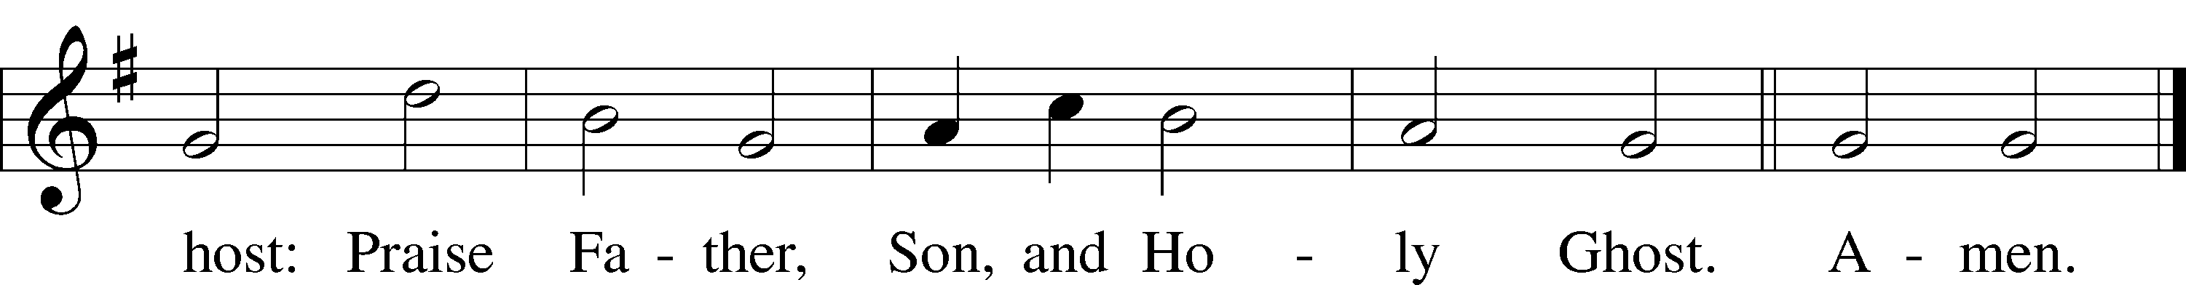
Public domain

(Please stand…)
THE PRAYERS OF THE CHURCH: based on Psalm 98
Pastor: Dear Lord, we thank You for everything You’ve done for us, and most of all for Your own Son, Jesus, our Savior. We will never stop praising You for this wonderful gift.
Congregation: Sing to the Lord a new song, for He has done marvelous things; His right hand and His holy arm have worked salvation for Him.
Pastor: We thank You for those missionaries long ago who brought the Good News to our people. When we were in darkness, You sent men and women to bring us the light. Thank you, Lord.
Congregation: The Lord has made His salvation known and revealed His Righteousness to the nation.
Pastor: O Lord, You are our Savior, we trust in You for all our needs, give healing to the sick, courage to those who are afraid, and peace to those we name in our hearts either silently or out loud. (a moment of silence) We praise You, gracious Lord, for all Your benefits to us. You give us home, friends and family, food, shelter, rest and everything we need. You give us sight and hearing and touch and taste and provide for all of our needs.
Congregation: Shout for joy to the Lord, praise His Name Amen.

SERVICE OF THE SACRAMENT

(Please be seated…)
THE WORDS OF INSTITUTION

DISTRIBUTION HYMNS: “Glorify thy Name”
Words and music by Donna Adkins

“Come Now Is The Time To Worship”
Words and Music by Brian Doerksen

I Love You Lord
Words and Music by Laurie Klein

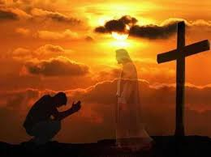

“He Is Exalted”
Words and Music by Twila Paris

Jesus let the things that break your heart
also break our hearts.
Amen

(Please stand…)
THE LORD’S PRAYER:
All: Our Father, who art in heaven, hallowed be thy name, thy kingdom come, thy will be done, on earth as it is in heaven. Give us this day our daily bread; and forgive us our trespasses as we forgive those who trespass against us; and lead us not into temptation, but deliver us from evil. For thine is the kingdom, and the power, and the glory, forever and ever. Amen

THE BENEDICTION

THE CLOSING HYMN: “I’ll Fly Away”
Words and Music by Albert E. Brumley

WELCOME TO GRACE LUTHERAN CHURCH: We are glad that you are here to worship God with us today! We pray that you will enjoy the wonderful fellowship as friends in Christ as God gathers us around His means of grace, the Word and Sacraments, to bless us with His treasured gifts of forgiveness, faith, abundant life and eternal salvation. If you are a guest, please also sign our Guest Book. Please talk to Pastor if you would like to learn more about becoming a member of Grace. Also, please join us for refreshments and fellowship after the Service. We invite you to come and worship with us often as God gathers us in His Grace.

WELCOME TO THE LORD’S TABLE: We invite and encourage all present who are baptized and faithful Christians, and who confess the Father, Son, and Holy Spirit to be the only true God and who believe that Jesus Christ died for the sins of the World and is our only hope and salvation…to join us in receiving the very and true body and blood of Christ in this Sacrament. The clear liquid cups in the center of the tray are non-alcoholic wine.

Children not yet confirmed in the faith are always welcome to join their parents at the Lord’s Table, but should keep their hands folded in front of them. The Pastor will give them a blessing.

SERVING TODAY: Acolyte: James Reynolds; Lector: David Walker; Communion Assistants: David Walker and Mike Sattelmeier; Usher: Terry Richardson; Altar Care: Bly family; Refreshments: Bly Family.

WEDNESDAY MARCH 8th: Acolyte: Emily Howard

SERVING NEXT SUNDAY: Acolyte: Maddie Schoepf; Lector: Monica Bacle; Communion Assistants: Steve Bringle and David Walker; Usher: Terry Richardson; Altar Care: __________; Refreshments: ________________.

FLOWERS: were placed on the altar to the glory of God from the Reynold’s family in celebration of Jim’s birthday.

THIS WEEK AT A GLANCE:

Today: March 12th
9:00 am Blue Grass Worship Service with Communion
10:10 am Children’s Vocal and Chime Choir Rehearsal
10:15 am Fellowship
10:30 am Adult Bible Study / Children’s Sunday School

Monday: March 13th
Pastor’s Day Off
5:30 pm Zumba

Tuesday: March 14th
11:30 am Gracious Ladies of Grace Luncheon (Chico’s)
3:00 pm Jan’s Mobile Gym
6:00 pm Weight Watcher’s (Parish Hall)

Wednesday: March 15th
12:30 pm Men’s Bible Fellowship (Chico’s)
4:30 pm Women’s Bible Study (Room 3)
5:30 pm Bell Choir Rehearsal
6:00 pm Potluck
7:00 pm Lenten Wednesday Service
Immediately after Vocal Choir Rehearsal

Thursday: March 16th
4:30 pm Missional Communities (Room 3)

Next Sunday: March 19th
9:00 am Worship Service with Communion
10:10 am Children’s Vocal and Chime Choir Rehearsal
10:15 am Fellowship
10:30 am Adult Bible Study / Children’s Sunday School

IN YOUR PRAYERS THIS WEEK: Linda Mullis, Joe Lamberson, Salem Shatwell, Kathy Greenwood, Michael Willard, France Vandivier, Katie Hoffman, Pastor Ray Peters, Walt Lepperd, Family and friends of Will Plagens, Kay Sattelmeier, family of Rev. Alfred Schubert II, Dennis Julson, Vernon Julson, Olga Odland, Jean Grafsgaard, Jenie Howard, Jenny Dean, Katie Higgs Wyrwicki, George Licis, Charles, Braydon, Champ, Amy, Elsie Hamilton, Sharon Jardas, Mary Ellen Jessel, Marcos Diaz, Kaci Doran, Auwina Weed, Sandy Harris, and those you are praying for at home. If anyone has a special prayer request please submit it in writing in the collection plate; or you may call Pastor Gary Faith at (504-858-8872), or Kris Howard at (305-296-5161).

GIFTS, TITHES, & ATTENDANCE LAST SUNDAY for March 5th were $5371.00 and the building fund received $160.00 with an attendance of 113 and the noise offering was $79.43. Lenten Wednesday Service we received $________ with an attendance of ___.

TO HELP US GROW… The Bible reading for Wednesday, March 15th is Genesis 27:1-27 and for next Sunday’s service the readings are Exodus 17:1-7, Romans 5:1-8, 13-17, and John 4:5-26.

HANDY MAN FOR THE SCHOOL: If anyone is interested in applying for the part time, flexible hours’ job of handy man for our school please contact our school secretary Judy Whitney at 305-296-8262.

APRIL 2ND IT’S ALL ABOUT RELATIONSHIPS: After service on April 2nd we will have an opportunity to grow in our relationships with each other and in our skills at building relationships. We will go from approximately 10:45 til 12:15 with a meal to follow. Please sign up so we know how much food to prepare.

IT HAS BEEN BROUGH TO MY ATTENTION that the mothers of our younger children would like the option of having their children taken to a nursery after the children sermon. If you know of anyone who has the gifts and the desire to make this happen have them contact Kris Howard or myself.

THIS WEEK WE CONTINUE OUR LENTEN JOURNEY FOR 2017 with our Wednesday Service at 7:00pm. Our theme this year is Biblical Heroes or Biblical Bummers. Our topic this Wednesday; Genesis 27:1-17 “Rebekah”. Join us for worship and if you have time for a meal before worship.

LENTEN POTLUCKS: Please come and enjoy a wonderful potluck dinner every Wednesday evening thru April 5th at 6:00pm before our weekly Wednesday services at 7:00pm.

A PROBLEM OR A BLESSING? Praise the Lord, we are starting to run out of room in our parking lot on Flagler. If you are healthy and see the parking lot getting full, please consider parking in our lot behind our school. Thanks.

NOISE OFFERING: Currently we are collecting for the Master Builders Center which is a mission to help children in Ethiopia have a home, food, and a relationship with Jesus. If you are interested in more info on the MBC, help yourself to one of the brochures in the lobby.
MISSIONAL COMMUNITIES: meets at 4:30pm on Thursdays. My apologies to anyone this causes an inconvenience. All are welcome to experience an opportunity to grow in our relationships with Jesus and His flock.

WE HAVE SET THE SCHEDULES for ushers, acolytes, lectors, and communion assistants for the 1st three months. If you would like to serve in any of these positions, please let Pastor or Kris know.

STEWARDSHIP LISTS: On the bulletin board by the front door of the church you will find the Altar Care, Refreshments, and Flower sign-up sheets for 2017. If you are able to help out with any of these please place your name in the spot on the date requested.

IF ANYONE IS INTERESTED IN TAKING THE ADULT INFORMATION CLASS because they want to know more about what we teach/believe and/or might be interested in membership please let pastor or Kris know.

“What are we doing that nobody else is
doing to reach people that nobody else
is reaching?

SOME DATES TO MARK ON YOUR CALENDAR
THE GRACIOUS LADIES OF GRACE: The Ladies had a well-attended gathering at the Brewery with lots of lively conversation and a lot of complaining about the parking situation. But there were no complaints about the food or service. Our server was the best, she kept us all happy. Quite a feat. We gave the Brewery a 5* and decided we needed a Mexican food fix so off to Chico's on the 14th of March at 11:30. If you’rer in a taco or maybe a tortilla mood come join us. Arriba, Abajo, Al Centro, y Pa Dentro! To your health!

APRIL 2ND: event to be announced at a later date

STAINED GLASS WINDOWS: We only have 9 clear glass impact windows in the bathrooms and front entry, and the two side entry doors that need to be replaced. When those are completed, the entire church will be protected with hurricane proof, impact windows. The cost of the windows is roughly $2000.00 each depending on size. Thank you, donors of the stained-glass windows and to all those who have contributed to the building fund for this project. Your generous giving is much appreciated.

THE GRACE LUTHERAN CHURCH WEB PAGE AND FACE BOOK PAGE now contains a vocal recording of last week’s sermon. So, if you are not able to attend church on Sunday please go to our website where you will find a copy of the bulletin and a recording of Pastor Faith’s sermon. https://gracelutherankw.360unite.com/home.

A NUMBER OF CAPITAL IMPROVEMENTS are needed to keep our facilities in good health for the future. Roof repairs are needed on school buildings and the parsonage. If you can help it would be much appreciated! A big thanks to all who
have contributed to these repairs.

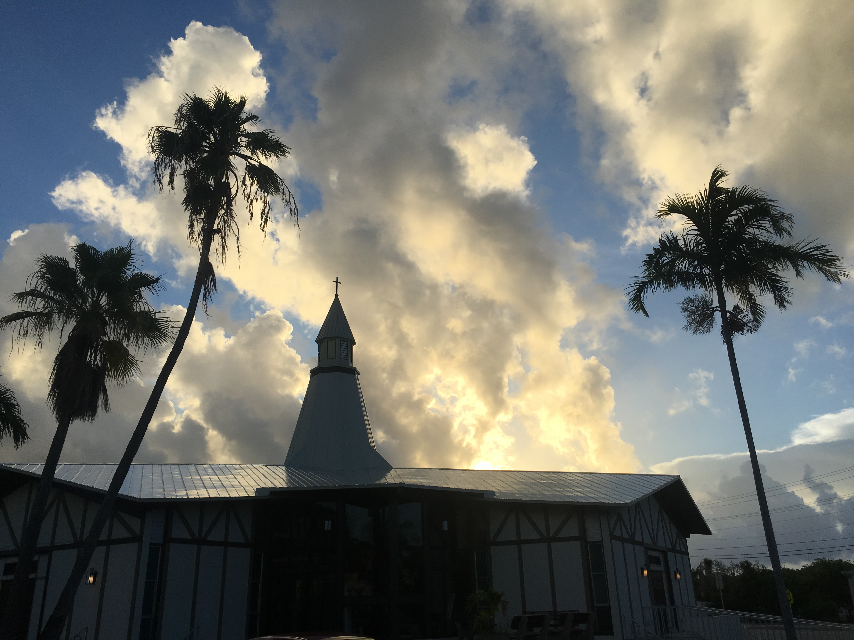

SUNDAY SCHOOL: Sunday school for all ages will follow refreshments from 10:30 until 11:30 in the following rooms.

High school is in room number 1 (just past the adult Bible study room on the right)

Middle school, 6th 7th and 8th grades, in room number 3 with Mike Sattelmeier and Jim Schuetzler. (Turn left down the school hallway to the first room).

3rd, 4th and 5th grades in room 5 with Don and Kris Bly. (third room left down the school hallway).

Preschool through second grade with JoAnn Broadbent in room 7. (Last room on the left down the school hallway)

Hope to see everyone there! Any questions? Ask Kris Bly, Sunday School director, 305-509-1447 or Kris Howard, church Secretary.

IF YOU ARE INSTRUMENTALLY INCLINED and would like to share your talents with an instrument during our services or accompany our organist and/or choir, please speak to our organist Debbie Schuetzler.

MUSIC MINISTRY: "Make a joyful noise to the Lord, all the earth!" Psalm 100:1. Whether you are here year-round or only part-time, we invite you to participate in our music ministry. Please speak with Beverly Walker or contact her with any questions at beverlywalker@gmail.com .

Children's Vocal and Chime Choir for Kindergarten - 5th grade: Rehearsal today from 10:10 - 10:25. Please meet by the piano.

Vocal choir: Rehearses on Wednesday immediately after the Service.
Bell Choir: Rehearsal on Wednesday from 5:45-6:15.

MEN’S BIBLE FELLOWSHIP: They meet the first and third Wednesday’s of each month at 12:30pm. Their next meeting will be March 15th located at Chico’s on Stock Island. All guys are welcome.

WOMEN’S BIBLE STUDY: Meet every Wednesday in room 3 from 4:30 pm to 5:30 pm. We will be enjoying a book by Tish Harrison Warren titled Liturgy of the Ordinary. She states that "God is near in overlooked moments and routines, we can become aware of God's presence in surprising ways. How do we embrace the sacred in the ordinary and the ordinary in the sacred? Come discover the holiness of your every day." If there are any questions, please contact Monica Bacle 305 923-0856.

