# Grace Lutheran Church

9806 NE Zac Lentz Pkwy.

Victoria, Texas 77904

Return Service Requested

Grace

Notes

## **A monthly newsletter for members and friends of Grace Lutheran**

[www.gracelutheran-tx.org](http://www.gracelutheran-tx.org)

email – [office@gracelutheran-tx.org](mailto:office@gracelutheran-tx.org)

Non Profit Organization U.S. Postage Paid Victoria, Texas 77901 Permit No. 353

### August 29, 2019

Vol. 42 No. 7



Grace Notes



**Sunday**

**September 8, 2019**

**All students will go to their new Sunday School classes and meet their new teachers.**

**Our teachers this year are:**

**3 yr – 1st grade – Rachel Bush**

**2nd - 6th grade – Cheryl Kroos & Wanda McNeley**

**7th thru 8th grade – (confirmation) Karl Koch & Pastor Keith RM 110**

**9th thru 12th grade – David Hempel & Layne Fuller Rm 131**

**Adult classes – Pastor Keith Rm 132**

**We will install teachers during the worship service.**

**Confirmation classes begin on Rally Day.**

**Acolyte training – if our younger students who are in the 3rd thru 5th grades would like to be on the schedule to acolyte (meeting the height requirement) there will be an acolyte training on September 15th during the SS hour. Please let Pastor Keith know you are interested.**

**Acolyte Schedule**

September 1 Madalynn Kroos

September 8 Katelyn Kahanek

September 15 Anna Aschenbeck

September 22 Micah Aschenbeck

September 29 Sam Truax

**ALTAR SCHEDULE**

**September**

Set Up – Carolynn Mueller

Take Down – Janet Shipman

**ELDER RESPONSIBILITY**

**September**

Teinert/David Hempel

Person to Secure Building Ushers for Sunday

September 1 Randy Weiser Sept. 1 Harjes & Koch

September 8 Skipper Koetter Sept. 8 Spies & F. Fuller

September 15 Chuck Mueller Sept. 15 Zieschang & Harvill

September 22 Layne Fuller Sept. 22 Deborah & D Hempel

September 29 Randy Weiser Sept. 29 Koetter & L. Fuller

**Lay Readers for September Flower Schedule**

**September 1 Dylan Hempel Sept. 1 Matthys**

**September 8 Darrell Hempel Sept. 8 Becker**

**September 15 David Hempel Sept. 15 David Hempel**

**September 22 Dalton Hempel Sept. 22 Open**

**September 29 Bill Matthys Sept. 29 Open**

  

**Media Room**

**Sept. 1 Moore**

**Sept. 8 Becker**

**Sept. 15 Doyle/Shurber**

**Sept. 22 Weiser**

**Sept. 29 Moore**

 



  Attention all Ladies -



Our next Bunco at Grace will be on Thursday, September 12th. Just bring a snacking food and $2. Please invite your friends or neighbors and come for an evening of fun with your sisters in Christ.

 

**LOOK BACK**

7/28/19 Worship 93 $5,301.00 Debt. Red $3,572.00

No SS $ -0- Benevolence $ 40.00

8/4/19 Worship 112 $6,849.00 Sunday School $ 119.00

SS 36 $ 27.00 Children’s Min $ 60.52

8/11/19 Worship 102 $5,693.00 Memorials $ 875.00

SS 36 $ 35.00 Utility Bldg. $ 250.00

8/18/19 Worship 132 $5,410.00 Misc. $ 43.77

SS 49 $ 33.00 Confirmation $ 500.00

8/25/19 Worship 110 $4,868.90

SS 34 $ 24.00

                        

**BBQ Chicken Sale – This will be the last time for this year so stack up! Our Grace BBQ team will be BBQing on Sunday, September 29th. We will sell whole chickens 1 for $9 or 3 for $25. We will also have beans available for sale for $1 per pint. Start taking orders now from your friends and neighbors and let Tammy know in the church office by Sunday, September 22nd.**



**             **

**COTTAGE BIBLE STUDY**

Our Cottage Bible Study continues on Tuesday mornings at 10:00am. This is a Bible study for women held each Tuesday morning and it is led by Pastor Keith. We will study the book of Amos. All women of the church are welcome to come and join this group of ladies.

                        

**LARGE PRINT BULLETINS**

If you would like for Tammy to print you a special large print bulletin for Sunday mornings, please call the office and let her know. This is not a problem at all. I will be glad to do it.

  IN OUR PRAYERS:



**PRAYER LIST FOR AUGUST 27, 2019**

1. Protection for our troops overseas.

2. Thanks to God for all His many blessings.

3. Pray for protection for President Trump and for guidance for our nation.

4. Pray for our nation to come back to God.

5. Continued healing, strength, and comfort for Cole Ohrt. We ask for God’s continue care for this young man to lift his spirits and show him some progress.

6. Continued healing and strength for Mac and Alice McKenzie and prayers for help from the

Lord with all their health problems.

7. Continued prayer for healing for August Hempel. He continues to need prayers for healing.

8. Thanks to God for 40 years of marriage for Mark and Dawna Weinberg and 52 years of marriage for Pam & Bill Matthys.

9. Peace and comfort for Cathy Phillips family as she was called home after battling cancer, friend of Beckers.

10. Healing for Jay Thigpen, Linda Moore’s nephew who is going thru cancer treatment.

11. Continued healing for Renee Gibbs, daughter of Jerry & June Snyder, diagnosed with aggressive breast cancer and undergoing treatments.

12. Healing for Ruby Rost going thru her radiation treatments for pancreatic cancer.

13. Healing for Stephen Theus, Mandie Hewitt’s boyfriend as he was injured in an accident while working on his truck. The truck ran over him. He was airlifted to San Antonio and has multiple injuries. Pray for guidance for the doctors as they treat him and for Mandie as she is by his side.

14. Continued healing and strength for Diana Deborah.

15. Healing and strength for Bob Ahrens and ask for guidance for the doctors to help with his pain.

16. Continued healing and strength for Frances Kahanek who is now back home.

17. Thanks to God for good test results for Pauline Hiller.

18. Continued healing and strength for Pastor Terry Coday as he had hip replacement and then a heart attack and still is in ICU in Detar.

19. Relief of pain for Ed Gingrich and pray that the doctors can find out what his problem is.

20. Pray that Dottie Harwell will find a job.

21. Pray for Jay that no cancer is present in mass removed from his throat, friend of Harjes family.

                        



The new confirmation classes for 2019 – 2020 will begin on Sunday, September 8th during the SS hour in the Sunday School room 110. Karl Koch and Pastor Keith will teach this class.

GRACE LADIES GUILD (LWML)

Grace Ladies Guild will resume meeting on Wednesday, September 18th at 3:00pm in the library. Janet Shipman will be the hostess and give the devotion. We will have election of officers for 2020. All ladies of Grace are invited to attend our meetings. Hope to see you there.

We will have a bake sale coming up on October 13th which is LWML Sunday.

                     

**YOUTH NEWS**

Thank you so much for your donations of empty ink cartridges, laser cartridges, and used cell phones over the past years to help support the Children’s Ministry fund while participating in a worthwhile recycling program. We want to re-emphasize this Fundraiser program and encourage your participation. For those who are not familiar, Funding Factory provides an ongoing fundraiser that **doesn’t** require our youth to ask the congregation for donations of money or to purchase items. Simply donate your used ink cartridges and laser cartridges. **They no longer accept used cell phones, digital cameras and other small electronic devices such as MP3 players and I-pods.** There are two drop off boxes in the church, one located in the hallway next to the men’s bathroom and another located near the Sunday School office. If you work for a business that is not already obligated to return or recycle printer and copier cartridges, please consider bringing these in for our recycle program as well. The Funding Factory allows youth organizations to earn points towards purchase of equipment, or receive a cash value for recycled items. You can learn more about the program by visiting FundingFactory.com. There is also a list of cartridges that they do accept if you would like to look to see if they accept your cartridges. Thank you for your support!

**Bethlehem Village 2019**



Bethlehem Village is an important outreach that Grace Lutheran Church has to the Victoria area. It is the only live nativity event that I know of that clearly reaches out with the message of the Gospel to both the young and the old. Furthermore it unifies us as a congregation because almost 1/3rd of our congregation’s membership participates in one form or another. Janet Shipman and Tammy Weiser will chair this event this year. The following are the areas we will need help with this year:

1) We need help getting the buildings down from the loft on Sunday,

October 6th

2) Find people to serve in the following areas

Kitchen – bake cookies, serve guests on Friday and Saturday night

Set up and take down of the village

Costumes – unpack, clean, iron and put up

Tour guides Advertising

Parking lot greeters Money Bag makers & sorters

People to be actors in the following ways:

Tax Collector booth Money Changer booth

Bakery booth Spice booth

Carpentry booth Clothier booth

Nativity (Mary, Joseph, baby Jesus) Pottery booth

City Gate Water well ladies

Stable with animals Inn Keeper

Shepherds Wise Men

Musicians Soldiers

Village People Rabbi & 2 students

Please contact the church office and let us know where you would be willing to help.

**THRIVENT CHOICE DOLLARS!**

**If you have insurance with Thrivent Financial, please contact your Thrivent representative to direct your Choice Dollars or you can do this online! In the past few years, Grace members have designated their Choice Dollars to come to the church and we have received a substantial amount of money that is being used to purchase items needed for the church. You can designate your church, Grace Lutheran, to receive your choice dollars or thousands of other nonprofit organizations. Visit Thrivent.com/thriventchoice or call 1-800-847-4836 or contact your local Thrivent representative.**

**We have also received team action monies this past year for Vacation Bible School. If you are a member of Thrivent, and would like to apply for a team action card for Bethlehem Village, please contact the church office and we can help you get started on applying for an action team event.**

                     

**YOUNG AT HEART GROUP**

The Young at Heart Group (group for retired folks) will meet on Tuesday, September 10th at 1:00pm for games day. We welcome anyone of you who like to play dominoes, cards, etc. to come and enjoy an afternoon of fun and fellowship.

                

MONDAY, OCTOBER 31ST



We will have our annual Trunk or Treat. Start thinking of how you will decorate your car and join us for a fun night of reaching out to our community with a safe way for children to Trick or Treat.  

**FIND A CLASS FOR YOU!!!!**



**3 yrs - thru 1st grade – teacher Rachel Bush - Rm 109**

**2nd – 6th Grades – teacher Cheryl Kroos & Wanda McNeley – Rm 106**

**7th & 8th Grades - teachers Karl Koch, & Pastor Keith– Rm. 110**

**Grades 9th – 12th – teacher David Hempel & Layne Fuller – Rm 131**

**Sunday Morning Adult Bible Classes**

**Rm 132 – teacher Pastor Keith**

                     

**VACATION BIBLE SCHOOL CORNER**



**Planning has begun for the 2020 summer. The dates have been set. The theme will be “Rocky Railway” so please keep the dates of June 22 – 26th, 2020 open! Please pray for guidance, for volunteers to help, monetary donations and for children to attend.**

**If you have any questions or would like to help, contact Angie Truax at 361-550-7619 or la**[**truax92@gmail.com**](mailto:truax92@gmail.com)**.**

**               **

Dear Members of Grace,



What happens when you forget that you forget? It seems like a strange question, but for many folks it slowly becomes a reality. Our minds and bodies are fragile things. Did you know that 1 in 10 Americans report having a family member suffering from Alzheimer’s disease?

Alzheimer’s doesn’t just affect the person who suffers from the disease, but it places a heavy toll on families as well. The average period a person with the disease needs care is eight years! It has been described as living through a funeral that never ends as people watch their loved ones ever so slowly ripped from their lives. Those afflicted with the disease don’t just forget who they are, often their very personalities are affected by the changes in their brains.

Fortunately we have a God who never changes. Who is always faithful to His people, slow to anger and abounding in love. He is a God of all compassion who has redeemed us even from our diseases. He has prepared for us an eternal dwelling where moth and rust cannot destroy; where thieves cannot break in and steal; and where the weakness of our mortal flesh shall be clothed with immortality.

Not only for those diagnosed with the disease, but also with those who care for them, we as the church pray. But prayer is not all we are called to give. We are called to love, support, and build up one another with encouragement. We are called to bear one another’s burdens that together we would endure even the ravages of this horrible disease.

Of course, Alzheimer’s is just one symptom of the greater problem that sin has ravaged on our bodies. All too often we forget how sinful we are and simply settle in to deteriorating lives of death. Apart from Christ, every human life is nothing more than a lifelong funeral. Apart from Christ we truly are the walking dead, often not even aware that we have no memory of what life really is.

Into a world of darkness Jesus shines His light. For those with Alzheimer’s this means the day will come when their life and memory is restored that they may once again know those they love. For the sinner lost in the darkness of their own minds – the walking dead – it means they finally receive life and the light of Christ reveals God’s love awakening them to eternal life.

If you would like to learn more about Alzheimer’s I encourage you to check out the online resource listed here: <https://www.lhm.org/men/pdf/6BE55.pdf>

Continue to watch, be vigilant, and helpful that you may see the doors of service God opens every day through which you may share His wonderful love!

In Christ,

Pastor Keith** **

**Church Extension Fund**

**Our newest investment opportunity is the RAINY DAY FUND. It only takes $25 to open your RAINY DAY FUND investment. This being a new investment will not let us transfer funds from an existing account.**

**Additional contributions to the RAINY DAY FUND must be done by electronic transfer at a minimum of $25 monthly, limited to one per household. RAINY DAY FUND interest rate is 1.250% up to $10,000 any amount over will receive the Flex Savings rate.**

**Exciting News! We now have brand new applications with the RAINY DAY FUND on them! They are available for download from our website. Please recycle old applications and replace with these new ones. We also have the RAINY DAY FUND flyer for you to download!**

**Chuck and Carolynn Mueller are our CEF representatives and if you have any questions, please feel free to give them a call at 361-564-2068.**

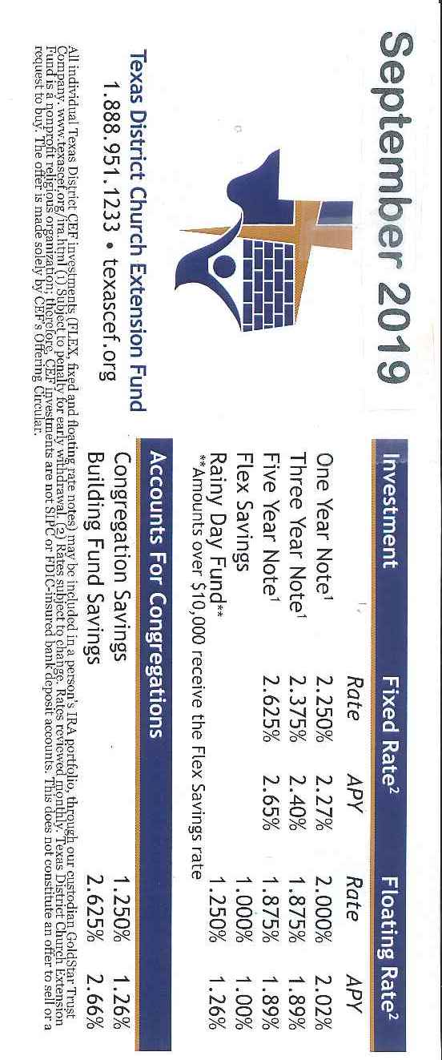

**The next blood drive at Grace will be held on September 29th from 10:30am to 1:00pm. Please make plans to give the lifesaving gift of blood. All donors will receive a $10 Target gift card.**



                

**BUNCO PARTY**

**FUN, FOOD & FELLOWSHIP**

The Women of Zion Lutheran Church of Mission Valley cordially invite you to a Bunco Party in their Fellowship Hall, FM 12183 FM 236, Victoria, Texas 77905. Men are also invited to play dominoes or 42.

When: Monday, September 9, 2019

Registration/Refreshments: 6 – 7pm

Bunco & Dominoes: 7:05pm

RSVP to Sheron Alex 575-7220 or the Church Office: 578-5447

                        

**WOMEN'S FELLOWSHIP**



We will have our planning meeting on Thursday, September 19th at 10:00am as we travel to Rockport to go to the Hummingbird Festival. We will talk about our year as we go down or as we eat lunch in Rockport. This group is a small group that gets together once a month. In the past we have gone shopping, have our annual garage sale, visit nursing homes, make baskets for our shut ins, and we have cleaned the nursery and kitchen. All women of the congregation are welcome to join us!

MEN'S BIBLE STUDY



Come and join our Tuesday night Men’s Bible Study led by Skipper Koetter. We resume on Tuesday, September 10th at 7:00pm. This is a nondenominational Bible study and all men are invited.

**                  **



Please familiarize yourself to know where the AED and first aids kits are located in our building. The AED (Automated External Defibrillator) is located at the main entrance hallway. We have a big first aid kit located in the hallway next to the kitchen.

                  

VCAM (Victoria Christian Assistance Ministry)

VCAM invites everyone to come to our OPEN HOUSE and Raffle drawing on Saturday, September 21 from 9am – 12pm at 108 N. Liberty (corner of Forrest St.). Enjoy refreshments, see our facility and learn more about our client services. The raffle drawing will be held at noon. You do not need to be present to win. If you would like to purchase raffle tickets, contact Elaine Harvill at 803-727-9010. **VCAM truly appreciates your support in any way**….clothing & food donations, monetary, volunteering, and especially prayers!

                

   Men’s Basketball



The Men’s Basketball will move to Thursday nights beginning Thursday, September 5th at 6:30pm. We invite all men to come and join us. Bring your friends and neighbors. If you have any questions, call Pastor Keith.



            

**LONGSHOT MEN’S RETREAT**

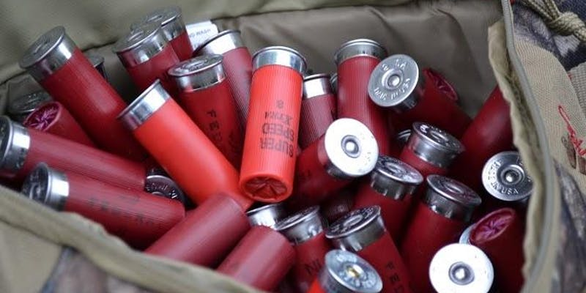

**Fri, Oct 18, 2019, 8:00 PM –**

**Sun, Oct 20, 2019, 12:00 PM CDT**

**Camp Lone Star**

**2016 Camp Lone Star Rd**

**La Grange, TX 78945**

The Longshot Men's retreat began in 2011 as an effort to bring men together around the common interests of shooting sports and disc golf, with the purpose of truly retreating and recharging. We live in a world that embraces the "every man for himself" mantra, yet God tells us through His word that we are supposed to support, encourage, strengthen and sharpen one another. That is what this retreat is about.

You will experience inspiring and practical teaching sessions delivered by inspiring and insightful teachers as we explore the topics that are particularly geared to men. Enjoy lodging and meals at Camp Lone Star; music, skeet , trap and Sporting clays, pistol and rifle ranges, disc golf competition, hiking, washers, horseshoes, and other guy stuff all for just $150.00 or less if you register early or with a group. This event will be limited to the first 150 men to register and pay. The weekend starts at 8:00 Friday evening, and will finish up before lunch on Sunday. You must be 18 or older to attend. **Contact Pastor Keith Aschenbeck by September 16 to register** and to get more information: [office@gracelutheran-tx.org](mailto:office@gracelutheran-tx.org) or 361-573-2232.

Dear Grace Family,



I would like to thank everyone for all the prayers, cards, and food that was done for me during my recent surgery and hospital stays. I especially want to thank Pastor Keith for all his visits and for staying with Joel during the ER stay. I also want to thank Stanley Zieschang and Skipper and Dotty for coming to the hospital and comforting Joel and my family during those scary hours at the ER. I am doing much better and want to say thanks again for your loving us during this time.

With love, Diana Deborah

                  

Dear Grace Family,



Thank you so much for the cards, phone calls, gift and prayers during Michael’s illness. We are so thankful to God that Michael is continuing to get better. Your support and prayers have lifted us up during this difficult time. May the Lord bless each of you.

Love,

Rhonda Boyd and Michael Boyd

Dear Friends at Grace,



I would like to thank everyone for all your prayers and comfort during Ernie’s illness and death. I thank all the ladies of the church that provided the wonderful meal for the funeral. Special thanks to Pastor Keith for the very meaningful message at the funeral.

Thank you again for everything,

Peggy Roensch

                  

JOIN US FOR FAMILY NIGHT



We will have Family Night on Wednesday, September 25th and October 23rd from 6 – 8pm. We will have a meal and then a fun devotion time. Please come and share in fellowship, food, devotion and fun. If you have any questions, please call the church office.

