# Grace Lutheran Church

9806 NE Zac Lentz Pkwy.

Victoria, Texas 77904

Return Service Requested

Grace

Notes

## **A monthly newsletter for members and friends of Grace Lutheran**

[www.gracelutheran-tx.org](http://www.gracelutheran-tx.org)

email – [office@gracelutheran-tx.org](mailto:office@gracelutheran-tx.org)

Non Profit Organization U.S. Postage Paid Victoria, Texas 77901 Permit No. 353

### July 31, 2019

Vol. 42 No. 6



Grace Notes

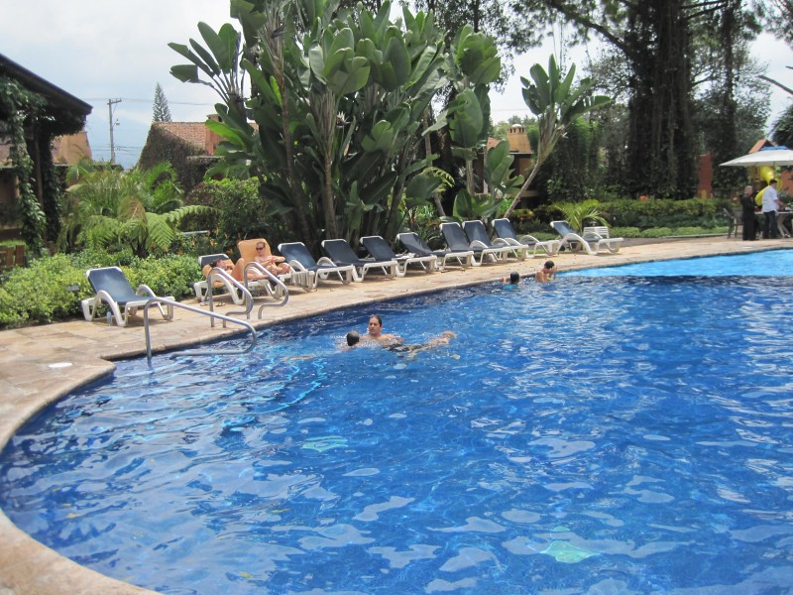

**GRACE FAMILY**

**SWIM NIGHT**

**FRIDAY, AUGUST 9TH**

**6:00 – 9:00PM**

**You are invited to attend the Grace Family Swim Night at Shenandoah Pool. Please bring a snack to share with the others. If you have any questions, please call Karl Koch 361-412-7798 or Kerri Kahanek at 361-237-5253.**

**Acolyte Schedule**

August 4 Kandace Koch

August 11 Kristine Koch

August 18 Anna Aschenbeck

August 25 Sam Truax

**ALTAR SCHEDULE**

**August**

Set Up – Cindy Doyle

Take Down – Janice Fuller

**ELDER RESPONSIBILITY**

**August**

Darrell Hempel/Epley

Person to Secure Building Ushers for Sunday

August 4 Layne Fuller 4 Spies & F. Fuller

August 11 Randy Weiser 11 Zieschang & Harvill

August 18 Chuck Mueller 18 Deborah & D Hempel

August 25 Skipper Koetter 25 Koetter & L. Fuller

**Flower Schedule**

Lay Readers for July Media Room Attendants

August 4 Ken Epley 4 Moore

August 11 Dustin Hempel 11 Becker

August 18 Randy Froehlich 18 Doyle & Shurber

August 25 Mark Weinberg 25 Weiser

August 4 Mueller

August 11 Harjes

August 18 Weinbergs

August 25 Dar Hempel

                     

  Attention all Ladies -



Our next Bunco at Grace will be on Thursday,

August 8th at 6:30pm. Just bring a snacking food

and $2. Please invite your friends or neighbors

and come for an evening of fun with your sisters in Christ.

**LOOK BACK**

6/2/19 Worship 90 $7,715.00 Debt. Red. $3,361.00

SS not counted $ -0- Memorials $ 50.00

6/9/19 Worship 106 $5,202.00 Misc. $ 570.11

SS 31 $ 18.00 Sunday Sch $ 171.00

6/16/19 Worship 122 $4,638.00 Benevolence $ 110.00

SS not counted $ -0- Childrens Min $ 20.00

6/23/19 Worship 120 $5,001.00 Special Gifts $ 934.00

SS 28 $ 34.00 Utility Bldg. $ 500.00

6/30/19 Worship 115 $4,401.25 Beth. Village $2,684.00

SS 23 $ 13.00 Food Pantry $ 25.00

7/7/19 Worship 97 $5,327.00 VBS $ 875.25

SS not counted $ -0-

7/14/19 Worship 117 $7,058.15

SS 25 $ 87.00

7/21/19 Worship 126 $5,232.00

SS 29 $ 39.00

                        

**LARGE PRINT BULLETINS**

**If you would like for Tammy to print you a special large print bulletin for Sunday mornings, please call the office and let her know. This is not a problem at all. I will be glad to do it.**

                        

**If anyone misses a Sunday and would like to have a DVD to watch at home, please call Tammy in the church office and she will be glad to make you a copy. We have all the new media running and copies are available.**

**KIDS STAMPS AVAILABLE**

**KIDS Stamps (formerly known as Tracky Stamps) are available every Sunday in the Sunday School hallway. These stamps are sold through Church Extension Fund. They are available in 25 cents and $1 stamps. This is a great way for your child to save and also helps churches in the Texas District. It is also a great opportunity for grandparents to start or add to a savings account for their grandchildren. See Chuck or Carolynn Mueller if you have any questions.**

                        

Dear friends at Grace,



Thank you very much for the kindness shown to me during my recent illness. All your prayers, cards, visits, phone calls and other expressions of Christian caring have been very much appreciated. Special thanks to Pastor Keith for visiting while I was hospitalized. My wife Doris is eager for me to get well so she can resume her regular Sundays on your organ bench!

Sincerely,

Floyd Wuensche

                        

 IN OUR PRAYERS:



**PRAYER LIST FOR July 23, 2019**

1. Protection for our troops overseas.

2. Thanks to God for all His many blessings.

3. Pray for protection for President Trump and for guidance for our nation.

4. Pray for our nation to come back to God.

5. Continued healing, strength, and comfort for Cole Ohrt. We ask for God’s continue care for this young man to lift his spirits and show him some progress.

6. Continued healing and strength for Mac and Alice McKenzie and prayers for help from the Lord with all their health problems.

7. Pray for Rev. Aaron Spratt with Alaska Mission for Christ and for this ministry.

8. Continued prayers for Sydney Chadbourne as she was taken off the ventilator and she is slowly improving. Reaction to dye for tests caused her body to shut down. Please also pray for her medical care takers to attend to her in the right way.

9. Continued healing and strength for Floyd Wuensche as he is home after having a pace maker installed.

10. Continued prayer for healing for August Hempel. He is doing much better and has now been moved to Warm Springs (Pam) for therapy to regain his strength.

11. Grant healing to Rose Lehmann, Denise Becker’s mom, from fluid retention as she was admitted to Seton Medical in Austin.

12. Healing for Jay Thigpen, Linda Moore’s nephew who is going thru cancer treatment.

13. Thanks and praise for God’s continued guidance for Kiel Weinberg as he continues to move into a new job.

14. Continued healing for Renee Gibbs, daughter of Jerry & June Snyder, diagnosed with aggressive breast cancer and undergoing treatments.

15. Healing for Ruby Rost who began her radiation treatment for pancreatic cancer.

16. Continued healing and strength for Michael Boyd, Molly Summerlin’s grandson and Rhonda Boyd’s son as he is doing much better.

17. Continued healing for Diana Deborah following another hospital stay, she is now home recovering.

18. Healing and strength for Kenny Zieschang for his legs as he goes through his journey with Multiple Sclerosis.

19. Continued healing for Ernie Roensch as he is now on Hospice and his earthly journey is drawing to an end and pray for his family.

20. Thanks for successful eye surgery for Joyce Foster, Susan Teinert’s mom.

21. Pray for the families of the people involved in the horrible traffic accident that killed 5 people.

22. Pray for healing for Robert from PTSD (Post Traumatic Stress) and alcoholism.

23. Pray for Jay Soule, Chris Soule’s dad, as he is at Detar with health issues.

**LWML GRACE LADIES GUILD**



Grace Ladies Guild met on June 19th for our end of the season Bunco and salad bar. We are now on break thru the summer. We will resume on September 18th. Please remember to empty your mites into the big box in the narthex area during the summer as Kim still sends this offering into District during the summer months.

Our June bake sale brought in a profit of $220.25 and this went to VBS. On August 11th, the executive board meeting will be held in Edna. We have also bought items for the food pantry in the amount of $113.17 from previous bake sale monies.

We hope all have a safe and fun summer and we will see you in September.

                       

**Victoria Christian Assistance Ministry**

**VCAM has begun ticket sales for their annual raffle fund raiser. There are 32 items with a total value over $5,000. The list of prizes is posted by the VCAM “basket” in the hallway near the Welcome Center. Tickets are available weekdays, from 9am-noon at their facility, 108 N. Liberty or Elaine Harvill will have tickets available at church. Cost of the tickets are $5 each or 6 for $25. The drawing will be held Saturday, September 21st at Noon as the finale of the Open House. All are invited to attend, but you need not be present to win. For more info, contact Elaine at 894-7651.**

I would like to thank everyone again for your generous gift back in February for my 25th year of service to Grace. Randy and I were able to take a week and went to Fredericksburg and enjoyed some much needed relaxing time in the hill country. Thank you and may God bless each of you as we serve the Lord together!



With Love, Tammy

                     

**We would like to thank all those who bought chickens at the end of June. Our profit was $1,029.17 and was applied to help with Bethlehem Village. Our next chicken sale will be on Sunday, September 29, 2019.**



**□   □   □   □   □   □**

**Pastor Keith continues to work on our church web site. Please check in from time to time to see what is posted. The website is:**



[**https://www.gracelutheran-tx.org**](https://www.gracelutheran-tx.org)

**□   □   □   □   □   □**

**HELP NEEDED**

The Board of Education is looking for volunteers to lead Sunday School for all age groups, nursery to adult. If you have any ideas for our youth, Sunday School or kids activities, please contact Karl Koch or the church office.

**□   □   □   □   □   □**

**We would like to thank all those who came to VBS, those that prayed, worked, donated items, brought their children or grandchildren, and for all the decorations and skits. We had 68 kids registered this year and the total of each day’s attendance rose as the week went on. We had so much fun and Angie Truax, our VBS coordinator has already got next year’s theme picked out. Mark your calendars now for June 22 – 28, 2020 and join us a journey on the “Rocky Railway”.**



I would like to thank all those who gave blood at our June blood drive. We had a very good turnout. Please put on your calendars the next blood drive at Grace will be on Sunday, September 29th.

                        

WOMEN’S FELLOWSHIP

We are currently on our summer break, but we will resume on Thursday, September 19th. We are planning a trip to Rockport to the Hummingbird Festival. Please let Dotty or Tammy know if you will be joining us. We will take our calendars and plan our year as we travel to Rockport, eat lunch and then visit the sites and hopefully see Hummingbirds!!!! All are invited to come along!!!

                           

**SYNODICAL CONVENTION:** Our beloved Lutheran Church – Missouri Synod (LC-MS) held its national convention in Florida on July 20-25. Delegates – pastors and laymen – from across the country gathered together for worship and to conduct the business of the Synod. They passed a number of resolutions from commendations, finances, operations, reaffirming Biblical teaching and more. You might think of a super-sized voter’s meeting! If you would like to learn more about what happened at the LC-MS convention, I encourage you to go to www.LCMS.org and follow the “Convention” link. We thank God for all the folks who gave up their personal time to serve the church in this way.

                           

**CHURCH EXTENSION FUND NEWS**

The Church Extension Fund has introduced a new way to save for something specific … or to be prepared for something unexpected. Here is what you have been waiting for… a new investment alternative. The Rainy Day Fund provides investors the opportunity to BE INTENTIONAL and BE PREPARED. The parameters are as follows:

**REQUIREMENTS**

* $25 initial deposit of new money
* $25 minimum added monthly by Electronic Funds Transfer (EFT)
* Limit one per household

**BENEFITS**

* Premium Rate on und up to $10,000*
* Up to 5 withdrawals annually
* Convenient Access
* No monthly fees

*Flex Savings Rate is applied to amount over $10,000

This is not a temporary investment like the Reformation Note was, but instead is a brand new product we are offering. Again, the focus is for a household to BE INTENTIONAL in their savings and for a household to BE PREPARED for those unexpected events. Chuck and Carolynn Mueller are our CEF representatives and if you have any questions, please feel free to give them a call at 361-564-2068.

**AUGUST CEF RATES 2019**

**One Year Note 2.250%**

**Three Year Note 2.375%**

**Five Year Note 2.625%**

**Floating One Year Note 2.000%**

**Floating 3 & 5 Year Note 1.875%**

**Flex Savings 1.000%**

**Rainy Day Fund 1.250%**

**Congregational Savings 1.250%**

**Building Fund Savings 2.625%**

**LONGSHOT MEN’S RETREAT**

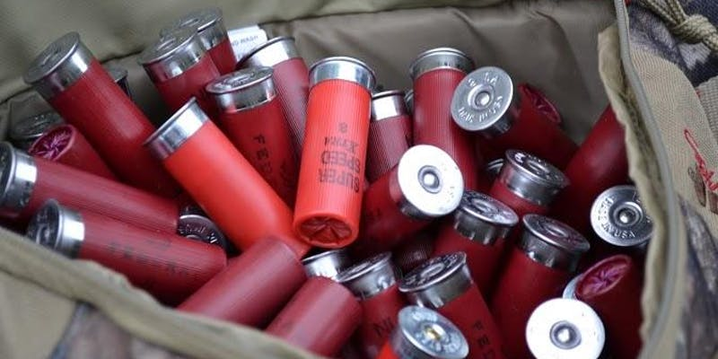

**Fri, Oct 18, 2019, 8:00 PM –**

**Sun, Oct 20, 2019, 12:00 PM CDT**

**Camp Lone Star**

**2016 Camp Lone Star Rd**

**La Grange, TX 78945**

The Longshot Men's retreat began in 2011 as an effort to bring men together around the common interests of shooting sports and disc golf, with the purpose of truly retreating and recharging. We live in a world that embraces the "every man for himself" mantra, yet God tells us through His word that we are supposed to support, encourage, strengthen and sharpen one another. That is what this retreat is about.

You will experience inspiring and practical teaching sessions delivered by inspiring and insightful teachers as we explore the topics that are particularly geared to men. Enjoy lodging and meals at Camp Lone Star; music, skeet , trap and Sporting clays, pistol and rifle ranges, disc golf competition, hiking, washers, horseshoes, and other guy stuff all for just $150.00 or less if you register early or with a group. This event will be limited to the first 150 men to register and pay. The weekend starts at 8:00 Friday evening, and will finish up before lunch on Sunday. You must be 18 or older to attend. Contact Pastor Keith Aschenbeck for more information: [office@gracelutheran-tx.org](mailto:office@gracelutheran-tx.org) or 361-573-2232.

**                                 **



**CONFIRMATION ORIENTATION MEEING**

We will have a confirmation orientation meeting for all students entering the seventh and eighth grades this year on Sunday, August 18th at 11:30am following Sunday School. If you have any questions, please call the church office.

We are in need of two adult chaperones (one male and one female). Call Pastor for more info.

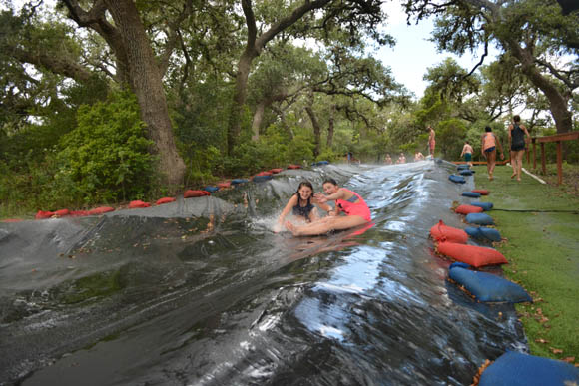

**Confirmation Retreat  
@ Camp Lone Star**

**September 27-29, 2019**

This retreat is designed specifically for **sixth-eighth grade** confirmation students. Participants will learn what it means to be a part of Christ’s body, and to be reminded of holding on to the firm and secure anchor of hope that is found in Christ alone.

                           

Dear family of Grace,



Looking over my desk of clutter, reminds me so much of how easily our lives too can become cluttered. Not only with the things we have yet to do but even with the things that have already been accomplished. Somehow even these things that should have been put away or thrown away still seem to clutter our lives, our thoughts, and even our relationships.

In life it seems there is always so much that we all need to get done. And soon our lives may become so cluttered with stuff that we feel overwhelmed, even lost, or at the very least out of control of what we often think should be somewhat orderly and predictable.

Maybe your life is cluttered with all the things you do to take care of kids, home, family, and spouse, or with what you do as a career, or both, and that doesn’t even include all the social functions, gatherings, dinners, and more that have to be done, accomplished, or completed. All this “clutter” takes our minds off what we should truly be thinking about; it causes worry, and fear. What have I forgotten? Did I miss something? Who have I left out?

Truly, these things, not in and of themselves, but all these things, when they become “clutter” are the result of sin in our lives, and that sin brings along with it all the emotions listed above. Into such a situation comes the grace of God with a peace that passes all understanding. After all, it is not for this world that we live. That is something that can easily and often be forgotten – especially amid the chaos. Christ did not come into this world as one of us that we remain imprisoned in a life of sin. No, He died for each and every one of our sins and weaknesses. He suffered on the cross that we wouldn’t have to live in the fear and worry of this life wondering if we have ever done enough, completed everything, or left anyone out.

Unfortunately, Jesus is the person we often leave out of the clutter of our lives. With all those other commitments, and responsibilities, it seems He often gets pushed aside, falls behind the desk, and gets forgotten. Of course, until something sudden happens and we need him.

Yet, Jesus is there all the time, not just in case of emergency. Jesus is there, and has redeemed you from this world filled with sin and distraction and clutter. To give you a peace to know that this is not what we live for. Rather we live for Him, in Him, and through Him. Only He can truly fill up our lives with good things. Only He can truly fill our lives with things that bring joy and peace, rather than fear and worry.

Let us take a moment each day to clear the clutter of our lives and see the clear shining light of our Lord and Savior who comes to us each and every Day. He does it not out of a vain desire for Himself and His own glory. He does it out of an unbelievably incredibly gracious love for you and for me.

Blessings in Christ,

Pastor Keith

**COLE OHRT**

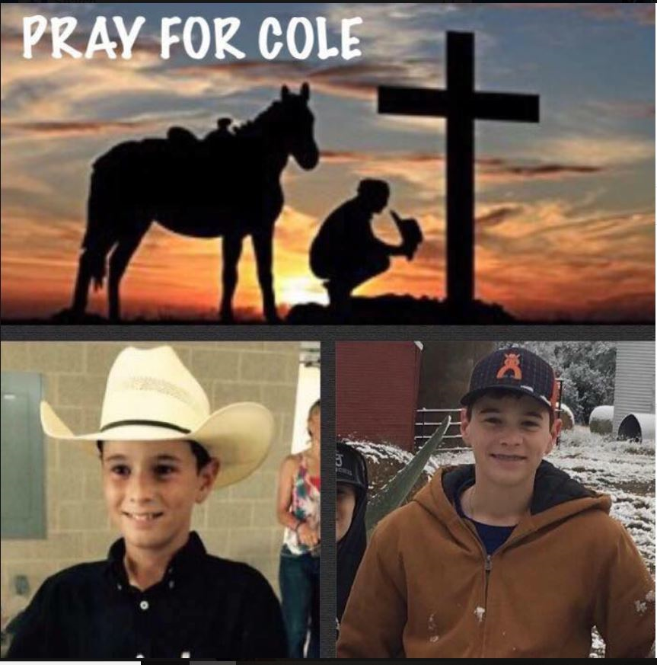

From Kim Froehlich - I would like to encourage everyone to lift Cole and his family in prayer daily. It would be great if we flooded Cole with cards from Grace Lutheran members.

On December 21, 2017, Cole Ohrt was in an accident while working and helping out on the ranch. Cole was doing what he always does, pulling his own weight on the ranch. Cole is not like any other 14 year old. He is a strong, responsible, dependable young man; his dad’s top hand. He is capable of doing the work of any grown man.

He and his family have been dealt a pretty bad hand. Cole is tough, but needs God to wrap his hands around his spinal cord and heal him. Cole is one tough cowboy, who has very strong faith, family, friends, and God on his side.

Each day is going to be a new day, and he and his family will take it one day at a time.

Please pray for Cole, Garrett, Julie, and all his family and friends that they may have the strength to provide the care he needs and the strength to take each day, one day at a time. Together, with God’s help, he will be Cowboy Tough and Cole Strong.

**July 18, 2019 update**

Hi everyone! Sorry it’s been so long since I’ve posted anything but the only way to access Facebook here is if your VPN is connected and half the time it won’t connect. Cole doing well. He’s finally over the tracheitis and has been showing improvement in his head and neck strength. Since the accident Cole has not been able to hold up his head for any length of time but as of today he’s able to hold it up for over a minute and a half in a sitting position. This may not sound long but it is an eternity when your muscles are weak. Cole very proud of this accomplishment! A few cards have been trickling in the past few days which is like Christmas for Cole. I know there are many others still floating around in the postal world and not sure when or if we’ll get them. Just wanted to say thank you to all who are sending them. They mean the world to Cole. Thank you for all your continued prayers as well. Stay cool! Heard it’s terrible hot back home.

The address for the hospital is:  
Kunming Tongren Hospital   
Cole Ohrt   
1099 Guangfu Road   
Xishan Shi, Kunming   
Shi, Yunnan Sheug   
China 650000  
Gabrielle 86 158-1201-2852

