# Grace Lutheran Church

9806 NE Zac Lentz Pkwy.

Victoria, Texas 77904

Return Service Requested

Grace

Notes

## **A monthly newsletter for members and friends of Grace Lutheran**

[www.gracelutheran-tx.org](http://www.gracelutheran-tx.org)

email – [office@gracelutheran-tx.org](mailto:office@gracelutheran-tx.org)

Non Profit Organization U.S. Postage Paid Victoria, Texas 77901 Permit No. 353

### May 30, 2019

Vol. 42 No. 5



Grace Notes

Mark your calendars for



June 17 – 21, 2019

**Vacation Bible School News!**

Well it’s that time of year again. VBS will be June 17th – 21st. The theme this year will be “ROAR! Life is wild God is good!”. Family members and friends are encouraged to join in daily for this special time at 9:00am. ROAR is for kids from 4 years old to 5th grade and will run from 9am to noon each day. We will also serve lunch. For more information, call Angie Truax at 361-550-7619 or the church office at 361-573-2232. Registration forms are at the welcome center. Please get your kids and grandkids, neighbors, etc. registered for a fun filled week!

**Date: June 17 -21, 2019**

**Place: Grace Lutheran Church**

**Time: 9:00am – 12:00 noon**

**Contact: Angie Truax**

**Acolyte Schedule**

June 2 Kandace Koch

June 9 Kristine Koch

June 16 Anna Aschenbeck

June 16 cross – Sam Truax

June 16 candle – Madalynn Kroos

June 23 Katelyn Kahanek

June 30 Madalynn Kroos

July 7 Sam Truax

July 14 Jessica Albrecht

July 21 Kandace Koch

July 28 Kristine Koch

jul

**ALTAR SCHEDULE**

**June**

Set Up – Angie Truax

Take Down – Tammy Weiser

**ELDER RESPONSIBILITY**

**June**

Teinert/Becker

Person to Secure Building Ushers for Sunday

June 2 Chuck Mueller 2 Zieschang & Harvill

June 9 Layne Fuller 9 Dustin Hempel

June 16 Skipper Koetter 16 Koetter & L. Fuller

June 23 Skipper Koetter 23 Harjes & Koch

June 30 Chuck Mueller 30 Spies & F. Fuller

July 7 Layne Fuller 7 Zieschang & Harvill

July 14 Skipper Koetter 14 Dustin Hempel

July 21 Chuck Mueller 21 Koetter & L. Fuller

July 28 Randy Weiser 28 Harjes & Koch

Lay Readers for June Media Room Attendants

June 2 Dylan Sexton 2 Weiser

June 9 Tyler Sexton 9 Moore

June 16 Dalton Hempel 16 Becker

June 23 Dawna Weinberg 23 Doyle/Shurber

June 30 Dustin Hempel 30 Weiser

July 7 7 Moore

July 14 14 Becker

July 21 21 Doyle/Shurber

July 28 28 Weiser

**FLOWERS FOR ALTAR**

**June 2 Open**

**June 9 Open**

**June 16 Open**

**June 23 Open**

**June 30 Open**

**July 7 Tucker**

**July 14 Weiser**

**July 21 Open**

**July 28 Open**

Attention all Ladies - Our next Bunco at Grace will be on



Thursday, June 13th & July 11th at 6:30pm. Just

bring a snacking food and $2. Please invite your

friends and neighbors and come for an evening of

fun with your sisters in Christ.

                         

**LOOK BACK**

5/5/19 Worship 94 $6,475.50 Debt Red $1,198.00

SS $ 23.00 Sunday Sch $ 92.00

5/12/19 Worship 168 $5,080.00 VBS $ 300.00

SS $ 18.00 Memorials $ 25.00

5/19/19 Worship 109 $5,041.22 Flowers $ 8.00

SS $ 15.00 Periodicals $ 9.00

5/26/19 Worship 105 $not counted yet Childrens Min.$ 160.00

SS 20 $ 36.00 Utility Bldg. $ 250.00

                        

 **KIDS (TRACKY STAMPS) AVAILABLE**



**KIDS (Kids Into Discipleship and Stewardship) are available every Sunday in the Sunday School hallway. These stamps are sold through Church Extension Fund. They are available in 25 cents and $1 stamps. This is a great way for your child to save and also helps churches in the Texas District. It is also a great opportunity for grandparents to start or add to a savings account for their grandchildren. See Chuck or Carolynn Mueller if you have any questions.**



We have had good attendance on the second Tuesday of each month to play games. Our next meeting will be on Tuesday, June 11th & July 9th at 1:00pm. We play Chickenfoot, Dominoes (42) and Yahtzee. Everyone has a good time. We invite everyone to join us!!! If you have any questions give Molly Summerlin a call.



**GRACE LADIES GUILD (LWML)**

**Grace Ladies Guild met on May 15th  for refreshments and a business meeting. There were 7 present. Our next meeting will be on June 19th. We will have a salad bar and play Bunco. Please bring a friend. All ladies of the congregation are invited to attend. We ask that you bring a salad of your choice for the salad bar. There will be a short business meeting at 3:00pm and then we will play Bunco and have the salad bar. This will be our last meeting before our summer break. Hope to see you there. Reminder, please bring your mites to this meeting as we have been asked to send them in every month.**

**Sunday, June 9th the Guild will sponsor a bake sale. Proceeds will go to VBS. All Guild members are asked to bring a homemade baked good. If anyone in our congregation would like to help by donating some homemade goodies, we would greatly appreciate it. Just bring them that morning.**



**               **

**LUTHERAN CHICKENS**



**ARE BACK**

**Our church BBQ team will have their next chicken BBQ sale of the year on Sunday, June 30th. We will sell whole chickens, one for $9 or three for $25. We will also have beans available by the pint for $1. Please take orders from your neighbors and friends. Tammy needs to have the count by Sunday, June 16th.**

**LARGE PRINT BULLETINS**

**If you would like for Tammy to print you a special large print bulletin for Sunday mornings, please call the office and let her know. This is not a problem at all. I will be glad to do it.**

**                **

Dear Members of Grace,



Church history can be amusing, confusing, and at times just plain quirky. In our modern 21st Century world we often lament the struggle to keep Christ in Christmas and the Resurrection the center of Easter. These laments are not without reason, but there is a bit of irony to be had when we look back at Church History regarding these matters.

First, let me state that much of what you see and read about these holy days and their supposed pagan roots is atently false and without any true basis, but you will likely find it hard to find the facts. The internet is full of misleading information and false assertions, but the truth gathers little traction… in my opinion the truth is too mundane for most ‘news’ organizations. But that is a whole different article.

The irony comes from several different points. First, you might be disheartened to learn that Christmas played a very minor if any role in the life of the early church. Early Christians just were not all that concerned with celebrating the birth of Christ. Not because it wasn’t important, but it was much less significant than other events. The high place that Christmas holds in the life of the church today, in terms of church history, is a recent development.

Easter, on the other hand, became the most central of holy days. In fact, Easter is actually celebrated every week on Sunday (the first day of the week). So significant was Easter that the early Christians changed their Sabbath day from Saturday to Sunday.

The real irony is that two of the most significant and celebrated days of the early Church hardly find even a mention today. The first came on May 30th this year (40 days after the resurrection.) It was the Ascension of Jesus! We did have a regular church service on June 2nd focused on the Ascension, but the early church would have celebrated with special services on the actual date. This is the day that Jesus “ascended into heaven and [was] seated at the right hand of the throne of God.” (cf. The Creeds). The significance of which is the celebration of Jesus wielding all power and authority: He truly is King of Kings and Lord of Lords and now sits before the throne of God interceding for us!

The second holy day we often pass over without much notice is Pentecost. This year Pentecost is on May 9th. Pentecost literally means 50th day as counted from the Passover(Easter). This is the day that Jesus sent the Holy Spirit upon the church to dwell in and with the People of God. He has come to bring comfort, to intercede for us, and to remind us of all that God has spoken to us. While the wise men brought gifts to Jesus, the Holy Spirit brings us gifts from God: faith, life, and salvation! Maybe this is the day we should actually exchange gifts as Christians!

For all the fanfare, expectation and lamenting that occurs with the birth of Christ, today little is noted about his actual coronation into His Kingdom. And with all the celebration of his coming, not much is made of the coming of the Holy Spirit – the one who is credited for calling, gathering, and enlightening the Church. The irony is that as we often lament keeping Christ in Christmas and Easter yet are hardly even bothered by the lackluster remembrance of the Ascension and Pentecost.

I guess the reason the world doesn’t do much to offset the celebrations of these other Holy Days is because we often do little to highlight them and celebrate them with the importance that they are due. God be merciful to us!

Thankfully, our salvation is not dependent on celebrating a variety of church holy days, but in the Cross of Christ where we were granted forgiveness, life and salvation. Thankfully the Lord continues to send us His Holy Spirit to keep us ever faithful as He rules His church in victory unto life everlasting. But please… take note of these days in the Church year; they are significant reminders of God’s full plan of salvation and without these events, we would have neither faith nor life! All of which we confess every Sunday in the Apostles and Nicene Creeds.

Blessings and Peace,

Pastor Keith

                             

IN OUR PRAYERS:



**PRAYER LIST FOR MAY 28, 2019**

1. Protection for our troops overseas.

2. Thanks to God for all His many blessings.

3. Pray for President Trump for guidance for our nation.

4. Pray for our nation to come back to God.

5. Continued healing, strength, and comfort for Cole Ohrt. We ask for God’s continue care for this young man.

6. Continued healing and strength for Mac and Alice McKenzie and prayers for help from the Lord with all their health problems.

7. Pray for Rev. Aaron Spratt with Alaska Mission for Christ and for this ministry.

8. Continued healing and strength for Billy Stange and his family as he continues his battle with cancer.

9. Pray for relief of pain & continued healing for Stanley Zieschang following his foot surgery.

10. Continued prayer for healing for August Hempel and for his family as they travel this long road of recovery with him.

11. Continued prayers for David Dierlam as he continues his battle with cancer.

12. Healing for Jay Thigpen, Linda Moore’s nephew going thru cancer treatment.

13. Continued healing for Gayle, Molly Summerlin’s sister, that God will give her peace and relieve her pain.

14. Continued healing for JoNell Martin, friend of Tammys, undergoing cancer treatment.

15. Continued healing for Renee Gibbs, daughter of Jerry & June Snyder, diagnosed with aggressive breast cancer and undergoing treatment.

16. Praising God! Sydney Chadbourne was finally able to go home after 3 months in the hospital following her heart transplant, niece of Schrameks.

17. Continued healing for Michael Boyd, Molly Summerlin’s grandson and Rhonda Boyd’s son, as he continues to heal following blood clots and seeks to see a specialist in Dallas. We ask God’s direction to clear the path of all the insurance roadblocks so he can see the right specialist for his condition.

18. Comfort for the family of Yvonne Triesch, close friend of Randy & Tammy, as she was called home last week.

19. Prayers for Monic Orht Dowitzky as she was diagnosed with stage 4 brain cancer, friend of Darrell & Susan.

20. A church member who wishes to remain anonymous needs our prayers for serious health issues and needs God’s help to deal with the problem.

**If anyone misses a Sunday and would like to have a DVD to watch at home, please call Tammy in the church office and she will be glad to make you a copy.**

**                           **

VOTER’S MEETING



JULY 28, 2019

10:30AM

                         

**GRACE KIDS IN ACTION!!!**

**Katelyn Kahanek –** Made A-Honor Roll for the 4th 9 weeks of 7th grade. She also received the Patriot Heart Award in volleyball for Good Character and has been recommended by grades, test scores and her math teacher for high school Honors Alegra 1.

**WAY TO GO KATELYN!!!**

                         

**MEDIA ROOM HELP NEEDED**

If you would like to help in the media room, please contact Tammy in the church office and she will make sure you have the training you need and will get you on the schedule when you feel comfortable. We currently have four people on the schedule and could definitely use some more.

**Church Extension Fund**

**Chuck and Carolynn Mueller are our CEF representatives and if you have any questions, please feel free to give them a call at 361-564-2068. The current June rates are as follows:**

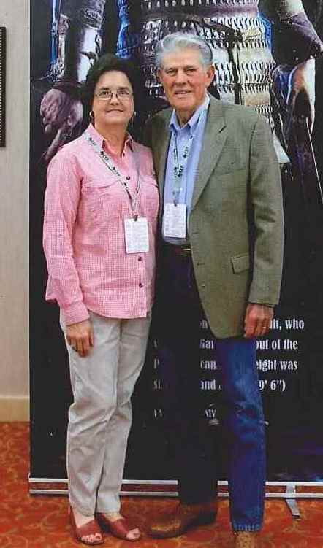

**JUNE 2019**

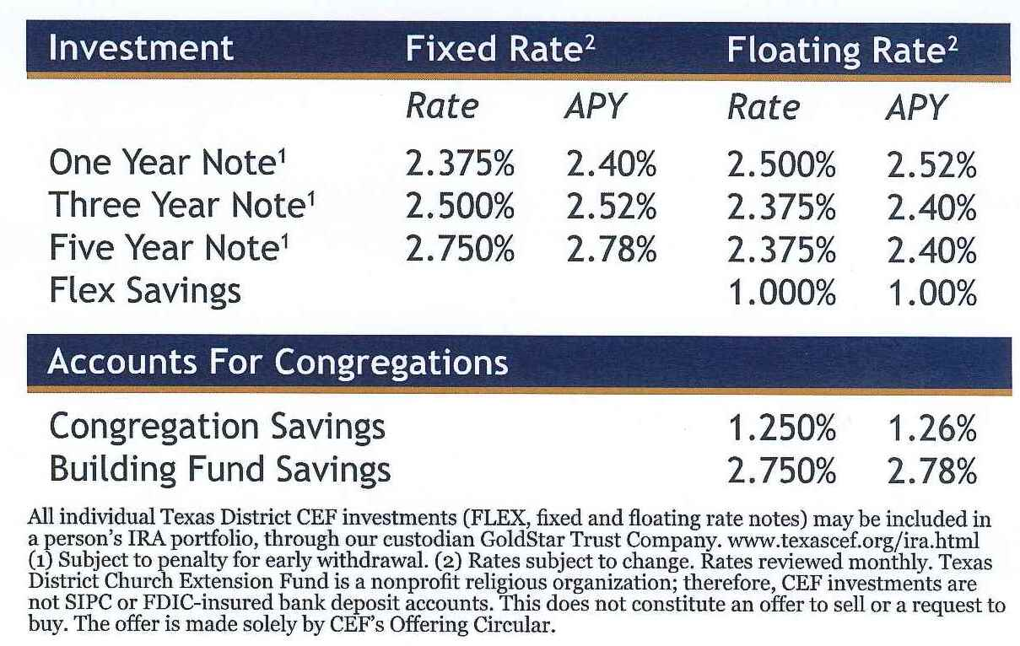

**HELP VCAM OUT!!!!**

**Victoria Christian Assistance Ministry (VCAM)**

School is out and families use more food! So VCAMis having a special collection during June and July of the following items: (regular size containers)

Mustard Ketchup Mayo Spaghetti/Tomato sauce Flour Sugar Cooking oil

Jello Corn Bread mix Vienna Sausage Ramen noodles Tuna Fruit cups

Pasta Mac&Cheese Pasta Peanut Butter Jello salt & pepper (picnic size shakers)

Toiletries: Bar soap Body Wash**\*** Shampoo**\*** Tooth paste

**\*please, no large/family sizes of the liquid products**

Household cleaners: Dish soap**\*** Toilet cleaner**\*** General purpose cleaners**\***

Smaller bottles of laundry detergent

Toilet paper and paper towels (larger packs are ok & will be broken down individually)

**And, as always, we are accepting summer clothing and shoes of all sizes**.

The collection basket is in the front hallway to the right of the sanctuary. I will put some copies of the list out for you to have handy when you are shopping.

**THANK YOU! THANK YOU! FOR SUPPORTING VCAM!! Your generosity and kindness make a huge difference for those in need!**

We are always looking for volunteers too! Come and check it out this summer!

**For more info contact Elaine Harvill 894-7651**

                

**SECURING THE BUILDING HELP NEEDED!!!!**

If anyone is interested in helping to lock up the building on Sunday mornings, please call Tammy in the church office. You would only need to do it about once every 5 weeks and longer if we get more people to help out. Tammy will walk you thru the building and tell you exactly what doors need to be checked and what A/C units need to be turned off. Please prayerfully consider helping with this matter.

                     

**NEWSLETTER UPDATE – THIS MONTH WE ARE COMBINING THE JUNE AND JULY CALENDARS AS IN THE SUMMERTIME THERE IS NOT AS MUCH ACTIVITIES. ALSO TAMMY AND PASTOR WILL BE TAKING SOME TIME OFF DURING THE SUMMER MONTHS AND THIS WILL HELP WITH THE SCHEDULE. THE NEXT NEWSLETTER WILL BE MAILED OUT AT THE END OF JULY WITH THE AUGUST CALENDAR.**

**                     **

**       Women’s Fellowship**

**May 16th was our last gathering until September. We enjoyed a potluck luncheon at the Koetter’s house with 6 in attendance. Our September meeting date is yet to be determined. Watch for dates in your bulletin!**

**                 **

**The next blood drive at Grace will be held on June 23rd from 10:30am to 1:00pm. Please make plans to give the lifesaving gift of blood. Donors will receive a $10 Valero Gas card, those with “0” blood type will receive a $20 Valero Gas card.**



                

Please continue to collect round Oatmeal containers for Rachel Bush. You can bring them to the Welcome Center and leave them. She will pick them up. Thank You!!!   



**SUMMER FUN FOR ALL – PLEASE SEE THE INSERT FOR THE FUN SUMMER ACTIVITIES FOR ALL FAMILIES IN THIS NEWSLETTER!**

**Important dates to remember are:**

**June 17 – 21 – VBS**

**June 23 – Party in the Park**

**June 28 & July 12 – Generals Baseball games**

**June 25 – August 13 – Men’s basketball**

**July 21 – Bowling**

**August 3 – Grace family river float trip**

**               **

**See where you can help out at Grace! There is always things needing to be done. Here are some areas! If you are interested, call the church office:**



**1. Media Room Help needed – you will be trained.**

**2. Help needed to secure the building on Sunday mornings.**

**3. Help needed to mow our huge church yard and vacant field next door. We can schedule teams if we can get enough people to help.**

We will continue to post things that need help with each week in the bulletin or you can ask Stephen Branson what he needs help with. Stephen is our head trustee.

***LAUGHS FOR TODAY!***

**Show and Tell -** A kindergarten teacher gave her class a “show and tell” assignment. Each student was instructed to bring in an object that represented their religion to share with the class. The first student got up in front of the class and said, “My name in Benjamin and I am Jewish and this is a Star of David.” The second student got up in front of the class and said, “My name is Mary. I’m a Catholic and this is a Rosary.” The third student got up in front of the class and said, “My name is Tommy. I am Lutheran and this is a casserole.”

**The Best Way to Pray** – A priest, a minister and a guru sat discussing the best positions for prayer, while a telephone repairman worked nearby. “Kneeling is definitely the best way to pray,” the priest said. “No,” said the minister. “I get the best results standing with my hands outstretched to Heaven.” “You’re both wrong, “ the guru said. “The most effective prayer position is lying down on the floor.” The repairman could contain himself no longer. “Hey, fellas,” he interrupted. “The best prayin’ I ever did was when I was hangin’ upside down from a telephone pole.”

**The Twenty and the One –** A well-worn one-dollar bill and a similarly distressed twenty-dollar bill arrived at the Federal Reserve Bank to be retired. As they moved along the conveyor belt to be burned, they struck up a conversation. The twenty-dollar bill reminisced about its travels all over the country. “I’ve had a pretty good life.” The twenty proclaimed. “Why I’ve been to Las Vegas and Atlantic City, the finest restaurants in New York, performances on Broadway, and even a cruise on the Caribbean.” “Wow!” said the one-dollar bill. “You’ve really had an exciting life!” “So tell me,” says the twenty, “where have you been throughout your lifetime?” The one dollar bill replies, “Oh, I’ve been to the Methodist Church, the Baptist Church, the Lutheran Church.” The twenty dollar bill interrupts, “What a church?”

*Items needed for VBS if you would like to donate:*



*80 ice cream cones*

*Bags of dry beans (12)*

*2 squeeze bottles Ketchup*

*5 lg. bottles of sprinkles*

*2 squeeze bottles Mayo*

*5 lg contianers Cool Whip*

*3 lg pkg. of ham lunch meat 80 small round brownies*

*3 lg pkg. of turkey lunch meat*

*80 small vanilla yogurt cups*

*18 bags of chips*

*1 lg bottle blue food color*

*8 large bags of Fritos 4 lg bags plain M & Ms*

*Cookies 3 lg bags pretzels*

*2 family size cans of Chili 80 zebra cakes*

*80 weiners for hot dogs 2 containers of animal crackers*

*80 vanilla pudding cups 3 lg cans Kool-Aid*

*3 lg cans lemonade 9 watermelons*

***70 paper towel tubes***  *Bags of rice (10)*

*2 x 4 – 12 ft long boards (5) Redi Mix concrete (5)*

*Monetary donations Prayers*

We are also in need of volunteers:

Storytelling Kitchen help (snacks and lunch)

Arts and crafts Helpers People to make decorations

People to set up People to clean up People to help decorate

If you have any questions, please call Angie Truax at 361-550-7619.

