# Grace Lutheran Church

9806 NE Zac Lentz Pkwy.

Victoria, Texas 77904

Return Service Requested

Grace

Notes

## **A monthly newsletter for members and friends of Grace Lutheran**

[www.gracelutheran-tx.org](http://www.gracelutheran-tx.org)

email – [office@gracelutheran-tx.org](mailto:office@gracelutheran-tx.org)

Non Profit Organization U.S. Postage Paid Victoria, Texas 77901 Permit No. 353

### October 25, 2018

Vol. 41 No. 10



Grace Notes



**Thanksgiving Eve Service**

**Grace Lutheran Church**

**Wednesday, November 21**

**at**

**7:00 PM**

**Acolyte Schedule**

November 4 Allison Bussey

November 11 Mason Bussey

November 18 Kandace Koch

November 21 Anna Aschenbeck

November 25 Kristine Koch

**ALTAR SCHEDULE**

**November**

Set Up – Terry Tucker

Take Down – Joy Schramek

**ELDER RESPONSIBILITY**

**November**

Epley/Zieschang

Person to Secure Building Lay Readers

November 4 Jason Bussey 4 Ken Epley

November 11 Randy Weiser 11 Randy Froehlich

November 18 Skipper Koetter 18 Jack Bussey

November 21 Chuck Mueller 21 Dawna Weinberg

November 25 Layne Fuller 25 Dylan Sexton

**USHERS MEDIA ROOM**

November 4 Zieschand & Harvill 4 Weiser

November 11 Deborah & Dustin Hempel 11 Moore

November 18 Koetter & L. Fuller 18 Becker

November 21 Harjes & Koch 21 Doyle/Shurber

November 25 Spies & F. Fuller 25 Moore

**FLOWER CHART FLOWERS**

**Nov. 4 Teinert**

**Nov. 11 Shipman**

**Nov. 18 Truax**

**Nov. 21 Thanksgiving**

**Nov. 25 Thanksgiving**

  

 

**LOOK BACK**

9/30/18 Worship 115 $3,282.18 Debt. Red. $1,202.00

SS 35 $ 44.00 Sunday Sch $ 104.00

10/7/18 Worship 117 $7,853.30 Utility Bldg. $ 125.00

SS 31 $ 24.00 Kids Stamp $ 20.00

10/14/18 Worship 115 $4,425.00 Luth. For Life $ 131.00

SS 59 $ 21.00 Beth. Village $2,260.00

10/21/18 Worship 128 $5,067.00 Breakfast $ 10.00

SS 29 $ 15.00

We have received bulletins in the office from these churches: First English Evangelical Lutheran Church, Victoria, Texas and Redeemer Lutheran Church, Austin, Texas.

                        

**LARGE PRINT BULLETINS**

**If you would like for Tammy to print you a special large print bulletin for Sunday mornings, please call the office and let her know. This is not a problem at all. I will be glad to do it.**

                   

 

Attention all Ladies -



Our next Bunco at Grace will be on Thursday, November 8th at 6:30pm. Just bring a snacking food and $2. Please invite your friends or neighbors and come for an evening of fun with your sisters in Christ.



**Upcoming Fall**

**Worship Times & Dates**

**November 18, 2018 –** Voter’s meeting at 10:30am

**November 21, 2018 –** Thanksgiving Eve Service at 7:00pm



**December 6, 2018 –** 6:00pm Rehearsal for Bethlehem Village



**December 7 & 8, 2018 –** Bethlehem Village 6 – 8pm

**December 5 –** Advent service at 7:00pm

**December 12 –** Advent service at 7:00pm



**December 19 –** Advent service at 7:00pm

**December 24 –** Christmas Eve Candlelight at 6:00pm

**December 25 –** No Christmas Day service

                        

We will decorate the Chrismon and Angel Trees on Tuesday, November 27th at 10:00am. We need a strong man to bring the tree down and put it up for the ladies to be able to decorate it. We will also be putting up the other inside decorations at that time. Anyone that can help are welcome to come!!!!



                                 

IN OUR PRAYERS:



**PRAYER LIST FOR OCTOBER 23, 2018**

1. Protection for our troops overseas.

2. Thanks to God for all His many blessings.

3. Pray for President Trump for guidance for our nation.

4. Pray for our nation to come back to God.

5. Healing and strength for Billie Truesdell.

6. Continued healing, strength, and comfort for Cole Ohrt having diaphragm pacer surgery so he can get off the vent.

7. Continued healing and strength for Mac and Alice McKenzie and prayers for help from the

Lord with all their health problems.

8. Praising God and thanking Him for successful hip replacement for Randy Froehlich. Ask for continued healing and no complications.

9. Asking God to relieve back pain for Eddie Miller.

10. Healing for Gayle, Molly Summerlin’s sister, going thru chemo and radiation for lung cancer.

11. Continued healing for Ed Gingrich following his second leg procedure and ask for no complications.

12. Strength for Gary Iraggi and his family as they are dealing with his cancer.

13. Continued healing and comfort for Fred Talbott, our flower bed guy, who has suffered severe health issues.

14. Peace and comfort for the family of Donna Bentley at her sudden passing.

15. Continued healing for Jeff Wakefield, cousin of Fred Fuller, recovering from back surgery.

16. Pray for continued healing for Kristine Koch following her eye surgery.

17. Prayer for Rose Lehmann, Denise Becker’s mom, asking for good results from Doppler tests of Rose’s heart and neck. She continues to struggle with COPD.

18. Prayer for Harold Palmer for peace, Tammy’s cousin, as his life on earth is coming to a close and pray for his family as they deal with his illness.

19. Thanks for successful back surgery for David Cobb, close friend of Randy & Tammys and ask for continued healing.

20. Peace and comfort for Ralph Jackson at his passing.

21. May God give all those fighting cancer strength, faith and comfort and healing.

22. Blessings on Stanley & Pam Zieschang’s 30th wedding anniversary. Safety for them as they travel to Hawaii on their vacation.

23. Thanks for good test results for Cindy Doyle and pray that the doctors will find out what caused her symptoms.

24. Birthday blessings for Nathalie Shurber.

25. Giving thanks to God for good results from all Pam Zieschang’s tests and for the tests to prepare for rotator cuff surgery following the return trip from Hawaii.

**                     **

**K.I.D.S. STAMPS AVAILABLE**



**Tracky Stamps are available every Sunday in the Sunday School hallway. These stamps are sold through Church Extension Fund. They are available in 25 cents and $1 stamps. This is a great way for your child to save and also helps churches in the Texas District. It is also a great opportunity for grandparents to start or add to a savings account for their grandchildren. See Chuck or Carolynn Mueller if you have any questions.**

**                      **

GRACE LADIES GUILD (LWML)

Grace Ladies Guild met on Wednesday, October 17. Our next meeting will be on Wednesday, November 14th at 3:00pm. Our hostess for this meeting will be Shirley Spies and she will also give our devotion. At this meeting, we will have a guest speaker, Barbara Brisell from House of Palms. Bags were handed out to our members to fill with items for moms and babies to be given to the House of Palms which is a ministry that helps young moms.

Our October bake sale brought in $220.00. Thanks to all that purchased baked goods and for those who brought items. The proceeds of this bake sale went to a single mom who is struggling.

We will decorate the Chrismon and Angel trees on Tuesday, November 27th at 10:00am.

**PERSONAL CARE KIT ITEMS**

A Personal Care Kit includes:

One Bath size towel (app. 52” x 27”)

Two bath size bars (4-5oz) soap

One adult size toothbrush in its org. pkg.

One sturdy comb, remove packaging

One metal nail clippers, remove packaging

*Toothbrush multi-packs may be used by sealing an individual toothbrush in a business envelope; no plastic bags or wrap. Do not add other items or leave out any of the items listed. All items should be new and in good condition. Wrap all items in the towel and tie securely with ribbons or yarn. Do not enclose the Kit or any of its contents in plastic bags.

**Bethlehem Village 2018 coming December 7 & 8**



Bethlehem Village will be held again this year on Friday and Saturday nights, Dec. 7 & 8th. Last year we had a great response from the congregation and the community. We still need people to volunteer to be a part of Bethlehem Village. The costumes are hanging in the game room. The following booths will be in this year’s village:

1. The City Gate 2. Money Changer

3. Census Tent 4. The Pottery

5. The Clothier 6. Musicians

7. The Bakery 8. Women at the well 9. The animals 10. The Carpenter Shop 11. Spice House 12. The Inn

13. The Nativity with baby Jesus 14. Wise Men

15. Crosses 16. Synagogue

The buildings have been brought down from the loft. We will set up all the buildings on Saturday, December 1, 2018.

We still need some parts filled. If you are interested in playing a part, speaking or non-speaking, please see the list at the welcome center. If you have any questions, call Tammy Weiser in the church office, 573-2232 or Janet Shipman 652-8372.

                  

**BLOOD DRIVE**



Thank you to everyone who donated at our recent drive. We had 10 donors give the life saving gift of life. Good job! Our next drive will be sometime in January. Watch for further details. If you should have any questions please contact Carolynn Mueller, chairman at 564-2068.

                           

WOMEN'S FELLOWSHIP

The Women’s Fellowship met for a planning meeting in September and in October, we cleaned the nurseries and swapped the baby nursery into the room where the TV is and put the toys into the Noah’s Ark room. On Thursday, November 15th we will meet at the church at 9:30am and go shopping in Cuero and have lunch out. We invite all the women of the congregation to join us and bring a friend.

                  

**Young at Heart Group**

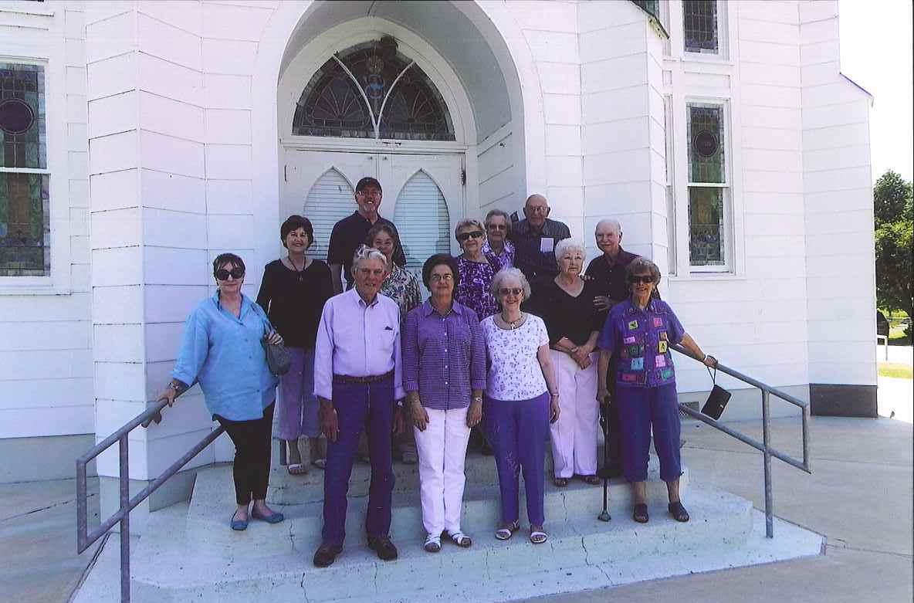

**The Young at Heart Group continues to meet on the second Tuesday of each month to play cards and dominoes. Our November meeting will be on Tuesday, November 13th at 1:00pm.**

                  

Regular Scheduled Voter’s Meeting



November 18, 2018

at 10:30am

                      



**How a Christian is like a Pumpkin**

A lady recently being baptized was asked by a co-worker what it was like to be a Christian. She replied, "It's like being a pumpkin:   
God picks you from the patch, brings you in, and washes all the dirt off you may have gotten from the other pumpkins. Then he cuts the top off and scoops out all the yucky stuff. He removes the seeds of doubt, hate, greed, etc. Then He carves you a new smiling face and puts His light inside of you to shine for all the world to see."

*Internet*

Ethel Guion has moved from Victoria to Colorado to live with her daughter. Below is her new address and email so you can keep in touch with her:



Ethel Guion

15033 E. 50th Ave.

Denver, CO 80239

Email – [jancasern@gmail.com](mailto:jancasern@gmail.com)

Phone 720-883-6011

□   □   □   □   □   □   □   □

We have recently received transfers for two new families. Below you will find their contact information:



Rev. Tom & Rita Wagstaff

45 Driftwood St.

Rockport, TX 78382

Tom 361-727-7287 Rita 361-205-0964

[wforgiven@juno.com](mailto:wforgiven@juno.com)

Charles & Susan Maluschka

313 Tuscany

Victoria, TX 77904

Charles 381-723-5771 Susan 281-723-4364

[Nightrules271@gmail.com](mailto:Nightrules271@gmail.com)

                     

VCAM (VICTORIA CHRISTIAN ASSISTANCE MINISTRY) UPDATE

Households provided for in September:

Households served – 1145

Food boxes – 998

Basic needs – 920

Clothing – 402

Home delivery – 12

Homeless – 28 (52 bags)

Financial assistance – 21

New VCAM clients served – 57

Homeless visits – 182

First Time VCAM Clients served - 68

Contact Elaine Harvill if you would like more information.

Dear Family of Grace Lutheran Church,



“Give thanks with a grateful heart! Give thanks to the Holy One! Give thanks because He’s given Jesus Christ His Son. Give thanks!”

I learned those words as a song while working at Camp Lone Star during the summer as a camp counselor. That refrain clearly states how each day of our lives should be lived: in thanksgiving to God!

November is upon us and, even though it is often thought of as the month of Thanksgiving, with it comes a host of things to think about. Many will begin to plan for the family get-togethers and holiday meals. Christmas lists for friends and family are being compiled. Thoughts of joy surround thoughts of reunion. Thoughts of sorrow encircle loved ones remembered. Even in the midst of the holidays life still happens.

Just because the holiday season is upon us doesn’t mean our circumstances in life change. In fact, many lament at how much their stress level increases this time of year. They simply wait for the New Year to come when it will all be over, when they can breathe a sigh of relief from all the hustle and bustle that comes this time of year.

November often ends up as a time when we talk a lot about stewardship. But, for the most part stewardship talk in church can often focus on only money. However, A steward was concerned with more than with just giving. Stewardship really is about managing that which has been placed in one’s care. To be effective at managing means one must take the time to evaluate, plan, commit, and execute.

Evaluating who we are, what we have, and what we are to do is an important task of any good manager. As a Christian, you are a child of God! You have the power of Christ enabling you to do all things! You are to bring glory to God in all things for the proclamation of Christ.

Planning involves looking at the resources God has given you, and developing a strategy for the use of those resources. Those resources include everything we have from our eyes, ears, and all our senses to our knowledge, talents, and attitudes along with our possessions and money. But honestly, how often do we think of stewardship in the light of planning? Who of us takes time to evaluate the unique way God has created each of us, and then plans ways to use that uniqueness in service to His Mission? Often people just jump in and go at; hoping for the best along the way. The reality we all know is that a good plan offers the best chance of success.

Commit to the plan! No marriage will last without people committed to the cause. No victory will be found in battle if soldiers easily waver from their task. We may say a lot of negative things about Muslim Extremists, but one thing we all know is how deeply committed they are to their cause. For us as Christians there should never being any question about our commitment. After all, we have a Lord and Savior who committed his very life to us. He was so committed to us that He endured the scorn of the cross in our place.

Execute the plan! Indeed you have been called according to God’s purpose. He indeed has a design for everything that you are and have. He has chosen to execute his plan of proclamation through YOU! By His grace, YOU have been chosen! YOU have been re-created!

God indeed evaluated you. Diagnosing you as a sinner he planned out your salvation. Committed to the cause, Jesus was born of the Virgin Mary, suffered, and died under Pontius Pilate. He continues to accomplish His plan of salvation through His Word. Equipping you through the Holy Spirit, He continues to bring life and salvation into a world of darkness.

Indeed, God has made us stewards – caretakers of all that we are and have; managers of His gifts that His glory may be made known each and every day. For this, let us ever give thanks in all we say, think, and do knowing that God has loved us! Let us thus manage who we are and what we have that God would receive all glory, honor, and praise!

In Christ,

Pastor Keith

                              

**November 2018 LCMS Stewardship Ministry Thought:**

Sometimes people don’t like it when pastors talk about stewardship. For some, it hits too close to home. It is easier to talk about bad people in Washington, in history, or overseas than it is to think about what our daily life in Christ is supposed to look like – how we are supposed to love our neighbor.

The fact that we don’t like hearing about stewardship certainly means we ought to face it. Here are a few simple and practical realities.

God calls us to first-fruits, sacrificial giving. This means we should give off the top. We should set a percentage of our income as a deliberate gift for the work of the Church and give that first. We write the check to the Lord’s work in the Church before we pay the mortgage or pay for our medicine or pay for anything else.

We don’t pay for all the stuff we need, and think we need, and then give from what is left over. That is the first-fruits idea. It is hard because we think we need all sorts of other things first. But that is the point of “sacrificial.”

Next, how could the starting point for Christian generosity and sacrifice really be anything less than a tithe – 10 percent? The ceremonial law of the Old Testament was never arbitrary. In the Old Testament, the Levites received this tithe so they could be full-time ministers.

Does the New Testament have a ministry that is larger or smaller? It is far larger: “Make disciples of all nations” (Matt. 28:19).

And we are still to have a full-time ministry: “The Lord has commanded that those who preach the Gospel should make their living from the Gospel” (1 Cor. 9:14).

So, if 10 percent was needed in the Old Testament, and we have a bigger mission need in the New Testament, how can we expect the Lord’s work to be done on less than a tithe?

First-fruits, sacrificial, generous giving – that’s the way. We shouldn’t fool ourselves into thinking that we’ve out-given God’s goodness or that we’ve given plenty.

We might be tempted to think so but consider – no one in the Church has given plenty because no one has given all. No one has died for his sins. Only the sinless Son of God did that.

Or, as St. Paul said, bringing the Good News of Jesus into the discussion of our giving to support the Lord’s work in the Church:

“I say this not as a command, but to prove by the earnestness of others that your love also is genuine. For you know the grace of our Lord Jesus Christ, that though he was rich, yet for your sake he became poor, so that you by his poverty might become rich” (2 Cor. 8:8-9).

As you can see, what the Bible commands about our stewardship can sting. It’s law, and the law shows our sins. It calls us to repentance.

The law is meant to expose and accuse for the sake of showing us Christ and His fulfillment of the law. If first-fruits, sacrificial giving has you squirming, that’s the point.

In Mark’s account of the feeding of the 5,000, Jesus took the disciples’ five loaves and two fish and blessed them. It was nothing among so many, but, of course, it was plenty. Jesus makes something from nothing.

Mark doesn’t say that all the disciples gave Jesus all the bread they had. It is quite possible some of them held something back. But even if they did, that didn’t stop Jesus from blessing them. Jesus makes something out of nothing.

He, who fed His people in the desert with Manna every morning, doesn’t need their bread. But they need to give it. And what they give, however little it might be, however grudgingly they do so, He blesses it.

He not only blesses those whom He feeds with it, but He blesses them, the givers – not just in that they wind up with (a basket full for each loaf) but that they learned to trust and rejoice in Him.

The Lord gives, and the Lord takes away. The Lord gives abundantly or asks us to fast. We do not know what will happen. Blessed be the Name of the Lord.

He does all things well and works all things together for good. The disciples don’t give their bread to Jesus because it is a good investment. They give it because He is good, they love Him, and they trust Him. Let us go and do likewise.

**                           **

**Texas Church Extension Fund**

For those of you who were unable to attend church this past Sunday, this will give you a short recap of what we covered in our program.

First of all, we are happy to announce that our investors here at Grace have accumulated over $700,000 in investments. Our goal is to reach the $1 million mark in the future.

Your investments give you a good interest rate:

1 year – 2.250%

3 year – 2.500%

5 year – 2.750%

Remember when you invest in church extension fund you are extending God’s kingdom by buying land and buildings which go toward building churches and schools and additional needs to existing facilities.

In honor of the 500th year of the reformation, a special 6 month investment was offered at a very good interest rate. I’m proud to say, that many of you participated in this opportunity and continue to remain as investors. Throughout the Texas District, there were over 1600 new investors of which more than 85% remain.

If by chance, you are not yet part of the Texas District Church Extension Fund Investment family, we joyfully invite you to join us today!

Last thing, your funds are always available in several days should the need arise. Also, discussed was the children’s stamp program (Kids Into Discipleship & Stewardship) and their savings along with a video. The video is available to the Sunday School teachers should they desire to show it to their class at a later date.

Contact Chuck & Carolynn Mueller should you have any questions.

(361-564-2068)

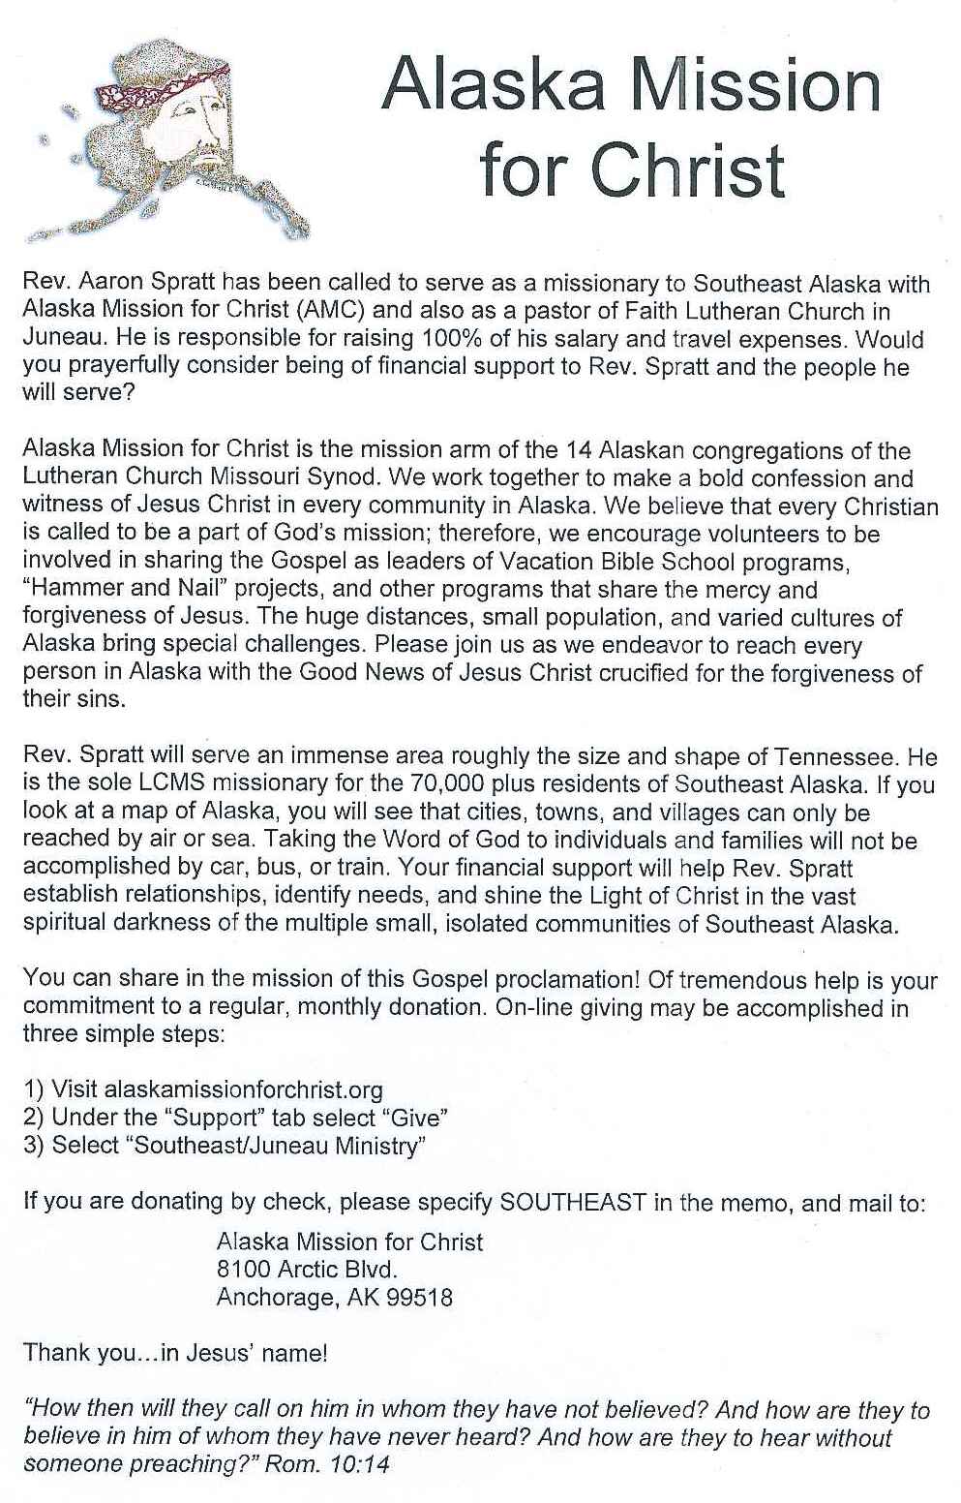

**Victoria Apartment Association is sponsoring OPERATION FIREFIGHTER**

**The Victoria Apartment Association, Victoria County Fire Marshal’s Office and the Victoria County Fire Department have joined together for the fourth year to bring Christmas to apartment families in need through Operation Firefighter.**

**Operation Firefighter provides toys, clothes, food and a complete Christmas dinner to apartment families in need. They are delivered to the families by Firefighter Santa and his Firefighter elves. They all arrive at the Apartment complex on Fire Trucks. In addition to the family being helped, all of the children at the complex receive goody bags and get to explore the trucks and have their photo taken with Santa.**

**Operation Firefighter is always looking for donations – toys, clothes, food and money. 2018 Sponsor cards are still available for a donation. We are also looking for places to place our collection boxes. Operation Firefighter holds several garage sales each year to raise money.**

**If you have any questions, please contact Toni Stithem at 361-571-8664.**

**HAPPY**

