First Lutheran
Preschool
Handbook

2017-2018

First Lutheran Church
420 North Washington
Papillion, Nebraska 68046

Preschool | 339-1178
Church Office | 339-3668

CONTENTS

Your Child…………..……………………………………….…3
Philosophy……………………………………………………..3
Purpose…………………………………………………………4
Curriculum……………………………………………………..4
Administration…………………………………………………5
License…………………………………………………………..5
Admission………………………………………………………5
Schedule of Classes…………………………………………….5
Tuition and Fees………………………………………………..6
Arrival…………………………………………………………..6
Departure……………………………………………………….6
Health and Safety..……………………………………………..7
Clothing..………………………………………………………..8
Snacks……………………………………………………………9
Birthdays………..…………………………………………….…9
Chapel……………………………………………………………9
Field Trips……………………………………………………….9
Holidays……………………………………………………….…9
Things to Bring to School……………………………………….9
Discipline……………………………………………………….10
Parental Contact……………………………………………….10
Helping Your Child Adjust to Preschool……………………10
Remember………………………………………………………11
Closings...………….……………………………………………11
Disaster Preparedness Plan……………………………………11
Reporting Suspected Abuse/Neglect...………………………12
Funeral Days…………………………….………………………12
Preschool Staff…………………………………………………..12
Contact Information…………………………………………….12

First Lutheran
Preschool

YOUR CHILD IS AN IMPORTANT PERSON

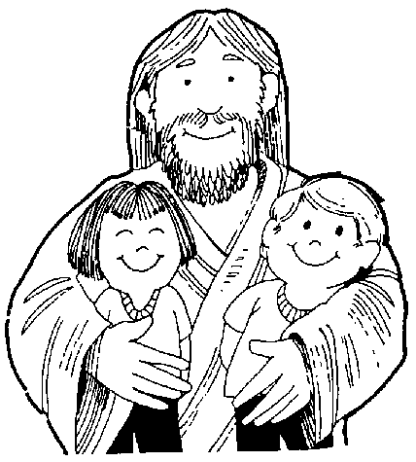
Your child is a very special gift from God.
God has made your child unique and different from any other child in many ways.
God has made you your child’s first and most important teacher. Your child learns from you every day and is learning as you talk, play, work, and interact with each other. That is why we here at First Lutheran Preschool believe in a strong parental involvement in your child’s education.

HOW YOUNG CHILDREN LEARN

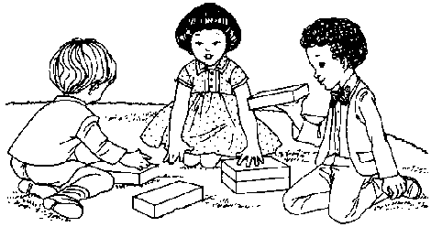
Each parent looks to a preschool for different reasons. For whatever the reason, the fact is that children learn by doing. One educator has stated, “A child’s play is work.” In play, the child learns by using his fingers, hands, toes, eyes, ears, and mouth with tangible objects. In playing, children increase their skills, creativity, and understanding.
In a room arranged for the children’s needs, you will see role-playing, dramatizations, intricate block structures, creative writing, sorting, classifying, counting, smelling, tasting, and touching. Children may be noisy and active but learning is taking place.

PHILOSOPHY

Proverbs 22:6 provides the foundation for early Christian education: “Train a child in the way he should go, and when he is old he will not turn from it.” We believe parents have the primary responsibility and privilege to provide Christian training for the child. First Lutheran Preschool can strengthen and support the parents by nurturing the child in his spiritual, intellectual, physical, social and emotional needs. It provides an atmosphere of Christian love, recognizing the individuality of each child and nurturing a positive self-concept.
Our Lord also commissions us to “go and make disciples...” (Matthew 28:18-20). First Lutheran Preschool is in an excellent position to reach out in love and make disciples. It is a place of Christian nurture that shares the love of Jesus, who said, “Let the little children come to me...” (Mark 10:14).

PURPOSE

First Lutheran Preschool shares the love of Jesus, nurtures the whole child and provides excellence in education.
Goals
¶ To affirm Jesus Christ as the loving Savior and Lord through formal education, worship, and a distinctive Christian environment.
¶ To nurture the child’s basic spiritual, intellectual, physical, social and emotional needs through a variety of experiences and activities.
¶ To recognize the individuality of each child through a well-rounded educational program.
¶ To help the child develop a healthy balance between autonomy and cooperation by providing opportunities for independent action and for group interaction.
¶ To encourage the child to express his faith at school, church and home.

CURRICULUM

Early childhood curriculum includes:
Outdoor play- running, jumping, climbing, ball throwing and catching.

Indoor play- blocks, trucks, housekeeping, puzzles, table games and sand play.

Art experiences- experimenting and creating with many types of media including paints, clay, paper, yarn etc.

Social Studies- meaning, value, and experience of seasons, holidays, homes, church, community, health etc.

Science experiences- planting and caring for seeds, observing animals, using senses to discover the world.

Number experiences- developing number concepts, patterning, categories, and spatial sense and number recognition by using counters, measuring cups and finger plays.

Language activities- storytelling, discussion, building vocabulary and enjoying books.

Alphabet experiences- understanding that letters have special meanings, can identify some letters, especially letters in their name, can notice the beginning sound of letters and writes (scribbles) as a part of a playful activity.

Musical experiences – singing, listening, rhythm, musical games, and movement to music.

Dramatic Play- socio dramatic play puppets, acting out stories.
Religious activities-daily lessons in Christian living with puppets, Bible stories, flannel graphs etc.

ADMINISTRATION
First Lutheran Preschool is operated under the auspices of First Lutheran Church, Papillion, Nebraska.

LICENSE
First Lutheran Preschool is licensed by the Nebraska Department of Health and Human Services.

ADMISSION
First Lutheran Church believes that educational opportunities and programs should be open to boys and girls on an equal basis. Therefore, First Lutheran Preschool admits students of any race, color, national and ethnic origin to all the rights, privileges, programs, and activities generally accorded or made available to students at the school. It does not discriminate on the basis of race, color, national and ethnic origin in administration of its educational policies, or admissions policies. First Lutheran Preschool is unable to meet the special needs of children with certain physical, mental, emotional or behavior disabilities.

Minimum Age
Enrollment is open to children who meet the minimum age requirement, which follows the current Department of Education standards. A child must be age three or four by July 31, of the school year.

Enrollment Limits
The number of children enrolled in any one class will not exceed the student-teacher ratio established by the state of Nebraska. The ratios are 18 students per teacher and teacher’s assistant in all classes.

SCHEDULE OF CLASSES

Class | Days | Tuition/Month | Time
3 year old class | Mon/Wed  Mon/Wed/Fri | $120 | 9 am - 12 noon
 |  | $150
4/5 year old class | Mon/Wed/Fri  Mon-Fri | $150
 |  | $185

TUITION AND FEES
For 2017-2018 monthly tuition is $120.00 for the Mon/Wed class, $150.00 for the Mon/Wed/Fri classes and $185.00 for the M-F class. Tuition holds the child’s place in the class. The monthly tuition fee is an average of the monthly cost that needs to be paid regardless of the number of sessions your child attends. A non-refundable registration fee of $75.00 is required at the time of registration.
The following is the schedule for paying tuition:
Tuition For Due $25 late fee after
September at Orientation August 30
October September 1 September 10
November October 1 October 10
December November 1 November 10
January December 1 December 10
February January 4 January 10
March February 1 February 10
April March 1 March 10
May April 1 April 10
Checks may be made out to First Lutheran Church. Payment may be placed in the Preschool Tuition Box located by the secretary’s window inside the main entrance. If you choose to prepay your child’s tuition, please mark the check with the months you are paying.
If tuition is not paid by the end of the month, the child will not be allowed to attend class until tuition is paid in full. If unusual circumstances arise, parents should visit with the Director.

ARRIVAL
The doors will be unlocked promptly at 8:55 am. It is permissible to use the handicapped spaces for Preschool arrival and departure. For the 4/5 year olds please enter the building through the north door and the 3 year olds please enter the middle west door from the west parking lot then proceed to the snack/cubby room to drop off backpacks and coats and then continue to your child’s classroom to sign him/her in. In order to insure your child’s safety, we require that an adult bring their child into the building and sign them in. If you have a message for the teacher, please write it on paper. Arrival time is hectic.

DEPARTURE
Please sign your child out at pick-up. A child will not be dismissed with anyone except a parent or someone designated by the parent. In the event that it is necessary for someone other than a parent or designated person to pick up the child, the code word will be used as verification. A copy of a court order is needed to prevent non-custodial parent from picking up a child. Doors will be unlocked from 11:50 am-12:10 pm.

LATE FEE
A Late Fee will be assessed at $1.00/minute beginning at 12:10 p.m. Please call ahead to let us know of unavoidable circumstances if you are going to be late. Thank You.

HEALTH AND SAFETY

Immunizations and Records
A Child’s Record for Preschool must be completed prior to attendance. A copy of your child’s shot record will be requested along with the child’s record form to fulfill the requirements below.
Students must have all required immunizations. According to Title 173, Nebraska Administrative Code, Chapter 4, the parent or guardian must “present within thirty days of enrollment…
(a) proof that the child is protected by age-appropriate immunization against measles, mumps, rubella, poliomyelitis, diphtheria, pertussis, tetanus, and haemophilus influenza type B; or
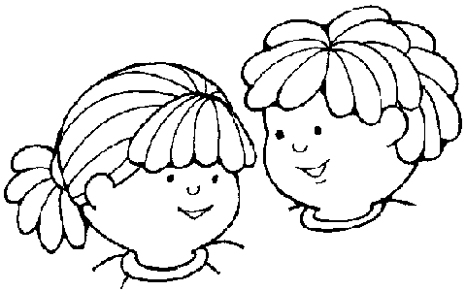
(b) certification by a physician, certified nurse practitioner, or physician assistant that immunization is not appropriate for a stated medical reason; or
(c) a written statement that the parent or guardian does not wish to have such child so immunized and the reasons therefore.”
The immunization history must contain “the name of the vaccines; the month and year for DTP/DT, OPV/IPV and Hib, and the day, month and year of administration of MMR; the name of the health practitioner or agency where the immunizations were obtained; and the signature of the physician, parent, guardian or of other such person maintaining the immunization history of the child, verifying that the child has received these vaccines.” Most doctors will copy this information for you if you call them.

Illness
Only children who are well can be accepted at school. Symptoms that are cause for keeping your child home include: a cold, coughing, sneezing, sore throat, earache, headache, fever, chills, or red eyes. If symptoms of illness are observed or if the child becomes ill during the day, the parent will be called and asked to pick up the child.
A child will not be permitted to attend school if he has any illness associated with a fever or any communicable condition such as diarrhea, ringworm, pink eye, chicken pox or measles. A child should not be brought to school if he has a fever or has experienced vomiting, diarrhea, skin rash or other serious symptoms within the last twenty-four hours. The child needs to be symptom free for 24 hours before he/she may attend class.
The parent or guardian should call the preschool office to let us know when their child is unable to attend due to illness. You may leave this information on the Preschool answering machine (339-1178).
Any known medical concerns should be brought to the attention of the teacher.

Medications
School personnel will not administer medications. A child may not bring any non-prescription or prescription medication to school. A doctor’s note will be required for any emergency medication kept at school such as an epi pen or an inhaler.

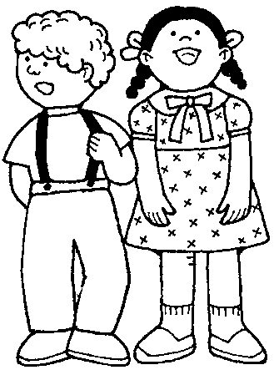
Accidents
In case of an accident or a medical emergency, every effort will be made to contact the parent. Parents are asked to notify the school immediately if there is a change of address or phone number. If hospitalization is necessary, parents will be asked to arrange for transportation. If the parent cannot be reached, the lead teacher and/or Preschool Director has the authority to call a doctor or ambulance or hospitalize the child at the parent’s expense. If the teacher/Preschool Director perceives the injury or illness is life threatening, the rescue squad will be called immediately and then the parents will be contacted as quickly as possible.

Insurance
All children enrolling at First Lutheran Preschool need to be covered under an insurance plan. Parents will need to provide coverage. A copy of the insurance card that your child is covered under will be required by the child’s first day of attendance. A child may qualify to be covered under the Kids Connection plan by the state of Nebraska if they are currently not covered under a family plan. You may call 1-877-632-5437 for more information.

Toilet Training
Children must be toilet-trained and have their bathroom habits well established before they are admitted to First Lutheran Preschool.

Buckle Up Your Children
According to Nebraska Law all children are required to ride correctly secured in a federally-approved child passenger restraint system.

CLOTHING
Children should be dressed in play clothes and walking/running shoes.
We require that no sandals or open shoes be worn. This is for the children’s safety. Our playground has a pea gravel surface and we run/play on the blacktop from time to time.
Have your child wear clothes that he or she can easily manage by himself for the restroom. All outerwear (coats, jackets, sweaters, boots, hats, mittens) and backpacks/school bags should be clearly marked with your child’s name.
We go outdoors year around, weather permitting and above 32 degrees.

SNACKS
There will be a mid-morning snack each day. Each child needs to bring his/her own snack. Nutritional snacks, such as fruit sections, vegetable sticks, cheese and crackers, raisins, finger sandwiches, etc., help set good nutritional habits for children.
Please inform the teacher of any allergies your child may have.

DUE TO some children being highly allergic to nuts, i.e. peanuts, peanut butter, and all nuts including air-borne allergies to nuts, NO snack will be allowed that contains nuts or nut products. Your cooperation in this matter is greatly appreciated!

BIRTHDAYS

We ask that no birthday party invitations be handed out at school. We understand you cannot invite the entire class but, unfortunately, 3, 4, & 5 year olds do not understand and then the result is hurt feelings. Thank you in advance for understanding!

CHAPEL
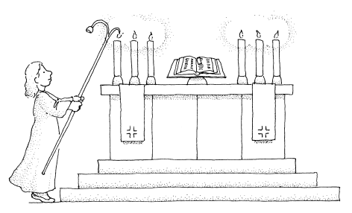
Every Wednesday the children will participate in chapel for an object lesson, singing and prayer.
We encourage you to stay and join us on these days. Chapel is usually about 15 minutes in length and begins at 9:15 am.

FIELD TRIPS
Field trips will be scheduled throughout the school year. Parents will be notified concerning these special activities. Parents will be asked to help provide safe transportation in accordance with the law.

HOLIDAYS
Christian holidays are observed at preschool. While it is impossible to ignore the secular holidays, we are called by Scripture to be set apart from the world. Holidays will be celebrated with a Christian emphasis for Thanksgiving, Christmas and Easter.

THINGS TO BRING TO SCHOOL
Please have your child bring a book bag or backpack to school each day. It should be clearly marked with your child’s name. PLEASE PROVIDE an extra change of clothes in a zip lock bag that will be kept in your child’s cubby. Clothes should be switched out with the change of seasons.
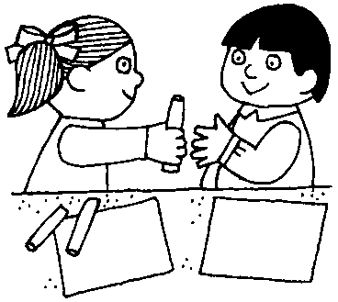
Toys, gum, candy, money, etc., should be enjoyed at home. There will be “sharing time” for children to bring special items. The teacher will inform you of these times.

DISCIPLINE
Discipline develops disciples. Discipline will be handled in a loving, Christian manner. The teachers will attempt to build good discipline by:
Encouraging and praising good behavior
Changing the environment
Redirecting the child
Removing the child from the group for a brief supervised time out

Sometimes a child may have difficulty in following the classroom rules. At that time a conference is called with the parents to discuss an individual approach with the child to help him or her subscribe to our rules.

PARENTAL CONTACT/GRIEVANCES/QUESTIONS/CONCERNS
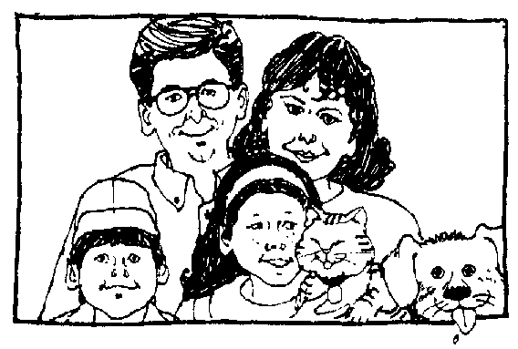
Please inform the staff with any information that would give insight into your child’s behavior, such as changes at home, a parent’s absence, guests, a newborn in the family, the inability of the child to sleep at night, etc. Please arrange for an appointment to discuss any problems regarding the child at school or at home. The better we understand your child, the better we are able to help him or her.
Parent-Teacher Conferences will be scheduled to discuss your child’s progress. You may also schedule a conference or phone call with your child’s teacher throughout the school year to check up on progress.
If you have a grievance, concern or question that has not been satisfied by talking with the teacher, please talk with the Director. If it still is not answered satisfactorily, ask the Director for information in how to contact the Children’s Ministry Board Director, our governing board.

HELPING YOUR CHILD ADJUST TO PRESCHOOL
Each child is special—no two are alike. For many children, starting preschool is a big adjustment. They need time to discover their place and feel at home.
A positive attitude on the part of a parent will help the child adjust to the new situation. However, it is important that a child is allowed to have other feelings about preschool. Let your child express true feelings and listen.
You may feel the need to stay with your child on the first or second day of preschool to help your child adjust. If it happens that your child has a difficult time adjusting to preschool you may find that leaving them quickly is easier on your child than prolonged goodbyes. The staff has had experience in handling adjustment problems with compassion and effectiveness.
If you continue to be concerned about your child’s adjustment to preschool, set up an appointment with the teacher. Be sure to show an interest in the preschool by asking your child what he or she did during the day.

REMEMBER
Remain excited and positive about the preschool experience. You can do a great deal to help your child have a positive experience.
Show interest in the things your child brings home. Ask your child to tell you about it. Each item is an example of a personal endeavor on the part of the child and is important to him or her. Praise and appreciate the thought and effort put into the project.
Listen to your child. Each experience is important to him or her.
Rest is important for the child and his or her success at school. Please ensure that your child gets plenty of sleep at night.
We also encourage parental guidance of television viewing. What your child sees on television may affect his thinking and attitude.
Help us to get to know your family. Share your family experiences with us. While they are not all positive, they affect each member of the family. Information shared with us to help you and your child function will be handled with confidence and respect for privacy.
Please contact the staff with any concerns you may have. We want the preschool experience to be positive for your child!
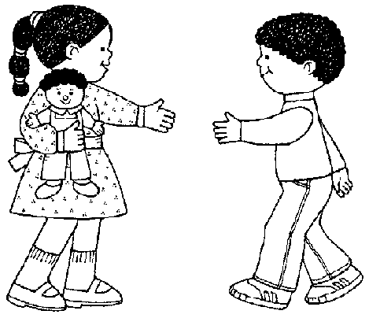

SEVERE WEATHER CLOSINGS
When severe weather conditions are in effect, and the Papillion-LaVista Schools close, then we are closed. Announcements are made on the three major TV stations. We trust your judgment and you make the final decision of whether it is safe to bring your child to school on bad weather days and school is not cancelled.

DISASTER PREPAREDNESS PLAN
- In the event of a tornado warning, children will be taken to the lower level as laid out in the tornado evacuation diagrams displayed in the classrooms.

- In the event of a fire or other disaster necessitating the evacuation of the building, children will be evacuated and led to the far west end of the west parking lot.

2a. At that point, a count will be taken of all children. When all children are accounted for, they will be led to the Papillion Fire Station.

2b. After arrival at the fire station, parents will be notified to pick their children at the station.

- Evacuation of special needs children will be dependent on the need of the individual child.
REPORTING SUSPECTED ABUSE/NEGLECT POLICY

- Preschool staff are required and mandated, by state law, to report suspicion of child abuse or neglect.

- Concerns of suspected abuse/neglect of a preschool child shall immediately be reported to the Director.

- The Director and teacher reporting the suspicion will immediately call the Child Abuse-Neglect Hotline (1-800-652-1999).

FUNERAL DAYS

At times during the school year, a funeral will be held in the Church Sanctuary. The north entrance is used for the funeral procession. On these special days we will use the west middle door entrance into the preschool or, on rare occasion, we may need to cancel school.

PRESCHOOL STAFF

Preschool staff meet the state requirements and qualifications as determined by the State of Nebraska and the Nebraska Department of Health and Human Services (DHHS). Staff are required to attend 6 clock hours of training per year in areas such as: safety, healthy environments, learning domains, physical development, and social development; the Director is required to attend 12 hours of training. Staff discipline is carried out by first having a dialog with the staff member, followed by two written warnings, and then suspension and/or termination. Staff follow state guidelines for immunizations. Staff illness policy is the same as that of our preschool children.

CONTACT INFORMATION
Please call the preschool office AND/OR email your teacher if your child will not be at school
Preschool 402-339-1178
Church Office 402-339-3668
Director – Dave Ricke’s email: preschool@1st-lutheran.org
Ms. Jackie’s email: bjgraham1@cox.net
Ms. Kathy’s email kluver143@centurylink.net
Website: www.1st-lutheran.org
Facebook: First Lutheran Preschool

*Be sure to “LIKE” us on Facebook and send the link to relatives so they may see what fun we are having at Preschool!

FIRST LUTHERAN CHURCH AND PRESCHOOL IS A NON-SMOKING FACILITY.

