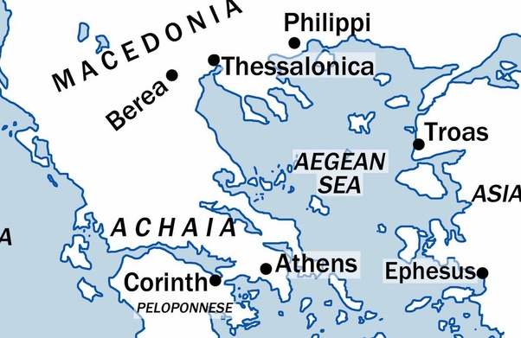
Welcome to Thessalonica
Acts 16:16-40 Summarize what had happened to Paul and Silas before coming to Thessalonica.
How would you have felt after having had that experience?

Acts 17:1 – What is the first thing that we are told about Thessalonica.
What does that say about the city of Thessalonica?

Acts 17:2- What was Paul’s custom? What would you call it instead of a custom?

Acts17:3-4- What was the point of his message?

What was the difference between what happened in Philippi and Thessalonica regarding the authorities?

Chapter 1
- What does the verse 1 tell us about what happened in Thessalonica?
- What makes it hard to say the words of verse 2 “always thank God for you”?
- What other portion of Scripture would help us say and mean those words? (hint: body of believers)
- Instead of putting emphasis of the things that are done what is stressed?
Explain how having that perspective can help us in our serving God.
- We know from Acts that he preached to Word but what also accompanied that preaching?
- What might be the suffering that Paul is referring to in verse 6?
- How would the actions of the Thessalonians been made known everywhere?
- Share a story of a Christian or Christians that was an inspiration to you so they might be known everywhere.
- There are 3 things that they did that he mentioned. Which one do you think was the hardest?
Next week:
1 Thessalonians chapter 2

