The Concordian
A Newsletter of Concordia Lutheran Church – ELCA
Superior, WI October 2018 Vol 37 No. 10
“Called to Nurture and Live our Faith, Encourage our Service, and Actively Share the Gospel”

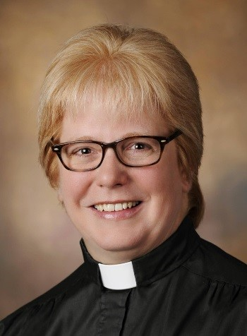
From the Pastor:

Grace to you and peace from God our Father and from our Lord and Savior, Jesus Christ.
As I write this article, the news is broadcasting the guilty pleas and verdicts of prominent people relating to financial crimes ranging from tax evasion to campaign violations. Also in the news is the report that more than 1000 youth were abused by bishops and other church leaders (more than 300 of them) in the Roman Catholic Church in Pennsylvania over a period of 70 years.
Why do things like this happen? How is it that people come to believe that “it’s okay to do this as long as I don’t get caught”?
The Bishop of the Madison (Wisconsin) Diocese of the Roman Catholic Church issued a five-page letter in response to the abuse. In his letter, he says, “There is nothing about these stories that is okay. These actions, committed by more than a few, can only be classified as evil, evil that cries out for justice and sin that must be cast out from our Church.”
Later, he recognizes that the crisis cannot be limited to the abuse detailed in the published report, and states, “The deeper crisis that must be addressed is the license for sin to have a home in individuals at every level…”
He’s speaking particularly of the leadership of the Roman Catholic Church, aghast (I believe) at how high a level the abuse was perpetrated (even by a Cardinal). I left the church part out of the quote because I am more involved with people not in that hierarchy, not acquainted with Cardinals, hardly aware of the prestige that can be attributed to bishops. “The deeper crisis that must be addressed is the license for sin to have a home in individuals at every level…”
We read in Paul’s letter to the Romans that “All have sinned and fall short of the glory of God” (Romans 3:23). We read further that “the wages of sin is death, but the fee gift of God is eternal life in Christ Jesus our Lord.” (Romans 6:23).
Dietrich Bonhoeffer, a German theologian martyred near the end of the Second World War, wrote in a book he titled, “Following” (now known as “The Cost of Discipleship) about something he called, “cheap grace. He said, “cheap grace is the preaching of forgiveness without requiring repentance, baptism without church discipline, communion without confession. Cheap grace is grace without discipleship, grace without the cross, grace without Jesus Christ.” In other words, cheap grace ultimately says that everything’s forgiven, so everything’s okay. It’s very close to saying, “do whatever you want…”
I know people who believe that, and I can’t help but wonder what their experience is upon being faced by the God of righteousness at the end of their lives.
All sin and fall short of the glory of God, and none of us can earn our way to righteousness. We must, however, work to eliminate as much of that which is most harmful as we can. We cannot allow our desires to protect a reputation to contribute to the continued abuses of others, financially, sexually, physically, spiritually, materially, or emotionally.
We start with ourselves, but we cannot wait until we have reached perfection (for we never will) to reach out to encourage others to turn from that which is harmful.
In today’s news (August 22) there was also an article about positive steps people are taking to welcome students to school at UMD. Positive banners and posters begin to add balance to that which has often been biased negatively in the past. It’s a start.
How can we start to have a more positive impact in this world? How can we reflect or display a light of God’s mercy and righteousness in a world dominated by abuse?
Come, and we’ll explore together ways to shine God’s light here in this world. In Jesus’ name. Amen

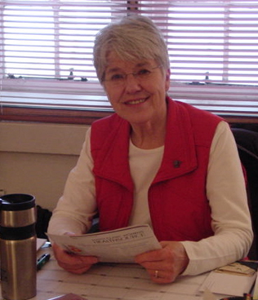
Parish Nursing Notes………………

Two of the health promotions for October are Healthy Aging and Fall Prevention. And we seem to always associate those issues with the “after-retirement” group. But when you stop to think about it, we are always “aging”—from the day we are born until the day we die. And we’re helping our children as they learn to walk and ride a bike to help “prevent falls.” And today, we’re trying to teach safe smart phone use to avoid falls and other accidents. Both of those topics are life-long concerns. And the approaches are appropriate for any age group.
A healthy diet is at the top of the list. That’s a little easier at this time of year with all the fresh and tasty garden produce available. We know about limiting saturated and trans fats, cutting back on sodium and added sugars, and getting more fiber and complex carbs. And that applies throughout life. If we get the healthy eating habits started early in life in our children, they are likely to be continued into old age.
Get active. Young tykes start out that way, exploring the world we live in. But then the interests seem to turn to smart phones and video games. Encourage outdoor, active pastimes. For some of you “slightly” older members, we are planning on starting a couple walking groups here at church this fall. A sedentary lifestyle has been linked to a shorter lifespan and a wide range of medical problems. So let me know if you are interested, and the best time of day for you. You’ll have a safe indoor environment and the company of others as well. And if I know Lutheran church groups, probably a coffee time as well!
Social involvement is crucial as well. Kids often get that at school, at church, and in their neighborhood. But they may need encouragement at home to participate. And the walking group above can offer that for you too—and may lead to other involvement in church activities. We’re really a nice bunch of people!
A safe environment is conducive to both healthy aging and fall prevention as well. The church can be a safe place for walking, but we need a safe home as well. Eliminate small throw rugs and long extension cords. Have adequate lighting and night lights. Use handrails and have grab rails available in the bathroom. Be aware of slippery surfaces, cracks, and other obstacles. Teach your children to be aware of their surroundings.
I’m sure most of you know one of my most quoted Bible verses, 1 Corinthians 6:19-20. “Or do you not know that your body is a temple of the Holy Spirit within you, which you have from God, and that you are not your own? For you were bought with a price; therefore glorify God in your body.” While care of our bodies is important and should be done out of thankfulness to God, a lean and toned body is never our ultimate goal—but rather to “glorify God in your body.”
Enjoy living an active, healthy, and happy life, so that you may share God’s many blessings………………..…..Jean.

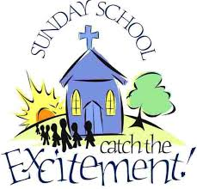

Concordia Fall Kick Off
Sunday, October 16

Sunday School at 9:00 a.m.
Worship at 10:00 a.m.

Picnic Lunch to Follow

Everyone is welcome!

Please invite your family, friends, and neighbors to join us!
CLCW News
As we approach the fall, I wanted to take this opportunity to review what CLCW is up to.

First, this past year CLCW had another successful rummage sale where we raised $1615 on the goods and $675 on the bake sale. The proceeds from the sale (with other money) allowed us to give out $500 in awards to four young members attending college. We also donated the proceeds from the bake sale to the organ fund. I want to remind everyone that we have a room in the fellowship hall that we are able to store items for next year’s sale. If you have items you want to donate, please do so at any time, just make arrangements with the office. Also, we schedule several work days throughout the year where we mark items, to avoid the 9th hour rush before the sale. Let me know if you are interested in working on one or more days, it is very much appreciated. Thank you to all who have helped out and especially Deb Harmer and Sue Martin, chairs for the sale and to Jean Reidash for coordinating the bake sale.

Last fall, in October, was the first annual vendor sale. It also was a success and thank you to Nancy O’Neill for chairing this event. It is scheduled again for October 27. The cost for a table is $25. Contact the office or Nancy if you are interested in a table. Also, if you are interested in helping out with this event, contact Nancy or the office.

Last December, CLCW kept the tradition and put on the Advent Tea. Thank you for Marie Peterson and Jean Riedasch who provided the lefse and to Jane Pietrowski and other women who did much of the food preparation, serving, clean up. Also, thank you to Carol Banker and Ann Marie Novak for the decorations. CLCW will again be planning an Advent Tea for this December. Help is always appreciated.

Although not specifically handled through CLCW, women of Concordia have been active in all aspects of service to the church. Thank you to the women who put in countless hours on the Altar Guild, ushering, counting money, serving at funeral lunches, the numerous committees, library board, heritage committee and council. I am not always aware of the time so many women put in in other ways, so if you are not mentioned, I apologize for not acknowledging you.

CLCW officers meet once a month and the general meeting, for all women of Concordia is scheduled for October 16 at 9:00 in the church library. We also have a general meeting in the spring. We are adding a fun activity, chair yoga, to our fall meeting. Please plan on coming and enjoy this activity and participate in the meeting. This is a non-strenuous type of yoga, that is done sitting in a chair. We need your input and recommendations for the upcoming year. At this meeting, we will be discussing the need and hope to find, people interested in becoming a CLCW officer. I have, along with Deb Grimsrud, been in charge for a number of years and feel it is not healthy to have the same individuals in charge year after year. Deb Harmer is the treasurer and Nancy O’Neill, the secretary. We need fresh ideas and are looking for individuals interested in becoming an officer. If you are interested or know someone who might be good, please let us know.
Enjoy the rest of your summer, Jan Lippitt
WALK and TALK
Are you interested in getting a little walking exercise? How about a little socialization? How about getting both in a safe and protected setting? We’re thinking about starting a walking group (or two) here at church. This is a safe area, protected from the sun, rain, bugs, and torn up sidewalks or walking trails. It’s also a very beautiful setting, and has a lot of nice people! We might have two groups to accommodate both working and retired individuals—one in the daytime, and one after working hours. We would like to start in October, probably the second week of the month. Please let Jean know if you are interested, and what days and hours would work best for you.
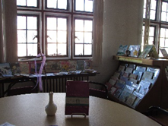
Greetings from the Library Team!
As summer draws to a close and we sense Autumn quietly knocking at the door, let us take some time to reflect on the many blessings/gifts that God bestowed on us. The sun, the rain, flowers, a productive garden, family, friends and the list goes on. We hope your summer was a blessed and enjoyable one!
A quote from F. Scott Fitzgerald sums it up quite nicely – “Life starts all over again when it gets crisp in the fall.” With that in mind, Concordia’s fall schedule will soon” start all over again”. Watch the weekly Church bulletin, the Concordian and the Concordia Connections for details/updates of the different activities/events. The Library Team will be meeting on a weekly basis, schedules permitting. The week day is yet to be determined. The Library Team had a few projects they worked on over the summer months and will continue to do so in the fall. So, please stop by and have a cup of coffee with us. Who knows, you just might find yourself getting involved in this ministry of the Church!
May your Fall be a Blessed and colorful one!
See YOU in the library!

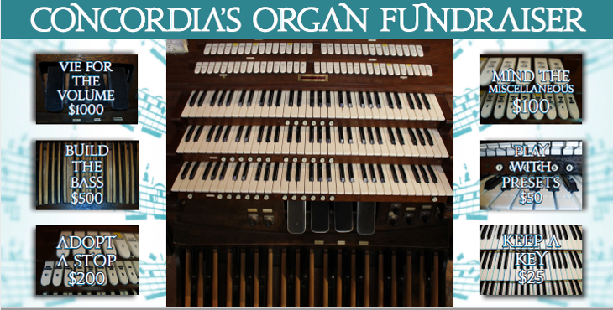

Organ Fund: $5599 of $36,000 raised as of August 27, 2018
Your donations are greatly appreciated!!!
Worship & Music Committee would like to lock in the lower bid for organ repairs.
As soon as we can raise $12,000, we expect to begin some repairs.
People are encouraged to give as soon as possible to reach the $12,000 mini goal (of the $36,000 total).
Patrick & Keli Casey
Richard & Renee Erickson
Gronski John & Anne Gronski
Robert & Rachel Hering
William & Janice Lippitt
Roy & Marie Peterson
Matthew &Andrea Piirainen
Jason & Anne Porter
Pete & Donna Quist
Matthew & Amy Ramsey
Tom & Karen Severson
Victor & Janet Ursin
William & Lori Van Damme

Benevolence Committee Meeting
Next meeting will be
October 9 at 11:00 a.m.

Altar Flowers for October
October 2
In Honor of all who labor for improvement of God’s creation by the Rowell Family
October 9
In Honor of Loved Ones by Millie Score and Family
October 16
In memory of Ken & Mildred Olson and Ray Nurmi by Michael & Joyce Olson
October 23
In memory of Jay Johnson by Joanne Johnson & Children – Julie, Jim, & Jeff
October 30
In memory of Robert & Jean Allen and Ted & Eileen Ketola by the Ketola Family
The following memorials are
acknowledged by the church office:
In Memory of: Given by:
In Honor of our Grandkids Pete & Donna Quist

If you sent a memorial and were not included on the list, please contact the church office
The DEADLINE for articles in the next issue of “The Concordian” is October 20
Announcements are due
by 9:00 am October 24
Concordian Helpers October 25 at 9:00 am.
Thanks for marking this on your calendar!
Night Out
October 5, 2018
Ladies will meet at Shamrock at 5:00 P.M. Men will meet at Tavern 105 at 5:30 P.M.
CLCW Fall Craft and Vendor Sale
October 27, 2018
Tables are $25

Please Contact Nancy O'Neill at 218-391-6141

Your Church Council members, working
together with you in ministry:

President, John Gronski 218.340.1813
Vice President, Gary Banker 715.392.2149
Secretary, Carol Lindegren 218.590.8238

Nancy Burley 218.464.7086
Matthew Eastman 218.409.9174
Jan Lippitt 715.394.9158
Nick Pristash 715.398.0488
Shawn Quist 218.343.6795
Eric Sewall 715.392.1559
Community Benevolence
John Gronski
Gary Banker
Jan Lippitt
Investment Committee
Gary Banker
Finance
Carol Lindegren
Personnel
Shawn Quist
Nancy Burley
John Gronski
Evangelism
Gary Banker
Youth and Family
Nick Pristash
Carol Lindegren
Worship and Music
Nancy Burley
Matthew Eastman
Eric Sewall
Gary Banker
Property Management
Matthew Eastman
Shawn Quist
Stewardship
(inactive, full council)

CLCW News
Fall General Meeting on October 16 at 9:00 a.m. in the chapel. The meeting will start with a short yoga class.
Fall Craft and Vendor Sale will be
October 27
Advent Tea will be December 3rd

Sue Avis, Carol Banker, Nancy Bohn, Susan Brannan, Matthew Breitzmann, Jeanne Downs, Brianna Frank, Eunice Grimsrud, Jarrett Gronski, Marcie Hanson, Andrew Harmer, Debra Johnson, Staci Johnson, Wyatt Johnson,
Ashley Kelleher, Alexander Ketola, Amy King,
Clara Komatz, Dawn Lambert, Jaylynne Lawler,
Jacquelyn Ledin, Joyce Littler, Merry Lott, Matthew McDonald, Sara Moore, Charissa Nelson, Brian Nelson, Dawn Nelson, Patrick Nelson, Joyce Olson, Matthew Peterson, Andrea Piiranen, Dennis Quam, Brett Quist, Donna Quist, Mildred Score, Barbara Sorenson, Marie Strom, Patricia Ullan, Erin Wahner, Jean Weber,
Michael Wick, Joseph Wojtoff, Nicholas Zehm
Serving in October
Ushers
October 2 Team II
October 9 Team III
October 16 Team I
October 23 Team II
October 30 Team III
Bus Driver
October 2 Brett Quist
October 9 Ken Harmer
October 16 Pete Quist
October 23 John Gronski
October 30 Kris Hanson
Scripture Readers
October 2 Mark Thompson
October 9 Ken Harmer
October 16 Anne Gronski
October 23 Steve Ledin
October 30 Kris Hanson
(Readings may be picked up in the office the prior week. If they are not picked up, we will mail them to the reader.)
Altar Servers
October 2 Altar Guild
October 9 Altar Guild
October 16 Altar Guild
October 23 Altar Guild
October 30 Altar Guild
Coffee Kiosk Servers
October 2 Carol Lindegren
October 9 Nancy Burley
October 16 Church Picnic
October 23 Shawn Quist
October 30 Eric Sewall
Financial Assistants
Deb Harmer & Sue Martin
Communion Assistants
October 2 Richard Wnek & LeRoy Eliason
October 9 Ken & Deb Harmer

October
Sunday | Monday | Tuesday | Wednesday | Thursday | Friday | Saturday
 |  |  |  |  |  | 1
2  9:00 Blood Pressure  10:00 Worship w/Communion | 3 | 4  9:00 Staff Mtg  4:00 Just For Kix | 5  10:00 Altar Guild  10:00 Library Workers  11:00 Text Study  5:00 Ladies’ Night Out-Shamrock  5:30 Men’s Night Out – Tavern 105 | 6  2:00 Superior Rehab worship | 7  (Office closed) | 8
9  10:00 Worship w/Communion  11:00 Benevolence Committee | 10  6:00 Property Management Committee | 11  9:00 Staff Mtg  4:00 JFK  6:00 Prayer Shawl | 12  10:00 Library Workers  11:00 Text Study | 13 | 14  (Office closed) | 15
16  Fall Kick Off  9:00 Sunday School  9:00 CLCW-Chapel  10:00 Worship  Picnic Lunch to Follow | 17  6:00 Worship  & Music Committee | 18  9:00 Staff Mtg  11:30 Ministerium  4:00 Just for Kix | 19  10:00 Library Workers  11:00 Text Study | 20  Newsletter Articles Due  2:00 Superior Rehab | 21  (Office closed) | 22  10:00 Prayer Shawl
23  9:00 Sunday School  10:00Worship | 24  Newsletter Announcements Due | 25  9:00 Concordian Helpers  9:00 Staff Mtg  4:00 Just for Kix  6:00 Girl Scout | 26  10:00 Library Workers  11:00 Text Study | 27  6:00 Council Mtg | 28  (Office closed) | 29
30
9:00 Sunday School
10:00 Worship

Concordia Lutheran Church Non-Profit Organization
1708 John Ave. U.S. Postage Paid
Superior, WI 54880 Superior, WI
Permit No. 254

Address Service Requested

Place label here

The Concordian is published monthly since 1981 by:
Concordia Lutheran Church
1708 John Avenue Superior, WI 54880
(715) 394-3762 – Office
(Formerly Concordia Churchman 1961-1981)

e-mail:
Pastor Michelle: rowell.michelle.r@usa.net
Church Office: concordiasuperior@gmail.com
Websites:
Church website: www.concordiasuperior.org
Synod website: www.nwswi.org
ELCA website: www.elca.org
Luther Point Bible Camp website: www.lutherpoint.org
Resource Center website: www.synodresourcecenter.org
Michelle R. Rowell, Pastor
Beth Sobczak, Keyboards
Gary Banker, Assistant Keyboards/Choir Director
Theresa Clemmer Financial Secretary
Jean Riedasch, Parish Nurse
Matthew Eastman, Custodian & Technologies
Editor: Theresa Clemmer
Contributors: Many
Assembly/mailing: Our faithful volunteers
The Concordian
October
Vol. 37 No. 10
A newsletter of Concordia Lutheran Church
Superior, Wisconsin
715.394.3762
www.concordiasuperior.org
NOTICE
If you are receiving this newsletter and do not wish to, please contact the church office. If you know someone who should receive it or wishes to be added, please have them contact our office.
Sunday Worship Schedule
9:00 Sunday School
10:00 am Worship
Communion served on the 1st and 2nd Sundays.
Fellowship (coffee & goodies) in the church library after the worship service (when scheduled).
Mission Statement
As members of the body of Christ at Concordia,
we are called to be God’s forgiven, gifted,
diversified and unified people.
By the power of the Holy Spirit,
we nurture and live our faith in Jesus Christ,
encourage our service in His church,
and actively share the Gospel
in our community and the world.

