October 24, 2022

“Why I Tithe” - An Interview with Bernie Hoffmann
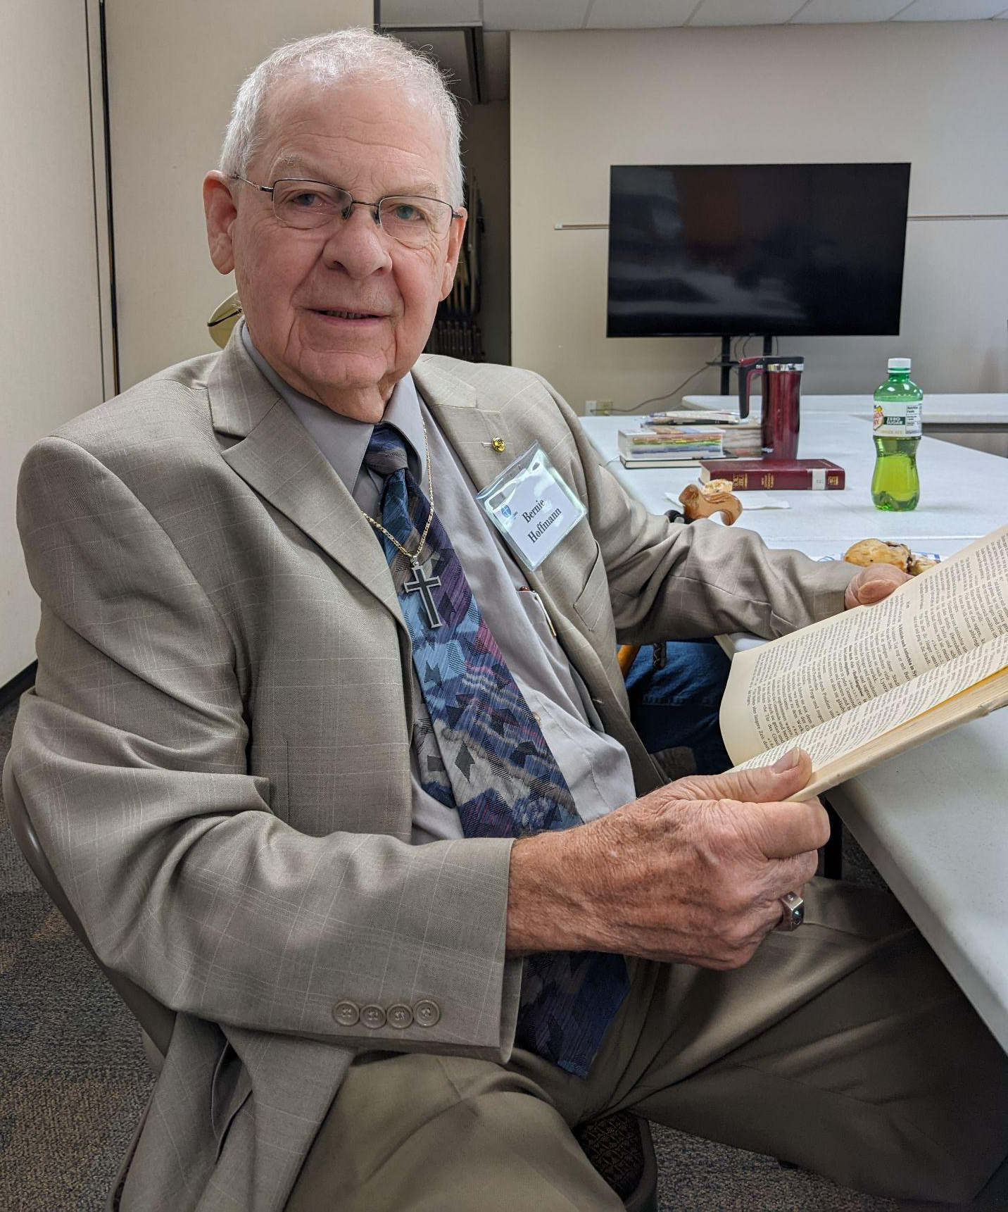
Bernie, how do you understand tithing?
Tithing is giving 10 percent of my gross earnings to the church. Not 10 percent of what I have left over after my taxes and all my bills are paid, but 10 percent of my gross.

That’s an impressive percentage. You must have been raised by parents who tithed and taught you this spiritual practice.
No, just the opposite. I had to teach this to my mother when she came to live with me. My parents were brought up in Germany where we had a church “tax” that paid for the minister’s salaries and the buildings. My parents never even considered that supporting the church and its ministries could be important to their faith.

What do you mean by that?
To me, tithing is a financial commitment - treasure management - that helps me escape the trap of selfishness by keeping myself spiritually focused on God. Tithing is not about money, but about trust. How much do I trust God and how much do I want to grow spiritually?

Each of us makes one of two choices in life. We either become emotionally attached to our money or we become emotionally attached to God who gives us our money. Practicing tithing helps us overcome the temptation to make money a false idol and therefore, to break the first commandment.

We hope we can love God and money, but deep down in our hearts we know this cannot happen. As Jesus said in Luke 12:34, “Where your treasure is, there your heart will be also.”

Wow. You have been a church member all of your life. Did you always tithe?
No. Most of my life I gave excuses for why I couldn’t tithe. I was in the restaurant business. I never knew what my income would be. How could I tithe? That was my biggest excuse. I had lots of excuses, but the truth was, I just didn’t trust God with my money.

But I learned to trust God when He sold my house and restaurant and moved me and my family to Georgia. There was not other explanation except that God was involved in these activities. I give my blessed wife, Marsha (who is in Heaven), credit for making sure that no matter what our income was, the first 10 percent went to the Lord.

That’s the way I still do it. I set aside 10 percent of anything that comes to me as income. My first fruits. It gives me an opportunity to thank God over and over again.

