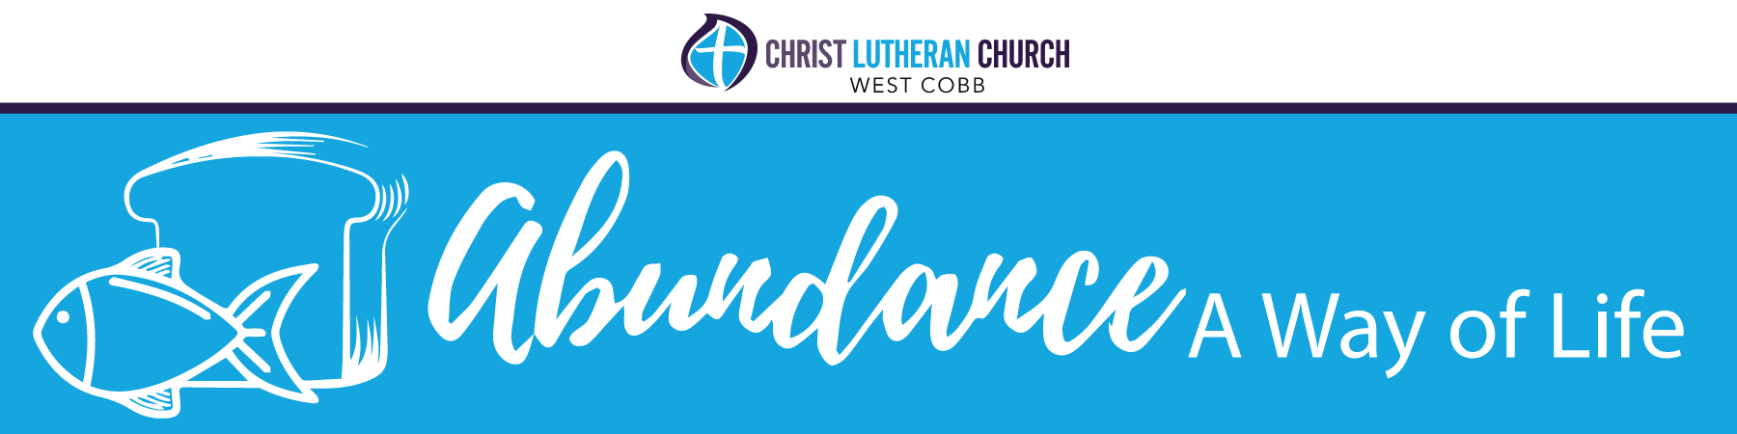
October 3, 2022

Welcome to the first edition of the 2023 Appeal Drive Abundance: A Way of Life newsletter. This newsletter will arrive in your mailbox every Monday for the next six weeks to highlight the wonderful life of our church family and to prepare us for the future.

If you were in worship yesterday, in person or virtually, you heard about our appeal campaign for our time, talent, and treasure. The time and talent portion of this appeal will be addressed in a fun way this coming Saturday at our Time, Talent, Tacos, and Tequila event starting at 5 p.m. Please join us to see all the opportunities available for you to contribute your time and talent while enjoying tacos and tequila.

Below, Artie Kappel talks about how he has used his gifts to God’s glory.

Living and Giving Confidently of our Time and Talent
By Artie Kappel

One of the best known psalms is Psalm 23, the Shepherd Psalm. It says the Lord is our shepherd. And the Lord, our shepherd, will provide for all that we need in both body and soul.

Do you live your life confidently knowing this? Many of us believe we suffer because we don't always get what we want. We start to believe the Lord; our shepherd will not provide for all we think we need. This becomes evident in our actions. Do we fail to give generously of our first fruits? When we are unsure of our future, do we stop believing in the Lord's promise to lead us into green pastures and still waters? We need to take a minute in our daily lives and listen. Listen to what the Lord, our shepherd, is telling us. Rethink our actions, and maybe it is to act.

Through the Word of God, we are made aware of His gifts to us. If we listen closely and follow our shepherd, we will be led to the green pastures and still waters. Through the Word, God uses the Holy Spirit in our lives and the lives of our family and friends to nourish our faith and lead us. I think the best news is that when we are lost, the Lord is right with us and carries us back.

I was led to Stewardship by listening to what God told me I needed to do. It started as a feeling, then more of a hey, you wake up; I put this in front of you for a reason! When I finally woke up and did what I felt that voice in my head was telling me to do, changes happened in my life. Being part of Stewardship and a small piece of the bigger picture in CLC has brought me closer to people I needed in my life at just the right time. I have felt more in touch with God and my faith. You need to make room in your lives to listen and to know that our Lord our shepherd is with you always.

If you have seen something in the bulletin or newsletter and had that fleeting thought of wanting to know more but dismissed it, that was the Lord giving you a nudge. Were you listening, or did you allow your busy life to decide for you? Allow the Word of God to nourish your faith.

Maybe it's to be a part of a committee and help when you can, like MUST or Cobb Street Ministries. But, perhaps you need to give the effort to join us at a function like the recent Rome Braves game and feel how gathering with like-minded people nourishes your faith and touches your soul. I look forward to seeing you at the next fellowship event!

