News and Announcements
Christ Lutheran Church Eagan April 8, 2017

Verse of the Week: 1 John 1:5

This is the message
we have heard from Him
and proclaim to you
that God is light
and in Him is no darkness at all.

I want to walk as a child of the light. I want to follow Jesus.
God set the stars to give light to the world. The star of my life is Jesus.
In Him there is no darkness at all. The night and the day are both alike.
The Lamb is the light of the city of God. Shine in my heart, Lord Jesus.
I want to see the brightness of God. I want to look at Jesus.
Clear Sun of Righteousness, shine on my path, And show me the way to the Father.
In Him there is no darkness at all. The night and the day are both alike.
The Lamb is the light of the city of God. Shine in my heart, Lord Jesus.
I’m looking for the coming of Christ. I want to be with Jesus.
When we have run with patience the race, We shall know the joy of Jesus.
In Him there is no darkness at all. The night and the day are both alike.
The Lamb is the light of the city of God. Shine in my heart, Lord Jesus.
LSB 411; © 1970, 1975 Celebration. Used by permission: LSB Hymn License .NET, no. 100012578.

Congregational Meeting
An informational congregation meeting has been scheduled for Sunday, April 15, right after the Sunday service in the fellowship hall. There will be no Sunday School or Bible study that week. The purpose of the meeting will be to have open dialogue to discuss the current financial situation of CLC. Rick Marko from MN South District will help facilitate this meeting.

This Sunday's lesson is Paul and Silas in Prison. Through the witness of Paul and Silas to the Philippian jailer and his family, the kingdom of God grew. So we also must ask God to help us live according to his Word and to use us to extend His kingdom of grace.

Who is my Elder?
Over the last year, some members have been wondering which Elder is assigned to them. The Elders have discussed this and believe the best Elder assigned to you is the one you already know and can have open discussions. So, the Board of Elders would like you to reach out to the Elder that best fits your needs rather than assigning an Elder to you or your family. The Board of Elders include:
Curt Hartog 612-968-2897 Dick Bielenberg 651-454-1530
Dennis Miller 612-801-4297 Robin Fink 651-686-0938
Please call any of the Elders for your needs.

Our Gifts to the Lord |  |  | Attendance
Mar 29, 30, Apr 1 Gen Fund | $8049.49 |  | Maundy Thursday, March 29 | 56
Mar 26-31 Joyful Response | $ 300.00 |  | Good Friday, March 30 | 51
Total | $8349.49 |  | Easter Sunday, April 1 | 176

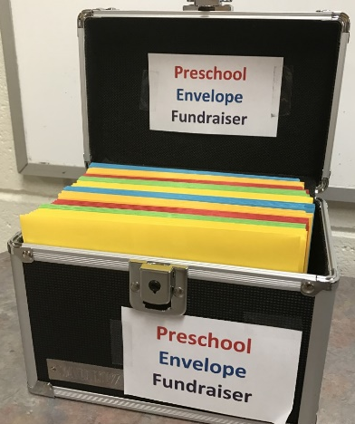
Preschool Envelope Fundraiser
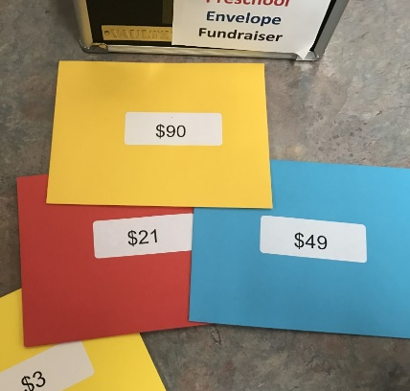
Have you seen this box on the table in the narthex? These envelopes all have different numbers on them. All you have to do is pick up one or more, put the money inside, and return the envelope any time in the next month. You can pick up any number – maybe your age, or a special date, or a combination of numbers. Be creative or just close your eyes and pick one!
This is the preschool's only fundraiser. They aren’t trying to sell you things you don’t need, and they aren’t asking you to work hard to raise funds. Since we are moving to full days and extended care in September, we will be making much more use of our outside space. We want to add a mud kitchen, play shade canopy, tire climbing structures, and a place for outside story and circle time. Please consider your part prayerfully and help this important ministry of CLC. Thank you for your continuing support!
______________________________________________________________________________________
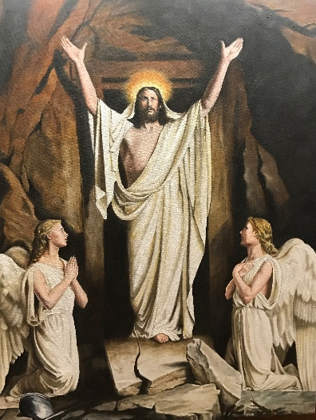
Special Paintings at Christ
Thank you to Larry Landis for sharing his touching paintings with us during Holy Week and Easter. They added to our worship and meditation.
This was overheard in office when the preschoolers were leaving the day after Easter: Little Ezeckiel said, “Mommy, look at these pictures! Jesus died and rose again!” What joy that brings to our hearts – the message of Easter from a child – through the artwork and from his teaching at our preschool. Praise God!

Confirmation Class will start meeting again!
Starting up again on Wednesday, April 4th from 6:30 – 7:15pm the confirmation class will continue learning about the Six Chief Parts of the Lutheran Faith put forth by Martin Luther which is followed by Youth Group from 7:15 – 8:00pm.
The Youth Group!
Any youth, 6th – 12th grades are encouraged to join in Youth Group on Wednesday nights from 7:15 pm until 8:00 pm.
We had our second youth fundraiser of the year – Palm Sunday Breakfast – where we profited just over $440! This money will be used to help send the youth to this summer’s servant event at Lutheran Island Camp in Henning, MN. We had a good showing of participation by our youth and a good attendance by church members who partook in the meal. Thank you for all your support for youth ministry!

Week of the Young Child
The Week of the Young Child is an annual celebration hosted by the National Association for the Education of Young Children (NAEYC) celebrating early learning, young children, their teachers, and families. This year's event is April 16–20, 2018!
2018 theme for Week of the Young Child:
Celebrating Our Youngest Learners Through S.T.E.A.M.
(Science, Technology, Engineering, Art, Mathematics)
Christ Lutheran Preschool will be celebrating this week with a visit from our local fire station and an assortment of fun days, such as Pajama and Stuffed Animal Day, Crazy Hair, Mismatch and Crazy Sock Day, and Sports Day! We’ll be sure to get some fun pictures to share!

