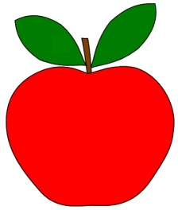
September Preschool News

Sept. 11-15 Jesus Time: God Made People (God knows us by name; We are His!)
Bible Words: I have called you by name, you are mine. Isaiah 43:1
Circle Time: All About Me
Color Green (We will be learning about “Green Choices”.)

Sept. 18-22 Jesus Time: God Made People (God knows us by name; We are His!)
Bible Words: I have called you by name, you are mine. Isaiah 43:1
Circle Time: All About Me
Letter A; Color Red; Circle Shape

Sept. 25-29 Jesus Time: God Made the World (Creation is God’s gift for us to enjoy!)
Bible Words: God saw that it was good. Genesis 1:10
Circle Time: Autumn
Letter B; Color Red (Review); Circle Shape (Review)
Special Event: Family Night Potluck – Tues., Sept. 26 at 5:30 p.m.
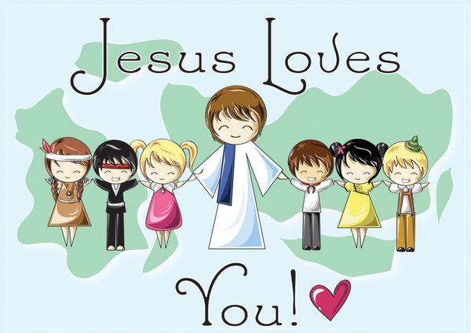
All are asked to bring a family-sized dish to share.

