CHRIST CHURCH CRUX
Volume 76 No. 210 CHRIST EVANGELICAL LUTHERAN CHURCH August 2019
Contact us:
Church office
Phone:717-334-5212 Fax:717-334-4958
churchoffice@christgettysburg.org
www.christgettysburg.org

Pastor
pastor@christgettysburg.org

Bookkeeper
bookkeeper@christgettysburg.org

Christ Lutheran Preschool
Phone: 717-334-6532
preschool@christgettysburg.org

Financial Secretary
financialsecretary@christgettysburg.org

INSTALLATION SERVICE FOR PASTOR JAY ECKMAN will be held on Sunday, August 25 at 4:00 p.m. in the nave. The congregation is invited to attend this service. Please join us! A reception will follow.

SAVE THE DATE: Sunday, September 8 at 1:00 p.m.-God’s Work Our Hands

Rally Day, September 8, Sunday School classes begin at 9:15 a.m.. Join us for a fun, educational, and faith growing experience!

Blessing of the Backpacks and Backpackers, Sunday, September 8.
All children are encouraged to bring their school backpacks to worship.
The Blessing of the Backpacks will take place during the children’s sermon at both services.

OPPORTUNITY FOR SERVICE….United Lutheran Seminary is seeking additional workers for the Gettysburg Brewfest, a seminary fundraiser, which will be held on August 17. The seminary pays $10/hour and will pay up to eight hours. You can volunteer, get paid, or forward your payment to your favorite ministry like Christ Church. If you are interested and would like more information, please contact Pastor Eckman at pastoreckman@christgettysburg.org. Thank you!
NEW MEMBER ORIENTATIONS… We have scheduled a New Member Orientation for Sunday, August 18 following the 10:30 worship service in the social room (basement of the church). During this session we will take you on a tour of the facilities and introduce the wide range of ministries at Christ Church. Please contact Heather King in the church office (334-5212) or churchoffice@christgettysburg.org to R.S.V.P.

THE GIFTS AND MEMORIALS COMMITTEE will have their quarterly meeting on Wed., August 14, 2019, in the Social Room at 9:30 a.m. Any committees wishing to make a request for funding from the Memorial Fund should fill out a request form and submit it before August 12. Memorial Fund monies are typically used for long term use items in the church. Some recent examples of Memorial Fund uses are the automatic door opener at the handicapped entrance and the purchase of 2 communion pouring chalices. The blank forms are located in the Gifts and Memorials mailbox next to the Administrative Assistant’s office. Place completed requests in that same mailbox. If there are any questions, please contact Jean Ask, 717-338-0777.
PASTOR HERR’S PAGE
Grace and peace to you in the name of the Father, +Son, and Holy Spirit. Amen.
July 2nd marked the 25th anniversary of my ordination into the office of the ministry of Word and Sacrament and inclusion on the roster of the Evangelical Lutheran Church in America. I thank the congregation for the reception following worship on June 30th and I appreciated the card shower along with your many expressions of kindness and Christian love. I give thanks to God for the opportunity to serve for twenty of those years at Christ Evangelical Lutheran Church. Thinking back over the course of these past twenty-five years of pastoral ministry, I am grateful for many things.
As a forgiven and redeemed child of God I give thanks to the Triune God for the gifts of grace, mercy, and faith. The love, support, and nurture of my parents and family cultivated my faith. The encouragement of members at Holy Spirit Lutheran Church in Lancaster, Pennsylvania assisted in keeping me interested in church. Pastors Richard Michael and Donald Green provided positive models of ordained ministry and helped me envision a vocation as an ordained Lutheran minister. Chapel Choir director Dexter Weikel, along with my fellow choir members, provided a community of faith and support during my time at Gettysburg College. By the time I entered the Lutheran Theological Seminary at Gettysburg in the fall of 1990, many other people and communities of faith had been a part of my journey to seminary.
During seminary the faculty educated, shaped and challenged me. Current Christ Church members, Eric Crump and Mark Oldenburg, were among those who guided my theological training and liturgical practice. My first-year field education experience at Christ Lutheran Church in Hagerstown, Maryland and my internship site at Christ Lutheran Church in Athens, Ohio would further develop and form my theological study and pastoral identity. Internship supervisor Pastor (now Bishop of the St. Paul Area Synod) Patricia Lull had a profound impact on how I understand Word and Sacrament ministry. She instilled in me the importance and power of the Word of God and the role of preaching in a congregation’s life. Her attentiveness to worship planning, Christian education, confirmation, administrative details and pastoral visitation were all significant in shaping my perspective on these elements of Word and Sacrament ministry.
In February 1994, Bishop Donald McCoid of the Southwestern Pennsylvania Synod informed me that I had been assigned to that synod for my first call. On Trinity Sunday that same year Hebron Evangelical Lutheran Church in Blairsville, Pennsylvania called me to serve as their pastor. In keeping with the fourteenth article of the Augsburg Confession, once that call came from the faithful at Hebron Lutheran Church I was eligible to be ordained. My ordination took place on July 2, 1994 at the Church of the Abiding Presence on the campus of the Lutheran Theological Seminary at Gettysburg. Several Christ Church members at the time participated in the service with Dexter Weikel directing the choir, David Erickson playing the organ, Eric Crump serving as crucifer, Jill Herr reading a scripture lesson and others participating in the laying on of hands. Herman Stuempfle composed a hymn for the occasion.
During my internship year I met Jill Kohlenstein and three years later we were married here in Gettysburg at the seminary chapel and our reception followed on the campus of Gettysburg College. Throughout the latter half of my seminary education, ordination, and past 25 years in ministry, Jill has been a constant presence of love and support for which I am most thankful. Our sons, Jared and Joshua, have had their baptismal faith shaped and nurtured by this congregation and for that Jill and I are grateful.
I share these reflections in gratitude to God almighty and to all those who have accompanied my ministry journey. It has been a joy and honor to serve Christ’s Church and the people of God for the past quarter century. I also share this because Christ Lutheran has played a significant role in many seminarians’ development and formation. With Pastor Jay Eckman’s Word and Sacrament ministry journey beginning, I remember how much I learned from the faithful at Hebron Lutheran and from colleagues who went out of their way to help me grow and understand more deeply congregational life and pastoral ministry. I encourage you to welcome Pastor Eckman as you welcomed me. I continue to learn much from this congregation and give thanks to God for you, your faithfulness, and commitment to the Gospel of Jesus Christ.
Thank you again for supporting my pastoral ministry and many others who have come through Christ Lutheran during their journey to ordination as pastors or consecration as deacons. May we all continue the important work of nurturing and lifting up the next generation of leaders in Christ’s Church. Soli deo Gloria! Glory to God Alone!
Your servant in Christ
Pastor Stephen R. Herr
A few weeks ago in worship, we heard Jesus say that we are to love the Lord your God ‘with all your heart and all your soul and…with all your mind’ (Matt: 22:37). To Love our God with our mind means, to dedicate our minds in knowing God. In fact, from wise kings to Jewish scholars, the Bible is full of intellectuals using thought processes to understand God clearly. Reasoning and keeping away false ideas of God is a form of worship.

That being the case, do you have any questions about theology that you’re scared to ask? Or that will get you in trouble? It turns out; you’re not the only one! Are there controversial topics that you see in the world where no one wants to answer? Sometimes there are!

That’s why we are creating Theology Unleashed. In this gathering, we will engage our minds through readings and discussion to help bring clarity to knowing God through the questions we all wrestle with. It’s a safe place not be afraid to ask the tough questions, even if we don’t find a final answer. We’ll do what we can to honestly and humbly tackle the difficult questions.

The hope is that this will be another source for theological discourse and lead you to a more profound love and understanding of Christ. Beginning in September, Theology Unleashed will meet twice a month from 6:30-8 pm at a location TBD on the following dates;
Sept 16 Oct 14 Nov 11 Dec 9
Sept 30 Oct 28 Nov 25
To begin, we will center our sessions on suffering. Specifically asking: What is the meaning of suffering in the sphere of Christ’s redemption? Please note that all readings will be provided in advance so that you will have time to read, think, and digest the material. I hope you can come!

Pastor Jay Eckman
* * * * * * * * * * * * * * * * * * * * * *
SAVE THE DATE! Treasure Sale, Saturday, Sept 28th 7 - 2 pm
How you can help:
- DONATE THE FOLLOWING ITEMS:
Toys/Games, Sporting equipment, Jewelry, Antiques, Kitchen and Dining ware/Utensils, Seasonal decorations, Framed pictures for all, and Lamps. All items are to be in good condition, clean, will all parts/pieces!

Donations will be accepted (in the social hall) during the following times:
Monday -Thursday, Sept 23 - 26, 9 AM - 2 PM
Thursday, Sept 26, 6 - 8 PM
Friday, Sept 27, 6 - 8 PM

If you need help to bring items from your car, please come Thursday and Friday evening from 6- 8 PM.
2. SIGN UP TO BRING BAKE GOODS:
Cakes, Pies, Muffins, Scones, Cupcakes, Bread, Fudge, Candy, Cookies, Brownies, Doughnuts, Whoopie Pies, etc. Please bring items that do not require refrigeration.

3. COME SHOP, SNACK, AND EAT A MEAL UNDER THE BRIDGE!

DON’T FORGET TO TELL YOUR FRIENDS AND NEIGHBORS!!
All proceeds from the Treasure Sale will go towards
the 2021 ELCA National Youth Gathering fund.
If you have any questions, please contact:
Martha Nelson marthamkn@aol.com (717) 283 - 9472 or
Pastor Eckman pastoreckman@christgettysburg.org (717) 334 - 5212 ext. 225
Lasagna
Sign-up for the Soup Kitchen
Without your help, we couldn’t meet our commitment on the third Monday of every month, to feed the guests of the Soup Kitchen.
Our 2019 list is on the bridge, please help us meet our monthly commitment. We have been asked to provide one more pan of lasagna per month (8) – the number of people coming to the Soup Kitchen is increasing. Please look ahead to the months of September, October, November, and December we only have one space filled.
A big thank you to the July providers.
July 15 August 19 September 16
Sara Laser $ Marion Cowdery $
Sara Laser/Janet Gable $ Marion Cowdery $
Karen Landry Carol Bream
Karen Landry Carol Bream
Gail Jones $ John Fehringer $
Lyn Badger Jean Lynch $
Lyn Badger Jean Lynch $
Diane Hiller Mary Bennett $

Just a reminder that all meals need to be at the Soup Kitchen by 10:00 a.m. unfrozen on the third Monday of every month. If this is difficult for you to do please call me. If you would like to participate but don’t have time to cook. You can purchase a Stouffer’s Party Size Lasagna (feeds 12) for about $15.00 and bring it to the Soup Kitchen or the church unfrozen. You can also provide a $15.00 check or cash to me and I will gladly purchase the needed lasagna.
Marie Chantelau 337-9623 or mchantelau@embarqmail.com and we can work out a pick- up schedule.

GIFTS and MEMORIALS
Given in memory of Peter Pennington
By
Michael and Lisa Leber

Safe Kids Information
A new school year is beginning, and it is time to look forward to September and the start of our Sunday School classes and the many special activities our youth will be involved with. But we need volunteers to help with these programs, and the volunteers must have Safe Kids clearances on file. If your name does not appear on the following list, you need to complete a Safe Kids packet. Packets are available in the Safe Kids mailbox located outside the Administrative Assistant’s office. On Sunday, August 18th from 2p.m-4p.m. members of the Safe Kids Committee will be available in the Social Room to help people navigate the website related to Safe Kids clearances. We need to remember the primary goal of the Safe Kids Policy of Christ Lutheran Church is to ensure the safety of all children in our care. This includes children participating in activities within our facilities and activities sponsored by Christ Lutheran at off-site locations.

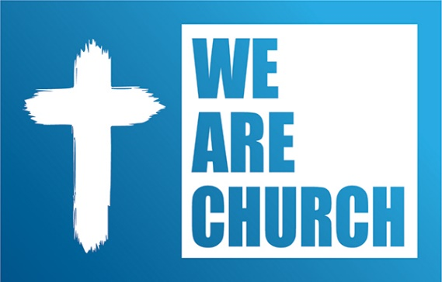
The Evangelical Lutheran Church in America will meet for its 15th Churchwide Assembly at the Wisconsin Center in Milwaukee, Wisconsin August 5-10. The assembly’s theme is We Are Church. The churchwide assembly is the highest legislative body in the ELCA and voting members from around the United States will participate. Pastor Herr will be attending as a voting member from the Lower Susquehanna Synod.
This year’s assembly will elect a Presiding Bishop and Secretary. Bishop Elizabeth Eaton has indicated she is open to serving another term. Secretary Chris Boerger is retiring and as a result the assembly will elect a new secretary. In addition, the assembly will act on the following items
- Recommended Proposed Social Statement: Faith, Sexism, and Justice: A Lutheran Call to Action
- Declaration of Our Inter-Religious Commitment: A Policy Statement of the Evangelical Lutheran Church in America.
- A recommendation of the use of ordination as the rite of setting apart both ministers of Word and Sacrament (pastors) and ministers of Word and Service (deacons). Currently, deacons are consecrated and if approved deacons would be ordained.
- Memorials (legislation) from the 65 synods of the ELCA
- Changes to the ELCA Constitution, Bylaws, and Continuing Resolutions
The assembly will conclude with a banquet celebrating the 50th anniversary of the ordination of women. The first woman to be ordained as a Lutheran pastor in North America was Elizabeth Platz in 1970.
You can follow the assembly by livestreaming it at www.elca.org Visit that site for more details and information about the ELCA and the Churchwide Assembly.
YOUTH GROUP
Dear parents of youth,

Thanks for all you do to invest in the life of your youth. You probably feel like an uber driver (ready to pick them up/drop them off when they call), coach (helping them perfect their sport and/or instrument), tutor (working with them on homework), guidance counselor (preparing them for the future) and, sometimes, a cheerleader (encouraging them to cross the finish line) all wrapped into one!

That's why, with all the insane busyness of parenting youth, it's easy to let church participation slide off the grid. It's tempting to think, "My kid's just too busy for worship or for a night of hanging out with other youth, playing some goofy games and hearing another Bible lesson."

Believe me, when I say, I understand the temptations. With all the programs and opportunities begging for youth's involvement, I see the constant pressure to measure every event through the lens of what matters most. But in the midst of it all, I want to encourage you to make participation in the life of the congregation a priority. Although you are the primary spiritual influence of your kids, I also believe that a strong youth ministry plays a vital role in the overall spiritual development of our young people.

Youth groups and small groups are places where our youth can wrestle through the theology you've been teaching them and to have it reinforced in powerful and personal ways under the guidance of a trusted adult. It's also a place where youth can wrestle with their struggles in a safe environment without being judged or condemned for doing so. In an age of bullying, gossip, slander, and hatefulness (which can destroy a youth's self-identity), young people need communities that can lift them up, encourage them and challenge them in all the right ways. The youth ministry that we strive to create at CELC is that type of community. But more than that, it's a place where they will continue to learn how to live and move and have their being in God. It's a place where they will experience the love that God has for them and all creation through a community-centered in Jesus Christ through the Holy Spirit.

It's important for your youth to see that this whole "Christianity thing" is more than just your belief system. They need to have models and mentors that reinforce all the spiritual truth they are learning from you. So, with all of this in the backdrop, below are some upcoming youth events that I want to encourage you and your youth's participation for 2019-2020. I promise it will be worth it!

Grace and Peace,
Pastor Jay Eckman

Youth Group Calendar

Aug 18th – Pool Party (Jr-Sr High) 4-6:30 pm

Sept 8th God’s Work our Hands
Sept 15 Youth Led Worship Service (JR-High) 6-8:30 pm
Sept 22 Senior High Night 6-8:30 pm
Sept 28 (Treasure Sale)
Sept 29 Confirmation
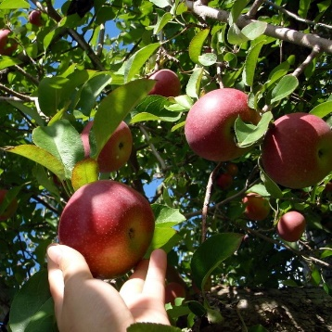
October 6 (Apple Gleaning w/ St. James) 1-3:30 pm
October 13 (youth night) 6-8:30 pm
October 17 (Ruth’s Harvest @ Lincoln Elementary School) 6:00 pm
October 27 (Halloween Party)

Nov 10 (Youth Night) 6-8:30 pm
Nov 24 (Youth Night) 6-8:30 pm

Dec 7-8 (9-12 Winterfest @ Nook) $155 per person.
Dec 15 Christmas Party

2020
Jan 12 (Youth Night) 6-8:30 pm
Jan 26 (Youth Night) 6-8:30 pm

Feb 6 (Ruth’s Harvest @ Lincoln Elementary School)
Feb 9 (Youth Night) 6-8:30 pm
Feb 23 (Youth Night) 6-8:30 pm

March 8 (Youth Night) 6-8:30 pm
March 22 (Youth Night) 6-8:30 pm

April 5 (youth night) 6-8:30 pm
April 19 (Youth Night) 6-8:30 pm

May 3 (Youth Night)
May 14 (Ruth’s Harvest @ Lincoln Elementary School)
May 17 (Youth Night)
May 31 (Youth Night)

June 7-12 VBS
June 14 – 19 All Saints Camp

July Summer Beach Trip?
July 26-31 LT Camp

Aug Welcome back pool party
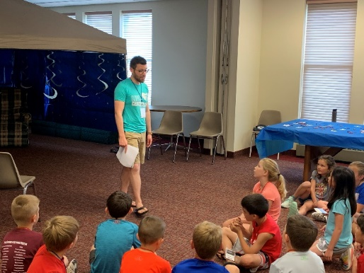
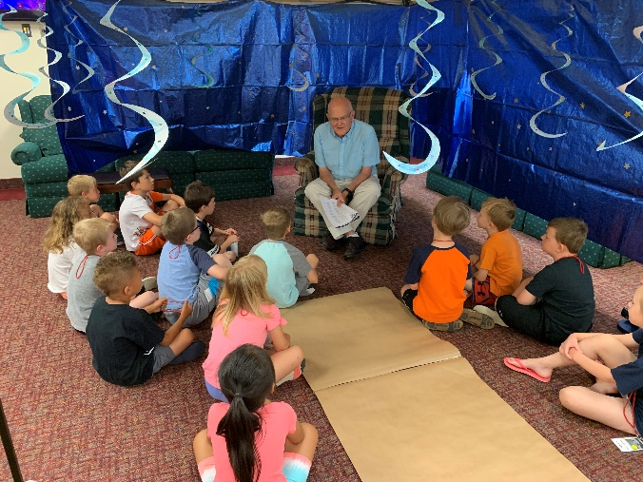

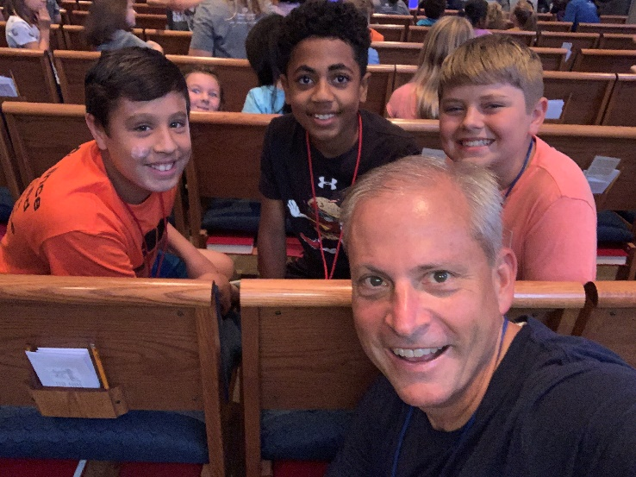
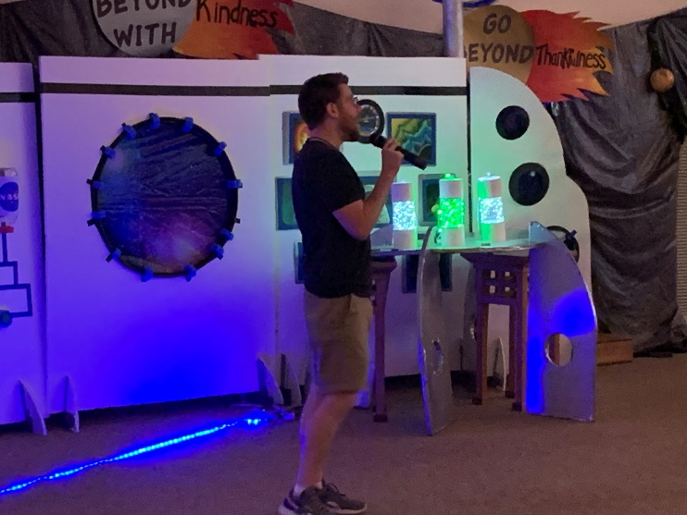

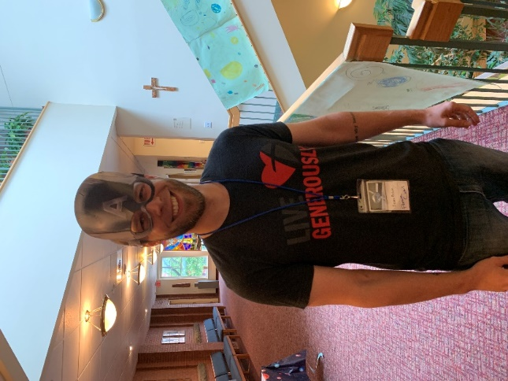

TO MARS AND BEYOND!
VBS 2019

NPS AMPHITHEATER WORSHIP SERVICE
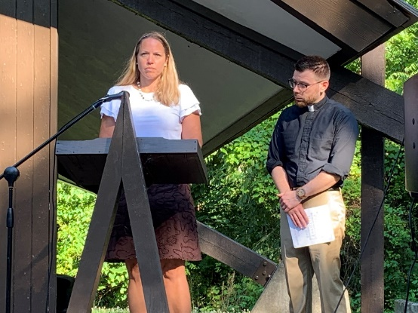
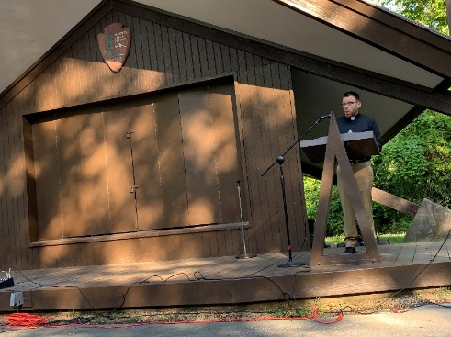

Tiff Rudisill and Pastor Eckman

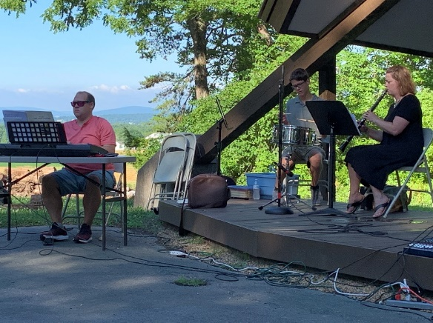

Cantor Cameron Wentz and the
Townsend family
THANK YOU TO BILL CHANTELAU AND THE PROPERTY COMMITTEE…At its June meeting the congregation council expressed its appreciation to Bill Chantelau and the property committee for their work in renewing the cupola, front stairs, sidewalk, and streetscape. Bill’s attentive work and presence throughout the project contributed greatly to the successful outcome. At worship on July 14th Bill announced that the project was fully completed including the straightening of the lightening rod on top of the cupola! Thanks again to all who were involved in bringing this project to a completion.
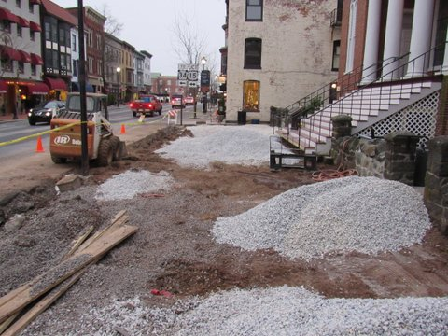
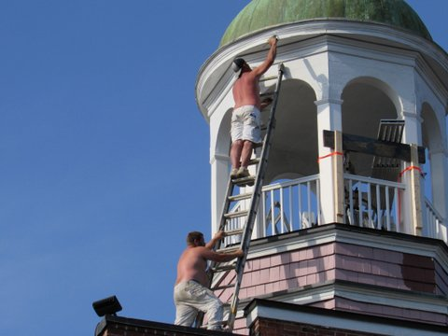

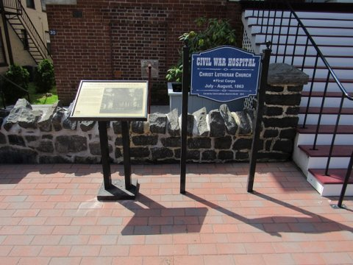

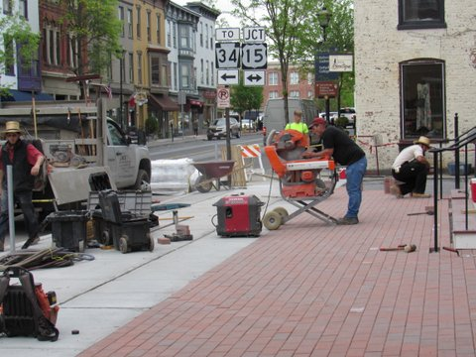
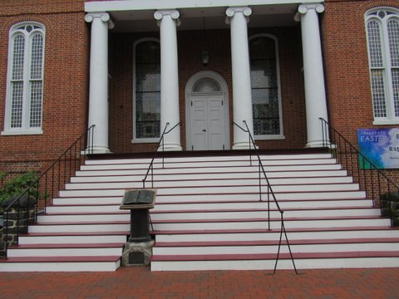
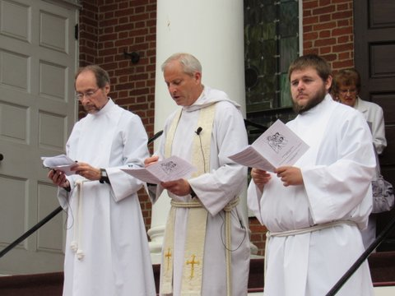

PRAYER REQUESTS
Please keep the following people in your prayers… John Fehringer, Anna Jane Moyer, Easter Dorsey, Marty Henderson, Jim Wright, Martin Schroeder, Marie Metcalf, Jennifer Russell, Diane Curtis, Stewart Bell, Bill Wellborn, Sr., Abby Blaney, Denny Moul, Pastor Sharon Blezard, Bill Houser, Pastor Jimmie Schwartz, Davalene Winters, Donna Mooney, Sue and Richard Trimmer, Donna Kime, Betty Wahlstrom, Dianne Curtis, Jeffrey Saneman, Rob Benge, Michael Burns, Jennifer Russell, Nicole Himes, friends and family at the death of James Townsend
Please keep our homebound members in your prayers… Helen Bream, Gladys Zech, Phyllis Hale
AUGUST BIRTHDAYS

8/1 – Peter Roy
8/3 – Albert Bachman
8/6 – Jane English, Lexis Sonoski
8/8 – Darla Conover, Richard Sonoski
8/9 – Helen Bream, Joanne Schwartz
8/11 – Leslie Carbaugh, John Jones
8/12 – Lyn Badger, Geoffrey Hillis
8/13 – Rebecca Neeley
8/14 – Mike Ropka
8/15 – Anna Jane Moyer, Madison Laing
Debra Mortland, Sherri Alms

8/17 – Mark Oldenburg, Dale Sciarretta
8/18 – Christina Hansen, Brandon Stone
8/19 – David Palesky, Ansley Peterman
8/20 –Pat Miller, Jim Wright
8/21 – Jason Townsend
8/25 – Langh Lian
8/27 – Jill Herr
8/28 – Ethan O’Dell
8/29 – Beth Reindollar, Erin Rhoads
8/30 – Michael Cooper-White, Liam Hansen
8/31 – Annie Granger
WEDDING ANNIVERSARIES

Mike and Sharon Saunders August 1, 1970
Frances and Walter Wagner August 2, 2019
Mark Oldenburg & Jill Schumann August 11, 1984
Bill Wellborn and Pam Vingsness August 13, 2014
Martin and Janet Schroeder August 18, 1973
John Spangler and Maria Erling August 22, 1981
Doug and Eunice Boden August 24, 1958
Ralph and Teresa Bowers August 24, 1974
John Wolfe and Kristin Rice August 24, 1985
Tom and Sara Laser August 27, 1960
Roland and Martha Hansen August 28, 1960

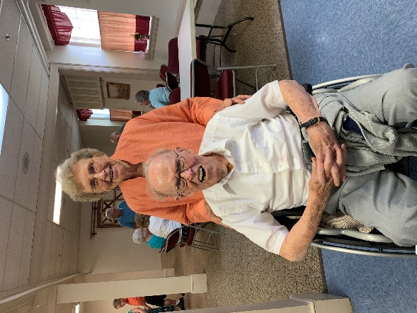
Dear Church family,
We feel especially honored to have been remembered with so many cards and greetings and the party after church, on the occasion of our 68th wedding anniversary. Thank you all for your prayers and loving concerns.
Orville and June Nyblade

