***The Seventh Sunday after Pentecost***

***July 27, 2025***

**Bethel Lutheran Church**

**P.O. Box 20, 502 South Ash - Sutherland, Iowa 51058-0901**

**712-446-3630 Church Answering Machine**

**Email:** [**bethel@midlands.net**](mailto:bethel@midlands.net)

**Website: blcsuth.360unite.com**

**Rev. David Matthews Jr.**

**Phone # (417) 318-1021**

**Email:** [revmatthews@pm.me](mailto:revmatthews@pm.me)

Pastor’s Office Hours Mon-Thurs 8:30am-12:00pm 1:30pm-5:00pm

**Bethel Church Secretary—Bridget Sickelka (712) 363-4926**

**Lutheran Family Service Counseling 712-276-9000**

**Holy Communion 1st, 3rd, & 5th Sundays of the Month**

**Worship Hours**

**Summer Hours**

**9:30 am Worship Service**



We welcome all of our worshipers this morning. We pray that the Holy Spirit will bless this time with an increase of faith in Jesus and love for one another. Please join us again in worship and fellowship.

**Our Worship** We follow Divine Service Setting 1 on page 151.

Hymns of Praise to the Lord: 504, 766 (stz. 1-5), and 766 (stz. 6-9).

**Our Response to God’s Love:**

**With our attendance last Sunday: 48 Communed 38**

Offerings to the Lord: Loose $425, General $1,660, Mission $29, IDW $50, Care Pkg. $10 Total $2,174.

Our adopted mission project for 2025 is $2,400 ($200 per month) for Noah’s Ark Daycare in Sutherland. They have need to help with their budget due to the renovations of the new location and inspection fees. **The second Sunday of the month we take an offering for this mission project.**

With our prayers for the sick and hurting: Judy Riedmann, Truel Bailey, Linda Nellis, Beverly Durst, Roman Fulkerson, Sara Sickelka, Janie Ebel, Ron Waggoner, Marilyn Fiddelke, Elaine Waggoner, Delmar Sickelka, and Brian Hohbach.

**Hospitalizations:** Please call Rev. David Matthews Jr. if you or someone from the congregation is in the hospital.

**Looking Forward to The Coming Week**

**Today:** **9:30 am – Family Worship**

No Church Activities are scheduled this week.

**Friday:** Pastor’s Day off

**Next Sunday****:** **9:30 am – Holy Communion**

|  |  |
| --- | --- |
| Lutheran Hour Ministries  Sundays at 8am on 102.9FM or 8:30am on KSCJ 94.9FM  August 3rd Airing  **"Proclaim His Glory"** Guest Speaker: [Rev. Dr. Dale A. Meyer](https://www.lhm.org/about/meyerbio.asp) Of course, we should search the Scriptures, but we search them for Jesus, the One to Whom the Scriptures point. (John 5:30-47)) | Iowa District West  August 3rd Airing  **This Is the Life** – “Give and Take” – A young Christian ad agency representative navigates a situation with an overly attentive married man.  Worship Service – Rev. Steve Weispfennig of St. John’s Lutheran Church in Yankton, SD, delivers the message “All is Vanity—Except Jesus” based on Ecclesiastes 1:2, 12-14; 2:18-26.  Additional information is available on the web site:[www.mainstreetliving.com](http://www.mainstreetliving.com/). |
|  | **Bethel Lutheran Church** will be live streaming our worship services on our Bethel Lutheran Church Sutherland Facebook page  @ 9:30 am on Sundays.  You can view the service afterwards on the Facebook account for up to 30 days before it is deleted. |
| **Building Healthy Families:** Whether it’s your growing awareness of the number of hours in your day tinged with anxiety or depression, or a gnawing feeling in your gut about the distance you’re feeling from your spouse, know that you don’t have to wait for a crisis to seek support. It’s often easier to prevent a problem from growing worse than to recover from one in full bloom. Pay attention to your mental, emotional, spiritual, and relational health. Talk to your pastor, a trusted Christian friend, or an LFS counselor, and remember (as the tee shirt says): It’s okay to have Jesus and a therapist, too! **Lutheran Family Service** [www.LutheranFamilyService.org](http://www.LutheranFamilyService.org) | |



* **Aug 10-13 – VBS @ Bethel 6:00pm-8:00pm**
* **August 10 – Concordia League – going to Sunday Service in Marcus – Paullina Lake Concession for lunch**
* **August 13 – Christian Outreach @ 6:00 pm**
* **August 13 – Elders Meeting @ 7:30 pm**
* **August 13 – Church Council @ 8:00pm**
* **August 16 – “Bible & Bacon” Men’s Group**
* **August 31 – Church Service will be at Zion Paullina @ 9:30 am w/ fellowship meal afterwards**
* **August 31 – Labor Day Food Stand @ 11:00am – 2:00pm**
* **Sept. 1 – Labor Day Parade @ 10:30am**

VBS is scheduled for Aug 10-13, from 6:00-8:00 pm.  Our theme this year is **'Epic Australian Adventure'**.  An unforgettable journey with Jesus.

Volunteers are needed to help us have another great experience for the kids!!  I need helpers for crafts, music, and serving food.  I plan on having a signup sheet in the church soon but you can call me any time to volunteer for a spot and I will sign you up!    Thank you!   - Georgette Ebel



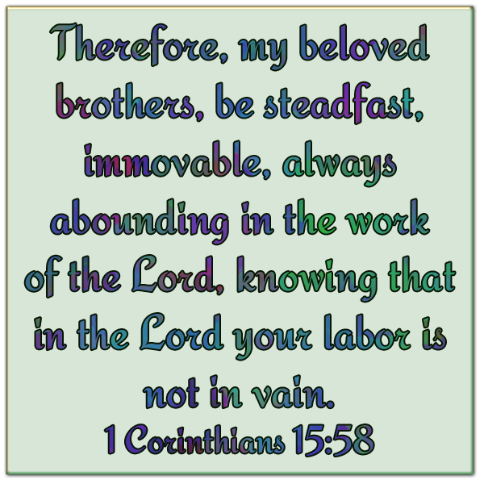



Jamie Stoll

Jeff Ebel

Meri Rickers



**Kevin & Traci Nelson**

**Jon & Marsha Rehder**

**Brian & Jamie Bailey**

**Branden & Courtney Johannsen**

**Kirk & Lisa Johannsen**