***The Sixth Sunday after Pentecost***

***July 20, 2025***

**Bethel Lutheran Church**

**P.O. Box 20, 502 South Ash - Sutherland, Iowa 51058-0901**

**712-446-3630 Church Answering Machine**

**Email:** [**bethel@midlands.net**](mailto:bethel@midlands.net)

**Website: blcsuth.360unite.com**

**Rev. David Matthews Jr.**

**Phone # (417) 318-1021**

**Email:** [revmatthews@pm.me](mailto:revmatthews@pm.me)

Pastor’s Office Hours Mon-Thurs 8:30am-12:00pm 1:30pm-5:00pm

**Bethel Church Secretary—Bridget Sickelka (712) 363-4926**

**Lutheran Family Service Counseling 712-276-9000**

**Holy Communion 1st, 3rd, & 5th Sundays of the Month**

**Worship Hours**

**Summer Hours**

**9:30 am Worship Service**



We welcome all of our worshipers this morning. We pray that the Holy Spirit will bless this time with an increase of faith in Jesus and love for one another. Please join us again in worship and fellowship.

**Our Worship** We follow Divine Service Setting 1 on page 151.

Hymns of Praise to the Lord: 576, 855, 623, 622, 633, and 708.

**Our Response to God’s Love:**

**With our attendance last Sunday: 43**

Offerings to the Lord: Loose $345, General $2,175, Mission $148, IDW $50, Sunday School $25 Total $2,743.

Our adopted mission project for 2025 is $2,400 ($200 per month) for Noah’s Ark Daycare in Sutherland. They have need to help with their budget due to the renovations of the new location and inspection fees. **The second Sunday of the month we take an offering for this mission project.**

With our prayers for the sick and hurting: Judy Riedmann, Truel Bailey, Linda Nellis, Beverly Durst, Roman Fulkerson, Sara Sickelka, Janie Ebel, Ron Waggoner, Marilyn Fiddelke, Elaine Waggoner, Delmar Sickelka, and Brian Hohbach.

**Hospitalizations:** Please call Rev. David Matthews Jr. if you or someone from the congregation is in the hospital.

**Looking Forward to The Coming Week**

**Today:** **9:30 am** – **Holy Communion**

**Thursday:** 7:00 pm – “Bible & Beer” Zion’s Men Group @ Paullina

**Friday:** Pastor’s Day off

**Next Sunday****:** **9:30 am – Family Worship**

|  |  |
| --- | --- |
| Lutheran Hour Ministries  Sundays at 8am on 102.9FM or 8:30am on KSCJ 94.9FM  July 27th Airing  **"Getting the Talk Started"** Lutheran Hour Speaker: [Rev. Dr. Michael Zeigler](https://www.lhm.org/about/zeigler-bio.asp) God's Law-talk prepares us for God's Gospel-talk. Author Tim Carter (The Executioner's Redemption) is featured. (Luke 11:1) | Iowa District West  July 27th Airing  **This is the Life** – “A Different Way” – In this Fisher family episode, Cousin Stanley visits and creates a difficult situation with a neighbor.  Worship Service – Rev. Michael Awe of Hope Lutheran Church in South Sioux City, NE, delivers the message, “What’s the Deal?” based on Genesis 18:20-33. Additional information is available on the web site: [www.mainstreetliving.com](http://www.mainstreetliving.com/).  . |
|  | **Bethel Lutheran Church** will be live streaming our worship services on our Bethel Lutheran Church Sutherland Facebook page  @ 9:30 am on Sundays.  You can view the service afterwards on the Facebook account for up to 30 days before it is deleted. |
| **Building Healthy Families:** It’s been said that children may not always be good at listening to adults, but they never fail to imitate them. Consider this: the words you speak are less important than the everyday life you lead. Your children (and grandchildren) are constantly learning about life by watching you. What an immense responsibility. What an incredible privilege! Pray that God will help you to be the kind of adult you want your child (or grandchild) to become. Find inspiration from the One whose love, humility, obedience, honesty, and faithfulness we’re encouraged to imitate. (Ephesians 5:1-2; Philippians 2:5-11; and 1 John 2:6) **Lutheran Family Service** [www.LutheranFamilyService.org](http://www.LutheranFamilyService.org) | |



* **Aug 10-13 – VBS @ Bethel 6:00pm-8:00pm**
* **August 10 – Concordia League – going to Sunday Service in Marcus – Paullina Lake Concession for lunch**
* **August 13 – Christian Outreach @ 6:00 pm**
* **August 13 – Church Council @ 8:00pm**
* **August 16 – “Bible & Bacon” Men’s Group**

VBS is scheduled for Aug 10-13, from 6:00-8:00 pm.  Our theme this year is **'Epic Australian Adventure'**.  An unforgettable journey with Jesus.

Volunteers are needed to help us have another great experience for the kids!!  I need helpers for crafts, music, and serving food.  I plan on having a signup sheet in the church soon but you can call me any time to volunteer for a spot and I will sign you up!    Thank you!   - Georgette Ebel



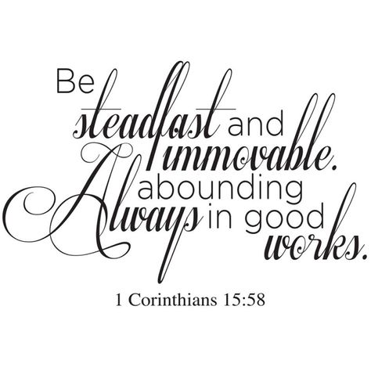

Scott Waggoner

Kirk Johannsen

Milt Hustedt

Nicole Nelson

We soon learned that our new church had an elder with a sense of humor. “At this church,” the elder said, “We follow the Noah principle of two by two. We have two Italian elders, two bald elders, and two very handsome older elders. I’m not Italian, so I’ll let you guess which group I’m in.”

After the elder spoke, the bald pastor started to speak. “I apologize,” he said, patting his head. “The power went out to my house this morning, so I couldn’t use my blow dryer. Does it look okay?”

