

Bethel Blessings

3rd Quarter newsletter

July – August - September

2025

“For as in one body we have many members, and the members do not all have the same function, so we, though many, are one body in Christ, and individually members one of another.” – Romans 12:4-5

**Our Website:** <https://blcsuth.360unite.com/home>

**Recommended Radio Stations:**

**-KICD 1240 AM** Spencer, IA

First English Lutheran Church Service 8:00 AM

**-KSCJ 94.9FM** Sioux Center, IA

The Lutheran Hour Sun 8:30 AM

**-KJIA 88.9 FM** Okoboji, IA

Lutheran Hour <https://www.lutheranhour.org/>

Lutheran Public Radio <https://issuesetc.org/>

Iowa District West<http://www.idwlcms.org/>

Lutheran Church Missouri Synod <https://www.lcms.org/>

Pod Casts https://podcasts.cph.org/show/the-concordia-publishing-house-podcast/

Bethel Lutheran Church will be live streaming our worship services on our Bethel Lutheran Church Sutherland Facebook page

@ 10:30 am on Sundays (9:30 am during summer hours).

You can view the service afterwards on the Facebook account for up to 30 days before it is deleted.

*From the Desk of Pastor Matthews*

Greetings in the name of Jesus,

In a few days we will celebrate the freedom and independence of our country that we have had for 249 years. It is a great time to reflect on the freedom that we have in our country, especially in regards to the 1st amendment, the right to practice religion freely.

While that freedom is important, we need to recognize where true freedom lies, and that is through Jesus Christ. Galatians 5:1, says, ***“For freedom Christ has set us free; stand firm therefore, and do not submit again to a yoke of slavery.”*** Later in Galatians chapter five, it says, ***“For you were called to freedom, brothers. Only do not use your freedom as an opportunity for the flesh, but through love serve one another. For the whole law is fulfilled in one word: “You shall love your neighbor as yourself.” But if you bite and devour another, watch out that you are not consumed by one another.”***

Our freedom comes from Jesus who died for the sake of all. We are free from sin, death, and the devil. We are also free from the various laws of the Old Testament, and that is the context that the apostle Paul is speaking to the Galatians, when he says, ***“do not submit again to a yoke of slavery.”*** He is telling them to not fall back into old habits, specifically circumcision. Paul is reminding them that their true freedom is in Christ, and in that true freedom they can serve one another as Christians, instead of gratifying their own desires.

That is why later in Galatians five, St. Paul says, ***“But if you are led by the Spirit, you are not under the law. Now the works of the flesh are evident: sexual immorality, impurity, sensuality, idolatry, sorcery, enmity, strife, jealousy, fits of anger, rivalries, dissensions, divisions, envy, drunkenness, origies, and things like these. I warn you, as I warned you before, that those who do such things will not inherit the kingdom the kingdom of God. But the fruit of the Spirit is love, joy, peace, patience, kindness, goodness, faithfulness, gentleness, self-control; against such things there is no law. And those who belong to Christ Jesus have crucified the flesh with its passions and desires. If we live by the Spirit, let us also keep in step with the Spirit. Let us not become conceited, provoking another, envying one another”*** (Galatians 5:18-26.)

Whenever Christ was crucified in His flesh, all the sins you had ever committed were crucified upon that tree. But that was not the end of it. Jesus rose, and ascended into the Heaven. Before Jesus ascended into Heaven, he instituted the waters of Holy Baptism, so that the Holy Spirit could come to His people. And that's the Spirit that St. Paul is talking about in the book of Galatians. That Spirit tries to lead us in the right direction, but our sinful nature and flesh hates this, the constant battle of being a saint and sinner simultaneously. And with being saint in Christ, you have freedom to live a different life, a life as a servant of God to your neighbor. Just imagine if we lived our life that way more often, this world would be a better place than it is currently. If you look closely at the list in Galatians five, the fruits of the spirit are in complete opposition to the fruits of the Spirit. A couple examples are drunkardnness verses self-control. People with self-control will know when it is time to set down a drink, whereas a drunkard doesn’t. Another example is sexual-immorality and jealousy versus faithfulness and peace. To have affairs outside of marriage is the complete opposite of faithfulness to your spouse, period. Jealousy and envy mean you desire somebody else’s possessions, while having peace is recognizing what you have is enough, and you are content with it.

That is not to say that people who are baptized will not sin, by no means, but we should actively try to reduce our sinning. Freedom in Christ, does not mean we get to sin more. It is the exact opposite, according to scripture, ***“What shall we say then? Are we to continue in sin that grace may abound? By no means! How can we who died to sin still live in it? Do you not know that all of us who have been baptized into Christ Jesus were baptized into his death? We were buried therefore with him by baptism into death, in order that, just as Christ was raised from the dead by the glory of the Father, we too might walk in newness of life”*** (Romans 6:1-4.)

The great thing is that as Christians, in our baptism, we were baptized into Christ’s death. We get to die, but also arise just as our Lord and Savior did. I pray that this letter reminds you of the freedom you have in Christ, because we ***“walk in the newness of life.”*** Walking in that newness of life, gives us the opportunity to serve our neighbor with love. May God be with you always.

In Christ’s Service,

Pastor David H. Matthews Jr.

Associate Pastor of Bethel Ev. Lutheran Church, Sutherland, IA & Zion Lutheran Church and School, Paullina, IA



**Treasurers Report**: - A Gieser CD has been renewed for one year and a LCEF CD renewed for two years. Lent soup/devotional free will offering has been donated 2/3 to Sutherland Fire station and 1/3 to Calumet Fire station.

**Pastors Report**: -

* Official Parish Acts: Release by death – Blaine Salzkorn; Released from membership – Hannah Jurgensen, Shelby Johnson, Aaron Tewes, and Jeremy Tewes.
* Sunday morning Bible class will be on hold during the summer months and will resume the Sunday after Labor Day. “Bible and Bacon” Men’s Group will continue on the second Saturday of the month. Breakfast is at 8:30am followed by bible study from 9:00am-10:00am.
* Continues to see nursing home, assisted living, and shut-ins for both Bethel and Zion churches. Pastor is also making in-home visits with congregational members to get to know them.
* During the month of May, Pastor Matthews attended a PALS retreat at Camp Okoboji. He also attended the IDW Convention in June. IDW mentioned during the convention that $18,000 was raised for Camp Okoboji renovations from the flooding. Thank you to all who helped donate.
* Pastor Matthews and the church councils of both Bethel and Zion are working on having a joint service and meal after the service for the month’s that have a 5th Sunday in them.
* Pastor Matthews and his family will be going on vacation from July 1 – July 7. Pastor Meyer will be conducting the Sunday service on July 6th at 9:30am. The service will be held at Zion, Paullina. No fellowship afterwards. No service at Bethel Lutheran that day. During this time if you have any emergencies, please contact Pastor Meyer at (712)261-1774.

**Elders Report:** Elders are working with Pastor on the membership list and finding address and phone numbers for inactive members so that Pastor may be able to visit them. Sutherland Bank is donating their old board room table and chairs to be used in the Sunday school room that will be transformed into Pastor’s office/meeting room.

**Trustees Report:** Heath has fixed the A/C unit in the church. Aaron has been working with Connie on purchasing new dehumidifiers for the basement fellowship hall. Don has put up the curtain rod in Pastor’s office. Trustees and Elders are working on cutting the tree that is going through the power line. Needing to talk with Mid-America on cutting power to the line so that we can cut it down and have Rodney haul the tree to the city tree dump. Planning on a work day either the last Saturday of June or middle of July to scrap and re-stain the trim around the church windows.

**New Business:** Live-streaming of church service on the church’s Facebook page has been going very well. Hartley assisted living and nursing have set up the large TV for them so that they may enjoy the service. We had two opportunities to donate to some worth causes. One was for Camp Okoboji to help them renovate the camp after last year’s flooding. Lutheran Family Services is having a “Grow and Go” challenge for congregations. If any congregation has 10 new members donate of LFS, they will present our pastor with a gift card for a night out on the town.

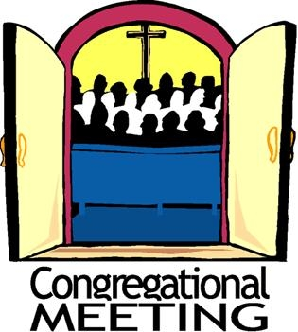

**Voter’s Meeting**

Sunday, July 13th

After the Church Service

Sign-up Sheet on church bulletin board for greeting on Sunday’s



**Concordia League**

April’s meeting was cancelled due to conflicts with scheduling. In May we enjoyed a “Game Night” at the church. June we had an “Appetizer Night” at the Cody’s. Everyone provided an appetizer to share. Everything was delicious.

Future events include a Picnic at Wiloway with the residents on July 16th at 5:30pm. We will grill some hamburgers or hotdogs. Members of Concordia League please bring a couple of side dishes to share. August we plan to attend the church service at Trinity, Marcus to welcome the new minister; also eating lunch at Paullina Concession stand. September will be our “Progressive Supper”. Appetizer will be at Vivian Hersom’s, Main Course will be at Ron & Kay Farquhar’s, Dessert is TBD on the location. Any one from the congreation is invited to join us for any event.

Christian Outreach

Church Ministry:

* Fellowship dinning room has been painted.
* Purchased a beverage bar for the Narthex, to be used before or after church. We have a Keurig Coffee machine, electric coffee pot, and beverage dispensers that everyone is welcome to use. We ask that you keep the beverages out of the sanctu Join us on Sundays that don’t have communion for coffee, snacks, and fellowship with each other.
* There will be a sign-up sheet on the bulletin board for the fellowship Sunday’s during the summer on non-communion Sundays for treats and drinks.
* Discussion continues on converting the large Sunday School of the NW corner into the Pastor’s office/meeting room. Sutherland bank is donating their old board room table and chairs for this room. Aslo looking at how to rearrange other rooms to make a space for Sunday School.
* Outdoor Picnic is Sunday June 29th after the church service. Service will be at 10:30am that day. Outreach will grill hamburger and hot dogs. There will be a sign up sheet for sides and desserts.
* We are moving our meeting day to the 2nd Wednesday of each month. Meeting time will stay the same of 6:00 pm.



Community Ministry:

* We did the “High Five” this year at the South O’brien elementary and ZSJ school. We also brought breakfast to the teachers and staff to enjoy.
* We plan to have a stand during the Sutherland Labor Day celebrations, the stand will be on that Sunday from 11:00am-1:00pm. We will be serving pulled pork nachos and sandwiches. Tonya and Aaron have already made the BBQ pulled pork for the meal. We will be asking for voluteers to work one-hour shifts and to make pies. Proceeds will go towards church updates.
* Tonya and Pastor are looking into a grant from IDW to update the float we use during the parade as more water bottle and items to be handed out during the parade. The new float this year is “Fishers of Men” themed. Looking for helpers to build the float in August and to walk/ride in the parade on Labor Day.

**If you have any ideas for Church or Community Ministry please share your ideas with a committee member.**



At the beginning of June, the LYC enjoyed a kickoff to summer with devotions based on the National Youth Gathering theme, "Endure", yard games, and feasting on smashburgers and all the fixings. We continue to have extra kids from the South O’Brien district join us for the fun.

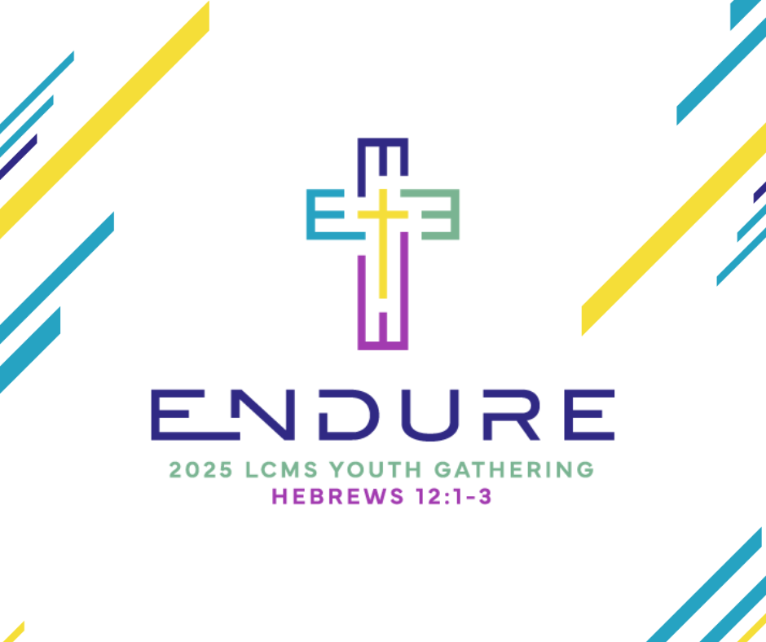We are busy making our final plans for the National Youth Gathering. We will be flying out of Minneapolis on July 19 to New Orleans, where we will spend five days in Bible Study, faith-building sessions, and attending the great closing programs each night at the Caesars Superdome. Please pray for our group of 7 for safe travels and the growth of our relationship with God. We will share our NYG experience with the congregation sometime this fall.

Sunday School News:  We are on summer break until September.  Pastor and I are going to meet later this summer to start planning our Sunday school curriculum for the 2025/26 year.  We are in desperate need of Sunday school teachers!!  Please contact Pastor or Georgette Ebel.



VBS is scheduled for Aug 10-13, from 6:00-8:00 pm.  Our theme this year is **'Epic Australian Adventure'**.  An unforgettable journey with Jesus.  Volunteers are needed to help us have another great experience for the kids!!  I need helpers for crafts, music, and serving food.  I plan on having a signup sheet in the church soon but you can call me any time to volunteer for a spot and I will sign you up!    Thank you!



Quilting Group

The quilting group completed over 100 quilts this past year!! Thank you to Kay Farquhar and Vernice Rahbush and her daughters for assembling and sewing so many beautiful quilt tops.

In May, seven boxes containing 57 quilts were delivered to the collection point in Spencer where they were brought to the Lutheran World Relief headquarters in Minnesota to be sent overseas to places in need.

The ladies met weekly on Tuesday afternoons to layer, pin, and tie the quilts starting in February and finished the first week in June. A special tahnks to Fran Oeffner for using the Thrivent program to purchase new material for the project, which was used for quilt backs.





“Big Thank You” goes out to all who have helped served in our church.

Pastor David Matthews – Pastor Don Meyer – Pastor John Reibhoff

Secretary – Bridget Sickelka

Church Council Members – Dwane Riedmann, Ryan Farquhar, Don Farquhar, Bridget Sickelka, Jeff Ebel, Jamie Sickelka, Brent Hustedt, Aaron Oolman, Heath Negus, Chris Sickelka

Church Finiance – Lynn & Marilynn Horstmann, Darin Johnson, Mark Drefke

Sunday School Teachers – Georgette Ebel and Jamie Stoll

LYC Leaders & Youth – Darin & Jenny Johnson, Jasper Johnson, Reese Farquhar, Chole Hustedt, Adrianna Ebel, Greta Hustedt

Church Organist – Ilon Negus

Church Computer Service and Live Steamin I-Pad – Chris & Bridget Sickelka, Brent & Becky Hustedt, Jeff Ebel, Jamie Sickelka

All Church Greeters & Welcomers

Bible Study Leaders – Pastor David Matthews, Tonya Oolman

Altar Guild – Roger & Mary Postma, Jamie & Denise Sickelka, Wyatt & Tayla Sickelka

Quilters – Vernice Rahbusch, Mary Postma, Marilynn Horstmann, Fran Oeffner, Sheryl Hustedt, Phyllis Lange, Kay Farquhar, Jan Oeffner, Judy Riedmann

Care Package Helpers – Milt & Sheryl Hustedt, Connie & Mary Cody, Vivian Hersom, Dwane & Judy Riedmann

College Care Package Helpers – Tonya Oolman, Kay Farquhar, Traci Nelson, Marsha Rehder, Heidi Farquhar, Sharon Litka

Christian Outreach Committee

Concordia League Members

Outdoor Flower Pots – Jo Horstmann

Outdoor Weeding – Connie Cody, Vivian Hersom

Painting Fellowship Room & Dining Room – Tonya Oolman, Heidi Farquhar, Liz Peters, Traci Nelson

Hanging Curtains – Don Farquhar

Friendship Sunday Potluck – Everyone who participated & brought food

Pre-Lent Taco Bar – Christian Outreach Committee, Marilyn Horstmann, Marsha Rehder, Mary Postma, Judy Riedmann, Fran Oeffner, and Connie Cody

Lenten Soup Dinner – Mary Postma, Jeff & Georgette Ebel, Ilon Negus, Fran Oeffner, Gerald & Phyllis Lange, Sheryl Hustedt, Don & Kay Farquhar, Jamie Sickelka, Bridget Sickelka, and all who donated ingredients

Lenten Service Snacks – Gerald & Phyllis Lange, Don & Kay Farquhar, Chris & Bridget Sickelka, Vivian Hersom, Mark & Connie Cody, Darin & Jenny Johnson, Jasper Johnson, Adianna Ebel, Reese Farquhar, and Chole Hustedt

High 5 Friday – Pastor Matthews, Tonya Oolman, Heidi Farquhar

South O’Brien School & ZSJ School Staff Breakfast – Tayla Sickelka, Connie Cody, Liz Peters, Jenny Johnson, Heidi Farquhar, Tonya Oolman, and Darla Negus

***Easter Lilies -*** Bridget & Chris Sickelka, one in memory of Bridget's father, Delbert Bretschneider, and one in memory of Chris's grandparents, Don & Darlene Sickelka and Pete & Delma Mueller  
Elaine Waggoner & Family, in memory of Glen Waggoner.

******Connie & Mark Cody, one in memory of Ken & Lois Cody, and one in memory of Dick & Bev Thiel.

Fran & Dan Oeffner, in memory of Oeffner/Rossow families.

Maurine Amendt, in memory of her sister, brother, and sister-in-law.

Vernice Rahbusch, in memory of John Rahbusch.

Delmar Sickelka, in memory of Clara Sickelka.

Roger & Mary Postma, in memory of Evelyn & Clarence Postma.

Easter Breakfast – Chris & Bridget Sickelka, Sydney Sickelka, Jordan Sickelka & Shelby Krueger, Georgette Ebel, and all who donated food items

Church Picnic – Christian Outreach for grilling meat and setting up, Aaron & Tonya Oolman, Hudson Oolman, Dwane & Judy Riedmann, Ryan & Heidi Farquhar, Liz Peters, all who donated salads and deserts.

Hopefully we haven’t forgotten anyone; but God knows if you helped.

Huge Thank You to all who say “YES” when called upon.





|  |  |
| --- | --- |
| 1 | Ryan Farquhar  Marsha Rehder |
| 5 | Troy Schueder |
| 6 | Frank Fogelman |
| 7 | Lisa Johannsen |
| 9 | Cheryl Fogelman  Tate Johnson |
| 12 | Becky Hustedt |
| 14 | David Mills  Cindy Schueder |
| 15 | Jamie Sickelka |
| 17 | Lester Tewes |
| 18 | Cole Drefke |
| 19 | Dwane Riedemann  Denise Sickelka |
| 21 | Scott Waggoner |
| 23 | Kirk Johannsen |
| 26 | Milt Hustedt  Nicole Nelson |
| 29 | Jamie Stoll |
| 31 | Jeff Ebel  Meri Rickers |



|  |  |
| --- | --- |
| 3 | Lynn Horstmann |
| 4 | Dani Rehder |
| 6 | Jordan Wohlert |
| 19 | Brian Bailey |
| 22 | Sherry Durst |
| 25 | Anthony Peters  Bonnie Rohrs |
| 27 | Traci Nelson  Delbert Schueder |
| 28 | Chris Sickelka |
| 31 | Delmar Sickelka  Jill Mews |

 

|  |  |
| --- | --- |
| 1 | Bruce Engelke |
| 4 | Marlene Vander Pol |
| 6 | Sean Negus |
| 7 | Carmen Waggoner  Ron Waggoner |
| 8 | Ophelia Matthews |
| 10 | Shirley Tewes |
| 15 | Kruse Magnussen |
| 16 | Wes Mills |
| 19 | Lindsay Jobst |
| 20 | Reese Farquhar |
| 23 | Jasper Johnson |
| 24 | Dan Oeffner |
| 25 | Lydia Hustedt |
| 29 | Teresa Hansen |



**July:**

|  |  |
| --- | --- |
| 8 | Alan & Regina Mills |
| 16 | Heath & Jill Mews |
| 19 | Denny & Sharon Litka |
| 27 | Kevin & Traci Nelson |
| 29 | Jon & Marsha Rehder |
| 30 | Brian & Jamie Bailey |
| 31 | Branden & Courtney Johannsen |

**August:**

|  |  |
| --- | --- |
| 1 | Kirk & Lisa Johannsen |
| 3 | Dan & Fran Oeffner |
| 13 | Cody & Dani Rehder |
| 14 | Robie & Rita Schau |
| 21 | Brent & Becky Hustedt |
| 24 | Dale & Brenda Miller |
| 25 | John & Ilon Negus |
| 26 | Ryan & Heidi Farquhar  Bruce & Paulette Rohwer |
| 30 | Jeff & Georgette Ebel |

**September:**

|  |  |
| --- | --- |
| 1 | Ross & Lindsay Jobst |
| 11 | Merle & Barb Jalas  Michael & Loretta Johannsen |
| 19 | Darin & Jenny Johnson |
| 20 | Gerald & Phyllis Lange |

How to deal with squrriels?

Church edition.

The Presbyterian church called a meeting to decide what to do about their squirrel infestation.  After much prayer and consideration, they concluded that the squirrels were predestined to be there, and they shouldn’t interfere with God’s divine will.

At the Baptist church the squirrels had taken an interest in the baptistery. The deacons met and decided to put a water-slide on the baptistery and let the squirrels drown themselves. The squirrels liked the slide and unfortunately, knew instinctively how to swim, so twice as many squirrels showed up the following week.



The Lutheran church decided that they were not in a position to harm any of God’s creatures. So, they humanely trapped their squirrels and set them free near the Baptist church. Two weeks later the squirrels were back when the Baptists took down the water-slide.

The Episcopalians tried a much more unique path by setting out pans of whiskey around their church in an effort to kill the squirrels with alcohol poisoning. They sadly learned how much damage a band of drunk squirrels can do.

But the Catholic church came up with a very creative strategy! They baptized all the squirrels and made them members of the church. Now they only see them at Christmas and Easter.

And not much was heard from the Jewish synagogue. They took the first squirrel and circumcised him.

Bethel Lutheran Church

502 South Ash St.

PO Box 20

Sutherland, IA 51058